Abstract
This report represents an analysis and evaluation of contemporary issues with modern-day divorce and whether change, with the introduction of the Divorce, Dissolution and Separation Act (2020), was necessary. The following paper uncovers that child and finance-related issues are of major significance and that change in relation to the law can be subjective and open to interpretation.
“An analysis of contemporary issues with Modern-day divorce and whether change was necessary”
By Artur Zacharski
Contents
Acknowledgements 2
Declarations 3
Chapter 1 – Introduction: 4
Chapter 2 – Literature Review: 8
Objective 1 - An analysis of Child-related issues: 8
Objective 2 - An analysis of Finance related issues: 12
Objective 3 - An analysis of the MCA (1973) and DDSA (2020): 15
Chapter 3 – Methodology: 18
3.1 Research Onion: 19
3.2 Research Philosophy: 20
3.3 Research Approach: 21
3.4 Methodological Choice: 22
3.5 Research Strategy: 22
3.6 Time Horizon: 23
3.7 Techniques for Data Collection, Processes and Analysis: 23
3.7.1 Sampling: 24
3.7.2 Reliability and Validity: 24
3.7.3 Limitations: 25
Chapter 4 – Findings: 26
4.1 “Critical analysis of the public's perception on modern-day divorce in England and Wales” 26
4.2 Findings: Description of Data Analysis and Results: 27
Chapter 5 – Conclusion: 42
Reference List 44
Legislation List 54
Case Law 54
Appendix 55

Acknowledgements

After dedicating three short years to studying Law and Criminology at UWTSD, I would like to sincerely thank Mike Durke and Laura Knight for their constant support throughout the completion of this dissertation as well as all modules undertaken in other years and semesters.
In addition, I wish to extend my personal thanks to James Drew for his share of knowledge and motivation regarding my future career. Of all the law modules I have studied, it was James's teaching style and delivery of content that made Family Law particularly enjoyable for me. As a result, I chose to focus my dissertation on contemporary issues within Family Law and intend to pursue a career in such field in the near future.

Declarations

This work has not previously been accepted in substance for any degree and is not being concurrently submitted in candidature for any degree.
STATEMENT 1
This dissertation is being submitted in partial fulfilment of the requirements for the degree of BA/BSc.
STATEMENT 2
This dissertation is the result of my own independent work/investigation, except where otherwise stated.
Other sources are acknowledged in the Reference Section.
STATEMENT 3
I hereby give consent for my dissertation, if accepted, to be available for photocopying and for interlibrary loan, and for the title and summary to be made available to outside organisations.
STATEMENT 4
I hereby give consent for my dissertation, if accepted, to be available on the university’s IT system to those who have consent to use the system.

Student’s Name: Artur Dariusz Zacharski

Signed: Zacharski

Date: 07/05/2024

Chapter 1 – Introduction:

The development of issues with regards to justice in divorce law can be uncovered from as far back as the 19th century with the introduction of the Matrimonial Causes Act (1857). Prior to the act's creation, divorce could only be obtained through a Private Act of Parliament which now could be considered as a rickety process as there were no fundamental procedures written within legislation for divorce. Primarily instigated by men, the Matrimonial Causes Act (1857) allowed married men to file for divorce by using grounds of adultery. Issues were uncovered within the act as the only possibility for women to file for divorce was if her life was endangered due to the adultery occurring (UK Parliament, 2024). Since then, divorce may be a sensitive process for people as it can affect not only the spouses themselves but also friends, family, or children around them. It can be considered that a rise of issues is inevitable as it is the formal process of ending a legal relationship where priorities may lie such as property rights or custody of children (Meyer, 2017). By considering the dissertation title, “An analysis of contemporary issues with modern-day divorce and whether change was necessary”, leads to a clear understanding that child and finance related issues are prevalent and commonly endured by couples in divorce proceedings (Laube, 2020). Such issues are relevant as both can not only be emotionally draining but can hold the potential to cause serious detriment for both spouses and their families. According to Vegita (2023), these are some of the most common issues that get brought up during the process of divorce and can be furthermore classed as relevant due to how complicated these issues and possible situations may turn out to be. This dissertation will attempt to analyse relevant issues regarding divorce, with the intention of being able to explain and provide necessary measures to limit the possibility of detriment. For example, regarding child-related issues, the literature review will attempt to uncover what type of issues children may face during a divorce, what measures should be taken by parents to avoid such issues, and what the government does to enforce a child’s safety during a divorce. The NHS (2021) suggests children who had a negative childhood, because of divorce or abuse, are more likely to develop a phenomenon called Adverse Childhood Experiences (ACE). These ACE’s can affect an adult in their day-to-day life with their emotions and decision making.

Secondly, financial issues are significant with regards to divorce as according to the Safeguarding Network (2023), in contemporary society, parents are more likely to prioritise their financial stability, just as much as their children’s well-being, during matrimonial dissolution. As lack of financial resources or a sustainable income can limit the parent from sufficiently supporting their family and thereby increasing the possibility of placing their child in a vulnerable situation. Such consideration of finance is significant as if assets are held jointly, matrimonial dissolution could cause detriment and an unequitable distribution (Allen, 2023). Most importantly, a combination of issues can be mentally challenging for vulnerable people, where one could experience stress or depression (Vitelli, 2015).

Finally, the last objective is to analyse the new Divorce, Dissolution and Separation Act (2020), (DDSA 2020). With the intention of discovering whether change of law was necessary, is no-fault divorce successful, and whether further change is needed. Additionally, the whole dissertation will attempt to understand whether such change in law limits or prevents child or finance related issues from occurring.
Through analysing the topic, the paper’s aim is to uncover and analyse issues that come with divorce. Considering that child and finance are the most relevant issues, conducting research around the topic will give the reader an insight of what problems people may face during a divorce, why they face them as well as consideration for change in behaviour in order to prevent such issues from arising. This paper intends to show this by addressing facts and statistics as well as researching relevant journal articles. Its aim is to almost prevent issues by promoting solutions to lower the chances of children being mistreated during the divorce process as well as lower the chances of spouses having issues with regards to finances. Furthermore, the time scale is important to consider since DDSA (2020) was introduced recently and therefore a potential limitation could be a lack of information surrounding the topic. With that in mind, the paper will also explain why the changes in divorce law were needed, was the change successful, and whether further changes are necessary. It will consider whether change in law was needed by examining case law and considering important factors such as: how long the process took or protection of vulnerable people during the old law compared to now. Whether change was successful by examining cases and analysing crucial points such as: whether there is an increase in divorce, increase or decrease in domestic abuse, or the length of time a spouse must wait before matrimonial dissolution, using the no-fault system. Lastly, whether further changes are needed. This can be answered by considering what the DDSA (2020) had to offer and whether the outcome of the act turned out to be negative for society.

It must be clear that this paper is only designed for a narrow group of demographics. In the sense that, although it considers UK law, only a certain age group might be interested in the topic as well as considering divorce in the traditional UK sense. Therefore, this dissertation will exempt itself from consideration of sharia or any other specific religious law due to the complexity and broadness of the subject if introduced. It is important to understand the demographic within this dissertation. Divorce is a topic most people might not be involved or interested in. Moreover, due to the sensitivity of the topic, information needs to be handled with care when delivering to the public in order to lower the chances of academical consequences. The chosen research approach for this dissertation is conducting a general public survey. The survey will consist of a series of questions designed to outline critical information and primary issues surrounding divorce, to the public. Its aim is to inform the public while also questioning their understanding of divorce and its consequences. Additionally, the survey will include quantitative style questions such as ‘agree or disagree’ regarding the DDSA (2020), to discover whether further change is necessary. That way expressed views from journal articles, public bodies and politicians can be put on contrast against the view from the participants. It is vague to say that the public will benefit from this piece of writing or survey. But its aim is to present an outlook on divorce from a non-public body and to ultimately challenge the views of such politicians or public bodies to see whether the correct change in law was met and if further changes are to be expected.

Chapter 2 – Literature Review:

Objective 1 - An analysis of Child-related issues:

The protection of children in any criminal or civil litigation proceedings is the government’s core principle through the enforcement of Section 1 Children Act (1989). Moreover, Aktar (2022) suggests that protection of children should be a parent’s priority, due to the profound consequences maltreatment may impose on the child’s well-being in the future. In essence, not only is it suggested that protection of children should be a parent’s priority, but the seriousness of consequences is also so profound that the government enforced it as a paramount consideration. Lloyd (2018) suggests abused children are more likely to experience educational barriers with regards to their concentration and disruptive behaviour in an academical setting. Therefore, regardless of whether maltreatment is physical or psychological, it must be a parent's best interest to protect children as much as possible, in order to grant them the opportunity to thrive in aspects such as education or socialising between friends. Mok, et al (2018) elaborates that children of separated parents and families are at an increased risk of being abused that of any other child. With a distinct concentration on the fact abuse may occur in scenarios where children lack supervision, increased stress factors within the matrimonial environment and potential vulnerability in an instable custodial arrangement. This underlines a notable concern regarding separation, by underlining that parents who are not careful during a divorce process are more likely to expose their children to potential harm or abuse. Moreover, Hess and Camara (1979) explained if parents hold a mutual and respective relationship, it will highly reduce the chances of negative development within children post-divorce. With this in mind, it can be assumed that divorced parents must maintain a healthy relationship in order to lower the chances of maltreatment and abuse, ultimately to ensure the child’s well-being and safety. In order to ensure children’s well-being, the NSPCC (2020) explains how correct and suitable communication is needed between children and parents. The NSPCC (2020) proposes parental behaviours that may be helpful to uphold during the process of a divorce. With the intention to minimise any possibility of a child experiencing detriment and ultimately, to lower the chances of negative brain development. It is suggested that; upholding routines such as taking the child to school or hobbies will ensure there is no imbalance in their day-to-day life, to avoid expressing negative feelings and behaviours such as blaming, and finally, with consideration of the children’s age, ensuring open and honest communication between parents and children to maintain a healthy and transparent relationship post-divorce. Moreover, the UK Government (2024) stresses how mediation during divorce could be crucial to finalise decisions and resolve conflicts regarding children. The UK Government (2024) explains how mediation can help divorced parents agree on where the children may live, when they see each parent, child maintenance payments, and if necessary, what type of communication is suitable. Ultimately, mediation can help facilitate discussions that otherwise would not be resolved, to find solutions that benefit everyone.

The World Health Organisation (2019) stresses the importance of parents providing a safe and stable environment for children to support their brain development. For instance, minimising any exposure to harmful substances or dirt, the World Health Organisation (2019) suggests that by taking such measures and maintaining an overall stable environment, it can help the child with regards their life-long cognitive abilities, socio-emotional and physical potential. Additionally, Hetherington (1979) underlines how most children may find divorce to be a difficult transition in life. It is necessary to recognise that divorce presents serious risks to a child’s well-being as well as measures past basic needs such as maintaining a clean-living environment. The principle of a divorce itself could be emotionally or physically harming to children and requires thorough control by the parents.

By considering that protection of children is the government’s paramount consideration (Children Act 1989), the government, without exception, priorities and acts when a child’s well-being is at risk. Through a combination of laws and policies the UK government upholds, safeguarding measures seen by charities and organisations can be noted as successful due to how efficient and promoting the law is towards the protection of children. For instance, section 47 of the Children Act (1989) suggests that if any public body, that being police or child protection services, has the reasonable suspicion that a child is or is likely to suffer significant harm, it is their statutory obligation to prevent such harm through necessary means. Regarding divorce, this act plays a crucial role for public bodies such as the police. As it sets out stable grounds to act if a situation arises where a child is being abused. Furthermore, the UK Government (2023) published an official statutory guidance that will alter the way multi-agencies work regarding child welfare. The guidance outlines key aspects of child-related issues and safeguarding measures that must be taken in order to improve and promote the welfare of children. One of which is how correct training must be delivered to the police and other police community support officers to efficiently identify whether a child is in danger. To elaborate, in the unfortunate event where a child may be subjected to harm due to a divorce. Many safeguarding measures are implemented by the UK government to identify and prevent such events from happening. From government supported charities such as the NSPCC, to creating legislation for the exact purpose of protecting children in the case of abuse, it can be noted that the government does have the intention to protect children entirely. Although the attempted efforts made by the government seem to be efficient, Statista Research Department (2023) published the total number of cruelties to children in the UK. The years 2022-23 had the highest number of cruelties ever, with 30,000 reported cases. In addition, Hewitt (2001) suggests after conducting research on child abuse cases, half of them occurred post-divorce.

Objective 2 - An analysis of Finance related issues:

While child-related issues are undoubtedly important and should be prioritised by parents. Finance and property related issues could also pose just as much or more stress and impact for both spouses post-divorce (Smith, 1997). Crowe-Urbaniak (2020) suggests that division of assets can be as challenging as child-related issues due to the division process containing aspects of uncertainty. The difficulties of division of assets stem from the fact that unless there is a mutual agreement between the spouses, the final resort will always be attending a court hearing (UK Government, 2024) This imposes issues such as cost of process and potential uncertainty. Uncertainty may be caused since there is no set formula to divide one’s assets post-divorce and is based on the judge's conscience and spouse's financial situation. For instance, the court will consider duration of marriage, age and health of spouses, income and earning capacity as well as any contracts or contributions involved, for example, a mortgage and who paid the greater amount (Mediation Bureau, 2024). Contracts or agreements that take place during the marriage are important to consider since both parties agreed on terms that are either favourable or that will or have caused detriment to both equally. For instance, Sweetman (2023) explains that if married couples experience detriment such as debt, then both parties hold that debt equally, assuming it was created with the intention to benefit and support them both during the marriage, and no undue influence was present. With everything considered, divorce comes with an equal split of responsibilities between the spouses to ensure fairness and that if a decision was made during a marriage, that decision and the consequences will stay after the marriage unless resolved.

Alimony or spousal maintenance in the UK refers to any financial support given by one spouse to the other following matrimonial dissolution. With the aim of underlining any economic disparity between the parties, it ensures that both spouses can maintain a reasonable living standard after separation (McMullen, 2011). Under section 25 of the Matrimonial Causes Act (1973), courts will determine and take into consideration a number of factors to calculate the sum of spousal maintenance due for the other partner. Section 25 states that factors include income, earning capacity, financial demands and contributions, duration of the marriage and age of parties. Such factors are taken into account to ensure that both parties are supported, and one does not endure detriment post-separation. Whether spousal support is fair depends on specific circumstances and is subjective since courts determine alimony (Burns, 2013). For instance, the case of McFarlane v McFarlane (2006) faced criticism due to the amount of spousal support Mrs. McFarlane received. Within the case, it is described that Mr. McFarlane is a successful man whom was ordered to pay £250,000 per annum to his former wife who had lost the potential to earn a great amount of money due to her marriage and pregnancy. Such cases underline how one party might feel like they have been treated unfairly due to the law and the subjective decision making of courts. To conclude, more often it is reasonable to say that alimony will take place, as according to Fisher & Low (2009), post-divorce, males are more likely to be financially wealthier. Through research and sampling, Fisher & Low (2009) concluded that a divorced male is more likely to have an increase in household income by 23%, whereas a women’s household income is more likely to drop by 31% post-divorce. Although uncertain, this suggests there is a possibility of a financial disparity regardless of the cause and therefore, it is reasonable for courts to consider alimony due to statistics and probability.
Such journey of separation may inflict emotional consequences as suggested by Kessler (2018). It was described that the identification of emotional and mental consequences within fathers and mothers post-divorce had remained stable in numbers. Experiencing emotional consequences such as depression or anger post-divorce is far more common than expected according to Cameron (2008). The research identified that it is inevitable that at least one-party experiences emotional consequences, but the party who initiates the divorce are the ones who are more likely to have emotional detriment in the future and that being completely happy post-divorce is highly unlikely. Furthermore, research conducted by Amato and Hohmann-Marriott (2007) indicates the likelihood of experiencing happiness or sadness post-divorce. Without taking negative aspects of the spouses and considering the quality of the relationship alone, the study concluded that couples who experienced “high distress” during the marriage are the ones who are more likely to experience happiness post-divorce. Vice versa, couples who experienced “low distress” are the ones who are more likely to feel detriment post-separation. Such happiness or sadness are identified due to the sudden life changes divorce presents and the emotional repercussions of divorce are many-sided. Meaning there are many aspects that contribute to feeling emotion post-divorce, that can inevitably affect an individual's quality of life.

Objective 3 - An analysis of the MCA (1973) and DDSA (2020):

The UK’s divorce law was considered stable, and that the creation of the previous divorce law (Matrimonial Causes Act 1973) was not to make divorce difficult, but to make separation an absolute resolution where the marriage had irreversibly broken down (Saunders, 1983). According to Fairbairn (2019), the Matrimonial Causes Act (1973) provided married individuals with a rational opportunity to carry out a divorce unless both parties agreed to do so. Within the act, it presented the opportunity to prove to courts that the marriage had irreversibly broken down by proving one or more of the five following facts: unreasonable behaviour, adultery, desertion, separation of two years with consent, and separation of five years without consent. The word rational is subjective but these five facts had a stable ground for reasonable divorce until the consideration of children. Justice Secretary & Lord Chancellor Rt Hon Robert Buckland QC MP explained that although there should be a fair approach to divorce with regards to both parties, the law should not interfere with protection of children and that a reform and introduction of the new DDSA (2020) will prevent conflict between spouses during the divorce process. It was described that there had been a “blame game” just to receive a divorce which unnecessarily affected families in the UK (Ministry of Justice, 2020). The DDSA (2020) presents the idea of no-fault divorce, meaning neither party are legally at fault nor have to prove anything. This prompts clean separation and reduces conflict (Fairbairn, 2020). Compared to the previous divorce proceedings, the DDSA (2020) proposes a 20-week window of guaranteed dissolution. Ultimately helping spouses recover after marriage (Lord Keen of Elie, 2019). In addition, Greatbatch & Dingwall (1999) presented the problem that spouses are more likely to encounter emotional or psychological abuse during mediation periods. This suggests that in some circumstances, salvaging a marriage would not be recommended given the challenging situation and heightened emotions. Therefore, protection for spouse's stems from the idea that abuse, in its entirety, is more likely to occur when one is to blame. Finally, by taking into consideration the number of processes that were present under the old divorce law, it can be assumed that the price of an average divorce which includes, court hearings, mediations and the application itself, would result to a great amount of money. With a total of 90,000 divorces in 2018 alone, it can be considered that a great amount of money had been spent by not only the spouses carrying out the divorce but also the legal system on judges, mediators, and solicitors (Office for National Statistics, 2019). With that in mind, the DDSA (2020) intends to cut costs of divorce for both the spouses and the government by eliminating the fact that a court hearing must be present and reducing the process to just applying for a divorce which costs a total of £593 (Dodgson, 2022).

On the other hand, giving such power of no-fault divorce to spouses can pose the issue of an increase in divorce cases. According to the Office for National Statistics (2023), there had been an increase in divorces since, for example, 2018, where the total number of divorces reached above 90,000 to 2022 being over 110,000. Although by coincidence of the introduction of the DDSA (2020), it is uncertain to consider that there is a correlation between the act's introduction and the sudden increase of divorce. One might argue that the financial and emotional strain of COVID-19 had an impact on divorce rates as described by Arraichi & Ghourdou (2023). Arraichi & Ghourdou (2023) presented the idea that although the DDSA (2020) was introduced, it was certain for divorces to be at a rise due to the fact that spouses who had issues within their marriage were stuck together during the lockdown period. Subsequently, increasing stress within the household and ultimately resulting in an increase in chances of divorce despite DDSA (2020). Moreover, although the process of a divorce with the introduction of DDSA (2020) had been simplified, reducing costs and emotional strain. Officials still present that the process will take 20 weeks (Lord Keen of Elie, 2019). Although still being an advantage, people that are in abusive marriages and fear for their well-being can be at risk due to how coercive a relationship can be.

Chapter 3 – Methodology:

To summarise. the literature review outlines the contemporary challenges divorced individuals and public sectors of England and Wales may experience, particularly in relation to child and finance-related issues. The intention behind this section of research is to acquire a greater understanding of what the general public believe to be contemporary issues with divorce, to understand whether the public has an understanding of the new Divorce, Dissolution, and Separation Act (2020) and, through provided information, to acquire their opinions related to change with regards to the divorce law and if change was necessary. In addition, the knowledge and information acquired through the literature review will be put on contrast with the general public’s beliefs. With the intention of establishing whether there is a sufficient understanding of the DDSA (2020) and if further awareness is necessary. Therefore, by taking the nature of the subject and the sensitivity it presents, this chapter will provide descriptive reasoning as to what research methods shall be chosen and will consider aspects such as strengths and weaknesses of each research method, as well as ethnical aspects that will ultimately guide the researcher in obtaining crucial information.

3.1 Research Onion:

The research onion is a framework developed by Saunders et al (2016) to aid students with their research methodology. It allows students to set foundations with regards to their research and by considering each layer of the research onion, researchers will be capable of facing issues regarding data collection and analysis procedures. This study will follow the structure of the research onion to ensure that all steps of research are taken with the intention to benefit the study completely and to produce a respective set of results.

Research Onion:
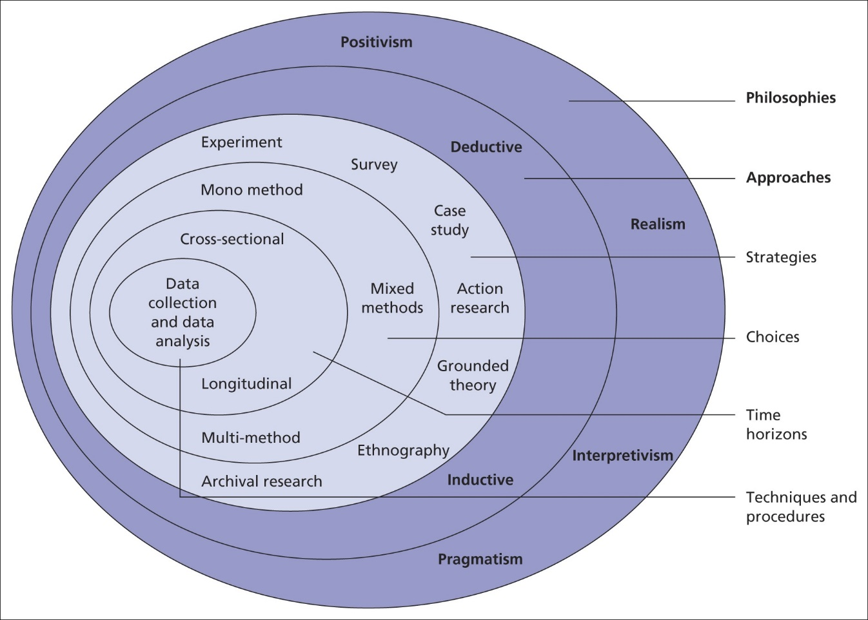

3.2 Research Philosophy:

The research onion has foundations where it describes that ontological and epistemological are the two beliefs research is fundamental built upon (Slevitch, 2011). Moon & Blackman (2017) refer to an ontological perspective as the understanding of nature of the subject, how authentic it is and how its presence can be interpreted and understood. Essentially, an ontological perspective determines how the researcher looks at information and what can be extracted from it, based on whether any assumptions or beliefs were present that formed their approach in research. On the other hand, Al-Ababneh (2020) refers to epistemology as research into the nature of knowledge. It describes the epistemological perspective as guidance for researchers about interpreting the nature of a specific subject and how one can find, explain and validate it for a particular study or research.
Although the research onion presents four philosophies, focusing on one and using it as a pragmatic focused approach will allow the researcher to gather and analyse information differently in the end (Saunders et al, 2016). By considering qualitative data, interpretivism is used to form a conclusion that seems sensible for the nature of the subject and any results it may produce (Nickerson, 2024). According to Elster (2007), the interpretivism research philosophy concerns the approach taken by researchers regarding a character's nature in social and cultural contexts. Moreover, interpretivism suggests that each person has their own subjective opinion and understanding of reality, and that research must revolve around people’s beliefs and ideas to achieve a further understanding (Pervin & Mokhtar, 2022). On the other hand, interpretivism may be a negative due to potential inconsistency. According to Kaptchuk (2003) the interpretivism research philosophy can lead to inconsistent results since subjective aspects of research cannot be measured as effectively as objective aspects. Meaning that the importance of a set of results can be potentially ignored or overlooked. Due to the nature of the study, analysing the subjectivity of participants against what the literature review presents is in need as the main objective of this research is to determine whether the general public understands modern-day divorce, issues surrounding it, as well as if further reform is needed. Therefore, this research will follow the interpretivism research philosophy.

3.3 Research Approach:

The second layer of the research onion consists of inductive and deductive methods of research (Melnikovas, 2018). Once deciding the interpretivism philosophy, it is understood that the inductive research approach would be the most appropriate for this given study. Kuczynski & Daly (2003) suggests that an inductive approach is beneficial for a study as it allows the researcher to develop a theory. Gabriel (2013) suggests that an inductive approach is when the researcher obtains information by observing the study and analysing any patterns or differences with the intention to generate theories and is usually linked to qualitative data. The need for developing a theory is significant as it will determine the public's perception on contemporary issues with modern-day divorce and therefore will produce a conclusion as to why the divorce law needs or does not need further change.

3.4 Methodological Choice:

Upon considering the fourth layer of the research onion, Plano Clark (2017) refers to the mixed method as a way in which researchers can mix both qualitative and quantitative data sets to produce a single set of data. According to Caudle (2004), qualitative data refers to any non-numerical information collected through methods of research like interviews or observations. It is considered that a person’s own opinion and input within a study is of quality, that can benefit the scope of the research and produce a more confident conclusion. Albers (2017) refers to quantitative data as numerical information that represents value within a study. Such data can be analysed far simpler than qualitative data as it can be transferred into charts or graphs. For example, the average age or most common gender of participants. In addition, the Office for Health Improvement and Disparities (2020) suggests that by utilising the mixed method, the researcher can overcome limitations. Turner et al (2017) suggests that such limitations can be overcome by using triangulation. Turner et al (2017) further explains that triangulation is the usage of multiple data, such as qualitative and quantitative, to validate findings.

3.5 Research Strategy:

According to Tsitsianis & Lovino (2020), the research strategy concerns any methods and strategies used to receive information efficiently. For instance, the chosen research strategy will be a survey. Macdonald (2012) refers to action theory (survey) as a method of research that can collect information over a period of time without the need of the researcher's participation. Shackleton et al (2022) describes that a survey can formulate qualitative and quantitative responses, depending on the researcher's input. Therefore, such use of a survey can allow the researcher to analyse responses as a group or individually, expanding quality of research and therefore, formulate a more convincing conclusion. Moreover, Neha (2021) explains that online surveys tend to be utilised more often than interviews as surveys can access a larger group of participants, ensuring sustainability and diversity of research.

3.6 Time Horizon:

The time horizon section from the research onion refers to the amount of time needed to complete the study and concerns the idea whether research shall be conducted within a small or large time period (Saunders et al 2016). Bryman (2016) explains that a cross sectional time horizon concerns data collection within a specific period. Wang & Cheng (2020) suggests that the use of a cross sectional time horizon is beneficial since it is far simpler and quicker in obtaining information. Therefore, it is reasonable to consider this time horizon when taking academic deadlines into account. In addition, the anticipated period in which data shall be collected will be between two to four weeks, which allows the continuation of data analysis and conclusion chapters before the academic deadline.

3.7 Techniques for Data Collection, Processes and Analysis:

The last layer of the research onion consists of the final processes used to ensure the study's validity and reliability through qualitative and quantitative data sets (Saunders et al. 2016). Since this research will be revolving around a survey, it will be capable of obtaining primary data. Such data will be obtained by utilising open and closed questions with the use of Google Forms. Stallard (2019) explains that an open question allows the participant to answer in detail. For example, ‘what is your opinion?’ Whereas a closed question limits the participant to answer shortly and directly, such as ‘yes’ or ‘no’ questions. In addition, Wright (2017) argues that utilising an online survey is beneficial for research since the use of internet can allow any individual direct access to the survey, wherever and whenever they want. Once enough data is collected, the use of Google Form’s facilities will be beneficial to produce graphs and thematic analysis of qualitative data to identify patterns and differences within the participants’ responses (Braun & Clarke, 2006).

3.7.1 Sampling:

According to Mujere (2016), sampling within a study determines how many participants will respond to the survey willingly. Mujere (2016), stresses that sampling an entire population is merely impossible and setting such high standards is unnecessary. Therefore, the ideal sample group will be within the UK. Not only to make this research simpler, but also the nature of research mainly concerns UK law.

3.7.2 Reliability and Validity:

According to Bruton (2000), the term reliability in research refers to the methods and procedures taken to achieve results and that if such research was to be conducted in the future, using the same methods and procedures should produce similar results. Therefore, in order to be certain that reliability is present. All methods and procedures of research and survey must be explained in detail. According to Brewer & Crano (2000), validity refers to the intention of the study and whether the results meet the intention. Moreover, Brewer and Crano (2000) suggest that to ensure validity, the researcher must clarify their intentions with the study by encouraging the participants to answer in a way that will benefit the researcher with their conclusion. Essentially, the researcher must ask the participants to answer responsibly towards the topic. Therefore, if the researcher cannot formulate a conclusion from the study, it will fall upon the participants lack of understanding towards the topic or human error.

3.7.3 Limitations:

The identification of limitations is essential when considering that data collection can be altered. Ross & Bibler Zaidi (2019) elaborates that the researcher must take into consideration potential limitations and that understanding such potential will allow the researcher to take extra measures to ensure that no detriment will occur during data collection. The most apparent limitation within this study is sampling. Since sampling data will revolve around social media, the sample size will be limited to people who have access to such social media and internet. Patten & Perrin (2015), explain that elderly people might not have access to social media or internet, which can affect the diversity of the data. This limitation is of high importance due to the nature of the subject. It is necessary to acquire a range of age in respondents to understand, analyse and explain each age group’s opinions towards modern day divorce. Lastly, this subject can be potentially sensitive for some. This research will ensure that all participants will be voluntarily willing to read potentially sensitive content, as well as all participants must be over the age of 18.

Chapter 4 – Findings:

4.1 “Critical analysis of the public's perception on modern-day divorce in England and Wales”

The following chapter aims to critically analyse all forthcoming findings regarding the public’s perception on modern-day divorce in England and Wales. Though presenting 18 different qualitative and quantitative questions, the survey aimed to collect personal opinions and beliefs of the participants on the given subject. Through the use of Google Forms, the survey was capable of obtaining 51 responses. Prior to participating, all volunteers were briefed about the researcher’s background, the survey’s topic and intention as well as ethical considerations such as anonymity. Moreover, all participants were required to be over the age of 18 and provide voluntary consent due to the nature of the survey. Such precautions were taken to ensure no distress was caused to the participants as well as to avoid all academic consequences.
All primary data will be analysed to identify any differences or similarities between the results. Analysis will provide an insight into the public’s views and beliefs surrounding modern-day divorce, while contrasting secondary findings in the literature review.

4.2 Findings: Description of Data Analysis and Results:

To begin the survey, the researcher ensured all participants had read the introduction by placing it at the very start. Such measure was taken to maintain ethical standards of research. According to Williams (2023), any survey conducted for academic purposes must comply with ethical guidelines to avoid invalidation by the university exam board. Ensuring the participant’s privacy and consent is necessary as described by Williams (2023), to guarantee a positive experience and respect the university’s reputation. Lastly, to ensure full anonymity and privacy, all participants were required to submit their responses, which otherwise would be deleted.
Question 1:
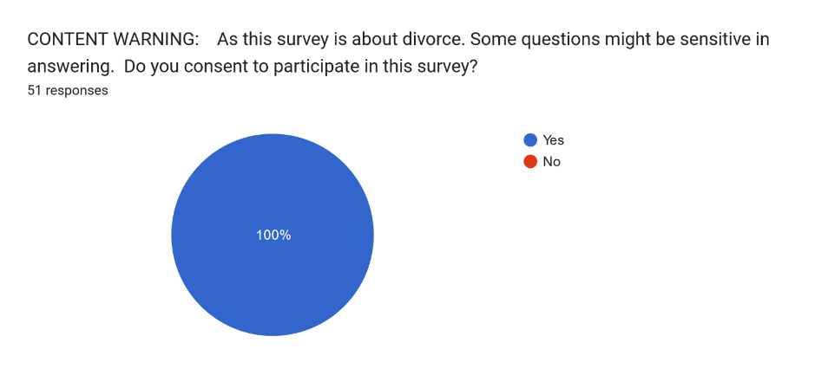

The second question was multiple-choice. All participants were asked to identify their age category ranging from 18 to 56 and above. Such information is necessary to explain and evaluate reasoning behind qualitative responses. For instance, with further analysis, it can be explained that some age groups have similarities or differences with their perspective regarding divorce. The majority of participants aged 18-24 (62.7%).
Question 2:
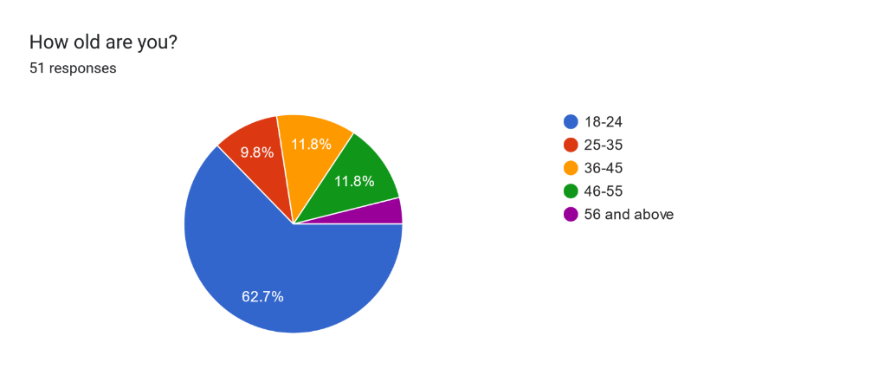

The third question intended to identify the participant’s gender. Same as age, this question was utilised to determine any similarities or differences between the genders of qualitative responses. Therefore, with this question and the use of an inductive approach, the researcher will be capable of forming a theory surrounding the subject such as: Gender X is more likely to be interested in divorce. The main gender was Female, which accumulated to 56.9% of all respondents (29 respondents), Second were Males with 41.2% of all respondents (21 respondents), and finally, non-binary which accumulated to 2% of all respondents (1 respondent).
Question 3:
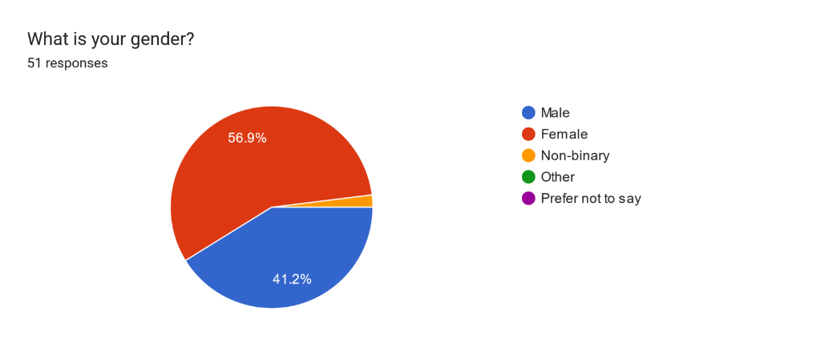

The fourth question intended on setting the scene with regards to the participants and their relation to divorce. 52.9% of respondents (27 respondents) believe they have been affected by a divorce, that being part of one or affected due to a family member or friend. On contrast, 47.1% of respondents (24 respondents) believe they have not been affected by a divorce in any way. Based on these findings, the Perception and Subjectivity Theory can be identified. The theory highlights how an individual’s perception of adverse effects of divorce can be subjective and influenced by personal beliefs or experiences. Such emotional closure can impact an individual's perception of negative effects of divorce and whether they are affected (Whitworth, 2021).
Question 4:
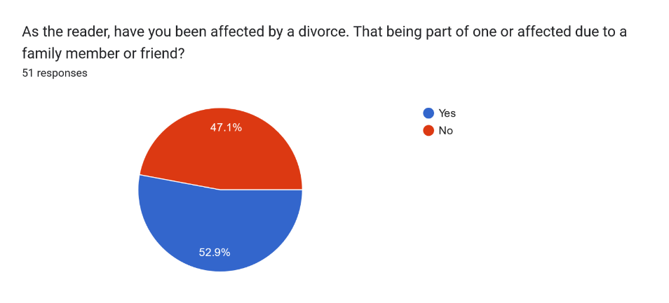

Question five was subsequently created in relation to question four. The intention of question five was to determine whether the affected participants had a positive or negative experience. The question also relates back to the findings in the literature review. For instance, Cameron (2008) suggested that it is inevitable that at least one-party experiences emotional consequences during a divorce. By considering the results from the question and the literature review findings, the theory of at least one person experiencing divorce negatively is true. This idea validates research presented in the literature review, making the study effective. 83.9% of participants (26 respondents) believe they had a negative divorce experience. Whereas 16.1% of participants (5 respondents) believe they had a positive experience.
Question 5:
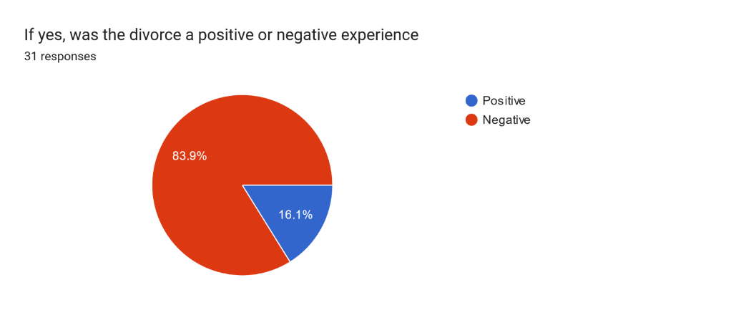Q5.

The intention of question six was to determine the public’s knowledge in relation to the previous divorce law. Suggesting if most participants are aware of the previous divorce law, most will be aware of the current one. 58% of participants (29 respondents) understood that fault was required prior to the introduction of the DDSA (2020), whereas 42% (21 respondents) did not. Furthermore, this raises the question whether there is a lack of awareness with regards to divorce. As a lack of awareness could make divorce more difficult and increase consequences post-separation (Damota, 2019).

Question 6:
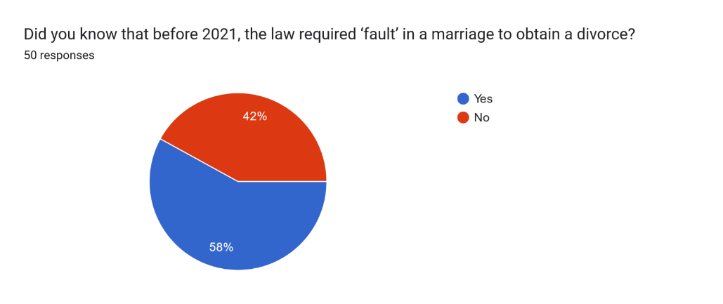

The seventh question asked the participants to identify any possible issues that could arise under the previous divorce law (Matrimonial Causes Act 1973). With a brief description of what the act enforced, the total number of responses reached 48. The use of thematic analysis allowed the researcher to identify three reoccurring themes. However, regarding potential limitations, responses that do not correlate to the research question will be excluded from analysis. To clarify, all qualitative responses will be categorised into such themes, to effectively analyse, interpret and visualise data (Maguire & Delahunt, 2017).

Question 7: The previous divorce law (The Matrimonial Causes Act, 1973) suggested that ‘fault’ is proven if one of the following factors are identified: unusual behaviour, adultery, desertion, two years of separation (non-consensual), and five years of separation (consensual). Knowing that a person must prove one of these five factors, What problems do you think would arise during a divorce process?

Theme 1 – Difficulty in proving fault - Eight respondents (16.7%) suggested the difficulty of proving fault through obtaining evidence, “Proving one of these faults must be difficult for the person who would like the divorce to go ahead”. With some highlighting falsification of evidence could be a consequence of such difficulty, “One could lie about evidence”. Nevertheless, all respondents suggested that proving fault could prolong the divorce process and therefore potentially subject a spouse to abuse “more tension within the matrimonial home”. Greatbatch & Dingwall (1999) suggests spouses are more likely to encounter psychological and emotional abuse during mediation period.
Theme 2 – Subjectivity and interpretation – 12.5% of respondents suggested the issue of subjective interpretation of terms such as “unusual behaviour” or “adultery” “some people might consider certain behaviours abusive, whereas some might not” and “People can interpret adultery differently” Such interpretation and subjectivity of fault terms could result in an unfair judgement or unreasoned divorce (Tinder et al, 2017).
Theme 3 – Family well-being and resilience within divorce – although this theme is broad, it represents a combination of potential issues resulting from proving fault. For instance, 37.5% of respondents suggested matrimonial related issues could result from the need to prove fault. Most considered matrimonial related issues to be family safety, emotional well-being and finance-related issues. “In cases where fault must be proven, children may become unintentional casualties of the process”, “Guilt, revenge tactics, making the divorce process harder than usual” and “financial burden when considering cost of solicitors and court hearings to prove such facts”.

The eighth question asked the respondents whether they are aware of the new divorce law (DDSA2020). Questioning whether all participants are aware of the DDSA (2020) ensures data reliability and accuracy. If respondents are not aware of the law but were questioned further about it, their responses may not mirror their true belief. 56.9% of respondents suggested they are aware of the DDSA (2020) (29 respondents), whereas 43.1% are not (22 respondents).
Question 8:
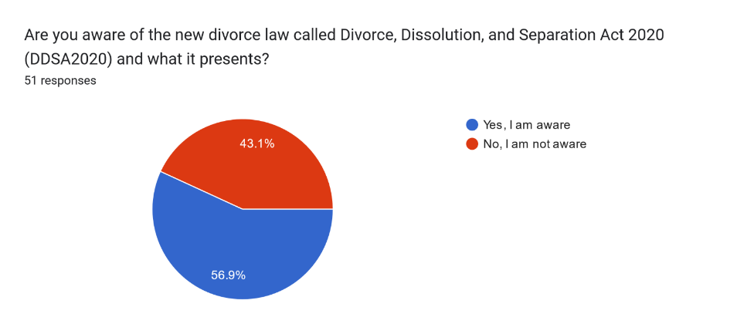

The ninth question was set to ask participants if they believe any problems could arise with no-fault divorce and to prevent the limitations set out in question eight. Question nine intended on fulfilling such aims by presenting a brief description of the DDSA (2020) and no-fault divorce. Fox (2023) suggests people who are aware of the survey’s subject are more likely to participate. 84.3% of respondents suggested they could expect problems with DDSA (2020) (43 respondents), whereas 15.7% of respondents did not (8 respondents).

Question 9:
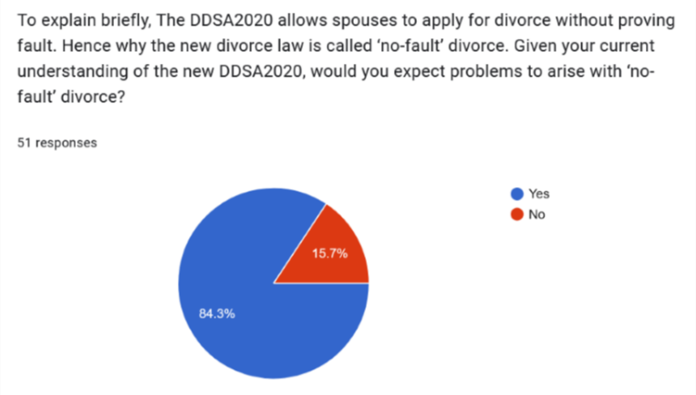

The tenth question was a continuation of question nine. Its intention was to identify the exact issues related to DDSA (2020). The total number of responses reached 44, which indicates a human error within question nine’s responses.

Question 10: “What type of problems would you expect? If a person in a marriage has the power to file for divorce without reason, what problems would you expect?”

Theme 1- Increased divorce rates and relationship instability – 45.5% of respondents (20 respondents) raised the issue of an increase in divorce cases due to the introduction of the DDSA (2020), “rise in unexpected divorce cases”. As well as all related respondents hinted relationship instability within the matrimonial home as a consequence of such widely obtainable divorce process. For instance, “Maybe out of anger someone would apply for this without thinking rationally about the situation”.
Theme 2 – Legal and financial vulnerability – This theme relates to potential legal and financial consequences regarding no–fault divorce. For instance, within the 22.7% of respondents, some suggested a party could experience legal issues such as asset distribution, if they are not aware of the divorce taking place the same way they would be with the Matrimonial Causes Act (1973), “if a spouse is caught off guard with a divorce without reason. a party could not prepare themselves emotionally but also legally”. Moreover, a respondent suggested unfair advantages with such system, “cannot object to the divorce”. Draghici (2023) suggests no-fault divorce is unfair as vulnerable spouses could be abandoned without reason.
Theme 3 – Impact on family dynamics – Theme three relates to potential emotional and psychological consequences of no-fault divorce on family dynamics, with a specific concentration on children being the primary victim. For instance, 15.9% of respondents in question ten suggested children could experience distress or confusion as they may struggle to understand the reasoning behind no-fault divorce, “if a child is involved they will grow up in a broke home which will affect their mental health”. Morin (2022) suggests children can experience distress and anxiety within the first year of divorce.

Following the tenth question, question eleven intended to ask the participants the contrary. 46 participants completed this question.

Question 11: “On the contrary, what benefits would you expect with DDSA (2020) and ‘no-fault’ divorce?”

Theme 1 – The ease and pace of divorce process – 32.6% of respondents suggested the process of divorce would be shorter with DDSA (2020), “The process would be simple and fast”. Due to the process becoming shorter and simpler, some respondents suggested a party is less likely to experience as much emotional strain, compared to the previous divorce law, “Less stress due to a quicker process”.
Theme 2 – Protection and empowerment of individuals – 30.4% of respondents emphasised that victims of matrimonial abuse are more likely to be protected, since DDSA (2020) lacks the need of fault and therefore prompts a quicker divorce, “abusive marriages can end easier “.
Theme 3 – Improved well-being and relationship dynamics – Due to the broadness of responses within theme three. Approximately 25% of respondents suggested that relationship dynamics between both spouses and children, post-divorce, are greatly improved with DDSA (2020). Some of which suggest family dynamics can improve as parties can reflect on their marriage without the need to prove fault, “without the need to blame. couples can allow the opportunity to reflect and resolve the problem”.

Question twelve intended on verifying the aims of objective one within the literature review. Out of 50 responses, all respondents suggested that the following measures are efficient ways in which children can be protected post-divorce.
Question 12:
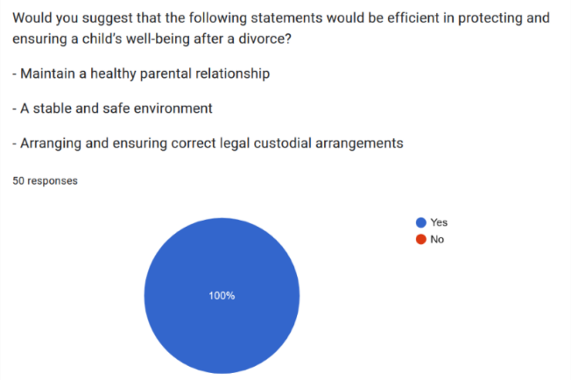

Question thirteen was placed for individuals who believed that the measures stated within question twelve were not efficient. There was only one response “.”, which suggests human error or an accidental input. Such answer will not be considered but will be shown to prove that human error is possible within a study.


Question fourteen was used to verify objective two within the literature review. Laube (2020) suggests child and finance are contemporary issues of divorce in the 21st century. Question fourteen asked:

“Apart from child related issues. What other issues could a divorced person experience?”

Of the 48 responses submitted, 46 will be considered. 30.4% of respondents (14 respondents) suggested mental health related issues are significant, with 6.5% (3 respondents) suggesting a prolonged exposure to mental health problems, post-divorce, could lead to substance abuse, “mental strain could lead to substance abuse”. According to Robinson et al (2018), of all people who have been diagnosed with a mental illness, that being depression or anxiety, 29% abuse alcohol or drugs. 10.9% of respondents (5 respondents) suggested social related issues with an emphasis on the difficulty of reconnecting with friends and family post-divorce, “Some people may develop fears of reconnecting with someone”. 2.2% of respondents (1 respondent) suggested that a person might worry about potential criminal activity, “Stalking”. According to Meyer (2019), 34 out of 1,000 divorced individuals are victims of stalking. Lastly, 56.5% of respondents suggest finance-related issues (26 respondents). The identification of finance-related issues within the responses were sought after, due to the findings in the literature review (Vegita, 2023).

Bar chart representing question 14’s responses:
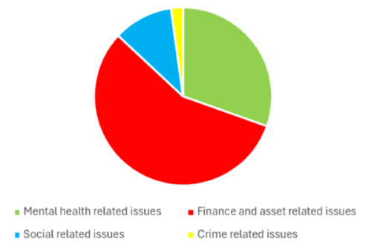

Question fifteen was used to capture the public’s general knowledge in areas surrounding divorce. 70% of respondents (35 respondents) were aware of the term alimony, whereas 30% (15 respondents) were not.
Question 15:
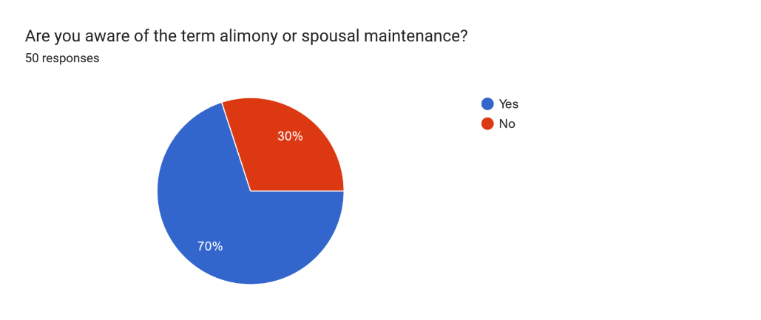

To continue, question sixteen intended to ask the participants to choose one out of three statements that best fit their opinion and belief towards alimony. All statements were provided from the literature review, and the outcome of the question was to determine whether change is necessary regarding the alimony process. For instance, 16% of respondents (8 respondents) suggest alimony is not fair due to it being a subjective topic within courts and therefore, such 16% of respondents can be considered as wanting change.

Question 16:
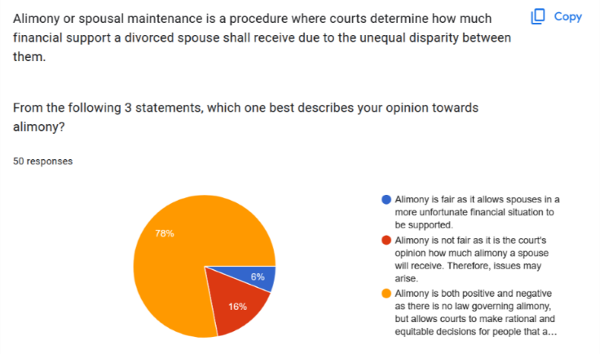

Question seventeen was used to verify research within the literature review. Cameron (2008) suggests divorce affects individuals mentally far more commonly than expected. 88% of respondents (44 respondents) agree, whereas 12% of respondents (6 respondents) do not agree. Through reliable sources and data gathered from participants, it is reasonable to expect mental distress as a result of divorce. Investigating the factors that would suggest otherwise could be an area of research that requires further attention.

Question 17:
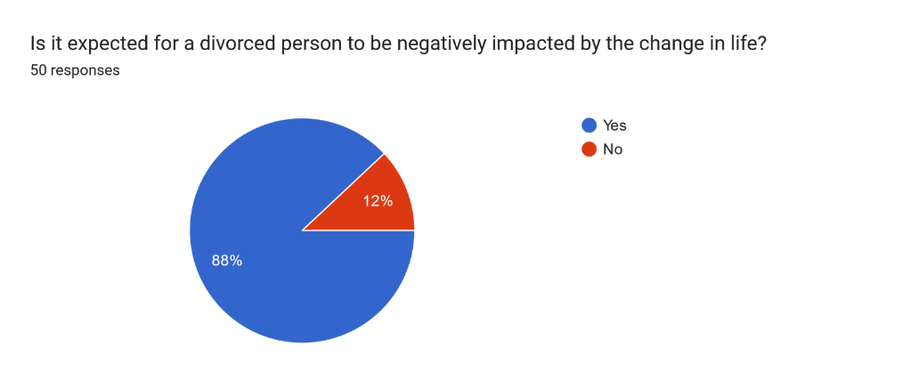

Lastly and same as question seventeen, question eighteen was used to ensure that research presented within the literature review is valid and reliable. Within question eighteen, both statements were presented within the literature review and 72% of respondents (36 respondents) believe to agree with both statements.

Question 18:
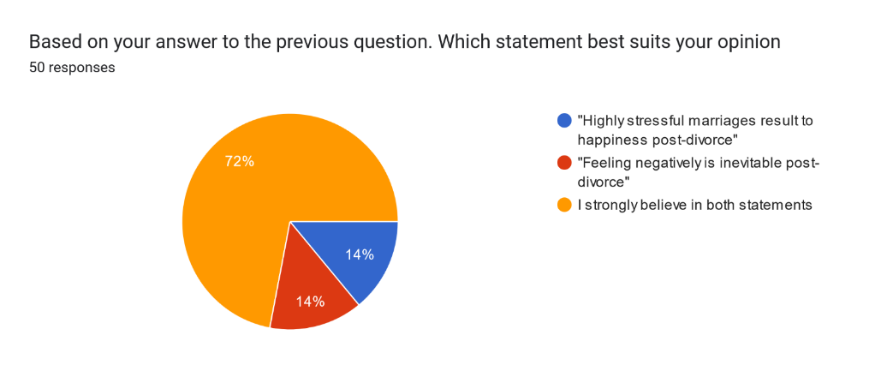

Chapter 5 – Conclusion:

In conclusion, the critical analysis of contemporary issues with modern-day divorce and whether change was necessary, as researched in this dissertation, brings insight on the multifaceted struggles an individual, family and friends could experience during marital dissolution. Through a deeper analysis of child and finance-related issues as well as the comparison of the Divorce, Dissolution and Separation Act (2020) (DDSA2020) and Matrimonial Causes Act (1973), this research paper intended on raising awareness and understanding of the challenges surrounding divorce and its aftermath. In addition, this research paper and analysis shown to hold far more content than expected and therefore could be a steppingstone for future continuation of research.
The conducted literature review consisted of three different objectives. Objective one highlighted the impact of divorce on children, with a specific concentration on abuse being more prevalent during divorce. Such issues are a contemporary concern since children who experience trauma (Adverse Childhood Experience/ ACE) are more likely to commit or be subjected to crime (Violence Protection Unit, 2023). In general, the main focus consisted of methods the government and parents must uphold to prevent harm towards children post-divorce. The research concluded that current measures of protection are inadequate, with 30,000 reported cases of child abuse in 2022-23, the highest it has ever been in the UK (Statista Research Department, 2023). Objective two explored the complexities partners could experience with regards to finance and how severe detriment one could endure. For instance, objective two discovered that finance-related issues and detriment stem from judgement of asset distribution and spousal maintenance. Although courts determine asset distribution and spousal maintenance on certain factors, it is purely a subjective approach with the potential of causing harm if carried out incorrectly. (McFarlane v McFarlane, 2006). Lastly, the comparison between DDSA (2020) and Matrimonial Causes Act (1973) revealed flaws within the legal framework of both acts, and the needs of modern families might not be satisfied due to no-fault divorce. While the Matrimonial Causes Act (1973) provided stable grounds for divorce, the DDSA (2020) presents a more humane and equitable approach to matrimonial dissolution, whereby one can achieve a divorce without the complications of proving fault. Research suggests there had been a rise in divorces since the implementation of DDSA (2020). However, objectifying such rise to the act is not definitive, as it was foreseen that divorces could spike due to the impact of COVID-19.

The analysis chapter provided real life evidence supporting the necessity of change in the realm of divorce. Using an online survey, the number of participants who advocated for no-fault divorce was predominant. With some citing its potential to ease emotional and financial burdens post-divorce. However, it is necessary to acknowledge the potential limitations with no-fault divorce. For instance, an increase in divorce cases and impact on vulnerable individuals. Additionally, further change may be required in the future with the advancement of society.

In light of these considerations, the findings of this dissertation and support from the general public, conclude that change was necessary. It is hoped that the findings of this research paper will emphasise the significance of free will and to support ongoing efforts in creating a more compassionate approach towards divorce, fostering for those who had complications with matrimonial dissolution in the past.

Reference List

- Aktar, M. (2022). The importance of protecting children. Available at: https://childbraininjurytrust.org.uk/2022/11/the-importance-of-protecting-children/#:~:text=That%20is%20why%20the%20prevention,which%20can%20last%20a%20lifetime. (Accessed on: 27/01/2024).

- Al-Ababneh, M. (2020). Linking Ontology, Epistemology and Research Methodology. Available at: https://papers.ssrn.com/sol3/papers.cfm?abstract_id=3708935 (Accessed on: 23/02/2024).

- Albers, M.J. (2017). Quantitative Data Analysis. Journal of Technical Writing and Communication. PP. 215–233. Available at: https://journals.sagepub.com/doi/abs/10.1177/0047281617692067 (Accessed on: 11/03/2024).

- Allen, K. L. (2023). Divorce myth: Assets are divided 50/50. Available at: https://www.cripps.co.uk/thinking/divorce-myth-assets-are-divided-50-50/ (Accessed on: 25/01/2024).

- Amato, P & Hohmann-Marriott, B. (2007). A Comparison of High- and Low-Distress Marriages That End in Divorce. Available at: https://doi.org/10.1111/j.1741-3737.2007.00396.x (Accessed on: 18/02/2024).

- Arraichi, A. & Ghourdou, T. (2023). "Analysing the Effect of COVID-19 on the Divorce Rates in England-Post-Pandemic: London as a Case Study." Available at: https://www.al-kindipublisher.com/index.php/jhsss/article/view/5737 (Accessed on: 19/02/2024).

- Biesta, G. (2010). Pragmatism and the philosophical foundations of mixed methods research. Available at: https://methods.sagepub.com/book/sage-handbook-of-mixed-methods-social-behavioral-research-2e (Accessed on: 23/02/2024).

- Braun, V. & Clarke, V. (2006). Using thematic analysis in psychology. Qualitative Research in Psychology. PP. 77-101. Available at: https://www.tandfonline.com/doi/abs/10.1191/1478088706qp063oa (Accessed on: 14/03/2024).

- Brewer, M.B. & Crano, W.D. (2000). Research design and issues of validity. Handbook of research methods in social and personality psychology. PP .3-16. Available at: https://books.google.co.uk/books?hl=en&lr=&id=NRWTAgAAQBAJ&oi=fnd&pg=PA11&dq=what+is+validity++in+research&ots=3Ji3xyVlnJ&sig=5c6McywbUxp8HCGlUbwuv1gQ0Dk (Accessed on: 13/03/2024).

- Bruton, A., Conway, J.H. & Holgate, S.T. (2000). Reliability: What is it, and how is it measured? PP .94–99. Available at: https://www.sciencedirect.com/science/article/abs/pii/S0031940605612114 (Accessed on: 13/03/2024).

- Bryman, A. (2016). Social Research Methods. Oxford University Press. PP.44-56. Available at: https://books.google.co.uk/books?hl=en&lr=&id=N2zQCgAAQBAJ&oi=fnd&pg=PP1&dq=Bryman,+A.+(2012).+Social+research+methods+(5th+ed.).+Oxford:+Oxford+University+Press.&ots=dqIAHWMaud&sig=5lVb_RuKEPcBfzWwdVFPLfLNcn0#v=onepage&q=Bryman%2C%20A.%20(2012).%20Social%20research%20methods%20(5th%20ed.).%20Oxford%3A%20Oxford%20University%20Press.&f=false (Accessed on: 04/03/2024).

- Burns, F. (2013). Surviving spouses, surviving children and the reform of total intestacy law in England and Scotland: Past, present and future. PP.85–118. Available at: https://onlinelibrary.wiley.com/doi/abs/10.1111/j.1748-121X.2012.00238.x (Accessed on: 15/02/2024).

- Cameron, L. (2008). The Possible Negative Emotional and Psychological Consequences in Children of Divorce. Available at: https://dc.cod.edu/cgi/viewcontent.cgi?article=1057&context=essai (Accessed on: 18/02/2024).

- Caudle, S.L. (2004). Qualitative data analysis. Handbook of practical program evaluation. PP. 417-438. Available at: https://books.google.com/books?hl=en&lr=&id=t39yhk2MD0AC&oi=fnd&pg=PA417&dq=what+is+qualitative+data+&ots=aR-RI_L_-Z&sig=JtdcRwpxRvS5nGYlwucwEPVFwBo (Accessed on: 11/03/2024).

- Crowe-Urbaniak, D. (2020). Reform of Financial Provision on Divorce: For the Few, Not the Many? Available at: https://www.euppublishing.com/doi/abs/10.3366/elr.2020.0632?journalCode=elr (Accessed on: 08/02/2024).

- Damota, M.D. (2019). The effect of divorce on families’ life. Journal of Culture, Society and Development. Available at: https://core.ac.uk/download/pdf/234691363.pdf (Accessed on: 01/05/2024).

- Dodgson, D. (2022). What is a D8 Form? The Private Office. Available at: https://www.theprivateoffice.com/insights/what-is-a-d8-form (Accessed on: 19/02/2024).

- Draghici, C. (2023). ‘From Indissolubility of Marriage to Unilateral Divorce on Demand: A Tardy Revolution in English Family Law’. Child and Family Law Quarterly. PP.16. Available at: https://openaccess.city.ac.uk/id/eprint/31711/ (Accessed on: 09/04/2024).

- Elster, J. (2007). Explaining Social Behaviour: More Nuts and Bolts for the Social Sciences. http://dx.doi.org/10.1017/CBO9780511806421 (Accessed on: 23/02/2024).

- Fairbairn, C. (2019). “No-fault divorce”. House of Commons Library. Briefing paper. Available at: https://researchbriefings.files.parliament.uk/documents/SN01409/SN01409.pdf (Accessed on: 19/02/2024).

- Fisher, H. & Low, H. (2009) Who wins, who loses and who recovers from divorce? Available at: https://www.researchgate.net/profile/Hamish-Low-2/publication/267833710_Who_wins_who_loses_and_who_recovers_from_divorce/links/55f29f8208aef559dc493bc8/Who-wins-who-loses-and-who-recovers-from-divorce.pdf (Accessed on: 19/02/2024).

- Flick, U. (2011). Introducing research methodology: A beginner’s guide to doing a research project. Available at: https://www.researchgate.net/publication/370680936_Flick_Uwe_2020_Introducing_Research_Methodology_Thinking_Your_Way_through_Your_Research_Project_3rd_ed_Thousand_Oaks_CA_SAGE_Publishing (Accessed on: 04/03/2024).

- Fox, S. (2023). Survey Response Bias: Why and How to Avoid It. Available at: https://survicate.com/blog/survey-response-bias/ (Accessed on: 30/03/2024).

- Gabriel, D. (2013). Inductive and deductive approaches to research. Available at: https://deborahgabriel.com/2013/03/17/inductive-and-deductive-approaches-to-research/ (Accessed on: 25/02/2024).

- Greatbatch, D. & Dingwall, R. (1999). The marginalization of domestic violence in divorce mediation. PP.174–190. Available at: https://academic.oup.com/lawfam/article-abstract/13/2/174/928284 (Accessed on: 19/02/2024).

- Hetherington, E.M. (1979). Divorce: a child’s perspective. American Psychologist. 34(10), PP .851. Available at: https://psycnet.apa.org/doiLanding?doi=10.1037%2F0003-066X.34.10.851 (Accessed on: 05/02/2024).

- Hess, R.D. and Camara, K.A. (1979). Post-Divorce Family Relationships as Mediating Factors in the Consequences of Divorce for Children. Journal of Social Issues. PP .79-96. Available at: https://spssi.onlinelibrary.wiley.com/doi/abs/10.1111/j.1540-4560.1979.tb00814.x (Accessed on: 01/02/2024).

- Hewitt, L. (2001). Child Abuse Review. PP .113-124. Available at: https://www.nationalcac.org/wp-content/uploads/2016/10/the-child-abuse-and-divorce-myth.pdf (Accessed on: 08/02/2024).

- Kaptchuk, T.J. (2003). Effect of interpretive bias on research evidence. Available at: https://www.bmj.com/content/326/7404/1453.short (Accessed on: 11/03/2024).

- Kessler, D. (2018). The consequences of divorce for mothers and fathers: Unequal but converging. LIVES Working Papers. PP .1-30. Available at: https://www.centre-lives.ch/sites/default/files/2020-11/lives_wp_71_kessler_2018.pdf (Accessed on: 15/02/2024).

- Kuczynski, L. & Daly, K. (2003). Qualitative methods as inductive (theory generating) research: psychological and sociological approaches. Available at: https://www.academia.edu/download/30557685/CH_18_Kuczynski___Daly.pdf (Accessed on: 11/03/2024).

- Laube, B. (2020). The Top 10 Issues in a Divorce. GREENBLATT & LAUBE, PC. Available at: https://greenblattlaube.com/blog/divorce/the-top-10-issues-in-a-divorce/ (Accessed on: 08/11/2023).

- Lloyd, M. (2018). Domestic Violence and Education: Examining the Impact of Domestic Violence on Young Children, Children, and Young People and the Potential Role of Schools. Available at: https://www.frontiersin.org/journals/psychology/articles/10.3389/fpsyg.2018.02094/full (Accessed on: 15/04/2024).

- Lord Keen of Elie. (2019). Divorce, Dissolution and Separation Bill. Statement UIN: HLWS1584. Available at: https://questions-statements.parliament.uk/written-statements/detail/2019-06-13/HLWS1584 (Accessed on: 19/02/2024).

- Lovino, F. & Tsitsianis, N. (2020). The Methodology of the Research. Available at: https://www.emerald.com/insight/content/doi/10.1108/978-1-83909-107-020201004/full/html (Accessed on: 27/02/2024).

- MacDonald, C. (2012). Understanding Participatory Action Research: A Qualitative Research Methodology Option. PP.34–50. Available at: https://journals.nipissingu.ca/index.php/cjar/article/view/37 (Accessed on: 29/02/2024).

- Maguire, M. & Delahunt, B. (2017). Doing a Thematic Analysis: A Practical, Step-by-Step Guide for Learning and Teaching Scholars. Available at: https://ojs.aishe.org/index.php/aishe-j/article/view/335/553 (Accessed on: 27/03/2024).

- McMullen, J.G. (2011). Alimony: What Social Science and Popular Culture Tells Us about Women, Guilt, and Spousal Support after Divorce. Available at: https://heinonline.org/HOL/LandingPage?handle=hein.journals/djglp19&div=5&id=&page= (Accessed on: 11/02/2024).

- Mediation Bureau. (2024). Division of assets during divorce. Available at: https://mediationbureau.co.uk/tpost/xzttx7jon1-division-of-assets-during-divorce (Accessed on: 15/04/2024).

- Melnikovas, A. (2018). Towards an Explicit Research Methodology: Adapting Research Onion Model for Futures Studies. Available at: https://www.google.com/url?sa=t&rct=j&q=&esrc=s&source=web&cd=&ved=2ahUKEwjJ5-qpgceEAxXc9AIHHRSlDFcQFnoECBAQAw&url=https%3A%2F%2Fjfsdigital.org%2Fwp-content%2Fuploads%2F2019%2F01%2F03-Melnikovas-Onion-Research-Model.pdf&usg=AOvVaw1HKahQt1SxDZRX6uD7ncFD&opi=89978449 (Accessed on: 25/02/2024).

- Meyer, C. (2017). What Is the Definition of Divorce? LiveAbout. Available at: https://www.liveabout.com/what-is-a-divorce-1103062 (Accessed on: 08/11/2023).

- Meyer, C. (2019). Stalking After Divorce Or Separation. LiveAbout. Available at: https://www.liveabout.com/stalking-after-divorce-or-separation-1102415 (Accessed on: 31/03/2024).

- Ministry of Justice (2020). Divorce ‘blame game’ to end. Available at: https://www.gov.uk/government/news/divorce-blame-game-to-end (Accessed on: 19/02/2024).

- Mok, P.L.H., Astrup, A., Carr, M.J., Antonsen, S., Webb, R.T. and Pedersen, C.B. (2018). Experience of Child–Parent Separation and Later Risk of Violent Criminality. National Library of Medicine. Available at: https://www.ncbi.nlm.nih.gov/pmc/articles/PMC6057277/ (Accessed on: 01/02/2024).

- Morin, A. (2022). The Psychological Effects of Divorce on Children. Available at: https://www.verywellfamily.com/psychological-effects-of-divorce-on-kids-4140170 (Accessed on: 30/03/2024).

- Moon, K. & Blackman, D. (2017). A guide to ontology, epistemology, and philosophical perspectives for interdisciplinary researchers. Available at: https://i2insights.org/2017/05/02/philosophy-for-interdisciplinarity/ (Accessed on: 22/02/2024).

- Mujere, N. (2016). Sampling in Research. Available at: https://www.researchgate.net/publication/313471921_Sampling_in_Research (Accessed on: 13/03/2024).

- Neha, J. (2021). Survey Versus Interviews: Comparing Data Collection Tools for Exploratory Research. Available at: https://www.proquest.com/docview/2505727565?pq-origsite=gscholar&fromopenview=true&sourcetype=Scholarly%20Journals (Accessed on: 13/03/2024).

- NHS (2021). Adverse Childhood Experiences (ACEs). NHS. Available at: https://mft.nhs.uk/rmch/services/camhs/young-people/adverse-childhood-experiences-aces-and-attachment/ (Accessed on: 10/11/2023).

- NSPCC (2020). Separation and divorce. Available at: https://www.nspcc.org.uk/keeping-children-safe/support-for-parents/separation-and-divorce/ (Accessed on: 01/02/2024).

- Office for Health Improvement and Disparities (2020). Mixed methods of study. How to use a combination of quantitative and qualitative data to evaluate your digital health product. Available at: https://www.gov.uk/guidance/mixed-methods-study (Accessed on: 25/02/2024).

- Office for National Statistics (2019) Divorces in England and Wales 2018. Available at: https://www.ons.gov.uk/peoplepopulationandcommunity/birthsdeathsandmarriages/divorce/bulletins/divorcesinenglandandwales/2018 (Accessed on: 19/02/2024).

- Office for National Statistics (2023) Divorce in the UK, 2021 and 2022. Available at: https://www.ons.gov.uk/aboutus/transparencyandgovernance/freedomofinformationfoi/divorceintheuk2021and2022 (Accessed on: 19/02/2024).

- Patten, E. & Perrin, A. (2015). Who’s left out in a Web-only survey and how it affects results. Available at: https://www.pewresearch.org/short-reads/2015/09/22/who-s-left-out-in-a-web-only-survey-and-how-it-affects-results/ (Accessed on: 14/03/2024).

- Pervin, N., & Mokhtar, M. (2022). The Interpretivist Research Paradigm: A Subjective Notion of a Social Context. Available at: http://dx.doi.org/10.6007/IJARPED/v11-i2/12938 (Accessed on: 23/02/2024).

- Plano Clark, V.L (2017). Mixed methods research. Available at: https://www.tandfonline.com/doi/full/10.1080/17439760.2016.1262619 (Accessed on: 11/03/2024).

- Robinson, L., Smith, M. and Segal, J. (2018). Dual diagnosis: Substance abuse and mental health. Available at: https://www.helpguide.org/articles/addictions/substance-abuse-and-mental-health.htm (Accessed on: 31/03/2024).

- Ross, P.T. & Bibler Zaidi, N.L. (2019). Limited by Our Limitations. Perspectives on Medical Education. PP .261–264. Available at: https://link.springer.com/article/10.1007/s40037-019-00530-x (Accessed on: 14/03/2024).

- Safeguarding Network (2023). Impact of poverty. Available at: https://safeguarding.network/content/safeguarding-resources/impact-of-poverty/ (Accessed on: 10/11/2023).

- Saunders, A.J.G.M. (1983). Botswana Matrimonial Causes Act-Further proposals for Divorce Reform. PP. 18. Available at: https://archive.lib.msu.edu/DMC/African%20Journals/pdfs/PULA/pula003002/pula003002003.pdf (Accessed on: 19/02/2024).

- Saunders, M., Lewis, P., Thornhill, A. (2016). Research methods for business students. Available at: https://search.worldcat.org/title/Research-methods-for-business-students/oclc/920729964 (Accessed on: 22/02/2024).

- Shackleton, S., Bezerra, J.C., Cockburn, J., Reed, M.G. & Abu, R. (2021). Interviews and surveys. In The Routledge handbook of research methods for social-ecological systems. PP. 107-118. Available at: https://library.oapen.org/bitstream/handle/20.500.12657/49560/1/9781000401516.pdf#page=140 (Accessed on: 13/03/2024).

- Slevitch, L. (2011). Qualitative and Quantitative Methodologies Compared: Ontological and Epistemological Perspectives. Journal of Quality Assurance in Hospitality & Tourism, PP .73–81. Available at: https://www.tandfonline.com/doi/abs/10.1080/1528008X.2011.541810 (Accessed on: 22/02/2024).

- Smith, I (1997). Explaining the Growth of Divorce in Great Britain. Scottish Journal of Political Economy. PP. 519-543. Available at: https://onlinelibrary.wiley.com/doi/abs/10.1111/1467-9485.00073 (Accessed on: 08/02/2024).

- Stallard, P. (2019). Difference between an open and closed question. Available at: https://www.arlingtonresearch.global/insights/what-is-the-difference-between-a-closed-and-open-question-in-research/ (Accessed on: 13/03/2024).

- Statista Research Department (2023). England & Wales: Child abuse 2019. Available at: https://www.statista.com/statistics/303514/child-cruelty-abuse-in-england-and-wales-uk-y-on-y/ (Accessed on: 08/02/2024).

- Sweetman, C (2023). Mortgage & Debt – What happens during a divorce? Available at: https://fair-result.co.uk/mortgage-debt-what-happens-during-a-divorce/ (Accessed on: 11/02/2024).

- Tenny, S., Brannan, J. and Brannan, G. (2022). Qualitative Study. National Library of Medicine. Available at: https://www.ncbi.nlm.nih.gov/books/NBK470395/ (Accessed on: 26/02/2024).

- Trinder, L., Braybrook, D., Bryson, C., Coleman, L., Houlston, C. and Sefton, M. (2017). Finding Fault? Divorce Law and Practice in England and Wales Full report. Available at: https://ore.exeter.ac.uk/repository/bitstream/handle/10871/32620/Finding_Fault_full_report.v.FINAL.pdf?sequence=1&isAllowed=y (Accessed on: 27/03/2024).

- Turner, S.F., Cardinal, L.B. and Burton, R.M. (2017). Research Design for Mixed Methods. Organizational Research Methods. PP .243–267. Available at: https://journals.sagepub.com/doi/abs/10.1177/1094428115610808 (Accessed on: 13/03/2024).

- UK Government (2024). Making child arrangements if you divorce or separate. Available at: https://www.gov.uk/looking-after-children-divorce/mediation#:~:text=A%20mediator%20can%20help%20you,where%20they%20live (Accessed on: 01/02/2024).

- UK Government (2024). Money and property when you divorce or separate. Available at: https://www.gov.uk/money-property-when-relationship-ends/get-court-to-decide (Accessed on: 15/04/2024).

- UK Government (2023). Working Together to Safeguard Children. Statutory Guidance. PP .113. Available at: https://assets.publishing.service.gov.uk/media/65803fe31c0c2a000d18cf40/Working_together_to_safeguard_children_2023_-_statutory_guidance.pdf (Accessed on: 08/02/2024).

- UK Parliament (2024). Obtaining a divorce. Available at: https://www.parliament.uk/about/living-heritage/transformingsociety/private-lives/relationships/overview/divorce/ (Accessed on: 24/01/2024).

- Vegita (2023). What is one of the biggest challenges of a Divorce lawyer? Medium. Available at: https://medium.com/@vegita0645/what-is-one-of-the-biggest-challenges-of-a-divorce-lawyer-b56dc7021f5c (Accessed on: 10/11/2023).

- Violence Protection Unit (2023). Adverse Childhood Experiences (ACEs). Available at: https://www.violencepreventionwales.co.uk/research-evidence/adverse-childhood-experiences-aces (Accessed on: 22/04/2024).

- Vitelli, R. (2015). Life After Divorce. Available at: https://www.psychologytoday.com/gb/blog/media-spotlight/201507/life-after-divorce (Accessed on: 14/11/2023).

- Wang, X. & Cheng, Z. (2020). Cross-Sectional Studies: Strengths, Weaknesses, and Recommendations. PP .65–71. Available at: https://www.sciencedirect.com/science/article/pii/S0012369220304621 (Accessed on: 13/03/2024).

- Whitworth, E. (2021). Perception Is Subjective: How We Sense Reality. Available at: https://www.shortform.com/blog/perception-is-subjective/#:~:text=t%20objectively%20real.-,In%20other%20words%2C%20perception%20is%20subjective.,us%20from%20being%20truly%20happy. (Accessed on: 01/05/2024).

- Williams, K. (2023). Ethical Surveys: A Guide to Responsible Research. Available at: https://surveysparrow.com/blog/ethical-surveys/ (Accessed on: 22/03/2024).

- World Health Organisation (2019). Clean, safe and secure environments to support early childhood development. Available at: https://cdn.who.int/media/docs/default-source/mca-documents/child/early-child-development/clean-safe-and-secure-environments-to-support-ecd.pdf?sfvrsn=d09abfca_6&download=true (Accessed on: 05/02/2024).

Legislation List

- Children Act (1989). Section 1. Available at: https://www.legislation.gov.uk/ukpga/1989/41/section/1 (Accessed on: 08/02/2024).

- Children Act (1989). Section 47. Available at: https://www.legislation.gov.uk/ukpga/1989/41/section/47 (Accessed on: 08/02/2024).

- Divorce, Dissolution and Separation Act (2020). Available at: https://www.legislation.gov.uk/ukpga/2020/11 (Accessed on: 14/11/2023).

- Divorce, Dissolution and Separation Act (2020). Explanatory notes. Available at: https://www.google.com/url?sa=t&source=web&rct=j&opi=89978449&url=https://www.legislation.gov.uk/ukpga/2020/11/pdfs/ukpgaen_20200011_en.pdf&ved=2ahUKEwiQ6MeE1pyFAxVHQkEAHSJIAF44FBAWegQIERAB&usg=AOvVaw3u8xQxt4pug3VxG81ynVhQ (Accessed on: 30/03/2024).

- Matrimonial Causes Act (1973). https://www.legislation.gov.uk/ukpga/1973/18 (Accessed on: 19/02/2024).

Case Law

- McFarlane v McFarlane (2006). UKHL 24. Available at: https://www.google.com/url?sa=t&rct=j&q=&esrc=s&source=web&cd=&ved=2ahUKEwif9tiXhKSEAxWeW0EAHfOVBzEQFnoECBkQAQ&url=https%3A%2F%2Fpublications.parliament.uk%2Fpa%2Fld200506%2Fldjudgmt%2Fjd060524%2Fmill.pdf&usg=AOvVaw2dGjBlUtd8YTkG-eIfLRnV&opi=89978449 (Accessed on: 11/02/2024).

Appendix









