Phoebe McGowan (1600144)
Art and Archaeology in Ancient Islam AHAC5018
Choose either one building or one object and explain its significance and importance within Islamic art and archaeology.

Islamic art and architecture help to define Islamic culture within the years 622 AD and the 1500s. As a modern society, we often look at objects and art selected by non-Islamic people and see these as the overall summary of Islamic culture throughout the early and late medieval period. However, close analysis into Islamic objects or buildings can tell us a lot more, and hold importance within Islamic art and architecture. The building I have chosen is the Kaaba in Mecca. I feel that this is a building which is particularly significant within Islam.
As an analytical approach to this, I will be looking into the origins of Islam, as Mecca holds a great role in this. Along with its history, the geography of Islam is also one centred within Mecca and then to another close city, in Medina. The prophet Muhammad was born in Mecca in 570 AD, in which, he belonged to the dominant tribe in this region, known as the Quraysh. ‘In 610 AD, he started to have visions which started his career as a messenger of Allah’ and inevitably led to the writing of the Qur’an. In 622 he became particularly involved in Medina’s affairs, after migrating there in response to his excommunication by the Quraysh. He returned back to Mecca after he defeated the Quraysh in 632 AD and continued his life as the last prophet and messenger of Allah. The gradual spread of Islam and the conquest of Arabia is documented and seen as a massive turning point for the formation of the Islamic state. ‘The appearance of the Islamic state in western Arabia was an event unparalleled in the history of the peninsula, and it had unparalleled consequences. It was the integrative power of the new state… that unleashed the expansive military potential of the peninsula and generated the Islamic conquest.’ The seventh century also gave way to the conquest of the Byzantine Mediterranean, which was advantageous for the Islamic state and its development in culture. ‘Armenia did contain rich pasturelands… possessed livestock, minerals, timber, and manpower… and it dominated some key trade routes as well as strategic mountains.’ The Byzantine Empire consisted of modern countries such as Syria, Egypt, Palestine, Turkey and others, and shows just how much of an impact Islamic conquests had and how rapidly these came about over such a large expanse of territories. (See Figure One). The Hajj al-Akbar (annual pilgrimage to the Kaaba) is one of the five pillars of Islam; along with the testimony of faith, prayer, giving zakat and fasting the month of Ramadan. This is important to bear in mind, that the Kaaba holds such importance within Islamic culture and is the centre point to which Muslims all over the world come together to the birthplace of the last prophet.
‘The Kaaba, meaning cube in Arabic, is a square building elegantly draped in a silk and cotton veil. Located in Mecca, Saudi Arabia, it is the holiest shrine in Islam’. (See figure Two). The date of which the Kaaba was built or by whom is unknown, but it is believed to have been rebuilt several times during the formation and expansion of the Islamic state. The architecture and physical appearance of this building, which is significant within Islam and the pillars of Islam, has been changed over time. One of the earliest accounts of a visit to the Kaaba describes the building as it was originally founded: ‘The Ka’ba is situated in the middle of the Haram Mosque, which is in the middle of the city of Mecca. The Ka’ba stands in the middle of the courtyard and is rectangular, with the length on a north-south axis. The door is towards the east. Entering the Ka’ba, you find the Iraq corner on the right, the Black Stone corner on the left, the Yemen corner at the southwest, and the Syrian corner at the northwest. The Black Stone is set in a large stone in one corner of the Ka’ba at about the height of a man’s chest…’ This account allows us as historians and archaeologists to study the way in which the building has adjusted since. For example, ‘The area around the Kaaba was expanded in order to accommodate the growing number of pilgrims by the second caliph, ‘Umar, who ruled 634-44 CE’ and was even set on fire in 683 AD. It was rebuilt in wood and stone and has more recently been accompanied by the addition of the kiswah, with a new edition replacing the last ‘every year on the 10th Dhul Hijjah, which coincides with Haj’. The material was altered in ‘1340 when the embroidery border tradition was introduced by the Egyptian ruler Hassan’. The material of the kiswah is particularly special. ‘The material is made up of silk and a gold embroidered band is sewn about three fourth the distance from the bottom… covered separately with richly embroidered Quranic verses’. The richness of the material shows how much significance this holds in the Islamic culture and within art also, as the richness of the material shows wealth and the colours are also important. ‘There is a hadith of the Prophet Muhammad that says: "Allah is beautiful and he loves beauty."’ Gold and silver also have played a major role in the art of Islamic culture and even though it is prohibited to have such materials in one’s possession, it is used a lot as a form of expression and devotion. Within first-hand accounts featuring the inside of the Kaaba, we can see what materials have been used. For example, materials are mentioned such as ‘marble’, ‘red marble’, and ‘gold and silver’. These are expensive materials, as opposed to materials such as mudbrick, and give the birthplace of Muhammad a sense of significance within Islamic art and archaeology.
‘Facing the Kaaba by assuming the qibla is the most ubiquitous use of the Kaaba, undertaken at every ritual prayer…’ This introduction to the Kaaba is one that highlights the significance of this building within Islam. Islamic architecture is impacted by the religion of Islam itself as it leads to features within Islamic buildings, such as mosques, which are not found within more western influenced buildings. For example an ‘essential element of a mosque’s architecture is a mihrab—a niche in the wall that indicates the direction of Mecca, towards which all Muslims pray’. Mosque architecture is highly influenced by the qibla, and the fact that the Kaaba is surrounded by a mosque is also significant within Islamic art and archaeology. Another influencing feature found within the Kaaba is the black meteorite found in one of its corners. ‘Muslims believe the prophet Mohammad once kissed the stone and during their mandatory trip to Kaaba, they try to kiss the Black Stone if possible’. With a black surface, the stone is believed to absorb humanities sins, therefore turning its colour from once white, to black. The significance which this stone holds in Islamic culture makes the building of the Kaaba, which encompasses this element, that much more important within Islamic art and archaeology. A mosque is often used as an environment for which the Islamic community, as well as non-Islamic people who wish to convert, can come together and read/write and discuss as well as to pray. The fact that the mosque surrounds the Kaaba not only encourages people to visit it, but also helps to consolidate a centre to which Islamic culture emits from. Another mosque of equal importance in relation to the Kaaba is the Mosque of Muhammad in Medina. Also known as Al-Masjid Al-Nabawi, the mosque of the prophet is seen as ‘the second holiest site in Islam after the Kaaba and the Sacred Mosque in Mecca’. This is seen as an important Muslim shrine, due to its relation to the ‘last Prophet’, as is the Dome of the Rock on Jerusalem. This is an ‘Islamic shrine on the Temple Mount’ which is significant as it is built where the Jewish Temple once stood. This is due to the Islamic conquest of the ninth Caliph in Jerusalem. These holy shrines, which relate to Mecca and the Prophet Muhammad, are important within this exploration of the significance of the Kaaba in Islamic art and archaeology, as they highlight the influence that Islamic architecture can have on Islamic culture. In my opinion, the most important of the these shrines, including the Kaaba and mosque enveloping around it, is the Mosque of Mecca as it stands as meeting place from which the Islamic community can meet, accommodate and worship. The Kaaba, though the most important within Islamic culture, would struggle to hold the vast number of visitors to its destination without the support of the mosque surrounding it.
In conclusion, the Kaaba is highly important within Islam and is an influencer in the Islamic culture; for example, through the direction of the Qibla and the Hajj al-Akbar. All mosques have been rebuilt with mihrabs or niches pointing towards the Kaaba in Mecca, showing how to has influenced the archaeology of Islamic buildings as well as its own. However the Kaaba, in terms of architecture, is rarely copied within Islamic culture. The lack of similarity between the Kaaba and other buildings within Islam holds a significance in how the Kaaba is viewed and worshipped. Contrary to this, the Kaaba is seen within art and is one of the main descriptive features of Mecca. For example, a nineteenth century piece of art showing Mecca, centralises the Kaaba on the canvas, and highlights the surrounding of the Kaaba with the Great Mosque of Mecca. (See Figure Three). In it, all roads in Mecca lead to the Kaaba and it is distinguishable by the kiswa which is covering it. Personally I believe that the Kaaba is a building which is significant and important within Islamic art, as we have seen previously through its use of colours, its architectural anomalies and how this is transferred into the medieval and modern canvas. It is also important within Islamic architecture; through the materials used to build the structure and the way that it has influenced the structure of buildings after its creation.
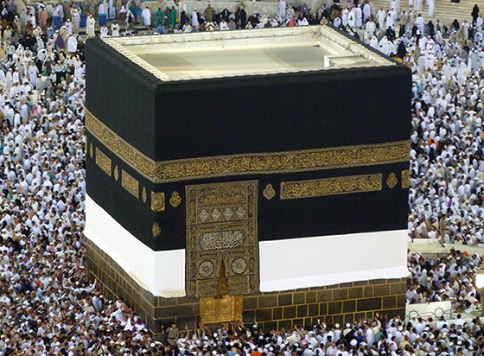
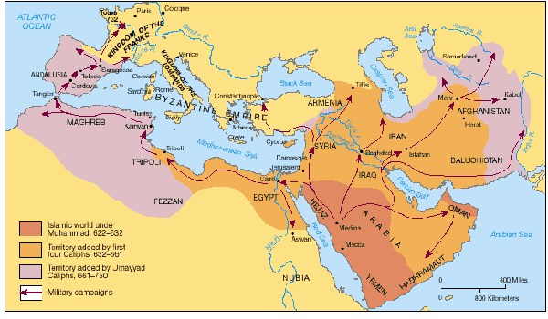
Figure One: Map showing the Early Islamic conquests from the years 622 – 750 AD
Figure Two: The Kaaba, covered in the Kiswah

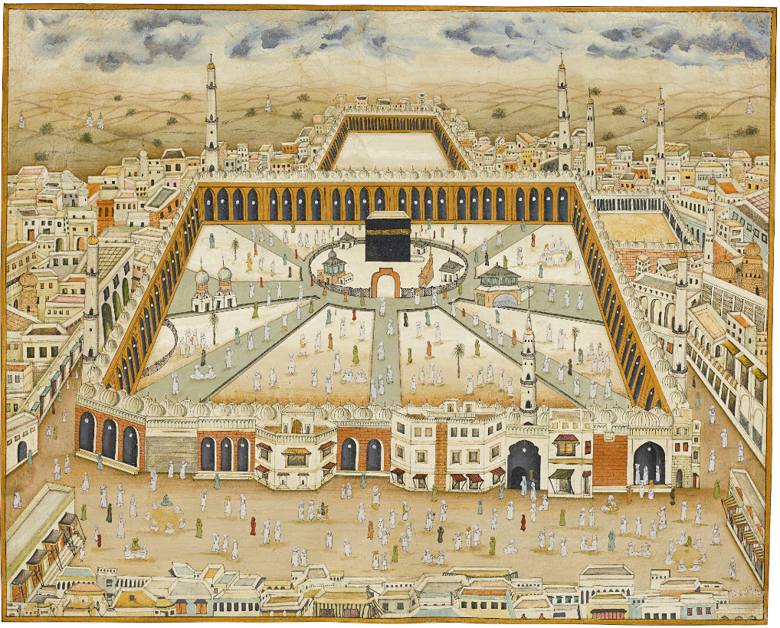
Figure Three: Nineteenth century painting of the city of Mecca

Bibliography

Coinlands.com, Early Islamic States, Coinlands.com, Available from http://www.coinlands.com/early-islamic-states.html, Accessed on [20/12/2017].
Darul Ihsan, The Kiswah, Darul Ihsan, Available from http://darulihsan.com/index.php/downloads/articles/articles-2/2012-12-18-11-04-03/item/4365-the-kiswah-%E2%80%93-basic-facts, Accessed on [20/12/2017].

Donner, Fred. M, The early Islamic Conquests (United Kingdom: Princeton University Press, 1981).
Dr. Macaulay-Lewis, Elizabeth, The Kaaba, KhanAcademy, Available from https://www.khanacademy.org/humanities/ap-art-history/west-and-central-asia/a/the-kaaba, Accessed on [18/12/2017].

Gamm, Niki, Gold as a decorative art in the Muslim Near East, Hurriyet Daily News, Available from http://www.hurriyetdailynews.com/gold-as-a-decorative-art-in-the-muslim-near-east-45715, Accessed on [18/12/2017].

Hill, Bryan, The Kaaba Black Stone, Ancient Origins, Available from http://www.ancient-origins.net/artifacts-other-artifacts/kaaba-black-stone-holy-stone-outer-space-003661/page/0/1, Accessed on [28/12/2017].

Hussain, Zarah, Islamic Art, BBC, Available from http://www.bbc.co.uk/religion/religions/islam/art/art_1.shtml, Accessed on [18/12/2017].

Islam Guide, What are the five pillars of Islam? Islam Guide, Available from https://www.islam-guide.com/ch3-16.htm, Accessed on [20/12/2017].

IsraelJerusalem, Dome of the Rock, IsraelJerusalem, Available from http://www.israeljerusalem.com/dome-of-the-rock.htm, Accessed on [28/12/2017].

Kaegi, Walter, Byzantium and the Early Islamic Conquests (United Kingdom: Cambridge University Press, 1992).
KhanAcademy, Introduction to Mosque Architecture, KhanAcademy, Available from https://www.khanacademy.org/humanities/art-islam/beginners-guide-islamic-art/a/introduction-to-mosque-architecture, Accessed on [21/12/2017].

Newsroom, The 7 roles of the Mosque, The Voice of the Cape, Available from http://www.vocfm.co.za/the-7-roles-of-the-mosque/, Accessed on [17/12/2017].

O’Meera, Simon, The Kaaba Orientations: Reading in the work of the Ancient House DRAFT (Edinburgh University Press, 2018).p.1.

Reem, Important Sites: the Prophet’s Mosque, InsideIslam, Available from https://insideislam.wisc.edu/2012/02/important-sites-the-prophets-mosque/, Accessed on [23/12/2017].

Roman Empire.net, Which modern day countries did the Roman Empire comprise of? Roman Empire.net, Available from http://www.roman-empire.net/maps/empire/extent/rome-modern-day-nations.html, Accessed on [20/12/2017].

Smart, Ninian, The World’s religions, Sec. Edition (London: Cambridge University Press, 1998).

Sothebys, A large view of Mecca, Sothebys, Available from http://www.sothebys.com/en/auctions/ecatalogue/2015/arts-islamic-world-l15223/lot.238.html, Accessed on [28/12/2017].

Thackston, Wheeler (trans), Naser-e Khosraw’s Book of Travels (Safarnama) (Persian Heritage Series, 36). Albany: SUNY Press, 1986, Cited in Islamic Art and Visual Culture, Ed. D. Fairchild Ruggles (Blackwell Publishing, 2011).

N. Smart, The World’s religions, Sec. Edition (London: Cambridge University Press, 1998).
F. Donner, The Early Islamic Conquests (United Kingdom: Princeton University Press, 1981). p.55.
W. E. Kaegi, Byzantium and the Early Islamic Conquests (United Kingdom: Cambridge University Press, 1992). p.181.
Roman Empire.net, Which modern day countries did the Roman Empire comprise of? Roman Empire.net, Available from http://www.roman-empire.net/maps/empire/extent/rome-modern-day-nations.html, Accessed on [20/12/2017].
Smart, The World’s religions, chapter 12.
Islam Guide, What are the five pillars of Islam? Islam Guide, Available from https://www.islam-guide.com/ch3-16.htm, Accessed on [20/12/2017].
Dr. Elizabeth Macaulay-Lewis, The Kaaba, KhanAcademy, Available from https://www.khanacademy.org/humanities/ap-art-history/west-and-central-asia/a/the-kaaba, Accessed on [18/12/2017].
Wheeler Thackston (trans), Naser-e Khosraw’s Book of Travels (Safarnama) (Persian Heritage Series, 36). Albany: SUNY Press, 1986, Cited in Islamic Art and Visual Culture, Ed. D. Fairchild Ruggles (Blackwell Publishing, 2011).
Dr. Elizabeth Macaulay-Lewis, The Kaaba, KhanAcademy, Available from https://www.khanacademy.org/humanities/ap-art-history/west-and-central-asia/a/the-kaaba, Accessed on [18/12/2017].
Darul Ihsan, The Kiswah, Darul Ihsan, Available from http://darulihsan.com/index.php/downloads/articles/articles-2/2012-12-18-11-04-03/item/4365-the-kiswah-%E2%80%93-basic-facts, Accessed on [20/12/2017].
Zarah Hussain, Islamic Art, BBC, Available from http://www.bbc.co.uk/religion/religions/islam/art/art_1.shtml, Accessed on [18/12/2017].
Niki Gamm, Gold as a decorative art in the Muslim Near East, Hurriyet Daily News, Available from http://www.hurriyetdailynews.com/gold-as-a-decorative-art-in-the-muslim-near-east-45715, Accessed on [18/12/2017].
Wheeler Thackston (trans), Naser-e Khosraw’s Book of Travels (Safarnama) (Persian Heritage Series, 36). Albany: SUNY Press, 1986, Cited in Islamic Art and Visual Culture, Ed. D. Fairchild Ruggles (Blackwell Publishing, 2011).
S. O’Meera, The Kaaba Orientations: Reading in the work of the Ancient House DRAFT (Edinburgh University Press, 2018).p.1.
KhanAcademy, Introduction to Mosque Architecture, KhanAcademy, Available from https://www.khanacademy.org/humanities/art-islam/beginners-guide-islamic-art/a/introduction-to-mosque-architecture, Accessed on [21/12/2017].
Bryan Hill, The Kaaba Black Stone, Ancient Origins, Available from http://www.ancient-origins.net/artifacts-other-artifacts/kaaba-black-stone-holy-stone-outer-space-003661/page/0/1, Accessed on [28/12/2017].
Newsroom, The 7 roles of the Mosque, The Voice of the Cape, Available from http://www.vocfm.co.za/the-7-roles-of-the-mosque/, Accessed on [17/12/2017].
Reem, Important Sites: the Prophet’s Mosque, InsideIslam, Available from https://insideislam.wisc.edu/2012/02/important-sites-the-prophets-mosque/, Accessed on [23/12/2017].
IsraelJerusalem, Dome of the Rock, IsraelJerusalem, Available from http://www.israeljerusalem.com/dome-of-the-rock.htm, Accessed on [28/12/2017].
Sothebys, A large view of Mecca, Sothebys, Available from http://www.sothebys.com/en/auctions/ecatalogue/2015/arts-islamic-world-l15223/lot.238.html, Accessed on [28/12/2017].
Coinlands.com, Early Islamic States, Coinlands.com, Available from http://www.coinlands.com/early-islamic-states.html, Accessed on [20/12/2017].
Dr. Elizabeth Macaulay-Lewis, The Kaaba, KhanAcademy, Available from https://www.khanacademy.org/humanities/ap-art-history/west-and-central-asia/a/the-kaaba, Accessed on [18/12/2017].
Sothebys, A large view of Mecca, Sothebys, Available from http://www.sothebys.com/en/auctions/ecatalogue/2015/arts-islamic-world-l15223/lot.238.html, Accessed on [28/12/2017].

