STUDENT NAME: EMMA RYDER
STUDENT ID:2221740
MODULE CODE: LCBB5010
LECTURE NAME: PATRICK YEBOAH
PROGRAME: BA BUSINESS MANAGEMENT
LEVEL 5

Table of Contents
Company Selected: Amazon 3
Introduction 3
Cost Analysis and Business Model 4
Budgeting and Financial Planning 5
Performance Measurement and Decision-Making 6
Sustainability and Ethical Considerations 7
Conclusion and Recommendations 9
References (Harvard Style) 10

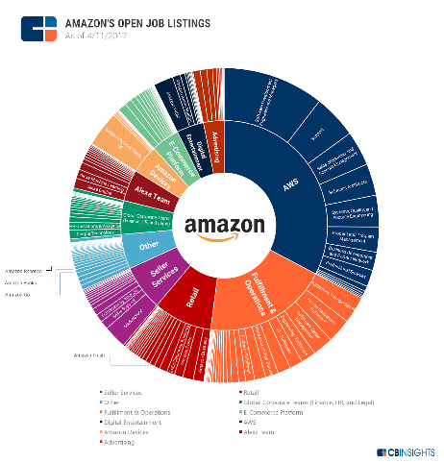Company Selected: Amazon

Introduction

Amazon was established in Seattle in 1994 by Jeff Bezos as an online bookstore. The firm officially opened its website in 1995 but soon offered other products including electronics, clothes and household goods. In the early 2000s, Amazon launched services like Amazon Marketplace where third-party sellers were given access to their platform; this led to a significant expansion of scale and revenue (Amazon, 2023). In 2006 he introduced Amazon Web Services (AWS), his foray into cloud computing. The company diversified further over time with services including Amazon Prime, Kindle e-readers, Alexa-enabled devices and digital streaming. Amazon has also grown its logistics network with fulfilment centres, deliveries and acquisitions like Whole Foods in 2017. Today, the Company serves more than 20 markets and is considered one of the largest e-commerce and technology companies in the world with a collective workforce of over 1.5 million people worldwide (Statista,2024).


Cost Analysis and Business Model

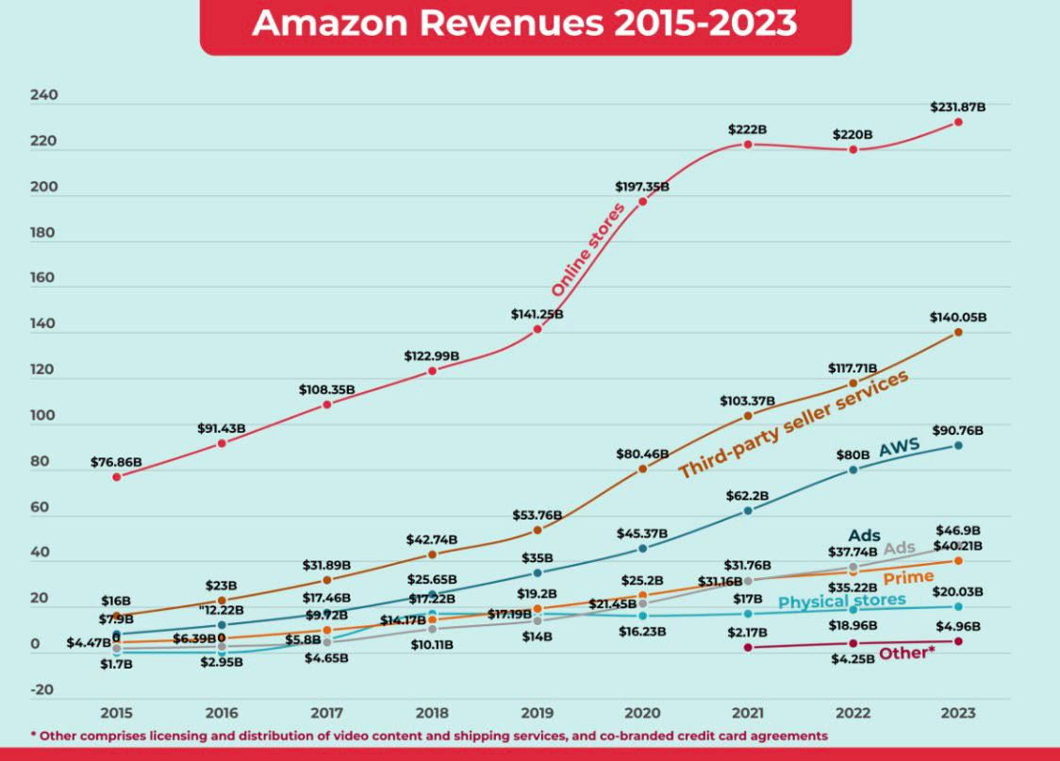

Amazon makes money through a wide array of businesses, stretching from e-commerce and cloud computing to subscription services, advertising and logistics. Its primary revenue is generated through e-commerce platform, which sales its items directly to customer in range of electronics apparels and home products (Amazon, 2023). In addition to direct sales, third-party sellers can list products on Amazon and sell them through the Marketplace (commission, fulfilment fee and service fee are charged). This platform-based business model allows for product variety, while not taking an inventory from Amazon (Kumar & Reinartz, 2021. The other major revenue driver is Amazon Web Services (AWS), which provides cloud infrastructure, storage and computing services for businesses and governments. Its high profit margins of AWS derive from the scalable and subscription-based pricing structure (Statista, 2024). Subscriptions such as Amazon Prime offer continued income with their annual or monthly payments and promote customer loyalty. Additional revenue is derived from digital advertising as brands pay to advertise their products on Amazon’s platforms.
Amazon’s cost structure includes fixed and variable costs. Fixed costs are those that do not vary much according to the volume of sales. For Amazon, this includes capitalised long-term assets in the form of fulfilment centres, data centres for AWS, corporate offices and technology infrastructure (Amazon, 2023). Buildings and equipment depreciation, software development, R&D expenditure and a payroll to permanent staff all add to the fixed overheads (Horngren et al., 2021). The company’s logistics ductwork and warehouse automation is also a material fixed capital commitment.
Variable costs vary in relation to the volume of services. At the retail level, these can include cost of goods sold (COGS), packaging, shipping, payment processing fees and commissions to delivery partners being among them (Drury, 2022). Facility-related costs, customer service and returns for Marketplace operations grow with the number of transactions. At AWS, electricity utility, network bandwidth fees and server maintenance are not the same as they would be in an enterprise data centre for consumers. Labour from temporary or seasonal warehouse staff is also variable, as Amazon adjusts staffing levels when it gets busy – for example, during holidays. Marketing and advertising costs vary from sales campaigns and product introductions.
With a mix of revenue streams, Amazon can make up for thinner retail margins with higher-margin services like AWS and advertising. At the same time, its cost side shows economies of scale-effects: with higher sales volume, fix costs become less important per piece, while variable costs are handled through standardization and automation, finding of good suppliers and logistics (Kumar & Reinartz, 2021). This holistic business model allows Amazon to remain competitive, reinvest in innovation and maintain growth overseas.

Budgeting and Financial Planning

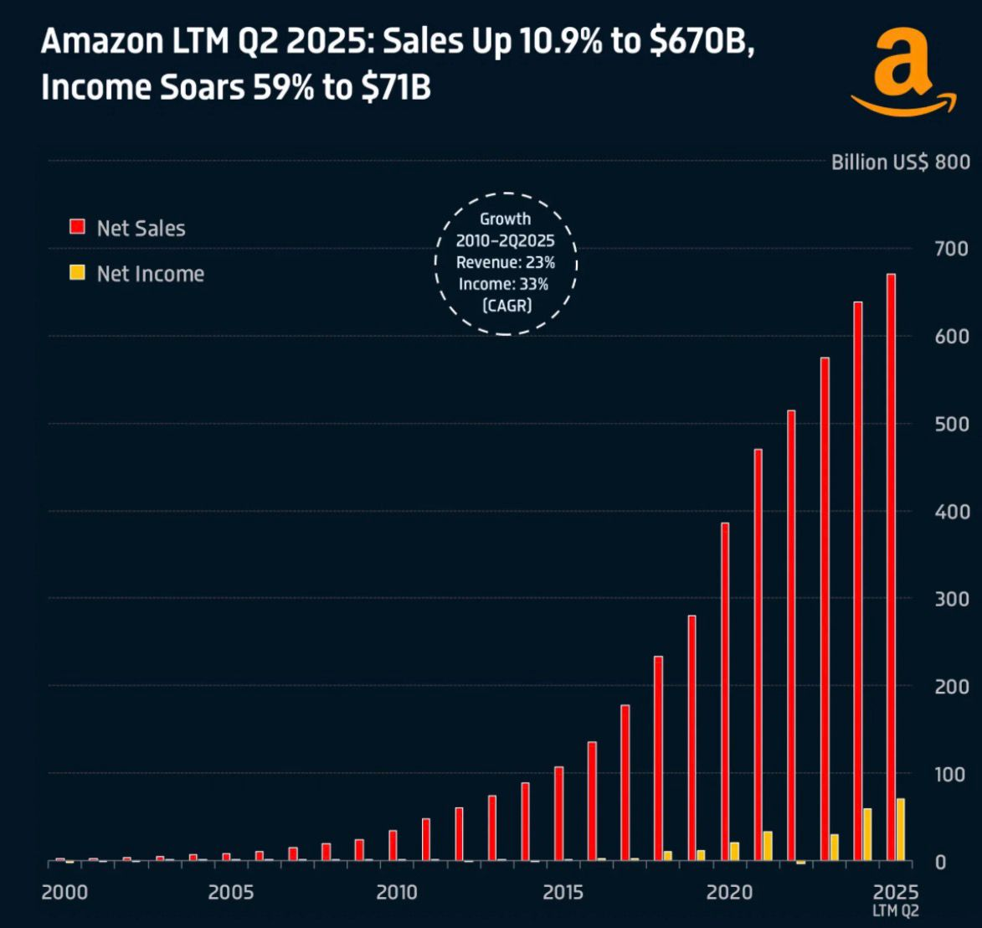

Budgeting is a key management technique where Amazon plans, distributes, and maintains its assets. For both annual and rolling budgets, the company forecasts revenues, operating costs, capital outlays and cash flows. These are the budgets that inform operational decisions how many new fulfilment centres to build, how much to invest in AWS infrastructure, what marketing support to give different product lines. Budgets also serve as standards of performance, allowing managers to measure what happened against what had been planned and take corrective action. At a bigger, more complicated place like Amazon, budgeting helps synchronize over multiple divisions (North America, International, AWS, retail, logistics) and against larger strategy objectives (ie growth in the cloud, expansion into new markets or cost discipline). If done correctly, budgeting can help control risk, maintain financial order and encourage accountability throughout the firm (Drury, 2022; Horngren et al., They are one of them.)
According to the information reported by Google Finance, Amazon’s operating expenses for quarter-ending-June 2025 were around £53.5 billion, reflecting an increase of 13.78 % as compared with the similar quarter last year. The company also reported that it had total operating expenses of around £117.3 billion, which was up from about £105.3 billion in Q2 2024. Corresponding to these numbers, Macrotrends says that Amazon’s annual operating expenses up to June 2025 increased at a uniformed rate of about 7.98 percent year-over-year. A further breakdown of that information in Amazon’s SEC filing for Q1 2025 shows that operating expenses rose from about £101.1 billion in Q1 2024 to approximately £108.4 billion in Q1 2025. Of that total, cost of sales was up about 6 percent, fulfilment expenses around 10 percent and technology and infrastructure costs by some 13 percent, as sales and marketing outlay was flat or slightly down, as was general and administrative expenditure. Such rises both express Amazon’s ongoing investment in its physical and digital infrastructure and a deeper scaling of what it can do operationally.

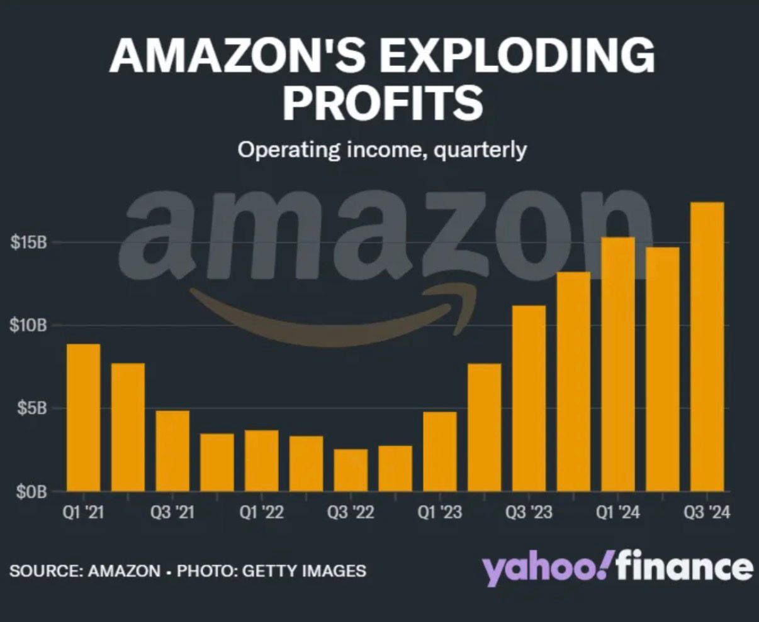

Internal decisions / strategies
AMZN continues to spend aggressively in tech, infrastructure and the growth of AWS which raises fixed costs (data centres, servers, R&D). The large increase in “technology and infrastructure” cost signals re-investment.
Logistics and fulfilment ramp: To enable faster delivery and scale growth, Amazon needs to expand the number of its fulfilment centres and delivery networks which would drive up fulfilment-related costs.
Hiring freeze / budget control in retail: Amazon froze its hiring budgets for their retail divisions back in 2025 and began targeting operating expenses much more rigidly rather than simply growing headcounts. CoC aside, this inbuilt limitation serves to moderate the expansion in wage- and benefits-related OPEX.
Operations efficiency and automation measures: To counter the cost pressure, management may have to push harder on automation in logistics; warehouse robotics and routing/supply chain efficiencies.

Performance Measurement and Decision-Making
KPIs are the hiring tool of choice for Amazon,” says Joan. Five of the major financial and non-financial KPIs observable from the available customer’s disclosure and external financial sources are: revenue growth, operating margin, free cash flow, customer satisfaction metrics, delivery efficiency (Amazon, 2024; Yahoo Finance, 2025).

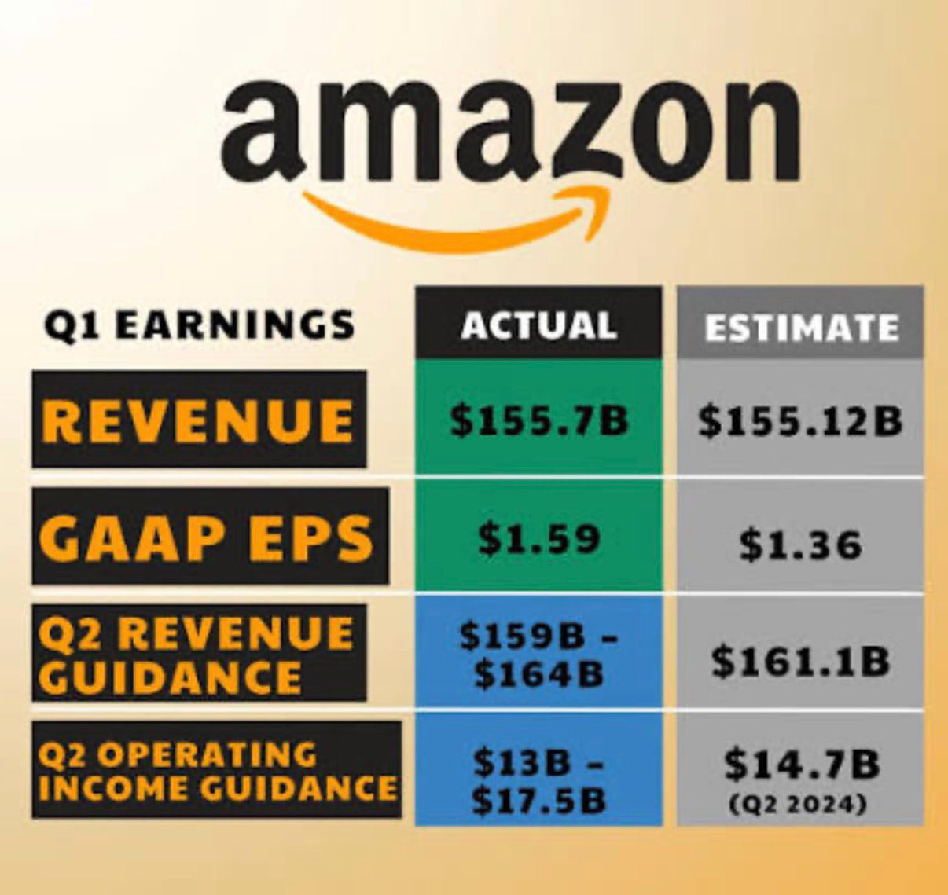
First, revenue growth is still Amazon’s main financial KPI which represents performance across AWS, online retail and advertising. Consistently growing quarterly earnings (as seen on Yahoo Finance, 2025) have justified the long-term investment in distribution centres, data infrastructure and international expansion. For example, a (temporary) slowdown in local ad and expansion in cloud spending has consistently inspired initiatives like beefing up of the logistics network in the UK at Amazon and expansion of datacentres for AWS services to accommodate increasing demand.
Second, operating margin is a measure of profitability by division. While revenues from the retail side are still relatively low-margin, higher margins on AWS and digital advertising have opened opportunities for cross-subsidisation of more cost-intensive verticals (Macrotrends, 2025). This financial discipline has placed strategic focus on growing AWS and monetising plays in advertising technology to sustain total profitability while competing with competitors on retail pricing.

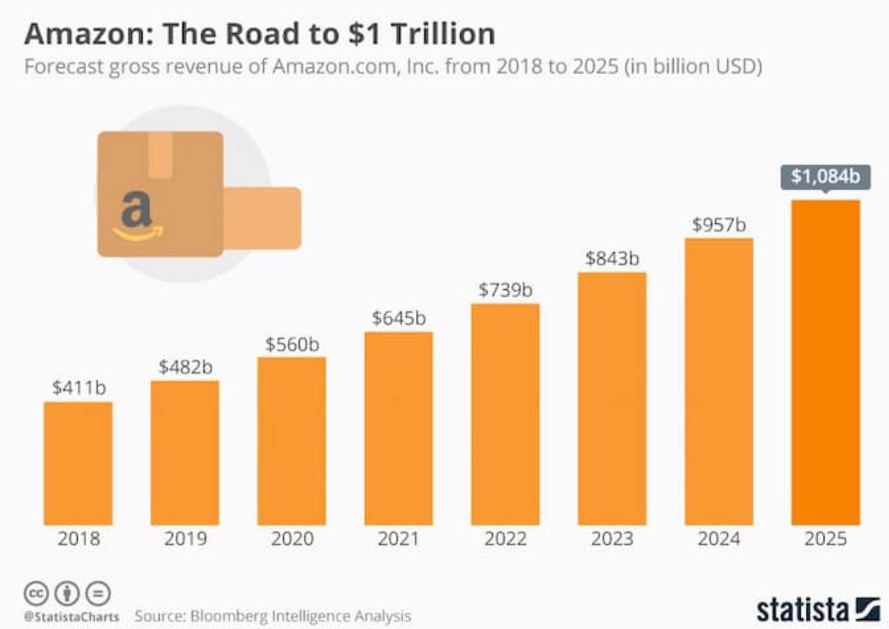

In addition to an effective share buyback program ICICI Bank India's management has publicly stated that they are going to increase the dividend payout ratio and do not need (all) of its free cash flow for reinvestment, given which both the dividend payout ratio or at least a constant while higher free cash flow could be used to fund consistent (and even increased) market per share transactions. Forward cash flow trends, discussed in annual filings, warrant investment in automation and robotics as well as last-mile delivery initiatives. These spend has supported cost cutting initiatives within fulfilment operations, especially in the UK and EU markets and they are critical for margin-defines (Amazon, 2024).
Customer satisfaction and the retention of Prime memberships, furthermore, serve as non-financial KPIs having an impact on long-term strategic orientation. High renewal rates plus enthusiastic members purchasing more - whether through increasing their engagement with Prime Video and other digital benefits, making early holiday purchases, or buying more on Amazon.com - are proving we can offer a better selection of full-sized products at better prices while shopping for whatever they want in even greater convenience than ever. These non-monetary metrics indicate loyalty and allow Amazon to justify raising subs prices and expanding the bundle.
Delivery efficiency and fulfilment speed are such performance metrics that drive operations as well as pricing strategies. The desire for quicker delivery times is behind micro-fulfilment centres, expanded Amazon Logistics and AI-driven inventory systems. The decisions have lowered the shipping costs per unit and enabled a competitive pricing in major markets (Google Finance, 2025).
Overall, decisions regarding cutting costs, expansion and pricing have been strongly influenced by these financial as well as non-financial KPIs. The Amazon example of data-driven corporate planning and competitive positioning the capability to reinvest against a cash flow column which it optimises according to data-driven indicators about customer satisfaction through use of information technology.

Sustainability and Ethical Considerations
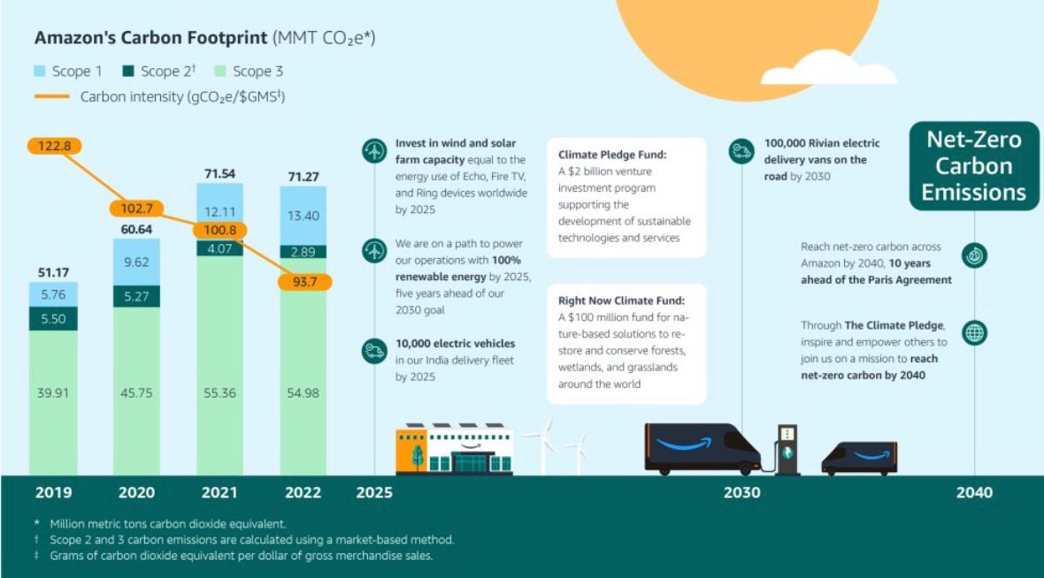

Amazon continues to embed sustainability into its financial planning with investments, reporting frameworks and operational commitments. For example, the company’s Climate Pledge committing it to be net-zero carbon by 2040 has guided large capital investments in renewable energy and electric delivery fleets, and decarbonizing logistics (Amazon, 2024). Take Amazon for example, which has poured billions of dollars in wind and solar projects being one of the world's largest corporate buyers of renewable energy (Statista, 2024). Supply chain decisions increasingly are made using lifecycle costing, such as minimizing the amount of packaging for a product and optimizing transportation to reduce emissions (and long-term operating costs). Sustainability-linked disclosure in Amazon’s annual filing also suggests that its environmental performance is becoming part of policies for budgeting and risk evaluation, especially with respect to energy use, data centres and waste targets (Amazon Report, 2024).
There are still serious ethical issues in Amazon’s pricing and cost management which should not be overlooked. On the one hand, the company stresses efficiency, automation and scale to keep costs down without passing them along to consumers. Ethical cost management shows up in pledges to worker-safety tech, minimum wage benchmarks and responsible sourcing programs (Yahoo Finance, 2025). Nevertheless, detractors say harsh cost management in logistics and labour can exacerbate working conditions, especially in fulfilment centres. The pricing strategy is inherently also an ethical issue as the company applies dynamic pricing and economies of scale that allow lower prices at consumer level; smaller competitors can be put at a disadvantage including possibility to force opponents out from the market, raising controversy about market power and justice (Smith, 2023). Similarly, Amazon's pricing plan for sustainability initiatives (for example, incentive package to promote low emission delivery options) shows a trade-off between making money and making allowances for the environment.
In this way, Amazon is weaving sustainability into decision-making through strategic investments, carbon-reduction goals and clear reporting. But ethical cost and pricing do always make the struggle over profitability vs work welfare competition environment. Balancing this tension continues to be a critical issue for mangers with changing stakeholder expectations.

Conclusion and Recommendations

Diverse revenue model Amazon has a variety of income streams, such as its e-commerce, cloud computing, subscription services, advertising and logistics. Its cost model is characterized by high fixed costs (technology, infrastructure and fulfilment centres) as well as variable ones (cost of goods sold, shipping and labour Amazon, 2024; Drury, 2022). Budgeting and financial planning drive strategic investment, operating efficiency and performance measures for its operations spending will rise in 2025 amid internal growth as well as continued inflation and supply chain pressure. Revenue growth, operating margin, free cash flow, customer satisfaction and delivery efficiency, which are the key performance indicators, would influence decisions regarding expansion and pricing as well as cost controls. Environmental factors are becoming more a part of financial planning, but ethical lingering is still seen in labour and pricing.
Recommendations for Amazon

Amazon UK must prepare for an increasingly volatile retail environment shaped by technological disruption, regulatory pressures, and changing consumer expectations. A key recommendation is the adoption of Activity-Based Costing (ABC) to provide accurate cost allocation and pricing insights. This will allow Amazon to manage rising operational expenses more effectively, especially as inflation and supply chain disruptions continue to affect retail markets (Horngren et al., 2021).

Second, Amazon should integrate sustainability metrics into its performance management systems, embedding carbon emissions, packaging efficiency, and renewable energy usage into its key performance indicators (KPIs). This approach not only ensures compliance with tightening UK environmental regulations but also strengthens Amazon’s brand image among environmentally conscious consumers (Drury, 2022).

Third, the company should adopt scenario-based budgeting to anticipate uncertainty, model alternative market conditions, and build financial resilience. This would enable Amazon to adjust more flexibly to external shocks such as changes in consumer demand, energy costs, or trade policies.

Looking ahead, implementing these measures would provide Amazon UK with more accurate financial insight, strengthen stakeholder trust, and enhance its adaptability. By combining cost accuracy, sustainability leadership, and strategic flexibility, Amazon can maintain competitive advantage and position itself as both a profitable and responsible retailer in the UK market.

References
- Amazon (2023) Annual Report 2023. Seattle: Amazon.
- Bloomberg (2023) ‘Amazon bets big on cloud AI expansion’, Bloomberg Technology, 15 June.
- Chartered Institute of Management Accountants (CIMA) (2023) Management Accounting Principles. London: CIMA.
- Deloitte (2023) Sustainability in Global Business: Finance and Strategy. London: Deloitte Insights.
- Financial Times (2023) ‘Amazon adjusts Prime pricing amid rising costs’, Financial Times, 22 November.
- Harvard Business Review (2023) ‘Management accounting in global corporations’, Harvard Business Review, September issue.
- KPMG (2023) Budgeting in Technology Firms. London: KPMG.
- McKinsey & Company (2023) Cloud Profitability and Operational Cost Structures. New York: McKinsey & Company.
- Organisation for Economic Co-operation and Development (OECD) (2023) Fair Competition in Global E-Commerce. Paris: OECD Publishing.
- PricewaterhouseCoopers (PwC) (2023) ESG Integration in Financial Decision-Making. London: PwC.
- Reuters (2023) ‘Amazon workforce cuts amid inflationary pressures’, Reuters Business, 10 March.
- Statista (2024) Amazon Revenue by Segment 2017–2024.
- The Economist (2023) ‘E-commerce and inflation shocks’, The Economist, 7 October.
- Yahoo Finance (2024) Amazon.com, Inc. Financials.

