MSC PUBLIC HEALTH AND SOCIAL CARE IN PRACTICE
COMMUNITY CARE AND MANAGEMENT OF LONGER-TERM CONDITIONS
LCHS7003 | COMPONENT 1

Depression
An Information Booklet on the Management of a Long-Term Condition
Prepared for health and care service users and professionals in the United Kingdom

Student Name: Jenishkumar Hirani (2518576)

Table of Contents
Introduction 3
Definition 3
Associated health risks 3
Aetiology 4
Impact of Depression 5
Causes of depression 6
Diagnosis of depression 8
Depression treatment 8
Recommendations 11
Conclusion 12
References 13

Introduction
The information booklet is about depression. Depression is a global health problem with rising prevalence, affecting 10.5 and 5.7 % of the global population (WHO, 2025). Depression is considered to be a disorder, characterised by a loss of interest in daily activities, fatigue, low mood as well as the generative symptoms that impair daily functioning (Yan et al., 2026). A survey report of Mental Health and Wellbeing in England has highlighted that about 20% of people aged above 16 years had experienced symptoms of a common mental health disorder, such as depression or anxiety (Harker, 2026). On the other hand, the NHS report highlights that about 72.2% had ever received a professional diagnosis of depression and 67.7% reported the presence of diagnosed depression in the past 12 months (Nhs, 2026). The prevalence of depression in women decreased with age, from 7.4% of 16- 24-year-olds to 2.5% of women aged 75 and over (Nhs, 2026). However, there was no clear association between depression and age for men.
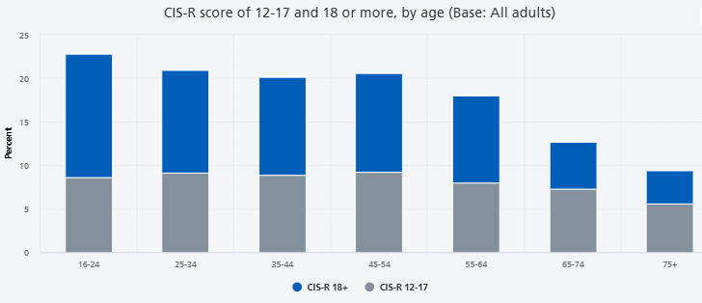
Figure 1: Age-based prevalence of Depression in the UK
(Source: NHS, 2026)
Additionally, the report of the Mental Health Foundation highlights that about 19.7% of people in the UK aged 16 and over showed symptoms of depression, which is a 1.5% increase from 2013 (Mentalhealth, 2026).

Definition
The World Health Organisation has defined depression as a serious mood disorder characterised by persistent sadness, loss of interest or pleasure in activities, and low energy lasting at least two weeks (WHO, 2025). It significantly impedes daily functioning, causing emotional, cognitive, and physical symptoms like sleep changes, guilt, or low appetite.

Associated health risks
According to WHO, there is a strong link between depression and other noncommunicable disorders and diseases (WHO, 2026). Depression increases the risk of substance use disorder and diseases such as diabetes and heart disease. It is also an important risk factor for suicide, which claims millions of lives each year. However, according to the NHS, Talking Therapies and aligned clinical standards from NICE, depression can also worsen existing medical conditions, making treatment more complex (NHS, 2023). However, it could be argued that these risks are often underestimated in clinical practice, as the focus tends to remain on psychological symptoms rather than physical health. Therefore, a more holistic approach is needed to manage both mental and physical health.
Mental health problems and emotional burden are associated with depression and cause several physical health risks (Frank et al., 2023). Individuals with depression often experience changes in appetite and sleep patterns. This can increase the risk of obesity, diabetes, and cardiovascular disease. Moreover, chronic stress and elevated cortisol levels in depressed individuals may weaken the immune system. Depression is further associated with unhealthy coping behaviours such as smoking, alcohol use or drug misuse.
Addressing these risk factors requires integrated care that combines mental health treatment with strategies to improve physical health and lifestyle.

Aetiology
According to the National Library of Medicine, the aetiology of major depressive disorder is believed to be multifactorial, including biological, genetic, environmental, and psychosocial factors (Bains and Abdijadid, 2023). Depression is a widespread long-term mental health condition affecting approximately 332 million people worldwide and over 7% of adults in the UK, posing a major global burden of disability (Santomauro et al., 2026). However, in early stages it is considered to be mainly due to abnormalities in some hormones, such as serotonin, norepinephrine, and dopamine. Increased risk of coronary heart disease among people with major depression persisted for years after their first depressive episode (Cao et al., 2022). The increased risk was present even for myocardial infarction occurring 10 years after the first depressive episode. High rates of depression have been found in older patients suffering from cerebrovascular disease. A recent study has suggested that cerebrovascular disease may have a pathological role in late-life depression. Inflammatory markers, particularly C-reactive protein, are associated with insomnia, anxiety and depression (Luo et al., 2025). The present study aims to identify core and breach symptoms within the anxiety depression CCRP network and to examine the structural differences in these networks across groups with different insomnia severity levels in a large cohort from the UK Biobank.
Depression arises from a complex interplay of biological, physiological and social factors (Chen et al., 2023). Social determinants, including unemployment, social isolation, poor living conditions, and chronic stress, further elevate the risk. However, about 1/3 of the risk of major depression in adults derives from genetic differences between individuals (Halverson, 2024). Several genetic polymorphisms have been linked to increased risk of depression in response to stress. It is linked with elevated cortisol and related neurohormones. However, the argument contrasts with genetic determination, showing that environmental stress and early childhood trauma trigger responses to abnormal biological stress (Hirai et al., 2025). Adverse Environmental factors, especially those associated with early childhood development, have attracted considerable interest as possible contributors to abnormal biological stress regulation.

Impact of Depression
It has been recognised that psychological, social as well as physical symptoms in the condition of depression are commonly identified (Berk et al., 2023). A depressed person may feel sad, hopeless and lose interest in things they enjoyed. Apart from this, the symptoms of depression persist for weeks or months and are severe enough to interfere with work, social life and family life.
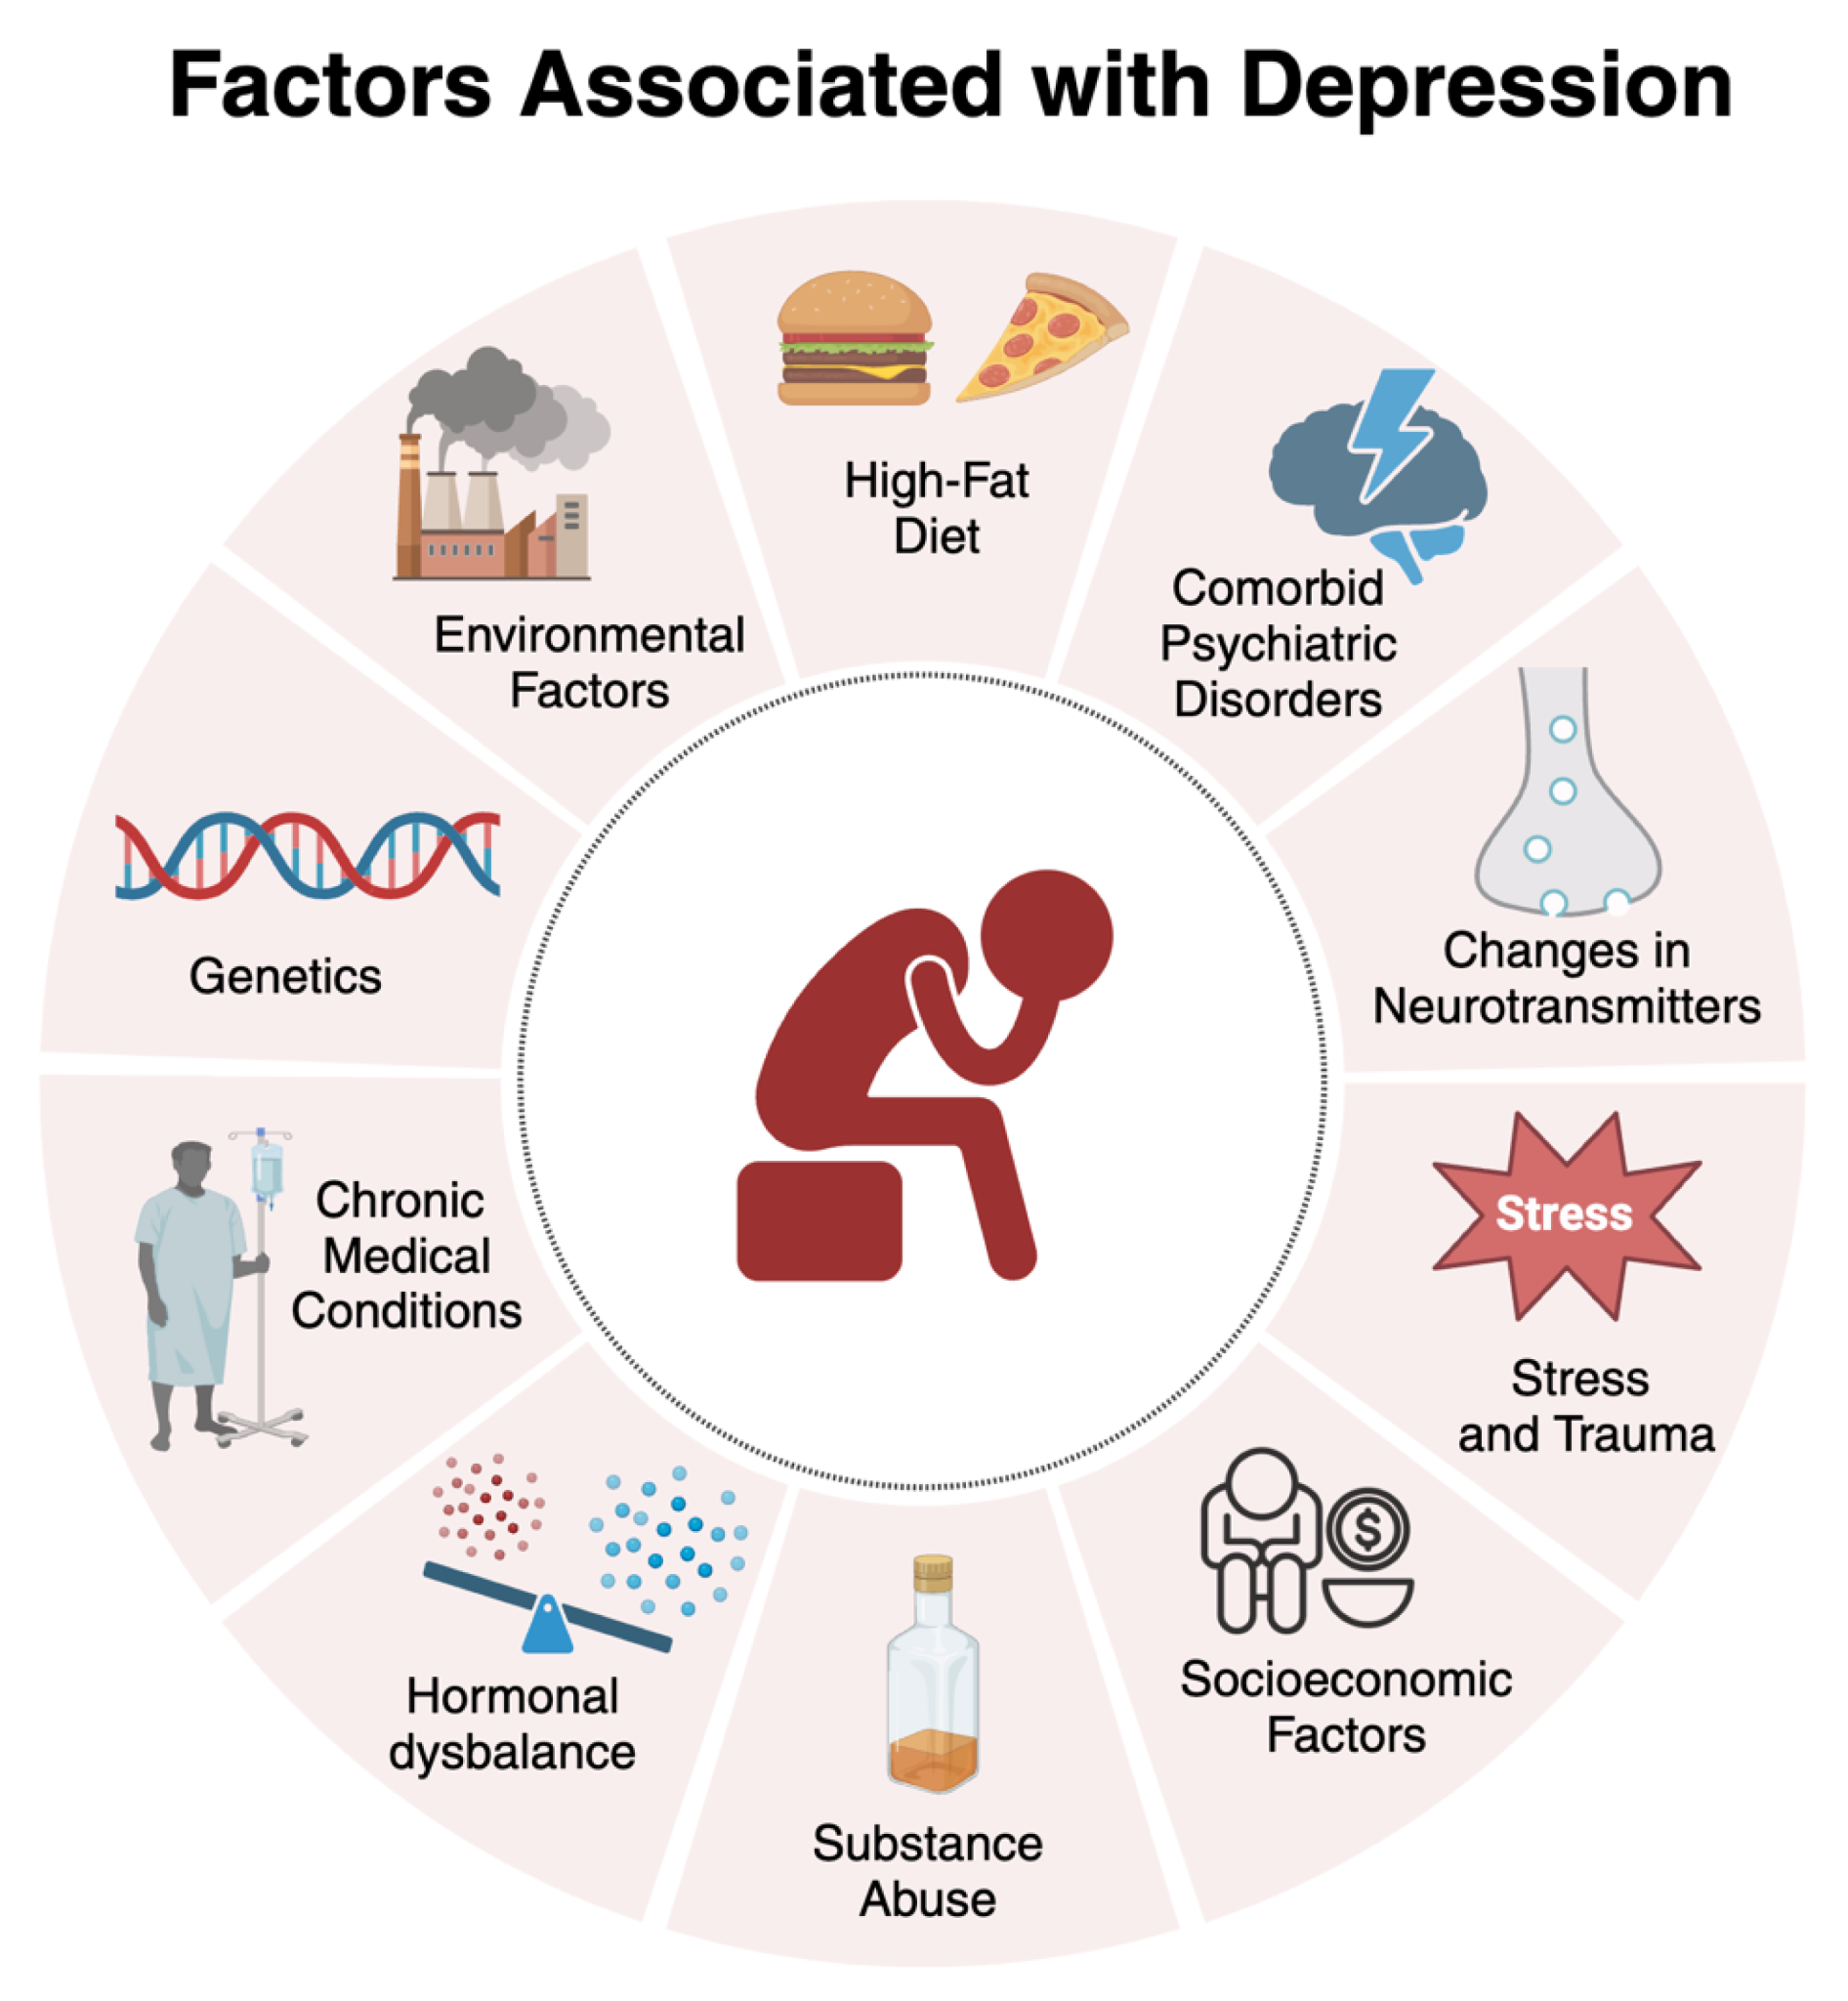
Figure 2: Factors of Depression
(Source: Alberti et al., 2024)
Psychological impact
- Continuous low mood or sadness
- Feeling hopeless and helpless
- Having low self-esteem
- feeling tearful
- Feeling irritable and intolerant of others
- Lack of motivation or interest in things
- Finding it difficult to make decisions.
- Not getting any enjoyment out of life
- Feeling anxious or worried
- Having suicidal thoughts or thoughts of harming yourself
Physical impacts
- Moving or speaking more slowly than usual
- Changes in appetite or weight
- Constipation
- Unexplained aches and pains
- Lack of energy
- Low sex drive and disturbed sleep
Social impacts
- Avoiding contact with friends and family
- Neglecting your hobbies and interests
- Having difficulties in your home, work or family life
Impact of depression on the UK’s family
Depression in the UK creates a heavy ripple effect across the family unit.
The symptoms are commonly recognised, and depression can also manifest in less obvious ways. Some individuals may experience persistent physical complaints such as headaches, digestive problems or unexplained pain, which can only lead to misdiagnosis. Emotional factors are also directly linked to this condition. Moreover, in some cases, depression can reduce motivation to maintain personal hygiene or complete daily tasks, which can impact the quality of life of the individuals. It has been found that the psychological impacts of depression are low self-esteem, difficulties in making decisions, and feeling anxious. Whereas the social impacts are neglecting hobbies and avoiding contact with friends and family.
Wider family impact
In some cases, family history is also seen as a cause of depression. Having a family member who has had depression in the past, such as a parent, sister or brother, increases the chances of depression three times (NHS, 2023). Moreover, Severe depression is partly associated with inherited genes, which accounts for 30- 50% of the overall risk (Angelini Pharma, 2026). This signifies that depression is usually caused by a combination of triggers such as life events, so having a family history of depression does not always trigger it to develop.

Causes of depression
Different causes can often combine to trigger depression. According to different studies, the NHS in the UK has suggested that older people are more likely to get depression, and it is more common in people who live in difficult social and economic circumstances (NHS, 2023). For example, one may feel low after being ill and then experience a traumatic event such as a bereavement, which brings on depression.
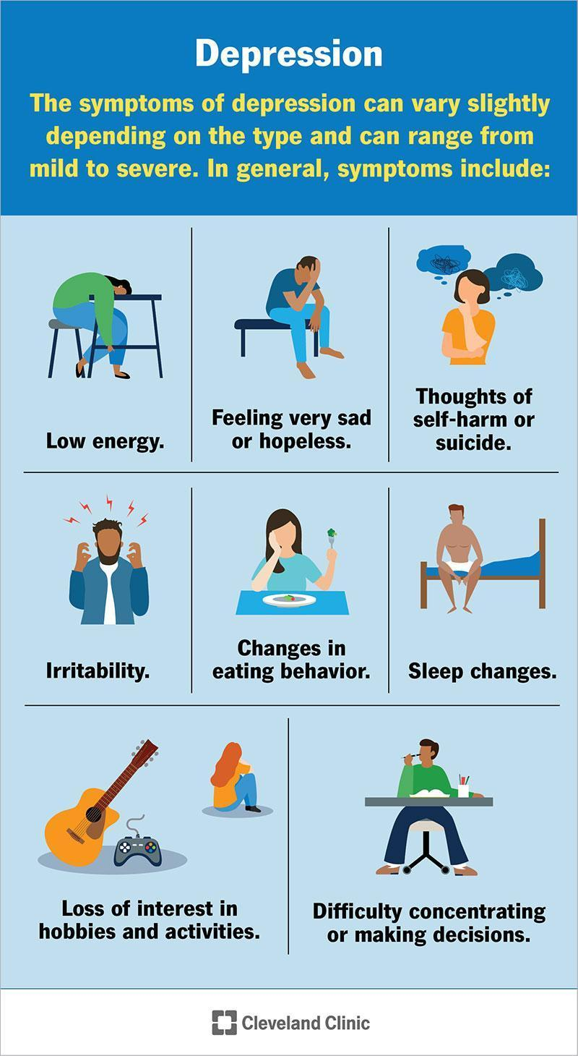
Figure 3: Different ranges of Depression
(Source: Cleveland Clinic, 2026)
Stressful events
More people take time to come to terms with stressful events such as a relationship breakdown (NHS, 2023). These stressful events increase the risk of becoming depressed, stopping seeing your friends and family and trying to deal with problems on their own.
Personality
Depression is caused by inherited genes from parents, early life experiences, or both (Levinson and Nichols, 2021). In essence, people may be more vulnerable to depression if they have certain personality traits, such as low self-esteem or being overly self-critical.
Menopause
Menopause is considered to be the period when a female or women’s menstrual cycle stops due to lower hormone levels (Thuraisingham and Nalliah, 2023). Sometimes menopause can trigger depression, particularly in the first few years. Menopause can also cause symptoms such as sadness and mood swings. Mental health symptoms caused by menopause are different from depression.
Loneliness
Feeling lonely caused by things such as becoming cut off from family and friends can increase the risk of depression (Prizeman et al. 2023).
Alcohol and drugs
Alcohol and drugs are related to depression through a bidirectional, high-risk cycle where substances alter brain chemistry, worsen low moods, and trigger co-occurring mental health disorders (Chiappini et al., 2025). This can result in depression. Cannabis can help you relax, but there's evidence that it can also bring on depression, particularly in teenagers.
Illnesses
A higher risk of depression occurs during long-standing or life-threatening illness, such as coronary heart disease, cancer or a condition that causes long-term pain (Shabbir and Parvinzadeh Gashti, 2026). Head injuries are also an often under-recognised cause of depression. A severe head injury can trigger mood swings and emotional problems.

Diagnosis of depression
For the diagnosis of depression, a person must have symptoms most of the day, nearly every day, for at least two weeks. One of the symptoms of depression is a depressed mood or a loss of interest or pleasure in most activities (Alshaya, 2022). People with only a few symptoms may benefit from treatment. The severity and frequency of symptoms and how long they last vary depending on the person.
A person with discrete symptoms of depression should consult with a healthcare provider, such as a primary care doctor, psychologist, or psychiatrist. During the visit, the provider may ask when the symptoms began, how long they have lasted, how often they occur, and if they keep them from going out or doing their usual activities. It may help to take some notes about the symptoms before the visit.
However, certain medications or medical conditions, such as viruses or thyroid disorders, can cause the same symptoms as depression (NIMH, 2024). The provider can rule out these possibilities by doing a physical exam, consultation or interview, and lab tests.

Depression treatment
American Psychological Association (APA) has recommended treatment for depression by providing a development panel, which consists of two distinct patterns, including initial treatments and other psychological guidelines (Mcquaid et al., 2023)
Initial treatment
For initial treatment of a patient with depressive disorder. There are some recommendations for the treatment of depression in children,
- Behaviour therapy
- Cognitive therapy
- Cognitive behavioural therapy
- Family therapy
- Play therapy.
- Problem-solving therapy.
- Psychodynamic therapy
- Supportive therapy

Pharmacotherapy guidance for initial treatment
There are a few medicines which doctor generally use for the treatment of depression
- Clomipramine
- Imipramine
- Mirtazapine
- Paroxetine
- Venlafaxine
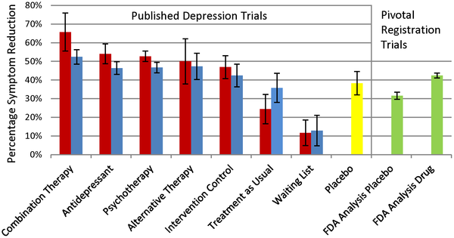
Figure 4: Effectiveness of different depression treatments
(Source: Khan et al., 2022)
Figure 3 demonstrates that the combination therapy is the most effective treatment for depression, followed by antidepressants and different psychotherapies.
The treatment of depression in the UK is mainly guided by the National Health Service NHS and clinical recommendations from the National Institute for Health and Care Excellence, which involves self-help, talking therapies and medicines (NHS, 2023). It is found that there is no single approach that works for everyone, and the treatment usually depends on the severity of symptoms and individual needs (Newman et al., 2022).
For individuals with mild depression, non-pharmacological approaches are often recommended as the first step. These include guided self-help, physical activity and speech therapy. However, Cognitive Behavioural Therapy is widely used in the UK and focuses on identifying and changing negative thought patterns to deal with depression (NHS, 2025). CBT helps to reduce symptoms and prevent relapse when combined with ongoing support (NIICE, 2022). However, access to such therapies is not always equal, and waiting times within NHS services can cause delays in treatment.
For moderate to severe depression, antidepressant medication is commonly prescribed. Selective serotonin reuptake inhibitors are prescribed as a first-line treatment for moderate to severe depression due to their low side effects compared to older medications (Chu and Wadhwa, 2023). These drugs work by increasing serotonin levels in the brain, which may help improve mood. While many patients benefit from medications, such studies have questioned their long-term effectiveness and highlighted potential side effects, and their view of treatment says that medication alone may not be sufficient for all patients (Moncrieff et al., 2022).
In recent days, there has been increasing focus on holistic and community-based approaches such as social prescribing, including connecting individuals to community groups and activities for treating depression (Aughterson et al., 2024). This involves linking patients to non-clinical services like exercise groups, volunteering or counselling support within the community. From a public health perspective, this approach appears to address social factors beneficial as its state contributing to depression, such as isolation and unemployment.
The NHS House of Care framework is a national theoretical model that supports person-centred care for people with long-term health conditions (NHS, 2026). It has been recognised that the NHS England has adapted chronic management principles into the House of Care Framework, a tangible metaphor designed to deliver personalised care planning for long-term conditions.
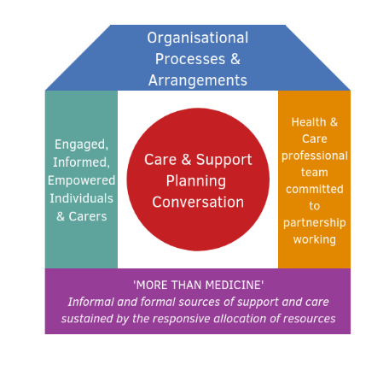
Figure 5: House Of Care Model
(NHS, 2026)
In the UK, the way depression is managed is not only based on clinical practice but is also heavily shaped by national policies and health and social care agendas. These policies aim to improve access to services, reduce inequalities and promote better long-term outcomes for individuals experiencing mental health conditions.
One of the most famous policies is the Five Years Forward for Mental Health, published by NHS England in 2016. Apart from this, the Chronic Care Model fosters productive interactions between informed patients and prepared, proactive practice teams across six interconnected system elements. However, these improvements and research suggest that many individuals still face delays in getting their treatment due to increasing demand and limited workforce capacity (Clark, 2018).
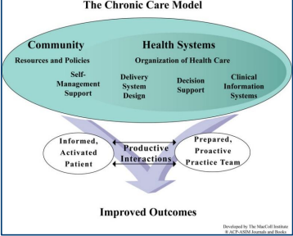
Figure 6: The Chronic Care Model
(Source: Boocha and Ploylearmsang, 2023)
Another important policy is the NHS Long Term Plan 2019, which further builds on previous strategies by focusing on integrated care and community-based services (NHS England, 2016). The application of The Chronic Care Model, an international Model, is designed for transforming complex chronic care delivery (Boocha and Ploylearmsang, 2023). The theoretical model highlights that optimal outcomes are achieved through productive interactions between an activated patient and a prepared, proactive practice team. However, it could be argued by the patient that the success of this approach depends heavily on funding and resources being very limited, which remain ongoing challenges within the healthcare system (The King’s Fund, 2020).
On the other hand, the Chronic Care Model (CCM) is considered to be an evidence-based framework designed to shift healthcare from reactive, episodic treatment to proactive, continuous, and patient-centred care for long-term conditions.
Public health organisations such as the Mental Health Foundation also contribute to the national agenda by promoting their own focus on awareness, prevention and early intervention strategies and policies. This, aimed at encouraging help-seeking behaviour, is particularly important, as many individuals with depression may not seek support due to fear or misunderstanding. (Mental Health Foundation, 2022).

Recommendations
From the discussion in the previous section, it can be understood that depression is a complex condition and it's manageable, but its management requires more than just medication or therapy alone. Even though the National Health Service has introduced many policies and services, there are still some gaps that need improvement. In my opinion, future strategies should focus more on person-centred care, self-management and better access to services.
Firstly, personal care should be given more importance in mental health services (Bell et al. 2023). At present, many treatments are already following general treatments and approaches, but not every individual experiences depression in the same way. A more personalised approach would involve listening to patients, understanding their needs and involving them in decision-making and the self-care process.
Secondly, self-management strategies should be promoted more effectively. Many people with depression can benefit from simple techniques such as regular exercise, mindfulness, maintaining a routine and using digital mental health applications (Kwon et al., 2024). On the other hand, it is important to consider that not everyone has equal access to technology, especially older adults or people from low-income backgrounds.
Finally, the need for more attention in long-term and severe cases of depression is pivotal for supporting individuals with chronic conditions or those patients who are approaching end-of-life care (Coffey et al., 2022). Providing emotional support, dignity, and comfort is important in these kinds of situations. Mental health services should work more closely with palliative care teams to ensure holistic care for these kinds of patients.
Overall, it can be said that improving depression management requires a combined approach which includes medical treatment, psychological support and social care. By focusing on person-centred care, improving access and strategies designed by community support, which are the better outcomes can be achieved for individuals and their families.

Conclusion
In conclusion, depression is a complex and multi-phased long-term condition. Addressing depression is not just about treating the symptoms of depression but also about promoting the overall well-being of the patient. Also, encourage self-management strategies such as structured routines, regular physical activities, mindfulness and access to digital mental health interventions. For better mental health, emphasise early intervention, equity, and integration of services, sharing that mental health support is widely acceptable to the local population's needs.
Family, friends and community support can make a big difference in helping someone to cope and recover from their situation. Encouraging self-care, such as regular exercise, maintaining routines, practising mindfulness, and using digital tools, can help people feel better and control their condition. UK policies like the NHS long-term plan and the Prevention Coalition for mental health focus on early support, equal access and better coordination between services to make sure everyone gets help when needed. Using new approaches like social prescribing and online therapies can also improve mental health outcomes and make care more accessible.
It is also important to raise awareness about depression in schools and universities, social care programs, workplaces and communities. A lady's recognition and support can prevent the condition from getting worse for the person. Promoting understanding reduces the risk by encouraging people to seek help and is an essential step for improving mental health and quality of life for everyone.

References
Alberti, A., Richer, D., Vieira, W.F., Iser, B.M., Meiry, R., Eliane Traebert, Becker, B., Hoffmann, B., Graziela Marques Leão, Souza, G. de, Fabiana Meneghetti Dallacosta, Kades, G., Madeira, K., Matheus Uba Chupel, Grossl, F.S., Souza, R., Soares, B.H., Ruppel, E., Erica, Martins, D.F. and Agostinetto, L. (2024). ‘Factors Associated with the Development of Depression and the Influence of Obesity on Depressive Disorders: A Narrative Review.’ Biomedicines,12(9), pp.1994–1994. Available at:https://doi.org/10.3390/biomedicines12091994
Alshaya, D.S. (2022). ‘Genetic and epigenetic factors associated with depression: An updated overview.’ Saudi Journal of Biological Sciences, 29(8), p.103311. Available at:https://pmc.ncbi.nlm.nih.gov/articles/PMC9232544/
Angelini Pharma (2026). Is depression genetic? Understanding genes, environment and risk. Available at: https://www.angelinipharma.com/expertise/mental-health/is-depression-genetic/ (Accessed: 16 March 2026).
Aughterson, H., Fancourt, D., Chatterjee, H. and Burton, A. (2024). ‘Social prescribing for individuals with mental health problems: An ethnographic study exploring the mechanisms of action through which community groups support psychosocial well-being.' Wellcome Open Research, 9(1), pp.149–149. Available at:https://doi.org/10.12688/wellcomeopenres.20981.1
Bains, N. and Abdijadid, S. (2023). Major Depressive Disorder. Treasure Island (FL): StatPearls Publishing.
Berk, M., Köhler‐Forsberg, O., Turner, M., Penninx, B.W., Wrobel, A., Firth, J., Loughman, A., Reavley, N.J., Mcgrath, J.J., Momen, N.C. and Plana‐Ripoll, O., (2023). ‘Comorbidity between major depressive disorder and physical diseases: a comprehensive review of epidemiology, mechanisms and management’. World psychiatry, 22(3), pp.366-387. Available at:https://doi.org/10.1002/wps.21110
Cao, H., Zhao, H. and Shen, L. (2022). ‘Depression increased risk of coronary heart disease: A meta-analysis of prospective cohort studies.’ Frontiers in Cardiovascular Medicine, 9. Available at:https://doi.org/10.3389/fcvm.2022.913888
Chen, X., Liu, M., Min, F., Tong, J., Liu, Y., Meng, Q. and Zhang, T., (2023). ‘Effect of biological, psychological, and social factors on maternal depressive symptoms in late pregnancy: a cross-sectional study’. Frontiers in psychiatry, 14, p.1181132. Available at:https://doi.org/10.3389/fpsyt.2023.1181132
Chiappini, S., Sampogna, G., Ventriglio, A., Menculini, G., Ricci, V., Pettorruso, M., Volpe, U. and Martinotti, G., (2025). ‘Exploring emerging psychopathological characteristics and challenges of novel depression subtypes: insights from the literature’. Frontiers in psychiatry, 16, p.1613251. Available at: https://doi.org/10.3389/fpsyt.2025.1613251
Clark, D. (2018) ‘Realising the mass public benefit of evidence-based psychological therapies’, Annual Review of Clinical Psychology, 14, pp. 39–60. Available at: https://pmc.ncbi.nlm.nih.gov/articles/PMC5942544/
Cleveland Clinic (2026) Depression – overview, symptoms and treatment. Available at:https://my.clevelandclinic.org/health/diseases/9290-depression (Accessed: 16 March 2026).
Frank, P., Batty, G.D., Pentti, J., Jokela, M., Poole, L., Ervasti, J., Vahtera, J., Lewis, G., Steptoe, A. and Kivimäki, M. (2023). ‘Association Between Depression and Physical Conditions Requiring Hospitalization.’ JAMA Psychiatry, 80(7). Available at:https://doi.org/10.1001/jamapsychiatry.2023.0777
Halverson, J.L. (2024). Depression: Practice Essentials, Background, Pathophysiology.Medscape.com. Available at:https://emedicine.medscape.com/article/286759-overview (Accessed: 16 March 2026).
Harker, R., (2026). Mental health statistics: prevalence, services and funding in England. Available at:https://commonslibrary.parliament.uk/research-briefings/sn06988/ (Accessed: 5 August 2026).
Hirai, Y., Kim, M., Ömer Kayra Koçhan, Aarav Kushwaha and Saqib, M.R. (2025). Epigenetic Impacts of Trauma and Environmental Stressors on Mental Health: Integrating Artificial Intelligence for Prevention and Intervention. Available at:https://www.oxjournal.org/epigenetic-impacts-of-trauma-and-environmental-stressors-on-mental-health/(Accessed: 16 March 2026).
Khan, A., Faucett, J., Lichtenberg, P., Kirsch, I. and Brown, W.A. (2022). ‘A Systematic Review of Comparative Efficacy of Treatments and Controls for Depression.’ PLoS ONE, 7(7), p.e41778. Available at:https://doi.org/10.1371/journal.pone.0041778
Kwon, H., Choi, I.Y., Kim, D.J. and Yoo, J.H., (2024). A review of current digital mental health care applications for anxiety symptoms and future prospects. Psychiatry Investigation, 21(6), p.551. Available at:https://doi.org/10.30773/pi.2023.0339
Levinson, D. and Nichols, W. (2021). Major depression and genetics. Genetics of Brain Function. Stanford Medicine. Available at:https://med.stanford.edu/depressiongenetics/mddandgenes.html(Accessed: 16 March 2026).
Luo, X., Zheng, S., Cheng, Y., Liu, S., Zeng, S., Fang, L., Du, S., Li, W., Yang, H., Huang, Z. and Zhang, B. (2025). ‘Differential Anxiety–Depression–CRP Network Structures Across Insomnia Severity Levels: Evidence From UK Biobank.’ Depression and Anxiety, 2025(1). Available at:https://doi.org/10.1155/da/8836588
Mcquaid, J., Lin, E., Washington, K., Jones, V., Kessler, M., York, N. and Mufson, L. (2023). ‘Clinical practice guideline for the treatment of depression across three age cohorts.’ American Psychological Association. Available at:https://www.apa.org/depression-guideline/guideline.pdf
Mental Health Foundation (2022) Mental health statistics and policy insights. London: Mental Health Foundation. Available at: https://www.mentalhealth.org.uk/our-work/policy-and-advocacy (Accessed: 16 March 2026).
Mentalhealth, (2026). Depression: statistics. Available at: https://www.mentalhealth.org.uk/explore-mental-health/statistics/depression-statistics (Accessed: 5 August 2026).
Moncrieff, J., Cooper, R.E., Stockmann, T., Amendola, S., Hengartner, M.P. and Horowitz, M.A., (2023). The serotonin theory of depression: a systematic umbrella review of the evidence. Molecular psychiatry, 28(8), pp.3243-3256. Available at:https://www.nature.com/articles/s41380-022-01661-0
NHS (2023). Treatment - Depression in adults. Available at:https://www.nhs.uk/mental-health/conditions/depression-in-adults/treatment/(Accessed: 16 March 2026).
NHS (2025). Cognitive behavioural therapy (CBT). Available at:https://www.nhs.uk/tests-and-treatments/cognitive-behavioural-therapy-cbt/ (Accessed: 16 March 2026).
NHS England (2019) The NHS Long Term Plan. Available at: https://www.england.nhs.uk/publication/the-nhs-long-term-plan/ (Accessed: 16 March 2026).
NHS, (2023). Causes of depression in adults. Available at:https://www.nhs.uk/mental-health/conditions/depression-in-adults/causes/(Accessed: 16 March 2026).
NHS, (2023). Symptoms – depression in adults. Available at:https://www.nhs.uk/mental-health/conditions/depression-in-adults/symptoms/(Accessed: 16 March 2026).
Nhs, (2026). Adult Psychiatric Morbidity Survey: Survey of Mental Health and Wellbeing, England, 2023/4. Available at: https://digital.nhs.uk/data-and-information/publications/statistical/adult-psychiatric-morbidity-survey/survey-of-mental-health-and-wellbeing-england-2023-24/common-mental-health-conditions (Accessed: 5 August 2026).
NIMH (2024). Depression. National Institute of Mental Health. Available at:https://www.nimh.nih.gov/health/publications/depression (Accessed: 16 March 2026).
Prizeman, K., Weinstein, N. and McCabe, C., (2023). ‘Effects of mental health stigma on loneliness, social isolation, and relationships in young people with depression symptoms’. BMC psychiatry, 23(1), p.527. Available at: https://doi.org/10.1186/s12888-023-04991-7
Santomauro, D.F., Miller, P.A., Shadid, J., Hanson, S.W., Vo, A., Roy, D.J., Hagins, H., Herrera, A.M.M., Scott, J.G., Erskine, H.E. and McGrath, J.J., (2026). ‘Updated trends in the global prevalence and burden of mental disorders, 1990–2023: a systematic analysis for the Global Burden of Disease Study 2023.’ The Lancet, 407(10543), pp.2040-2064. Available at:https://doi.org/10.1016/S0140-6736(26)00519-2
Shabbir, A. and Parvinzadeh Gashti, M., (2026). ‘Camphor's Therapeutic Uses and Potential Hazards: An In-Depth Review of Its Medicinal Applications’. Molecules, 31(4), p.648. Available at:https://doi.org/10.3390/molecules31040648
The King’s Fund (2020) Mental health policy and NHS performance. Available at:https://www.kingsfund.org.uk/insight-and-analysis/reports/how-nhs-performing-august-2020 (Accessed: 16 March 2026).
Thuraisingham, C. and Nalliah, S., (2023). ‘Is menopause managed well enough in general practice?.’ Malaysian Family Physician: the Official Journal of the Academy of Family Physicians of Malaysia, 18, p.49. Available at: https://doi.org/10.51866/cm.264
WHO (2025). Depressive disorder (depression). Available at:https://www.who.int/news-room/fact-sheets/detail/depression (Accessed: 16 March 2026).
WHO (2026) ‘Depression: “Let’s talk,” says WHO as depression tops list of causes of ill-health’, WHO News, 30 March. Available at:https://www.who.int/news/item/30-03-2017--depression-let-s-talk-says-who-as-depression-tops-list-of-causes-of-ill-health (Accessed: 16 March 2026).
WHO (2026) Mental health of older adults. Available at:https://www.who.int/news-room/fact-sheets/detail/mental-health-of-older-adults (Accessed: 16 March 2026).
WHO (2026). “Depression: let’s talk” says WHO, as depression tops list of causes of ill health. Available at:https://www.who.int/news/item/30-03-2017--depression-let-s-talk-says-who-as-depression-tops-list-of-causes-of-ill-health (Accessed: 16 March 2026).
Yan, C., Yan, P., Yu, Z., Zhang, J., Song, M. and Mao, H., (2026). ‘Cognitive function and depressive symptoms in major depressive disorder: a smartphone-based study of outpatients from a sleep-disorders clinic in China’. Frontiers in Psychiatry, 17, p.1713792. Available at:https://doi.org/10.3389/fpsyt.2026.1713792

