University of Wales Trinity Saint David

Wales Institute of Science and Art



Performance Analysis

Motorcycle Dynamics (ACHA5004)

Oska Robertson
2301207
28/03/26

Contents
Introduction 3
1. Rider Telemetry Analysis 3
1.1 Data Overview 5
1.2 Braking Behaviour 5
1.3 Throttle Application 5
1.4 Cornering Performance 6
1.5 Overall Performance and Recommendations 6
2. Data Acquisition System Design 6
2.1 System Objectives 6
2.2 Sensor Selection and Functionality 6
2.3 Sampling and Data Resolution 7
2.4 System Integration and Architecture 7
2.5 Design Constraints and Trade-offs 7
3. Calibration, Setup and Testing 8
3.1 Installation Process 8
3.2 Calibration Procedures 8
3.3 Testing and Validation 8
3.4 Common Issues and Solutions 9
3.5 Reflection on Process 9
4. Data Evaluation and System Review 9
4.1 Data Quality Assessment 9
4.2 System Effectiveness 9
4.3 Limitations of the System 9
4.4 Recommendations for Improvement 9
4.5 Engineering Evaluation 10
5. Conclusion 10
6. References 10

Introduction
In modern motorsport engineering, data acquisition systems are fundamental to understanding and improving vehicle performance. The ability to measure, record, and analyse real-time data allows engineers to make informed decisions regarding both machine setup and rider technique. This is particularly important in motorcycle applications, where performance is highly sensitive to rider input and dynamic load transfer (Bosch, 2018).
Motorcycles differ significantly from four-wheeled vehicles due to their inherent instability and reliance on rider control. Small variations in throttle application, braking force, or body positioning can result in significant changes in performance. As a result, accurate telemetry data is essential for identifying performance trends and understanding how rider behaviour influences lap time.
This report presents a detailed analysis of rider telemetry data alongside the design and implementation of a data acquisition system for a Kawasaki ZXR750. Telemetry data from three professional riders, Simon Crafar, John Hopkins, and Garry McCoy, is analysed to compare riding styles and identify performance differences. Key parameters such as throttle position, braking behaviour, and speed are examined to determine how each rider approaches different phases of the lap.
In addition to rider analysis, the report outlines the design of a practical data acquisition system using 2D data logging equipment. This includes sensor selection, sampling strategy, system integration, and real-world considerations such as reliability and signal quality. The setup, calibration, and testing processes are discussed, followed by an evaluation of system performance and potential improvements.
The aim of this report is to demonstrate how data acquisition can be used as a tool for performance analysis and engineering decision-making in a motorsport environment.

Rider Telemetry Analysis

Figure 1: Simon Crafar Telemetry Trace (Throttle, Speed, Brake)
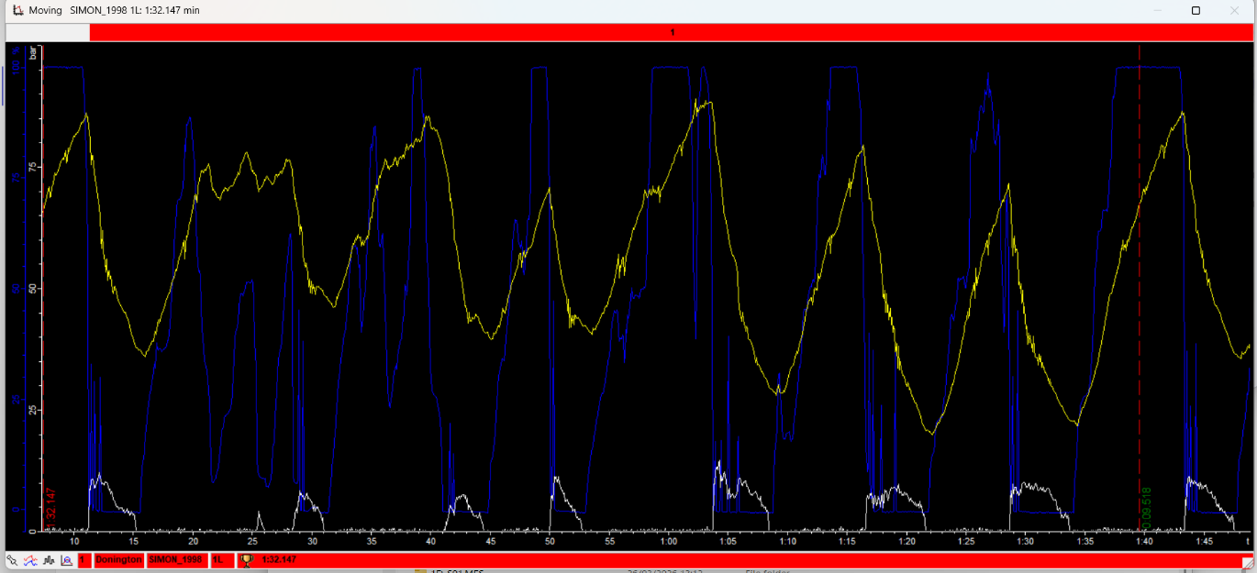
Figure 2: John Hopkins Telemetry Trace (Throttle, Speed, Brake)
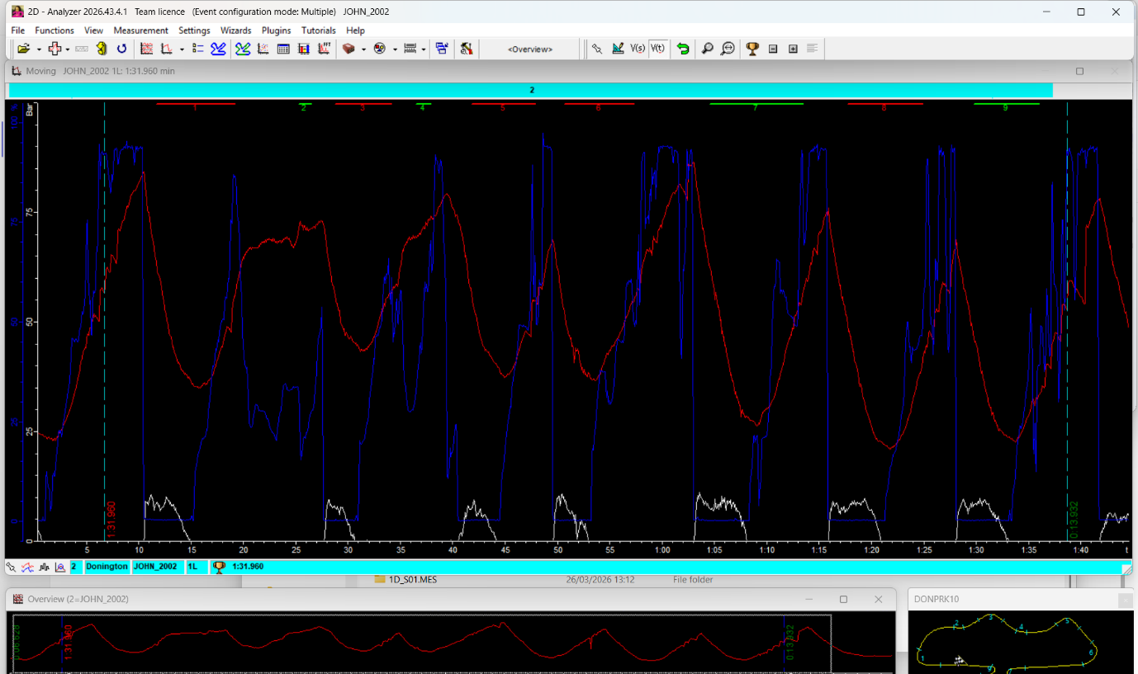

Figure 3: Garry McCoy Telemetry Trace (Throttle, Speed, Brake)
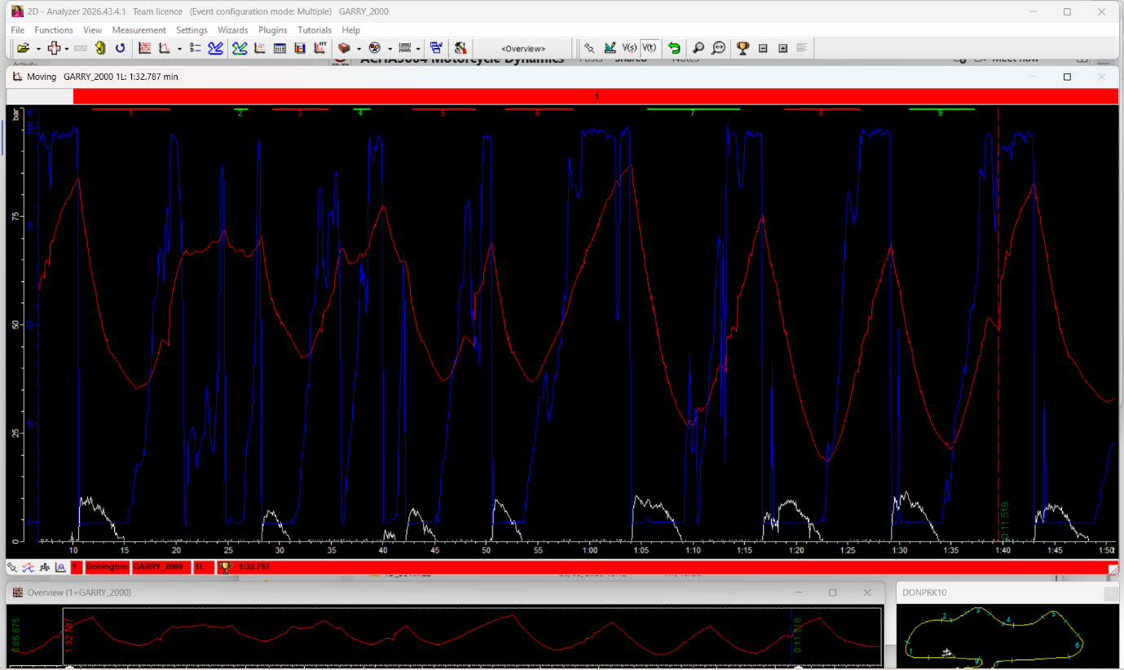

1.1 Data Overview
Telemetry data from three professional riders was analysed over a single lap of Donington Park using 2D data acquisition software (2D Datarecording Ltd., 2023). The riders analysed were Simon Crafar (1998), John Hopkins (2002), and Garry McCoy (2000). Key data channels included throttle position, brake pressure, and vehicle speed.
The recorded lap times were 1:31.960 for Hopkins, 1:32.147 for Crafar, and 1:32.787 for McCoy. Figures 1 to 3 illustrate the telemetry traces for each rider. These traces allow direct comparison of rider inputs and how they influence overall performance.

1.2 Braking Behaviour
Braking behaviour is one of the most significant factors influencing lap time, particularly in heavy braking zones. The telemetry data shows clear differences between the riders.
John Hopkins demonstrates the most aggressive braking approach. As shown in Figure 2, his brake trace features sharp increases in pressure and high peak values. This suggests a late braking strategy, where braking is delayed to maximise time spent at higher speeds on straights. This approach increases front tyre load significantly, which can improve braking performance but also increases the risk of instability if grip limits are exceeded (Cossalter, 2006).
Simon Crafar adopts a more progressive braking style. His brake trace, shown in Figure 1, is smoother and more consistent, with fewer abrupt changes. This indicates controlled weight transfer and improved stability during corner entry. Such an approach reduces the likelihood of front tyre overload and promotes consistent performance across laps (Gillespie, 1992).
Garry McCoy shows shorter and more abrupt braking phases. He transitions quickly from braking to throttle application, suggesting a focus on reducing time spent decelerating. While this may allow earlier acceleration, it can compromise corner entry stability and reduce overall control.

1.3 Throttle Application
Throttle control is critical for maximising acceleration while maintaining traction. The telemetry data highlights clear differences in how each rider applies throttle.
Crafar demonstrates smooth and progressive throttle application, as shown in Figure 1. This indicates effective management of rear tyre grip, allowing controlled acceleration without exceeding traction limits. Smooth throttle application reduces the likelihood of wheel spin and improves consistency.
Hopkins applies throttle more aggressively, with faster transitions from closed to open throttle. This behaviour increases acceleration but also places greater demand on rear tyre grip. The ability to apply throttle aggressively without losing control suggests a high level of rider confidence and skill.
McCoy exhibits the most aggressive throttle behaviour, with frequent spikes and fluctuations visible in Figure 3. This suggests operation at or near the limit of rear tyre grip, likely inducing controlled sliding. While this can be advantageous in certain conditions, it reduces efficiency and increases variability in performance (Milliken and Milliken, 1995).

1.4 Cornering Performance
Cornering performance is influenced by both braking and throttle behaviour. Analysis of speed traces provides insight into how each rider negotiates corners.
Crafar maintains relatively consistent cornering speeds, indicating smooth transitions and effective line selection. This suggests a balanced riding style focused on maintaining momentum through corners.
Hopkins shows more variation in speed but achieves higher overall performance. His aggressive braking and acceleration allow him to gain time despite reduced smoothness.
McCoy shows larger fluctuations in speed, with more pronounced drops and recoveries. This suggests instability during cornering, likely due to aggressive throttle inputs and reduced braking control.

1.5 Overall Performance and Recommendations
Hopkins achieves the fastest lap time through aggressive riding techniques, including late braking and rapid throttle application. However, this approach may be less consistent over multiple laps.
Crafar demonstrates a more stable and repeatable riding style, with smooth inputs and balanced control. McCoy shows aggressive behaviour that reduces overall efficiency.
Improvements could include smoother throttle application for aggressive riders and increased braking intensity for more conservative riders.

Data Acquisition System Design

2.1 System Objectives
The primary objective of the data acquisition system was to capture accurate and reliable data relating to rider inputs, vehicle dynamics, and engine performance. The system needed to operate effectively in a high-vibration, high-temperature environment while maintaining data integrity.

2.2 Sensor Selection and Functionality
Sensor selection is critical in ensuring that meaningful data is captured. Sensors were chosen based on their ability to measure key parameters influencing performance.
Throttle position sensors provide direct measurement of rider input, allowing analysis of acceleration behaviour. Brake pressure sensors measure braking force and provide insight into braking strategy.
Wheel speed sensors are essential for determining vehicle speed and identifying slip conditions. Comparing front and rear wheel speeds allows detection of traction loss during acceleration or braking.
Suspension displacement sensors measure fork and rear shock movement. These sensors provide valuable information on load transfer, which is a key factor in vehicle stability (Cossalter, 2006).
Additional sensors such as lambda, airbox pressure, and coolant temperature provide information on engine performance and operating conditions. These parameters are important for ensuring engine reliability and efficiency.

2.3 Sampling and Data Resolution
Sampling rate selection has a significant impact on data quality. High-frequency signals require high sampling rates to capture rapid changes accurately. If sampling rates are too low, important transient events may be missed.
For example, suspension movement during braking occurs rapidly and requires high sampling rates to capture accurately. In contrast, temperature changes occur more slowly and can be sampled at lower rates.
The selection of appropriate sampling rates ensures a balance between data accuracy and storage efficiency (Turner, 2009).

2.4 System Integration and Architecture
The system was centred around a 2D data logger, which collected data from multiple sensors. Integration with the ECU allowed certain parameters to be recorded without additional sensors.
Wiring was carefully routed to minimise interference and prevent damage. Shielding and grounding were used to reduce electrical noise.
Sensor placement was carefully considered to ensure accurate measurement. Poor placement can result in incorrect data and reduce the effectiveness of the system.

2.5 Design Constraints and Trade-offs
Several constraints influenced the system design, including cost, weight, and complexity. High-performance sensors provide better accuracy but are more expensive. A balance was required to achieve acceptable performance within practical limits.
Durability was also a key consideration. Components needed to withstand harsh operating conditions without failure.
In addition to basic functionality, sensor selection must also consider the impact on data interpretation. For example, wheel speed sensors not only provide vehicle velocity but also allow the calculation of slip ratio when compared between front and rear wheels. This is particularly important in high-performance motorcycles where traction limits are frequently approached.
Similarly, suspension displacement sensors provide more than simple movement data. They allow engineers to infer load transfer characteristics during braking and acceleration phases. Excessive front suspension compression during braking may indicate overly aggressive rider input or suboptimal suspension setup, while insufficient rear squat under acceleration may suggest limited traction.
Trade-offs are also present in system design. High-precision sensors offer improved accuracy but increase system cost and complexity. In contrast, lower-cost sensors may introduce measurement uncertainty, which must be considered during analysis. The chosen system therefore represents a compromise between performance, cost, and practical implementation.
Another important consideration is data synchronisation. All sensor channels must be correctly time-aligned to ensure accurate interpretation of cause-and-effect relationships. For example, throttle application must be accurately matched with changes in speed and suspension behaviour. Poor synchronisation can lead to incorrect conclusions and reduce the effectiveness of the data acquisition system.

Calibration, Setup and Testing

3.1 Installation Process
The installation of the data acquisition system involved mounting sensors in appropriate locations and ensuring secure connections. Proper installation is essential to ensure reliable data collection.

3.2 Calibration Procedures
Calibration ensures that sensor outputs correspond to actual physical values. This includes zeroing sensors and applying scaling factors.
Incorrect calibration can lead to significant errors in data interpretation. For example, incorrect brake pressure calibration could result in misleading conclusions about braking performance.

3.3 Testing and Validation
Testing involved monitoring live data to ensure that all sensors were functioning correctly. This allowed identification of issues such as signal noise or incorrect readings.
Validation ensures that the data collected is accurate and reliable.
A structured calibration procedure is essential to ensure the accuracy of all measured parameters. Each sensor must be checked for both offset and scaling errors prior to use. For example, brake pressure sensors should read zero when no pressure is applied, and any deviation from this must be corrected through calibration. Similarly, suspension displacement sensors require accurate reference points to ensure that measured movement corresponds to actual physical displacement.
During testing, validation of sensor data is equally important. This involves comparing expected behaviour with recorded signals. For instance, an increase in brake pressure should correspond with a reduction in vehicle speed and increased front suspension compression. If this relationship is not observed, it may indicate a fault in the sensor or data logging system.
Common faults encountered in data acquisition systems include signal noise, intermittent connections, and sensor drift. Signal noise can be caused by electromagnetic interference and is typically addressed through improved shielding and grounding. Intermittent connections may result from poor wiring or connector issues, while sensor drift can occur due to temperature changes or component wear.
Addressing these issues requires a systematic approach to troubleshooting, ensuring that reliable data is obtained before performance analysis is conducted.

3.4 Common Issues and Solutions
Common issues include electrical noise, vibration, and sensor misalignment. Electrical noise can be reduced through proper shielding, while vibration effects can be minimised through secure mounting.

3.5 Reflection on Process
The testing process highlighted the importance of attention to detail and effective teamwork. Small errors in installation or calibration can significantly affect data quality.

Data Evaluation and System Review

4.1 Data Quality Assessment
High-quality data is essential for accurate analysis. Data must be free from excessive noise and accurately represent real-world behaviour.

4.2 System Effectiveness
The system successfully captured a wide range of data, allowing detailed analysis of rider behaviour and vehicle performance.

4.3 Limitations of the System
Limitations include potential inaccuracies in sensor data and environmental effects such as vibration and temperature.
An important aspect of data evaluation is the consideration of measurement uncertainty. All sensors have inherent limitations in accuracy and precision, which can influence the reliability of the data. Understanding these limitations is essential when interpreting results, particularly when comparing small differences in performance between riders.
Repeatability is another key factor in assessing data quality. A reliable data acquisition system should produce consistent results under similar conditions. Variations in data may indicate external influences such as environmental changes or inconsistencies in rider input.
It is also important to distinguish between real performance trends and anomalies within the data. Isolated spikes or irregular signals may not represent actual behaviour and should be treated with caution. Filtering and data smoothing techniques can be used to improve clarity, although excessive filtering may remove important transient information.
From an engineering perspective, the value of a data acquisition system lies not only in its ability to record data but also in the accuracy and reliability of that data. A well-designed system allows engineers to make informed decisions, whereas poor-quality data can lead to incorrect conclusions and ineffective performance improvements.

4.4 Recommendations for Improvement
Improvements could include higher-quality sensors, improved mounting techniques, and increased sampling rates.

4.5 Engineering Evaluation
The system demonstrates the importance of careful design and implementation. Effective data acquisition requires both suitable hardware and correct usage.

Conclusion
This report has demonstrated the importance of data acquisition in motorsport engineering. The analysis of rider telemetry highlights how different riding styles influence performance. The design and implementation of a data acquisition system shows how data can be collected and used for analysis.
The project highlights the importance of combining theoretical knowledge with practical application to achieve meaningful results.

References
2D Datarecording Ltd. (2023) 2D Data Logging Systems and Sensors Overview.
Bosch (2018) Automotive Handbook.
Cossalter, V. (2006) Motorcycle Dynamics.
Gillespie, T.D. (1992) Fundamentals of Vehicle Dynamics.
Milliken, W.F. and Milliken, D.L. (1995) Race Car Vehicle Dynamics.
Turner, J.W.G. (2009) Automotive Sensors.

