Professional career development

(BMSW4004_LON)

Bianca Sanfilippo

Professional Career development report

By Raúl Torres (2115143)

Index

Table of Contents
Index 2
Personal reflection on the role play: Recruitment and selection 3
Skills and knowledge which contribute towards working effectively 5
Knowledge of legislation 6
Personal strengths and areas for further development 8
Short- and long-term Targets (Using Smart targets) 9
Conclusion 10
References 11
Appendix: 13

Personal reflection on the role play: Recruitment and selection

On this section I am going to reflect on the role play carried out in class in week 8 on the 8th of August of 2022, as part of assignment 1 for my module of professional career development. To do that I will use Kolb’s model of reflection. ‘The process whereby knowledge is created through the transformation of experience” (Kolb, 1984).

Kurt (2020) said that when the 4 stages of the theory are completed, people are able to learn from their own reflections on situations that happened to them by Appling abstract ideas in novel contexts. The learner can integrate new observations to their current understanding with each new experience.

Stages of the method:

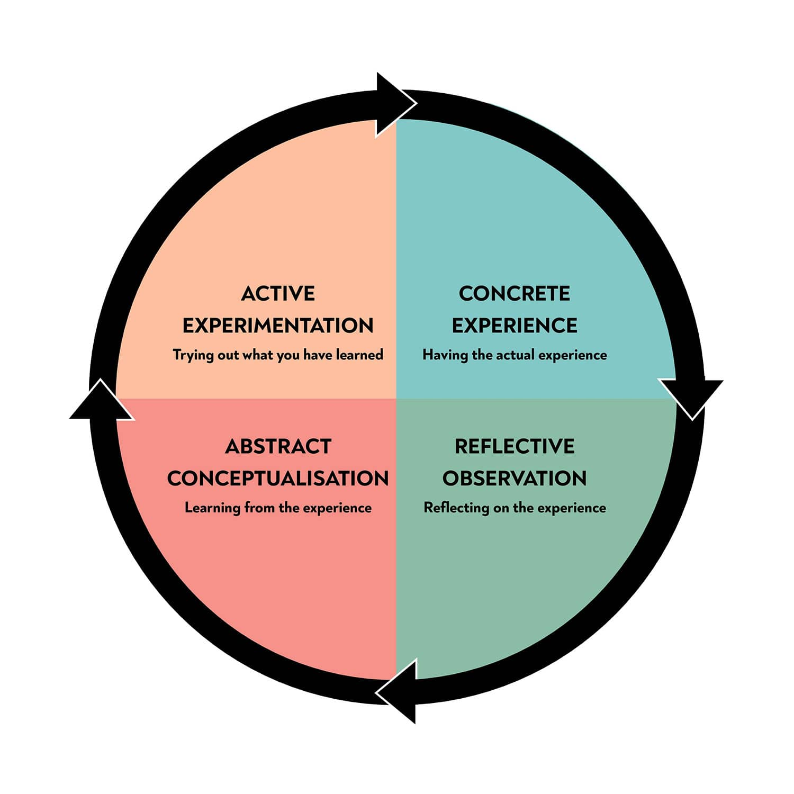

As stated by Norther Illinois University (2012), role plays performed by students where real scenario situations are mirrored, are useful to help them critically think and see complex topics with a different perspective. Some of the benefits are, motivation from students, learn skills which can be used in the future, and enable them to critically observe their peers.

On this roleplay I needed to represent two sides of a work interview. On the first part of the role play, I was the Human resources manager for a video games company, which would interview my partner Lilia who was applying to be an admin assistant. This first part I found it to be easier, mainly because I would be supporting and the one being marked was Lilia. Also, being the interviewer is an easier role, as I only needed to ask a few questions and Lilia would be the one doing most of the talking. Because of that, I would be able to pay more attention on my body language and on how I should behave.

On the second part of the role play, I would swap roles with Lilia. This time I would be an applicant to be a Marketing Executive. Therefore, it was my time to be interviewed and although I was the one who wrote the questions that would be asked to me, I was clearly more nervous. I remember starting quite insecure, and that is something that always happens to me. I recall the feeling from previous job interviews that I lived in the past. I can’t help to get nervous even when I know the answer to the questions. I realised during the interview that I already have many of the inter-personal skills needed for the job, which I gain throughout my professional life in the luxury retail industry. On the other hand, the main thing that I lack is the qualifications required for this job.

Further on during the interview, I started to feel more comfortable and gain more confidence on my speech. I stopped tapping my feet on the floor, and I was smiling and looking into Lilia’s eyes. I guess, overall I did a good job answering the questions.

Getting nervous it is something that I would like to improve for future experiences, as I believe that confidence has a big impression on people that do not know you. That said, what I learnt from this role play combined with my previous experiences, showed me that in the future I should prepare and be confident when speaking about my inter-personal skills. I will make sure that the person in front of me realises that I possess all the needed factors that will make me stand out from other candidates.

Skills and knowledge which contribute towards working effectively

I want to pursue a career in marketing. To do so, my first objective is finishing a BA on Business and Management, which will be useful to reach my goal.

To become a Marketing executive, I will need to be able to carry out pricing strategies for products or services that are developed by the executive, based on customer demand. Also, analyse sales data to determine the efficiency of the ad campaigns. Marketeers take care of client’s social media accounts as well as blogs and articles. They are also in charge of the market research by analysing data to prepare relevant campaigns. Moreover, they are often seeking advertising opportunities in different platforms and also are monitoring competitors’ activities. (Indeed, N/D)

Skills required to be a Marketing executive are: (Target Jobs, N/D)
Great communication skills and being a team player. This creates a positive organizational culture, ensures that individuals have the knowledge they need to perform well, and eliminates inefficiencies. (Coursera, 2022). English literacy skills, including English language written and verbal. This is needed on a daily basis in order to communicate with clients, managers, and other members of the team. Also, when doing presentations and meetings.
IT skills are imperative, 92% of adults in the UK use the internet, organisations that do not have a web presence and interact with clients online may be losing opportunities to build their business. The use of social selling and digital marketing may establish enduring relationships with your clients. Moreover, being able to work with programs specialised on this field and operate websites might be required. (Barclays, 2012)
Attention to details and good organisation skills will be useful when joggling with different projects at the same time, organise the daily planner, and keep a good time management.
Lastly having a great commercial awareness in order to keep the future of the business running.

Other skills that I will need to become a good Marketing executive and consequentially evolve my career on this field would be:

Data Analysis: comprehending what information is valuable and what is not, being comfortable working with data from a range of sources and campaigns, and being able to use your research to shape future actions.
Research skills: Knowing how to execute quality research from credible sources is a valuable skill that will elevate the results of your projects. (Krakoff, N/D)

Knowledge of legislation

In order to carry out any job in the UK is important to have a knowledge of legislation, such as:
The equality act (2010):
Which gives the United Kingdom a discrimination law that protects individuals from unjust treatment and encourages a more egalitarian and equal society. It combines over 116 individual pieces of legislation into a single Act. The Act establishes a legal framework to defend individuals' rights and advance equality of opportunity for all.

It's based on 9 protected characteristics: (Equality and Human rights commission, 2020)
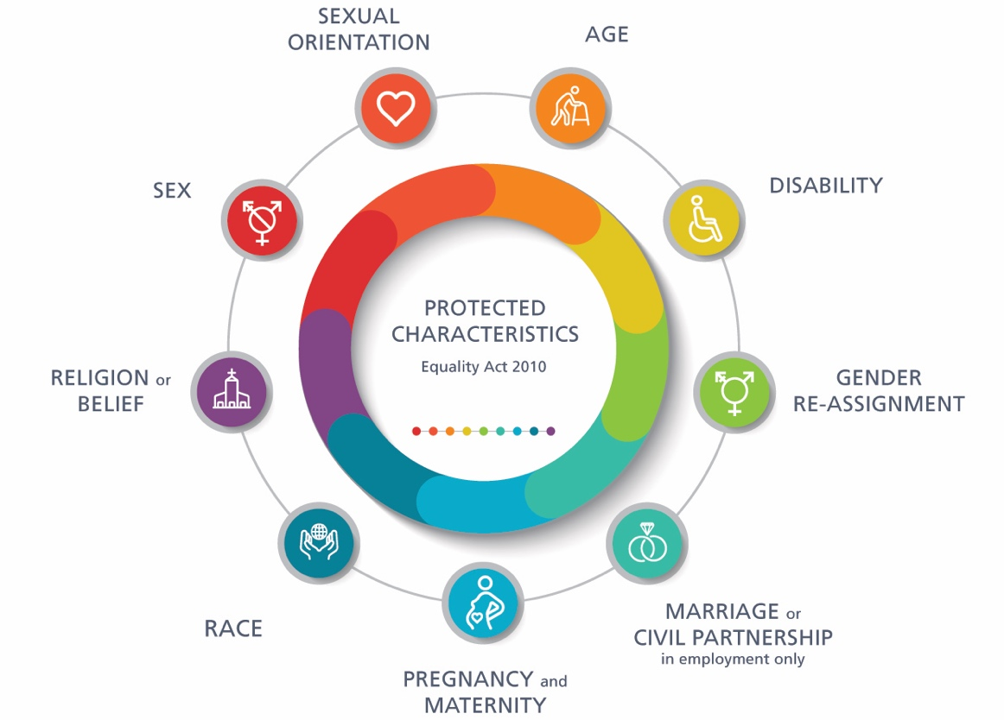

Data protection legislation:

The Data Protection Act of 2018 regulates how organisations, companies, or the government should manage your personal information. The ‘data protection principles are the strict rules that should be followed in order to use personal data.

- used fairly, lawfully, and transparently
- used for specified, explicit purposes
- used in a way that is adequate, relevant and limited to only what is necessary
- accurate and, where necessary kept up to date
- kept for no longer than is necessary
- handled in a way that ensures appropriate security, including protection against unlawful or unauthorised processing, access, loss, destruction or damage
Users have the right to know what data the government and other organisations are keeping about them under these regulations. (UK Government N/D)

Health and safety at work act:

The major piece of legislation controlling workplace safety and health is the Health and Safety at Work Act of 1974. It addresses both the employer's and the employee's obligations in creating a safe working environment. These have a direct impact on the day-to-day activities of a company. (BBC N/D)

Statutory rights of employment in the UK:

Workers in the UK are entitled to some employment rights which includes:
Minimum wage payments, statutory leave payments either when on holidays, paternity, maternity, sickness, and unlawful deduction of wedges. Moreover, to not work more than 48 hours per week. They also have the right to be protected against discrimination and unfair dismissal. (UK Government N/D)

Personal strengths and areas for further development

Swot Analysis:

Strenghts | Weakneses | Opportunities | Threats
Communication skills | Time Managing | Great amount of Experience | Competition of other applicants
Leadership skills | Organization skills | Doing this course | Time (Work/ Study)
Sales Skills | Excel & Numbers | High rise of marketers | No experience in the field
Writing skills | No Qualifications on the field | Wide range of friends in the field | Transport in London

Being a professional with more than ten years in the Luxury Hospitality/ Retail field, gave me enough experience to have great communication skills in the workplace. In those years, I learnt how to have a good rapport with senior management and other member of the teams I have been work with. In addition, I learnt how to properly communicate with clients in order to build trust and relationships with them, which was always enriching for me and for the business I was bringing to the companies. Most of these interactions are made via digital technologies through smartphones or email, etc. Therefore, to accomplish that I needed to achieve a good level of English written grammar.

I also been manager of a large team where I gain a demonstrated great leadership skills. I was a reference and an example of professionalism, giving the team the tools necessary to excel at their roles, and giving them confidence to know that they could approach me when they needed to face a challenge. Additionally, working in a fast-paced environment, I learnt how to deal with difficult situations where I needed to be able to use my problem-solving skills on a promptly manner, in order to reach clients expectations.
On the fields that I previously worked and in Marketing, is imperative having sales skills which I also learnt on these years of experience.

The first challenge that I need to face is not having any qualifications that states I am fit for the role of marketeer. Thankfully, signing up to this course means that I already took the first step to achieve the qualifications required.

My biggest weaknesses are time managing and organisational skills. Although, I always present my work on time, I tend to procrastinate my time and that leads to stress when reaching deadlines. That being said, since I started this course, I learnt some techniques that helped me to improve on that fields. Looking into the future and knowing that those skills are needed to succeed on a marketing career, I will keep implementing them to minimise future setbacks.

Although I have threats of many competitors applying for the same roles in London, it is good to see that Marketing is a field that is always in demand. In addition, a good opportunity for me is knowing that many of my friends are in the field who could recommend me once I gain my qualifications.

Short- and long-term Targets (Using Smart targets)

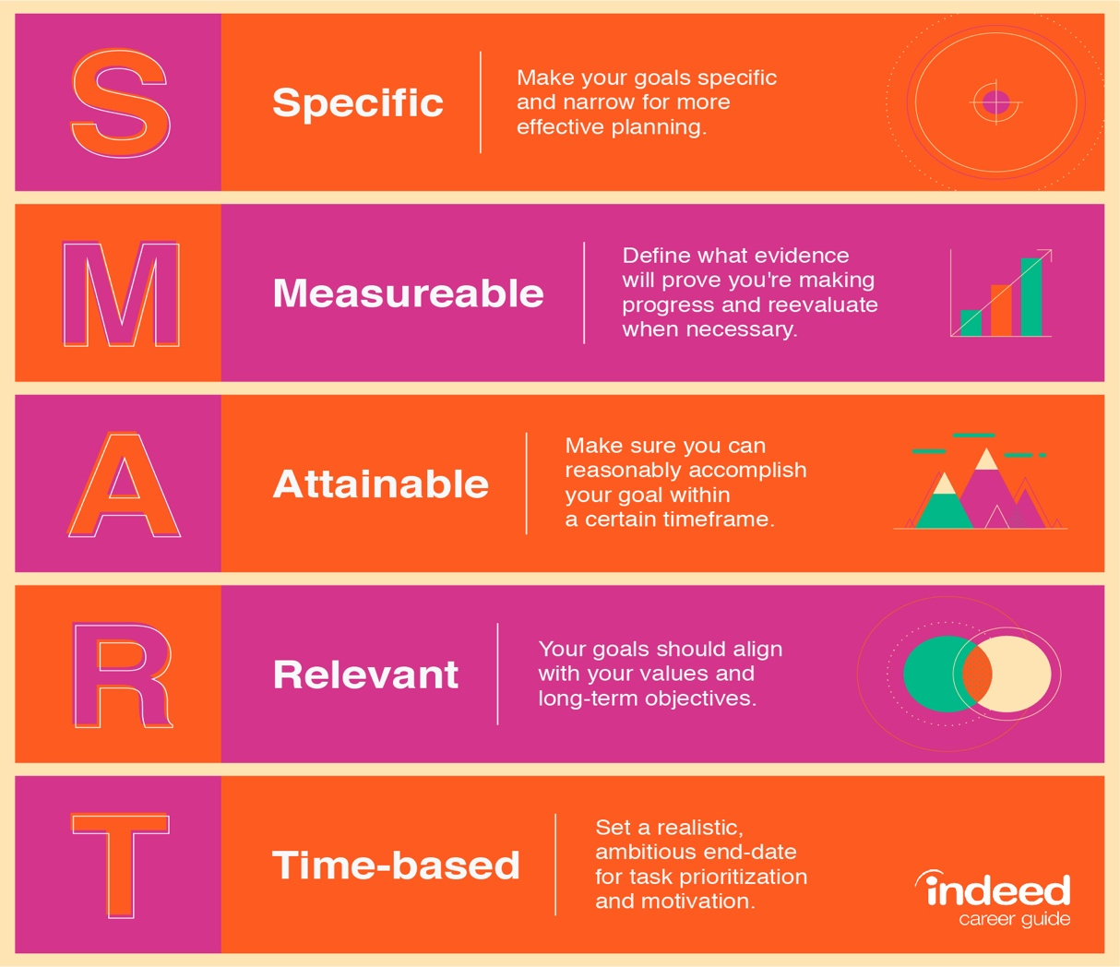

Short / medium term plan (3 Months- 2 years)

As I am currently finishing the course on skills of the workplace, my nearest goals are to enrol on the second year of the undergraduate program to have a business B.A. degree. As I put some effort during this course, I can see that the previous results on all my prior modules will make possible to achieve my first goal. My intention is to apply myself during the remaining two more years whilst remaining motivated, so I can achieve good results which will make the process of selection easier for me once it is time to apply for a Marketing job application. Whilst continuing tudying, I will remain working for Louis Vuitton and facing the responsibilities that my role requires to keep succeeding on what I do.

Long term plan (3- 5 years)

The main objectives of my long-term plan will be to get a degree in Business and be hired at a Marketing company.
If I keep applying to my studies throughout the coming years with determination, I aim to get good grades, which will be the result of the time dedicated to achieving my goals. In the next 5 years I see myself leaving the retail business, and taking on board all the learning acquired to succeed on the next chapter of my professional life.

Conclusion

During this course and particularly on this module, I was able to reflect on myself personally and professionally. Understanding what I am good at and where I need to improve is essential for working on myself and becoming a better professional. This assisted me in determining my objectives and developing an implementation plan that will support me in making the right decisions and identifying what I must do in order to accomplish my goals.

References

- Barclays, (2021). Digital skills for the workplace. Available at: https://digital.wings.uk.barclays/blog/digital-skills-for-work/ (Accessed: 4 September 2020)

- BBC, (N/D). Legislation. Avaialble at: https://www.bbc.co.uk/bitesize/guides/zcs4ng8/revision/4 (Accessed: 4 September 2020)

- Coursera (2022). Why Is Workplace Communication Important? And How to Improve It. Available at: https://www.coursera.org/articles/workplace-communication (Accessed: 4 September 2020)

- Equality and human rights commission (2022). What is the equality act? Available at: https://www.equalityhumanrights.com/en/equality-act-2010/what-equality-act (Accessed: 4 September 2020)

- Indeed, (N/D) Marketing Executive Job Description: Top Duties and Qualifications. Available at: https://uk.indeed.com/hire/job-description/marketing-executive?gclid=Cj0KCQjwmdGYBhDRARIsABmSEeM9dqlThBTggsdYCh-pEyClDgLqzC2JEP1gZAkRkqpQgre8OPAXyL0aAjQjEALw_wcB&hl=en&aceid=&co=GB (Accessed: 4 September 2020)

- Kolb, D.A. (1984). Experiential learning: experience as the source of learning and development. Englewood Cliffs, NJ: Prentice Hall.

- Krakoff, S. (N/D) What skills do you need for marketing in 2020?. Champlain college. Available at: https://online.champlain.edu/blog/what-skills-do-you-need-for-marketing#:~:text=At%20its%20core%2C%20marketing%20is,your%20work%20as%20a%20marketer. (Accessed: 4 September 2020)

- Kurt, S. (2020) Kolb’s Experiential Learning Theory & Learning Styles. Educational technology. Available at: https://educationaltechnology.net/kolbs-experiential-learning-theory-learning-styles/ (Accessed: 4 September 2020)
- Norther Illinois university (2012). Role playing. Available at: https://www.niu.edu/citl/resources/guides/instructional-guide/role-playing.shtml (Accessed: 4 September 2020)

- Target Jobs. Marketing executive: Job description. Available at: https://targetjobs.co.uk/careers-advice/job-descriptions/marketing-executive-job-description (Accessed: 4 September 2020)

- UK Government, (N/D). Data protection. Available at: https://www.gov.uk/data-protection. (Accessed: 4 September 2020)

- UK Government (N/D) Employment status. Available at: https://www.gov.uk/employment-status/worker (Accessed: 4 September 2020)

Appendix:

Questions asked in the Role play:

- Tell me about yourself
- Why do you think you are a good candidate for the role?
- Tell me one time that you went beyond your job description.
- Tell me one time that you turned a negative into a positive situation.
- Why are you leaving your current job?

- Additional questions from the interviewee: How long would it take to get an answer ?

Job application form

Application for Marketing executive
Your details

Name: Raul Torres Dominguez

Education and training
Please give details:

-Certificate of Higher Education Skills for the Workplace – University of Wales Trinity Saint David, London Campus

-Spanish LOE Bachillerato (equivalent GCSE) (September 2004 - July 2006)
Pollensa, Mallorca, Spain

Qualifications
Please give details:

-Certificate in Dance Instruction (September 2003 - July 2004)
Orthos Health & Formation
Globally recognised Certificate received with Distinction from this leading Spanish health and fitness organisation.

-Professional Diploma in Dramatic Arts (September 2006 - July 2007)
CEF Drama School, Mallorca, Spain

-Full European driving license

Employment history

Your current or most recent employer

Name of employer: Louis Vuitton

Job title: Client Advisor

Length of time with employer: From February 2022 - Present

Duties:

- Opening duties including: opening cashiers, making sure the visual merchandise is up to the standards, making sure the high jewellery pieces are on display and secured.

- Assisting daily briefing to ensure a smooth operation throughout the day.

- Revising Clients requests and act accordingly to achieve the best client satisfaction, including preparing appointments that I might have with VIC Clients.

- Assisting Harrods associates regarding Louis Vuitton requests their clients might have.

- Dealing with returns and complaints.

- Assisting new starters with their induction and guidance on company policies and procedures.

- Closing duties including: Cashing up, Locking cages, Leaving the shop as per standard for the next day

Previous employers
Please tell us about other jobs you have done and about the skills you used or learned in those jobs.

Fendi – Client Advisor, Harrods, London 2020 - 2022

- First point of contact for all team members, when engaging with client style requests

- Fendi Ready to wear specialist and Styling ambassador

- Individual elevated client experience, focused on 360 lifestyle approach

- Proactive clientele engagement, providing exceptional customer service experience demonstrating an excellent product knowledge.

- Meeting and achieving KPIs, exceeding targets and expectations by remaining motivated

May Fair Hotel, Front of house Supervisor, London 2016 – 2020

- Managing a team of over 25 people

- Being a property key holder

- Writing hand over reports and coordinating follow up actions with senior management

- Money management, including counting up and reporting

- Mediating customer complaints

- Taking ownership of issues and coordinating with relevant parties to ensure that they are resolved promptly with minimal impact to the business, often under pressure

Supporting statement
Please tell us why you applied for this job and why you think you are the best person for the job.

A job in marketing is something that interests me; it's exciting and stimulating and packed with creativity. I believe that this is a fast-growing industry that is highly competitive; but I am guided by my resilience to achieve my dreams, and these encouraged me to aim for higher academic achievements.
The marketing profession requires individuals with good interpersonal skills, who are dedicated, quick thinking, robust, diplomatic, articulate and have a competitive flare, all of which are skills and attributes that I recognise in myself.
This role appeals to me because it is arguably the most invigorating and vital department of this business with a responsibility to initiate new challenges and opportunities.
Since I moved to London from Palma de Mallorca, my main objective was to keep improving my life, so I took as a priority to work hard to professionally achieve my goals. During this time and after the graduation at university of Wales I acquired the necessary skills that I need for the role. I am A quick learner who is flexible and able to adapt easily to any new role, task, or situation with an excellent written and oral communication skills in both English and Spanish. I am able to quickly build rapport with colleagues, customers, and members of the public. In addition, I possess great problem-solving skills and I can efficiently make decisions when under pressure.

Right to work in the UK
Do you need a work permit to work in the UK? Yes

Declaration
I confirm that to the best of my knowledge the information I have provided on this form is correct and I accept that providing deliberately false information could result in my dismissal.

Name: Raul Torres

