
Student Name : Shraddhaben Sanjaykumar
Sharma

Student Id: 2539611

Master of Business Administration (MBA)

Module Name : Marketing Management

Module code : LCMB7024

Table of Contents
Introduction 3
Task 1: Marketing Environment Analysis 3
1.1 Natural Environment as a Strategic Marketing Driver for BHP 3
1.2 Technological Environment as an Enabler of BHP's Low-Carbon Transition 5
Critical Link Between the Two Environmental Actors 7
Task 2: Strategic Growth and Competitive Positioning 7
2.1 Strategic Growth Approach Using the Ansoff Matrix 7
2.2 Achieving Competitive Advantage During the Low-Carbon Transition 8
2.3 Strategic Recommendations 9
Transition to Conclusion 10
Conclusion 10
Task 3: Critical Reflection on AI Usage 10
a. Tool Disclosure 10
b. Critical Evaluation of AI Output 11
c. Contribution Analysis 11
d. Ethical and Professional Reflection 11
References 13

List of tables:
Table 1: Critical Analysis of the Natural Environment’s Influence on BHP 5
Table 2: Critical Analysis of the Technological Environment Influencing BHP 7
Table 3: Evaluation of Ansoff Matrix Options for BHP 9

List of figures:
Figure 1: External Natural Environment Pressures Influencing BHP's Transition to Lower-Carbon Products 6
Figure 2: Technology-Enabled Low-Carbon Value Chain for BHP 8

Introduction
The worldwide mining sector is moving towards the less-carbon production process as governments, investors and customers are demanding more sustainable mining of the resources. Being a giant mining company, BHP has to cut down on the emissions without affecting their competitiveness and decarbonisation of the downstream industries like steelmaking. This report evaluates the Natural and Technological marketing environments changing BHP low-carbon transition in the framework developed by Kotler et al. It analyses their contribution to strategy, market positioning and sustainability projects and suggests an Ansoff Matrix growth strategy to enhance the competitive advantage and business model of low carbon of BHP.

Task 1: Marketing Environment Analysis

1.1 Natural Environment as a Strategic Marketing Driver for BHP
A key external factor that influences the worldwide mining industry is the natural environment (Amoah and Eweje, 2023). The environment concerns, the way of customer expectations, investor choice and regulations and corporate reputation accordingly affect the factors by which Kotler et al. determine shifts in the marketing environment. In the case of BHP, climate change and the shift to net-zero emissions demand company repositioning of its portfolio and value proposition focused on sustainability.
Although the direct emissions of BHP are not that high, the production of downstream steel causes the largest amounts of these emissions. Therefore, suppliers are more often being brought to bear by customers to aid in decarbonisation using less-carbon materials, invention and open environmental reporting. Sustainability has thus emerged as a parameter in business-to-business marketing and long-term partnerships.
The transition to low-carbon also provides great growth prospects. Increased demand on copper and nickel is growing due to increased investment in renewable energy, electric vehicles and energy storage (Schönfisch, Dasgupta and Wanner, 2024). BHP has been diversified to these commodities giving an indication that, instead of merely establishing compliance costs, environmental change may be used to reposition the market in the long term and grow.
Environmental pressures are however also a challenge. Risks and threats associated with climate conditions like lack of water; loss of species and hostile weather make operations continuity uncertain and higher in cost. Meanwhile, increased scrutiny by the investors, governments and other stakeholders endears quantifiable environmental performance important. The introduction of environmental stewardship in the marketing strategically is hence important as it helps in preserving stakeholder confidence, corporate legitimacy and competitive advantage in the long term.
Table 1: Critical Analysis of the Natural Environment’s Influence on BHP
Environmental factor | Strategic opportunity | Strategic challenge | Marketing implication
Global decarbonisation | Higher demand for copper and nickel | Costly portfolio transformation | Position BHP as a net-zero enabler
Climate change | Growth in clean-energy minerals | Weather and water risks | Promote measurable sustainability outcomes
Sustainability expectations | Stronger ESG reputation | Greater stakeholder scrutiny | Increase transparent sustainability communication
Circular economy | Resource recovery innovation | Higher implementation costs | Differentiate through responsible resource management

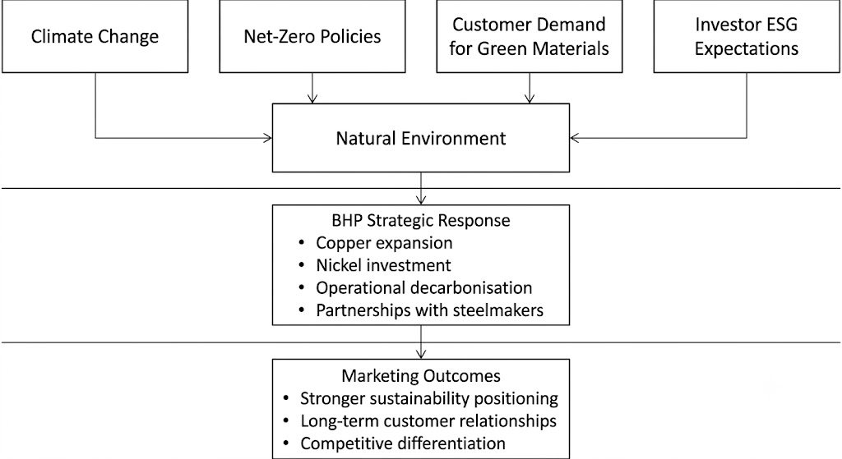
Figure 1: External Natural Environment Pressures Influencing BHP's Transition to Lower-Carbon Products
Source: Self-created
Figure 1 illustrates how environmental pressures influence BHP's strategic marketing decisions and transition towards lower-carbon products.

1.2 Technological Environment as an Enabler of BHP's Low-Carbon Transition
In the Kotler et al framework of marketing environment, technological environment is one of the primary external driving forces affecting competitiveness by providing new capabilities, changing production and affecting customer value. To BHP, technological innovation is critical in terms of ensuring the attainment of decarbonisation agenda and satisfaction of governments, investors and industrial customers on the sustainability aspects.
Some of the critical technological advancements lead to hydrogen-direct reduced iron (DRI), electric arc furnaces (EAFs), carbon capture, utilisation and storage (CCUS) and renewable-powered mining (Dhurandhar, 2025). Though BHP is a mining company, it works along with steel manufacturers to commercialise these technologies since a majority of pollution associated to its iron ore takes place in the downstream processing. This is an indicator of a change towards value creation through collaboration and enhanced relations with customers.
Another way in which technology enhances the operations of BHP is that it automates, uses artificial intelligence, digital twins and real-time environmental monitoring. Self-driven machinery, predictive maintenance, and data-driven optimisation decrease fuel consumption, waste and energy usage, and offer objective demonstration of sustainability performance (Ejaz, and Bakhsh, 2023). These features enhance credibility of ESG and distinguish BHP among the business-to-business markets.
Other effects of rapid innovation are that it is a higher risk of technological obsolescence and competitive imitation. Hence as long as BHP does manage to align innovation with matters of customer needs, strategic alliances and the long-term marketing goals, technology offers a lot of opportunity.
Table 2: Critical Analysis of the Technological Environment Influencing BHP
Technological development | Strategic opportunity | Strategic challenge | Marketing implication
Hydrogen-based steelmaking | Supports demand for premium iron ore | Uncertain commercial scalability | Position BHP as a sustainability partner
AI and automation | Improve efficiency and reduce emissions | High investment and reskilling costs | Showcase innovation leadership
Carbon capture (CCUS) | Lower-carbon production | High costs and limited deployment | Reinforce decarbonisation commitment
Digital ESG reporting | Improve transparency | Cybersecurity and data risks | Build trust through credible reporting

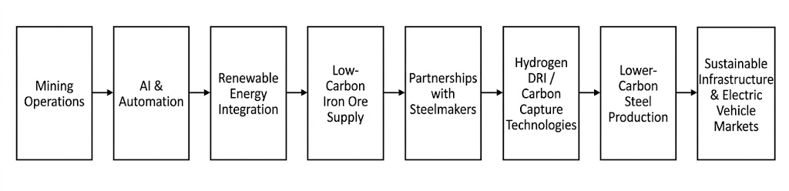
Figure 2: Technology-Enabled Low-Carbon Value Chain for BHP
Source: Self-created
Figure 2 illustrates how technological innovation supports BHP's transition towards lower-carbon products while creating value throughout the industrial supply chain.

Critical Link Between the Two Environmental Actors
A combination of the natural and technological environments creates a strategy of low-carbon in BHP. Technology facilitates practical solutions to environmental pressures which provide the need to change (Peláez et al., 2023). They combine to ensure that BHP marketing proves to be effective through proving evident sustainability, customer value, stakeholder building trust, supporting long term relationships and providing competitive differentiation through innovation that is in line with the changing environmental expectations.

Task 2: Strategic Growth and Competitive Positioning

2.1 Strategic Growth Approach Using the Ansoff Matrix
As shown in the environmental analysis, BHP is a firm that works in a market that is undergoing a lot of structural change as a result of decarbonisation, technological innovation and growing stakeholder expectations. Based on this, Product Development is the best growth strategy in the Ansoff Matrix as it allows BHP to design lower-carbon products and solutions on value addition to its current industrial customers (Kivrak, 2023). Instead of penetrating new markets, BHP has an opportunity to tap into the relationship that it has had with steel manufacturers, automotive firms and renewable energy sectors as well as augmenting its product range to assist clients with their net-zero goals.
In contrast to market penetration that is aimed at boosting sales on the already existing products, Product Development enables BHP to maintain its competitive edge by innovating. The plan is aligned with the current investments of the company in high-quality iron ore, low-carbon steelmaking alliances and low-carbon iron ore as well as other main minerals like copper and nickel, which have been vital to renewable energy infrastructure and electric cars. Such move is an indicator of evolving customer demand as buying behaviour is shifting towards integrating environmental performance with the conventional variables such as quality, cost and reliability in supply.
Table 3: Evaluation of Ansoff Matrix Options for BHP
Ansoff Strategy | Suitability for BHP | Critical Evaluation
Market Penetration | Low | Limited growth potential as commodity markets is mature and sustainability expectations require innovation rather than increased sales of existing products.
Product Development | High (Recommended) | Enables development of lower-carbon products while strengthening relationships with existing customers and supporting global decarbonisation.
Market Development | Moderate | Offers geographical expansion opportunities but does not directly address the industry's sustainability transition.
Diversification | Low | Higher commercial risk because it requires entering unfamiliar industries beyond BHP's core mining capabilities.

2.2 Achieving Competitive Advantage During the Low-Carbon Transition
Although the Ansoff Matrix helps determine the direction in which the company will grow, sustainable success can only be achieved as BHP achieves competitive advantage. In the Porters Generic Strategies, the most suitable strategy is differentiation since the issue of environmental sustainability has emerged as a key source of value among the industrial customers (Vehbi, Farmanesh and Solati Dehkordi, 2025). There is growing demand among organisations to find suppliers who can help them reduce carbon emissions, and who show clear ESG performance and engage in joint innovation.
The idea of developing products that are more eco-friendly through the integration of lower-carbon products with state-of-the-art technologies can also be utilized by BHP to enhance differentiation (Petronela Cozma et al., 2024). Diverse investments in operations that use renewable energies, artificial intelligence, autonomous mining technologies and collaboration with steel producers allow the company to provide environmental advantages that can hardly be matched by its competitors. These potentials make BHP be seen as strategic sustainability partner and not just a supplier of commodities and it has reinforced customer associations over the long-term and lowers chances of price-based competitions.
Differentiation in itself, however, is not enough, unless it is backed up by quantifiable environmental results. Both customers and investors demand to see indications of emissions reductions and positive management of resources as well as responsible sustainability reporting.

2.3 Strategic Recommendations
As a means of maximising effectiveness of Product Development strategy, BHP would need to focus on three strategic initiatives. To start with, the company must further invest in joint research with steel producers to further commercialize low-carbon steelmaking technologies. These collaborations will empower customer relation and decarbonisation of the industry. Second, as it seeks to enhance the efficiency of its operations, BHP needs to increase its investment in digital technologies, such as artificial intelligence and real-time environmental monitoring, to be able to seek data on sustainable operations that BHP will be able to verify to support its positioning. Lastly, the organisation needs to reinforce the idea of its sustainability-oriented marketing approach by conveying quantifiable environmental performance outcomes via yearly sustainability reports, ESG communications and customer involvement initiatives (Borges, and Grosskopf, 2025). Actual environmental performance will be displayed, which will support competitive differentiation and increase the confidence of the stakeholders.

Transition to Conclusion
Generally, Product Development presents the best strategic direction of BHP since it will respond to the evolving market trends, rising technology and growing need of low carbon products (Lorenc et al., 2023). Combined with a differentiation strategy, with an innovation-driven approach and transparent sustainability performance, this strategy will help BHP gain long-term competitive advantage, alongside the global shift towards a low-carbon economy.

Conclusion
The interaction between the technological and natural marketing environments has led to the shift done by BHP to have a lower-carbon business model. Market demand is changed under the impacts of environmental pressures, and technology allows sustainable operations and decarbonisation of the customer. Product Development is the most appropriate growth strategy, which BHP can use to provide innovative low-carbon products, building upon the current relationships. Together with sustainable innovation, partnership and transparent reporting, this is a better way to increase the stakeholder trust, resilience and long-term competitive advantage of a carbon-conscious mining industry.

Task 3: Critical Reflection on AI Usage

a. Tool Disclosure
Artificial Intelligence (AI) was an auxiliary tool when creating this report as it positively influenced the efficiency of research and academic writing. ChatGPT and Microsoft Copilot were the main tools utilized (Khalifa and Albadawy, 2024). The concepts of marketing were explained with the help of ChatGPT, and it was recommended to use the tool to structure a report and make written texts more readable; Microsoft Copilot helped to summarise the information and find the topically related themes of sustainability and strategic marketing. Only guidance and drafting assistance work of AI was performed and final report was thoroughly scrutinized, revised and polished. The use of AI has been approved based on the guidance of the University on the use of AI responsibly.

b. Critical Evaluation of AI Output
All of the information generated by AI was thoroughly checked to be included in the report (Bandi, Adapa and Kuchi, 2023). The information provided in case of individual companies and the strategies were checked with the help of reputable resources, such as the Principles of Marketing the Annual Report published by BHP, peer articles and publications in reputable organisations, such as the International Energy Agency. There were instances of general statements and statements that were not supported by evidence in some AI responses. These were recognized by following them to original sources and were revised or deleted. This process of verification was to ensure that the report was grounded on valid, reliable and evidence-based information as opposed to unverified AI products.

c. Contribution Analysis
AI was used in the initial information involved in preparing the report; it helped generate ideas, provided the structure of the report and enhanced the academic style of writing (Black and Tomlinson, 2025). The choice of BHP as case organisation, discussion of the Natural and Technological marketing environment actors, discussion of strategic opportunities and challenges, and the recommendation of Product Development as the ideal choice of Ansoff Matrix strategy proposal was however, adopted on my own understanding of assessment insinuations and supporting literature. The critical analysis, conclusions and recommendations that the report formed, thus, represent my personal judgement, other than AI-generated opinions.

d. Ethical and Professional Reflection
There are extensive benefits to the employment of AI, and it enhances efficiency and assists the collection of information, but there are also certain ethical issues associated with AI, such as accuracy, bias and scholarly integrity(Enciso , 2025). Both the blind use of AI and the follow-up of blind recommendation might result in erratic conclusions or ungrounded recommendations. Thus, AI is not to substitute independent thinking but it is an assistant that can help in decision-making. This evaluation has reiterated the essence of assessing the AI-generated content, recognizing their usage openly, and the deployment of critical thinking during the research procedure. Wholesome AI implementation allows scientists and marketers to enjoy the advantages of technological invention without compromising the vision of the academic validity, ethical responsibility and trustworthiness of their work.

References
Amoah, P. and Eweje, G. (2023). Organisational drivers and sustainability implementation in the mining industry: A holistic theoretical framework. Business strategy and the environment. [online] Available at: https://onlinelibrary.wiley.com/doi/abs/10.1002/bse.3438.
Bandi, A., Adapa, P.V.S.R. and Kuchi, Y.E.V.P.K. (2023). The power of generative AI: A review of requirements, models, Input–Output formats, evaluation metrics, and challenges. Future internet, [online] 15(8), p.260. Available at: https://www.mdpi.com/1999-5903/15/8/260.
Black, R.W. and Tomlinson, B. (2025). University students describe how they adopt AI for writing and research in a general education course. Scientific reports, [online] 15(1), pp.1–10. Available at: https://www.nature.com/articles/s41598-025-92937-2.
Borges,, W. and Grosskopf, J. (2025). Sustainability Programs: A Design Guide to Achieving Financial, Social, and Environmental Performance. [online] Available at: https://books.google.com/books?hl=en&lr=&id=7VFOEQAAQBAJ&oi=fnd&pg=PR15&dq=the+organisation+needs+to+reinforce+the+idea+of+its+sustainability-oriented+marketing+approach+by+conveying+quantifiable+environmental+performance+outcomes+via+yearly+sustainability+reports,+ESG+communications+and+customer+involvement+initiatives&ots=2DAQ9C8k6X&sig=nNZy88XRLL5RMJqNE2cwQ8bOaGI.
Dhurandhar, Dr.A.P. (2025). High-Grade ore in a decarbonising world: Simandou, green steel and the strategic repositioning of India’s iron ore sector. International journal of Research and scientific innovation, [online] 12(11), pp.1605–1616. Available at: https://www.researchgate.net/profile/Ashokaditya-Dhurandhar/publication/398880037_High-Grade_Ore_in_a_Decarbonising_World_Simandou_Green_Steel_and_the_Strategic_Repositioning_of_India’s_Iron_Ore_Sector/links/694bd0219aa6b4649dc4292d/High-Grade-Ore-in-a-Decarbonising-World-Simandou-Green-Steel-and-the-Strategic-Repositioning-of-Indias-Iron-Ore-Sector.pdf.
Ejaz, , U. and Bakhsh, M. (2023). AI-driven predictive maintenance in autonomous public transit systems for smart cities. [online] researchgate.net. Available at: https://www.researchgate.net/profile/Umair-Ejaz-3/publication/394069296_AI-driven_predictive_maintenance_in_autonomous_public_transit_systems_for_smart_cities/links/6887b0f300a2407910a4cfb7/AI-driven-predictive-maintenance-in-autonomous-public-transit-systems-for-smart-cities.pdf.
Enciso , R. (2025). Artificial intelligence in research: Enhancing efficiency or compromising integrity a systematic review. [online] researchgate.net. Available at: https://www.researchgate.net/profile/Rey-Enciso/publication/389747542_ARTIFICIAL_INTELLIGENCE_IN_RESEARCH_ENHANCING_EFFICIENCY_OR_COMPROMISING_INTEGRITY_A_SYSTEMATIC_REVIEW/links/67d19851e62c604a0dd73e4d/ARTIFICIAL-INTELLIGENCE-IN-RESEARCH-ENHANCING-EFFICIENCY-OR-COMPROMISING-INTEGRITY-A-SYSTEMATIC-REVIEW.pdf.
Khalifa, M. and Albadawy, M. (2024). Using artificial intelligence in Academic writing and research: An essential productivity tool. Computer methods and programs in Biomedicine update, [online] 5(1), p.100145. Available at: https://www.sciencedirect.com/science/article/pii/S2666990024000120.
Kivrak, U. (2023). Is There a Green Future for the Transformer Industry. [online] Academia.edu. Available at: https://www.academia.edu/download/114028781/Is_There_a_Green_Future_for_the_Transformer_Industry._final.pdf.
Lorenc, S., Leśniak, T., Kustra, A. and Sierpińska, M. (2023). Evolution of business models of Mining and energy sector companies according to Current market trends. Energies, [online] 16(13), p.5212. Available at: https://www.mdpi.com/1996-1073/16/13/5212.
Peláez, R.M., Brust, A.O., Rivera, S., Félix, V.G., Ostos, R., Brito, H., Félix, R.A. and Mena, L.J. (2023). Role of Digital transformation for achieving sustainability: Mediated role of Stakeholders, key capabilities, and technology. Sustainability, [online] 15(14), p.11221. Available at: https://www.mdpi.com/2071-1050/15/14/11221.
Petronela Cozma, Bețianu, C., Raluca-Maria Hlihor, Isabela Maria Simion and Gavrilescu, M. (2024). Bio-Recovery of metals through biomining within Circularity-Based solutions. Processes, [online] 12(9), pp.1793–1793. Available at: https://www.mdpi.com/2227-9717/12/9/1793.
Schönfisch, M., Dasgupta, A. and Wanner, B. (2024). Projected global demand for Energy storage. The materials research society series, [online] pp.29–52. Available at: https://link.springer.com/chapter/10.1007/978-3-031-48359-2_3.
Vehbi, A., Farmanesh, P. and Solati Dehkordi, N. (2025). Nexus amid green marketing, green business strategy, and competitive business among the fashion industry: Does environmental turbulence matter? Sustainability, [online] 17(5), p.1769. Available at: https://www.mdpi.com/2071-1050/17/5/1769.

