MSc Computer Networks and Cyber Security

Construct and Mitigate Security Vulnerabilities and Weaknesses.

Assignment ACCA7019

By
Julie Millard P150865

Lecturer: Dr Carlene Campbell

Abstract
With many organisations now using the internet for day-to-day business operations, and more people working from home, cyber-attacks are on the increase. It is only realistic to expect companies to be more aware of necessary security requirements that are needed to counteract such attacks.
Each successful cyber-attack or security breach is detrimental to the organisation it was aimed at not only financially, where there is a likelihood of legal repercussions, but also with the organisation’s reputation. Once a reputation has been sullied, it can be extremely difficult to restore.
This report takes an overview of what network security is. It examines how a network is set-up from a security point-of-view and outlines the types of attacks that are known to plague organisations.
Included is a blueprint of the network design to be implemented by a Network Security Engineer, and a breakdown of the hardware required and the hardware specifications.
The report introduces penetration testers, what they are and how they work, and suggests penetration tests to implement on an ongoing basis.
Finally, there is a Gannt chart for the time required to set-up a secure network and invoice for the services.

Table of Contents
Table of Figures 5
1 Introduction 6
2 Part 1 - Describe the Security Threats Facing Modern Network Infrastructures. 6
2.1 Network Security 6
2.2 Types of Threats and Attacks 7
2.2.1 Malware 7
2.2.2 Phishing 7
2.2.3 Man-in-the-Middle Attack 7
2.2.4 Denial of Service Attack 7
2.2.5 SQL Injection 8
2.2.6 Zero-day Exploit 8
2.2.7 DNS Tunneling 8
2.3 Tools and Procedures 8
2.3.1 Employee Training 8
2.3.2 Update Software 8
2.3.3 Firewall 8
2.3.4 Device Hardening 10
2.4 Securing a Network 12
2.4.1 Privilege level 13
2.5 Countering Cyber-Attacks 13
2.6 Implementing Cisco Network Foundation Protection (NFP) 13
2.7 Endpoint Vulnerabilities 14
2.8 Security Policy 14
2.9 Testing Network Security 15
2.10 Layer 2 Security 15
2.11 Network-Based Intrusion Detection 17
2.12 Signature Attributes 17
2.13 Virtual Private Network (VPN) 17
2.14 IPSec VPN 17
2.15 Cisco ASA 19
3 Part Two - Propose a Secure Network Infrastructure Based on a Given Scenario. 25
4 Project Proposal 25
5 Outline of Solution 25
5.1 Resiliency 25
5.2 Flexibility 25
6 Description 25
6.1 Security 26
7 Risks 27
8 Recommended Security Test 27
9 Conclusion 28
Bibliography 29
Appendix 32
1 Blueprint of Network 32
2 ASA 5505 Firewall 33
3 Cisco C3650 24 Port Multilayer Switch 34
4 Gannt Chart 36

Table of Figures
Figure 1: ACL 9
Figure 2: Zone-Based Policy Firewall 10
Figure 3: AAA Authentication for SSH 11
Figure 4: TACACS+ Server 11
Figure 5: Radius Authentication 12
Figure 6: Radius Server 12
Figure 7: Privilege Level Example [16] 13
Figure 8: IPSec Tunnel Commands Part 1 [29] 18
Figure 9: IPSec Tunnel Commands Part 2 [29] 18
Figure 10: ASA Wizard [31] 19
Figure 11: ASA Landing Page [31] 19
Figure 12: ASA VPN Protocols [31] 20
Figure 13: ASA Image Being Added [31] 20
Figure 14: ASA Local Database Selection [31] 21
Figure 15:DHCP Address Pool [31] 21
Figure 16: DNS Address [31] 22
Figure 17: VPN Exempt from NAT [31] 22
Figure 18: Web Launch Connection [31] 23
Figure 19: Commands Preview Page [31] 23
Figure 20: Landing Page Updated [31] 24
Figure 21: Blueprint A2Z Technologies 32
Figure 22: Server Room Cluster 32
Figure 23: DMZ Cluster 33
Figure 24: Cisco ASA 5505 Firewall [30] 33
Figure 25: Cisco ASA 5505 Firewall Specifications[30] 34
Figure 26: Cisco C3650 48 Port Switch [32] 34
Figure 27:Cisco 48 Port Switch Specifications [32] 35

1 Introduction
A2Z Technologies Ltd. is a medium sized business that requires a network infrastructure overhaul to ensure their company has adequate cyber-security protection. They have remote workers that access the company intranet as well as employees that utilise Bring Your Own Technology (BYOT).
Over sixty-eight percent of medium size businesses in the UK are victim of cyber-attacks, according to the Government Website. [1] with over half of this size of businesses being a victim of cyber-attacks it is not without reason to imagine companies wanting to be more proactive in providing security requirements necessary to counteract such attacks.
Part One of this report looks at the vulnerabilities associated with organisation’s networks and ways to mitigate cyber-attacks and/or data breaches, with a brief look at what security means to a network.
Part Two of this report covers a scenario for A2Z Technologies Ltd. to have a Security Consultant draw up a network blueprint for their organisation. It covers the timescale, cost and security required for the network, along with information on network cyber-attacks. Furthermore, there are penetration tests outlined, that the author considers pertinent to network security. A Gannt chart and invoice is also incorporated in this part of the report.

2 Part 1 - Describe the Security Threats Facing Modern Network Infrastructures.
In this section the report will cover network security, types of attacks that are used against networks, and how to mitigate these types of attacks.

2.1 Network Security
Network security can be described as actions used to protect your network from infiltration. It is made up of many different types of defence and includes controls and policies to be followed to ensure the integrity and usability is protected.
One way this is achieved is by ensuring only individuals that are authorised have access to the network. [2]
Network security encompasses both software and hardware to defend against attacks from a range of threats and works to stop malicious actors from executing threats or exploits.
Where a network connects to internet, the edge, multiple defence layers are combined to ensure the best protection for the network. It is intended that the defences will stop exploits and threats from entering, and if infiltration does occur then the defences should help minimise the spread of the infection or attack. [3]
Beyond prevention, network security employs detection techniques to review file behaviour and identify patterns of malicious intent in traffic that is encrypted.
Securing the network is essential in protecting organisations both large and small and ultimately is necessary to protect against infiltration which could lead to personal information being accessed or even proprietary information being seized. Stealing information is not the only threat. Once a network is compromised information can be altered or even destroyed.
By blocking sites that are considered risky, filtering incoming emails for phishing attacks, spam, or even emails with malicious attachments can aid in reducing the risk of a cyber-attack. [4]

2.2 Types of Threats and Attacks
There are numerous threats and attacks that could compromise an organisation’s security. According to Cisco [5] the most common cyber-attacks are:

2.2.1 Malware
Malware is a term used for malicious software that has been designed specifically to cause harm to, or exploit devices, networks or services. [5], [6] Malware is usually activated by clicking on something. It could be an attachment in an e-mail, a link to an often-used website, sometimes just opening and email will trigger malware.
Once active, the malware installs unwanted software onto the system which in turn can spy, collecting information to be extracted at a later date, activate dangerous or harmful software which might modify, destroy, or render the network inoperable, or even hold the company to ransom by encrypting vital information.
Malware can be broken down into sub-categories such as: Virus; Worms; Trojan; Adware; Scareware; Ransomware; Fileless Malware; and Spyware.

2.2.2 Phishing
Phishing attacks are a social engineering attack which uses fraudulent communications that appear to be from trustworthy sources. They are designed to entice victims into disclosing personal data. This could be information such as date of birth, pet name, mother’s maiden name, national/social insurance number etc., login-in information, even credit card information.
This is achieved in many ways. By using emotions such as urgency, fear, curiosity or greed, victims are duped into opening attachments, or clicking on links that take them to false websites set-up to capture information.
Types of phishing can be further categorised as: Email Phishing; Spear Phishing; Microsoft 365 Phishing; Business Email Compromise (BEC); Whaling; Social Media Phish; Vishing or Voice Phishing; Malware Phishing; Smishing; Pharming; and Clone Phishing. [7]

2.2.3 Man-in-the-Middle Attack
A Man-in-the-Middle attack (MitM), as the name suggests is an attack that takes place between two parties. The attacker inserts themselves between the conversation, hijacking the flow of connectivity. Once this has been achieved the hijacker can alter the data being transmitted and received, steal information, or even redirect the transmission altogether.
MitM attacks include: Address Resolution Protocol (ARP) Poisoning; Session Hijacking; Wi-Fi Eavesdropping; Hypertext Transfer Protocol Secure (HTTPS) and Domain Name System (DNS) Cache poisoning. [5]

2.2.4 Denial of Service Attack
A Denial of Service (DoS) attack works by flooding the network or computer with requests/traffic. When this happens, legitimate users are unable to connect or access the network which is denying service.
Flooding takes two forms. Internet Control Message Protocol (ICMP) flooding and Synchronise acknowledge ((SYN-ACK) shortened to SYN) flooding. ICMP flooding or ping flood sends spoofed packets (internet protocol (IP) packets that contain modified IP source addresses intended to obfuscate the original identity) to every computer in the network. While a SYN flood exploits the Transmission Control Protocol (TCP) by initiating the TCP connection sequence on an open port. Once initiated, the sequence is not completed which leaves the port occupied and unable to process any other request. This is repeated until the ports are overwhelmed and shut down. [8]
Similar to a DoS attack is the Distributed Denial of Service (DDoS) attack which is conducted the same way as a DoS attack, but the attackers use multiple compromised computers to launch the attack.

2.2.5 SQL Injection
Structured Query Language (SQL) injection is a cyber-attack that utilises malicious code in the form of an SQL query through the input data to the application from the client. When successful, this attack allows the database to be modified. This modification can be to alter existing information, delete, or add information. It also allows the database to shut down. [9]

2.2.6 Zero-day Exploit
Whenever a new flaw is exposed, whether it is a network or software vulnerability cyber criminals use this information to carry out an attack on the system before a fix to the problem has been administered. [5]

2.2.7 DNS Tunneling
DNS tunneling uses the DNS protocol to transfer data. This is achieved by encoding data and hiding it inside either the query or response. By Obfuscating the information in this way, attackers are able to send information from an external server through the tunnel to the compromised device and conversely exfiltrate data to the external server. [10]

2.3 Tools and Procedures
To assuage malware and cyber-attacks against networks, a variety of tools and procedures can be implemented.

2.3.1 Employee Training
When it comes to any cyber-attack, “people are the weakest link” [11] according to Kevin Mitnick who is said to be the world’s number one hacker. [12] Educating employees to the many types of cyber-security threats, how they can be recognised and the correct company procedures to follow if one is identified, is a necessary and ongoing undertaking for security.

2.3.2 Update Software
Keeping software updated with new patches to repair any flaws that have been discovered is a fundamental procedure for organisations. (2.2.6) [13]

2.3.3 Firewall
Using a firewall that has been configured with access control lists (ACLs) is another way to protect a network. They are a list of statements that either permit or deny access and must be set out sequentially to work. Standard ACLs utilise the source IP address for filtering while extended ACLs will filter using both source and destination information. [13], [14] Depicted in Fig 1 is an ACL to block remote access to the routers except for the PC using IP address 192.168.3.1
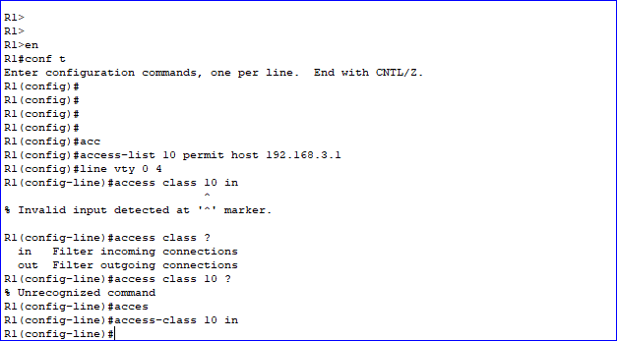
Figure 1: ACL
Zone-Based Policy Firewall (ZPF) is illustrated in Fig 2. This example will permit the internal hosts to access all the external resources, while denying external host access to any of the internal resources. An extended ACL 101 will permit all IP protocols from the inside network to any destination.
The class map type inspect command set up with a match all option is used to create a class map named IN-CLASS-MAP. There is also a match group command initiated that will match the ACL 101.
Next the policy type inspect command is used to create the policy IN-2-OUT-PMAP. The policy map references the class map previously created and specifies how the action of inspection for this map will work. The zone pair security command was executed creating the zone-pair to identify the source and destination, the in and out. The security policy for this is added. The zone member security command is used in the interface configuration mode to outline the interior and exterior zones.
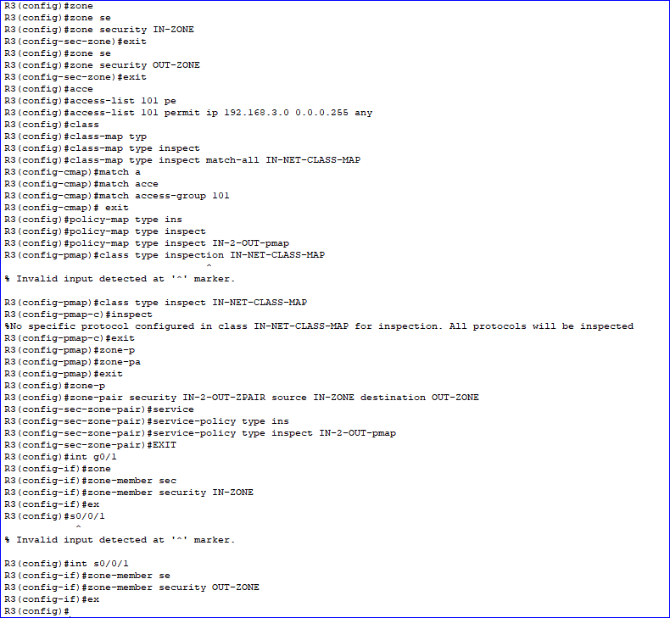
Figure 2: Zone-Based Policy Firewall

2.3.4 Device Hardening
Device hardening refers to different techniques used to help secure a network. They include using Authentication, Authorisation and Accounting (AAA), updating all firmware and patches (2.3.3), ensuring all unnecessary services, ports and protocols are disabled, implement a policy for password strength. Using access control lists to permit or deny access, configure secure protocols on all devices, use encryption where possible, and monitor all logs. [15] Fig 3 depicts AAA authentication on a router.
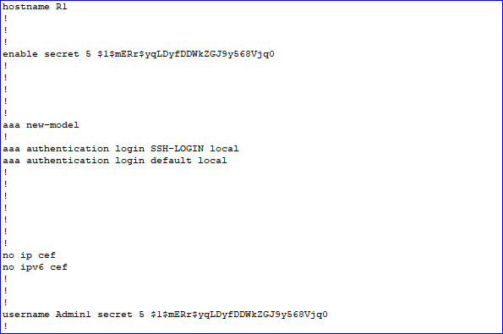
Figure 3: AAA Authentication for SSH
Fig 4 is an example of AAA service on a TACACS+ Server.
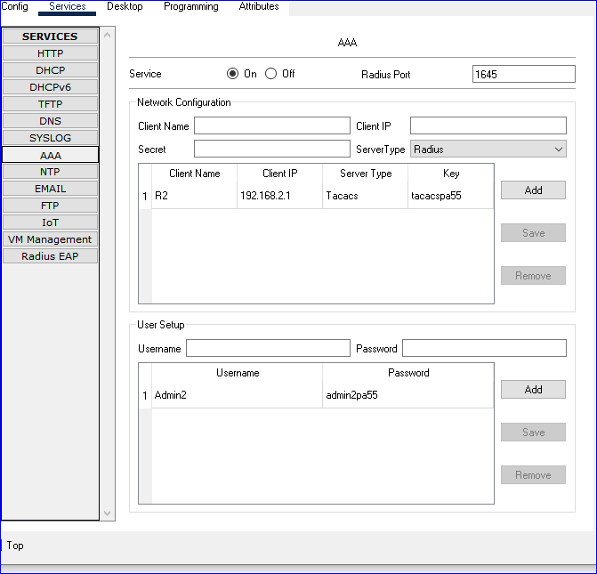
Figure 4: TACACS+ Server
Fig 5 depicts AAA authentication using Radius on a router.
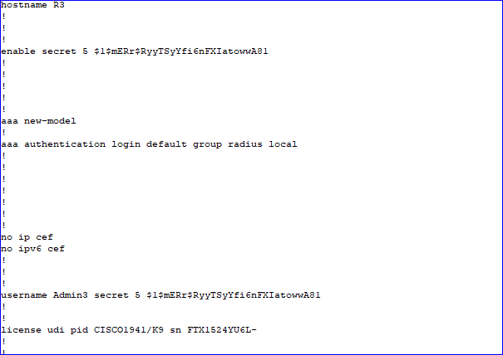
Figure 5: Radius Authentication
Fig 6 is an example of AAA authentication set up on a Radius server.
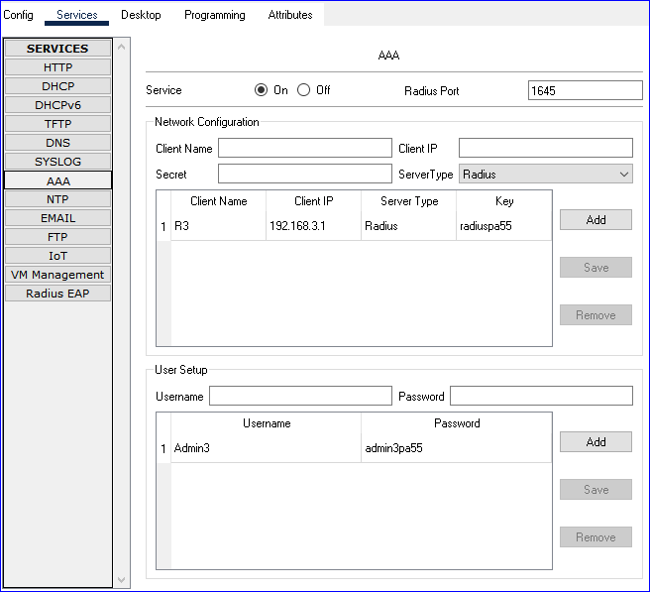
Figure 6: Radius Server

2.4 Securing a Network
Device hardening (2.3.5) also covers the fundamental principles for network security. Ensuring the network is confidential, has integrity and has availability depends on keeping abreast of all new patches, while implementing strong policies for passwords, such as minimum length, using upper-, and lower-case characters, and special characters. Regularly changing passwords is also recommended as this reduces the risk of a successful brute-force attack by limiting the time available for the attack to work. Network security is necessary from the outside in, and the inside out. People are the most vulnerable part of any security. [11] Therefore as mentioned in (2.3.1) ongoing training for employees is essential.

2.4.1 Privilege level
Controlling who can access what information is also very important. Using privilege levels is one way of controlling this. Level 1 is the lowest level and level 15 is the highest. So, setting up a privilege level for example could include support being allowed at level 5, Jr Admin to be given a level 10 and the Sr Admin to have the highest level of 15. Fig 7 depicts the configuration for this set-up.
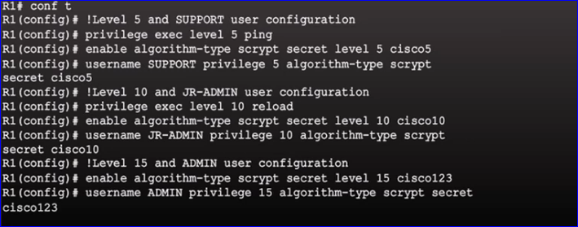
Figure 7: Privilege Level Example [16]

2.5 Countering Cyber-Attacks
One of the best ways to mitigate the effect of an attack is to have multiple back-ups of the organisation’s essential files. These are ideally kept in a separate location such as in a cloud service, and/or offline. They should be tested regularly to ensure they work as expected and to confirm the process works adequately. [13]
When protecting against the spread of viruses, trojan horses or worms, the implementation of ant-virus software is the first defence. There are four phases in mitigating the effects once infected.
Firstly containment, finding out who is infected and how far the infection has spread and then separating the two.
Quarantine is the second step, once the infected machines are identified they need to be isolated or preferably removed from the network to stop further infection.
The third step is inoculation, this includes scanning the infected systems and patching the vulnerabilities.
Finally, the fourth step is to cleanse the system of all infection, patch any vulnerabilities and re-install corrupted software. [17]

2.6 Implementing Cisco Network Foundation Protection (NFP)
The NFP framework uses several security procedures to ensure switches and routes are secure even when the network is being attacked. The three sections of protection are the management plane, the control plane, and the data plane.
The management plane encompasses the Secure Shell (SSH) and Telnet protocol used for remote access by administrators and Trivial File Transfer Protocol (TFTP) used when transferring files between client and server. The management plane can be secured employing a password and login policy, displaying a legal notice, using HTTPS and SSH for confidentiality of data and ensuring access control based on role. [18], [19]
Control plane consists of traffic used for routing protocols and Address Resolution Protocol (ARP) messages.
The security measures for this level would be to enable routing protocol authentication to stop routing updates that are fraudulent, set up Control Plane Policing (CoPP), a Cisco proprietary feature that allows the user to manage the traffic flowing to the network devices route processor. [18], [19] Using the AutoSecure to control the functions of the management plane as well as the forwarding services and router functions. [18], [19]
Data plane comprises of traffic used by the end user. This includes instances of when a user would browse a website for example. The security used for this would be to create ACLs that control the traffic and users. By creating ACLs, the NFP can diminish spoofing attacks, provide control for the bandwidth used, protect the Control and Management Plane, add port security to limit MAC address spoofing and flooding attacks, protect the DHCP switch and server, use a DHCP snooping table to prevent ARP poisoning and/or spoofing attacks by implementing Dynamic ARP Inspection (DAI). Using the DHCP snooping table can also protect against IP spoofing with the aid of IP Source Guard. [18], [19]

2.7 Endpoint Vulnerabilities
When a device connects to your network it becomes an endpoint. Therefore, every device connected to your network becomes an opportunity for the network to become infected. This could be from an unauthorised download, and email, or even by inserting an infected Universal Serial Bus (USB) stick. Of course, other ways an endpoint can be vulnerable is by missing patch updates or using software with known vulnerabilities. (2.3.3)

2.8 Security Policy
To implement a comprehensive security policy, there are several steps to be covered. The policy needs to be implementable and enforceable, while clearly defining individual’s responsibility. The policy is required to be well documented, effectively distributed and clearly communicated. [20], [21]
Having a policy that is flexible allows for the policy to be sustainable over a prolonged period. The policy should not be dependent on any software or hardware being used as improvements and upgrades are an ongoing process. It should outline how the policy is to be updated and by whom. To ensure usability, a regular review of the policy should be implemented.
Finding out what the company considers to be critical assets, and how best to protect them is one of the goals. This includes the company network.
Employees should be given a description of what is considered to be acceptable use of the assets, what is regarded as permissible use and what is not allowed. This assists in encouraging the employees to protect the company’s information and systems.
The policy should be considered an essential read for all personnel that use any of the resources outlined as likely targets. [20], [21]
A Risk Analysis should be conducted to identify what is to be protected and whom it is being protected from. This should ascertain how the protection should be addressed.
Identifying the various possible threats to the company allows for these threats to be counteracted and neutralised while keeping abreast of new threats as they emerge will be an ongoing task.
Employees need to realise how important the security policy is. They should be informed of the damage that can be caused by violating the policy and what the consequences are should the policy be violated. Whether the consequences are considered a firing offence, or even if the offence merits legal action. [20], [21]

2.9 Testing Network Security
To ensure the network security is working, and to identify any weaknesses, the network should be tested. There are many tools and techniques that can be utilised for this process. There are network Intrusion Detection Systems (IDS), which as the name states, detects intrusions. It does this by monitoring and examining a copy of the network traffic for suspicious activity. Then there are Intrusion Prevention Systems (IPS). This system examines live data and stops malicious traffic from entering the network. [22]
Penetration testing is another way to test the network. There are different levels of testing from White Hat which is where the tester has pertinent information about the network and the company, there is Grey Hat, this penetration tester has less information about the network and company, and the Black Hat tester which has no previous information about the system or company.
The testers are given scope of what they are testing for and have limits to what attacks, if any they can perform. If they should penetrate the network, they have limits to where they can go, even if the opportunity arises for them to explore all parts of the company.
The penetration testers can use tools such as Ettercap, Nmap, Nessus, Wireshark, Burp Suite, Hydra, Kali Linux, Metasploit to scan networks, find vulnerabilities and then use a variety of exploits that are freely available, or even create their own exploit to test the system. [23]

2.10 Layer 2 Security
There are numerous layer 2 attacks, the most common are:
VLAN hopping which occurs on virtual networks where an attacker takes control of the VLAN by exploiting the Dynamic Trunk Protocol (DTP) and spoofing the switch. The second method is called Double Tagging, and this is achieved by adding an extra tag to the VLAN the attacker is attached to. For example, if the attacker is attached to the native VLAN the tag would have the native VLAN tag and the gate of the target.
To protect against this type of attack any unused port should be disabled and put into an unused VLAN. Ensure auto-trunking is disabled, on all facing ports, confirm the trunking on all infrastructure port are explicitly configured. Make the Native VLAN use the dot1q tag, and all the trunk ports should use dedicated VLAN ID.
DHCP starving and DHCP spoofing attacks are also well-known layer 2 attacks. DHCP starving is an attack that occurs when the request for bogus DHCP addresses floods the server. The server responds to these requests depleting the server IP address range and therefore genuine requests cannot obtain an IP address. This also opens the way for a rogue DHCP server to be created.
DHCP spoofing uses the rogue server to answer the requests for genuine IP addresses and any other configuration settings such as Transmission Control Protocol/Internet Protocol (TCP/IP) and replaces the Default Gateway IP Address and the DNS server IP address with the attacker’s addresses. This permits MitM attacks to take place. If the attacker were to initiate a bogus DNS server as well, then they could potentially replicate a trusted website from where they could perform phishing attacks.
Cisco has a feature called DHCP Snooping which when implemented would validate messages the DHCP received and filter any invalid messages or messages from unreputable sources. [24]
ARP poisoning is a MitM attack that takes place when an attacker’s MAC address is linked with a legitimate IP address. Once this has taken place the attacker receives all the information that should have gone to the original IP address. As this is a MitM attack the information travelling from A to B can be re-routed, altered, or destroyed.
DAI is used to counteract ARP poisoning on DHCP devices by intercepting the requests and responses and using DHCP snooping. If you do not have a DHCP device but would still like to use the DAI, then the table would require a static entry. [24]
Spanning Tree Protocol (STP) manipulation attacks occur when a root bridge is compromised. This is achieved by forcing an STP recalculation. As the hacker system has been calculated as the lowest bridge priority, it now becomes the root bridge. This can cause a DoS attack because of the interruption in service as the STP recalculation takes place, and as the attacker can keep forcing STP recalculations, the DoS is repeated.
Using PortFast on end-user ports that have a host attached is one way to protect against STP attacks as it changes the state of the port from blocking to forwarding.
Root Guard keeps ports in a non-designated state therefore disallowing it from becoming the root bridge.
Loop Guard stops ports from becoming designated ports should a failure lead to a unidirectional link.
Bridge Protocol Data Units (BPDU) Guard used on ports that are PortFast enabled is used to restrict a port should it receive a BPDU.
Content Addressable Memory (CAM) TABLE Attacks, also known as Media Access Control (MAC) address overflow attacks occur when the MAC table is filled before old entries expire. This is achieved by flooding the switch with MAC source addresses that are fake.
Once the table is full, the switch starts routing incoming traffic to all the ports without referring to the CAM table, it acts in the same way a hub does. This allows an attacker to capture the frames being sent from host A to host B within a local VLAN and perform MitM attacks.
To stop this from happening Port Security needs to be configured on the interface configuration level of static access ports. [25]

2.11 Network-Based Intrusion Detection
As mentioned in (2.9) network-based IDS works by analyzing a copy, not live traffic of a network. The traffic is compared to known attacks held in a library, and if one is identified, or if any irregular activities are detected, an alert is initiated and passed to the administrator.

2.12 Signature Attributes
Signatures are rules that are used by IDS and IPS to identify anomalous, invasive, or malicious activities. This is accomplished by comparing the incoming traffic to knows signatures, or characteristics of known viruses, worms, or malicious traffic. Inconsistent activity such as a breech in company policy can also be identified. They have limitations such as if a known virus has been altered, then the comparison will fail. [18], [26]

2.13 Virtual Private Network (VPN)
A virtual private network is a secure connection created to traverse the internet. It allows organisations to connect their internal network (intranet) to various sections of the corporation that may be situated in separate geological locations while maintaining a level of security required by company. It can assist with employees who work remotely [18], [27], [28]

2.14 IPSec VPN
IPSec is used to give added security to VPNs by providing confidentiality, integrity, and authentication. It uses the Diffie-Hellman (DH) algorithm to create a secure key exchange. Confidentiality is obtained with the use of encryption, while the integrity is secured with the use of a hashing algorithm. Internet Key Exchange (IKE) is used for authentication.
IPSec has two modes, tunnel, and transport mode. The tunnel mode discloses the IP address and shields the IP header, whereas the transport mode encrypts the contents while revealing the IP header. [18], [27], [28]
To enable different networks to communicate with each other on a network, an IPSec tunnel can be configured. This is created with the following commands being configured on each end of the tunnel.
An ACL is created to permit the traffic to flow across the tunnel. Then a ISAKMP policy and key are initiated. The IPSec transform-set will be initiated, create a crypto map, and apply it to the required interface.

For example, if router 1 were on one side of the tunnel, the commands would be:
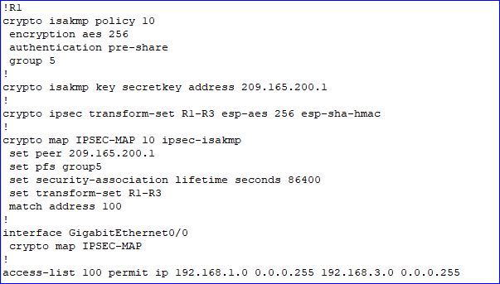
Figure 8: IPSec Tunnel Commands Part 1 [29]
While the commands for the router at the other side of the tunnel, called router 3 for example, the commands would be as seen in Fig 9.
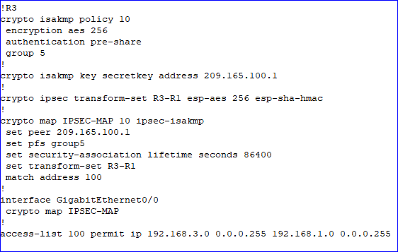
Figure 9: IPSec Tunnel Commands Part 2 [29]

2.15 Cisco ASA
The Cisco Adaptive Security Appliance (ASA) series consists of many models, The ASA 5505 has many features, it monitors and tracks connections on the network and performs stateful packet inspections of traffic that travers the network.
The ASA 5505 includes an antivirus as standard. It is able to perform static, default and dynamic routing protocols including Enhanced Interior Gateway Protocol (EIGRP), which is a Cisco proprietary advanced distance-vector routing protocol used to perform automated routing configurations and decisions, Routing Information Protocol (RIP), which is an older distance-vector routing protocol that uses hop count to limit the number of hops to and from a destination, and Open Shortest Path First (OSPF), which is an interior gateway protocol that uses link-state routing algorithms. [30]
The AnyConnect VPN Connection Setup is used to configure the remote access VPN as shown in Fig 10.
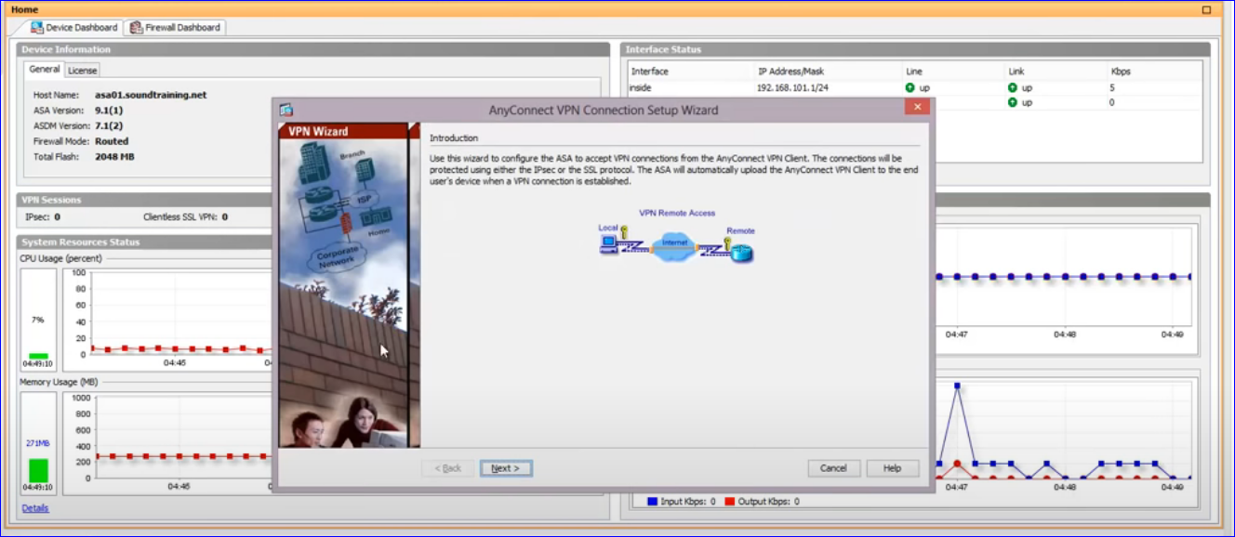
Figure 10: ASA Wizard [31]
The ASA Landing Page is illustrated in Fig 11.
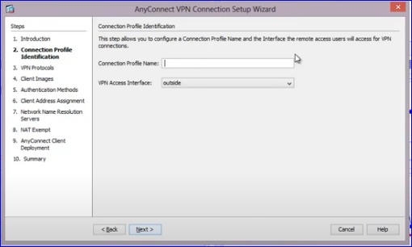
Figure 11: ASA Landing Page [31]
The VPN protocols to be used, along with the device certificate are shown in Fig 12.
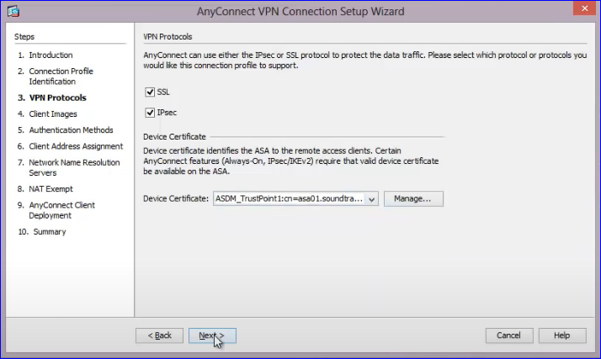
Figure 12: ASA VPN Protocols [31]
The ASA reads the flash system to add the AnyConnect image that have been added. Fig 13.
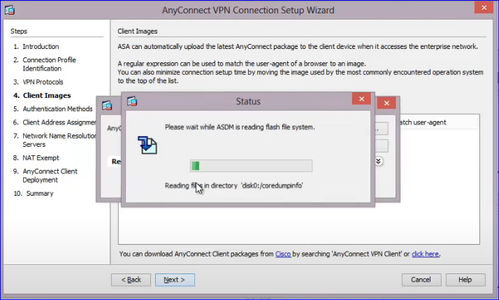
Figure 13: ASA Image Being Added [31]

Choose an authentication method. TACACS+, and Radius would be chosen at this point. Fig 14 illustrates a local database being selected.
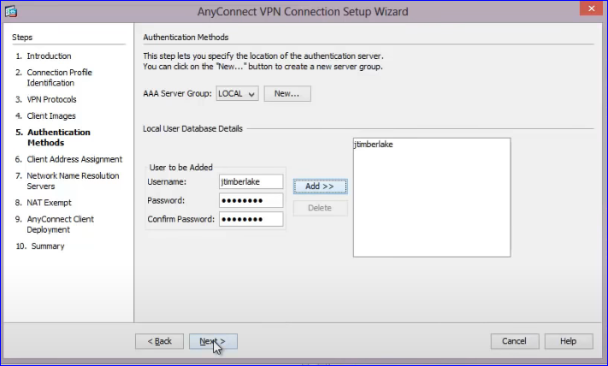
Figure 14: ASA Local Database Selection [31]

DHCP address pool for VPN clients was created and given a different address range from the LAN in Fig 15.
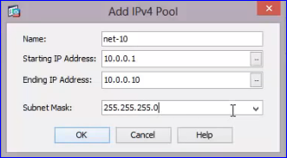
Figure 15:DHCP Address Pool [31]

The DNS Address is added as depicted in Fig 16.
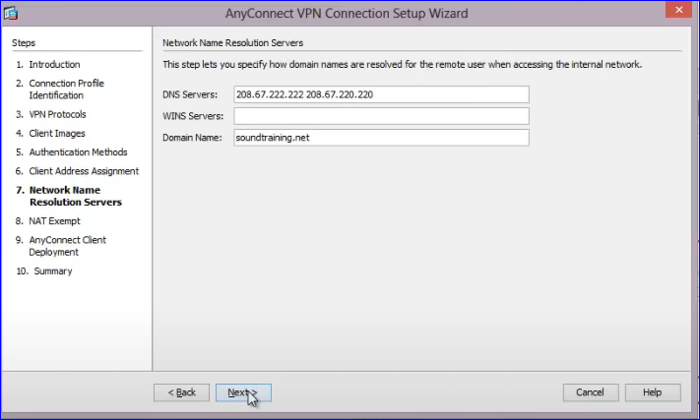
Figure 16: DNS Address [31]
The VPN traffic is exempt from Network Address Translation (NAT) in Fig 17.
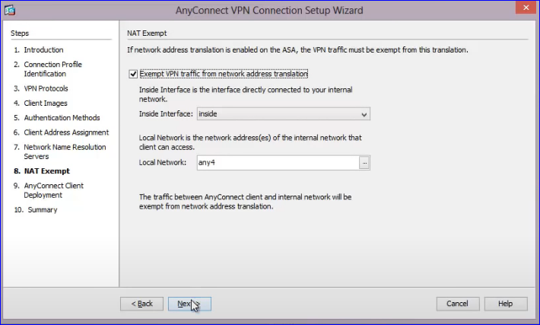
Figure 17: VPN Exempt from NAT [31]

The web launch connection was chosen in Fig 18.
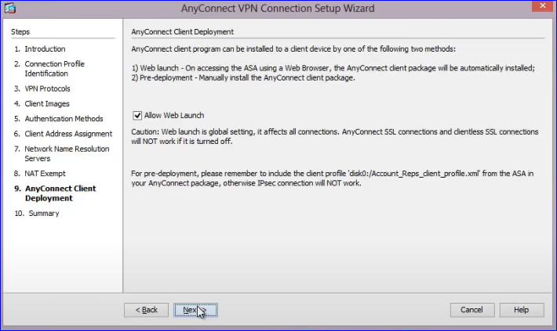
Figure 18: Web Launch Connection [31]
The next page is the Commands Preview page. Fig 19.
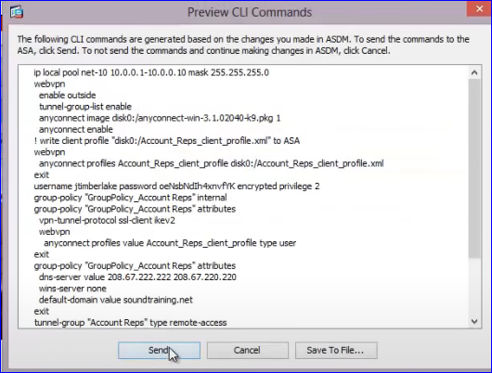
Figure 19: Commands Preview Page [31]

Landing page with the group added Fig 20.
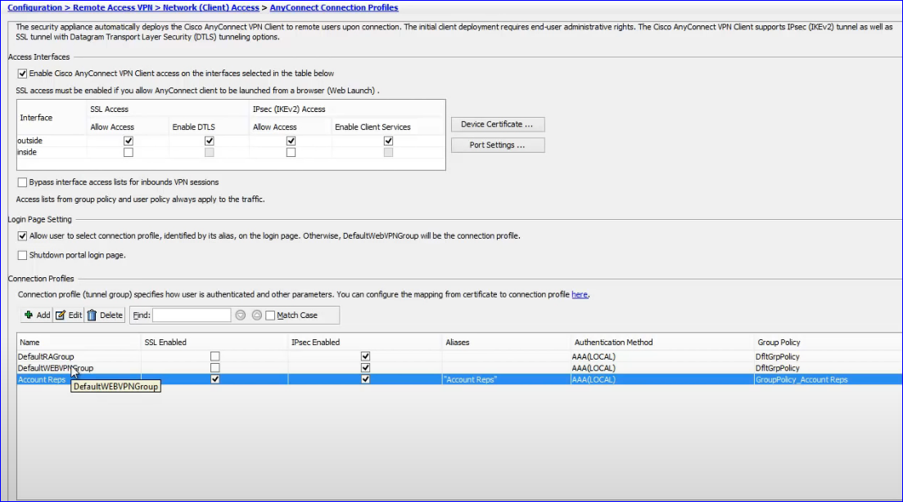
Figure 20: Landing Page Updated [31]

3 Part Two - Propose a Secure Network Infrastructure Based on a Given Scenario.
Part two of the report will outline the scenario given for A2Z Technologies Ltd.

4 Project Proposal
A2Z Technologies Ltd. is a medium-sized high-tech electronic manufacturer. It consists of two buildings located in Swansea and Cardiff. There are six departments, and employees that work from home utilising cloud service.
There is an existing network and A2Z would like new blueprints designed for a secure network infrastructure that allows remote access for employees. The timeline for completion is three months. The cabling infrastructure already exists as does the IoT infrastructure for physically securing the server room.
The company will be dealing with all the necessary certificates for any hardware and software purchased.

5 Outline of Solution
For a medium sized organisation of between two hundred and one thousand devices, a modular hierarchical network is suggested.
The design consists of three layers, each layer is responsible for specific functions within the network. This allows each layer to consist of the most beneficial hardware and software to optimize performance. Hierarchical models can be used for Local Area Networks as well as Wide Area Networks.
The layout implements a star topology with network connectivity using layer two and layer 3 switches.
The access layer allows the employees access to the network and can be set-up to include virtual networks. The virtual networks will be used so that each department will have its own network. Therefore, the restriction of access will create greater security.

5.1 Resiliency
The network is to continue to be accessible under normal and abnormal circumstances. Normal traffic flow is considered as including events such as maintenance and scheduled events, and abnormal to include excessive traffic loads, irregular traffic patterns, a denial-of-service event (intentional or not), if hardware or software were to malfunction or fail, and any other event that is unexpected. To obtain this outcome, the use of Cisco 3560 Switches is recommended.

5.2 Flexibility
The modular hierarchical design allows for sectional portions of the network to be modified at any time, while allowing for an increase in capacity, or the addition of new services. Therefore, allowing for future scalability.

6 Description
The Server Room will include an Internet of Things door, which will be monitored with a motion detector and a web camera. The door will only allow access to relevant personnel. Inside the closet the air conditioning will also be controlled via an IoT server. An ASA 5505 firewall is connected to the exterior router, outlined in Appendix 2, and a VPN to the Cardiff branch office. To connect to the intranet, the firewall is connected to two Cisco 3560 multilayer switches detailed in Appendix 3. This is to allow for redundancy. These servers will be the point of contact for all the departments.

The DMZ is also located in the server room. It consists of a Cisco 24-port switch, a PC for Management, and the company servers. The servers are Authentication, Authorisation and Accounting Access Control Server (AAA ACS); HTTP; Email; DNS; DHCP; IoT server and a file server.
There will be two AAA ACS one configured with Terminal Access Controller Access-Control System (TACACS+) and the other with Remote Access Dial-In User Service (RADIUS).
Cloud services are in place for disaster recovery and a BYOT connection to the company infrastructure.

6.1 Security
Inspecting the existing security policy and updating where necessary will be part of the security checks.
The password policy is to include ensuring all passwords are encrypted, to include alphanumeric and special characters, one uppercase character and to be a minimum of ten characters in length. Passwords are not to be written down anywhere.
There will be a maximum number of attempts allowed for logins, along with a time limitation. All unnecessary services and ports are to be shut down. The access control list will be in line with company policy.
It is suggested that social engineering tactics be explained to all employees, random checks to be implemented to see how well the employees understand the tactics. Follow-up individual educational plans to be implemented for employees that fail two or more checks.
A legal notification will be configured on all routers. An example is: “WARNING No Unauthorised Access Is Allowed. Trespassers Will Be Prosecuted”.
SSH to be used for remote communication. Https to be initiated on all websites. Role-based access controls to be enabled, allowing restricted access to individual users. ACLs and Extended ACLs to be implemented to mitigate attacks against the network.
The switches will be configured with VLANS which will isolate the departments and so add security, and the layer three switches will be configured for inter VLAN routing. Port Security will be implemented on all switches, and any unused ports will be disabled.
AAA and ACLs to be implemented on all wired/wireless LAN access points and switches, all edge routers, firewalls along with all routers. The ASA firewall will implement Zone Based Policy, along with Global ACL, to aid in the flow of traffic while keeping security measures intact.
NAT and Port Address Translation (PAT) will be used on the firewall which will obfuscate the intranet address.
The ASA firewall will be configured to use the RADIUS server to authenticate all VPN connections. The TACACS+ and RADIUS server protocols will include a secret password containing upper and lower case, alphanumeric and special characters. A local user to be set up for backup should the AAA server not be reachable. RSA public, private key pairing for SSH access.
A domain name to be implemented so the RSA Key pair required for SSH access can be implement. There will be a TACACS+ server key to verify identity. A default method list to be created for the server giving the order of user authentication methods.
With the use of the control-plane functionality, management interface will be allowed to use SSH. All other protocols will be disallowed.
An IPSec VPN with pre-shared authentication to be initiated for the Cardiff Office.
Troubleshooting of the network will be carried out and will include:
- Initial penetration test.
- Scanning the network for any vulnerabilities.
- Social engineering test using e-mails.
- Testing IoT security on server room.
A Gannt Chart located in the appendix shows the time cycle required for the project. A purchasing list along with a projected invoice for the work, is also in the appendix.

7 Risks
The risks associated with this proposal are as follows:
- The equipment is not delivered in a timely manner.
- The troubleshooting takes longer than expected.
- The cabling to completed by a subcontractor.

8 Recommended Security Test
Once the network is in place, and the security measures have been implemented, it is recommended that security testing takes place on a regular/irregular basis. The tests could be carried out in house, or by employing a penetration tester.
There are three tests that are recommended.
- Social engineering. This could include sending out bogus emails with links that need to be clicked stating software updates are required, phone calls asking for information that is protected, or fake demands for password updates that take the employee to a bogus site where their information could be compromised.
- MitM attack on the network, to include scanning the network for any vulnerabilities.
- Physical testing – checking to see if any passwords are left out in the open, stuck to the underside of keyboards, or even stuck on the sides or bottom of monitors.
The social engineering and MitM attack could be carried out, as mentioned, in house, or by employing a penetration tester. There are three types of penetration testers. White, Grey and Black Hat testers. White Hat are usually given more information about the company and asked to carry out testing with this knowledge. The Grey Hat would have less information and the Black Hat would only know the name of the company. Each type of tester would be given strict instructions that would have to be adhered to, and each would give a written report of their findings. Hiring one of these testers to see if they could physically infiltrate the company would also be useful in ascertaining the physical security of the workplace. For example, could a person piggy-back an employee to enter a building, and if so, how far into the building could they penetrate?

9 Conclusion
The new hardware and cable to be installed and configured within a three-month period. The Gannt Chart, located in Appendix 4, outlines the workflow. The solution to the new requirements is set out above and covers the security measures that will be included in the configuration of the appliances. A pro-forma invoice is also located in Appendix 5.

Bibliography
[1] U. Government, “https://www.gov.uk/government/statistics/cyber-security-breaches-survey-2020/cyber-security-breaches-survey-2020,” lONDON UK, 2020.
[2] Cisco, “What Is Network Security?,” Cisco Website. 2021.
https://www.cisco.com/c/en_ca/products/security/what-is-network-security.html
[3] N. Y. Conteh and P. J. Schmick, “Cybersecurity:risks, vulnerabilities and countermeasures to prevent social engineering attacks,” Int. J. Adv. Comput. Res., vol. 6, no. 23, pp. 31–38.
[4] F. Ainnul Yaqin, “Development of a Network Security System with Mikrotik in SMK Muhammadiyah 2 Kuningan,” J. Mantic, vol. Volume 4, no. 1, pp. 117–122, 2020.
[5] C. Paquet, “What Are the Most Common Cyber Attacks?,” Products and Services, 2021. [Online]. Available: https://www.cisco.com/c/en_ca/products/security/common-cyberattacks.html#~types-of-cyber-attacks.
[6] McAfee, “What is malware?,” 2020. [Online]. Available: https://www.mcafee.com/en-ca/antivirus/malware.html.
[7] “Email Phishing, Vishing & Other Types of Attacks | Webroot,” Webroot Smarter Cybersecurity. 2020.
[8] S. Weisman, “What are Denial of Service (DoS) attacks? DoS attacks explained,” NortonLifelock, 2020. [Online]. Available: https://us.norton.com/internetsecurity-emerging-threats-dos-attacks-explained.html.
[9] Kingthorin, “SQL Injection,” Open Web Application Security Project, OWASP. 2020.
http://svn.cacert.org/CAcert/SecurityManual/secpolicy.pdf
[10] M. R. Franco Palau, Carlos Catania, Jorge Guerra, Sebastian Garcia, “DNS Tunneling: A Deep Learning basedLexicographical Detection Approac,” arXiv:2006.06122, 2020.
[11] K. Mitnick, “Cyber Security Articles & News,” Mitnick Secur., 2017.
http://svn.cacert.org/CAcert/SecurityManual/secpolicy.pdf
[12] Kaspersky, “Top 10 Most Notorious Hackers of All Time,” Kaspersky Lab, 2021. [Online]. Available: https://www.kaspersk y.com/resource-center/threats/top-ten-greatest-hackers.
[13] O. G. Website, “Mitigating malware and ransomware attacks,” National Cyber Security Centre, 2020. [Online]. Available: https://www.ncsc.gov.uk/guidance/mitigating-malware-and-ransomware-attacks#makeregularbackups.
[14] Norton, “5 reasons why general software updates and patches are important,” 2021. [Online]. Available: https://us.norton.com/internetsecurity-how-to-the-importance-of-general-software-updates-and-patches.html.
[15] Cisco, “Cisco Guide to Harden Cisco IOS Devices,” 2021. [Online]. Available: https://www.cisco.com/c/en/us/support/docs/ip/access-lists/13608-21.html.
[16] P. Awwad, Configuring and Assigning Privilege Levels. 2019.
http://svn.cacert.org/CAcert/SecurityManual/secpolicy.pdf
[17] Cisco, “CCNA Security: Worm, Virus and Trojan Horse Attacks,” 2021. [Online]. Available: https://www.certificationkits.com/cisco-certification/ccna-security-certification-topics/ccna-security-describe-security-threats/ccna-security-worm-virus-and-trojan-horse-attacks/.
[18] D. C. Campbel, “Securing the Management Plane,” UWTSD Network Security, vol. PowerPoint. p. 22, 2021.
[19] Cisco, “Cisco Network Foundation Protection (NFP) framework,” Cisco Website, 2021. [Online]. Available: https://geek-university.com/ccna-security/cisco-network-foundation-protection-nfp-framework/.
[20] I. Sun Microsystems, “Developing a Security Policy,” 2001.
http://svn.cacert.org/CAcert/SecurityManual/secpolicy.pdf
[21] D. Danchev, “Building and Implementing a Successful Information Security Policy.” WindowsSecurity.com, pp. 1–25, 2021.
[22] Cisco, Implementing Cisco IOS Network Security (IINS): (Authorized Self-Study Guide). Cisco Press, 2009.
https://www.ciscopress.com/articles/article.asp?p=1336425
[23] OWASP, “Penetration Testing Methodologies,” 2021.
https://owasp.org/www-project-web-security-testing-guide/latest/3-The_OWASP_Testing_Framework/1-Penetration_Testing_Methodologies
[24] Y. Bhaiji, “LAYER 2 ATTACKS & MITIGATION TECHNIQUES,” Cisco Systems Inc, 2005. [Online]. Available: https://www.sanog.org/resources/sanog7/yusuf-L2-attack-mitigation.pdf.
[25] A. Mason, CCNP Security Secure 642-637 Quick Reference, 1st ed. Cisco Press, 2011.
https://www.ciscopress.com/articles/article.asp?p=1681033&seqNum=2
[26] K. Scarfone and P. Mell, “Intrusion Detection and Prevention Systems,” Spec. Publ. 800-94 Guid. to Intrusion Detect. Prev. Syst. (IDPS), 2007.
[27] P. K. Singh and P. P. Singh, “A Novel Approach for the Analysis & Issues of IPsec VPN,” Int. J. Sci. Res. (IJSR), India Online, vol. Volume 2, no. Issue 7, pp. 187–189.
[28] O. Adeyinka, “Analysis of problems associated with IPSec VPN Technology,” in Canadian Conference on Electrical and Computer Engineering, 2008, pp. 001903–001908.
[29] Danscourses, “Create an IPsec VPN tunnel using Packet Tracer - CCNA Security,” 2018. [Online]. Available: Create an IPsec VPN tunnel using Packet Tracer - CCNA Security.
[30] Cisco, “Cisco ASA 5505 Firewall Edition Bundle - security appliance.” [Online]. Available: https://www.grandandtoy.com/en/product/SY10808145.aspx?utm_source=google&utm_medium=cpc&utm_campaign=SEM-Grand-And-Toy-Smart-Shopping-Uncategorized-EN&utm_content=always-on&s_kwcid=AL!8312!3!385725938521!!!u!297949417811!&gclid=Cj0KCQjwyZmEBhCpARIsALIzmnKHldcmIV9fspTv5g5ppK2nxoPjWUgGZCr9dinQfqb3ADwiF3Rj1U0aAj9EEALw_wcB.
[31] D. Crawley, R, “Cisco ASA AnyConnect Remote Access VPN Configuration.” 2020.
https://www.youtube.com/watch?v=1oJ1JwYAC8w
[32] Cisco, “WS-C3650-48PS-S.” [Online]. Available: https://www.hnstechinc.ca/product/ws-c3650-48ps-s.

Appendix

1 Blueprint of Network

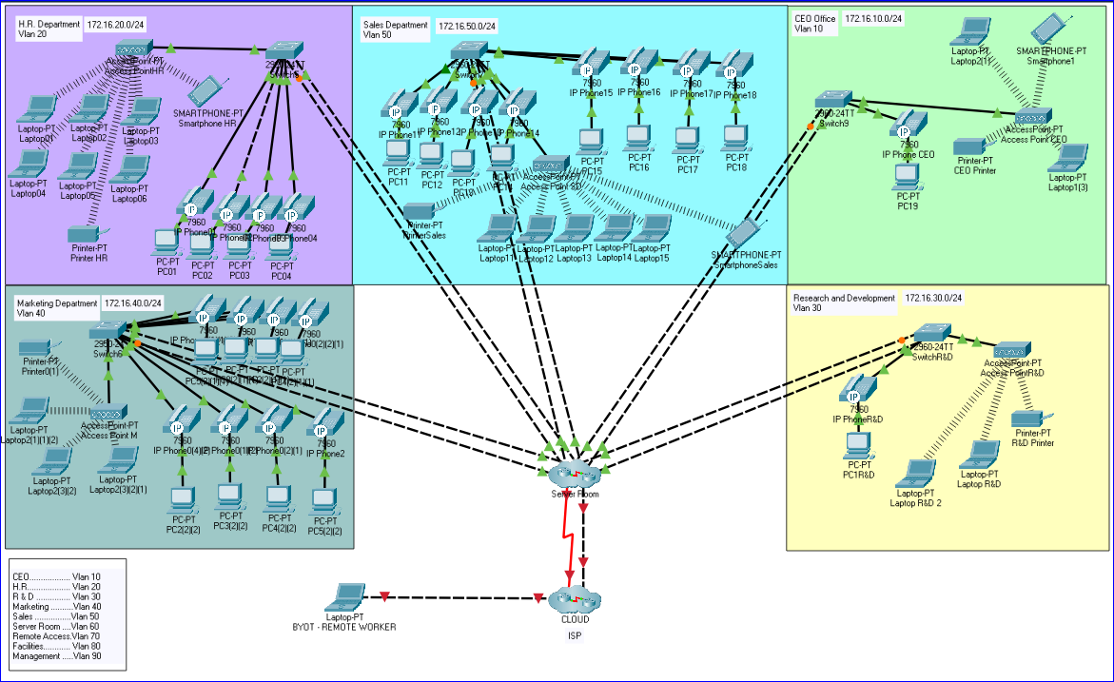
Figure 21: Blueprint A2Z Technologies
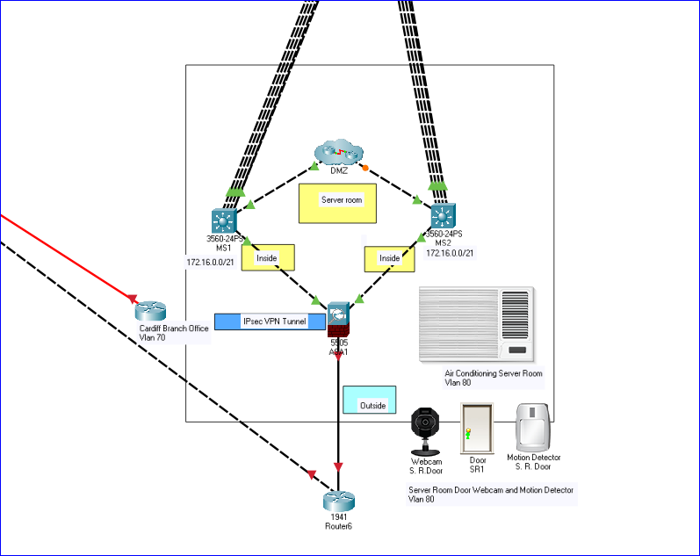
Figure 22: Server Room Cluster

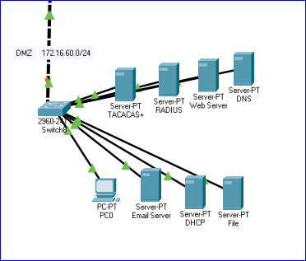
Figure 23: DMZ Cluster

2 ASA 5505 Firewall

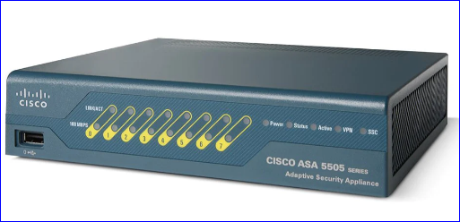
Figure 24: Cisco ASA 5505 Firewall [30]

Specification overview of Cisco ASA 5505 Firewall. Fig 2.

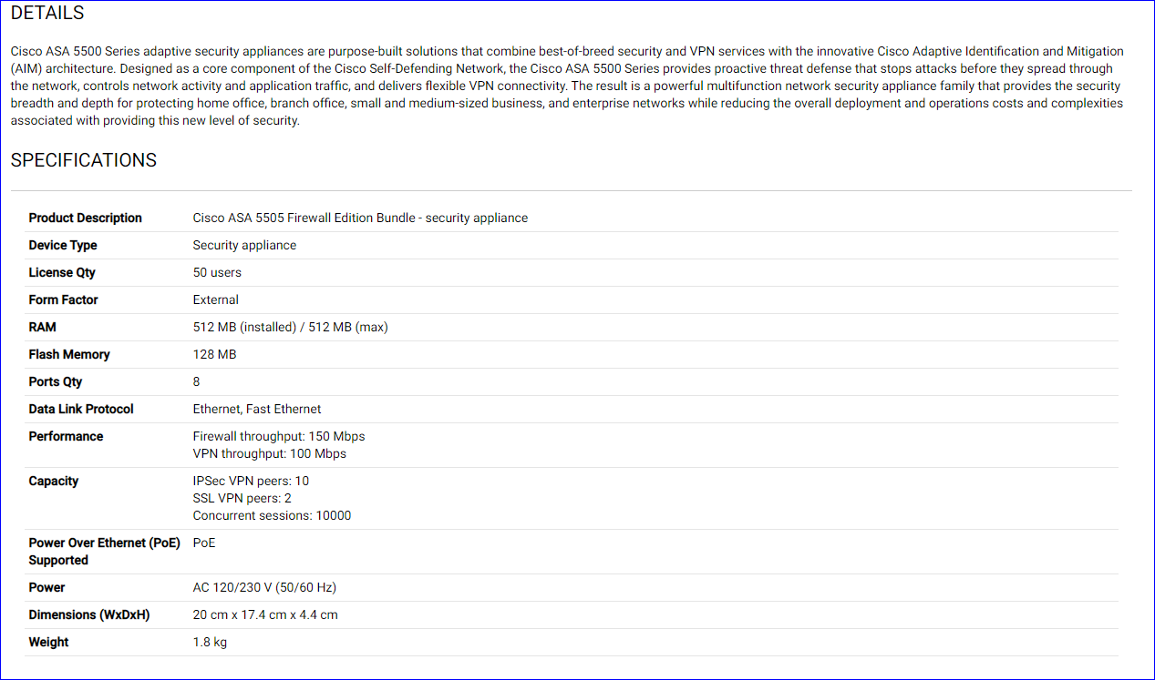
Figure 25: Cisco ASA 5505 Firewall Specifications[30]

3 Cisco C3650 24 Port Multilayer Switch

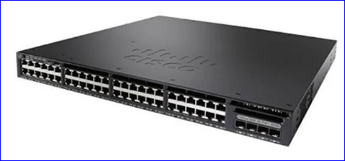
Figure 26: Cisco C3650 48 Port Switch [32]

Specifications for C3650 24 Port Multilayer Switch

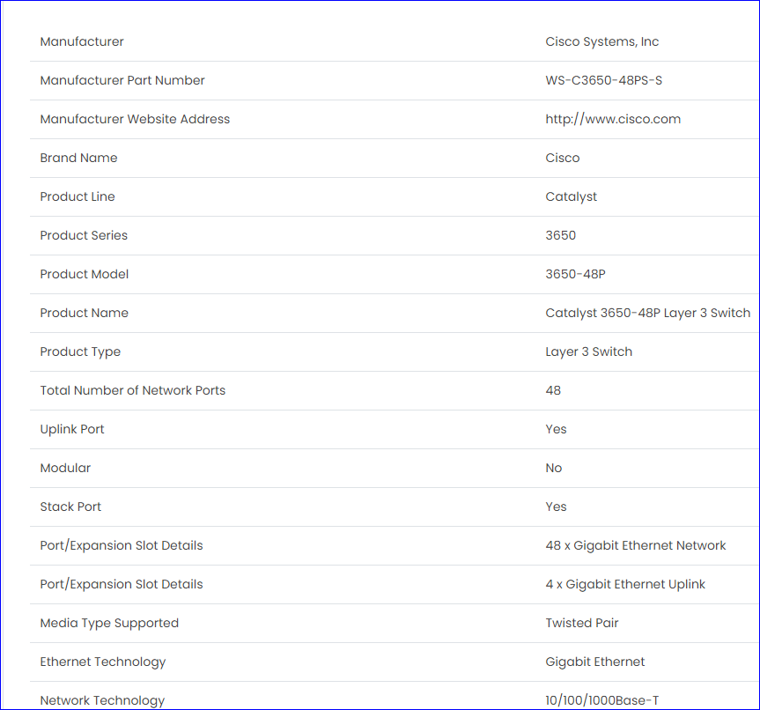
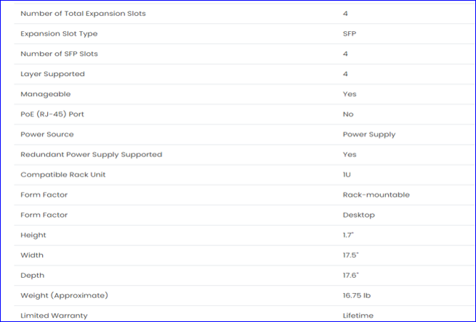
Figure 27:Cisco 48 Port Switch Specifications [32]

4 Gannt Chart
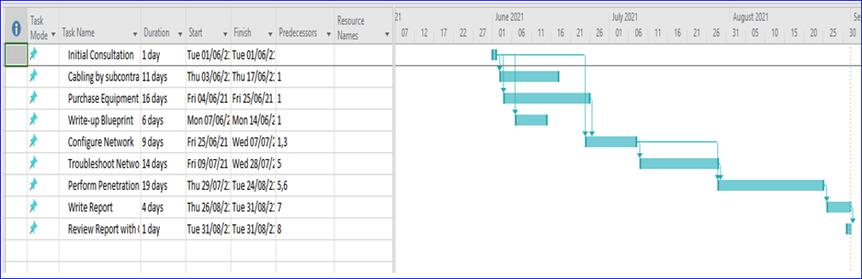

5 Invoice



marking criteria and Student FEEDBACK

This section details the assessment criteria. The extent to which these are demonstrated by you determines your mark. The marks available for each criterion are shown. Lecturers will use the space provided to comment on the achievement of the task(s), including those areas in which you have performed well and areas that would benefit from development/improvement.

Common Assessment Criteria Applied (Assignment 1) | Marks available | Marks  awarded
1. Engagement with Literature Skills
Extent of research and/or own reading, selection of credible sources, application of appropriate referencing conventions.
Your research on security threats facing modern network infrastructures and other areas to aid solutions to part 1 and 2 have demonstrated excellent engagement with the literature. However, more peer-reviewed articles could have been used to aid your discussions. (Grade mark: 80.00%) | 10 | 8
2. Knowledge and Understanding Skills
Extent of knowledge and understanding of concepts and underlying principles associated with the discipline.
You have demonstrated excellent understanding of the research and shown critical awareness of current problems and insight. (Grade mark: 80.00%) | 10 | 8
3. Cognitive and Intellectual Skills
Analysis, evaluation and synthesis; logic, argument and judgement; analytical reflection; organisation of ideas and evidence
See comments in report to improve conclusion.  You have Use the knowledge and understanding gain from part 1 to propose and implementation solution for A2Z:  • You have wrote the proposal explaining your choices and security measures.  • You have not done a proposed cost analysis for implementing the solution(s); which include software, hardware, etc. However you have outline the risks.  • You have done the timeline for the implementation. Gantt chart in appendix  • You have explained to A2Z at least three attacks that will plagues the organisations network infrastructure  • You have recommended and explained three types of test to be conducted after the implementation to ensure the network infrastructure is secure (black, grey or white box testing).  • You have provide an invoice for the professional/consultancy service as a Network Security Engineer. Within appendix  (Grade mark: 82.00%) | 25 | 20.5
4. Practical Application Skills
Deployment of methods, materials, tools and techniques; application of concepts; formulation of innovative and creative solutions to solve problems.
You have not submitted a fully working Cisco Packet Tracer file along with the routers and ASA configuration txt files of the design (figure and table) laboratory task given part 1. However, screenshots of the configurations for most of the devices given in the tasks were explained and included in your written report.  The knowledge and understanding gain from part 1 packet tracer implementation was used to:  • To implement a working Cisco packet tracer design (instead a constructed and label the blueprint design) for the given case study as well as it was explained (excellent job). (Grade mark: 88.00%) | 50 | 44
5. Transferable Skills for Life and Professional Practice
Attributes in professional practice: individual and collaborative working; deployment of appropriate media; presentation and organisation.
Your report was professionally done. (Grade mark: 90.00%) | 5 | 4.5

Assignment Mark (Assessment marks are subject to ratification at the Exam Board. These comments and marks are to give feedback on module work and are for guidance only until they are confirmed. ) | Late Submission Penalties (tick if appropriate) |  | 85%
 | Up to four weeks late |  | 85%
 | First Attempt? |  | 85%

