Marketing Fundamentals Analysis and Evaluation

Module: Marketing Fundamentals

Student Name: Atanas Antonov
Student ID: 2011641
Module Code: LCBB4004

Table of Contents
Introduction 3
Marketing Mix 6
Product 7
Price 7
Promotion 8
Place 8
Conclusion 8
References 10

Introduction
There are five steps to the marketing process. They are Mission, Situational Analysis, Marketing Strategy, Marketing Mix, and Implementation and Control. These stages further have their sub-stages. The Mission involves the Mission statement and corporate objectives. The second stage in the marketing process is the Situational Analysis which includes the sub-stages of identifying opportunities, SWOT Analysis, 5C Analysis, and PESTLE Analysis. The third step in the marketing process is Marketing Strategy. Marketing Strategy involves the sub-stages of defining the firm's target audience, setting measurable goals, and defining the budget of the firm. The fourth stage in the marketing process is the marketing mix, a popular academic theory used as a measuring stick for an organisation's marketing. The sub-stages in the marketing mix involve the product development of an organisation, the pricing, the promotion of the product, and the place and distribution. The last stage in the marketing process is Implementation and Control. This stage includes the sub-stages of putting plans into action and monitoring results.

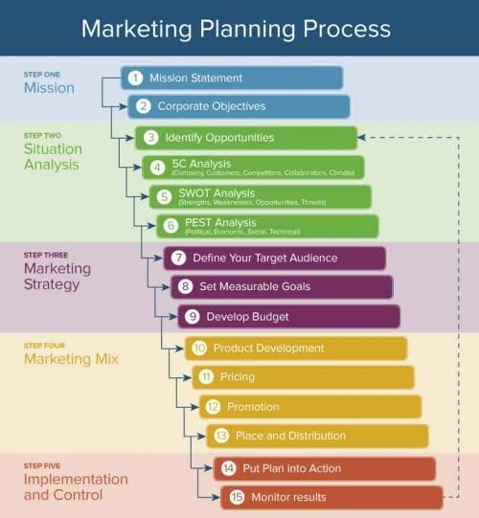
Fig 1: Marketing Planning Process
Source (smartsheet.com)

A strategic form of marketing planning involves taking steps towards setting necessary objectives and goals. Internal and external business factors need to be analysed, products need to be planned. Additionally, the planning needs to be implemented, and appropriate tracking of organisational goals needs to occur to ensure that the progress planned takes place (Urbina, 2020). This essay will assume the organisational example of Apple fitted into the marketing context to study some of the aforementioned stages in detail.
Apple has been the winner of the CMO Survey Award for Marketing Excellence for the last seven years. Their strategic marketing plan, in brief, is as follows:
- The Mission Apple is to dedicatedly make premium quality innovative products (Ewa et al., 2017).
- Apple's Situational Analysis is driven by its passion for understanding the needs of its customers. Apple makes an effort to focus on those products that are integral to its mission and foster a collaborative healthy working culture.
- Apple's marketing strategy relies heavily on the brand loyalty of their existing customers while launching new products and services in the market (Bofasa, 2018).
- Apple's marketing mix is positioned to offer a range of products. Apple values premium pricing and depends on regulated guidelines for distribution.
- Apple's Implementation and Control in the marketing process allow every Apple product to complement the other and work hand in hand in the same ecosystem. This strategy tempts customers to stay within the brand and at the same time creates a loyal customer base.
This strategic marketing process puts everything in place so that every step taken contributes to the success of the business. Instead of executing vague ideas through activities, Apple chooses to create a long-lasting solid plan that weaves their goals into a seamless experience in their products. This is possible only because of the marketing process that they follow. Using these steps, Apple creates products and services that delight their customers and corner their competitors.
The role that the marketing environment has to play in building Apple's products in the market is significant. This is because if the marketing environment for Apple is hostile, Apple will not be able to successfully retain its products in the market and hold the reputation they have today. The reputation that Apple has today is to a large extent because of the premium quality of products that Apple manufactures. These products would not have gained a name in the market if the market environment did not favour them. Therefore, it is important to study the role that the market environment has to play in a little detail.
Apple's external macro environment can be studied with the help of Porter's five forces analysis.

- The existence of rivalry for Apple in the market is medium. Apple's most renowned rival is Microsoft that produces the Windows Operating System. Apple's computer rivals are Lenovo, Dell, HP. In the MP3 market, Samsung is a powerful rival of Apple (Tien et al., 2019). Therefore, we can see that using Porter's five forces we can successfully track Apple's competitors in the market to help Apple study them and gain an edge over them.
- The threat of entrants that Apple faces, as studied through Porter's five forces, is low. This is because Apple has positioned itself as the leader in the market. They have created a reputable brand image for themselves. Holding the large market share that they do acts as a big advantage for Apple. The threat of new entrants is low because the aforementioned rivals of Apple also have a significant image in the market (Tien, 2020).
- There is a medium threat of substitution of Apple products as studied through Porter's five forces. Substitutes for Apple products such as iPod can be CD, DVD, MD players. Androids and smartphones can substitute iPhones. Laptops and netbooks can substitute iPads.
- The bargaining power of suppliers is perceived to be medium through Porter's five forces. The raw materials that Apple uses through their suppliers and labour are perceived to be a threat for them. iPhone has multiple functions like video players, camera, memory. The power of suppliers is low there. However, at the same time, Apple purchases a large amount of hardware. This automatically translates into Apple also having power over suppliers, which they can depend on.
- The bargaining power of buyers is considered to be medium as studied through Porter's five forces. Sharing music from one person to another without paying for it through Apple is considered illegal (Bilovodska et al., 2020). Several Apple retailers may pressurise Apple to lower its prices for the benefit of their sales. Sales may be low during times of an economic downturn, such as the current scenario of the pandemic.

Marketing Mix
The 'how' of the marketing process depends on the marketing mix. The marketing mix consists of 4Ps. These 4Ps are Product, Price, Promotion, and Place. The 4Ps help businesses convey the value of their products to their customers. Additionally, they allow businesses to position their products, and it's a competitive advantage in the market.

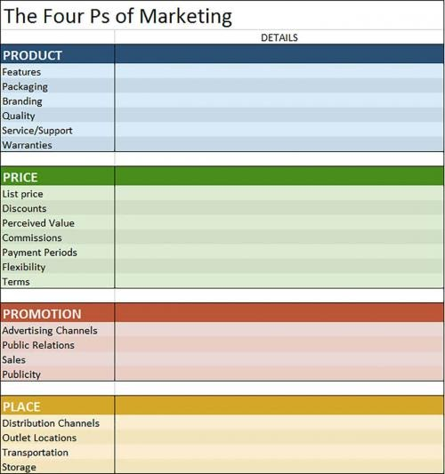
Fig 2: 4Ps of Marketing
Source (smartsheet.com)

Product
A product in the 4Ps of the marketing mix stands for the product manufactured by Apple. Products are considered to solve problems. Products are considered as a solution to the problem. The products of Apple are considered to be a solution for Apple's Mission that is mentioned above. Apple products convey the Mission of Apple to its customers. Product in the 4Ps helps Apple gain a clear understanding of their product and service, the use that customers can avail from it, the needs that the said product/service satisfies. Additionally, it also helps Apple to reach a conclusion as to what features are required in the said products to meet the needs of the customers. They explore the possibility of where the customer could be using the said product, the competitors of the said product, and its comparison with similar products.

Price
The price factor in the 4Ps determines the price that the target audience is willing to pay for the price of an Apple product (Wu et al., 2018). Factors that need to be regarded while considering the price point are discounts, list price, payment periods, and the price for manufacturing the product. There are other factors such as the competition, the health of the economy, the price point of their competitors, and any similar models to be considered.
The marketing message that Apple creates around its product depends on the market and the audience.

Promotion
The promotion is the third factor conveyed by the 4Ps in the marketing mix. The way that Apple communicates with their target market about the value and benefit of their products and services counts for promotion (Dahiya and Gayatri,2018). Promotion is perceived as an opportunity to educate customers about their products and services. Promotion allows Apple to teach the customers the value their products can offer and how it meets their needs. There are multiple ways that Apple indulges in advertisements through this process. There is direct marketing, social and paid search, public relations, advertising, and sales promotion that boost the brand awareness of Apple among the masses (Anupriya et al., 2021). Apple also conveys marketing messages through television, billboards, and sponsored events (Biaudet, 2017). The promotion in the 4Ps also teaches Apple to question how their competitors do their marketing. Additionally, it suggests to Apple the best time to promote their products.

Place
The fourth and last P in the 4Ps stands for Place in the Marketing Mix. The place factor for Apple holds the significance of product distribution. This helps Apple to devise how to get its products across to its customers. This makes the buying process easier. The place stands for distribution channels, transportation, and outlets to reach the product to the target market. The place from the 4Ps encourages Apple to ask questions such as where customers should look for Apple's products, which platform, online or offline, should be best for selling Apple products. Apple also considers if a sales force should be hired to reach its products to its customers or if they should consider selling directly to their customers. The place from the 4Ps in the marketing mix encourages Apple to ponder on the best distribution channels for its products. It also encourages them to study and gain from where and how their competitors are reaching their customers.

Conclusion
It is evident from the essay above that without a proper marketing strategy, an organisation can't thrive or retain its position in the market. This essay makes a successful study of the marketing process involved for Apple, a popular organisation, to convey the importance of the marketing process.

References
Anupriya, V., Maheswari, G.S. and Kavitha, M., 2021. FACTORS DETERMINING BRAND RESONANCE OF APPLE IPHONE. Psychology and Education Journal, 58(2), pp.6629-6634.
Biaudet, S., 2017. Influencer marketing as a marketing tool: The process of creating an Influencer Marketing Campaign on Instagram
Bilovodska, O., Melnyk, Y., Alenin, Y. and Arkusha, L., 2020. IMPLEMENTATION OF MARKETING AND LEGAL TOOLS IN THE PROCESS OF COMMERCIALISATION FOR INNOVATIVE PRODUCTS IN STRATEGIC MANAGEMENT AND ENTREPRENEURSHIP. International Journal for Quality Research, 14(4).
Bofasa, C.B., 2018. The BCG matrix and Marketing strategies of Apple. Матеріали Ⅸ Регіональної науково-практичної Інтернет-конференції молодих вчених та студентів „Маркетингові технології підприємств в сучасному науково-технічному середовищі “, pp.144-146.
Dahiya, R. and Gayatri, 2018. A research paper on digital marketing communication and consumer buying decision process: an empirical study in the Indian passenger car market. Journal of Global Marketing, 31(2), pp.73-95.
Ewa, W.J., Milosz, P., Martyna, K. and Michal, N., 2017, June. Apple products: A discussion of the product life cycle. In 2017 International Conference on Management Science and Management Innovation (MSMI 2017) (pp. 159-164). Atlantis Press.
Tien, N.H., 2020. International distribution policy comparative analysis between samsung and apple. International Journal of Research in Marketing Management and Sales 2019, 1(2), pp.24-27.
Tien, N.H., Dat, N.V. and Chi, D.T.P., 2019. Product Policy in International Marketing. Comparative Analysis between Samsung and Apple.“. International Journal of Research in Marketing Management and Sales, 1(2), pp.129-133.
Urbina, N.R.O., 2020. Positioning process in marketing: steps and stages. Revista Academia & Negocios, 7(1), pp.55-64.
Wu, Y.L. and Li, E.Y., 2018. Marketing mix, customer value, and customer loyalty in social commerce: A stimulus-organism-response perspective. Internet Research.

