Short term and long-term benefits for young people through their involvement in youth work.
This assignment will identify and highlight the importance of short term and long-term benefits for young people through their involvement in youth work. The essay will also include demonstrations on how the outcomes are linked to contemporary policy. Throughout, the assignment will be underpinned by both policy and theory in order to provide a clear understanding on the benefit and impact Youth Work has on young people in society. Out of a wide array of policies, this assignment will look at the most relevant for beneficially impacting Youth Work delivered to young people today, these will be: Extended Entitlement; 2002, Youth Work in Wales; Principles and Purposes 2013, Young People, Youth Work, Youth Service National Youth Service Strategy for Wales; 2007, National Occupational Standards; 2012, National Youth Work Strategy for Wales; 2014-2018, Youth Engagement and Progression Framework, and the Well-being of Future Generations (Wales) Act 2015. Lastly, a brief summary of Dr John Rose’s influential work will be included, as this has also played a major role in the youth work that is provided for young people in today’s society.

The National Assembly for Wales created the Extended Entitlement in order to ensure that direction and guidance is provided in Youth Work. By creating the Extended Entitlement, it has allowed Health and Social care establishments working with young people to improve their practice, leaving service users with many short and long-term benefits through accessing help and holistic support within these organisations. This policy ensures that local authorities, work well with statutory, voluntary and independent sectors to obtain coherent Youth Work Services for young people which is not only beneficial for Youth and Community Workers but also the clients.

Page 10 of the Extended Entitlement, puts emphasis on The Universal Entitlement which states “Every young person in Wales has a basic entitlement”. These entitlements benefit Young people through their involvement in youth work. One example of this would be; young people have an entitlement to access education, training and/or work experience tailored to their needs. This is beneficial in the short term as young people not only have the opportunity to learn and broaden their knowledge, but also to seek long term employment and become a productive and influential member within society. Due to this legislation, Young people can now also access personal support and advice where and when needed and with clear ground rules on confidentiality, in an environment where the focus is on building young people’s capacity to become independent, and to make positive choices. This is beneficial as they will feel able to access support when required to face any difficulties they may be experiencing in order to benefit their future in the long term.

The Youth Work in Wales: Principles and Purposes, (Youth Work in Wales review Group 2013) document was produced for all professionals working in the youth work sector, and young people themselves actively accessing or seeking to access youth work. The documents main objective is to underpin the key principles and purpose of youth work in the UK which can benefit young people in the short and long term. Page 1 states that “The delivery of youth services provides a powerful mechanism for engaging with and listening to young people.” This is an extremely important part of youth work, as professionals must always engage and listen to their clients to ensure that they can try their best to deliver good quality holistic support at all times, which can have a positive contribution to a young person’s life.
The voluntary engagement of young people is what Youth work is based upon, thus being beneficial for young individuals as they have the opportunity to participate and access youth work if they wish too. Often, this is a more beneficial approach to youth work as young individuals aren’t forced to participate as it is not compulsory, making young people more aware that youth work is always tailored to their needs and preferences. This can benefit young people, although they do not feel compelled to participate in activities, young individuals often seek belonging, and having the opportunity to be a part of youth work is something they appreciate and want to be a part of.

The Young People, Youth Work, Youth Service National Youth Service Strategy for Wales (WAG 2007) is an extended document of the 2000 Extended Entitlement framework. This contemporary policy highlights Children and Young People’s Rights to Action. Smith, Mark K. (2007) said that “The Welsh strategy looked to active participation, wider skills development and enhanced emotional competence.” This is beneficial for young people accessing youth work services in both the short and long term as they are given the opportunity to develop life skills that are essential in becoming an active member in society in the future.
The document includes several targets in terms of what Youth Services had to achieve, and it is thought by Smith, Mark K. (2007) “that the use of such targets too often descends, in practice, into a lot of 'box-ticking', […] however this has now been changed as building services and developing community responses to the needs of young people is a much slower and uneven process.” This is beneficial for young individuals, as todays main focus in youth work is on the personal development of each and every individual and organisation, rather than a whole spectrum of youth and community services.
The document also highlights the current resources available for youth and community organisations to fund youth services. This is beneficial for young individuals, as there is information available for professionals regarding actions they can take to ensure that there is an ongoing provision to benefit service users now and for the future.

The National Occupational Standards (LSIS, 2012) was developed to support employment and to teach professionals the knowledge and skills required in order to become an effective member of a workforce. The National Occupational Standard is extremely advantageous for young individuals in the community seeking work, as it ensures that personalised support is accessible for individuals, particularly individuals with disabilities or are at any disadvantage. This allows young individuals in the community to learn and adjust the skills required, in order to pursue in a stable career which enables them to stay in secure employment. This contemporary policy also benefits young individuals as Youth work practitioners are required to apply their skills and knowledge that is informed by a set of values to ensure a holistic approach to work is always provided for each service user.
According to the ‘NOS’ in 2008 it was agreed by the youth work sector that the main purpose of youth work is to ‘Enable young people to develop holistically, working with them to facilitate their personal, social and educational development, to enable them to develop their voice, influence and place in society and to reach their full potential’. As the purpose of youth work was emphasised, it now ensures that there are secure guidelines for youth work professionals, such as the Functional Map for Youth Work. This allow professionals to work towards meeting the needs and preferences of individuals to benefit their health and wellbeing as values are always at the core of youth work.

The National Youth Work Strategy for Wales 2014-2018 (WG, 2014) is aimed towards any organisations providing youth work provision to young individuals between the ages of eleven and twenty-five. This policy benefits young individuals in the short and long term as it aims to support young people to develop life skills and resilience. It states in the National Youth Work Strategy for Wales book that this particular strategy
Recognises the value and role of open-access youth work provision; promotes a stronger connection between youth work provision and formal education; identifies the need for closer working between statutory and voluntary youth work organisations; and identifies the need to significantly strengthen the evidence base on the impact of youth work across Wales. The Welsh Government, national and local voluntary organisations, as well as local authorities, will need to work together to successfully implement the identified actions and drive youth work forward. - Page 1
Due to this strategy young individuals have benefited in three different ways. The first being, that young people can continue to have access to diverse informal and non-formal learning opportunities that challenge their thinking, and develop their skills. The second benefit is that there has been a strengthening of the strategic relationship between youth work organisations and formal education on a national basis. Lastly, there has also been better coordinated and more consistent youth work offered to young people from youth work organisations in the statutory and voluntary sector.

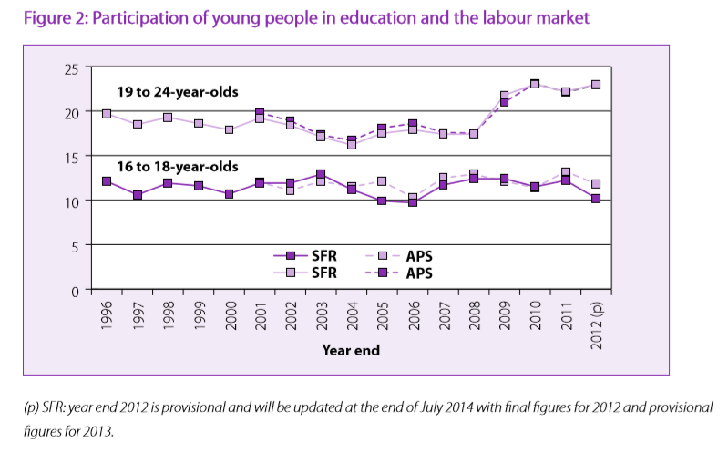
The Youth Engagement and Progression Framework aims to reduce the number of young people who are not in education, employment or training which is also known as ‘NEET’. There are six component elements included in the framework which are effective at increasing youth engagement and progression. These are to; identify young people most at risk of disengagement, provide better brokerage and co-ordination of support, provide stronger tracking and transition of young people through the system, ensure provision meets the needs of young people, strengthen employability skills and opportunities for employment and provide greater accountability for better outcomes for young people. Through meeting all these six component elements with young individuals, it would allow the young individuals who are considered as ‘NEET’ to access the opportunity to become educated, and/or employed. This would positively influence and benefit their overall health and wellbeing in the short and long term, as they will be able to work in order to have a steady annual income in order to support themselves with all aspects of their lives, such as housing, food, or childcare. According to the Welsh Assembly Government Local authorities have the key leadership role in the framework’s implementation. They are working closely with Careers Wales, youth services, schools, colleges, work based learning providers and other partners to ensure those most at risk of becoming NEET or who are already NEET are identified and provided with the support they need to get them back on track. (Youth Engagement and Progression, WAG, Last updated 16th October 2015)

The Well-being of Future Generations (Wales) 2015 (WG, 2015) act has an enormously positive impact on the well-being of young individuals in society. According to the Welsh Government “The Act will make the public bodies listed in the Act think more about the long term, work better with people and communities and each other, look to prevent problems and take a more joined-up approach.” (updated 8th august 2016). Additionally, this legislation ensures that young individuals are taken into consideration as the act expects public bodies to work better together to ensure the needs within the youth provision are consistently met.

Group work and experiential learning can benefit young people in many ways. Both group work and experiential learning will allow young individuals to develop a set of skills that are extensively important to gain future employment. Theorist David Kolb highlights the importance of experiential learning, and represents his theory through a four-stage learning cycle in which the learner touches all the bases. Kolb (1974) states that “learning is an integrated process with each stage being mutually supportive of and feeding into the next. It is possible to enter the cycle at any stage and follow it through its logical sequence.”

According to John Rose, 2007 stated in Jeffs, and Smith (2010) the importance of staying on at school or even having good attendance make benefits for young people. Gender, race, disability and sexuality have also an impact on the involvement of youth within the community, Jeff (2010) and Giddens (1990) believes that the young people of todays society can be influenced by wealth or poverty. If young people are born in an affluent area to wealthy parents and are from a working class background the young people are more likely to be an active member of their community. Scotland have promoted ‘show racism the red card’ within schools to give young people the same opportunity regardless of race, gender, or sexual orientation.
In conclusion, this assignment has identified and highlight the importance of short term and long-term benefits for young people through their involvement in youth work. The essay has also demonstrated on how the outcomes are linked to contemporary policy. Throughout, the assignment has been underpinned by both policy and theory in order to provide a clear understanding on the benefit and impact Youth Work has on young people in society. This assignment has look at the most relevant policies, and readers will now have an understanding on how all the policies mentioned interrelate to benefit youth work practice for young individuals in society and improve their overall health and well-being.

Reference list-
- https://www.base-uk.org/nos
- EXTENDING ENTITLEMENT: support for 11 to 25 year olds in Wales Direction and Guidance July 2002- http://gov.wales/docs/dcells/publications/160108-extending-entitlement-en.pdf
- http://gov.wales/topics/people-and-communities/people/future-generations-act/?lang=en
- HM Government (2004) Every Child Matters: Change for children. London: Department for Education and Skills
- H. M. Government (2005) Youth Matters, London: Department for Education and Skills.
- McLeod, S. A. (2017). Kolb - learning styles. Retrieved from www.simplypsychology.org/learning-kolb.html
- Jeffs, T. J. (1979) Young People and the Youth Service, London: Routledge and Kegan Paul.
- Jeffs, T. and Smith, M. K. (eds.) (2010) Youth work practice. Basingstoke: Palgrave Macmillan.
- National Assembly for Wales (2000) Extending Entitlement: supporting young people in Wales, Cardiff, Corporate Policy Unit.
- http://www.nya.org.uk/wp-content/uploads/2014/06/National-Occupation-Standards-for-Youth-Work.pdf
- Smith, Mark K. (2007) 'Young people, youth work, Youth Service. The National Youth Service Strategy for Wales', the encyclopaedia of informal education. http://infed.org/archives/gov_uk/young_people_youth_work_youth_service.htm
- Youth Work in Wales: Principles and Purposes (Youth Work in Wales review Group 2013)
http://www.cwvys.org.uk/wp-content/uploads/2014/06/Youth-Work-in-Wales-Principles-and-Purposes-March-2014.pdf
- Young People: Youth Work: The Youth Service. Towards a National Youth Service strategy for Wales (WAG 2007)
http://dera.ioe.ac.uk/7452/1/YS-strat-consultation-v1-e.pdf%3Flang%3Den
- http://gov.wales/topics/educationandskills/skillsandtraining/youthengagement/?lang=en
- Youth engagement and progression framework Implementation plan http://gov.wales/docs/dcells/publications/131007-ye-framework-implementation-plan-en.pdf

