Computational Methods

2D Transient Heat Equation Solved with the Explicit Finite Difference Method

James Wybron 1103748

Contents
1. Introduction 4
1.1 Aim and Objectives 4
1.2 Methodology Overview 5
1.3 Structure of the Report 5
2. Governing Equation 6
2.1 Background………………………………………………………………………………………..7
2.2 Mathematical Definition 6
2.3 Definition of Terms 6
3. Finite Difference Method 7
3.1 Finite Difference Approximations 7
3.2 Discretisation of Space and Time 7
3.3 Explicit Finite Difference Formulation 7
3.4 Fourier Number and Stability Criterion 7
4. Initial Condition, Boundary Conditions and Analytical Solution 8
4.1 Initial Condition 8
4.2 Boundary Conditions 8
4.3 Analytical Solution 8
5. Codes’ Details and Explanations 9
5.1 Problem Definition and Governing Equation 9
5.2 Material Properties 10
5.3 User Inputs and Spatial Discretisation 10
5.4 Numerical Stability Criterion 11
5.5 Grid Creation 12
5.6 Boundary Conditions 13
5.7 Time Marching and Finite Difference Scheme 14
5.8 Convergence and Steady-State Detection 14
5.9 Analytical Solution and Validation 15
5.10 Results Visualisation 16
5.11 Summary 17
6. Validation of the Numerical Model 18
7. Sensitivity Analysis of Key Numerical Parameters 19
7.1 Influence of Grid Spacing 19
7.2 Influence of Time Step 20
7.3 Influence of Thermal Equilibrium Tolerance 21
8. Limitations of the Numerical Model 23
9. Suggested Improvements and Future Developments 24
10. Conclusion 25
11. References 26
12. Appendix – MATLAB Code 27

1. Introduction
Heat transfer by conduction is a fundamental physical process governing the transport of thermal energy within solid materials. It plays a critical role in many engineering applications, including electronic device cooling, heating and cooling manufacturing processes, thermal management of machinery, and structural components subjected to thermal loading. Inadequate prediction of temperature distributions can lead to component failure, loss of efficiency, compromised safety and energy wastage. Making accurate thermal analysis essential in engineering design and operation of many pieces of equipment that are taken for granted (Incropera et al., 2017; Holman, 2010).
While analytical solutions to heat conduction problems provide valuable theoretical insight, they are only available for a limited range of geometries and boundary conditions. Engineering systems often involve complex geometries, material variations, and changing operating conditions that cannot be analysed analytically. As a result, numerical methods are essential for modelling heat transfer in practical engineering applications. (Özisik, 1994).
Among numerical methods, the finite difference method is widely used due to its conceptual simplicity and direct relationship to the governing differential equations. When applied explicitly in time, the explicit finite difference method enables efficient and transparent solutions of transient heat conduction problems. However, the explicit finite difference method is conditionally stable, and its accuracy and reliability depend strongly on the choice of numerical parameters such as grid spacing, time step, and convergence tolerance (Smith, 1985; LeVeque, 2007).

1.1 Aim and Objectives
The aim of this report is to develop, implement, and critically evaluate a numerical model for two-dimensional transient heat diffusion in an aluminium plate. The method of analysis will involve implementing and using the explicit finite difference method using MATLAB as the software medium to carry out testing and parameter alteration.
The objectives are to:
- Formulate the governing heat conduction equation for a two-dimensional solid domain;
- The governing equation is discretised in space and time using finite difference methods.Implement the EFDM in MATLAB with robust input handling and stability enforcement;
- Validate the numerical steady-state solution against an analytical solution;
- Conduct a sensitivity analysis examining the influence of grid spacing, time step, and convergence tolerance.
- Critically assess the limitations of the numerical model and propose potential improvements.

1.2 Methodology Overview

The heat equation is solved using simple finite-difference methods in time and space. Fixed-temperature boundary conditions are applied so the numerical results can be compared with a known analytical solution. The temperature is updated step by step until it changes only insignificantly, which is taken as thermal equilibrium. The results are then checked against the analytical solution using plots and error values, and a sensitivity study is carried out to assess the model's reliability.

1.3 Structure of the Report
Chapter 2 introduces the governing heat equation. Chapter 3 discusses finite-difference discretisation and examines stability considerations. Chapter 4 covers the initial and boundary conditions and the analytical solution. Chapter 5 details the MATLAB implementation. Chapter 6 validates the numerical model. Chapter 7 includes a comprehensive sensitivity analysis. Chapter 8 addresses the limitations of the numerical approach, while Chapter 9 offers suggested improvements. Finally, Chapter 10 concludes the report.

2. Governing Equation

2.1 Background

The heat conduction equation comes from applying energy conservation to a small section of material, together with Fourier’s law of heat conduction. For a solid with uniform properties and no internal heat generation, the equation describes how heat spreads through the material over time (Carslaw and Jaeger, 1959; Incropera et al., 2017).

2.2 Mathematical Definition
For a two-dimensional geometry with no heat source term, the transient heat conduction equation is given by:
$$\frac{∂T}{∂t}=α\left(\frac{∂^{2}T}{∂x^{2}} + \frac{∂^{2}T}{∂y^{2}}\right)$$
where $T(x,y,t)$is the temperature (°C), $x$and $y$are spatial coordinates (m), $t$is time (s), and $α$is the thermal diffusivity (m² s⁻¹).

2.3 Definition of Terms
The thermal diffusivity, α, is defined as:
α = k / (ρcₚ)
where k is the thermal conductivity (W m⁻¹ K⁻¹), ρ is the density (kg m⁻³), and cₚ is the specific heat capacity (J kg⁻¹ K⁻¹). Thermal diffusivity describes how quickly temperature changes move through a material and is a key parameter in transient heat conduction problems (Holman, 2010; Özisik, 1994). For example, copper has a much higher thermal conductivity than plastic, meaning heat spreads through copper more quickly, which influences how each material is used in practice.

3. Finite Difference Method

3.1 Finite Difference Approximations
Finite difference approximations are obtained using Taylor series expansions. By expanding the temperature in time, a forward difference is used to approximate the time derivative, which introduces a truncation error of order O(Δt). In a similar way, expanding in space allows a central difference to be used for the second spatial derivative, which has a truncation error of order O(h²) (Smith, 1985; Chapra and Canale, 2015).
These truncation errors help explain the accuracy of the numerical method and show how the choice of time step and grid spacing affects the quality of the numerical solution.

3.2 Discretisation of Space and Time

The spatial domain is divided into a uniform Cartesian grid with spacing h in both the x and y directions. Time is also divided into equal steps of size Δt. The temperature at grid point (i, j) at time step n is written as $T_{i,j}^{n}$. This notation makes it easier to write the governing equation in a form that can be solved numerically (LeVeque, 2007).

3.3 Explicit Finite Difference Formulation
Applying the finite difference method to the governing equation gives the following explicit update equation:
$$T_{i,j}^{n+1}=T_{i,j}^{n}+r\left(T_{i+1,j}^{n}+T_{i-1,j}^{n}+T_{i,j+1}^{n}+T_{i,j-1}^{n}-4T_{i,j}^{n}\right)$$
This equation updates the temperature at each grid point using the values at the four neighboring points. It is commonly referred to as a five-point stencil and is widely used for solving two-dimensional transient diffusion problems (Smith, 1985; Morton and Mayers, 2005).

3.4 Fourier Number and Stability Criterion
The Fourier number, r, is defined as:
$$r=αΔt/h^{2}$$
For the two-dimensional explicit finite difference method, the solution remains stable only if r is less than or equal to 0.25. This condition comes from a stability analysis and ensures that numerical errors reduce over time rather than increase (Richtmyer and Morton, 1967; LeVeque, 2007). For this reason, choosing suitable values for the grid spacing and time step is important to obtain reliable numerical results.

4. Initial Condition, Boundary Conditions and Analytical Solution

4.1 Initial Condition
The initial condition assumes that the entire plate starts at a uniform temperature of 0 °C. This simplifies the analysis of the transient response and is commonly used in benchmark heat conduction problems (Incropera et al., 2017). In real applications, temperatures are rarely uniform and are affected by factors such as location, time of day, season, and surrounding conditions. These effects are neglected here in order to focus on the numerical behaviour of the model.

4.2 Boundary Conditions
Dirichlet boundary conditions are applied to all four edges of the plate. The north boundary is held at a constant temperature $T_{0}$, while the south, east, and west boundaries are fixed at 0 °C. These boundary conditions are selected because they match the analytical solution provided in the coursework brief, allowing direct comparison and validation of the numerical results.

4.3 Analytical Solution
The analytical solution is written as a Fourier series made up of multiple terms. The accuracy of this solution depends on how many terms are included. Using too few terms can lead to noticeable errors, especially near the boundaries where temperature changes are more rapid. For this reason, a sufficiently large number of terms is used to ensure the solution converges and provides an accurate representation of the thermal behavior (Carslaw and Jaeger, 1959; Özisik, 1994).

5. Codes’ Details and Explanations
This section provides a detailed explanation of the MATLAB code developed to solve the two-dimensional transient heat conduction problem for an aluminium plate. Each major section of the code is described, linking the numerical implementation to the underlying physical principles and governing equations. The numerical approach is also evaluated with respect to stability, accuracy, and validation against an analytical solution.

5.1 Problem Definition and Governing Equation
The MATLAB code is used to solve the transient heat conduction equation for a two-dimensional aluminium plate. The governing equation is given by:
∂T/∂t = k/(ρcₚ) (∂²T/∂x² + ∂²T/∂y²)
This equation describes how temperature changes with time and position within the plate. It is based on Fourier’s law of heat conduction together with the principle of energy conservation and is commonly used to model transient heat transfer in solid materials (Incropera et al., 2011).
The aim of the code is to calculate a numerical solution to this equation using the explicit finite difference method. Dirichlet boundary conditions are applied on all sides of the plate, with the boundary temperatures specified.
Additional information has also been included at the beginning of the code, such as section headings and author details, to improve clarity and organisation. A screenshot of this information is shown below.
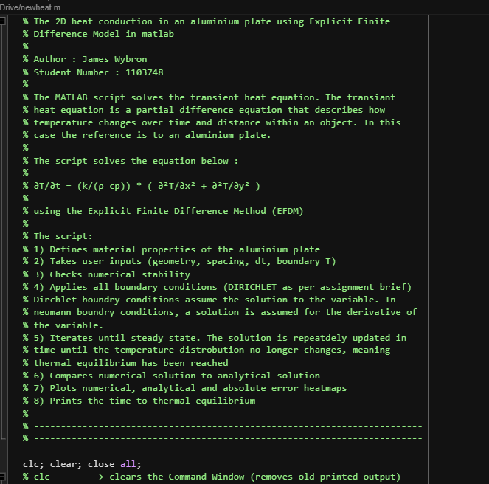
Figure 1 - Screen shot of code layout structure from MATLAB

5.2 Material Properties
The first main section of the code defines the thermophysical properties of aluminium, including thermal conductivity, density, and specific heat capacity. These properties determine how heat is transferred through the material.
The thermal diffusivity is then calculated using:
α = k / (ρcₚ)
Thermal diffusivity describes how quickly heat spreads through a material. Materials with a higher thermal diffusivity respond more quickly to temperature changes. This parameter is important for both the physical behaviour of the system and the numerical stability of the explicit time-marching scheme (Özisik, 1993).
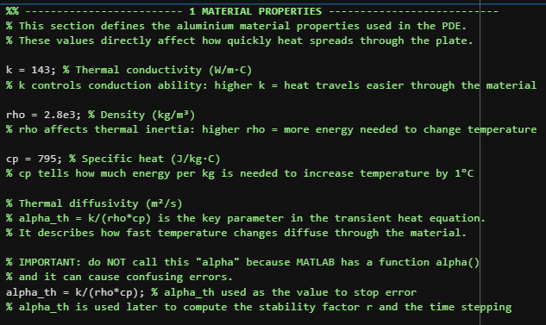
Figure 2 - Screen shot from MATLAB of materials properties code section

5.3 User Inputs and Spatial Discretisation
The plate geometry, grid spacing, time step, and boundary temperature are specified by the user when the code is initialised. The plate width and height define the physical domain, while the grid spacing determines the spatial resolution of the numerical solution.
Input validation is implemented to ensure:
- The physical dimensions of the plate are positive and non-zero.
- The grid spacing divides the domain exactly, ensuring that grid points align precisely with the physical boundaries.
The spatial domain is divided into a uniform Cartesian grid. The number of grid points in each direction is chosen so that the boundary points are included. Using a uniform grid makes the finite difference calculations simpler and helps maintain consistent accuracy across the whole domain.
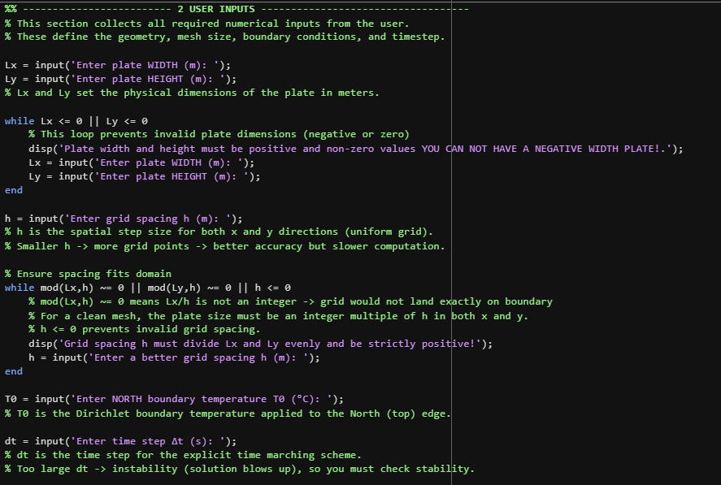
Figure 3 - MATLAB code showing code use to allow user inputs to be given in the command window
The trade-off between accuracy and computational cost is clearly illustrated by the choice of grid spacing. Smaller grid spacing improves spatial resolution but leads to an increased number of nodes, which in turn raises the computational time. To enhance user experience, error messages and polite prompts have been integrated into the code.

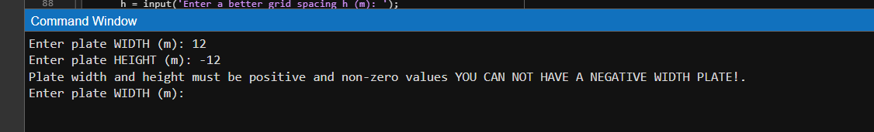
Figure 4 - Screenshot of the command window with a helpful prompt. Instructing the user that an input is incorrect

5.4 Numerical Stability Criterion
The explicit finite difference method is conditionally stable, meaning that the time step must be chosen carefully. For a two-dimensional heat conduction problem, stability requires the Fourier number to satisfy:
$$r=αΔt/h^{2}≤0.25$$
This condition ensures that heat does not move unrealistically fast between grid points within a single time step. If this requirement is not met, the numerical solution can become unstable and produce incorrect results (Patankar, 1980).
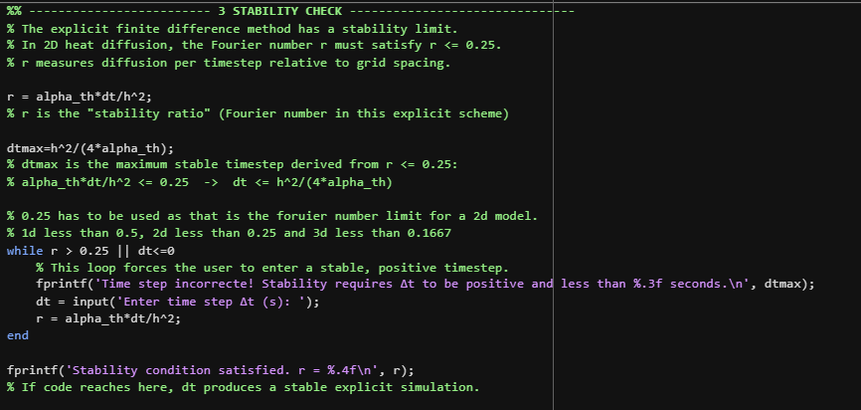
Figure 5 - Screen shot directly from MATLAB code of the stability check section with annotated notes
The code calculates the stability parameter and enforces this condition by repeatedly prompting the user to enter a valid time step if the criterion is not met. This safeguard ensures that all simulations are physically meaningful and numerically stable.

5.5 Grid Creation

The grid creation step divides the aluminium plate into a set of points where the temperature is calculated. This is required for the finite difference method, as it allows the spatial derivatives in the governing equation to be approximated using difference equations.
The number of grid points in the x- and y-directions is calculated from the plate dimensions and the chosen grid spacing, as shown below:
Nₓ = Lₓ / h + 1, Nᵧ = Lᵧ / h + 1
The extra grid point ensures that the boundary points of the plate are included, which is necessary for correctly applying the Dirichlet boundary conditions.
A two-dimensional temperature matrix is then set to zero to represent the initial temperature of the plate. Each value in the matrix corresponds to the temperature at a specific grid point, with rows representing the y-direction and columns representing the x-direction.
A uniform Cartesian grid is generated using the meshgrid function, which creates matrices containing the coordinates of each grid point. Although these coordinates are not required for the finite difference calculations, they are useful for evaluating the analytical solution and for plotting the temperature distribution. Using a uniform grid keeps the numerical approach simple and provides consistent accuracy across the domain.
Overall, this process converts the physical plate into a numerical grid that can be analysed using the explicit finite difference method. The chosen grid spacing represents a balance between accuracy and computational cost, as smaller spacing improves resolution but increases run time.
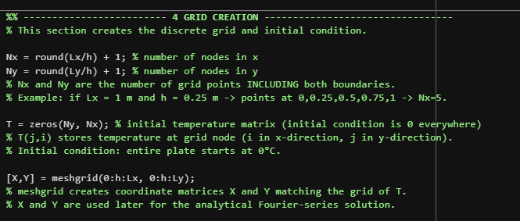
Figure 6 - Screenshot of MTLB code showing a section of grid creation

5.6 Boundary Conditions
Dirichlet boundary conditions are applied to all four sides of the plate, in line with the assignment requirements. The north boundary is held at a constant temperature, while the east, west, and south boundaries are fixed at zero temperature.
Dirichlet boundary conditions directly specify the temperature at the boundaries. This differs from Neumann boundary conditions, which define the heat flux instead. Using Dirichlet conditions helps ensure that the heat conduction problem is well-defined and has a unique solution (Özisik, 1993).
The boundary temperatures are enforced at every time step. This is necessary because the numerical update process could otherwise change the boundary values, leading to results that do not satisfy the physical constraints of the problem.
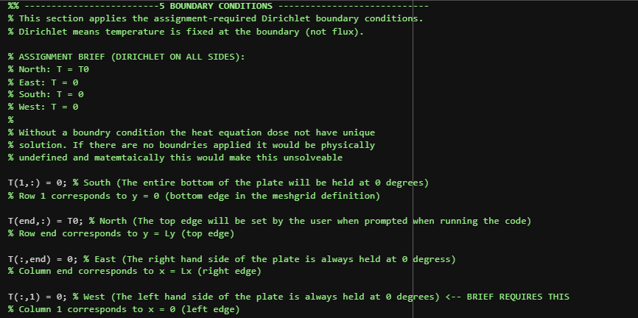
Figure 7 - Screenshot of MATLAB code setting up boundary conditions

5.7 Time Marching and Finite Difference Scheme
The transient solution is calculated by stepping the temperature field forward in time using an explicit time-marching loop. At each time step, the temperature at each interior grid point is updated using a five-point finite-difference approximation of the Laplacian.
This update equation represents heat diffusion from the four neighbouring grid points. In physical terms, heat flows from hotter to cooler regions, and the temperature change at a grid point depends on the temperature differences between that point and its surrounding nodes.
The explicit method is straightforward to implement and easy to understand, but it requires careful selection of the time step to maintain numerical stability. Even so, the explicit approach is suitable for educational and demonstration purposes because of its simplicity and clear formulation. (Smith, 1985).

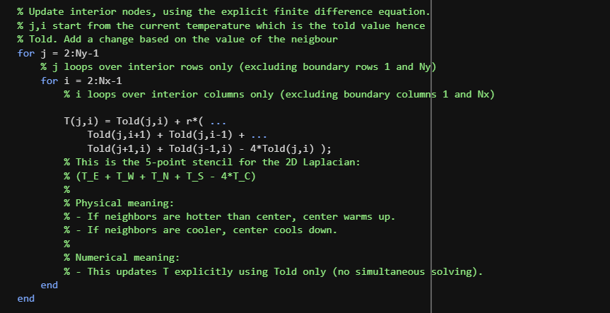
Figure 8 - MATLAB section of code for Time Marching & Finite Difference Scheme

5.8 Convergence and Steady-State Detection
Convergence and steady-state detection are implemented within the main time-stepping loop (Section 6 of the MATLAB code). At each timestep, the temperature field from the previous iteration is stored and compared with the updated field. The maximum absolute temperature change across the domain is evaluated, and when this value falls below a predefined tolerance, the solution is considered to have reached steady state. The total time required to reach equilibrium is accumulated and reported, allowing the transient behaviour of the system to be assessed.
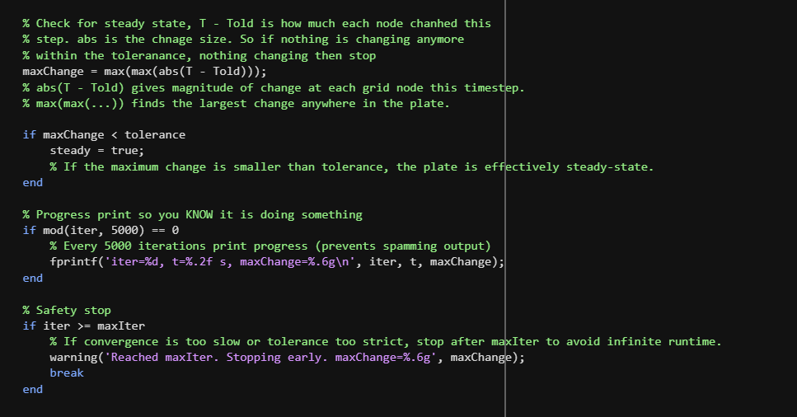
Figure 9 - MATLAB section of code for Convergence & Steady-State Detection

5.9 Analytical Solution and Validation
To validate the numerical solution, an analytical steady-state solution is computed using a Fourier series formulation. At steady state, the transient heat equation reduces to Laplace’s equation, for which closed-form solutions exist under Dirichlet boundary conditions (Carslaw and Jaeger, 1959).
The analytical solution is approximated using a finite number of Fourier terms, as it is not possible to evaluate an infinite series numerically. Increasing the number of terms improves accuracy but also increases computational cost.
Validation is performed by computing the pointwise absolute error between the numerical and analytical solutions. Both the maximum and mean errors are reported, providing quantitative measures of accuracy. This comparison demonstrates that the numerical method converges to the correct physical solution.
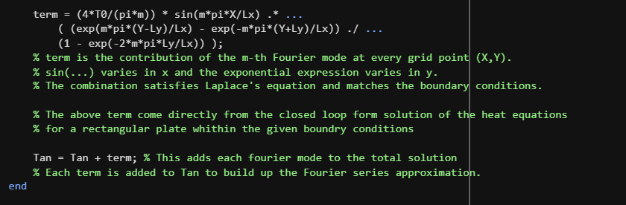
Figure 10 - MATLAB section of code Analytical Solution and Validation

5.10 Results Visualisation
The final temperature distributions are presented using contour heatmaps. Separate plots are generated for the numerical solution, the analytical solution, and the absolute error.
Visual comparison of the numerical and analytical temperature fields shows strong agreement, while the error distribution confirms that discrepancies are small and smooth. This visual validation complements the quantitative error metrics and provides confidence in the correctness of the numerical implementation.
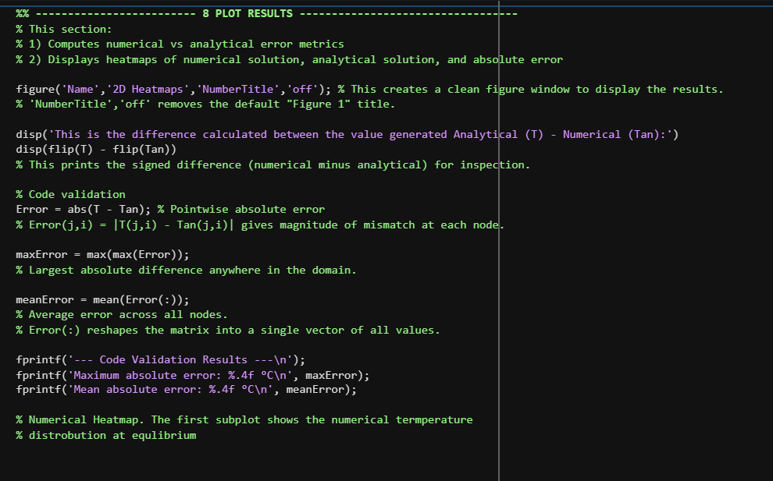
Figure 11 - Section of MATLAB code used for result visualisation
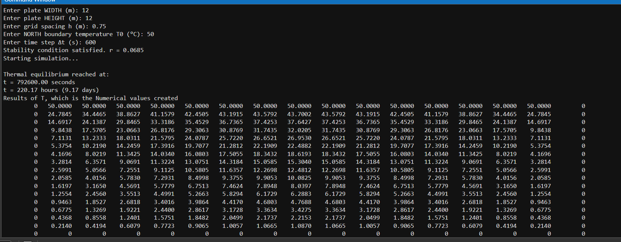
Figure 12 - Visualisation of values in the command window after the script is run with user inputs
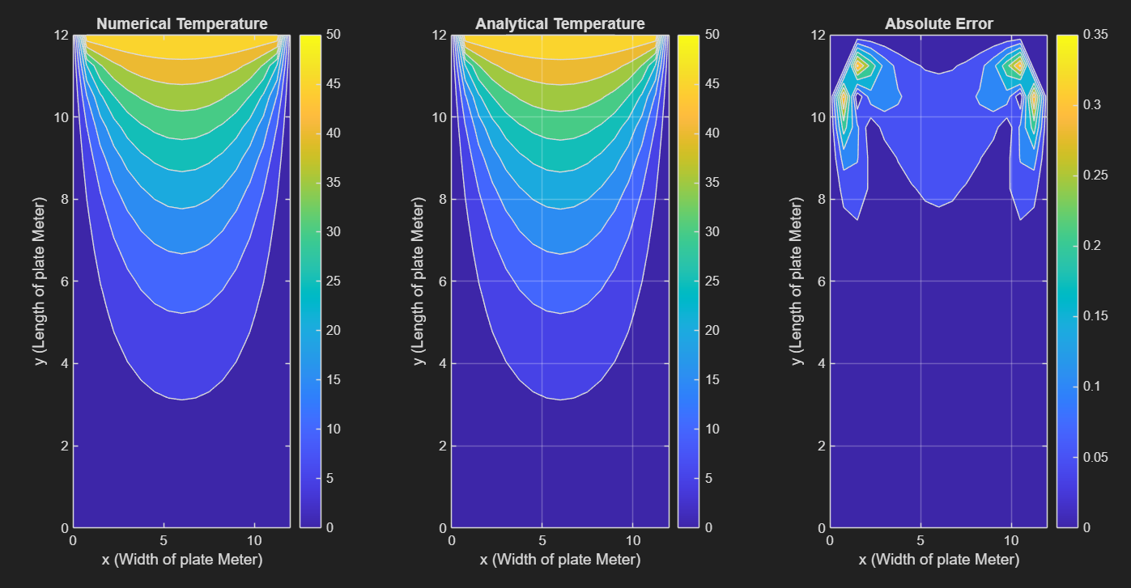
Figure 13 - plotted graphical representation of data for numeric, analytical and error all side by side for comparison

5.11 Summary
The MATLAB code successfully implements an explicit finite difference solution to the two-dimensional transient heat conduction problem. The numerical method is stable, physically consistent, and validated against an analytical solution. The structure of the code, combined with input validation, stability checks, and convergence monitoring, ensures robustness and reliability. Overall, the implementation provides an accurate and well-justified numerical model of heat conduction in an aluminium plate.

6. Validation of the Numerical Model

The model is validated by comparing the numerical steady-state temperature distribution obtained using the EFDM with the corresponding analytical solution. A visual comparison is carried out using heatmaps of the numerical solution, the analytical solution, and the absolute error between them.
Quantitative validation is performed by calculating the maximum absolute error and the root mean square error. These values provide clear numerical measures of how closely the numerical results match the analytical solution. The small error values obtained indicate good agreement between the two solutions, showing that the numerical model performs as expected under stable conditions and is consistent with second-order spatial discretisation (Smith, 1985; LeVeque, 2007).

7. Sensitivity Analysis of Key Numerical Parameters
Sensitivity analysis is essential for evaluating the robustness and reliability of numerical models and for understanding how numerical parameters influence accuracy and computational cost (Chapra and Canale, 2015).

7.1 Influence of Grid Spacing
Reducing the grid spacing increases the spatial resolution and reduces truncation error, but it also significantly increases the number of grid points and the computational effort required. The results show that using smaller grid spacing leads to longer predicted thermal equilibrium times and increased computation time.
This trend is consistent with the second-order truncation error, O(h²), associated with the spatial discretisation method and is well documented in the numerical analysis literature (Morton and Mayers, 2005; LeVeque, 2007). As the grid spacing becomes very small, the change in thermal equilibrium time between successive cases becomes minimal and eventually unnoticeable when rounded to the nearest second. This is also shown graphically.

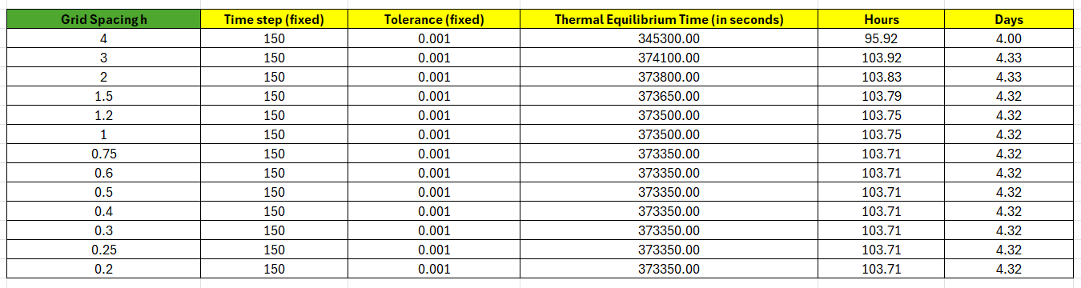
Figure 14 - Excell screen shot showing results of altering grid spacing and its effect on time to equilibrium
With the tabulated results, two additional columns were added for hours and days. This was done because it can be difficult to grasp the extent of time in seconds, and the hours and days provide some clarity to the results. However, all graphical representations are in seconds.

Figure 15 - graphical representation of results from varying grid spacing to reach equilibrium
The results of the graph show that thermal equilibrium time is largely independent of grid spacing up to a value of 3, beyond which numerical inaccuracies arise due to excessive spatial coarsening.

7.2 Influence of Time Step
The time step controls both the temporal resolution and the numerical stability of the solution. Using larger time steps reduces the number of iterations required, but moves the solution closer to the stability limit and increases the risk of numerical error. Smaller time steps improve accuracy in time, but require more computation.
These trends are typical of explicit numerical schemes and demonstrate the trade-off between efficiency and accuracy (Smith, 1985; Chapra and Canale, 2015). This behaviour can be clearly seen in the results, where reducing the time step leads to a shorter predicted thermal equilibrium time.
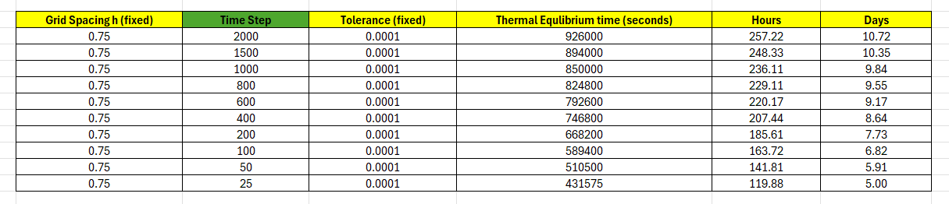
Figure 16 - Excel results for altering the time step and its effect in seconds on reaching thermal equilibrium

Figure 17 - Graphical representation of altering the time step and its effects on thermal equilibrium in terms of time
The results show that thermal equilibrium time is strongly dependent on the time step at low values, but approaches convergence as the time step increases. However, beyond this point, numerical inaccuracies may start to occur.

7.3 Influence of Thermal Equilibrium Tolerance
The convergence tolerance determines how strictly thermal equilibrium is defined in the simulation. Using a tighter tolerance increases the time required to reach equilibrium, while a looser tolerance reduces the computational effort but may cause the simulation to stop too early. This behaviour highlights the difference between numerical convergence and the true physical steady state of the system (Özisik, 1994).
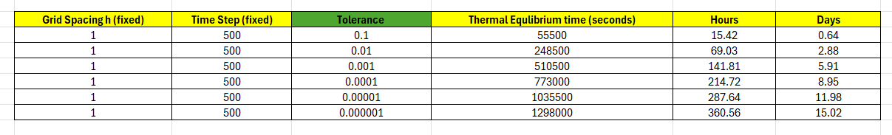
Figure 18 - Excel results of altering the Tolerance and its effects on reaching thermal equilibrium in terms of time

Figure 19 - Graphical representation of altering the tolerance condition and its effect on time in reaching thermal equilibrium

8. Limitations of the Numerical Model
The EFDM is conditionally stable and is affected by truncation and round-off errors. The sensitivity analysis shows that improving accuracy by reducing the grid spacing or using a stricter convergence tolerance leads to a higher computational cost. In addition, defining thermal equilibrium using a numerical convergence criterion is a practical approach for coding, but it does not always fully represent the true physical steady-state behaviour of heat transfer. These limitations highlight the importance of careful parameter selection and suggest that alternative numerical methods could be explored to improve performance and accuracy (LeVeque, 2007; Özisik, 1994).
In a real-world situation, a plate exposed to environmental conditions would behave very differently. Factors such as ambient temperature, air movement, and heat losses to the surroundings would all influence how the plate heats up and cools down. These effects are not included in the numerical model; however, the model still provides a cost-effective and useful method for analysing heat transfer behaviour during the research and development stage.

9. Suggested Improvements and Future Developments
Future improvements to the model could focus on improving stability, efficiency, and physical realism. One improvement would be to use an implicit time-stepping method, such as the Crank–Nicolson scheme. Unlike the explicit method, implicit methods remain stable when larger time steps are used, which would reduce the number of iterations required while still maintaining accuracy, particularly for long simulations (Morton and Mayers, 2005).
The model could be enhanced by implementing an adaptive time step. Rather than using a fixed time step, the code could automatically adjust the time step during the simulation. Larger time steps could be employed when temperature changes are minimal, which would reduce computation time, while smaller time steps could be applied during periods of significant temperature changes to ensure accuracy. This approach improves efficiency without markedly affecting the results. (Chapra and Canale, 2015).
One possible improvement would be to adopt a more physically meaningful convergence criterion. Currently, steady state is determined by observing changes in temperature between time steps. This approach could be enhanced by also considering the overall heat balance or ensuring that temperature changes remain minimal over several consecutive time steps. Implementing these measures would reduce the risk of terminating the simulation too early and would more accurately reflect true steady-state heat transfer behavior. (Özisik, 1994).
The computational efficiency of the code could be improved. This can be achieved by minimizing the use of nested loops and utilizing more vectorized array operations. While this won't alter the numerical method itself, it will significantly reduce run time, particularly when working with finer grids. (Incropera et al., 2011).
The boundary conditions can be made more realistic. The current model uses fixed temperature boundaries. However, in real applications surfaces exchange heat with the surrounding air through convection. By replacing the fixed boundary temperatures with convective boundary conditions, the model would better reflect environmental effects and enhance the realism of the simulation. (Smith, 1985).

10. Conclusion
A numerical model for two-dimensional heat diffusion in an aluminium plate has been successfully developed using the Explicit Finite Difference Method . The model was validated against an analytical solution and demonstrated accurate results under stable conditions. The results were automatically displayed in tables in the command window, along with graphical representations.
The sensitivity analysis highlighted the influence of grid spacing, time step, and convergence tolerance on model performance. An optimal balance was found between efficiency, accuracy, and computational time. While the EFDM is appreciated for its simplicity and transparency, its limitations suggest opportunities for further development using more advanced numerical techniques, which are discussed in detail in Section Nine, Suggested Improvements. However, it is important to note that this model does not account for environmental or real-world factors. Therefore, it can be beneficial for research purposes without incurring the costs of practical applications.
Conducting the experiment in a real-world setting would be interesting. However, achieving the same level of accuracy as the numerical model may not be feasible. Additionally, if thermocouples or any other form of monitoring were used, their metallic bodies could affect heat distribution, as their contact with the plate would change the overall surface area.
From that point, the theoretical model also has many advantages over a real-world application. More than likely, any testing application must be confirmed with real testing to allow a product or material to go into application.

11. References
Carslaw, H.S. and Jaeger, J.C. (1959) Conduction of Heat in Solids. 2nd edn. Oxford: Oxford University Press.
Chapra, S.C. and Canale, R.P. (2015) Numerical Methods for Engineers. 7th edn. New York: McGraw-Hill.
Holman, J.P. (2010) Heat Transfer. 10th edn. New York: McGraw-Hill.
Incropera, F.P., DeWitt, D.P., Bergman, T.L. and Lavine, A.S. (2017) Fundamentals of Heat and Mass Transfer. 7th edn. Hoboken: Wiley.
LeVeque, R.J. (2007) Finite Difference Methods for Ordinary and Partial Differential Equations. Philadelphia: SIAM.
Morton, K.W. and Mayers, D.F. (2005) Numerical Solution of Partial Differential Equations. Cambridge: Cambridge University Press.
Özisik, M.N. (1994) Finite Difference Methods in Heat Transfer. Boca Raton: CRC Press.
Richtmyer, R.D. and Morton, K.W. (1967) Difference Methods for Initial-Value Problems. New York: Wiley.
Smith, G.D. (1985) Numerical Solution of Partial Differential Equations. Oxford: Oxford University Press.
Zienkiewicz, O.C., Taylor, R.L. and Zhu, J.Z. (2013) The Finite Element Method. 7th edn. Oxford: Butterworth-Heinemann.
Carslaw, H.S. and Jaeger, J.C. (1959) Conduction of Heat in Solids. 2nd edn. Oxford: Oxford University Press.
Incropera, F.P., DeWitt, D.P., Bergman, T.L. and Lavine, A.S. (2011) Fundamentals of Heat and Mass Transfer. 7th edn. Hoboken: Wiley.
Özisik, M.N. (1993) Heat Conduction. 2nd edn. New York: Wiley.
Patankar, S.V. (1980) Numerical Heat Transfer and Fluid Flow. New York: Hemisphere.
Smith, G.D. (1985) Numerical Solution of Partial Differential Equations. Oxford: Oxford University Press.

12. Appendix – MATLAB Code
% The 2D heat conduction in an aluminium plate using Explicit Finite
% Difference Model in matlab
%
% Author : James Wybron
% Student Number : 1103748
%
% The MATLAB script solves the transient heat equation. The transiant
% heat equation is a partial difference equation that describes how
% temperature changes over time and distance within an object. In this
% case the reference is to an aluminium plate.
%
% The script solves the equation below :
%
% ∂T/∂t = (k/(ρ cp)) * ( ∂²T/∂x² + ∂²T/∂y² )
%
% using the Explicit Finite Difference Method (EFDM)
%
% The script:
% 1) Defines material properties of the aluminium plate
% 2) Takes user inputs (geometry, spacing, dt, boundary T)
% 3) Checks numerical stability
% 4) Applies all boundary conditions (DIRICHLET as per assignment brief)
% Dirchlet boundry conditions assume the solution to the variable. In
% neumann boundry conditions, a solution is assumed for the derivative of
% the variable.
% 5) Iterates until steady state. The solution is repeatdely updated in
% time until the temperature distrobution no longer changes, meaning
% thermal equilibrium has been reached
% 6) Compares numerical solution to analytical solution
% 7) Plots numerical, analytical and absolute error heatmaps
% 8) Prints the time to thermal equilibrium
%
% ------------------------------------------------------------------------
% ------------------------------------------------------------------------

clc; clear; close all;
% clc -> clears the Command Window (removes old printed output)
% clear -> clears variables from the Workspace (fresh run, no leftovers)
% close all -> closes any open figure windows (prevents plots stacking up)

%% ------------------------- 1 MATERIAL PROPERTIES ---------------------------
% This section defines the aluminium material properties used in the PDE.
% These values directly affect how quickly heat spreads through the plate.

k = 143; % Thermal conductivity (W/m·C)
% k controls conduction ability: higher k = heat travels easier through the material

rho = 2.8e3; % Density (kg/m³)
% rho affects thermal inertia: higher rho = more energy needed to change temperature

cp = 795; % Specific heat (J/kg·C)
% cp tells how much energy per kg is needed to increase temperature by 1°C

% Thermal diffusivity (m²/s)
% alpha_th = k/(rho*cp) is the key parameter in the transient heat equation.
% It describes how fast temperature changes diffuse through the material.

% IMPORTANT: do NOT call this "alpha" because MATLAB has a function alpha()
% and it can cause confusing errors.
alpha_th = k/(rho*cp); % alpha_th used as the value to stop error
% alpha_th is used later to compute the stability factor r and the time stepping

%% ------------------------- 2 USER INPUTS -----------------------------------
% This section collects all required numerical inputs from the user.
% These define the geometry, mesh size, boundary conditions, and timestep.

Lx = input('Enter plate WIDTH (m): ');
Ly = input('Enter plate HEIGHT (m): ');
% Lx and Ly set the physical dimensions of the plate in meters.

while Lx <= 0 || Ly <= 0
% This loop prevents invalid plate dimensions (negative or zero)
disp('Plate width and height must be positive and non-zero values YOU CAN NOT HAVE A NEGATIVE WIDTH PLATE!.');
Lx = input('Enter plate WIDTH (m): ');
Ly = input('Enter plate HEIGHT (m): ');
end

h = input('Enter grid spacing h (m): ');
% h is the spatial step size for both x and y directions (uniform grid).
% Smaller h -> more grid points -> better accuracy but slower computation.

% Ensure spacing fits domain
while mod(Lx,h) ~= 0 || mod(Ly,h) ~= 0 || h <= 0
% mod(Lx,h) ~= 0 means Lx/h is not an integer -> grid would not land exactly on boundary
% For a clean mesh, the plate size must be an integer multiple of h in both x and y.
% h <= 0 prevents invalid grid spacing.
disp('Grid spacing h must divide Lx and Ly evenly and be strictly positive!');
h = input('Enter a better grid spacing h (m): ');
end

T0 = input('Enter NORTH boundary temperature T0 (°C): ');
% T0 is the Dirichlet boundary temperature applied to the North (top) edge.

dt = input('Enter time step Δt (s): ');
% dt is the time step for the explicit time marching scheme.
% Too large dt -> instability (solution blows up), so you must check stability.

%% ------------------------- 3 STABILITY CHECK -------------------------------
% The explicit finite difference method has a stability limit.
% In 2D heat diffusion, the Fourier number r must satisfy r <= 0.25.
% r measures diffusion per timestep relative to grid spacing.

r = alpha_th*dt/h^2;
% r is the "stability ratio" (Fourier number in this explicit scheme)

dtmax=h^2/(4*alpha_th);
% dtmax is the maximum stable timestep derived from r <= 0.25:
% alpha_th*dt/h^2 <= 0.25 -> dt <= h^2/(4*alpha_th)

% 0.25 has to be used as that is the foruier number limit for a 2d model.
% 1d less than 0.5, 2d less than 0.25 and 3d less than 0.1667
while r > 0.25 || dt<=0
% This loop forces the user to enter a stable, positive timestep.
fprintf('Time step incorrecte! Stability requires Δt to be positive and less than %.3f seconds.\n', dtmax);
dt = input('Enter time step Δt (s): ');
r = alpha_th*dt/h^2;
end

fprintf('Stability condition satisfied. r = %.4f\n', r);
% If code reaches here, dt produces a stable explicit simulation.

%% ------------------------- 4 GRID CREATION ---------------------------------
% This section creates the discrete grid and initial condition.

Nx = round(Lx/h) + 1; % number of nodes in x
Ny = round(Ly/h) + 1; % number of nodes in y
% Nx and Ny are the number of grid points INCLUDING both boundaries.
% Example: if Lx = 1 m and h = 0.25 m -> points at 0,0.25,0.5,0.75,1 -> Nx=5.

T = zeros(Ny, Nx); % initial temperature matrix (initial condition is 0 everywhere)
% T(j,i) stores temperature at grid node (i in x-direction, j in y-direction).
% Initial condition: entire plate starts at 0°C.

[X,Y] = meshgrid(0:h:Lx, 0:h:Ly);
% meshgrid creates coordinate matrices X and Y matching the grid of T.
% X and Y are used later for the analytical Fourier-series solution.

%% -------------------------5 BOUNDARY CONDITIONS ----------------------------
% This section applies the assignment-required Dirichlet boundary conditions.
% Dirichlet means temperature is fixed at the boundary (not flux).

% ASSIGNMENT BRIEF (DIRICHLET ON ALL SIDES):
% North: T = T0
% East: T = 0
% South: T = 0
% West: T = 0
%
% Without a boundry condition the heat equation dose not have unique
% solution. If there are no boundries applied it would be physically
% undefined and matemtaically this would make this unsolveable

T(1,:) = 0; % South (The entire bottom of the plate will be held at 0 degrees)
% Row 1 corresponds to y = 0 (bottom edge in the meshgrid definition)

T(end,:) = T0; % North (The top edge will be set by the user when prompted when running the code)
% Row end corresponds to y = Ly (top edge)

T(:,end) = 0; % East (The right hand side of the plate is always held at 0 degress)
% Column end corresponds to x = Lx (right edge)

T(:,1) = 0; % West (The left hand side of the plate is always held at 0 degrees) <-- BRIEF REQUIRES THIS
% Column 1 corresponds to x = 0 (left edge)

%% -------------------------6 TIME LOOP -------------------------------------
% This section performs the transient simulation using explicit time stepping.
% At each timestep:
% 1) Copy old temperature field (Told)
% 2) Update interior nodes using the 2D Laplacian finite difference stencil
% 3) Reapply boundary conditions (so boundaries stay fixed)
% 4) Check if solution has converged to steady state

t = 0;
% Simulation time starts at 0 seconds.

% Convergence criterion threshold:
% 1e-6 is VERY strict and can take ages. For coursework a good value is 1e-3 to 1e-4.
% Choose a value you can justify as "negligible change" and still runs fast.
tolerance = 0.0001; % This is the CC Value. This value will be altered throughout the project to
% input different magnitudes to alter the outcome values
% tolerance is the steady-state stopping criterion: max change anywhere in the plate must be < tolerance.

steady = false;
% steady is a logical flag controlling the while loop.
% The simulation runs until steady becomes true.

% t= 0 sets the initial simulations time to zero, this is the start of the
% trsnient analysis. It is needed as the heat equation is time dependent.
% We need to track how long it takes to reach equlibrium, each loop adds
% dt to t
%
% tolerance defines how small the temperature changes must be before finaly
% stopping. This gives a practical definition of 'steady state'
%
% steady = false creates a logical flag, tells the program that we are not
% at steady state yet, it controls the while loop and runs until the steady
% state has become true.

fprintf('Starting simulation...\n');
% Prints a start message so the user knows the program is running.

% Safety + progress (stops tail-chasing and shows it is working)
iter = 0;
maxIter = 500000; % safety cap
% iter counts the number of timesteps taken.
% maxIter prevents an infinite loop if convergence is too slow or impossible.

while ~steady %keep looping while steady is NOT true

iter = iter + 1;
% Increment timestep counter.

Told = T; % previous step, save the previous temperature field, you need
% the old value to be able to calulate the new value
% Told stores the temperature field from the previous timestep.
% Explicit methods require using only old (known) values to compute new ones.

% Update interior nodes, using the explicit finite difference equation.
% j,i start from the current temperature which is the told value hence
% Told. Add a change based on the value of the neigbour
for j = 2:Ny-1
% j loops over interior rows only (excluding boundary rows 1 and Ny)
for i = 2:Nx-1
% i loops over interior columns only (excluding boundary columns 1 and Nx)

T(j,i) = Told(j,i) + r*( ...
Told(j,i+1) + Told(j,i-1) + ...
Told(j+1,i) + Told(j-1,i) - 4*Told(j,i) );
% This is the 5-point stencil for the 2D Laplacian:
% (T_E + T_W + T_N + T_S - 4*T_C)
%
% Physical meaning:
% - If neighbors are hotter than center, center warms up.
% - If neighbors are cooler, center cools down.
%
% Numerical meaning:
% - This updates T explicitly using Told only (no simultaneous solving).
end
end

% Reapply Dirichlet BCs (IMPORTANT: keep boundaries fixed every time step)
% Even though boundaries were set earlier, we must reset them every timestep.
% This prevents numerical drift of boundary values due to updates/copying.
T(1,:) = 0; % south value is fixed at 0
T(end,:) = T0; % north fixed at T0
T(:,end) = 0; % east fixed at 0
T(:,1) = 0; % west fixed at 0 <-- BRIEF REQUIRES THIS

% Update time
t = t + dt;
% Each loop corresponds to one timestep, so simulation time advances by dt.

% Check for steady state, T - Told is how much each node chanhed this
% step. abs is the chnage size. So if nothing is changing anymore
% within the toleranance, nothing changing then stop
maxChange = max(max(abs(T - Told)));
% abs(T - Told) gives magnitude of change at each grid node this timestep.
% max(max(...)) finds the largest change anywhere in the plate.

if maxChange < tolerance
steady = true;
% If the maximum change is smaller than tolerance, the plate is effectively steady-state.
end

% Progress print so you KNOW it is doing something
if mod(iter, 5000) == 0
% Every 5000 iterations print progress (prevents spamming output)
fprintf('iter=%d, t=%.2f s, maxChange=%.6g\n', iter, t, maxChange);
end

% Safety stop
if iter >= maxIter
% If convergence is too slow or tolerance too strict, stop after maxIter to avoid infinite runtime.
warning('Reached maxIter. Stopping early. maxChange=%.6g', maxChange);
break
end

end

% Displaying that the thermal equlibrium is reached in days or minutes,
% hours etc
t_seconds = t;
t_hours = t_seconds / 3600;
t_days = t_hours / 24;
% Converts the final steady time into more readable units.

fprintf('\nThermal equilibrium reached at:\n');
fprintf('t = %.2f seconds\n', t_seconds);

if t_hours < 24
fprintf('t = %.2f hours\n', t_hours);
else
fprintf('t = %.2f hours (%.2f days)\n', t_hours, t_days);
end

%% ------------------------- 7 ANALYTICAL SOLUTION ---------------------------
% This section computes the analytical steady-state solution for the same
% boundary conditions, so you can validate your numerical method.
% The analytical solution is given as a Fourier series (infinite series),
% approximated here by summing a finite number of terms.

Tan = zeros(size(T)); % creates a matrix the same size as the numerical solution,
% this will store the analytical temperature at each grid point
% Tan(j,i) will represent the analytical temperature at the same coordinates as T(j,i).

% The analytical solution is expressed as a fourier series and is approximated
% using a finite number of terms. You cant compute infinity.
% (This analytical form matches DIRICHLET boundaries: west/east/south = 0, north = T0)

for n = 0:100000 % more terms = better match, but not infinity. There is a limit to what MATLAB can run, theres a trade off between accuracy and time taken!
% n indexes Fourier modes. You sum lots of modes to approach the true solution.
% Using 100001 iterations is very expensive but increases accuracy.

m = 2*n + 1; % only odd terms will apear in the solution due to the boundry conditions
% Many rectangular Dirichlet solutions produce only odd harmonics due to symmetry.

term = (4*T0/(pi*m)) * sin(m*pi*X/Lx) .* ...
( (exp(m*pi*(Y-Ly)/Lx) - exp(-m*pi*(Y+Ly)/Lx)) ./ ...
(1 - exp(-2*m*pi*Ly/Lx)) );
% term is the contribution of the m-th Fourier mode at every grid point (X,Y).
% sin(...) varies in x and the exponential expression varies in y.
% The combination satisfies Laplace's equation and matches the boundary conditions.

% The above term come directly from the closed loop form solution of the heat equations
% for a rectangular plate whithin the given boundry conditions

Tan = Tan + term; % This adds each fourier mode to the total solution
% Each term is added to Tan to build up the Fourier series approximation.
end

disp('Results of T, which is the Numerical values created')
disp(flip(T))
% flip(T) is displayed so the output appears with the "top" of the plate first (visual preference)

disp('Results of Tan, which is the Analytical values created')
disp(flip(Tan))
% Same for analytical matrix.

%% ------------------------- 8 PLOT RESULTS ----------------------------------
% This section:
% 1) Computes numerical vs analytical error metrics
% 2) Displays heatmaps of numerical solution, analytical solution, and absolute error

figure('Name','2D Heatmaps','NumberTitle','off'); % This creates a clean figure window to display the results.
% 'NumberTitle','off' removes the default "Figure 1" title.

disp('This is the difference calculated between the value generated Analytical (T) - Numerical (Tan):')
disp(flip(T) - flip(Tan))
% This prints the signed difference (numerical minus analytical) for inspection.

% Code validation
Error = abs(T - Tan); % Pointwise absolute error
% Error(j,i) = |T(j,i) - Tan(j,i)| gives magnitude of mismatch at each node.

maxError = max(max(Error));
% Largest absolute difference anywhere in the domain.

meanError = mean(Error(:));
% Average error across all nodes.
% Error(:) reshapes the matrix into a single vector of all values.

fprintf('--- Code Validation Results ---\n');
fprintf('Maximum absolute error: %.4f °C\n', maxError);
fprintf('Mean absolute error: %.4f °C\n', meanError);

% Numerical Heatmap. The first subplot shows the numerical termperature
% distrobution at equlibrium
subplot(1,3,1); % makes a 1 row * 3 coloumns layout and selects plot 1
contourf(0:h:Lx, 0:h:Ly, T); % Draws a coulor heatmap of matrix T
% contourf draws filled contours (a smooth heatmap-like plot).

colorbar; % adds scale showing what temperature each colour repesents
title('Numerical Temperature');
xlabel('x (Width of plate Meter)');
ylabel('y (Length of plate Meter)');

% Analytical Heatmap
subplot(1,3,2);
contourf(0:h:Lx, 0:h:Ly, Tan);
colorbar;
title('Analytical Temperature');
xlabel('x (Width of plate Meter)');
ylabel('y (Length of plate Meter)');
grid
% grid overlays grid lines (visual aid).

% Absolute Error Heatmap
subplot(1,3,3);
contourf(0:h:Lx, 0:h:Ly, abs(T - Tan));
% Plot the absolute error distribution so you can see *where* mismatch is largest.

colorbar;
title('Absolute Error');
xlabel('x (Width of plate Meter)');
ylabel('y (Length of plate Meter)');
grid

