Collaborative composition:
For this composition I improvised and recorded a saxophone riff over the chords. This was also the basis of the melody in the verse. I also made the drums on a drum pad using the abbey road kit by native instruments. I then exported each drum as an audio stem for mixing. I helped with the overall structure of the song when I did an arrangement which I sent back to be iterated on. See screenshot below for some evidence of involvement.
Song: I'll be Your Dart 5_12.wav
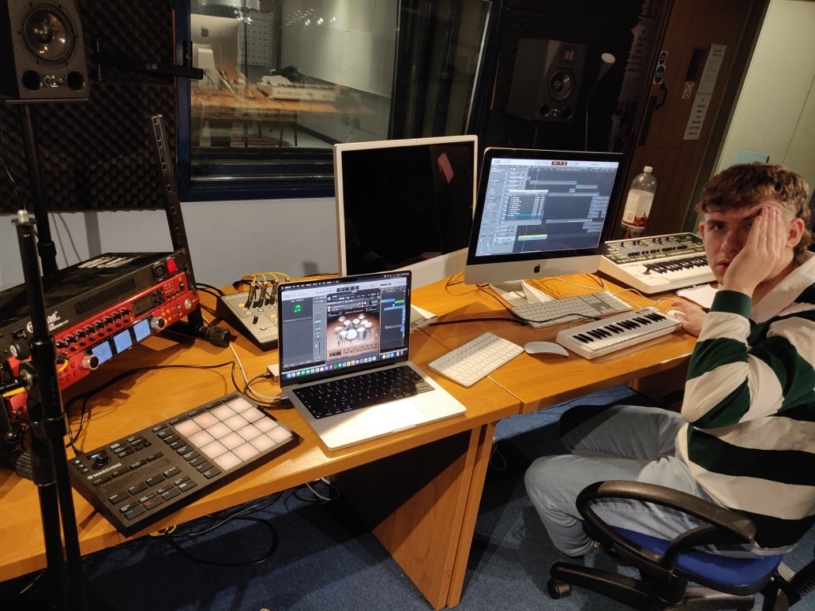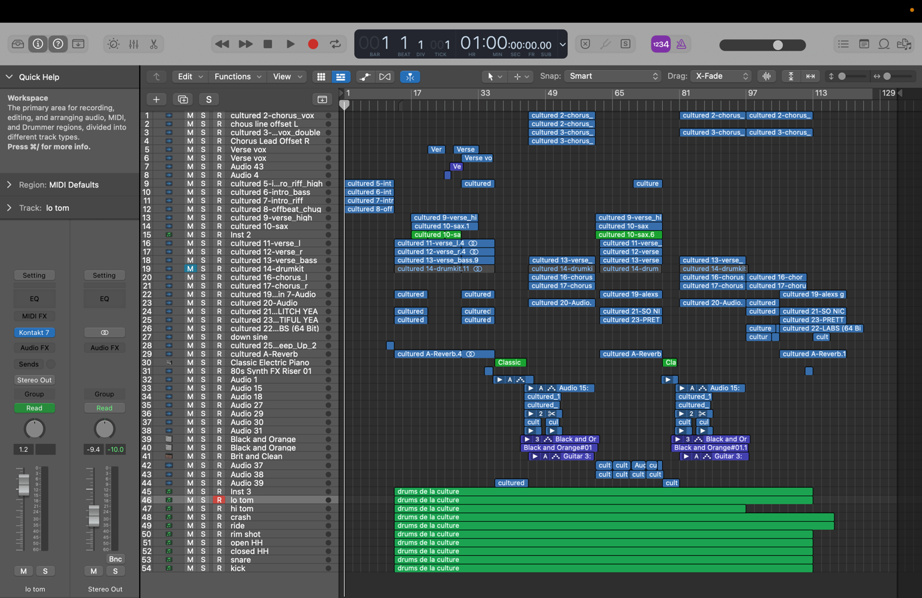
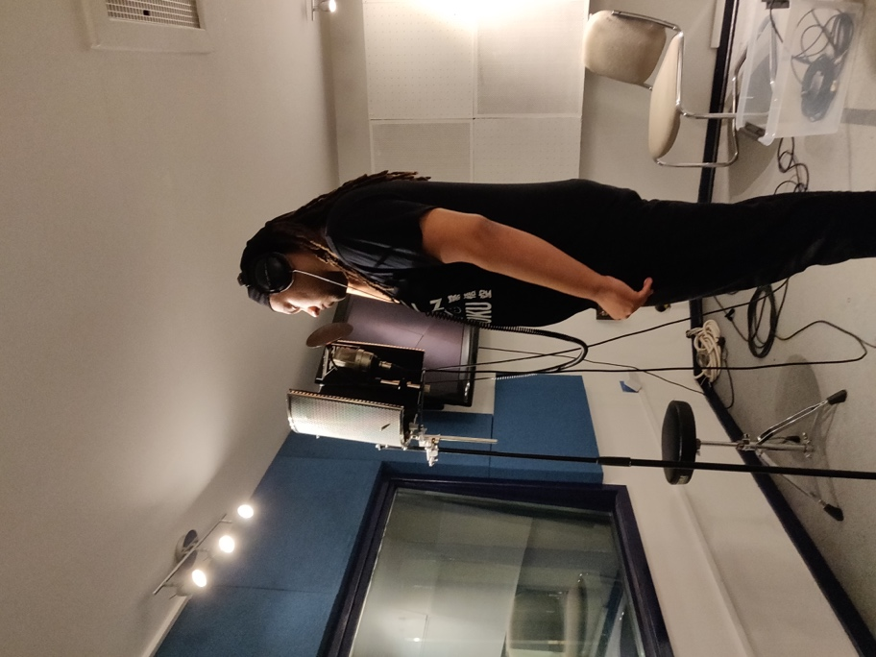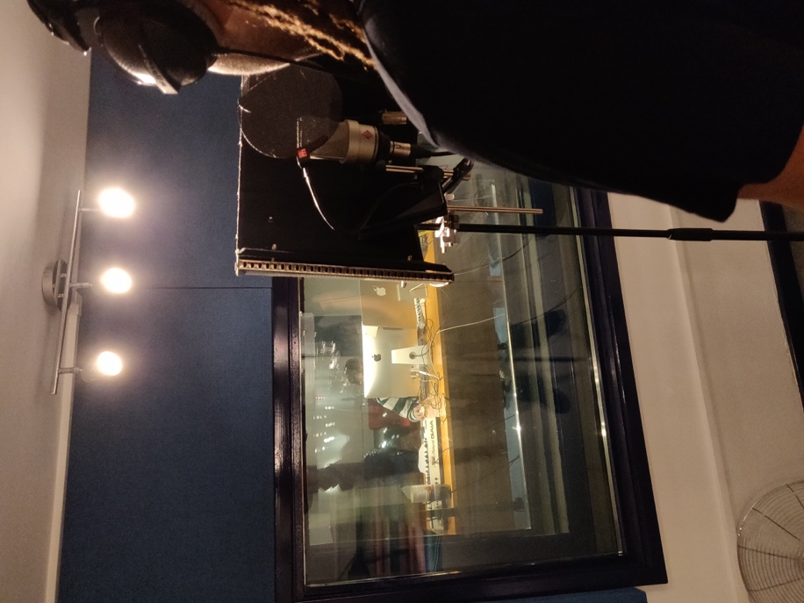

Virtual Collaboration:
For this part of the assignment, I made an instrumental on logic. I sampled 4 bar guitar riff and created a synth melody and drums to go with it. I sent it to Dontay using OneDrive and he added vocals and mixed it. We communicated over Instagram
Song: virtual collab v2.wav
virtual collab v2.mp3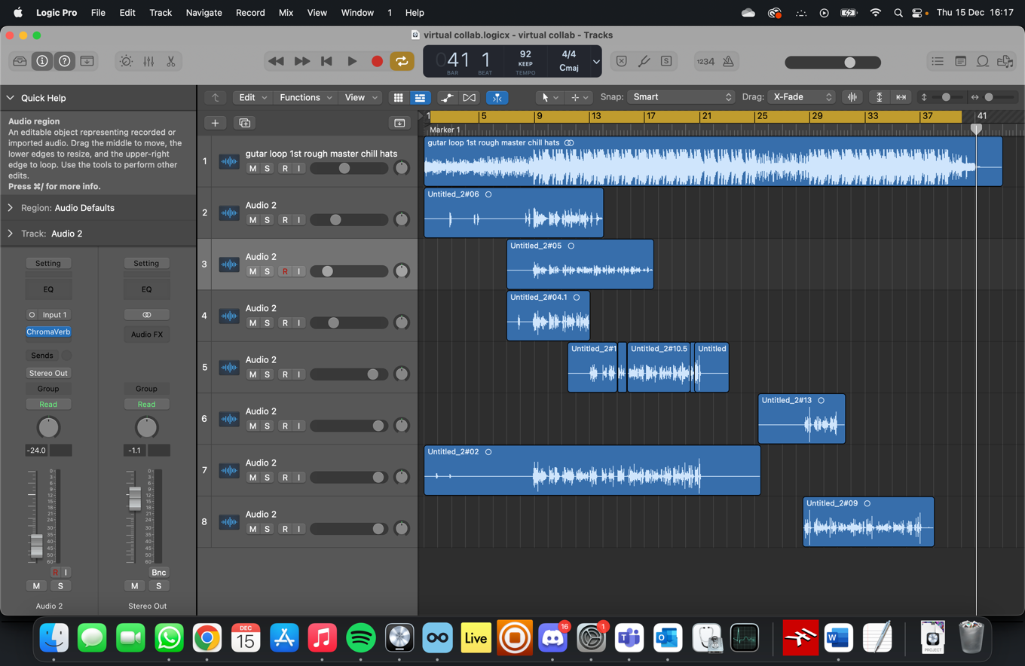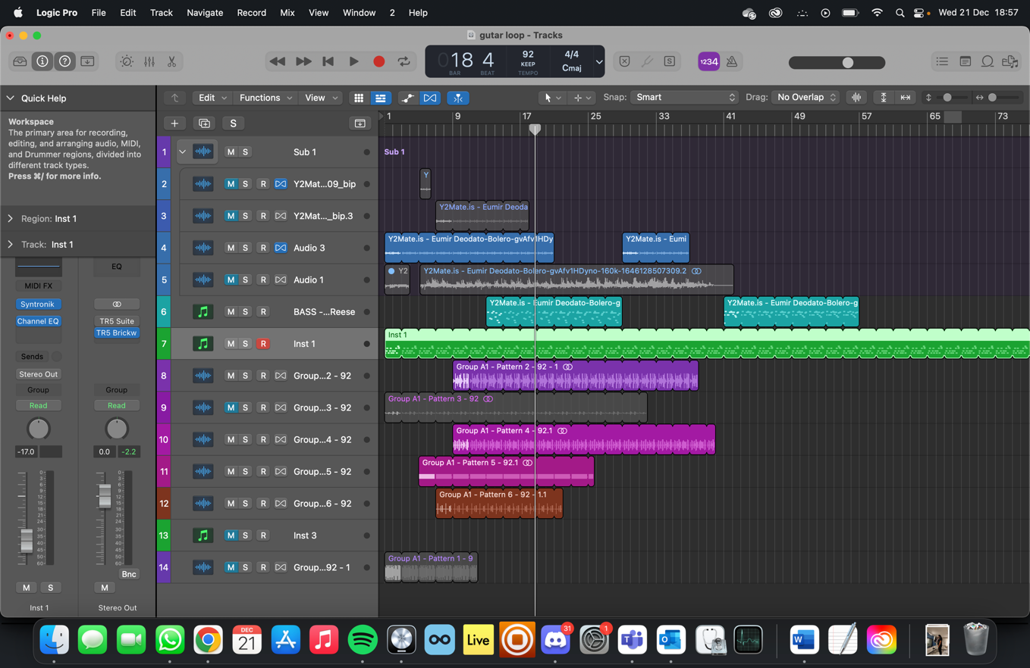
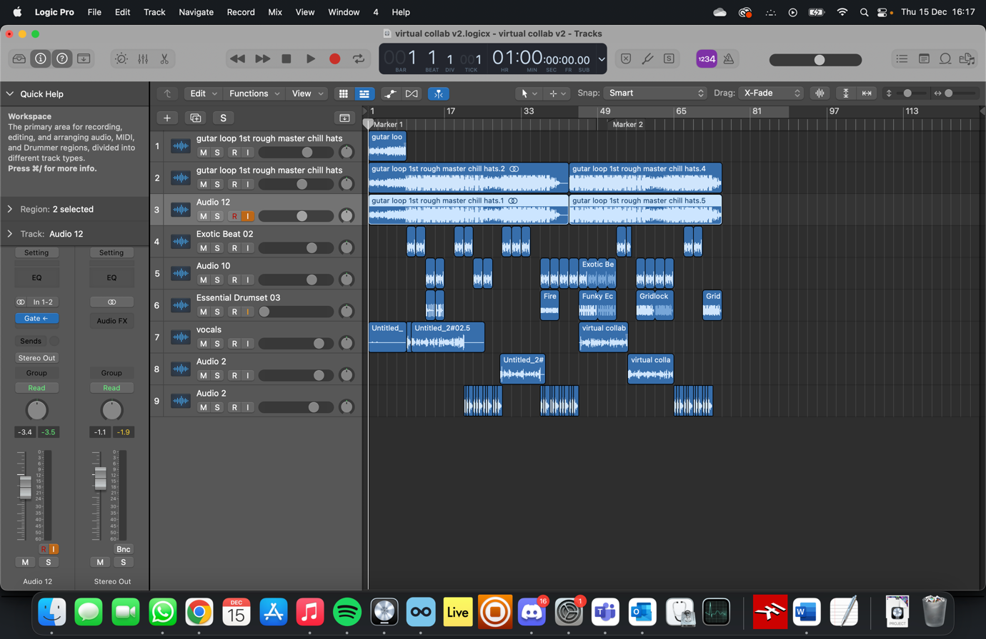

Visual Branding
My branding is inspired by surfing which is very important to me. It started off as a background I found online, I tried some colour variations before deciding on one. I also had to increase the font size because it was not clearly visible. For me the background invokes vibrancy and has an almost psychedelic quality.
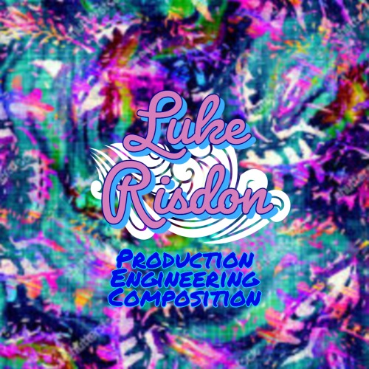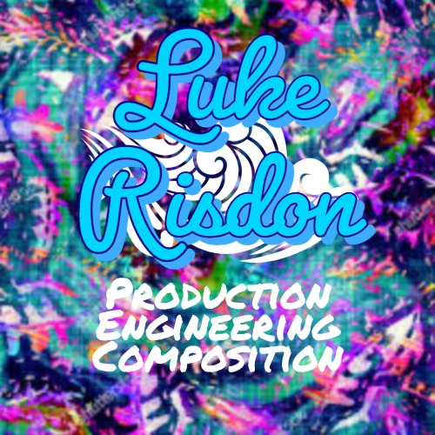
Animation: Visual Branding.mp4
Online Portal: https://www.youtube.com/channel/UCalx2_8yquQp0ocBbUk04SA

Biography

Luke Risdon is a talented saxophonist and producer born and raised in the city of Nottingham. With a passion for music and a love for creating, Luke has been exploring and creating music for many years.
Influenced by the likes of Red Hot Chili Peppers, Aphex Twin, and Kanye West, Luke began his musical journey at the age of 7 when he played drums on stage with the folk legend Boo Hewerdine. Their collaboration was a hit with the audience. Throughout his life, he has attended the Stainsby folk festival every year since he was 3 months old, and last year he was able to be part of the live sound team.
Luke has always been involved in school bands and theatre productions, so far culminating in a performance at Rock city, the biggest club in Nottingham, in a battle of the bands competition. They won the chance to perform at the Splendour festival, further solidifying his talent and passion for music.
It was in 6th form that Luke discovered a passion for production and composition, and he has continued to explore and develop his skills as a producer.
With his talent and dedication to his craft, Luke continues to expand his skillset. He is constantly seeking out new opportunities and challenges to showcase his talents and push himself to grow as a musician and producer.

