  Component One: Student Journal  Contribution to Overall Module Assessment: 25% | Student No: | 2239363
 | Module Title: | Hotel Administration and Front Office
 | Module Code: | BMIH4004
 | Lecturer: | Dan Payne
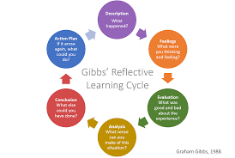
Gibbs reflective model: Abraham Gibbs introduced Gibbs reflective model in 1988 focusing on learning from experience. There are six stages of Gibbs reflective model like description, feeling, analysis, evaluation, conclusion and action plan. I think Gibbs reflective model will be helpful for me to measure my performances and roles as a front manager of the Ashford International Hotel & Spa.
Description: As a manager, I performed different activities to give satisfactory services to customers. I focused on different actions like communicate with customers, resolve guests concern, schedule shift, organize office budget, monitor services to customers and arrange different training and learning program to improve qualities and capabilities of employees. As a manager of the Ashford International Hotel and Spa, I tried to paly effective contribution to improve customers services, manage obstacles and perform outstanding actions to achieve organizational goals and missions (Adeani and et al, 2020).
Feeling: I have both positive and negative feeling as a manager of the Ashford International Hotel and Spa. I tried to utilize existing resources to improve actions and give competitive services to customers in the hotel industry. The positive reviews from customers made me happy and satisfied (Corgel and et al, 2011). Sometimes, poor dedication and wrong approaches of employees made me disappoint to conduct desired actions in the marketplace. I encouraged employees to be responsible and dutiful to perform satisfactory duties for the sustainable growth of the Ashford International Hotel and Spa.
Evolution: As a manager, I showed high effort and efficiency to manage hindrances and conduct desired functions in the hotel industry. My theoretical knowledge and practical quality played an effective role on overall functions in the front office of the Ashford International Hotel and Spa. My problem-solving skill, communication skill, stress management quality, IT knowledge and so on helped me to perform outstanding actions to increase my professional value and acceptance (Hammer, 2016). Sometimes, I bemused in different crucial situations but strategically managed those to improve organizational growth and progression of Ashford International Hotel and Spa.
Analysis: I have gathered huge knowledge and practical experiences by performing actions as a manager of the Ashford International Hotel and Spa. Different customers showed various approaches and personality according to their ethnic, religious and social statues. As a manager, I tried to communicate and interact with those versatile customers to offer services and improve their satisfaction. As a manager, I also tried to manage the approaches and activities of employees in the workplace (Nurlatifah and et al, 2023). I always tried to establish a fruitful workplace environment so employees perform well and customers get satisfactory services and facilities. I also showed good personality and became emotionally intelligence in any haphazard situations in the front office of the Ashford International Hotel and Spa.
Conclusion: As a manager, my performance and contribution were satisfactory that increases professional value and acceptance to both employees and customers (Sekarwinahyu and et al, 2019). But I have some areas of lacking that make me disappoint to gain a better professional life in future time. I need to improve different skills and qualities like communication skill, IT knowledge, adaptive thinking quality, stress management quality and so on. Besides, I have to be more serious and punctual to compete desired roles and responsibilities within specific time schedule. Moreover, I have to be more professional and emotionally intelligence for being confident and optimistic in any haphazard situation in the workplace.
Action plan: This is the last step of Gibbs reflective model where individuals try to make initiative plan and strategy for improving weak areas. As a manager, I will try to improve my whole lacking sides within next one year. I will try to improve my customer services and communication skills writhing next two months. I will try to develop my technological skills and qualities within next three months. In future professional place, I will be more adaptive and collaborative to cope with any changing business environment. I will try to improve my stress management quality by next six months. Within these times, I will show high dedication and effort to develop my personal and professional skills.

Component Two
Contribution to Overall Module Assessment: 25%
Trip Advisor Review Response
Dear Paul
Most welcome to you for your compliment and positive review about our services to customers in the hotel industry. As a manager, I felt blessed for your coming and your trip members. As a manager, I tried to offer best services and facilities to you and your trip members for improving satisfaction. I guided each employee to show high effort and dedication to behave well with you and offer goods and services according to your demand. As a respectful gust, we tried to show high dignity and respect with you. We offered healthy and hygienic goods to fulfil your demand and increase our organizational value. Your compliment makes us blessed and stimulate to offer best services in the future time.
You are welcome for the future trips in our hotel industry. Again, thanks for your compliment about our services and facilities to customers.

Best regards
Georgiana Otesanu
Front Manager
Ashford International Hotel and Spa

Screen shot of referenced Trip Advisor review used:
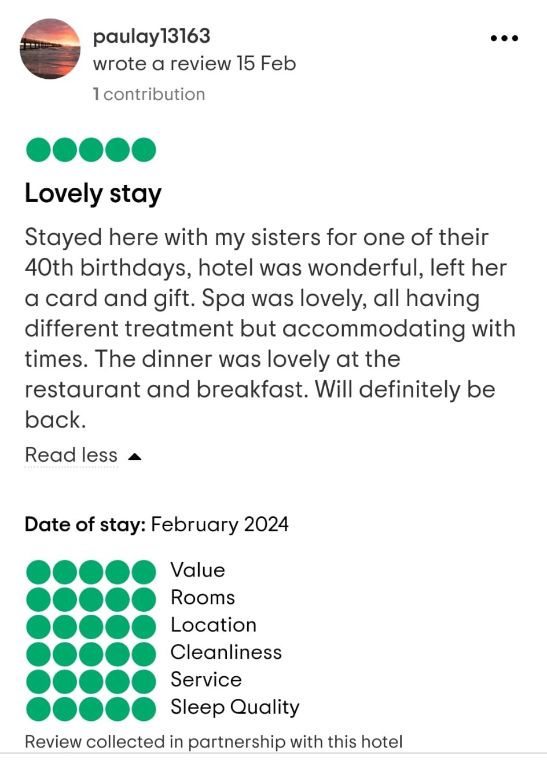
Source: (www.tripadvisor.com)

Letter of complaint response
Dear J Blake
I hope you are happy and well. I am welcoming to you for visiting our hotel industry and taking services. But I am sorry for your objections about our services and facilities. Your first objection is about the cleanliness of the room of our hotel. Your objection is true and I am apologizing for this problem. Before your entry, other customers stayed the room 330 and made garages. I guided the housekeeping department to clean the room. They tried best but field to completely clean the room within very short time. Next time, we will try to ensure a clean and hygienic environment to our hotel rooms, basins, balcony and toilets.
Your second objection is the poor speed of Wi-Fi. I am sorry for this problem. The router of 330 on room was spoiled and I also repaired by electric department. But the problems of the router did not solve completely. I will immediately contact with the electric department to change the router and improve the network services to customers.
Your third objection is the noise from the neighbouring rooms. It also frustrated to me for the poor approaches and behaviours of customers in the hotel industry. I guided each customer to follow our hotel rules and perform legal action procedures. But the noise from the neighbour room was out of control to me. The employees of our hotel directs to the members of those rooms to speak slowly but they did not follow that (Tesone, 2010). However, next time we will make initiative plans and strategies to controls the wrong approaches and action procedures of customers in the hotel industry.
Your last objection is the poor services and facilities from the employees of the Ashford International Hotel & Spa. It disappointed to me for the poor and unsupportive approaches and behaviours of employees. I will arrange an immediate meeting to guide employees to behave well with customers and offer them best services to improve their satisfaction. I will arrange different training and learning programs to improve personal and professional qualities of the employees of Ashford International Hotel and Spa.
However, your all objections have noted that will be helpful for our strategies and customers services polices in the hotel industry. As a manager, I will try to solve those immediately to improve customer’s services and enhance organizational value and reputation in the competitive business place. I will try to progress overall services and facilities to customers. Besides, I will stimulate employees to be more responsible and dutiful to manage obstacles and perform efficient functions in any haphazard business environment. I will offer innovative and competitive services to customers than other hotel industries in the marketplace.

Best regards
Georgiana Otesanu
Front manager
Ashford International Hotel and Spa

Component Three:
Contribution to Overall Module Assessment: 50%
Writing in essay format

Key Skill 1 – Customer Service Skills


In business place, customer service is a fundamental skill for the manager of any small or prominent hotel industry. The front manager of the Ashford International Hotel and Spa needs to posse this noble quality to offer best services to customers for improving their satisfaction. Each manager can focus on empathy, active listening skill, problem solving skill, technical knowledge, patience, tenacity, adaptability and so on to offer best services to customers. In business place, customer service skills of manager increase professional value and acceptance to the employer of any company in the marketplace.
Customer’s services and satisfaction are key objectives of any small or prominent business organization in the marketplace. Without customer services, any business organization cannot prosper in the competitive marketplace. The manager is a key person of any company to make strategies and plans for improving customer’s services and facilities (Melián and et al, 2016). In this time, manager must be rational and intellectual to make strategic decision and plan to improve customer’s services in business places. The manager of any business organization must possess good behaving quality to communicate with customers and offer them services according to dynamic demand.
The manager of any company must show empathy to understand the emotions and expectations of customers in the marketplace. Active listening skills and adaptive thinking are other necessary qualities for the manager to maintain relations with customers and offer them services. In modern business place, technological knowledge is another fundamental quality of manager to perform outstanding actions and offer competitive services to customers (Khan and et al, 2015).
The organizational success of each hotel industry relies on the best services and satisfaction of customers. Manager should posse various noble qualities and skills to improve customers services and satisfaction in any complex business environment.

Key Skill 2 – Communication Skills

Communication skill is a key quality of each manager to interact with employees, customers and other individuals in business place. In modern business place, communication skill is a fundamental requirement for becoming a manager of any small or large business organization. The front officer of the Ashford International Hotel and Spa need to hold different qualities like active listening skills, social media knowledge, fluent speaking quality, confident, body language, feedback and so on (Han and et al, 2021). All those skills and qualities will be supportive to communicate with employees and customers in the marketplace.
Active listening skill helps the manager to listen attentively the speaking of audience in the marketplace. In this time, manager can ask questions and give response according to the opinion and expectations of audience. Manager must show empathy during communicating with employees and customers also must show proper value and dignity. Confident and fluency are necessary requirements for an effective communication process of any manager (Kukreti and Dani, 2020).
Today, modern technologies and social media tools are fundamental requirements for the distance communication in business place. The managers of the Ashford International Hotel and Spa must be expert at using social media and digital tools to practice distance communication with customers and employees. Facebook, Instagram, Twitter, LinkedIn, WhatsApp and so on will be helpful for the managers to share and collect information from any distance places (Yang and et al, 2014).
The front manager of the Ashford International Hotel & Spa must posse verbal, non-verbal and writing communication skills to communicate with different categories employees and customers in business places. In verbal communication, manager must use different language according to the audience to share and collect information. In nonverbal communication, manager must show good body language, gesture and approaches to maintain different disable man in business place. The manager of the Ashford International Hotel and Spa can practice written communication according to the audience approaches and expectations in business place (Hassan and et al, 2016).

Key Skill 3 – Organizational Skills

In business place, organizational skill of a manager refers to the strategic approaches to manage resources and perform effective actions in any haphazard business environment. Organizational skill is a key requirement for the manager of any business organization. The front manager of the Ashford International Hotel and Spa need to posse different organizational skills like good decision-making quality, time management ability, leadership quality, emotional intelligence, strategic thinking, adaptability, conflict management quality and so on. All those skills are necessary requirements for improving organizational skill of any manager of a company.
The performance of any company depends on a good organizational skill of a manager. The front manager of the Ashford International Hotel and Spa needs to make effective decisions and plans to use and utilize existing resources and facilities in any complex business environment. The manager can make strategic plan according to the dynamic business environment. The manager must show emotionality intelligence and rational approaches in any haphazard business environment. Maximum use and utilization of resources will be key objectives to manage and organize action procedures in the workplace. The front manager of the Ashford International Hotel & Spa can conduct different research programs for making decisions and strategies to improve overall functions in competitive business place.
Leadership quality of a manager has a big influence on the organisational approaches and activities in the workplace. In this time, the front manger of the Ashford International Hotel & Spa can practice different leadership theories like functional leadership, situational leadership, horizontal leadership and so on to manage actions in any complex business environment. The front manager must be adaptive, dynamic and systematic to manage actions and cope with any changing business aspects in the marketplace. Theoretical knowledge and practical quality have a big influence on overall organizational skills and approaches of a manager (Ramanathan and et al, 2016). In this time, the front manager of the Ashford International Hotel and Spa can improve theoretical knowledge and practical quality to organize and manage actions in any tough business situation.

Key Skill 4 – Problem Solving Skills

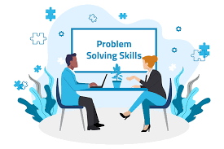
In business place, problem-solving skill of a manager refers to strategic approaches to manage and solve any critical problem facing in the workplace. The front manager of the Ashford International Hotel & Spa must posse different problems solving skills like- analytical thinking, conflict resolution quality, emotional intelligence, ability to inspire, creativity and productivity, leadership skills, motivation quality and so on. Without problem solving skills, the manager of any company cannot perform satisfactory actions to achieve organizational gols. Problems are common aspects in business placed but the manager of any company need to manage those problems effectively. The problems solving skills of a manger plays a supportive role to manage obstacles and establish a fruitful workplace environment.
The front manager of the Ashford International Hotel & Spa must be analytic and strategic thinker to manage problems and run satisfactory actions to increase organizational sustainability. The manager of this hotel industry must focus on the ultimate reason of any problem to solve that effectively. Emotional intelligence and resilience can play a supportive role to manage problem and run satisfactory action procedures. Employers are the great assets for any hotel industry to conduct whole operations and manage any problem facing in business place. The front manager of the Ashford International Hotel and Spa must guide employees to be more responsible and dutiful to operate efficient actions and play an outstanding contribution to overall organizational success in the marketplace.
Conflict among employees is a common aspect in business place. The manager of any company needs to manage conflict and establish a fruitful workplace environment. In this time, the front manager of the Ashford International Hotel and Spa must guide and motivate employees to show supportive and collaborative behaviours in the workplace. Time management quality is a noble characteristic of any manager in business place. Proper time management quality helps any manager to perform effective actions within satisfactory time schedule. On the other hand, poor time management quality managers fall them into different critical situations and problems in the workplace. However, the front manager of the Ashford International Hotel and Spa must progress theoretical knowable and practical skills to improve problem solving quality and perform outstanding actions in any hazard business environment.

Reference List

Adeani, I.S., Febriani, R.B. and Syafryadin, S., 2020. Using GIBBS’reflective cycle in making reflections of literary analysis. Indonesian EFL Journal, 6(2), pp.139-148.

Chen, R.X., Cheung, C. and Law, R., 2012. A review of the literature on culture in hotel management research: What is the future?. International Journal of Hospitality Management, 31(1), pp.52-65.

Corgel, JB, Sturman, MC & Verma, R. 2011 The Cornell Schoolof Hotel Administration on Hospitality: Cutting Edge Thinking andPractice, John Wiley & Sons, Incorporated, Hoboken.
Hammer, J. 2016 Revenue superstar! The simple rules of hotel revenue management. Great Britain: Amazon. Solomon, M. 2018The Heart of Hospitality. New York: SelectBooks, Inc.
Han, S.H., Lee, J., Edvardsson, B. and Verma, R., 2021. Mobile technology adoption among hotels: Managerial issues and opportunities. Tourism Management Perspectives, 38, p.100811.

Hassan, S.A., Husin, N.S. and Ban, A., 2016. Productive Practices of Hotel Management System Using Usability Approach: A Case Study. Advanced Science Letters, 22(8), pp.1905-1908.

Khan, I., Garg, R.J. and Rahman, Z., 2015. Customer service experience in hotel operations: An empirical analysis. Procedia-Social and Behavioral Sciences, 189, pp.266-274.

Kukreti, R. and Dani, R., 2020. Individual factors and internship satisfaction of hotel management graduates. International Journal of Advanced Science and Technology, 29, pp.878-884.

Melián-González, S. and Bulchand-Gidumal, J., 2016. A model that connects information technology and hotel performance. Tourism management, 53, pp.30-37.

Nurlatifah, L., Purnawarman, P. and Sukyadi, D., 2023, December. The implementation of reflective assessment using Gibbs’ reflective cycle in assessing students’ writing skill. In AIP Conference Proceedings (Vol. 2621, No. 1). AIP Publishing.

Ramanathan, R., Ramanathan, U. and Zhang, Y., 2016. Linking operations, marketing and environmental capabilities and diversification to hotel performance: A data envelopment analysis approach. International Journal of Production Economics, 176, pp.111-122.

Sekarwinahyu, M., Rustaman, N.Y., Widodo, A. and Riandi, R., 2019, February. Development of problem based learning for online tutorial program in plant development using Gibbs’ reflective cycle and e-portfolio to enhance reflective thinking skills. In Journal of Physics: Conference Series (Vol. 1157, No. 2, p. 022099). IOP Publishing.

Tesone, D. 2010 Principles of management for the hospitality industry. London: Routledge.

Yang, Y., Luo, H. and Law, R., 2014. Theoretical, empirical, and operational models in hotel location research. International Journal of Hospitality Management, 36, pp.209-220.

Https://www.tripadvisor.co.uk/Hotel_Review-g190759-d251442-Reviews-Ashford_International_Hotel_Spa-Ashford_Kent_England.html(aces:17 Feb 2024)

