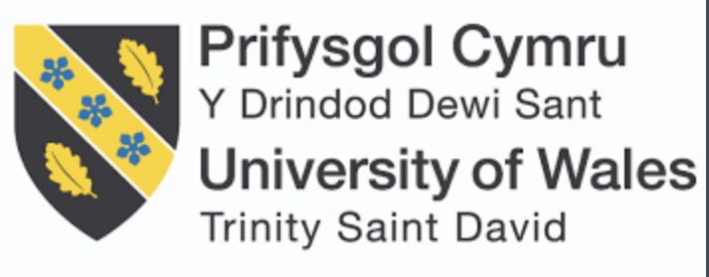
Module title -Enterprise and Entrepreneurship
Module code – LCLM4006
Assessment – Business plan
Student Name – Stefania Diana Deliu
Student ID number – 2433437
Lectures name- Stephen Malone

Business Plan: Glamour Touch Nail Studio

1. Executive Summary

Glamour Touch Nail Studio is a proposed nail and beauty business that will provide professional nail treatments including manicures, pedicures, acrylic extensions, gel polish, nail art, and basic hand and foot care treatments. The business will be located in Birmingham city centre and will target women aged 16–45 who are interested in beauty, self-care, and fashion trends.
I took into consideration this location as its provider a huge amount of foot-traffic and giving me the benefits of walk-ins' customers.

The purpose of this business is to offer affordable but high-quality nail services in a clean, safe, and welcoming environment. The business aims to build a strong local customer base through social media marketing, excellent customer service, and competitive pricing.

An estimated £8,000 in startup funding will be required to cover equipment, rent deposit, stock, insurance, and marketing costs. The business is expected to break even within the first 6–9 months of operation.

I plan to make more local customers since its beneficial to myself and my company however I can create loyalty cards and offers for my loyal customers which will make them come back for good deals, I make sure every client feels comfortable, listened to, and leaves loving their nails. I focus on clean work, good vibes, and results my clients wants. I am a confident nail technician and will look forward to a challenge.

TABLE OF CONTENTS

Title…………………………………………………………1
Business Plan……………………………………………2
Table Of Contents………………………………………3
Overview of the business idea………………………4-5
Market Research………………………………………..6
PESTEL analysis…………………………………………7
Marketing communications………………………….8
Financial plan…………………………………………….9
Reference lists………………………………………………..10

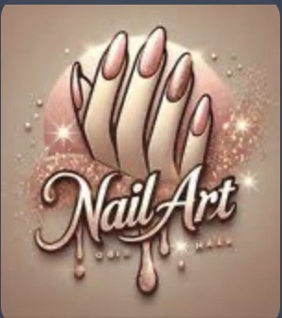
OVERVIEW OF THE BUSINESS IDEA
https:// www.pinterest.com/ideas/nail-logo/937033752008/

Business Concept
The proposed business is a luxury nail studio offering:
- BIAB (Builder in a Bottle)
- Acrylic extensions
- Gel manicures
- Nail art and custom designs
- Pedicures
- Nail repair and maintenance services
The salon will focus on high-quality products, hygiene, and creating a relaxing, aesthetic environment that encourages repeat customers.
Mission Statement
To provide high-quality nail services in a professional, clean, and welcoming environment that makes clients feel confident and valued.
Objectives
- Build a loyal client base within 6 months
- Achieve monthly revenue of £4,000+ by Month 6
- Maintain 80% repeat customer rate
- Develop strong Instagram and TikTok presence
Legal Structure
The business will operate as a sole trader initially. This structure is simple to set up, requires minimal paperwork, and allows full control over decision-making. As the business grows, it may later become a limited company.
As I am a sole trader I will need regular work place inspections as the are important for maintaining a safe and clean nail studio I will also need health insurance as it protects both me and my clients as they have access to medical care in the eventual of accidental injuries or other risks regular inspections are needed as they uphold a critical role in sanitation standards in addition to health and inspections I will also make sure my equipment is sterilised for each client. I will make sure each client have their own bag that includes (cuticle cutters, Files, cuticle oil, buffers) for their nail appointments overall this creates a safer environment for me and my clients ensuring our wellbeing.
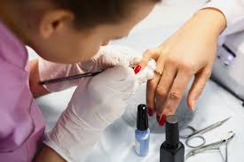
Health insurance improves access to healthcare and reduces financial risk (World Health Organisation, 2010). https://truthout.org/articles/nail-salon-workers-face-respiratory-illness-and-cancer-risks-study-shows/
Management Structure
Initially, the owner will manage:
- Nail services
- Booking system
- Social media marketing
- Stock control
- Customer service
In the future, additional nail technicians may be hired as demand increases.
On social media I will be concentrating on making videos on Instagram TikTok and YouTube such as tutorials, Post pictures before and after on how to prepare the nail and how to be building the nail which will attract more customers.
I will also be showing followers online the life of a nail technician and the progress of my development in nails and to make my customers feel more comfortable. I will be providing snacks! Slow Music and comfortable environment, I will provide loyalty cards for customers and on their 6th appointment I will be offering 50% off for any set since it is a gift from me to my customers.
MARKET RESEARCH
Industry Overview
The UK beauty and nail industry has experienced consistent growth due to social media influence, celebrity trends, and increasing demand for beauty services. Nails are considered an affordable luxury, meaning demand remains strong even during economic downturns.
The UK nail and beauty industry has experienced sustained growth due to increased consumer interest in self-care and the influence of social media trends (Statista, 2023).
Beauty services are often viewed as affordable luxuries, meaning consumer demand remains relatively stable even during periods of economic pressure (Mintel, 2022).
Target Market
Primary Target Customers:
- Women aged 18–40
- Students and young professionals
- Social media users
- Individuals attending events (birthdays, holidays, weddings)
These customers value appearance, quality service, and aesthetic presentation.
Competition
There are many nail salons in Birmingham; however, many compete on price rather than quality.
Competitive advantages will include:
- Strong branding and Instagram presence
- Clean, modern interior
- High-quality products
- Excellent customer service
- Appointment-only system to reduce waiting time
PESTEL Analysis
Political
UK regulations require businesses to follow health and safety standards. Licensing and hygiene compliance are essential.
Economic
Cost-of-living pressures may affect spending; however, beauty treatments are considered small affordable luxuries.
Social
Self-care culture and social media trends increase demand for nail treatments. Nail art trends spread quickly online.
Technological
Online booking systems, Instagram marketing, TikTok promotion, and card payment systems improve accessibility and customer reach.
Environmental
There is increasing demand for cruelty-free, vegan, and environmentally friendly nail products.
Legal
The business must comply with:
- Health and safety regulations
- Public liability insurance
- COSHH regulations
- Data protection for customer information
MARKETING COMMUNICATIONS
Social media platforms such as Instagram and TikTok are effective marketing tools for small beauty businesses, as visual content strongly influences consumer engagement and purchasing decisions (Kotler and Keller, 2016).
Marketing Objectives
- Gain 1000 Instagram followers within 3 months
- Achieve 70% bookings through social media
- Build strong customer reviews
Marketing Strategies
Social Media Marketing
Instagram and TikTok will be the main platforms. Content will include:
- Before and after photos
- Nail art videos
- Client testimonials
- Trend-based designs
Paid Instagram ads will target women aged 18–40 in Birmingham.
Word of Mouth
Discounts for referrals will encourage customers to bring friends

Promotional Offers
- 10% discount for first-time customers
- Loyalty card (free treatment after 5 visits)
- Student discount
Branding
The brand will focus on:
- Luxury but affordable
- Pink, nude, and gold aesthetic
- Clean and professional image
Financial Plan
Equipments needed:
- Nail desk, Lamp, Chair, Draws
- Nail gels, acrylic powder, Top/base coat, Acetone, Brushes, Gems
- Electric nail drill
- Tips/ Tools
- Steriliser
I will be offering a range of nail service including acrylic nails, gel nails, BIAB (Builder in a bottle), manicures, pedicures, and relaxing hand and foot massages.
Process for acrylic and gel nail extensions will range from £25-£35, depending on the leg the of the tips. BIAB services will be priced between £30-£40. Hand and foot massages are priced separately.

Reference list
1.World Health Organisation (2010) Health systems financing: the path to universal coverage. Geneva: World Health Organisation.
2.Kotler, P. and Keller, K.L. (2016) Marketing management. 15th edn. Harlow: Pearson Education.
3.Mintel (2022) Beauty and personal care services – UK. London: Mintel Group Ltd.
4.Statista (2023) UK nail salon industry revenue. Hamburg: Statista.
5.World Health Organization (2010) Health systems financing: the path to universal coverage. Geneva: World Health Organization.
6.Pinterest (2026) Nail logo. Available at: https://www.pinterest.com/ideas/nail-logo/937033752008/ (Accessed: 27 February 2026).
7.Montoya, L.D. and Lamplugh, A. (2019) ‘Nail salon workers face respiratory illness and cancer risks, study shows’, Truthout, 8 December. Available at: https://truthout.org/articles/nail-salon-workers-face-respiratory-illness-and-cancer-risks-study-shows/ (Accessed: 27 February 2026).

 | CASH FLOW
 |  | MONTH
 | Cash in | 1
 | Loan- start up capital | £11,850
 | Sales (total sales of product and/or services) | £3,500
 | Other | £0
 | Total cash in-flows (A) | £15,350
 |  | MONTH
 | Cash out-expenses | 1
 | Rent or premises costs | £800
 | Business rates for your business premises | £0
 | Utilities (gas, electricity, water) | £200
 | Insurance | £25
 | Telephone and internet | £40
 | Marketing and advertising expenses | £150
 | Vehicle running costs | £60
 | Equipment purchase or leasing | £1,300(desk, chair, lamps, drills- Paid Month 1)
 | Postage, printing, stationery | £30
 | Transport and delivery | £20
 | Professional fees (legal, accounting etc.) | £50
 | Cost of sales (Cost of product) | £400
 | Wages your own | £800
 | Staff wages | £0(I will not be providing any staff wages as I am a Sole Trader)
 | Any other | £0
 | Any other | £200 (Booking system, cleaning supplies, refreshments)
 | Total cash out-flows (B) | £4,075
 | Your net cash flow (A-B) | £15,350-£4,075=£11,275

