Student Name: Nicole Elliott
Student Number: 1814930
Module Number: BMSW4002 – Effective Communication and Teamwork
Title: Effective Communication Within the Business

Executive Summary
Within this report, it talks about different communication methods and how Sarah can use to ensure her business is running correctly. It talks about the challenges her business can face and the different measures she can take to enable the success of her business. Different methods of communication are used for different situations, this report will show you the different ways you can use each method.

Introduction
With today’s competitive climate within the business world, constantly changing their strategies, every businesses aim is to try to gain a higher position in the marketplace. Businesses do not expand and improve by just providing or supplying a product or service to the customer. Communication between the managers and employees about changes to the business is key, as it prepares them to adapt to any changes within their work, leading employees and managers to become more confident at work and more loyal to the company. In this case study report, the following topics will be assessed;
- The different methods of communication - what they are and how you can use them
- The importance of communication within the workplace – the effects it can have in the workplace
- How to use communication to increase the performance in the workplace to avoid bankruptcy and failure
Why is effective communication important?
Effective communication within a business is crucial as it is the core in which the business revolves around. It can also be used to ensure any important information from different levels of hierarchy within the business, are circulating correctly to avoid errors or miscommunication. Keeping track of employee performance in Sarah’s business can be a means of effective communication, as this would make employees aware of their work effort and enable them to see the affects it can have within the business. If an employee is performing poorly, Sarah would communicate directly to the employee, teaching them how to avoid the error or fault enabling their performance to increase. If a spillage has been made in the store, a sales assistant would also use this method by communicating with the cleaner to avoid accidents.
When the managers in Sarah’s respond quickly to ideas and questions, the employees feel that their input is valued, leading them to become more committed and engaged within their work. By assigning an employee to respond promptly and personally to all employees concerns and ideas, ensure that the feedback gets the respect it deserves. According to Defranzo. S (2015) “Feedback’ is used to describe the helpful information or criticism about prior action or behaviour from an individual, communicated to another individual (or a group) who can use that information to adjust and improve current and future actions and behaviours.” According to Grossman. D (2016) “ensuring that important information and access to additional resources are given to the employees, increases the chance of success within their job role and within the business, leading this to be the top priority for building engagement within the business”.
The different types of communication and the different effects
Downward Communication
The downward communication method is one of the oldest types of communication, which is more frequently used and is known more to different businesses in terms of communication. Using the downward communication enables the higher level of authority to communicate with the lowest level of authority, regarding work related matters. Downward communication can be sent or received either oral, written, visually and by electronic devices.
If you as the manager wanted to send information to a sales assistant, regarding working overtime shifts in order to help cover shifts that would be normally covered by the employee who is on maternity leave, the manager would use the downward communication method to approach the chosen employees in order to find out their availability. If the employees are available to work overtime, you as the manager will be able to construct new work rotas, enabling the business to maintain reaching goals without errors or faults due to unattendance and low staff.
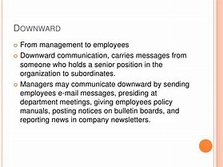Read Banking 2016
Internal and External Communication
Internal and external communication is used to promote the business about what offers the business has to offer. By using different methods of communication, it will make it easier to give or receive information or feedback about the business.
According to Ahmed. A (2019) “The main purpose of internal communication is to identify and share company goals”. This means that by using internal communication within the business will likely increase the chances of creating progress and avoiding error. If a manager in Sarah’s workplace wanted to share group effort and work performance in a meeting with their colleagues, they would use internal communication to gather the other work colleagues together, at a suitable time and ensure they have all received the message.
According to Surbhi. S (2017) “external communication is the type of formal communication in which the business will communicate with outside sources or organizations/parties such as customers, shareholders or clients etc. It can be used to maintain a relationship or to exchange information that could be crucial to each party”. Using external communications within Sarah’s business is also ideal and can be useful if the stockroom assistants needed to contact a delivery company. They would use telecommunications to contact the company regarding late or missing stock, enabling the stockroom assistants to keep track of the incoming and outgoing stock. This can reduce stress and workload within the business by ensuring that any incoming or outgoing stock can be traced.
Internal Source External Source
Delivery Company
Stockroom Assistant

Upward Communication
The upward communication method is used in order to send the information from the lowest level of authority within the business to the highest level of authority within the business, for example; if a sales assistant needed to make the manager in Sarah’s business aware of a sales increase or decrease, they would use upward communication as a method to send information via. Audio call, email, written and even face to face directly to the manager, this would be called upward communication. This method is often used for decision making, enabling lower level of authority to discuss their actions and opinions with their superiors, or to even give feedback or suggestions about different subjects within the workplace to them. Upward communication is also an advantage in the business, as it makes the managers aware of how an employee feels about the business and the environment they work in, if a manager knows that an employee is not happy with a work related matter, the manager can make procedures to ensure that each is employee is happy within their role and working at an active rate.

The importance of two-way communication
Two-way communication in the workplace is important because it helps a message between the sender and receiver, be clearly understood and decoded, so that the task or role can be performed in the correct way, without miscommunication or misunderstanding.
Two-way communication does not necessarily have to be face to face, if Sarah needed to contact the employee that is on maternity leave about work related information or ideas, she would call or email them ensuring they have received the message. This method of communication is ideal, as it is fast and efficient, leaving the Sarah or the employee able to focus on other work-related tasks. If an employee in Sarah’s business had a problem with their work, they should feel that they can talk to other members within the business about work related problems. Engaging with employees about issues or ideas about the business, will enable them to feel important, leading them to likely be more engaged with their work.
Below is a diagram of how two way communication is used.
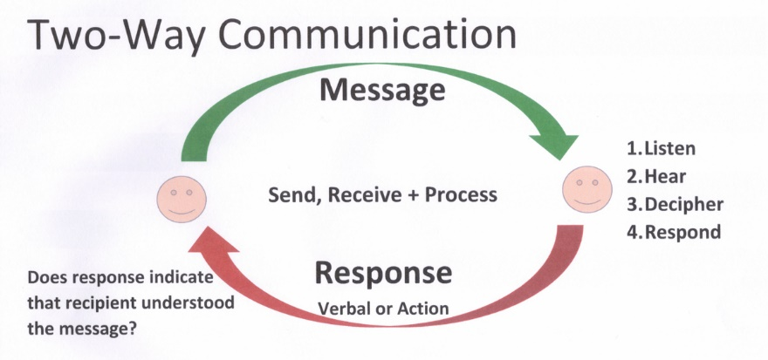Gilstrom. K 2015

Non-Verbal Communication Within the Workplace
Non-verbal communication is widely used in the workplace, different cues such as, facial expressions, posture, or eye contact can be a means of non-verbal communication within the workplace, sometimes employees and employers are unaware that they are even doing it. If a stockroom assistant within Sarah’s business were to be struggling with unpacking an item, it would be advisable for another member of the stockroom to help this employee, to avoid frustration or upset from the employee, leading to a lower performance of work. By practising learning how to read non-verbal communications can avoid upset between members of the business because you can learn to convey your message more clearly and effectively.
Huntington. M (2019) “Nonverbal communication indicates how a person is feeling in relation to what they are saying, and it also reflects how people react to the message. Communicating an important message to your colleagues with excitement and enthusiasm may have a greater impact on your audience regarding the importance of the message versus delivering the message with a monotonous tone and facial expression.”

Heathfield. S (2018) said, “The manager is also responsible for planning and maintaining work systems, procedures, and policies that enable and encourage the optimum performance of its people and other resources within a business unit”.

Conclusion & Recommendations
with one less sales assistant, that means that the sales are not processing as quick as they would if there were 12 sales assistants, leading to a decrease in profits and overload of work for the other sales assistants. Using internal and external communications to communicate with the employee that is on maternity leave, updating them on useful information about changes or procedures within the business, will ensure that they have all crucial information upon their arrival back at work. Due to the sales assistant that is on maternity leave, it would be ideal to search for a temporary employee to cover the shift for the time required in order to keep the business running in a timely and controlled manner. You will notify the managers of the new and temporary employee, which will train the employee the roles of a sales assistant, with the help from other sales assistants.
Communicating with the customers about offers and updates about the company will increase the chances of a customer buying or using your product/service. If the company markets their product or service correctly, then sales will increase due to an increased fan base and increase in customers. Communication within each member of staff should be used in order to keep the business flowing and increasing with growth as it would with a full team by ensuring that managers are making the sales assistants aware of the offers and updates as soon as they receive them, will enable the sales assistants to provide more up to date product information. By showing the customers great product knowledge, it will make the customers feel better purchasing a product or using a service that an employee has shown great information and product knowledge on.

Once you have considered your audience and work environment, it is best to decide what channels of communication you can use in order to keep the business running smoothly and to find the best ways of communication in order to make employees engage and share ideas that can improve the business. If the employee knows the errors they are making, they are less likely to make errors and faults and it will be easier for them to focus on fixing them. When acting on feedback, not only does it encourage employees to take ownership, but it is also vital to an employees ongoing performance within the workplace.

References
Ahmed. A .(2019). The Importance of Internal & External Communication – available at:- https://bizfluent.com/info-8691408-importance-internal-external-communication.html - accessed 25th July 2019
DeFranzo. S (1st July 2015) 5 Reasons Why Feedback is Important – Available at:- https://www.snapsurveys.com/blog/5-reasons-feedback-important/ - accessed 1st August 2019
Gilstrom. K (22nd April 2015) Effective Communication on Board – Available at:- https://currents.bluewatercruising.org/articles/effective-communication-board/ - Accessed 9th August 2019

Grossman. D (19th April 2019) Two-Way Communication: 4 Tips for a More Engaged Workplace – available at:- https://www.yourthoughtpartner.com/blog/bid/59576/4-steps-to-increase-employee-engagement-through-two-way-communication - accessed 25th July 2019
Heathfield. S (28th October 2018) Sample Manager Job Description – available at:- https://www.thebalancecareers.com/sample-manager-job-description-1919126 - Accessed 25th July 2019
Huntington. M (8th March 2019) How Nonverbal Communication Can Help in the Workplace - Available at:- https://smallbusiness.chron.com/nonverbal-communication-can-workplace-21523.html - accessed 1st August 2019
Read Banking (26th September 2016) Downward communication definition and Examples of Downward Communication - available at:- https://readbanking.blogspot.com/2016/09/downward-communication-definition-and.html - Accessed 9th August 2019
Surbhi. S (9th May 2017) Difference Between Internal and External Communication – Available @:- https://keydifferences.com/difference-between-internal-and-external-communication.html - accessed 25th July 2017

