University of Wales Trinity Saint David
Wales Institute of Science & Art



Engine Performance Characteristics
Motorsport/Motorcycle/Vehicle Technology (ACHA4003/4004/4012)

Lewis Cox
2004098
(Motorcycle Engineering Y1)

Submission Deadline 30-Nov-2020
Contents
1 Introduction 2
2 Experimental Procedure 2
3 Results 4
4 Analysis 6
4.1 B.S.F.C. Variation with Engine Speed (Figure 4) 6
4.2 Torque Variation with Engine Speed (Figure 2) 6
4.3 Brake Power Variation with Engine Speed (Figure 3) 7
5 Conclusion 8
6 Evaluation & Further Work 9
7 Bibliography 10
8 Acknowledgements 12
9 Appendix 13
9.1 Dimensions & Correction Factor Data 13
9.2 Formula Used 13
9.3 Excel Data Table 14

Introduction
The aim of the test was to collect data from an engine dynamometer and calculate engine performance values. The data would then be graphed and analysed. The performance values required to be calculated were Corrected Power, Torque, BMEP, B.S.F.C. and Brake Thermal Efficiency.

Experimental Procedure
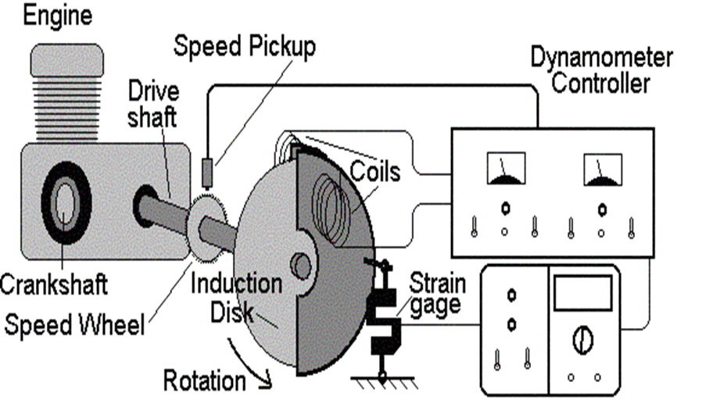
The type of dynamometer used for the test was a Schenk WS230. To acquire torque values, this type of dynamometer uses electromagnetism (Schenk , 2001) and a strain gauge as shown in Figure 1, rather than hydraulic dynamometers that use impellers that rotate inside of a fluid. Electromagnetic dynamometers use a toothed rotor (induction disk) connected to the engine crank, which rotates through a magnetic field. The magnetic field acts a brake to the rotor, increasing the load on the engine. The opposing magnetic field of the rotor and the dynamometer outer casing, causes the outer casing to rotate against a strain gauge. The strain gauge produces a voltage that the computer software then compares to a calibration curve, which enables a torque value to be found.
Figure 1 - An example of a dynamometer set-up. (Engineering Insider, 2018)

The engine used for the test was an imported 1988 Honda Civic CRX 1600. The engine was fitted with a drum aftermarket air filter, not the factory airbox. It also did not have the factory exhaust system fitted and instead was using the building extraction system.

A sweep test was used to collect data from the dynamometer with the parameters detailed in figure 2. The sweep test was used as a fast way of collecting data with minimal strain on the engine however, this sacrifices accuracy due to the speed of the test. This is in comparison to a step test, where the engine is held for a period of time at set rpm values, allowing sensors to settle thus giving more accurate data. For the purposes of this test, high accuracy was not needed.
Table 1 - Dynamometer Test Parameters
Throttle % | 100 | Ramp Down Time (s) | 5
Start-up Ramp Time (s) | 1 | End Engine Speed (rpm) | 1000
Total Ramp Time (s) | 15 | Data log Intervals (rpm) | 50
Starting Engine Speed (rpm) | 1250
Final Engine Speed (rpm) | 5000

Results
(See Appendix for Excel results tables and formula used)
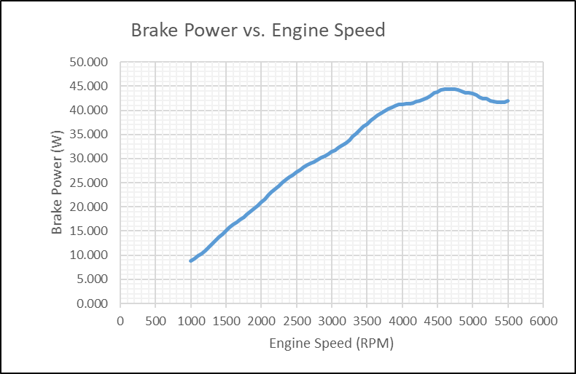
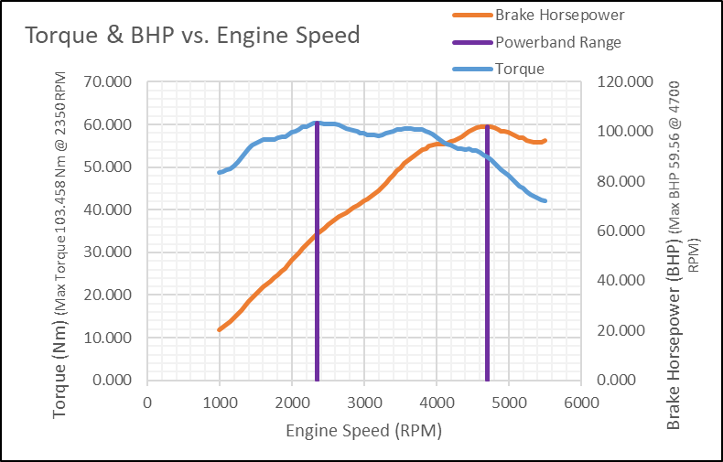 Figure 2 - Torque vs. Engine Speed / Brake Horsepower Vs. Engine Speed
Figure 3 - Corrected Power (Brake Power) vs. Engine Speed

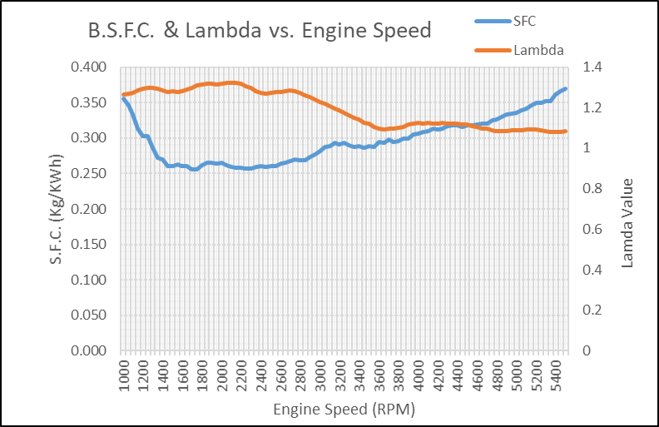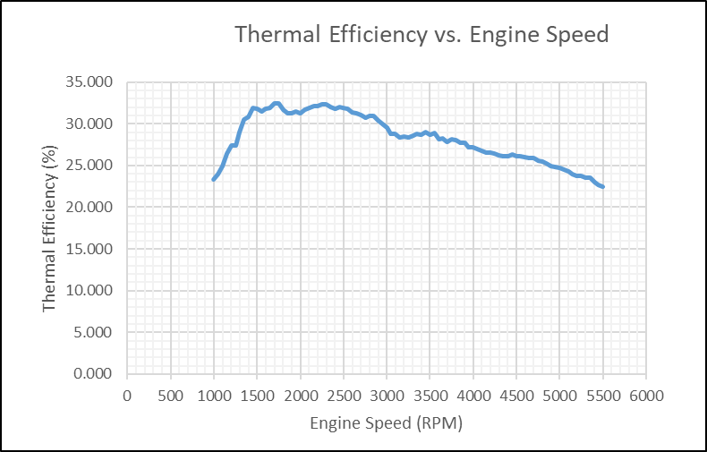
Figure 4 - Lambda and B.S.F.C vs. Engine Speed
Figure 5 - Thermal Efficiency vs. Engine Speed
Table 2 - A summary of the calculated performance characteristics
Peak Torque (Nm) | 103.458 @ 2350 RPM
Maximum Brake Power (KW) | 44.432 @ 4700 RPM
Maximum Thermal Efficiency (%) | 32.461% @ 1750 RPM
Minimum B.S.F.C. (Kg/KWh) | 0.256 @1700-1750 RPM
Maximum Lambda Value | 1.322 @2100 RPM
Max B.MEP | 812.560 Kpa@2350 RPM

Analysis

B.S.F.C. Variation with Engine Speed (Figure 4)
The minimum Brake Specific Fuel Consumption calculated from the test was 0.256 Kg/kWh. This is a typical value for a gasoline engine (x-engineer.org, 2017). This value was achieved within the range 1700-1750 rpm however, between 1600 RPM and 3000 RPM the graph shows a relatively consistent value.
Whilst the engine was within this RPM range, it was operating at its most efficient in terms of air intake, due to a combination of the factory design of the intake, valve timing and the aftermarket air filter that was fitted for this test. This is supported by the lambda plot on figure 4, showing the engine was running most lean (λ>1) until it starts approaching 3000 RPM, at which point the B.S.F.C. begins to increase.
Both increasing and decreasing the engine speed, outside of the 1600-3000 RPM range, resulted in an increase in the B.S.F.C.. At low RPM, this can be attributed to the energy lost as heat (see Figure 5, thermal efficiency plot) during the longer time delay between power strokes. As the engine speed increased, the energy losses due to frictional forces within the engine including the heating of the oil, cause the B.S.F.C. value to rise (autospeed.com, 2008). Additionally, it is possible the engine was over-fuelled in order to cool the cylinder at high RPM. Ultimately, the B.S.F.C. would have continued to increase as power declined and fuel consumption increased with engine speed.

Torque Variation with Engine Speed (Figure 2)
Peak torque was achieved at 103.458 Nm at 2350 RPM. This is within the engine speed range where the B.S.F.C was lowest and thermal efficiency was at its greatest, allowing for maximum chemical energy to be converted into kinetic energy. The curve is flat, and peak torque is low in the RPM range, being typical in the design of a road car to increase ease of use during normal driving. The factory specification for torque is 144 Nm at 5700 RPM (carfromjapan.com). 5700 RPM was not tested, however 144 Nm would not be expected, given that the engine is running without an exhaust system and given that the Torque and Power began to decline above 5000 RPM.
Beyond peak torque, the frictional forces within the engine are still increasing with engine speed. Therefore, more of the indicated power is used to overcome the frictional forces, reducing torque output.
An additional cause for torque drop-off, which would be dependent on the engine design, may include a decrease in the volumetric efficiency of the cylinders, as the induction stroke is too rapid for the maximum air/fuel mixture to be drawn into the cylinder. The valve durations (overlap, lead and lag) and ignition timing would also be optimised for a certain range of RPM to maximise volumetric and combustion efficiency. The further from this engine speed, the further the decrease in force applied to the piston.

Brake Power Variation with Engine Speed (Figure 3)
Maximum brake power was achieved at 44.432 KW (59.56 BHP) at 4700 RPM. Using the equation P=(2πNT)/60, as engine speed (N) increases, the power output will also increase. Similarly, as torque (T) increases, power increases. This explains why brake power continues to increase after peak torque, and even during torque decline. As long as the engine speed increases at a faster rate than torque decreases, the power will continue to increase. Beyond peak power at 4700 RPM, the more rapid decline in torque leads to the decline in power.
The factory specification for power is 96 KW at 6800 RPM (carfromjapan.com). Based on the power and torque curves, it is unlikely that the engine would have achieved this if the test had progressed to 6800 RPM. The torque curve shows an increasing rate of decline to 5500 RPM, which leads to the power curve starting to tail also. Maximum engine power is created at a Lambda value of around 0.86 λ (A. Stark (a)). The test engine was running much leaner with lambda values peaking at 1.3 λ.

Conclusion
In its current state (running lean, drum air filter and without exhaust system ), the engine appears to have been designed for typical road driving between 2350-4700 RPM based on the peak torque value and peak power value, which would be considered typical for a road car . This would give consistent power delivery for ease of use. The results demonstrate the relationship between torque and power P=(2πNT)/60.
The engine was at its most thermal efficient and had lowest S.F.C. at 1750 RPM.
The BMEP value of 812.56 Kpa (8.12 Bar) is poor by modern standards. A BMEP value considered good for a naturally aspirated engine would be 1200-1400 KPa (12-14 Bar)(J. Fenske, 2020). The 1.2L 2020 Corsa, max torque 118 Nm at 2750 RPM, has a BMEP value of 1235.7 KPa (12.35 Bar) based on factory specifications (automobile-catalog.com).

Evaluation & Further Work
The calculation of performance values gave similar results to typical values of other engines indicating that the calculations performed were likely correct. Additionally the graphs plotted showed the expected curves.
A comparison of the results from a test with the factory airbox and exhaust system fitted (with tuning of the AFR to 1 – 0.86 λ) would be useful, to determine to what degree this altered the engine performance, particularly with the low BMEP figure that was calculated. Further to this, performing the test at different throttle percentages (e.g. 25%, 50%) would be useful to see any variation in S.F.C. caused by pumping loss.

Bibliography
K. Aoi, M. Hiroshi, K. Nomura (01-Feb-1986), Optimization of Mult-Valve Four Cycle Engine Design-The Benefit of Five-Valve Technology, SAE Technical Paper 860032.
Automobile-Catalog.com, 2020 Opel Corsa 1.2 (75) (man.6) Engine Horsepower / Torque Curve. Available https://www.automobile-catalog.com/curve/2020/2916770/opel_corsa_1_2_75.html (accessed 07-Nov-2020).
B. Ashok, K. Nanthagopal (2019), ‘Eco Friendly Biofuels for CI Engine Applications’, Advances in Eco-Fuels for a Sustainable Environment, pp.407-440.
Carfromjapan.com, Honda CR-X Released in 8/1988, Available https://carfromjapan.com/specifications/honda/cr-x/581710492afaa2c4b2871c1c (Accessed 07-Nov-2020).
J. Edgar (2008), Brake Specific Fuel Consumption. Available at https://www.autospeed.com/cms/a_110216/article (Accessed 06-Nov-2020).
Darkside Developments Blog (27-Jul-2018), Reading a Dyno Graph. Available at https://www.darksidedevelopments.co.uk/Blog/reading-a-dyno-graph/ (Accessed 06-Nov-2020).
Engineering Insider (05-Mar-2018), Dynamometer: Introduction, Types & Working. Available at :https://engineeringinsider.org/dynamometer-introduction-types-working/2/ (Accessed 05-Nov-2020).
J. Fenske (15-Apr-2020), The Best Way To Compare Car Engines – BMEP, Engineering Insider, Video uploaded to Youtube.com. Available at https://www.youtube.com/watch?v=bE_1JYrlYYU. (Accessed 07-Nov-2020).
Honda Motor Co. LTD (Nov. 1987), Shop Manual Civic Coupe CRX Chassis Maintenance and Repair.
J. Robinson (2000), Motorcycle Fuel Systems Techbook, Haynes Publishing, Sparkford.
Schenk Pegasus GmbH (2001-05-01), Technical Specification Eddy-Current Dynamometer W Series, The DÜRR Group, Darmstadt.
A. Stark (a), Air-fuel ratio, Lambda and Engine Performance, Available at https://x-engineer.org/automotive-engineering/internal-combustion-engines/performance/air-fuel-ratio-lambda-engine-performance/ (Accessed 09-Nov-2020).

A. Stark (b) (19-Aug-2017), Brake Specific Fuel Consumption (BSFC). Available at https://x-engineer.org/automotive-engineering/internal-combustion-engines/performance/brake-specific-fuel-consumption-bsfc/ (Accessed 06-Nov-2020).

Acknowledgements
Thanks to Mark Fall for providing the dynamometer data and Andrew Harrison for guidance with the report.

Appendix

Dimensions & Correction Factor Data
Table 3 - Input data for calculations
 | (Shaded cells show data collected from the dynamometer by Mark Fall)
 | Engine Spec |  | S.G. Gasoline^{B} | Gasoline Calorific Value^{C} | Standard Conditions |  | Measured Ambient Conditions |  |  | Correction Factor | Torque Arm Radius^{D}
 | Stroke^{A} | Bore | S.G. Gasoline^{B} | Gasoline Calorific Value^{C} | Baro | Temp | Baro | Humidity | Temp | Correction Factor | Torque Arm Radius^{D}
 | (m) | (m) | (g/m³) | (KJ/Kg) | (Bar) | (K) | (Bar) | (%) | (K) | 1.0063 | (m)
 | 0.0903 | 0.0751 | 0.739 | 43.4*10³ | 1.01325 | 293 | 1.0189 | 46 | 300 | 1.0063 | 0.815776
 | Bore Area (m²)= | 0.0044 |  |  | (DIN 70020)

Notes
A- | Stroke calculated from capacity of 1600cc and bore diameter which were found in the workshop manual -
 | HONDA MOTOR CO. LTD, HONDA CIVIC COUPE CRX 1600 1988
B- | S.G. of Gasoline used -
https://www.engineeringtoolbox.com/specific-gravity-liquids-d_336.html
(Accessed 05-Nov-2020)
C- | Calorific Value of Gasoline used -
https://www.engineeringtoolbox.com/fuels-higher-calorific-values-d_169.html
(Accessed 05-Nov-2020)
D- | Torque arm radius found printed on calibration plate of dynamometer.

Formula Used
Torque (Nm) – $T=WR$ where; (W=load (N)) (R=Radius Torque Arm (m))
Brake Power (W) - $P=\frac{2πNT}{60}$ where; (N=engine speed (RPM)) (T=Torque (Nm))
Corrected Power (kW) - $P_{S}= P×\frac{Standard Pressure (Bar)}{Ambient Pressure (Bar)}×\sqrt{\frac{Ambient Temp (K)}{Standard Temperature (K)}}$
B.S.F.C (Kg/kWh) – $B.S.F.C. = \frac{Fuel Flow Rate \left({lmin}^{-1}\right)×60×Fuel S.G. ({gm}^{-3})}{P_{s} (kW)}$
BMEP (KPa) - $BMEP= \frac{T×4π}{Capacity (l)}$
B. Thermal Efficiency (%) - $η_{t}={P_{S} (kW)}/{\frac{Mass of Fuel (kg)}{Calorific Value (kJ)}}$

Excel Data Table

