B&B accommodation entrepreneurs: a critical analysis of motivations for choosing rural B&B accommodation business in China.
Research plan

Hello, everyone! My Chinese name is Dandan Shen, my English name is danny, my student number is 1900241. It is my great pleasure to introduce to you about my research plan in this short video. First of all, I’d like to go through briefly about my motivation in choosing this topic. My research topic is about B&B accommodation entrepreneurs: a critical analysis of motivations for choosing rural B&B accommodation business in China.

The initial reason why I choose this topic is that, as a college teacher, I am also a designer in my spare time, and I have done a lot of rural landscape planning and design. I was impressed deeply by the countryside with its natural landscape. Besides, some of my friends and classmates started their own B&B accommodation businesses in recent years. Last but not the least, my previous education background and working experience both involves rural B&B issues which enables me to get access to both practical and academic resources.

This video will mainly focus on the following three aspects. First- background information about B&B accommodation, then I will discuss some related theoretical background basis, like the push–pull model of business start-up in tourism research, strategic issues faced by small-and medium-sized tourism businesses. And thirdly, based on the literature review, I will discuss the method to analyze the start-up motivation factors and business challenges for rural B&B accommodation businesses in China.

1 Introduction
  - Background
The term B&B varies from country to country. In Britain it is usually called B&B, homestay in Malaysia and America, accommodation in the Farm in Europeans, minshuku in Japan. There are also places with guesthouse or pension.

The tourism industry in China has witnessed a robust growth in recent years. Indeed, the tourism industry has become an important source of revenue and contributes to sustainable development for China’s economy. Rural cultural tourism such as the home-stay accommodation business has been shown to bring immediate benefits such as successfully providing job opportunities for local communities and improves qualities of life for local people.

A bed and breakfast (B&B) is a “nontraditional” form of accommodation that provides guests with personal service and high-level host–guest interaction, usually in rural settings where the establishment is owner-operated. Bed-and-breakfast establishments (B&B) present a unique sector within the tourism industry. These are “types of accommodation where visitors or guests pay to stay in private homes, where interaction takes place with a host and/or family usually living on the premises and with whom public space is, to a degree, shared” (Lynch 2005, pp. 534–535). In recent years, B&B has been favored by tourists because it can provide tourists with various and interesting personalized life experiences. (Yang,2019)

In the past 20 years, the popularity and number of homestays has increased dramatically throughout the world, especially in rural areas. According to statistical reports, there were 42,658 homestays and 1.5 million rural homestays available at the end of 2015 in Mainland China alone, an increase of 42.19% compared to the second quarter of 2014. A recent study has shown that 79% of leisure travelers intend to stay at a B&B.

Interestingly, we’ve seen a lot of designers, architects and florists have invested in home-stay accommodation in rural area of China. Let's have a look at some interviews with homestay entrepreneurs. The first one is Moganshan big music wild village homestay. The host of the homestay was two college classmates. They both share a common interest in traveling, which has inspired them to do something travel-related together. They did a lot of urban planning, and they always felt that the design was too big, and they wanted to do something down-to-earth, something that really belonged to them. Another host of homestay left his glorious city-life behind when he moved to Moganshan six years ago. He was one of the primary designers of the 2010 World Expo in Shanghai, yet felt dissatisfied and empty with his work, after combating liver cancer, he moved to the countryside to build a life among the mountains. He wanted to build a house that would grow and blend in with its surroundings. It also carries his memory of the countryside.

1.2 Statement of the research problem
The main motivations of B&B entrepreneurs are different to those of small- and medium-sized enterprises (SMEs) business in other sectors. what actually motivates entrepreneurs to ventures into B&B accommodation businesses – an under researched area？

1.3 Need for significance of the study
In addition to developing the theory on B&B accommodation businesses, the findings of this research will have relevance for policy making and supportive measures at the government levels to create an environment that will stimulate the competitiveness of SMEs in B&B accommodation businesses in their attempts for business growth and key strategy for economic improvement.

1.4 Research Question
Therefore, three questions aroused my interest to study.
Research Question 1: What are the primary motivational factors that motivate the entrepreneurs to become involved in rural B&B accommodation tourism businesses in China?
Research Question 2: What are the underlying motivation factors for B&B entrepreneurs, especially for some technical professionals?
Research Question 3: What are the challenges entrepreneurs’ or rural B&B accommodation operators encounters in this unique industry?

2 Literature review
2.1 The push–pull model of business start-up in tourism research
Motivation is the reason for a behaviour (Solomon, 2009). Hunger et al. (2000) contend that motivations for business start-up can be grouped within three broad categories, namely opportunity-driven, internal decision-driven and external decision-drive. Kirkwood (2009) stated that among common pull and push motivations for becoming entrepreneurs in most studies include a desire for independence, monetary reward, lack of job or career prospects, and a desire for work-family balance. Schuckert et al. (2008) stated that the common motivations for business start-up including a desire for independence and financial gain, flexibility of time, to balance work responsibilities and earning potential and familial responsibilities. Bennett and Dann (Z2000), and Walker and Webster (2007) identify motivators such as the desire for self-fulfilment or independence, greater wealth or being one’s own boss.

Motivations can generally only be determined by asking people to state them, but people often have multiple motivations and rarely analyse them. The survey research method was used to conduct the current study. The instrument consisted of several items relating to entrepreneurs’ perception and motivations were used for gathering information for the study. (Ahmad,2014)

2.2 Strategic issues faced by small-and medium-sized tourism businesses
As part of strategic issue in small- and medium-sized tourism sector, it has been argued that the role of government and its related agencies is crucial in creating an environment that is conducive to smaller business tourism success. The similar issue was also found by small tourism entrepreneurs in Ghana where the government support in term of funding were limited and insufficient (Mensah and Kojo, 2010).

2.3 conclusion
I summarized the main points of the literature review with the situation of the table.
Most research on homestay focuses on consumer satisfaction, consumer choice, and consumer perception. However, the literature on home-stay accommodation entrepreneurs is quite limited. There was one about Motivations for choosing home-stay accommodation businesses in Peninsular Malaysia. Blackburn and Smallbone (2008) root research into motivations as the starting point in this field of research. Moreover, there is no article on the Motivations for choosing home-stay accommodation businesses in China. And we also know from the literature that there are some characteristics differences between the eastern and western homestay entrepreneurs. Therefore, I think my research is very meaningful.

3. Research Methodology
3.1 Research aims
The aim of this research is identification of motivational factors which provides a clearer account of what actually motivates entrepreneurs to ventures into home-stay accommodation businesses – an under researched area. In addition to developing the theory on home-stay accommodation businesses, the findings of this research will have relevance for policy making and supportive measures at the government levels to create an environment that will stimulate the competitiveness of small- and medium-sized enterprises (SMEs) in home-stay accommodation businesses in their attempts for business growth and key strategy for economic improvement.
3.2 Research paradigm
Axiology- This study will contribute to a better understanding of entrepreneurial theory by providing further evidence about the primary motivations, and the challenges faced by the B&B accommodation entrepreneurs.
Ontology
- There is a single, objective fact about the primary motivations of B&B entrepreneurs that can be observed through science.
- There are multiple, subjective facts about the underlying motivation factors of B&B entrepreneurs especially for some technical professionals, which are affected by the social positionality between individuals.
Epistemology
- The motivation factors of B&B entrepreneurs can be obtained through the questionnaire analysis of quantitative research.
- The challenges encountered by B&B entrepreneurs can be obtained through questionnaire analysis of quantitative research.
- The push and pull motivation factors of B&B entrepreneurs of some technical professionals are subjective. It can be obtained through in-depth interviews of qualitative research due to the differences between individuals.
f
(source: A Medical Science Educator’s Guide to Selecting a Research Paradigm: Building a Basis for Better Research, Megan E.L. Brown & Angelique N. Dueñas,2019)

Research philosophy-Epistemology- Positivist and Interpretivist
Research Approaches- deductive and Inductive
Research Strategies- Combining Quantitative and Qualitative Strategies (multi-strategy research)
Quantitative
motivational factors of entrepreneurs to entered B&B accommodation
Issues and challenges encountered by B&B accommodation entrepreneurs in China
Qualitative
qualitative analysis of push and pull start-up factors for B&B accommodation businesses in China

methods- Questionaires and depth-interviews
The dimensions of motivation are made up of items in the questionnaire that are evaluated in the form of a 1–5 Likert scale (where 1 is the most negative evaluation and 5 the most positive).
In order to obtain a comprehensive answer to the research questions, a qualitative in-depth interview was also conducted with 35 home-stay entrepreneurs. The interviews followed those used in MacDonald and Jolliffe (2003) study which include respondent observation on the development and progress of tourism in the area, and their attitudes and perceptions of rural tourism development. Questions were open ended in order to gain more spontaneous opinions. This allowed the freedom to pursue topics that were not on the list and provided interesting extra data (Ryan, 1995).

4. Conclusions and recommendations
4.1 achievement of objectives
This study will contribute to a better understanding of entrepreneurial theory by providing further evidence about the primary motivations, what entrepreneurs believe they need for business start-up, and the challenges faced by the home-stay accommodation entrepreneurs.

4.2 Limitation of research
- Validity
the data collection was limited to one industry and one country, thus it suggests comparative work in similar context in different sectors and countries.
it would be interesting to explore the socio-economic impact of this home-stay accommodation businesses from the perception of operator’s which is ignored in this study.
it must be stress that the study is a snapshot in time. The home-stay accommodation businesses are fast changing business and industry demand and expectations can alter quickly. Thus, the motivators in the push–pull model for the home-stay entrepreneurs are liable to change over time.
- Representativeness
Homestay industry is different from other industries and has its own particularity
- Low response rate
Many B&B entrepreneurs are not willing to participate in your questionnaire. Sometimes they don’t run B&B themselves.
- Bias
Whether the sample is representative of the target population.
- Positionality
Due to the influence of different entrepreneur's age, race, educational background, social culture, professional identity, experience and other factors, the cognition of the problem is different. This is also a positional issue of the study.
That’s pretty much about my introduction of research plan. Thank you for watching.

Appendix 1: References
Ahmad, S. Z., Jabeen, F., & Khan, M. (2014). ‘Entrepreneurs choice in business venture: Motivations for choosing home-stay accommodation businesses in Peninsular Malaysia’. International Journal of Hospitality Management, 36, pp.31-40.
Bansal, H., Eiselt, H., 2004. Exploratory research of tourist motivations and planning. Tour. Manage. 25 (3), 387–396.
Bennett, R., Dann, S., 2000. The changing experience of Australian female
entrepreneurs. Gender Work Organ. 7 (2), 75–83.
Bhuiyan, M.A.H., Siwar, C., Ismail, S., Islam, R., (2011). The role of home stay for eco-tourism development in east coast economic region. Am. J. Appl. Sci. 8 (6),540–546.
Blackburn, R.A., Smallbone, D., 2008. Researching small firms and entrepreneurship in the UK: developments and distinctiveness. Entrep. Theor. Prac. 32 (2),267–288.
Brown, M. E., & Dueñas, A. N. (2019). A Medical Science Educator’s Guide to Selecting a Research Paradigm: Building a Basis for Better Research. Medical Science Educator, 1-9.
Chan, J., Baum, T., 2007. Motivation factors of ecotourists in ecolodge accommodation: the push and pull factors. Asia Pac. J. Tour. Res. 12 (40), 349–364.
Chan, J., Quah, W., 2008. Key issues on managing small and medium-sized accommodation businesses: an exploratory study. TEAM J. Hosp. Tour. 5 (1), 13–26.
Hamilton, R., 1987. Motivations and aspirations of business founders. Int. Small Bus.J.6 (1), 70–78.
Harris, M., Gibson, S., 2006. Determining the common problems of early growth of small businesses in Eastern North Carolina. SAM Adv. Manage. J. 71 (2), 39–45.
Hunger, J.D., Korsching, P.F., Peter, G., 2000. In: Reynolds, P. (Ed.), The Interaction of Context and Founders Motivation to Start a New Venture in a Rural Setting. Babson College, Wellesley, MA.
Kirkwood, J., 2009. Motivational factors in a push-pull theory of entrepreneurship. Gender Manage.: Int. J. 24 (5), 346–364.
Liu, A., (2006). Tourism in rural areas: Kedah, Malaysia. Tour. Manage. 27 (5), 878–889.
Lu, Z., Chiang, D., 2003. Strategic issues faced by Ontario hotels. Int. J. Contemp. Hosp. Manage. 15 (6), 343–345.
Lynch, P. A. (2005). The commercial home enterprise and host: A United Kingdom perspective. International Journal of Hospitality Management, 24, 533-553.
MacDonald, R., Jolliffe, L., 2003. Cultural rural tourism: evidence from Canada. Ann. Tour. Res. 30 (9), 307–322.
Mensah, E., Kojo, S.,2010. An empirical study of the role of motivation and government support among self-employed Women in Ghana’s Tourism Industry. In: International Council for Small Business (ICSB) World Conference Proceedings. Hilton Cincinnati Netherland Plaza, Cincinnati, Ohio, USA, pp. 1–39, June 24-27.
Okpara, J., 2011. Factors constraining the growth and survival of SMEs in Nigeria: implications for poverty alleviation. Manage. Res. Rev. 34 (2), 156–171.
Pusiran, A., Xiao, H., 2013. Challenges and community development: a case study of home-stay in Malaysia. Asi. Soc. Sci. 9 (5), 1–17.
Ryan, C., 1995. Researching Tourist Satisfaction: Issues, Concepts, Problems. Routledge, London.
Solomon, M., (2009). Consumer Behavior: Buying, Having, and Being. Pearson Education, Upper Saddle River, NJ.
Schuckert, M., Peters, M., Fessler, B., 2008. An empirical assessment of owner-
manager motives in the B&B and vacation home sector. Tour. Rev. 63 (4), 27–39.
Wang, E. S. T., & Juan, P. Y. (2016). ‘Entrepreneurial orientation and service innovation on consumer response: A B&B Case’. Journal of Small Business Management, 54(2), pp.532-545.
Walker, E.A., Webster, B.J., 2007.Gender, age and self-employment: some things change, some stay the same. Women Manage. Rev. 22 (2), 122–135.
Yang, R. (2019). Research on the B&B (Bed and Breakfast) Market Network Attention in China Based on Baidu Index.
Yit (2015) Chinese Boutique B&B : Life Outside of the House [video]. Available at:
https://www.youtube.com/watch?v=vb1-lHR7kRM (Accessed: 18 Dec. 2015).
Yit (2016) Chinese Boutique B&B[video]. Available at:
https://www.youtube.com/watch?v=1Bci1aYLKLc&t=126s (Accessed: 5 Jan. 2016).
Yuan, J., Tsai, T., & Chang, P. (2018). ‘Toward an entrepreneurship typology of bed and breakfasts’. Journal of Hospitality & Tourism Research, 42(8), 1315-1336.

Appendix 2: Useful Links
1. What is Your Researcher Positionality?
https://decolonizingresearch.wordpress.com/2016/02/25/what-is-your-researcher-positionality/
2. WHAT DOES POSITIONALITY MEAN?
https://www.dictionary.com/e/gender-sexuality/positionality/
3. What is Positionality
https://www.igi-global.com/dictionary/queering-the-marianist-charism/23040
4. positionality
https://www.lexico.com/definition/positionality
5. Thinking about Positionality
https://prezi.com/mwkdn3ob1kxh/thinking-about-positionality/
6.Literature Review - Finding the Resources
https://libguides.library.cityu.edu.hk/litreview/evaluating-sources
7. Evaluate Your Sources
https://guides.library.uoit.ca/literaturereview/evaluate-sources
8. Writing a Literature Review in Social Sciences
https://guides.lib.fsu.edu/c.php?g=353387&p=2382272
9. Tips to Evaluate Sources
https://libguides.asu.edu/c.php?g=264095&p=1763442#s-lg-box-5389254
10. Literature Review - what is a Literature Review, why it is important and how it is done
https://lit.libguides.com/c.php?g=664499&p=4701470
11. Yit (2015) Chinese Boutique B&B : Life Outside of the House [video]. Available at:
https://www.youtube.com/watch?v=vb1-lHR7kRM (Accessed: 18 Dec. 2015).
12. Yit (2016) Chinese Boutique B&B[video]. Available at:
https://www.youtube.com/watch?v=1Bci1aYLKLc&t=126s (Accessed: 5 Jan. 2016).

Appendix 3: Figures and Tables
Figure 1. Situated dissertation researcher positionality (Throne, Bourke et al., 2018).
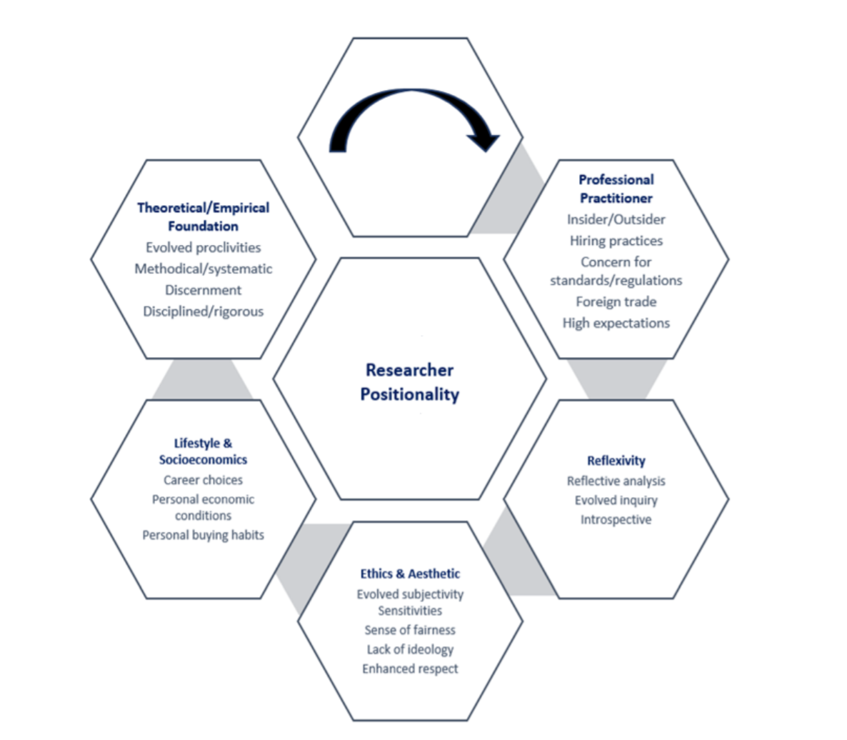

Figure 2. intersectionality
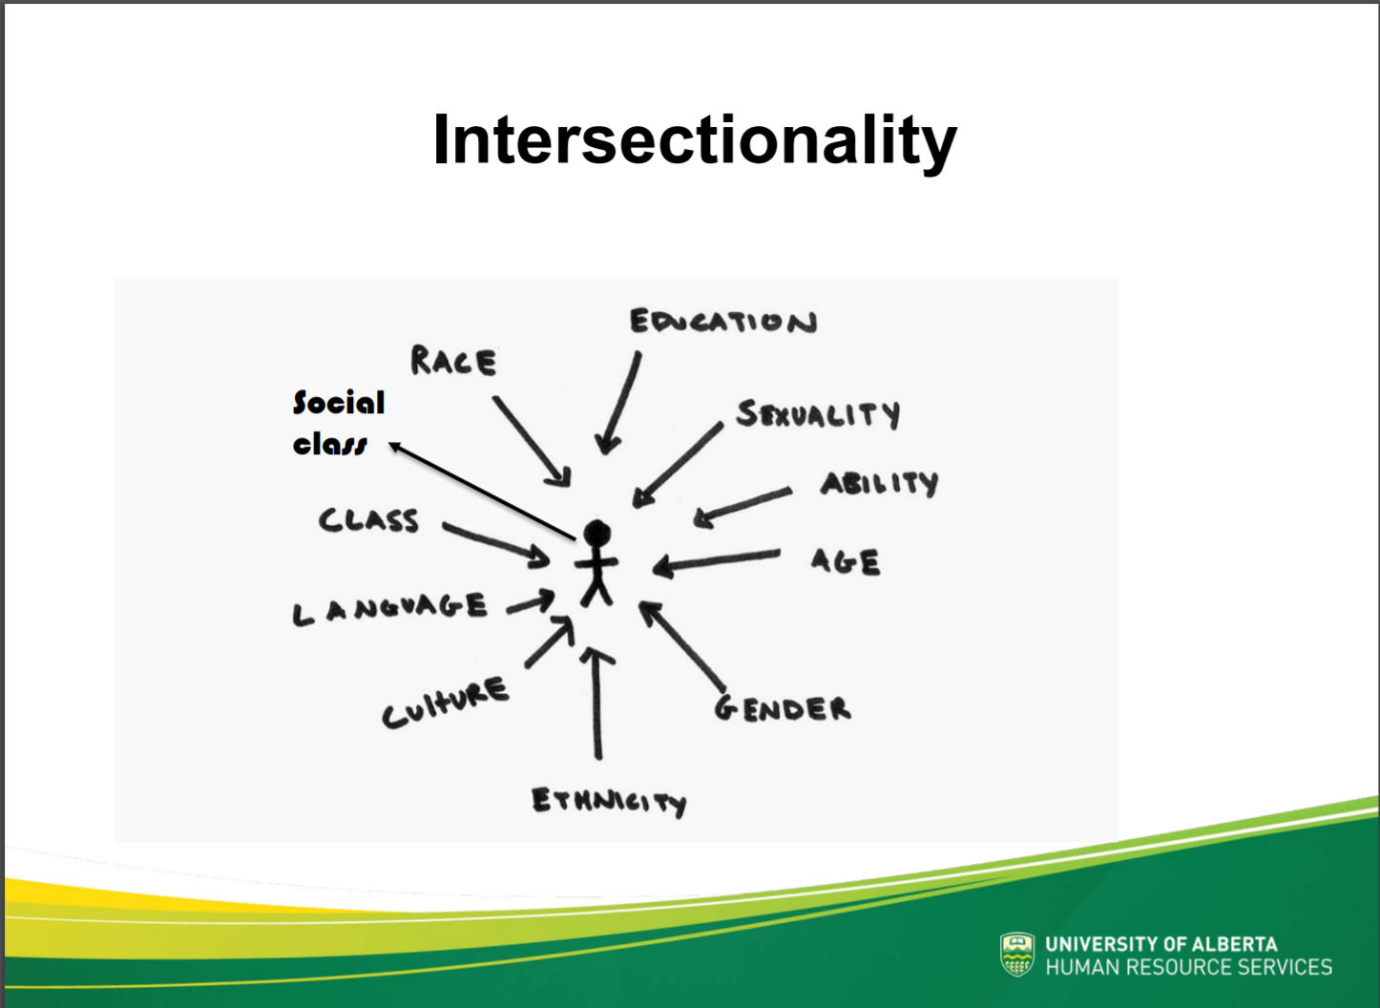
(Source:https://cloudfront.ualberta.ca/-/media/gradstudies/professional-development/gtl-program/gtl-week-august-2018/2018-08-28-social-location-and-unconscious-bias-in-the-classroom.pdf)
Figure 3: research questions and research goals
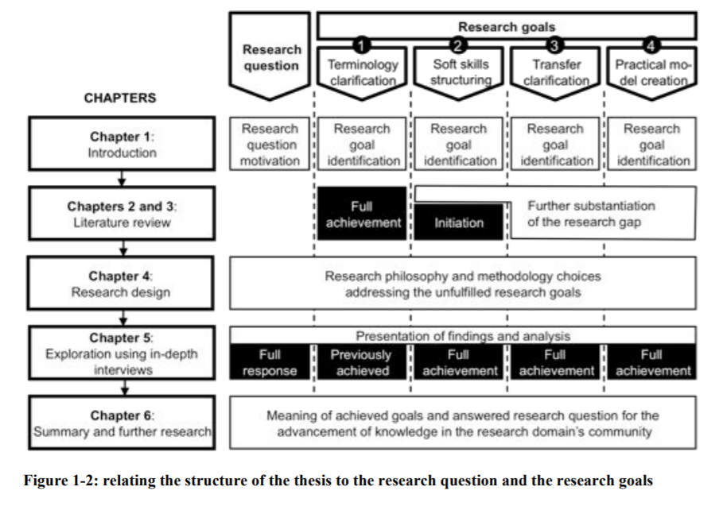
(source: Brown, M. E., & Dueñas, A. N. ,2019).
Figure 4: summary of research design choices using an adaptation of the research onion of Sauders et al. (2003), extended by the aspect of axiology
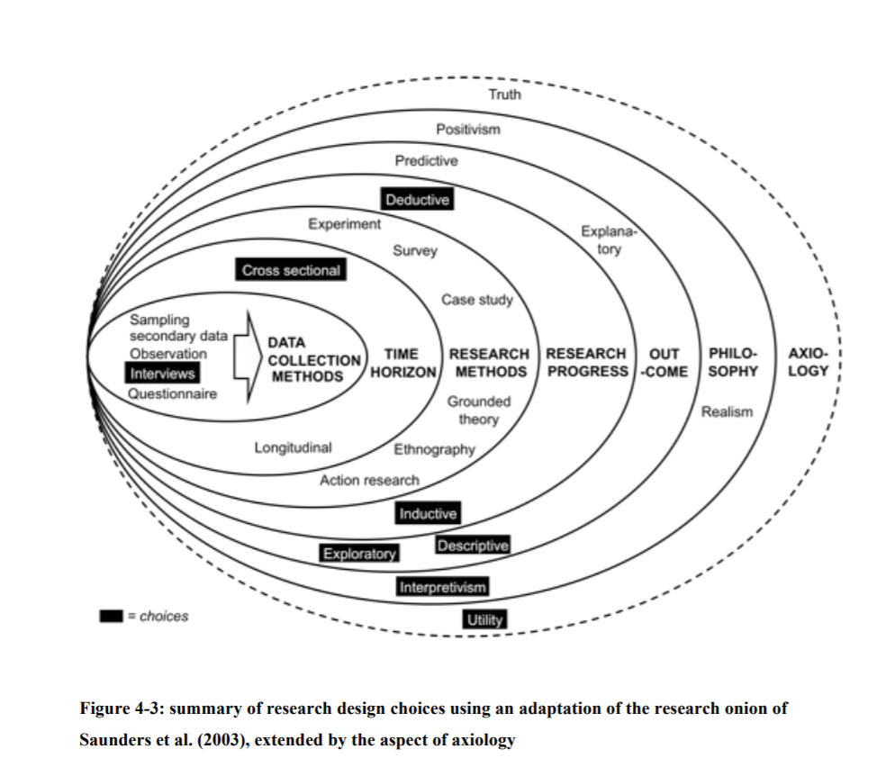
(source: Brown, M. E., & Dueñas, A. N. ,2019).

Figure 5: The building blocks forming a piece of work’s research paradigm and how they interrelate. Image is an adapted version of Grix’s paradigmatic building blocks. Image adapted by authors to include axiology as an important block not originally detailed
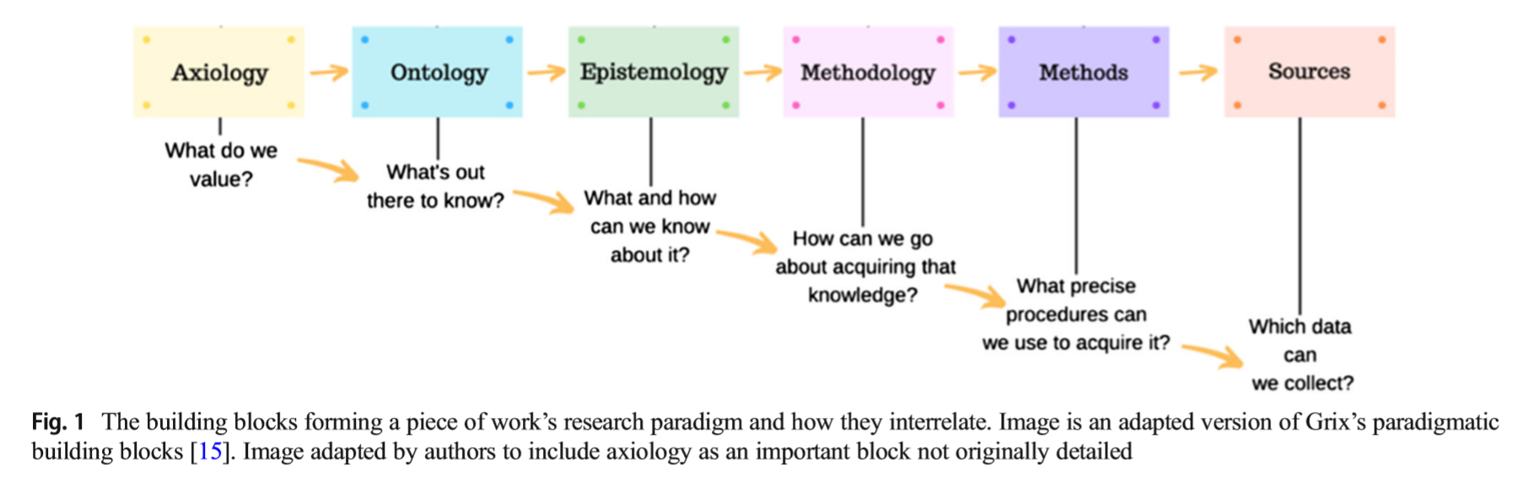
(source: Introducing students to the generic terminology of social research, Grix J. ,2002).

Figure 6: The building blocks of a research project’s paradigm within the four mainmedical science education paradigms summarized.
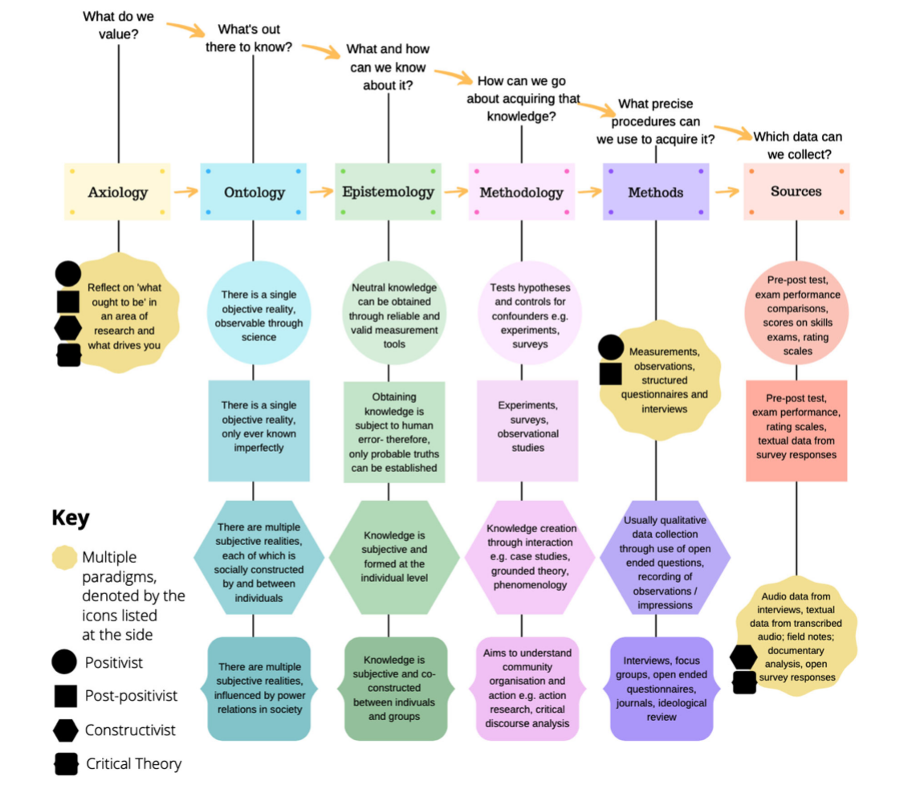

Figure 7: Tips to Evaluate Sources
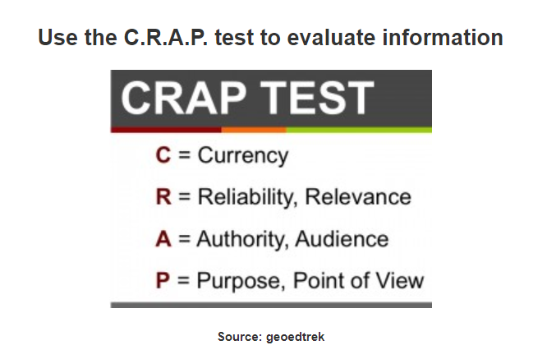
(Source: https://libguides.asu.edu/c.php?g=264095&p=1763442)
Figure 8: how to read academic texts
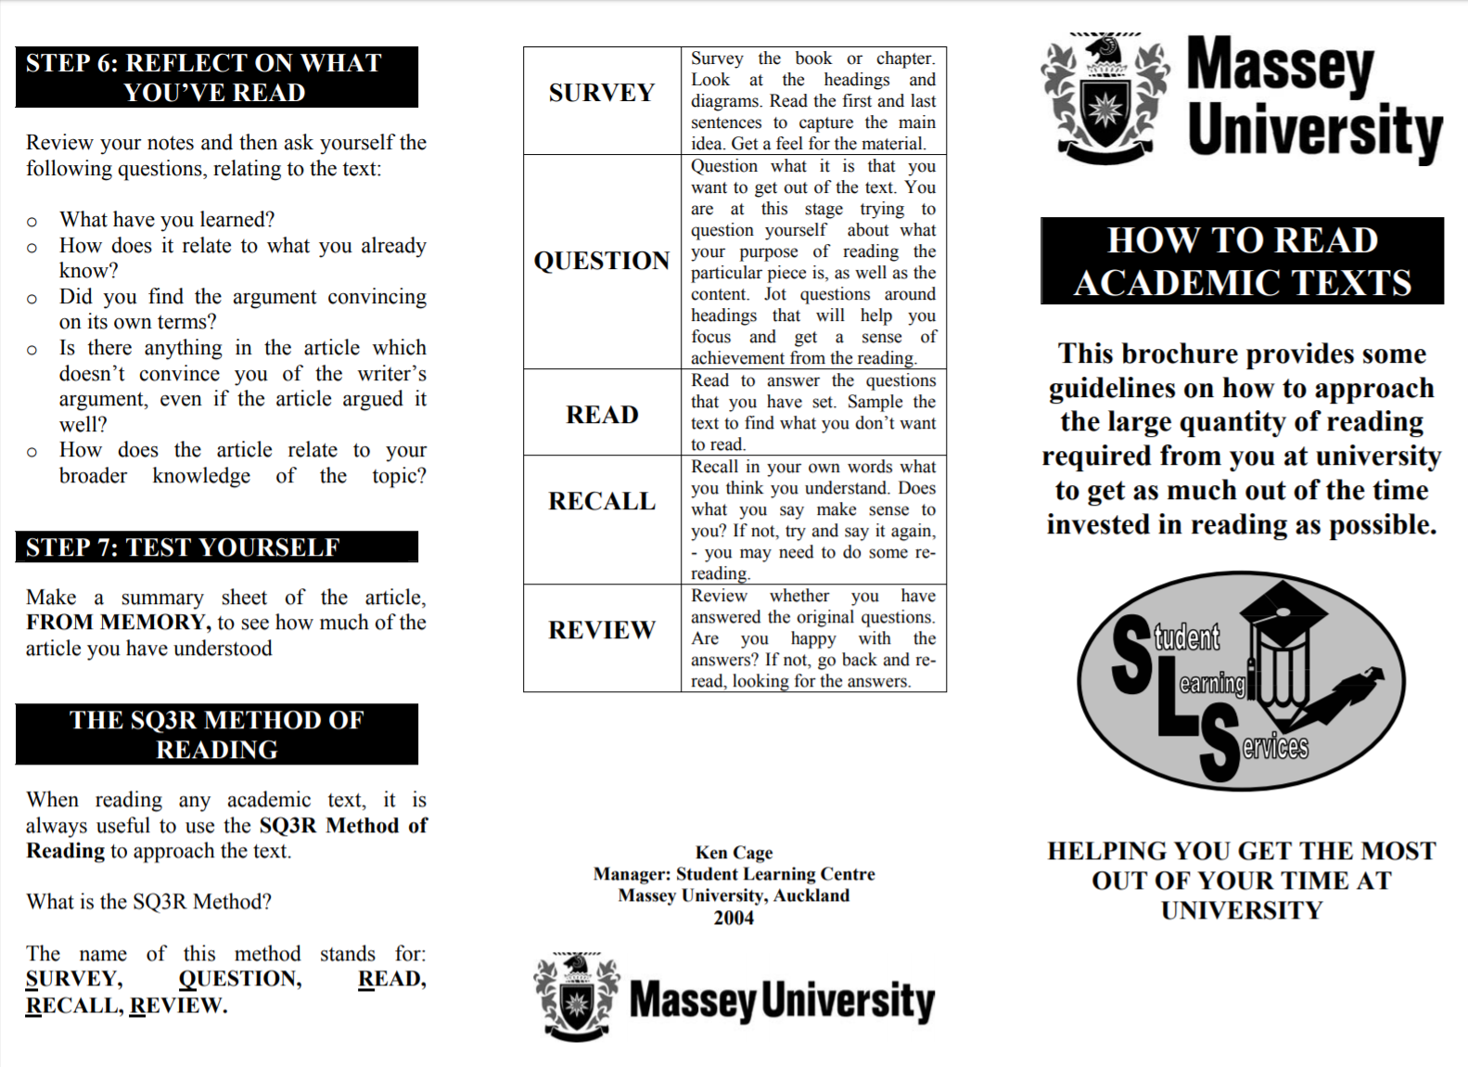
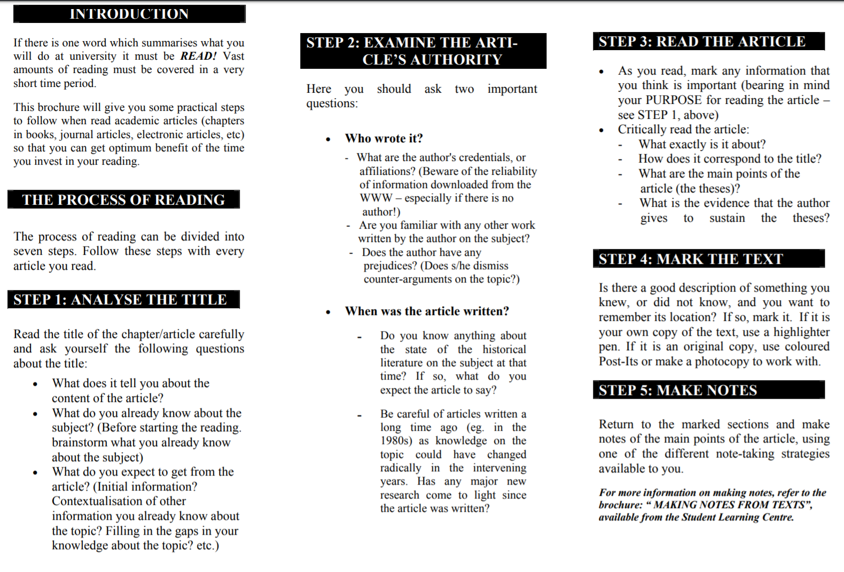
(Source: https://www.massey.ac.nz/massey/fms/Student%20services/Student%20Learning%20Development%20Service/Documents/Albany/Brochures/Study%20skills/Reading%20academic%20texts.pdf)

Figure 9: Pattern notes- Linear notes
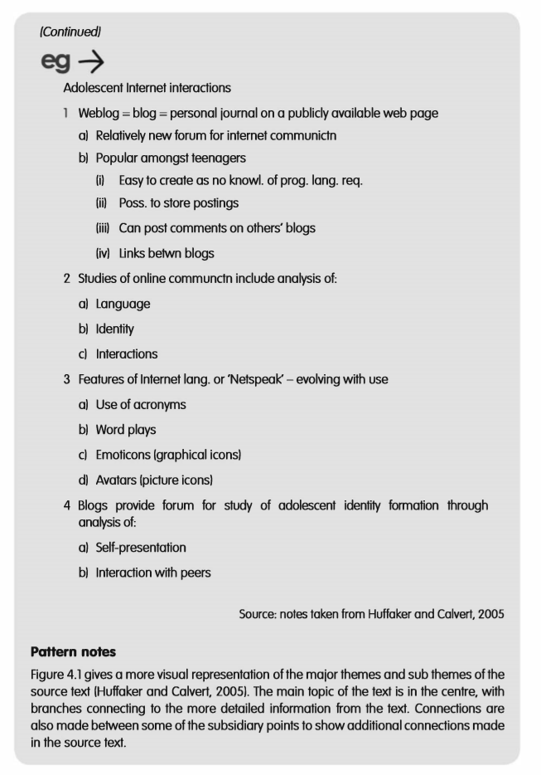
(Source: notes taken from Huffaker and Calvert, 2005).

Figure 10: Pattern notes- A global summary
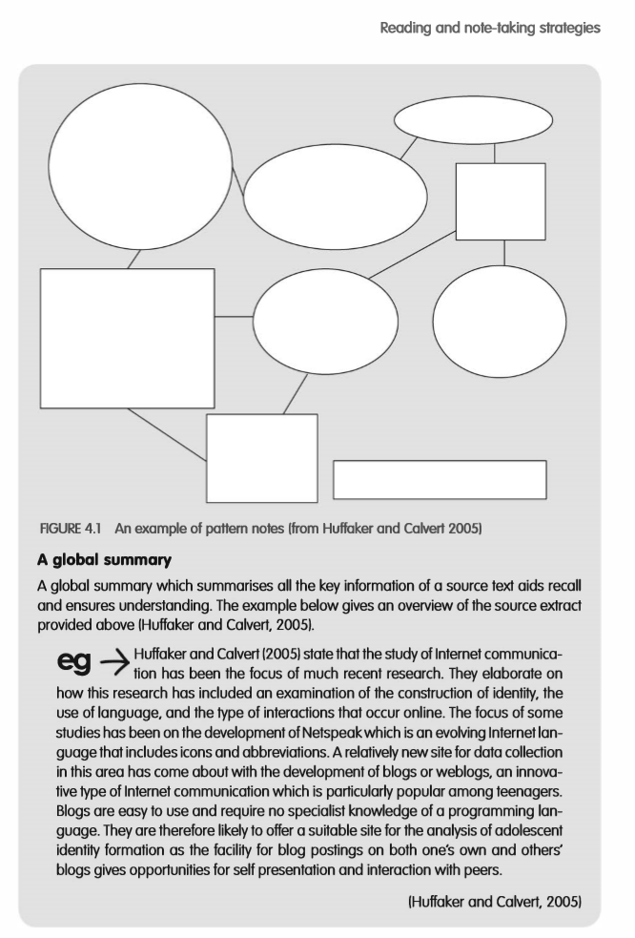
(Source: notes taken from Huffaker and Calvert, 2005).

Figure 11: Reflex Interaction, Reflective Analysis, and Critically Reflexive Questioning
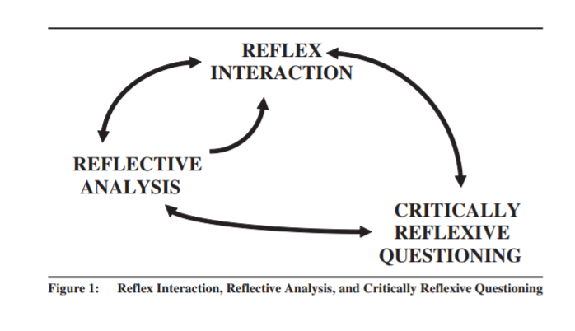
(Source: On Becoming a Critically Reflexive Practitioner, Cunliffe,2004).

Figure 12: The evaluation process vs traditional research
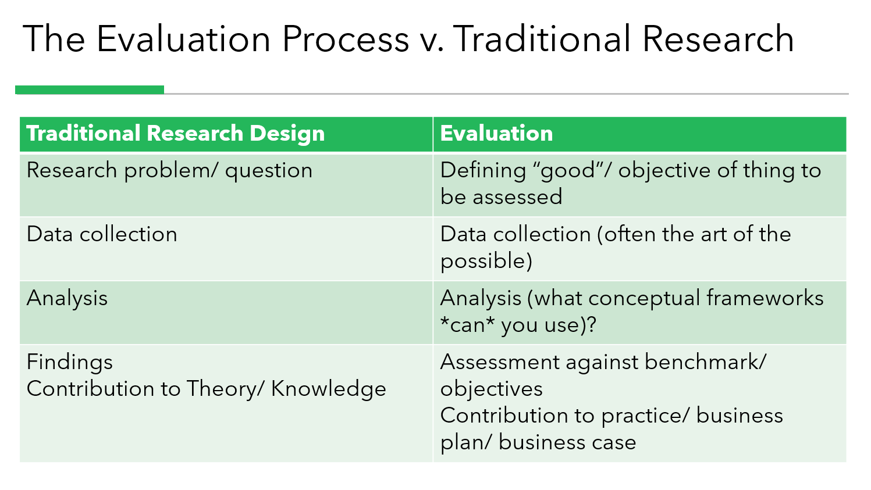
(Source: class PPT, Caroline,2019).

Table 1: research projects in nascent, intermediate and mature areas of management
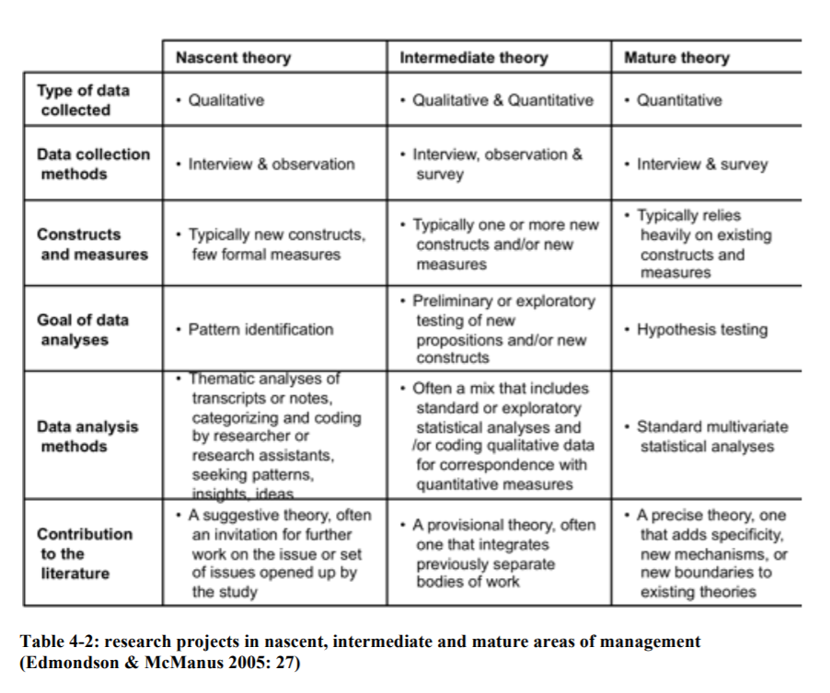
(source: Brown, M. E., & Dueñas, A. N. ,2019)

Table 2: Evaluation Criteria
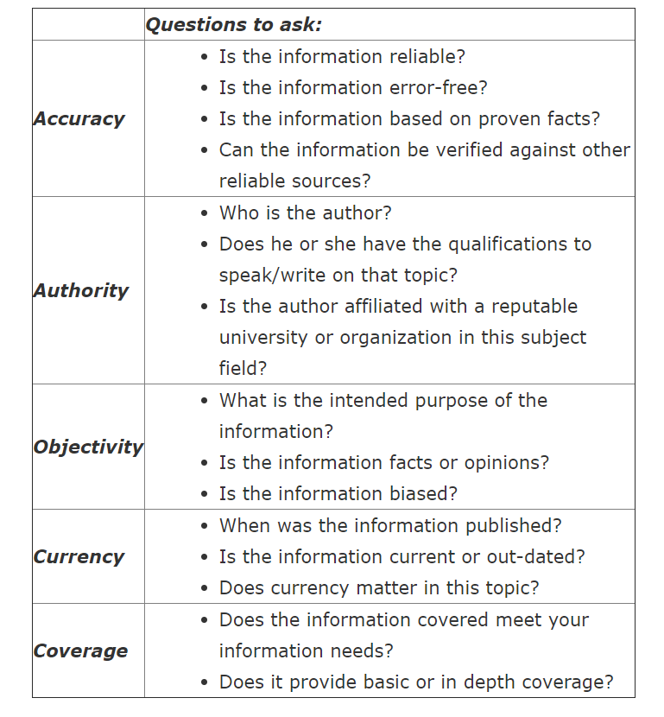
(Source: https://libguides.library.cityu.edu.hk/litreview/evaluating-sources)

Appendix 4: Development Activities
In class, Caroline gave us a quiz to test our attitudes on age, race, occupation, etc. If an accident happens to a ship, we can only save five people on board. Caroline give us the papers with figure’s information about their age, race, and occupation. There was a thirty years old black nurse, a sixty-years-old white doctor, a sixteen-years-old pregnant woman, a policeman, a lawyer, a thirty years male manager, a housewife and so on. When we finish the test, we found that everyone had different attitudes about their occupation, age, race, etc. Opinions differ as to who should be saved. This is also a reflection of each person’s position will affect his view. Since I went back to China, I didn’t bring the specific material of the characters I practiced in class with me, so I'm sorry that I can’t put photos here.

