

Student: Maings Melgar Vargas
Number: 1817131
Module Title: Problem Solving and Decision Making
Cod: (BMSW4004)
Lecture: Afzal Munna
Title: Internal Communication of Holborn’s Restaurant

Table of Contents
Introduction 3
1. The problem at the workplace 3
1.1 Chosen problem 3
1.2 Reasons for the problem 3
1.3 Disadvantages of the problem 3
1.4 Resolving the problem 4
1.5 Experience of the problem 4
1.6 Seven steps to problem-solving 4
2. Decision making 5
2.1 Types of decision 5
2.2 Factors affecting decision making 5
2.3 Ingredients of good decision making 5
2.4 Fishbone Analysis 6
2.5 SWOT Analysis 6
2.6 PESTEL Analysis 7
2.7 Porter’s Five Force Analysis 7
3. Solution 8
3.1 Proposed Solution 1 8
3.2 Proposed Solution 2 8
3.3 Evaluation of the Proposed Solutions 8
4. Implementation 9
4.1 Plan Implementation for the proposed solution 9
4.2 Monitor and review of an implementation plan 10
5. Conclusion 12
6. References 13
Appendix 14

Introduction
The aim of the report is to analyse the communication problem in Holborn’s restaurant, one of the biggest restaurants in London. Restaurants serve the most delicious food and provide the best hospitality service to the customers (holborndiningroom.com 2018). But the problem regarding the weaknesses within the workplace of the restaurants can harm the customer services as well. In addition, some recommendation for the problem is discussed in the report.

1. The problem at the workplace

1.1 Chosen problem
The internal communication gap among the employees and management has been a crucial problem for Holborn’s restaurant. In addition, there is workplace bullying and harassment faced by the employees that are discussed in the following report. Bullying and internal communication problems reduce the work quality and can impact on the reputation of the restaurants.

1.2 Reasons for the problem
The problem is related to bad communications among the workers in the restaurant. The interpretation of the information between business managers and managers caused the communication gap. The cultural diversity and the lack of education are also the reasons behind the communication disorder. The ambitions and jealousy within the employees cause bullying and harassment. The people with less power have a lack of leadership that causes communications disorder within the workplace.

1.3 Disadvantages of the problem
Communication gap reduces collaboration among the employees in the restaurants. In the hospitality industry, communication is one of the basic skills that is needed for management. Lack of effective communication can create a workplace failure and that reflects the accomplishment of the job.

1.4 Resolving the problem
In order to resolve the problem, the employees must be encouraged to communicate in a necessary way. It strengthens the relationship. Casual language can create a crucial barrier to the effective communication system. The manager must improve communication skill in terms of enhancing productivity and maintaining harmony in the workplace. In order to conduct effective communication, the employees must be open-minded and communicate to promote a healthy working environment and teamwork.

1.5 Experience of the problem
The problem I have faced in the restaurant as a trainee assistant HR manager is miscommunication with my manager. I have offered some strategies to implement for the betterment of the company, but my manager did not understand what I was trying to convince. The individual has created a big scene and scolded me in front of all the trainees. I felt quite insulted and tried to focus more on the leadership and communication skill of myself.

1.6 Seven steps to problem-solving
- The first step to problem-solving is to identify the issue and understand different views from employees.
- The second step is to comprehend others' interests and separate the interests according to the priority.
- The third step includes a list of solutions that have possibility to solve the issues.
- The next step is to analyse and apply the appropriate solution from the previously generated list.
- The fifth stage is to apply the best option among a wide range of option to implement the solution.
- The sixth step includes the documentation of agreements with all the details.
- The last step is to monitor and review the implemented solution to the problem.

2. Decision making

2.1 Types of decision
There are five kinds of decisions such as organisational, strategic, programmed, policy and individual or group decisions.
- Organisational decision undertakes on a specific condition of the organisation.
- According to Huff et al. (2016), a strategic decision is made on the problems that are crucial and it requires the alternative solution to the problem.
- Programmed and non-programmed decisions use computer terminology in decision-making.
- Policy and operative decisions are basic to management to make decisions based on the organisational framework.
- Group decisions are taken after a discussion placed among the members of management and employees.

2.2 Factors affecting decision making
In order to make an effective decision, several factors are affecting the process. According to Li et al. (2020), the perception of different personalities in an organisation can be different that creates trouble for the decision-makers. Sometimes the situations and time do not become appropriate for an effective decision-making process. Objects such as persons or events can affect the process.

2.3 Ingredients of good decision making
There are five types of ingredients to implement an effective decision-making process. High-quality information about the company and its workers help the decision-makers to implement an appropriate solution. Data integration and data quality are highly required for effective decision-making. Shared vocabulary or data management system is required, it helps to reduce the unstructured data from the database (Adair, 2019). Accessing advanced technologies is important for the improvement of the decision-making process in an organisation. In order to gain the trust of the employees’ transparency of data is essential.

2.4 Fishbone Analysis
Fishbone analysis helps to manage the quality of the solutions and measure the environment of the organisation. Variation is a part of the analysis. Different methodologies are considered to ensure quality. According to Harris et al. (2017), it is a cause and effect diagram to help the management to identify the reasons for the problem and variation. The name suggests that the management and find the best solution to the problem must recognise the causes of the problem.
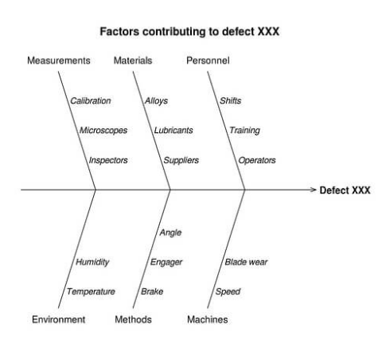
Figure 1: Fishbone diagram
(Source: Harris et al., 2017)

2.5 SWOT Analysis
Restaurants serve the most delicious food and provide the best hospitality service to the customers. But the problem regarding the weaknesses within the workplace of the restaurants can harm the customer services as well. According to Gurel and Tat (2017), SWOT-analysis helps to identify the strengths and weaknesses of the organisation and also enables opportunities for the future. The threats are also analysed in the SWOT analysis. In terms of an effective decision making, SWOT analysis is important.

2.6 PESTEL Analysis
PESTLE analysis is an evaluation of different factors that are affecting the organisation as well as the country in which the organisation is currently operating. The economical, political and social factors are included in the analysis that make an impact on the company (Christodoulou and Cullinane, 2019). The factors influence the business organisation to make benefits and they are identified carefully to analyse the regulated factor to improve the efficiency of the company.

2.7 Porter’s Five Force Analysis
According to Lewis (2017), Porter five forces is a framework that helps to analyse the present competition of a company and its sustainable competitive advantages in the industry. By using these five forces, the managers of Holborn can analyse its strategic position in the global market and can enhance the profitable opportunities in customer services.
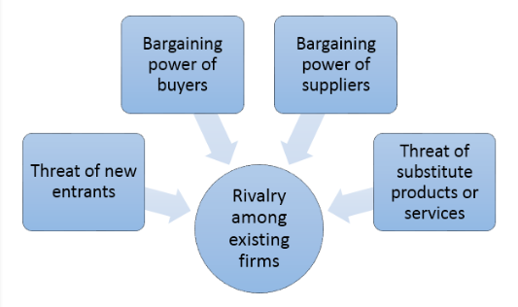
Figure 2: Porter’s Five Forces Analysis
(Source: Lewis, 2017)

3. Solution
The process of conducting and implementing the solution includes four stages. The first stage is to generate ideas. The managers present a range of questions or problem questionnaires to the participants to be answered. The manager and moderator arrange the discussion and direct everyone to give their ideas in brief and work together. Each participant generates ideas and presents them to solve the problem.

3.1 Proposed Solution 1
The communication gap among the employees in the Holborn restaurant can be solved by implementing the proposed solution. The behavioural approach of the managers must be analysed to identify the cause of the problem. The managers must notice the behavioural changes among the employees that can reduce bullying and harassment in the workplace. The manager must improve communication skill in terms of enhancing productivity and maintaining harmony in the workplace.

3.2 Proposed Solution 2
The other solution is to gather the data about several problems faced by the employees and managers. The easy way to collect all the information about the problem is to conduct a survey effectively. For the survey, the questions such as what behaviours are the barrier of good communication and list some recommendations for the problem. Shared vocabulary or data management system is required, it helps to reduce the unstructured data from the database. The manager must check all the colleagues are getting similar attention and do not prepare any psychiatric disorder such as jealousy and others.

3.3 Evaluation of the Proposed Solutions
The proposed solutions can be implemented in the Holborn restaurant to reduce the communication problem among the workers. The behavioural approach of the managers helps to identify the cause of the problem. In order to resolve the problem, the employees must be encouraged to communicate in a necessary way. It strengthens the relationship. Casual language can create a crucial barrier to the effective communication system. The manager’s communication skill enhances productivity and maintains harmony in the workplace. Lack of effective communication can create a workplace failure and that reflects the accomplishment of the job. Effective use of decision-making and problem-solving techniques enabled the company to fight back and regain the trust of the workers and customers as well. By implementing the solutions, the company allowed the workers to give their opinion freely and the management agreed to follow the feedback and demand of the workers to maintain the harmony in the workplace and make the production process active.
According to Vercic and Vokic (2017), the easiest way to solve the internal communication gap is to schedule a survey and identify the key issues among the employees. Once the managers commit the process the problems will automatically start reducing. The proposed solutions reach all the possible outcomes of the problem and help to overcome the problem positively.

4. Implementation

4.1 Plan Implementation for the proposed solution

Goal | Strategy | Time duration
Improving communication skill | Apply a range of discussions over the problems and get recommendations from the employees. Starting group discussion and analysis | 2 months
Implementation of data collection | To conduct a survey and identify the key issues among the employees | 3 months

4.2 Monitor and review of an implementation plan
There are several numbers of tools available to monitor and review the implementation plans in the organisation.
PDSA: The implementation of planning, doing, studying and acting in an effective manner helps to test the changes before the implementation of the solution and after that. Using the PDSA cycle the organisation enables the framework for testing and implementing the proposed solutions. It enables further improvement for the organisation and identifies the aims of the solution and changes that can affect the result for further improvement. PDSA is a four-stage cycle to plan and study the cycle of tasks to carry out the change and assess its impact. It reflects the changes and ideas that are implemented. The next change cycle of full implementation of the ideas generated in the proposed solution is performed in the last stage (Leis and Shojania, 2017).
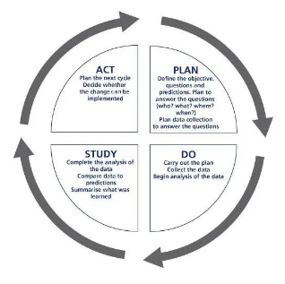
Figure 3: PDSA cycle
Source: (Leis and Shojania, 2017)

Gantt chart: In terms of planning and testing the proposed solutions, creating a Gantt chart can be effective. By making a GANTT chart the tasks are easily analysed and help to identify critical tasks that must be completed on time. According to Ong et al. (2016), it is helpful to monitor the process as it holds the record of date and time while taking immediate actions.
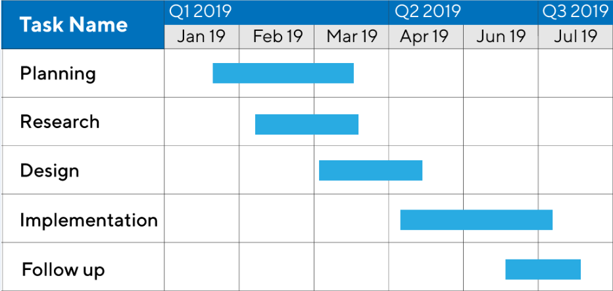
Figure 4: Gantt Chart
(Source: Ong et al. 2016)
Kotter’s 8-step model: According to Radwan (2020), Kotter’s 8 step model helps to establish the urgency of holding a meeting and inform the employees to communicate. It creates a vision for change and considers producing more changes in the process that must be needed to monitor and review the technique.
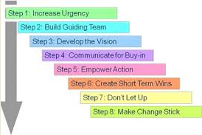
Figure 5: Kotter’s 8 step model
(Source: Radwan, 2020)

5. Conclusion
After analysing the report, it can be concluded that communication ethics enhances the chance to maintain harmony within the workplace if there is lack of communication ethics there must be conflicts to maintain the relationship between the management and the workers in the organisation. Effective use of decision-making and problem-solving techniques enabled the company to fight back and regain the trust of the workers and customers as well. By implementing the proposed solutions, the company allowed the workers to give their opinion freely and the management agreed to follow the feedback and demand of the workers to maintain the harmony in the workplace and make the production process active.

6. References
‌Adair, J. (2019). Decision Making and Problem Solving: Break Through Barriers and Banish Uncertainty at Work. Kogan Page Publishers.
Gürel, E. and Tat, M. (201). SWOT analysis: a theoretical review. Journal of International Social Research, 10(51).
Harris, T.E., Lilley, K.A. and Walter, R.K. (2017). The varying role of vertebrae in Pacific fishbone analysis: comparing tropical versus temperate midden assemblages. International Journal of Osteoarchaeology, 27(6), pp.1038-1047.
Holborn Dining Room. (2018). Holborn Dining Room | British Brasserie London | Holborn Restaurants. [online] Available at: https://holborndiningroom.com/#homepage-popup [Accessed 8 Apr. 2020].
Huff, A.S., Milliken, F.J., Hodgkinson, G.P., Galavan, R.J. and Sund, K.J., 2016. A Conversation on Uncertainty in Managerial and Organizational Cognition', Uncertainty and Strategic Decision Making (pp. 1-31). Emerald Group Publishing Limited.
Leis, J.A. and Shojania, K.G. (2017). A primer on PDSA: executing plan–do–study–act cycles in practice, not just in name. BMJ quality & safety, 26(7), pp.572-577.
Lewis, R. (2017). Porter's Five Forces of competitive advantage.‌
Li, N., Huang, J. and Feng, Y. (2020). Human performance modeling and its uncertainty factors affecting decision making: a survery. Soft Computing, 24(4), pp.2851-2871.
Ong, H.Y., Wang, C. and Zainon, N. (2016). Integrated earned value Gantt chart (EV-Gantt) tool for project portfolio planning and monitoring optimization. Engineering Management Journal, 28(1), pp.39-53.
Radwan, A. (2020). Lead transformational change, minimize resistance with 8‐step model. Dean and Provost, 21(7), pp.1-5.
Verčič, A.T. and Vokić, N.P. (2017). Engaging employees through internal communication. Public Relations Review, 43(5), pp.885-893.

Appendix

