Leaflet
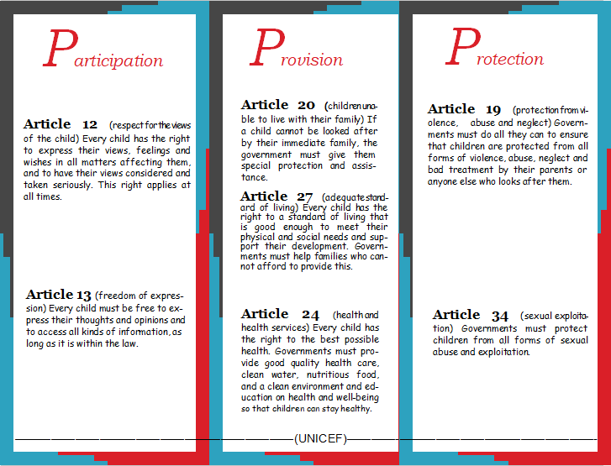

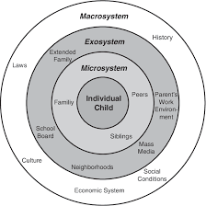
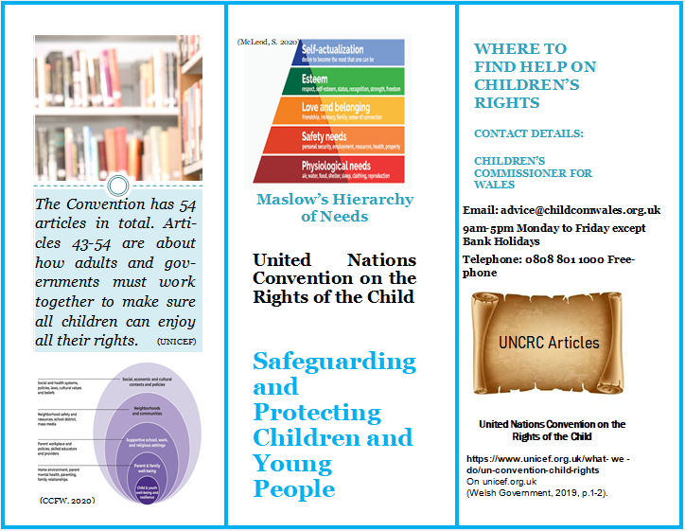
(Elliot and Davies, 2018)
‘The Convention has 54 articles in total. Articles 43–54 are about how adults and governments must work together to make sure all children can enjoy all their rights...’ (UNICEF)

References

Elliott, S. and Davis, J. M. (2018) Challenging Taken-for-Granted Ideas in Early Childhood Education: A Critique of Bronfenbrenner's Ecological Systems Theory in the Age of Post-humanism. Available at: https://www.semanticscholar.org/paper/Challenging-Taken-for-Granted-Ideas-in-Early-A-of-Elliott-Davis/e6c7e9d7e1a23ea8f25cf816272ab642673e9dfc (Accessed: 27th March 2021)
McLeod, S. (2020) Maslow’s Hierarchy of Needs. Available at: https://www.simplypsychology.org/maslow.html#gsc.tab=0 (Accessed: 13th February 2021).
UNICEF (undated) How we Protect Children’s Rights with the UN Convention on the Rights of the Child. Available at: https://www.unicef.org.uk/what-we-do/un-convention-child-rights/ (Accessed:28th January 2021).
Welsh Government (2019) Policy and Strategy. Children’s Rights in Wales. Available at: https://gov.wales/childrens-rights-in-wales (Accessed: 31st January 2021).

Rationale
Burton et. al., (2014, p.74, citing Kempe et.al.,1985) reveal ‘The notion that children could be abused by their parents and care givers was only first posited...’ by American Dr Harold Kempe in 1962 and documented in the paper ‘The Battered Child Syndrome’. In the late 1960s the NSPCC ratified the paper and proceeded to enlist the involvement of the government and media to help eliminate ‘the systemic failures’ in safeguarding children (Burton et.al., 2014, p.74). UK Government acts and policies on safeguarding children and young people have since evolved, particularly in the field of children’s rights. As such, the UNCRC ‘provides an ideal approach for children to learn about their human rights’ as they are ‘relevant to children’ suggested by Fauziati (2018, p.470-471).
The Welsh Government (2014, p.5) reveal that in 1991 the UK Government ratified the United Nations Convention on the Rights of the Child (UNCRC) 1989 and it came into force on 15th January 1992. Moreover, ‘In 2002 the National Assembly for Wales (NAfW) ‘...developed the Seven Core Aims for children...’ and in January 2004 ‘...adopted the UNCRC as the underpinning basis for its policies concerning children and young people’ (Welsh Government, 2014, p.5). Likewise, ‘The Welsh Assembly has now adopted the UNCRC as a guide to all its work’ underpinning policy making for safeguarding children. Notably, the UNCRC and the seven core aims are embodied by the ubiquitous influence of the 3Ps which are the rights to Provision, Participation and Protection (BASW, 2008, p.2). Henceforth, children’s rights ‘has been enshrined into Welsh law’ (Welsh Government, 2014, p.8).
Resultantly, the Welsh Government (2016, p.8) propose that ‘we have a duty to raise awareness of children’s rights’ which can be achieved ‘with the use of posters and leaflets...’. For that reason, the objective of the design and content of this leaflet is to raise awareness of children’s rights and to serve as a means to ‘engage the public fully with accepting co-responsibility to protect children’ (Collins and Foley, 2008, p.185). Burton et al., (2014, p.74) elucidate the point that it is often ‘a member of the public who takes decisive action in terms of safeguarding’. Nevertheless, the primary target audience for this leaflet is, and must be, children and young people at risk of harm and in need of protection. This is in accordance with national guidance, Working Together to Safeguard Children 2010, to provide ‘appropriate information to the child about his or her right to protection and assistance’ (Jones and Walker, 2011, p.61). Notably, this leaflet can be a useful resource ‘for children to learn about their rights...’ (Harcourt and Hagglund, 2013, p.286).
To compare past and present safeguarding perspectives, the first major child abuse enquiry dating back to 1973 will be examined, and the child at risk and in need of protection was 8-year-old Maria Colwell. Her death, at the hands of her step father, led to changes in policies which are still in place today including a register of at-risk children (Scott, 1975). The ensuing Children’s Act 1989 placed emphasis on parental responsibility and children’s involvement with professionals (Burton et.al., 2014), arguably, two key factors attributable to the death of Maria Colwell.
Some thirty years later, the case of Victoria Climbie ‘seemed to reiterate the same sad failures of people and systems’ (Collins and Foley, 2008, p.184). Burton et.al., (2014, pp.77,94) reveal numerous failings in that, ’Victoria Climbie was never spoken to in her own language’ and although she was ‘known to twelve different agencies’ there was ‘poor inter-agency liaison’ and notably a lack of child protection training. It is worthy of a note that due to the failure of a joined-up approach, ‘everybody’s responsibility’ was adopted as the fundamental focus in UK Government ECM Green Paper 2003. The issue that ‘multi-disciplinary working with families is a complex and demanding process’ arose from the ‘findings of the Victoria Climbie enquiry’ (Frost and Robinson, 2007, p.184), and could be conjectured as a catalyst for the revision of government safeguarding polices.
Sims-Schouten et al., (2019, p.6) offer an alternative perspective, gained through feedback and research around multiagency teams, that ‘the families would prefer to have a team around the worker and just have one worker to themselves’. However, if specialist support is necessary the family will work with more than one professional which can negate this proclaimed preferred model of working. Pertinently, the construct of this model should keep in mind the ‘...ongoing cuts to support and early intervention services’. This infers that ‘choices will need to be made about who is receiving help...’ or not (Sims-Schouten et al., 2019, p.7). A further suggestion that 19th century ‘Government welfare policy was focused on separating the ‘deserving’ from the ‘undeserving’ (Sims-Schouten et. al., 2019, p.2, citing Skinner and Thomas, 2017) underlines similarities with the 21st century dilemma of finance and provision, ‘centralising ‘deservedness’, that determined and determines children’s access to services’ (Sims-Schouten et. al., 2019, p.1). However, the deserving/undeserving dichotomy should no longer exist or be relevant, by virtue of UNCRC articles 1 and 2, for the right to participation, protection and provision for all children and young people (see appendix 2).
The Welsh Government (2016, p.11), in correlation with UNCRC Article 20 (see appendix 1), illustrate the right to provision for every child who cannot live at home. Children have the right to live in a family where they get the care, support and help they need and ‘Foster families across Wales provide this each and every day for thousands of children’. Sadly, this particular right for provision was withdrawn in the case of Maria Colwell as she was placed back into the care of her mother and step father, despite signs of reluctance and distress (Scott, 1975). Relevantly, Jones and Walker (2011, p.61) juxtapose three pointers. Firstly, that if there is no evidence of significant harm to the child ‘the professionals have no option but to withdraw from the family’ even against the expressed wishes of the child. Secondly, ‘The rights of the child are ‘trumped’ by the rights of the parents to bring their child up as they wish’. Finally, and poignantly, Maria Colwell’s parents invoked this right and as only evidence of significant harm, as opposed to low-level harm, can supersede parents’ rights it was endorsed.
Contrastingly, Welsh Government (2016, p.12) reveal The Social Services & Well-being Wales Act (2014) guidelines that,
everyone will have to work together to improve the well-being of people who need care and support from social services...This includes listening to the views and feelings of a child or young person about how care and support is provided to them when needed.
This indicates that ‘Safeguarding children is now more clearly understood as an activity that is done with our children rather than to them’ (BASW, 2008, p.2) and typifies the right to participation detailed in Article 12 and 13 of the UNCRC (see appendix 1). ‘In response to this convention...participatory approaches have been incorporated into child protection legislation and policies in a number of countries’ (Woodman et al., 2018, p.476, citing Healy,1998). This includes the UK and Wales NHS (2008, p.10) recommend that ‘Their wishes and feelings should always inform any decisions that are made about them’. Likewise, Collins and Foley (2008, p.195) propose that ‘Practitioners can listen to children, include children and families, and achieve the appropriate balance between participation and protection...’.
Conspicuously, the right to provision has been omitted from this conjecture which could arguably influence the outcome of protection and ultimately the safeguarding of the child. This is clearly exemplified in the case of Maria Colwell whereby the provision of foster care was withdrawn. Equally, participation failed to be facilitated, as her signs of distress were not acted upon. Had the rights to provision and participation been upheld, a different outcome of protection may have ensued. Indeed, as Woodmen et al., (2018, p.476) explain participation ‘improves the quality of services that impact on them’.
Theorist Urie Bronfenbrenner’s Ecological System Theory (1979) deepens the discourse on parents and carers and surmises that ‘the family thus plays a key role...’ and ‘it does so in terms of the personal characteristics of all individuals in the family...’ along with family interactions (Rosa and Tudge, 2013, p.243). The previously discussed cases exemplify this in that the institution of the family can be at the core of abuse, and Bronfenbrenner validates this with recognition of ‘social-class influences on child rearing’ (Rosa and Tudge, 2013, p.243).
In order to properly understand Bronfenbrenner’s supposition, UNICEF reveal Article 34 (see appendix 1) which specifies the right to protection from sexual abuse and exploitation. Significantly, this form of abuse could potentially occur due to a deficiency of basic needs. Goepel et al., (2015, p.182) explain that ‘Neglect and poverty can predicate sexual exploitation’ as ‘It is possible that some children from homes where they are neglected...’ and deprived of ‘affection, attention...or basic needs such as food, will be particularly attracted to exploitative adults’. Such deprivation contravenes UNCRC Articles 24 and 27 (see appendix 1) which state that governments must provide ‘good quality health care, clean water, nutritious food, and a clean environment’. According to 20th century psychologist Maslow, in his Hierarchy of Needs (1943), these basic, lower-order deficiency needs ‘are essential to optimal human existence’ revealed by Noltemeyer et al., (2012, p.1862-1863) who further report that from an early study ‘individuals from lower socioeconomic backgrounds were more concerned with deficiency needs’. This lower social class can predicate a dysfunctional nature of child rearing, conceivably inferred by Bronfenbrenner’s recognition of social class influences. Furthermore, it could be proposed that the disquiet of deprivation is borne out of fear of the possible risk of abuse.
Additionally, McAuley et al. (2006, p.159, citing Petit and Curtis,1997) suggest that ‘In the case of physical abuse, parents are usually the perpetrators’ often due to the stress of poverty and social isolation which can engender out of control behaviour or inappropriate discipline. There are many consequences of physical abuse including aggression, depression, low self-esteem, poor academic performance and impaired social competence (McAuley et al., 2006). Similarly, a report commissioned by the NSPCC identified a strong association between abuse and ‘poorer emotional well-being, self-harm and suicidal thoughts’ (Burton et al., 2014, p.75). Herein lies a paradox, in that ‘ children were judged to be at risk against a much broader range of indices...’ including ‘...child mental health problems and child poverty’ (Collins and Foley, 2008, p.189) illustrating a paradoxical interrelationship of the risks for abuse and the consequences of abuse.
Goepel et al., (2015, p.188) suggest that school practitioners are in a position to help children with mental health difficulties and help improve children’s ‘levels of awareness and self- esteem...so are less likely to seek...attention from predatory adults’. Goepel et al., (2015, p.187-188) proffer two further pointers on the impact of a school practitioner’s role. Firstly, helping children improve their self-esteem can help ‘maintain good relationships with their parents and carers’ and can consequently give a child confidence to make a disclosure and talk to someone they trust. Secondly, a school practitioner ‘can play an important role in this process’ as ‘these children may feel that you are the one adult...that they can confide in’. Any disclosure of abuse or harm must be shared with the local education authority (LEA) and as such the Great Britain, Children Act (1989, section 47) report that when in receipt of a disclosure a local authority will ‘have reasonable cause to suspect that a child...is suffering, or is likely to suffer, significant harm’ and must resultantly decide whether or not to take safeguarding action. These safeguarding actions of sharing demonstrates the practitioner’s vital role in an effective multi-disciplinary approach of participation, provision and protection in partnership and accordance with school, LEA and government policies.

In brief, government guidance stipulates that everyone working with children have a duty and responsibility to identify and respond to suspected abuse or harm as ‘Children and young people are dependent on others not only to notice their plight but to take appropriate action’ (Burton et.al., 2014, p.74). It is critical that professionals in health, education and social services sectors ‘work together within the models of multi and inter-agency working’. Sadly, ‘The ‘integrated approach to safeguarding often fails children and is evident it is not always working’ (Burton et.al., 2014, p.74). This is undeniably true in the aforementioned tragic cases of Maria Colwell and Victoria Climbie. Although, it is possible that Government reform can reverse the historic trends of catastrophic failings of safeguarding in the UK with its revised joined up approach and safeguarding policies, crucially, underpinned by the UNCRC. Furthermore, the subject of finance features in Government policies, past, present and future, on account of the UNCRC’s prerequisite for governments to provide services and financial support for families, exemplified in Articles 24 and 27 (see appendix 1). As both UK and Welsh Governments have ratified the UNCRC, safeguarding should be financed accordingly and should therefore be more robust.
This leaflet has been designed to promote safeguarding utilising the doctrine of the 3Ps within the UNCRC, which is at the core of revised UK and Welsh government safeguarding policies. Hopefully, tragic errors of the past can be eradicated, as the future of safeguarding our children and young people appears to be in the safe hands of children’s rights.

Appendices
Appendix 1 UNICEF (no date)

Appendix 2 (UNICEF, no date)

Article 1 (definition of the child) Everyone under the age of 18 has all the rights in the Convention.
Article 2 (non-discrimination) The Convention applies to every child without discrimination, whatever their ethnicity, sex, religion, language, abilities or any other status, whatever they think or say, whatever their family background.

References

192 Frost and Robinson
BASW (2008) All Wales Child Protection Procedures. Available at: https://www.basw.co.uk/system/files/resources/basw_125225-1_0.pdf (Accessed: 1st February 2021).
Burton, M., Pavord, E. and Williams B. (2014) An Introduction to Child and Adolescent Mental Health. London: Sage Publications Ltd.

Collins, J. and Foley, P. (2008) Promoting Children’s Wellbeing. Policy and Practice. Bristol: The Policy Press in association with The Open University.
Copyright © 2007 John Wiley & Sons, Ltd. Child Abuse Review Vol. 16: 184–199 (2007)
Copyright © 2007 John Wiley & Sons, Ltd. Child Abuse Review Vol. 16: 184–199 (2007)
DOI: 10.1002/car
DOI: 10.1002/car
Fauziati, E. (2018) UNCRC, Child Friendly School, and Quality Education: Three Concepts One Goal. Available at: https://publikasiilmiah.ums.ac.id/xmlui/bitstream/handle/11617/10589/Endang%20Fauziati.pdf?sequence=1&isAllowed=y (Accessed: 29th January 2021).
Frost, N. and Robinson, M. (2007) Joining up Children’s Services: Safeguarding Children in Multi-Disciplinary Teams. Child Abuse Review (16) pp.184-199. . Available at: https://onlinelibrary.wiley.com/doi/epdf/10.1002/car.967?saml_referrer (Accessed: 29th January 2021).
Goepel, J., Childerhouse, H. and Sharpe, S.(2015) Inclusive Primary Teaching. 2nd edn. Northwich: Critical Publishing Ltd.
Great Britain (1989) Children Act 1989: Elizabeth II. Chapter 47 (1989) London: The Stationery Office. Available at: https://www.legislation.gov.uk/ukpga/1989/41/section/47 (Accessed: 1st February 2021).
Harcourt, D. and Hagglund, S. (2013) Turning the UNCRC upside Down: a bottom-up perspective on children’s rights. International Journey of Early Years Education, 2013 Vol. 21(4), pp. 286-299. Available at: http://dx.doi.org/10.1080/09669760.2013.867167 (Accessed: 3rd March 2021).

HM Government (2018) Working Together to Safeguard Children Statutory Framework: legislation relevant to safeguarding and promoting the welfare of children. Available at: https://assets.publishing.service.gov.uk/government/uploads/system/uploads/attachment_data/file/942455/Working_together_to_safeguard_children_Statutory_framework_legislation_relevant_to_safeguarding_and_promoting_the_welfare_of_children.pdf (Accessed: 1st February 2021).
Jones, P. and Walker, G. (2011) Children’s Rights in Practice. London: Sage Publications Ltd.
McAuley, C., Pecora, P. and Rose, W. (2006) Enhancing the Well-being of Children and Families through Effective Interventions. London: Jessica Kingsley Publishers.
Noltemeyer, A., Bush, K., Patton, J. and Bergen, D. (2012) The Relationship Among Deficiency Needs and Growth Needs: An Empirical Investigation of Maslow’s Theory Volume 34, Issue 9, pp. 1862-1867, ISSN 0190-7409, Available at: https://www-sciencedirect-com.ezproxy.uwtsd.ac.uk/science/article/pii/S0190740912002265 (Accessed: 5th March 2021).
Rosa, E. and Tudge, J. (2013) Urie Bronfenbrenner’s Theory of Human Development: Its Evolution From Ecology to Bioecology. Journal of Family Theory and Review 5: pp 243-258. Available at: https://onlinelibrary.wiley.com/doi/epdf/10.1111/jftr.12022 (Accessed: 8th March 2021).
Scott, P. D. (1975)The Tragedy of Maria Colwell. The British Journal of Criminology. 15(1) pp.88-90. Available at: https://doi.org/10.1093/oxfordjournals.bjc.a046614 (Accessed: 2nd March 2021).
Sims-Schouten, W., Skinner, A. and Rivett, K. (2019) Child safeguarding practices in light of the Deserving/Undeserving paradigm: A historical & contemporary analysis. Child Abuse & Neglect, Volume 94, pp.1-12 104025, ISSN 0145-2134 Available at: https://doi.org/10.1016/j.chiabu.2019.104025 (Accessed: 3rd March 2021).
UNICEF (undated) How we Protect Children’s Rights with the UN Convention on the Rights of the Child. Available at: https://www.unicef.org.uk/what-we-do/un-convention-child-rights/ (Accessed:28th January 2021).
Wales NHS (2008) All Wales Child Protection Procedures. Available at: http://www.wales.nhs.uk/documents/childprotectionenglish.pdf (Accessed: 1st February 2021).
Welsh Government (2014) Children’s Rights Scheme 2014. Available at: https://gov.wales/sites/default/files/publications/2020-10/childrens-rights-scheme-2014.pdf 2014 (Accessed:28th January 2020).
Welsh Government (2016) Welsh Governments Response to Young Wales’ Report to the UN Committee on the Rights of the Child Available at: https://moodle.uwtsd.ac.uk/pluginfile.php/212389/mod_resource/content/1/160128-reponse-young-wales-report-en.pdf (Accessed: 28th January 2021).
Woodman, E., Roche, S., McArthur, M., and Moore, T. (2018). Child protection practitioners: Including children in decision making. Child & Family Social Work, 23(3), 475–484.Available at: https://doi.org/10.1111/cfs.12439 (Accessed: 8th February 2021).

