THERMODYNAMICS EXAM 2017-18

- QUESTION ONE / Closed System: (10 marks)

A rigid container equipped with a stirring device contains 5 kg of water. The stirring device is switched on for 10 minutes. Determine the change of specific internal energy in kJ/kg during this time; knowing that the water container loses heat at a rate of 1 kW and 3 kW of power is applied to the stirring device.

- QUESTION TWO / Open system, steady-flow process: (20 marks)

A saturated stream of water at 10°C is mixed with another superheated stream of water at 300 kPa and 250°C in an insulated mixing chamber. The mass flow rate of the cold stream is three time that of the hot one and the stream exits at a rate of 15 litres/min and 300 kPa. Determine the temperature, the quality and the mass flow rate of the exit stream.
$T_{1}$ = 10°C
${\dot{m}}_{1}$ = 3 ${\dot{m}}_{2}$
Saturated liquid water

Mixing Chamber

Water,
Sat liquid-vapour mixture
${\dot{V}}_{3}=15 l/{min}$
$$P_{3}=300 kPa$$
$T_{3}$, $x_{3},{ \dot{m}}_{3}$

$T_{2}$ = 250°C, $P_{2}$= 300 kPa
$${\dot{m}}_{2}$$
Superheated water

Assumptions:
- This is a steady-flow process since there is no change with time.
- KE and PE changes are negligible.
- There are no work interactions.
- The device is adiabatic and thus heat transfer is negligible.
- Tables A-4, A-5 and A-6 are to be used.
- In a saturated liquid-vapour mixture, the mass fraction of vapour is called the quality and is expressed as:
$$x=\frac{m_{vapour}}{m_{total}}$$
Quality may have values between 0 (saturated liquid) and 1 (saturated vapour). It has no meaning in the compressed liquid or superheated vapour regions. In the saturated mixture region, the average value of any intensive property y is determined from:
$$y=y_{f}+x.y_{fg}$$
where f stands for saturated liquid, g for saturated vapour and y stands for v, u or h.
- For specific volume, $v_{fg}=v_{g}-v_{f}$

- QUESTION THREE / Open system, unsteady-flow process: (20 marks)

An insulated rigid tank initially contains air at 500 kPa and 47°C. A valve connected to the tank is opened, and air is allowed to escape the tank until the pressure inside drops to 200 kPa, at which point the valve is closed. The air temperature during the process is maintained constant by an electric resistance heater placed in the tank. If the electrical work is 600 kJ, determine:
- The mass of air that has escaped the tank during the process,
- The volume of the tank.
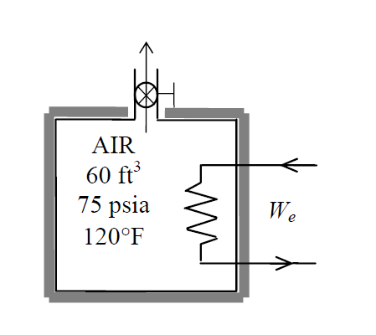

T₁ = T₂ = T_{exit} = 47°C

u₁ = u₂

W_{Elec}
Assumptions:
- Air is considered as an ideal gas.
- The gas constant of air and the properties of air can be found in Table A-2 and Table A-17.
- Kinetic and potential energy changes are negligible.
- There are no heat and no boundary work interactions involved.
- The temperature of the air at the outlet is considered to be the same as the air temperature inside the tank.

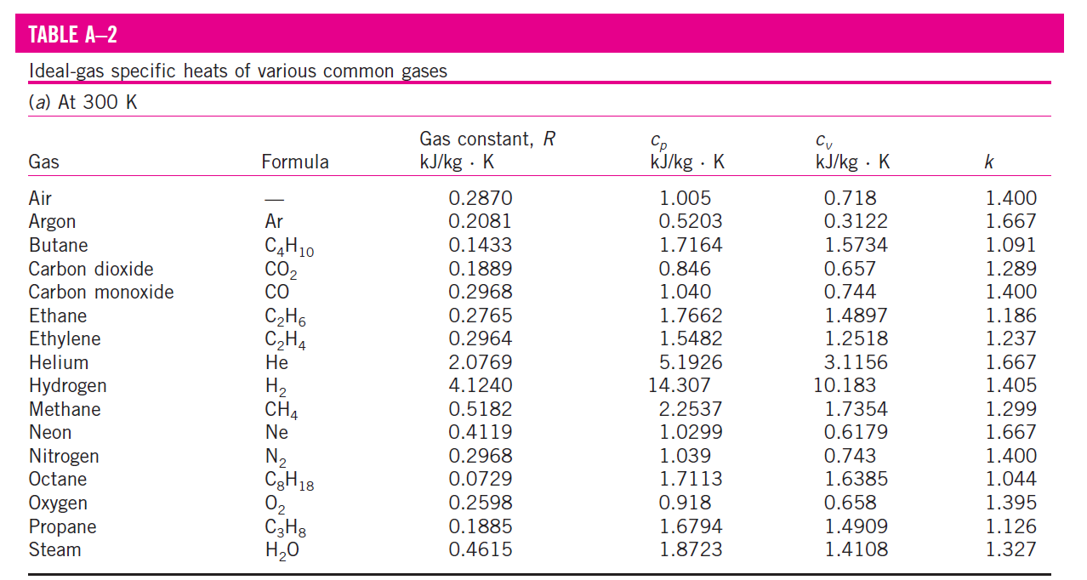

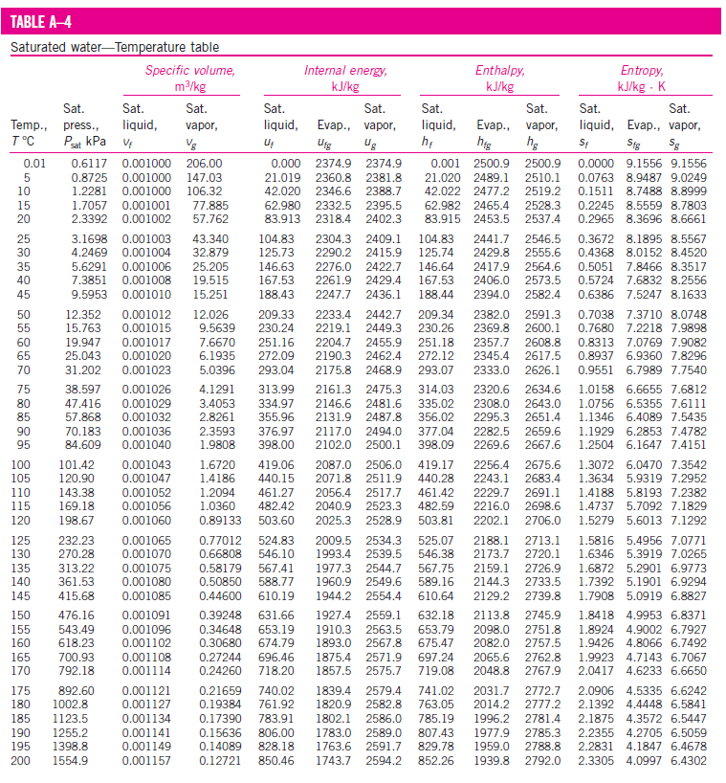

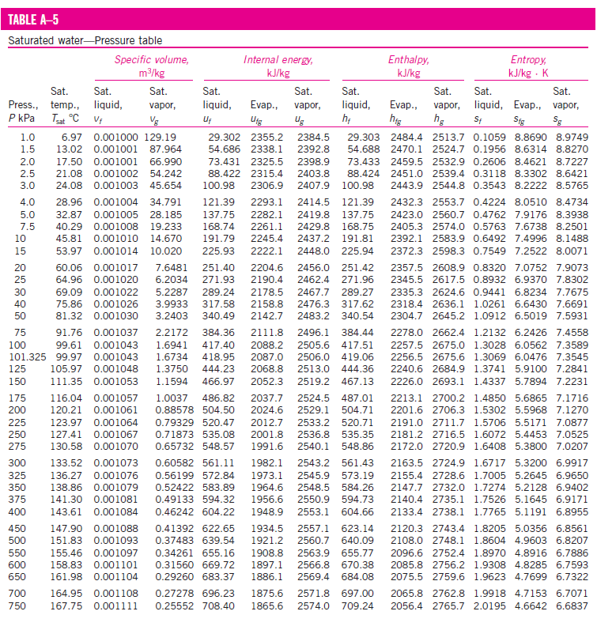

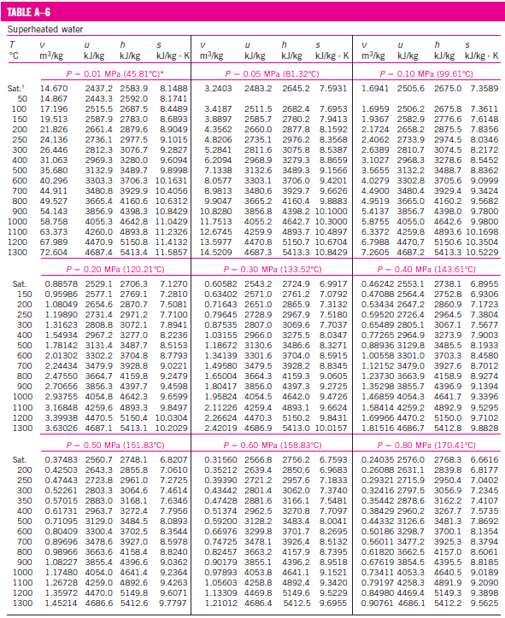

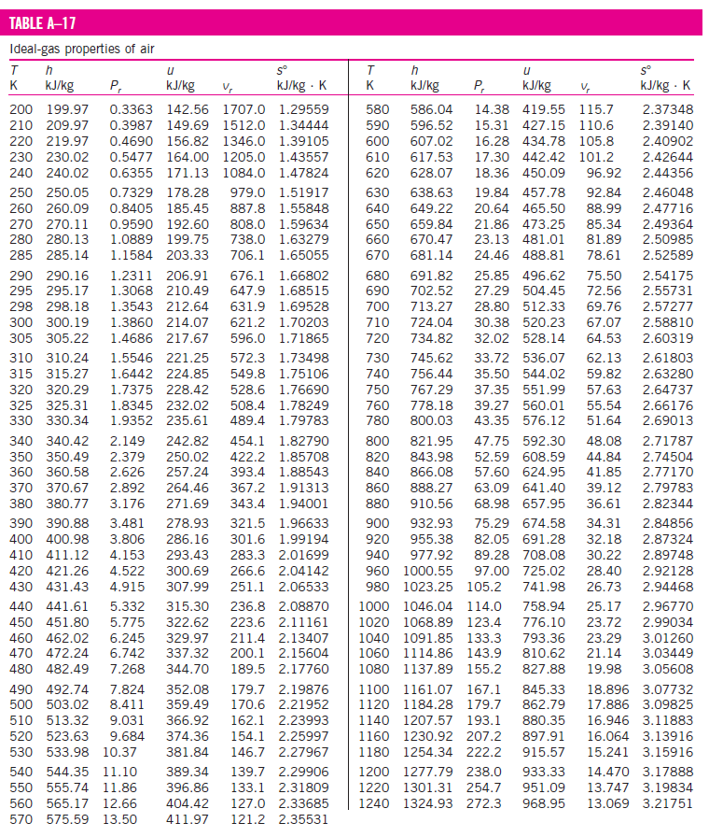

Diwedd/End

