ABSTRACT: Computer-aided diagnosis (CAD) technology is one of the hotspots of current scientific and technological research, and the classification method of benign and malignant lung nodules in CT images is part of it. Lung nodules are an early manifestation of lung cancer. The classification and diagnosis of benign and malignant lung nodules are very important for physicians to evaluate the stage of the nodules and individualized treatment plans. In order to improve the classification accuracy of lung nodules and better assist physicians in the early diagnosis of lung cancer, this paper proposes a method for benign and malignant lung nodules classification based on deep learning. The hierarchical network structure of the convolutional neural network (CNN) which has powerful feature learning and feature expression capabilities, can process massive medical image data and has achieved excellent results in medical image analysis tasks.
The CAD system is mainly composed of the extraction of the Region of Interest (ROI) of the lungs and the classification of benign and malignant lung nodules. The extraction of the ROI is by segmenting the lung parenchyma and extracting the region of interest to remove unnecessary interference from tissues and organs. The classification and recognition of lung nodules is a criterion for accurately evaluating the classification performance of a classifier. This paper focuses on the two key points of the computer-aided diagnosis system: the extraction of the ROI from the lung CT image and the classification of benign and malignant lung nodules. The main tasks are as follows:
(1) Aiming at the problem of excessive manual segmentation or only segmentation of lung parenchyma in traditional segmentation methods, the paper uses a lung region of interest segmentation method. First, the method of histogram equalization is used to enhance the original lung CT image and improve the clarity and recognizability of the image. Then combined with the threshold method to segment the lung parenchymal image. Finally, the ROI is extracted from the lung parenchyma image to reduce noise interference. This article selects LIDC-IDRI as the data set, performs data enhancement and pre-processing on the data, and then uses it as input to the classification network for training.
(2) The deep learning method is applied to the classification of lung nodules, and a ResNet-based classification method of benign and malignant lung nodules is proposed. The backbone network of the method model is constructed based on ResNet-50. The main classification network is trained with the malignant degree of nodules as the supervision information, and the five-fold cross-validation method is used for training. Specifically, the data in the data set is divided into five groups for training. And finally, get five sets of training results and get the average value as the experimental result. Finally, the experimental results use accuracy and AUC value as evaluation indicators to evaluate and verify the performance of the experimental model. The experimental results fully highlight the advantages of deep learning in the field of image classification: automatic extraction of learned features, avoiding manual extraction of features, and classification results are more objective and accurate. This method has a high classification effect. Compared with other methods and classification networks, the effectiveness of this method is verified.
Keywords: lung nodule classification; lung parenchymal segmentation; deep learning; convolutional neural network
Table of Contents
ABSTRACT III
1. INTRODUCTION 1
1.1 Research background 1
1.2 Research status 2
1.3 Research goals and content 5
1.4 Organizational structure of the paper 5
2. RELATED THEORETICAL KNOWLEDGE 7
2.1 CT examination technology and knowledge about lung nodules 7
2.1.1 CT examination technology 7
2.1.1 Knowledge about lung nodules 8
2.2 Deep learning 9
2.2.1 Deep learning related theoretical knowledge 9
2.2.2 Theoretical knowledge of neural network technology 10
2.3 Theoretical knowledge of CNN 14
2.3.1 Convolutional layer 15
2.3.2 Pooling layer 16
2.3.3 Fully connected layer 17
2.3.4 Loss function 18
2.3.5 Optimization 19
2.4 Chapter summary 20
3. LUNG CT IMAGE EXTRACTION AND PREPROCESSING OF DATA 21
3.1 Introduction 21
3.2 Lung CT image enhancement 22
3.3 Lung parenchymal segmentation 23
3.4 ROI extraction 26
3.5.1 Dataset 26
3.5.2 Data enhancement 28
3.6 Chapter summary 30
4. CLASSIFICATION OF BENIGN AND MALIGNANT LUNG NODULES BASED ON RESNET 31
4.1 Introduction 31
4.2 Classification process of CNN 32
4.3 CNN classic model 33
4.3.1 LeNet model 33
4.3.2 AlexNet model 34
4.3.3 ResNet model 36
4.4 Classification of benign and malignant lung nodules based on ResNet-50 37
4.5 Experimental design and result analysis 40
4.5.1 Experimental environment and settings 40
4.5.2 Evaluation standard 41
4.5.3 Analysis of training process 43
4.5.4 Analysis of results 45
4.6 Chapter summary 47
5. SUMMARY AND FUTURE EXPECTATIONS 48
5.1 Summary 48
5.2 Future expectations 49
6. REFLECTION 50
7. REFERENCE 51
APPENDICES 53

1. INTRODUCTION

1.1 Research background
Globally, the incidence and mortality of lung cancer are extremely high and have been on the rise [1]. It is also one of the cancers with the highest incidence and mortality in China [2]. Compared with other cancers, the biological characteristics of lung cancer are complex. Many patients have no obvious special symptoms in the initial stage of the disease. Most of the clinical manifestations that can attract patients' attention are advanced lung cancer, and the best treatment opportunity has been lost [3]. The American Cancer Society's research report shows that the current survival rate of lung cancer patients within 5 years is less than 17% [4]. If early detection and treatment can be obtained, the survival rate can be increased to more than 55% [5]. Therefore, if the patient is correctly diagnosed and treated when the patient is in the early stage of lung cancer, the cure rate of lung cancer patients can be greatly improved, and it will play a very important role in the cure effect in the later stage. The main manifestation of early lung cancer is pulmonary nodules [6], and there are many types of lung nodules. Common morphological features of lung nodules include round masses, ground glass, and edge burrs.
For computer tomography (CT) [7], it has become an important basis for the study of human pathology in medicine. Medical images can directly reflect the health of the patient's body organs. Lung nodules are divided into benign and malignant nodules. Compared with benign nodules, malignant nodules are more likely to develop into lung cancer, which is a serious hazard to human health. The treatment methods for the two nodules are different. Therefore, it is found in CT images. For lung nodules, doctors need to determine benign and malignant lung nodules. Compared with X-ray scanning, the imaging effect of CT scanning has been greatly improved [8], and by scanning the lungs layer by layer, it is easy to screen the lesions that are missed by X-ray scanning. Because traditional X-ray scans can only scan one image of the lungs longitudinally, while CT scanning technology can scan the lungs laterally at certain intervals. Depending on the length of the interval, dozens to hundreds of CT images can be obtained. With the development of CT imaging technology, it is possible to clearly and intuitively observe the location and shape of lung diseased tissues and improve the detection rate and diagnosis rate of lung nodules. Radiologists usually need to read the malignant nodules [9] in the chest CT scan layer by layer. This method requires a high degree of skill and concentration.
With the development of computer technology, the introduction of CAD [10] has effectively alleviated these problems. CAD refers to the use of computer technology to calculate and analyse data such as images and pathology to assist in the discovery of lesions, thereby improving the accuracy of diagnosis [11]. Although there are many CAD systems that can be effectively used in the field of lung nodule detection, these traditional CAD systems still have many shortcomings. Traditional CAD systems are based on some artificially pre-designed low-level features, such as grayscale, texture, and shape. However, the shape, size, and texture of real nodules in the lung parenchyma are highly variable, and low-level feature descriptions cannot fully represent these real nodules, so the detection accuracy of nodules is not high. The CAD study of lung nodules usually includes two key steps: the localization of the lesion area and the analysis of the lesion. Among them, the location of the lesion area is to extract the lesion area from the normal lung tissue and select different segmentation algorithms according to the characteristics of the lesion to completely extract the lung nodules. Lesion analysis refers to the classification of benign and malignant pulmonary nodules, the use of classification algorithms to analyse the characteristics of various nodules, and the accurate classification of nodules by CAD, thereby effectively improving the automatic diagnosis rate of lung cancer.
The concept of Deep Learning was proposed in 2006 [12]. As a branch of machine learning, since deep learning is good at discovering the complex structure of high-dimensional data, the learning process using generalized targets can automatically learn the characteristics of the data. Deep learning interprets and processes data by imitating the mechanism of the human brain and has made major breakthroughs in the fields of speech recognition, image recognition, and natural language understanding. With the rapid development of deep learning in the past few years and the great success of deep convolutional neural networks in the field of computer vision, deep convolutional neural networks (CNN) [13] have become more and more widely used in the field of medical images. CNN is very convenient for image feature extraction, only need to design a reasonable network structure and network parameters, the convolution kernel can generate a feature map every time the image is convolved. By deepening the network structure reasonably, you can learn the deeper features of the image. CNN can automatically extract features from images. Compared with the method of artificially designing features, CNN have a wider range of applications, and the extraction of image features is more comprehensive and profound. The introduction of deep learning methods will greatly improve the diagnostic accuracy and efficiency of traditional computer-aided diagnosis systems, which has great research significance.
In summary, the computer-aided detection and computer-aided diagnosis system of lung nodules is very important for the early diagnosis of lung cancer. This article researches the classification of benign and malignant lung nodules based on CNN in deep learning [14]. The method is to improve the classification accuracy of lung nodules, assist doctors in diagnosis, provide doctors with objective decision-making support, and ultimately improve the survival rate of lung cancer patients.

1.2 Research status
Before deep learning was fully developed, traditional machine learning methods were mainly used to classify lung nodules. Traditional machine learning methods rely on feature extraction from images, and these features determine the accuracy of classification. Traditional methods usually use threshold method, region growth, and statistical model-based methods [15] to segment the lung area, and then extract nodule candidates from the lung area, and finally use rule-based or machine learning methods to classify the candidate nodules and get Lung nodules. Diagnosis and classification of malignant and benign nodules can assist radiologists in staging assessment of nodules and develop individual treatment plans. The traditional lung cancer CADx system usually uses the process of nodule segmentation, feature extraction, feature selection, and classification of benign and malignant nodules in the analysis of lung nodules. At present, many scholars are committed to the research of lung cancer CADx system and have achieved good results.
Most solutions of traditional methods are based on hand-made image features of lung nodules to train classifiers, such as support vector machines, artificial neural networks (ANN) and so on. Extracting the graphical features of lung nodules from lung CT images is an important step in our subsequent classification of benign and malignant nodules, which is directly related to the classification performance of the computer-aided diagnosis system. Feature engineering in traditional digital image processing generally extracts the graphic features of lung nodules from four perspectives: shape features, grayscale features, texture features, and spatial location features, and distinguishes benign and malignant nodules based on them. Some experts have raised several methods to increase the accuracy of the classification of benign and malignant nodules. For example, Geiger et al [16] extracted the graphic features of lung nodules from the perspectives of texture features and shape features, and then input the extracted feature data into classifiers such as decision trees and support vector machines to distinguish benign nodules from benign nodules. For malignant nodules, the experimental results show that the effective extraction of texture features is of great significance for the diagnosis of lung cancer. And Cheng et al [17] analysed the relationship between lung CT images and the pathological differentiation of peripheral lung adenocarcinoma, and the experimental results showed that if the target lesion contains pleural traction sign, deep lobe sign, and burr sign, and its diameter is greater than 30 mm. Then the patient is likely to have malignant peripheral lung adenocarcinoma. In addition, Vergara et al [18] used an unsupervised wavelet transform algorithm to effectively extract the graphic features of lung nodules, extracted 11 key features of lung nodules, and then used support vector machines to distinguish benign and malignant nodules. Besides, Samuelsson et al [19] used genetic algorithms to select many graphical features of lung nodules, and then input the optimized feature data into a linear discriminant analysis model to distinguish benign lung nodules from malignant lung nodules, which achieved a good classification effect. As for texture features of lung nodules, Wang et al [20] used grey-level co-occurrence matrices and local binary patterns to characterize the graphic characteristics of lung nodules and input the mined feature data into support vector machines to distinguish between benign lung nodules and malignant lung nodules. Furthermore, the subject of Mukhopadhyay et al [21] is to extract the graphic features of lung nodules at the three levels of shape feature, texture feature and edge feature, and then input the extracted lung nodule feature data into the support vector machine classifier to distinguish benign and malignant nodules appear. However, the performance of traditional CAD lung nodule classification algorithm for the classification of benign and malignant lung nodules has not been particularly high, even lower than that of experienced clinicians. This is because most lung nodule feature extraction methods are relatively simple, which makes the extracted lung nodule features are also relatively single and makes the algorithm model unable to fully describe the characteristics of lung nodule images.
Recently, deep learning, especially deep CNN, has become the most successful image classification technology, providing a unified framework for joint feature extraction and classification. There have been studies on applying CNN to benign and malignant lung nodules and some good results have been achieved in the classification. For instance, Shen et al [22] intercepted images of different scales for the same nodule and resampled the images of different scales to the same resolution size and designed a CNN model with multiple branches, and each branch inputs an image of one scale. The features output by each branch are spliced ​​for classification. And Zhao et al [23] considered the small nodule size and the small number of samples and designed a lightweight AgileNet with two convolutional layers for classification. Besides, Zhang et al [24] used ensemble ideas to fuse eight existing CNN models including AgileNet, ResNet, GoogLeNet, etc. to judge the benign and malignant categories of nodules. Furthermore, Kumar et al [25] intercepted the 2D image of the nodule, input it into the autoencoder to extract the features, and finally used the decision tree for classification. Moreover, Shen et al [26] proposed an interpretable 3D CNN model. The model has multiple output branches. The main branch outputs benign and malignant nodules, and the remaining branches output other diagnostic results except for benign and malignant nodules. It is believed that these branches can explain the model's ability to learn from the input image and the content learned, and finally the neural network features on these branches are merged into the main branch for benign and malignant classification. In addition, Xie et al [27] performed multiple designs on model input and proposed a complex network model based on Resnet and U-net. And Xie et al [28] proposed a transferable multi-model ensemble algorithm based on deep learning. The algorithm uses three ResNet-50 models pre-trained in ImageNet data to represent the overall appearance and the difference of voxel values. And the heterogeneity of lung nodule shapes was used to classify the benign and malignant lung nodules. By testing on the LIDC data set, a classification accuracy of 93.4% was achieved. In order to improve the accuracy of classification of benign and malignant lung nodules and reduce the rate of misdiagnosis and missed diagnosis, Lin et al [29] proposed a benign and malignant classification model of lung nodules based on a residual network. By constructing a 26-layer residual network, the lungs were obtained. Through testing on the LIDC data set, the accuracy rate is 97.53%, the sensitivity is 97.91%, and the specificity is 97.18%. From other aspects, Wang et al [30] proposed an algorithm for evaluating benign and malignant pulmonary nodules based on recurrent neural networks, which includes a hierarchical structure of recurrent neural networks, where each layer can be trained at the same time to improve training efficiency.
The application of deep learning methods in lung nodule detection is gradually increasing, which is mainly reflected in the feature extraction and classification of lung nodules using convolutional neural networks. How to integrate the step-by-step pulmonary nodule detection program into an end-to-end detection system, and continuously improve the accuracy and efficiency of detection, is a very worthy research direction. The application of deep learning methods to the field of computer-aided diagnosis has also become a research hotspot for scholars at home and abroad. The introduction of deep learning methods will greatly improve the diagnostic accuracy and efficiency of traditional computer-aided diagnosis systems. In recent years, with the rapid development of deep learning, general target detection algorithms based on deep learning have gradually emerged. It will also be a new trend to improve these target detection algorithms and apply them to the field of lung nodule detection. These immeasurable application prospects have aroused the research enthusiasm of many domestic and foreign experts and scholars, who are constantly working hard to explore and advance in these directions.

1.3 Research goals and content
Based on the analysis of the research background and current status of the appeal, this paper designs a deep CNN architecture for the classification of benign and malignant pulmonary nodules. Mainly study the classification of benign and malignant pulmonary nodules in CT images. Considering various problems when designing traditional features, the paper proposes a method for categorizing benign and malignant pulmonary nodules based on CNN technology. Later, in order to further improve the classification effect, it is proposed based on ResNet classification method of benign and malignant lung nodules. The main research work of the thesis is as follows:
(1) In order to achieve the extraction of lung CT images and data preprocessing, firstly, the original lung CT images are enhanced to improve the clarity and recognizability of the images, which is beneficial to the next step of lung parenchymal segmentation. Then, use the threshold segmentation method to segment the lung parenchyma on the CT image of the lungs to extract ROI. Choose LIDC-IDRI as the data set of this article, use the data enhancement method of adjusting brightness, picture flip and picture rotation to preprocess the data, and then use it as input to the classification network for training, and get the experimental results.
(2) A ResNet-based classification method for benign and malignant lung nodules is proposed. The backbone network of the method model is constructed based on ResNet-50 and improved according to the problem situation. The main classification network uses the malignant degree of the nodule as the supervised information for training and uses the 50% discount. The cross-validation method is used for training, which specifically divides the data in the data set into five groups for training separately, and finally obtains the average of the five groups of training results as the experimental result and verifies the effectiveness of the method according to the evaluation standard.

1.4 Organizational structure of the paper
This article has deeply studied the classification method of benign and malignant lung nodules based on deep learning. There are five chapters in total. The main research content of each chapter is as follows:
Chapter 1 is the introduction to the research, which explains the research background and significance of this topic. It introduces the analysis of the status of the classification of lung nodules and gives the main research content and overall structure of this article.
Chapter 2 is related theoretical knowledge. It introduced the relevant knowledge of CT examination technology and lung nodules, focusing on deep learning and CNN related theoretical knowledge, including neural network technology, convolutional layer, pooling layer, fully connected layer, loss function and other related knowledge. In addition, this article also introduces the optimization algorithm used in detail.
Chapter 3 focuses on lung CT image extraction and data preprocessing. It mainly introduces the related theories of hole filling, opening and closing operations and mask operations, and uses these methods to process lung CT images and extract ROI. It focuses on the selection of data sets and several ways of data enhancement.
Chapter 4 is the classification method of benign and malignant lung nodules based on ResNet [45]. It researches the CNN classification process and classic CNN models, including LeNet [47], ALexNet [48] and ResNet. This paper introduces the method model and backbone network ResNet-50 in detail, and finally explains the experimental settings, and analyzes the model training process and experimental results.
Chapter 5 is the summary and prospect, which makes a systematic summary of the research done on this subject. It analyzes the existing problems in the current research and look forward to the direction of the next research work.

2. RELATED THEORETICAL KNOWLEDGE
With the development of medical imaging technology, modern imaging equipment has provided great convenience for clinical disease diagnosis. In order to better understand the classification of benign and malignant pulmonary nodules and understand the methods and models, this chapter first introduces the CT examination technology and knowledge of pulmonary nodules, and then elaborates on the related technical theories of neural networks and CNN.

2.1 CT examination technology and knowledge about lung nodules

2.1.1 CT examination technology
Computed tomography (CT) is a commonly used disease detection instrument, which was put into use in clinical practice as early as 1974 [31]. According to the different scanning rays, it can be divided into: X-ray CT, γ-ray CT and ultrasound CT. CT inspection technology is mainly to use specific rays to surround a specific part of the human body to perform a tomographic scan of a certain thickness. After the detector receives the rays that pass through the organs, they are converted into digital signals through a series of transformations and input into the computer to deal with. The black shaded area in the CT image represents the low absorption area. The density of these areas is low, such as the lung, which contains more gas. Therefore, the dark area appears in the CT image; while the white shadow area represents the high density. Absorption areas, these areas have higher density, such as organs and bones, so they appear as light-coloured areas in CT images. Compared with X-ray images, CT images have higher resolution for tissues of different densities. Although the density of various tissues and organs in the human body is not much different, and the absorption coefficient is close to water, it can also form a more obvious contrast, which is easy for doctors to distinguish. This is the most prominent advantage of CT images, and it is also one of the main methods of in-depth inspection. Based on this feature, the lesions occurring in the body can be clearly displayed in the CT image. Figure 2-1 is a CT image of lung.
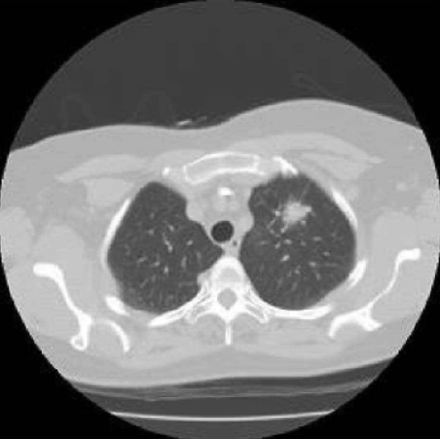
Fig.2-1 CT image of lung
In medical applications, the X-ray absorption levels of different organs or tissues of the human body are usually converted into CT values ​​to reflect the density of the substance. The higher the CT value, the higher the density of the substance. The CT value is equal to the difference between the absorption coefficient of the substance and the absorption coefficient of water, divided by the absorption coefficient of water, and then multiplied by the graduation factor. The calculation method of the CT value is shown in formula (2-1).
$CT=\frac{μ-μ_{w}}{μ_{w}}×K$ （2-1）
Among them, μ represents the X-ray absorption coefficient of various tissues of the human body, $μ_{w}$represents the absorption coefficient of water, K is the graduation factor, and the unit of CT is Hu [32]. The absorption coefficient of water is 10, and the CT value is 0 Hu. Different tissues in the human body have different absorption coefficients, so their CT values ​​are also different, usually between -1000 Hu ~ +1000 Hu. Normally, the CT values ​​of different organs are in different ranges, but there are also cases where the ranges are crossed.

2.1.1 Knowledge about lung nodules
Lung nodules are an early symptom of lung cancer and a common lung disease. The correct rate of ordinary X-ray chest X-ray examination is only about 50%, and part of it is often misdiagnosed or missed. A lung lesion that is generally round or quasi-round, not accompanied by lymph node disease, and completely surrounded by lung parenchyma. The main morphological characteristics of pulmonary nodules are calcification, cavity, sphericity, burrs, and lobes. Among them, the edges of malignant nodules have the characteristics of lobes, burrs and blurry borders. Calcification is the calcium deposit of the lesion, which usually appears as a high-density shadow in CT images. The calcification form of benign nodules is characterized by stratification, popcorn style, and centrality [33].
Lung nodule usually refers to a round-shaped lesion with a diameter of no more than 30 mm in the lung. Its density is higher than that of normal lung tissue. Its growth tissue morphology can be observed on CT images. Doctors are differentially diagnosing the characteristics of lung nodules that are usually observed at time mainly include whether it is round or not, how the density and changes are, whether the edge of the nodule is clear and how the shape is. Due to the different characteristics of lung nodules and their different positions on CT images, they can be divided into solid nodule, part-solid nodule and ground glass nodule. Among them, the density of some solid nodules is uneven, which is the most likely to cause cancer and the highest degree of malignancy. Ground-glass nodules are fuzzy shadows in the lungs. The density of the nodules is slightly higher than that of the surrounding lung parenchyma, and the outlines of the blood vessels and trachea in the lungs are blurred. The internal density of the solid nodules is relatively uniform, composed of soft tissues, and the internal blood vessels and trachea are completely covered.

2.2 Deep learning

2.2.1 Deep learning related theoretical knowledge
Deep learning is a process of simulating human cognition and learning of things. Deep learning technology uses non-linear transformation to perform high-dimensional abstraction of data. It extracts and combines various types of shallow features to transform them into more representative high-dimensional features. High-dimensional features describe the intrinsic properties of things. Compared with some methods of manually designing features in the past, the advantage of deep learning technology is that it can learn more representative and effective features through a large amount of data. The concept of deep learning originates from the research of artificial neural networks, and artificial neural networks abstract the neural structure of the human brain from the perspective of information processing, establish simple models, and form different networks according to different connection methods, referred to as neural networks for short. Deep learning is also developed from the artificial neural network model [34].
Deep learning builds a deep neural network model that contains multiple hidden layers and is trained on a large amount of data to learn more effective features from it, and finally achieve accurate classification or prediction. Therefore, "deep model" is the means, and "feature learning" is the goal. Deep learning emphasizes the depth of the model structure and the importance of feature learning. Through layer-by-layer feature transfer and transformation, the feature representation of the original space is transformed into a new feature space, thereby making classification or prediction more accurate. Using big data to learn features can express richer internal information than manually designing features. When we are training the deep learning network model, we should make full use of the middle layer neurons, which can reduce the parameters in the network model, and only in this way can the calculation and generalization capabilities of the model be improved. On the other hand, the deep model structure is far stronger than the shallow model structure in extracting global features and context information. According to different aspects of problem solving and application fields, deep learning has many different network models, such as CNN, Restricted Boltzmann Machines (RBM), and Recursive Auto Encoders (RAE), Deep Belief Nets (DBN) and Recurrent Neural Network (RNN), etc.

2.2.2 Theoretical knowledge of neural network technology
A neural network is formed by connecting multiple simple neuron units to each other in a certain way. Although the structure and function of each neuron is very simple, a network system composed of a large number of neurons can accomplish many very complex tasks. The neural network system is a highly complex nonlinear dynamic system. It not only has the common characteristics of general nonlinear systems, but more importantly, it also has its own characteristics, such as high-dimensionality, extensive interconnection between neurons and adaptability or self-organization.
Neural network is very prominent in non-linear expression ability and can also accept a part of signal noise. The neural network can adaptively adjust the parameters from the training set and perform calculations based on the gradient. It is precisely because the neural network has the ability of self-learning parameters that the network is widely used in the field of image and speech. In fact, the mathematical model of neural network is connected by a large number of neuron nodes. Each neuron node in the network is accompanied by an activation function, and the input of the neuron node and the activation function determine the output value of the neuron node. And there is usually a weighting operation between the neuron nodes, that is, a weighting operation is performed on the output of the previous node. Before the network training starts, we initialize these weights randomly, and constantly update these weights during the model training process. When the neural network is trained, the size of the weight directly reflects the contribution of its corresponding input to the final goal of the neural network. In addition to weights, another linear component applied to the input is called bias. It is added to the result of multiplying the weight and the input. The purpose of adding bias is to make the range of the final result changeable, so that the neural network can simulate any linear function. Weights and biases are the most important parameters for learning and updating during neural network training.
Neuron is the most important part of the structure of neural network [35]. The model structure diagram of neuron is shown in Fig.2-2. Each neuron has corresponding input and output. Where $X_{1}{,X}_{2},X_{3}….X_{n}$ represents the input of the neuron,$w_{1}{,w}_{2},w_{3}….w_{n}$ represents the weight of the neuron, and b represents the bias signal. The bias signal will work when the signal amount is set, $f(∙)$is the activation function, and out represents the final output of the neuron.
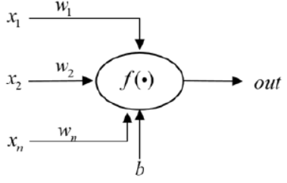
Fig.2-2 The model structure diagram of neuron
Formula (2-2) indicates that the input of the neuron gets the final output through weighted summation.
$out=f\left(x_{1}w_{1}+x_{2}w_{2}+L+x_{n}w_{n}+b\right)=f(W^{T}X+b)$ （2-2）
Where $X_{1}{,X}_{2},X_{3}….X_{n}$ represents the value of the input in different dimensions, $w_{1}{,w}_{2},w_{3}….w_{n}$ is the corresponding weight in different dimensions, and X and W represent the input of the neuron and weight.
Activation function is to selectively activate or inhibit the features of the neuron nodes, which can enhance the activation of useful target features, and inhibit or weaken the features that have little effect or uselessness. The activation function is generally non-linear, which is equivalent to introducing a non-linear unit to the neural network, so that the neural network can solve non-linear problems. In the multilayer neural network, if the activation function is not used, the multilayer neural network is actually equivalent to a single-layer network, that is, the output is actually a linear combination of the inputs. If a nonlinear activation function is used, the neural network model has the capability of nonlinear mapping in the feature space. In addition, the activation function can also construct a sparse matrix to make the output of the neural network sparse. The sparseness can remove the redundancy in the data and retain the most effective data features. The activation function must have some basic characteristics, such as monotonicity and differentiability. The monotonic activation function ensures that the single-layer network model has convex function performance. Differentiability ensures that the gradient descent algorithm can be used to update the model weights.
The activation functions often used in training include Tanh, ReLU, and Softmax. Among the above three common activation functions, the most commonly used nonlinear activation function is the Softamx function. It can normalize the data, that is, to map the input value of any interval to the interval from 0 to 1. The Softamx function formula is shown in (2-3), and the function curve is shown in Fig.2-3. The function curve is S-shaped, as can be seen from the figure, when the input range is 5 to positive infinity, it will be mapped to a small cell. The derivation formula of the Softmax function is shown in (2-4), and the function diagram of the derivation formula is shown in Fig.2-4. The Softmax function as an activation function has some disadvantages: First, the problem of gradient disappearance is prone to occur during network training, because the maximum value of the Softmax function derivative is 0.25, and the two sides quickly tend to 0. When backpropagating multiple times in a multilayer network, the gradient will quickly drop to 0, which seriously affects the network training effect; the second is that the output of the Softmax function is greater than 0, indicating that all the inputs of the next layer of neurons are greater than 0, then the partial derivative of the Softmax function for each weight is greater than 0, when calculating the gradient of each weight of a certain neuron in backpropagation, all the gradient directions are the same, and the weights are updated in the same direction, which will easily cause the network to converge slowly; the third is that the power operation is involved, which is expensive and affects the network training.
$f\left(x\right)=\frac{1}{1+e^{-x}}$ （2-3）
$f\left(x\right)=\frac{1}{1+e^{-x}}=\frac{1}{1+e^{-x}}\left(1-\frac{1}{1+e^{-x}}\right)=f(x)(1-f(x))$ （2-4）
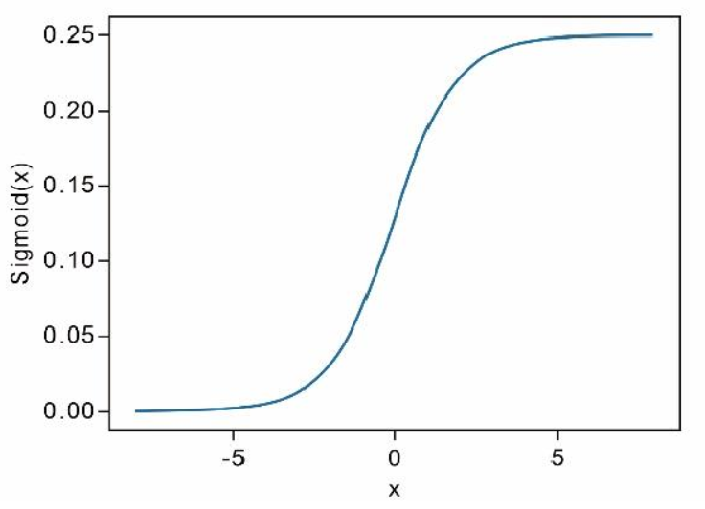
Fig.2-3 Sigmoid function graph
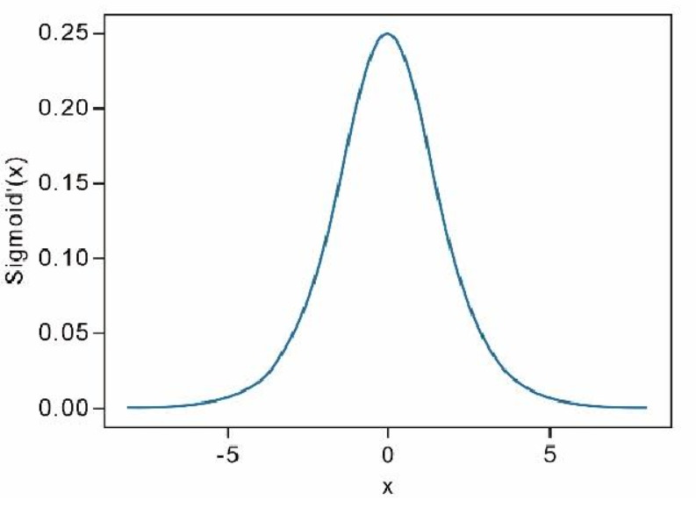
Fig.2-4 Sigmoid derivative function graph
The Tanh function is also called the hyperbolic tangent function. This function is the ratio of the hyperbolic sine function and the hyperbolic cosine function. The value of the function is distributed between -1 and 1. Its expression is shown in formula (2-5). Take the derivative to get formula (2-6). The Tanh function graph is shown in Fig.2-5. Similar to the SoftMax function, the Tanh function also has the problem of vanishing gradient.
$tanh\left(x\right)=\frac{sinh⁡(x)}{cosh⁡(x)}=\frac{e^{x}-e^{-x}}{e^{x}+e^{-x}}$ （2-5）
${\left(tanhx\right)}^{'}=1-\tanh^{2}x$ （2-6）
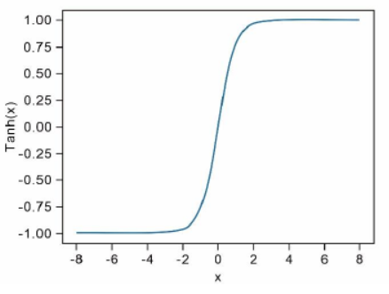
Fig.2-5 Tanh function graph
The ReLU function is also called a linear rectification function and is defined as shown in formula (2-7). When the input is less than zero, the output is also zero. When the input is greater than zero, the output is the input value. The derivative is shown in formula (2-8). When the input is greater than zero, the derivative is always 1; otherwise, it is always 0. The ReLU function is different from the above two conventional activation functions in that it is simple to calculate and does not include exponential level operations. Therefore, in the process of stochastic gradient descent, its calculation speed and convergence speed are accelerated, and the problem of gradient disappearance is also reduced. The ReLU activation function is used in most convolutional neural networks currently used. Fig.2-6 shows the ReLU function graph.
$f\left(x\right)=\left\{\begin{aligned}0 x<0 \\ x x≥0\end{aligned}\right.$ （2-7）
$f^{'}\left(x\right)=\left\{\begin{aligned}0 x<0 \\ 1 x≥0\end{aligned}\right.$ （2-8）
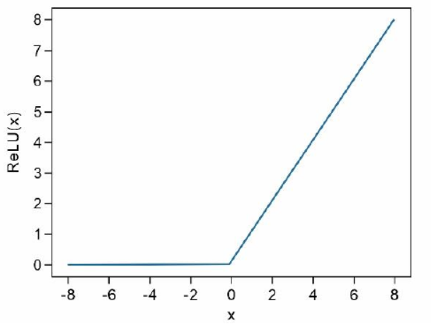
Fig.2-6 ReLU function graph
The Leaky ReLU function is an improvement to the ReLU function. The definition is shown in formula (2-9), and the function curve is shown in Fig.2-7. The derivative used in calculating the gradient is shown in formula (2-10). This function only outputs 0 when the input is 0, which solves the problem that the ReLU function tends to make the neuron no longer active.
$f\left(x\right)=\left\{\begin{aligned}ax x<0 \\ x x≥0\end{aligned}\right.$ （2-9）
$f^{'}\left(x\right)=\left\{\begin{aligned}a x<0 \\ 1 x≥0\end{aligned}\right.$ （2-10）
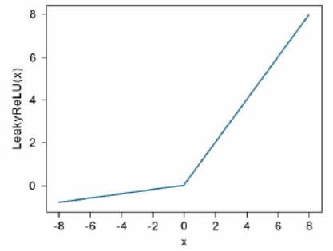
Fig.2-7 Leaky ReLU function graph

2.3 Theoretical knowledge of CNN
CNN has a deep network structure and is a very classic forward propagation network model, which has particularly outstanding performance in the field of voice and image. The rise of CNN can be traced back to 1989. Le Cun et al. [37] successfully applied CNN to handwritten digit recognition. CNN usually consists of one or more convolutional layers, pooling layers, and fully connected layers. Such a combined structure can make full use of the input two-dimensional data. Natural image processing and speech recognition are actually to solve the two-dimensional input problem, and CNN can get better output results. The CNN model is also trained using Back Propagation. Compared with a fully connected network, CNN requires fewer parameters and performs better.
CNN can efficiently obtain the feature representation of the original image, which makes it possible to directly identify the image feature from the original image material without pre-processing. Compared with other neural networks, the advantages of CNN technology include two aspects: (1) Local connection: the convolution kernel only establishes connections with neurons in the upper layer of receptive fields, because digital images have adjacent pixels. Spatial characteristics with high correlation and low correlation between pixels far apart; (2) Shared weights: in different areas of the image, the performance of the same feature is the same, which makes it possible to use a convolution kernel to perform the same on different receptive fields. Local connections and shared weights can not only reduce the complexity of the model, but also make the training of the network easier.

2.3.1 Convolutional layer
The convolutional layer is composed of several convolution kernels, which are used to calculate different feature maps and learn feature representations about the input. Specifically, each neuron in the current feature map is connected to the area of ​​the adjacent neuron in the upper layer. When operating on the same feature map, it is necessary to use the same convolution kernel to perform convolution operations to achieve Parameter Sharing. The feature value $z_{i,j,k}^{n}$ at the position $(i,j)$ in the k-th feature map in the n-layer is calculated by formula (2-11):
$z_{i,j,k}^{n}=w_{k}^{n}x_{i,j}^{n}+b_{k}^{n}$ （2-11）
Among them, $w_{k}^{n}$and $b_{k}^{n}$ respectively represent the weight and bias matrix of the k-th feature map in the n-layer. It can be seen from the convolution calculation formula that the parameters for generating the feature value of the feature map are shared. The parameter sharing of the convolution operation refers to the use of the same parameters in multiple functions in a model. In traditional neural networks, when calculating the output of a layer, each element of the parameter matrix only participates in the calculation once. The parameter sharing in the convolution operation ensures that only one parameter set needs to be obtained through learning, which can reduce the complexity of the model and train the network more quickly. Traditional neural networks use matrix multiplication to establish the connection between input and output. Among them, each parameter in the weight matrix represents the connection between an input value and an output unit. This means that each output unit is connected to each input unit. However, CNN have the characteristics of sparse connectivity. Therefore, in CNN, the size of the convolution kernel is much smaller than the size of the input. This means that the parameters are reducing and the calculation efficiency is improved. The connection modes of the input and output layers of traditional neural networks and CNN are shown in Fig.2-8 and Fig.2-9, respectively, where x is the input and y is the output. As can be seen from the figure, each neuron in the input layer of the traditional neural network is connected to all neurons in the output layer, while the neurons in the input layer of the convolutional neural network are sparsely connected with the neurons in the output layer.
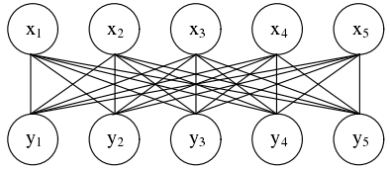
Fig.2-8 Traditional neural network input and output connection
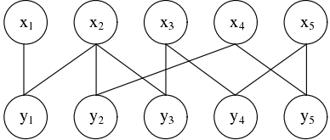
Fig.2-9 CNN input and output connection mode
When the convolutional layer is equipped with multiple convolution kernels, the neuron output calculated according to a convolution kernel is formed into a two-dimensional matrix, called a channel, and multiple convolution kernels output multiple channels and form a three-dimensional matrix, called as the feature map output by the convolutional layer, the output of each intermediate network layer can be called a feature map.

2.3.2 Pooling layer
In convolutional neural networks, there is usually a pooling layer after the convolutional layer, especially when it is applied in the image and voice fields. The pooling layer is to reduce the size of the convolution output, reduce the size of the convolution kernel during the subsequent convolution, thereby expanding the receptive field, so that the ability of the model to extract features can be increased. On the other hand, the pooling layer can reduce the amount of calculation and prevent over-fitting to speed up the network convergence speed. There are also two very important parameters in the pooling layer: one is the pooling window, and the other is the displacement distance of the pooling window. Commonly used pooling methods are maximum pooling and average pooling. The demonstration diagrams of maximum pooling and average pooling are shown in Fig.2-10.
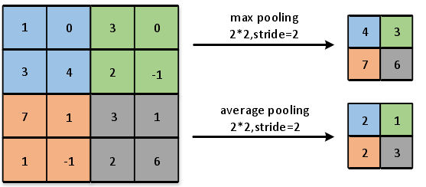
Fig.2-10 Demonstration diagram of maximum pooling and average pooling
The size of the pooling layer core in Fig.2-10 is 2*2, and the step size is 2. The concept of the size and step size of the core of the pooling layer is similar to that in the convolutional layer. The maximum pooling operation is to take the maximum value in the core at the corresponding position, and the average pooling operation is to go to the average value in the core at the corresponding position. Generally, the largest pool layer performs better in practice. When the image is calculated in the pooling layer, the input and output sizes of the image usually change. In the commonly used maximum pooling and average pooling calculation processes, the back propagation calculation methods of the two are different. In the forward propagation of maximum pooling, only the position of the maximum value needs to be recorded. However, during back propagation, only the position recorded by the forward propagation is passed to the current position as a residual error, and the remaining positions are all zero. In the forward propagation process of averaging pooling, the average value is recorded every time, but the residual is averaged to all positions in the back propagation.

2.3.3 Fully connected layer
Each node in the fully connected layer is connected to all nodes in the previous layer. Fully connected layer often plays a role in constructing "classifiers" in CNN. In CNN, the functions of operations such as convolutional layer, pooling layer, and activation function are to extract features of input data, that is, to use distributed features to represent these input data. The function of the fully connected layer is to map these learned distributed features to the label space of the sample. For example, for an image classification task, suppose there are 10 categories in total, and some feature maps are obtained after feature extraction of the input image. At this time, it is necessary to use multiple fully connected layers to integrate these feature maps and reconnect them into a 10-dimensional vector, each dimension represents a category, so as to achieve the purpose of constructing a "classifier". Due to its fully connected characteristics, the fully connected layer generally has a very large amounts of parameters. Sometimes the fully connected layer can also be replaced by a specific convolutional layer. The fully connected layer is not an indispensable hidden layer of the CNN, and the CNN without a fully connected layer is generally called a fully convolutional network. In some CNN, the fully connected layer can be partially replaced by global average pooling, which averages all the values ​​of each channel of the feature map as the output.

2.3.4 Loss function
The last layer of the neural network is usually the loss function layer. This function is used to measure the deviation between the network output value and the label value. The loss function consists of measuring the deviation between the predicted value and the label value and the constraints of the parameters. The three commonly used loss functions of convolutional neural networks are the average absolute error, the cross entropy loss function, and the mean square error loss function [38-40].
Mean Absolute Error (MAE) is usually used in regression tasks. It can also measure the degree of deviation of two sets of one-dimensional or multi-dimensional data. When applied to one-dimensional data, its definition is shown in formula (2-12), the mean value of the sum of the absolute values ​​of the difference between the expected output and the real output. Compared with the mean square error, the loss function is more robust to abnormal samples, but it is not smooth at its extreme points, which affects the search for the optimal weight.
$MAE\left(l,y\right)=\frac{1}{n}∙\sum_{i=1}^{n}{\left|l_{i}-y_{i}\right|}$ （2-12）
The cross entropy loss function is often used in classification problems, including Binary Cross Entropy (BCE) and Categorical Cross Entropy (CCE). The two-class cross entropy is shown in formula (2-13). As shown in formula (2-14), where c is the number of categories, $l_{i,j}$ is the expected output of the i-th sample corresponding to the j-th category, and $y_{i,j}$ is the corresponding real output.
$BCE\left(l,y\right)=\frac{1}{n}∙\sum_{i=1}^{n}{-\left[l_{i}∙logy_{i}+(1-l_{i})∙log⁡(1-y_{i})\right]}$ （2-13）
$CCE\left(l,y\right)=\frac{1}{n}∙\sum_{i=1}^{n}{\sum_{j=1}^{c}{-}l_{i,j}∙logy_{i,j}}$ （2-14）
Mean Squared Error (MSE) is usually used in regression tasks to measure the degree of deviation of two sets of one-dimensional or multi-dimensional data. When used in one-dimensional data, its definition is shown in formula (2-15), which is the mean of the sum of squares of the difference between the expected output and the real output, where $l_{i}$ is the expected output of the i-th sample,$y_{i}$ is the real output of the i-th sample, and n is the number of samples. Because there is a squaring operation in the formula, samples with a large difference between the actual output and the expected output will have a greater impact on the value of the loss function, so the loss function is not suitable for situations where there are many abnormal samples.
$MSE\left(l,y\right)=\frac{1}{n}∙\sum_{i=1}^{n}{{\left(l_{i}-y_{i}\right)}^{2}}$ （2-15）

2.3.5 Optimization
In the training process of the CNN, firstly, the weights need to be initialized to optimize the objective function between the real output and the expected output. The current optimization algorithms can be divided into two categories: one is the first-order optimization algorithm, which passes calculate the gradient of the objective function with respect to the weight to optimize the objective function. It only involves the first-order partial derivative and the calculation is simple. The commonly used optimization algorithms include gradient descent algorithm, Adam, etc. [41-42]; the first type is the second-order optimization algorithm, which passes calculate the second-order partial derivative of the objective function with respect to the weight to optimize the objective function. The calculation is complicated, but the optimization effect is better in some cases. The objective function is not easy to fall into the local minimum and cannot reach the global minimum. Newton iteration method is commonly used.
Stochastic gradient descent method. More specifically, the algorithm can be divided into three categories according to the amount of input data for the algorithm. The first type is to select only one sample to optimize and update the parameters during the model training process. This type of algorithm is called the single-sample stochastic gradient descent method; the second type is to select a part of the sample during model training to update and optimize the parameters. Mini-batch gradient descent method; the last type is called batch descent method if all samples are selected for parameter update optimization during model training. Among these three algorithms, the mini-batch gradient descent algorithm is the most used. Here, the learning rate is set to ρ, the initial parameter is set to $θ_{0}$, and the gradient is set to g. Then the calculation of the new parameter $θ$ obtained is shown in formula (2-16).
$θ=θ_{0}-ρ∙g$ （2-16）
The momentum stochastic gradient descent method is an improvement on the stochastic gradient descent method. The algorithm introduces the concept of momentum in physics, so that the algorithm skips the local minimum to achieve global convergence. As shown in formulas (2-17) and (2-18), assuming the learning rate is ρ, the momentum parameter v, the initial value of the parameter is $θ_{0}$, the initial value of velocity is v, and the value of gradient is g, the new parameter $θ$ obtained by the algorithm is expressed as follows:
$v=a∙v-ρ∙g$ （2-17）
$θ=θ_{0}+v$ （2-18）
The Adam optimization algorithm can be regarded as an extension of the gradient descent algorithm. Both use the gradient of the objective function to the weight to update the weight, but the Adam optimization algorithm uses the first-order moment estimation and the second-order moment estimation of the gradient to design an independent for each weight adaptive step length has better optimization effect. Here set the global learning rate value to ρ, the initial parameter value is $θ_{0}$, the small constant is δ, the speed at which the moment estimation decays $σ_{1}σ_{2}$, the cumulative variable r of the gradient and the gradient g, the first moment and second order distance are respectively s, r. Then formula (2-19) and formula (2-20) can be obtained.
$s=σ_{1}∙s+(1-σ_{1})∙g$ （2-17）
$r=σ_{2}∙r+(1-σ_{2})∙g⨀g$ （2-18）

2.4 Chapter summary
This chapter mainly introduces the related knowledge of CT examination technology and pulmonary nodules, and then introduces the related theoretical knowledge of deep learning and CNN in detail. Deep learning is developed from the neural network model. The CNN consists of a convolutional layer, a pooling layer, and a fully connected layer. The principles and functions of these three parts are introduced, and the principles of several loss functions are introduced. Finally, the characteristics and principles of commonly used CNN parameter optimization algorithms are introduced.

3. LUNG CT IMAGE EXTRACTION AND PREPROCESSING OF DATA

3.1 Introduction
The ultimate goal of CAD is to classify benign and malignant lesions, but one of the factors that affect the classification effect depends on the pre-processing of CT images in the early stage. The image segmented out the ROI of suspected lung nodules. Segmentation of lung nodules directly is a challenging task. The lung CT images contain a lot of irrelevant noise information, such as the scanning bed, trachea, and other lung tissues. Therefore, if the segmentation is incorrect or the segmentation result is incomplete, it will lead to mis-judgments by doctors and CAD systems, resulting in inaccurate classification results and delaying the diagnosis and treatment of patients. Lung nodules generally exist in the lung parenchyma. Therefore, in order to segment the lung nodules, the lung parenchyma can be selected as the object for pre-processing, and then the segmented lung parenchymal image can be used to segment the ROI that is suspected to be a lung nodule. The lung parenchyma refers to the internal area of ​​the lungs in the CT image, which does not include the outline of the chest cavity and the middle trachea. As shown in Fig.3-1, the inside of the outline is the lung parenchyma.
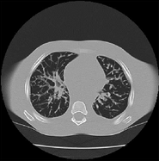
Fig.3-1 Lung parenchymal image
The traditional segmentation of lung parenchyma must first use image segmentation algorithms, such as the maximum between-class variance method, watershed algorithm, etc., to convert the original CT data from grayscale images to binary images. In this paper, the method of extracting lung parenchyma is to firstly threshold the image to obtain a binary image, then perform morphological operations to obtain a lung parenchymal template and multiply the template and CT image to obtain a lung parenchymal image. The extraction of the ROI can use methods such as threshold segmentation, region growth, and watershed. The flowchart of extracting the ROI is shown in Fig.3-2.
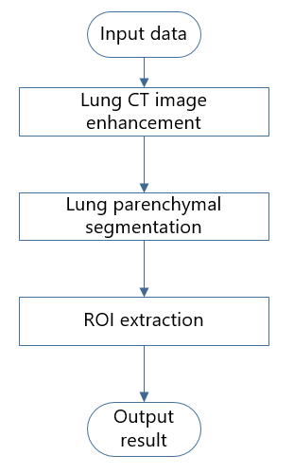
Fig.3-2 ROI extraction flowchart

3.2 Lung CT image enhancement
In order to improve the visual effect of medical images, the computer can analyse and understand the image, according to the characteristics of the image, the existing problems or the purpose of the application, the method adopted to improve the image quality, or the measures to strengthen certain features of the image, called image enhancement. The role of image enhancement is mainly reflected in highlighting the area or edge of interest, suppressing the background area and reducing the interference of noise, so as to obtain an image with a better display effect for a specific task. The contrast of light and dark in lung CT images is poor, and the lesion area in some CT images is not obvious. If it directly uses the threshold method to segment the lung parenchyma, it will be impossible to find the appropriate threshold because of the small difference in the internal grey value of the lung CT image. It can first use image enhancement methods to improve the contrast of light and dark CT images of the lungs.
Image enhancement refers to the expansion of the grey scale of the image to be processed, and the expansion of the brightness difference between the images to obtain an image with higher brightness. Enhancing the useful information in the image can improve the visual effect of the image in specific applications. The most important thing is to make the unclear image clear, improve the quality and recognition of the image, and expand the difference between different objects in the image. The image is more conducive to observation or further analysis and processing. Image enhancement is generally through highlighting or enhancing certain features of the image, such as edge information, contour information, texture information, and light-dark contrast, so as to better display the useful information of the image, which is conducive to more recognition and can fully improve the image value of use. Under certain standards, the image processed by image enhancement technology is better than the original image. This article uses the histogram equalization (HE) method to achieve image enhancement. HE is a very common and simple and effective image enhancement method. The HE algorithm changes the grey value of each pixel in the image by equalizing the grey distribution histogram of the image and is mainly used to enhance the contrast of the image with a small grey dynamic range. In the original image, due to problems such as the acquisition conditions, the grayscale distribution of the pixels in the image may be concentrated in a narrow interval, resulting in the image not being clear enough. For example, the grey level of an over-exposed image is concentrated in the high-brightness range, while underexposure will make the image grey-level concentrated in the low-brightness range. Using HE, the grey distribution histogram of the original image can be transformed into a uniform distribution form, thereby mapping a narrow grey dynamic range to a wide grey dynamic range. In other words, the basic idea of HE is to determine a mapping curve through the histogram of the grayscale distribution of the image, which is used to perform grayscale transformation on the image. That is, the grey value that plays a major role in the picture is expanded, and the grey value that does not play a major role in the picture is merged, thereby increasing the image contrast, adjusting the image brightness, and improving the display effect to achieve the purpose of enhancement.

3.3 Lung parenchymal segmentation
To achieve lung parenchymal segmentation, the preferred method in image processing is to use an algorithm that can automatically select a threshold based on image data. The basic process is as follows:
(1) Select the initial estimated value T for the global threshold;
(2) Use the initial estimated value T divides the image to generate two sets of pixels. Among them, G1 is composed of all pixels whose grey value is greater than T, and G2 is composed of all pixels whose grey value is less than or equal to T;
(3) Calculate the average grey values $m_{1}$ and $m_{2}$ in the G1 and G2 regions respectively;
(4) According to the average grey value calculates a new threshold:
$T=(m_{1}+m_{2})/2$ （3-1）
(5) If the two average grey values ​​no longer change (or the threshold T no longer changes), then T is the threshold, otherwise repeat steps (2) ~ (4) in a loop.
After the iterative threshold method, the lung CT image is divided into two parts, one is the lung parenchyma and the outer area of ​​the chest cavity, the colour of this part is white, and the pixel value is 0. The other part is the black area with the pixel value of 1. This part of the area is mainly the outline of the chest cavity and the middle of the two lungs. The segmentation effect is shown in Fig.3-3.
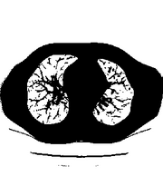
Original image Result
Fig.3-3 Threshold method segmentation comparison chart
From Fig.3-3, we can see that the threshold method realizes the separation of lung parenchyma and thoracic cavity contour. The white area in the middle is the lung parenchyma, and the thoracic cavity contour is the surrounding black area. However, this is only a preliminary segmentation. The scan lines and background at the bottom of the image have not been removed, so it is necessary to design an algorithm to remove incoherent areas. The basic algorithms used in this chapter to remove the noise area include inversion, opening operation, closing operation, hole filling and mask operation.
Hole filling: A hole refers to a black area surrounded by white pixels in a binary image. To fill holes in a binary image, all black pixels in the area need to be filled with white.
The process of opening operation is first corrosion and then expansion. It can eliminate small objects, separate adjacent objects, and smooth the boundaries of objects while not changing their appearance significantly. The open operation of kernel B on image A is defined as formula (3-2):
$A°B=(A⨀B)⊕B$ （3-2）
The process of closing operation is first expansion and then corrosion. It is used to fill smaller holes, connect adjacent objects, and smooth the boundaries of objects while not changing its shape significantly. The closed operation of kernel B on image A is defined as formula (3-3):
$A∙B=(A⊕B)⨀B$ （3-3）
Masking operation is also called Image masking. It refers to the process of using the selected image to completely or partially occlude the image to be processed to control the image processing area. The main application of mask operation in medical images is to extract regions of interest. Assuming that A is the original image and B is the template, the mask operation is defined as formula (3-4):
$F(x,y)=\left\{\begin{aligned}A\left(x,y\right), B\left(x,y\right)=1 \\ 0, B\left(x,y\right)=0\end{aligned}\right.$ （3-4）
The whole process is shown in Fig.3-4. The final lung parenchymal segmentation effect is shown in Fig.3-5.
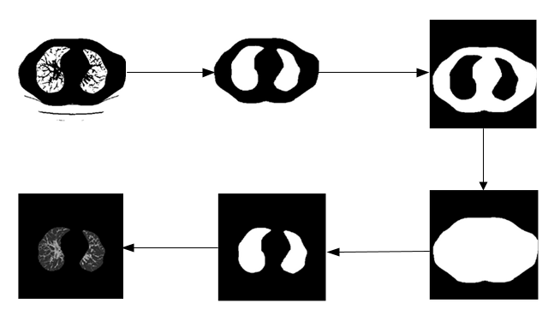
Fig.3-4 Preliminary lung parenchymal segmentation
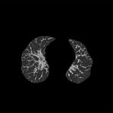
Fig.3-5 Lung parenchymal segmentation effect picture

3.4 ROI extraction
After segmentation of the lung parenchyma in the early stage, there has been a higher recognition rate. However, the feature extraction and benign and malignant recognition of lung nodules are mainly for ROI, so further processing of lung parenchyma and ROI extraction can further improve the recognition rate and recognition speed. Since there are still many small blood vessels and tissues in the lung parenchyma, which will hinder the subsequent processing to a certain extent, the extraction of ROI must first denoise the lung parenchymal image. Morphological method [43] is a more commonly used method, which can remove a part of tissue and blood vessels, reduce irrelevant interference, and remove small spaces and some protrusions. After the lung parenchyma is processed by the morphological opening operation, the obtained image is binarized by the threshold method, and finally the region of interest is obtained by the mask operation. 3.5 Data pre-processing

3.5.1 Dataset
The LIDC database is an international public lung image database initiated by the National Cancer Institute (NCI), promoted by the National Institutes of Health (NIH), and established with the participation of the Food and Drug Administration (FDA). The purpose is to facilitate the development, training and evaluation of lung cancer detection and CAD systems. The initial version of LIDC contains 399 scans. The data set selected in this article is the LIDC-IDRI data set [44]. LIDC-IDRI is a 1018 scan that extends LIDC to 1010 patients. In order to improve early detection of lung cancer, the American Cancer Institute initiated the collection of the LIDC-IDRI (The Lung Image Database Consortium) data set. This data set was initiated by the NCI. It is a large-scale chest medical image annotation data set. It consists of chest medical image files (such as CT) and corresponding medical diagnosis results. It includes 1018 research examples, each data in the example has been diagnosed and annotated in two steps by four experienced thoracic radiologists. For each case, the LIDC-IDRI dataset uses a series of clinical lung CT pathological images and an auxiliary XML file to describe its detailed condition. Fig.3-6 is a schematic diagram of CT images of the lungs.
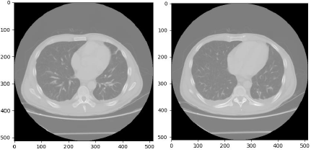
Fig.3-6 Schematic diagram of lung CT image
The XML file records the results of the two-stage image labeling process completed by four professional clinical radiologists. In the initial blind review stage, each radiologist independently analyzes each lung CT scan image, and the pathological area divides into three categories: lung nodules greater than or equal to 3 mm, lung nodules less than 3 mm, and lung nodules greater than or equal to 3 mm. In the subsequent non-blind review stage, the marking results of the remaining three doctors were compared anonymously, and each radiologist independently assessed the rationality of his marking and gave a final opinion on the classification of the pathological area. The purpose of this process is to identify as much as possible all the pathological areas of lung nodules in each lung CT scan image without compulsory requirements to form a consensus, so as to ensure the accuracy of lung nodule labeling results. The various types of feature information are shown in Table 3-2.
Table 3-2 Information table related to the characteristics of lung nodules
Feature name | Score value
malignancy | 1. Highly impossible  2. Relatively impossible  3. Difficult to determine  4. More likely  5. Highly possible
margin | 1. Blurred edges, difficult to define  2. Clear edges
sphericity | 1. The nodules are linear  2. The nodules are oval  3. The nodules are round
subtlety | 1. Difficult to detect  2. Difficult to detect  3. Generally difficult to detect  4. Relatively easy to detect  5. Very easy to detect
spiculation | 1. Present  2. Not present
texture | 1. Non-entity  2. Part of the entity  3. Entity
calcification | 1. Popcorn  2. Stacked  3. Entity  4. Non-central calcification  5. Central calcification
internalStructure | 1. Soft tissue  2. Liquid  3. Fat  4. Air
lobulation | - Yes  - No
The benign and malignant pulmonary nodules are scored according to their characteristics. The score is divided into 5 levels. The higher the score, the more severe the malignant degree of the pulmonary nodule. The malignant degree (MML) of each nodule is obtained by calculation, and its MML<3 is expressed as a benign nodule, MML=3 is expressed as an indeterminate nodule, and MML>3 is expressed as a malignant nodule. Four radiologists judged the degree of malignancy, and marked the location, size, and degree of malignancy. Finally, each reading physician independently reviewed his own annotation results and the other three anonymous annotation results and proposed the final diagnosis results.

3.5.2 Data enhancement
Deep learning is driven by data, so a large amount of data is needed to improve algorithm performance. In most cases, the data provided by the database cannot meet the needs of benign and malignant classification of lung nodules. Regularization will cause the model to overfit, unsupervised training makes training more complicated, and the disadvantage of transfer learning is that it is difficult to solve. Data enhancement is a commonly used data preprocessing method for deep learning. Its advantages are low cost and good results. Therefore, in order to increase the image data of benign and malignant lung nodules, this chapter uses the data enhancement method to generate images based on the existing data. There are several ways to enhance the data used in the experiment:
(1) Adjust brightness: By increasing or shrinking the pixel value of the original image, the brightness can be reduced and increased, and data of different brightness can be generated. The image size selected here are all 64x64 pixels, and the brightness of the original image increases and decreases as shown in Fig.3-7.
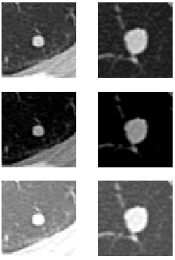
(a) (b) (c)
Fig.3-7 Adjust brightness: (a) original image; (b) increase image brightness; (c) decrease image brightness
(2) Picture flip: including horizontal flip and vertical flip, data is generated by flipping. Horizontal flip refers to flipping the image centred on the vertical axis, and vertical flip refers to flipping the image centred on the horizontal axis. Flip the image horizontally and vertically as shown in Fig.3-8.
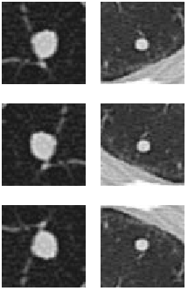
(a) (b) (c)
Fig.3-8 Picture flip: (a) the original picture; (b) the image is flipped horizontally; (c) the image is flipped vertically
(3) Picture rotation: Rotate the image clockwise or counterclockwise by a certain degree with the center of the image as the origin and fill in the vacant pixel positions with adjacent pixel values. The rotated image is shown in Fig.3-9.
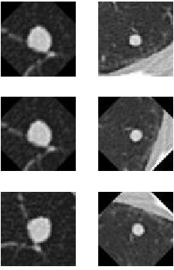
(a) (b) (c)
Fig.3-9 Picture rotation: (a) the original picture; (b) the image is rotated counterclockwise; (c) the image is rotated clockwise

3.6 Chapter summary
This chapter mainly introduces some basic procedures and information of lung CT image extraction and data pre-processing. First, the method of histogram equalization is used to enhance the image and highlight the useful information in the image. Then use related algorithms to segment the lung parenchyma, leaving only the lung parenchyma area. Finally, the lung parenchyma is denoised and the ROI is extracted. Data pre-processing includes dataset selection and data enhancement, and several methods of data enhancement are introduced in detail.

4. CLASSIFICATION OF BENIGN AND MALIGNANT LUNG NODULES BASED ON RESNET
In order to improve the classification effect, this chapter proposes a classification method of benign and malignant lung nodules based on ResNet [45]. The method model selects a deeper ResNet-50 as the backbone network for extracting features and uses feature interception and jump connections to improve it according to the actual situation of the problem to extract more representative features of nodules. The experimental results show that ResNet-50 can further improve the effect of nodule classification.

4.1 Introduction
Since the imaging manifestations of malignant nodules in lung cancer on the early stage are mostly asymptomatic or mild symptoms, it is extremely difficult to be found. When they are found, there is usually no indication for resection. Therefore, it is of great significance for the early detection, screening and judgment of lung nodules. In order to make human intervention for malignant nodules as early as possible, so as to prolong the survival time of patients and improve patients' living standards, once the nodules are detected, they must be diagnosed, that is, benign and malignant classification (medical experts call it qualitative). The diagnosis of malignant pulmonary nodules is mainly based on the analysis of the external shape of the pulmonary nodules. Among them, the shape of malignant nodules is characterized by lobular signs, burrs, pleural depression, etc., and their edges are usually irregular. The lung nodules are characterized by concentrated calcification in the center or clusters of calcium salt deposits with clear and smooth edges. In this case, the lung nodules are more likely to be benign. However, due to the large number of lung cancer patients, doctors have to process thousands of CT images every day, resulting in low diagnosis efficiency for doctors. Because manual reading takes a long time and is easily affected by the doctor's subjective factors, the patient cannot get the diagnosis result in time and delay the condition. With the development of computer technology and artificial intelligence, it has become possible to use computer-assisted doctors to diagnose benign and malignant lung nodules.
The classification problem of benign and malignant lung nodules studied in this paper refers to how to automatically classify the CT images of lung nodules. The categories include benign and malignant nodules, which are two classification problems. The key to solving the problem is nodule feature extraction. The benign and malignant pulmonary nodule classification based on traditional features needs to consider which aspect of the nodule is to be extracted and what technology to use to extract this feature. The solution of both problems requires manual analysis and determination. For example, the design uses the Markov-Gibbs random field model to extract the texture features of the nodules, or the design uses the spherical harmonic function expansion technology to extract the shape features of the nodules. The traditional features of this manual design lack flexibility and are difficult to generalize lung nodules appearance characteristics. The benign and malignant pulmonary nodules classification method based on CNN technology can directly extract features representing the appearance of the nodules for classification by constructing a network model, and the network design is flexible and has high universality. In view of the small number of nodules, the presence of noise in CT images and other interfering factors such as lung tissue, and the weak presence of nodules in the image, a solution based on CNN technology is proposed. The method in this chapter considers the use of deeper network extraction lung nodule features are used for classification, so a better solution must be designed to deal with the above problems in order to obtain a higher classification accuracy rate. The key to the classification task of benign and malignant pulmonary nodules is to extract the representative and discriminative features of the nodules. However, due to the existence of various problems, it is often difficult for neural networks to extract such features. There are two further ideas in this chapter: the first is to select a deeper backbone network and enable it to focus on the nodule extraction features; the second is to use existing resources as much as possible.

4.2 Classification process of CNN
The benign and malignant classification of lung nodules generally uses supervised or unsupervised machine learning algorithms, but traditional machine learning classification methods require manual extraction of relevant features in the process of lung nodule recognition. Some of the characteristics are obtained through the use of medical knowledge by experienced doctors, such as the calcification, lobules, and cavities of the lesion. Some features are obtained based on intuitive morphological features, such as the area, boundary, and sphericity of the region of interest. Experiments show that these features play a positive role in further helping doctors diagnose benign and malignant nodules. However, traditional machine learning methods mainly extract the underlying features manually. Different experts use different methods to extract different features, and different features have a great impact on the classification results. If the machine can automatically extract the learned features in the CT image and find out the lung nodules and healthy CT images, then the third-party results will be more objective and convincing.
Deep learning can construct a neural network that mimics the mechanism of the human brain for analysis and learning. The features extracted by the neural network are similar to the features of biological visual recognition, so it can improve the accuracy of classification. The biggest difference between deep learning and traditional methods is that the machine automatically learns the recognized features, instead of manually extracting it as in the traditional methods, so that the information extracted without manual intervention is more objective and accurate. As a research direction of deep learning, CNN has become a common method in the field of pattern recognition and image classification. CNN are based on neural networks and are trained on data sets through the Backpropagation Algorithm.
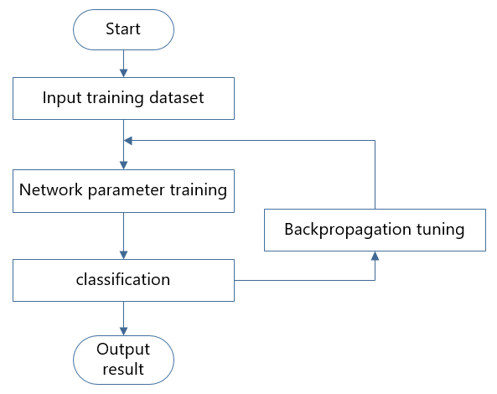
Fig.4-1 CNN classification flowchart
The flow chart of benign and malignant lung nodules classification based on CNN proposed in this paper is shown in Fig.4-1. The data set used is the LIDC-IDRI data set. The classification model mainly includes two steps of training and testing the data set. The training phase mainly includes the modification of the network structure and the fine-tuning of the training parameters. CNN will read the data set and extract the features during training. In the testing phase, the features extracted by the network will be tested, and finally classified by Softmax implements classification.

4.3 CNN classic model
CNN is actually a kind of mapping from input to output. The training of the network is to find the closest best mapping function that can reflect this recognition task. The neurocognition machine [46] can be considered as the first CNN to be applied. Through the special organization structure of local connection between neurons and hierarchical processing, the CNN divides a visual task into several sub-tasks and extracts and merges the features of these sub-tasks layer by layer through the feature extraction plane connected in a stepwise manner to complete the final visual task. The advantage of this is that even if the target is slightly shifted or distorted, the model still has good recognition capabilities.

4.3.1 LeNet model
In 1998, Le Cun et al. [47] proposed the use of gradient-based backpropagation to train the CNN LeNet-5 and achieved quite good results in the recognition of MNIST handwritten pictures. The trained LeNet-5 transforms the original 32*32 handwritten picture into a series of feature maps through repeated convolution and pooling operations, and then passes the high-level feature expression of the image through the fully connected layer to the softmax layer for classification. The network has a total of 7 layers, including 3 convolutional layers, 2 pooling layers, 1 fully connected layer and 1 output layer, with a total of about 60,840 training parameters and 340,908 connections. The specific structure diagram is shown in Fig.4-2.
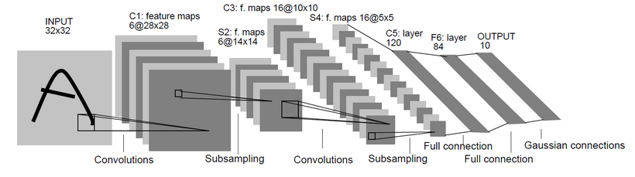
Fig.4-2 LeNet network structure diagram
The first layer is the convolution layer, which consists of 6 different types of convolution kernels, the size of the convolution kernel is 5*5, and the stride is 1. The second layer is the down-sampling layer, also commonly referred to as the pooling layer. Each value in the secondary feature map is connected to the 2*2 neighborhood in the primary map. After a primary feature map is pooled, 6 secondary feature maps with a size of 14*14 are obtained. The third layer is a convolutional layer, the size of the convolution kernel is still 5*5, and the stride is 1. In order to extract more detailed features, the convolution kernel of this layer is set to 16. The fourth layer is down-sampling layer 4, which still uses 16 cores of size 2*2 for pooling operations. The five layers are convolutional layer 5. In order to maximize the extraction of diversified features, the number of feature maps is expanded to 120, and each neuron in these feature maps is 5*5 of all the feature maps of downsampling layer 4 neighborhoods are connected, and the size of the feature map becomes 1*1 after passing through the convolutional layer 5. In fact, this has constituted a full connection between the downsampling layer 4 and the convolutional layer 5. The sixth layer is a fully connected layer, with a total of 84 nodes and 10164 trainable parameters. The last layer is the output layer. Although the CNN can obtain an effective representation of the original image, this enables the CNN to directly identify the rules of vision from the original pixels and after very little preprocessing. However, due to the lack of large-scale training data at that time and the computing power of the computer, LeNet-5 was not ideal for handling complex problems.

4.3.2 AlexNet model
In 2012, AlexNet proposed by Krizhevsky et al. [48] won the first place in the classification competition of the large image database ImageNet, opening a new chapter in deep learning. Compared with other models, the AlexNet model has made the following three improvements: First, it uses horizontal flipping, translation transformation and other data augmentation technologies in data; second, it uses dropout mechanism in network technology. Effectively prevent the network from overfitting and overfitting. It uses ReLU with higher comprehensive efficiency to replace the traditional sigmoid function and tanh function and uses LRN local response normalization technology to improve the generalization ability of the network model; third, in terms of hardware it uses multi-GPU parallel training to improve the training speed of the network model. The AlexNet network has a total of 8 layers, including 5 convolutional layers and 3 fully connected layers. The network needs to learn 60 million parameters, involving 650,000 neurons, and the input of the network is a 227*227 color image. The specific structure diagram is shown in Fig.4-3.
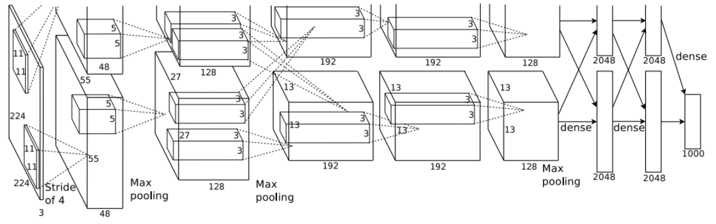
Fig.4-3 AlexNet network structure diagram
The first layer is convolutional layer 1, the size of the convolution kernel is 11, the step size is 4, and the number of output channels is 96. AlexNet carried out LRN (Local Response Normalization) local response normalization operation. LRN mimics the function of lateral inhibition in neurobiology. In biology, lateral inhibition means that the activated neuron inhibits the neuron connected to it. The purpose of LRN local response normalization is to achieve local inhibition by drawing on the side inhibition thought of biological neurology, so that a larger response value will be larger, which can improve the generalization ability of the network. The second layer uses the same steps as the first layer, except that the size of the convolution kernel is adjusted from 11 to 5, and the step size is adjusted to 1. The third layer is the convolution layer 3. The size of the convolution kernel continues to be smaller than the previous two layers and is 3*3, and the number of channels increases to 384. The fourth layer is the convolutional layer 4, the operation is the same as the convolutional layer 3, the purpose is to extract the feature information of the picture by repeated convolution. The fifth layer is the convolutional layer 5. The size of the convolution kernel and the convolutional layer 4 remain unchanged, and the number of output channels is changed from 384 to 256. The last layer is a fully connected layer. AlexNet uses overlapped maximum pooling in CNN. Previously, average pooling was commonly used in CNN, and AlexNet all used maximum pooling to avoid the blurring effect of average pooling. And AlexNet proposes to make the step size smaller than the size of the pooling core, so that there will be overlap and coverage between the outputs of the pooling layer, which improves the richness of features. But if one convolutional layer is removed, the entire AlexNet network will be degraded, which will have a great impact on the result.

4.3.3 ResNet model
In 2015, ResNet of the MSRA He Kaiming team won the first place in the classification and detection of the ImageNet competition. ResNet mainly solves the problem of how deeper neural networks converge. The main innovation of ResNet is to propose a residual learning structure, the essence of which is to add an identity mapping, which converts the original function H(x) that needs to be learned into F(x)+x. The author assumes these two function expression effects are the same, but the optimization difficulty of F(x) is much easier than that of H(x). The idea is to encode based on the residual vector in the image getting along, that is, through a remake, a problem is decomposed into a multi-scale residual problem, so that the difficult problem of deep network training and optimization can be solved well. Compared with VGG [49], the 152-layer ResNet is 8 times deeper than VGG, but the complexity is reduced. The specific network structure is shown in Fig.4-4.
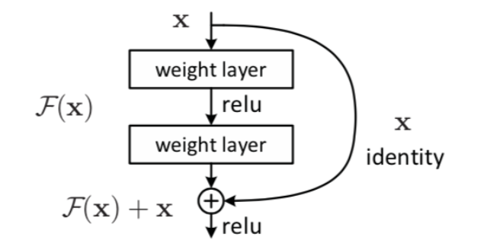
Fig.4-4 Basic structure of ResNet
The ResNet network is mainly divided into 5 parts. The main structure of ResNet-50 and ResNet-101 is the same. The only difference between them is Conv4_x. ResNet-50 has 6 Res Blocks, while ResNet-101 has 23 Res Blocks. The difference between the two is 17 Res Blocks, which is 17 * 3 = 51 floors.
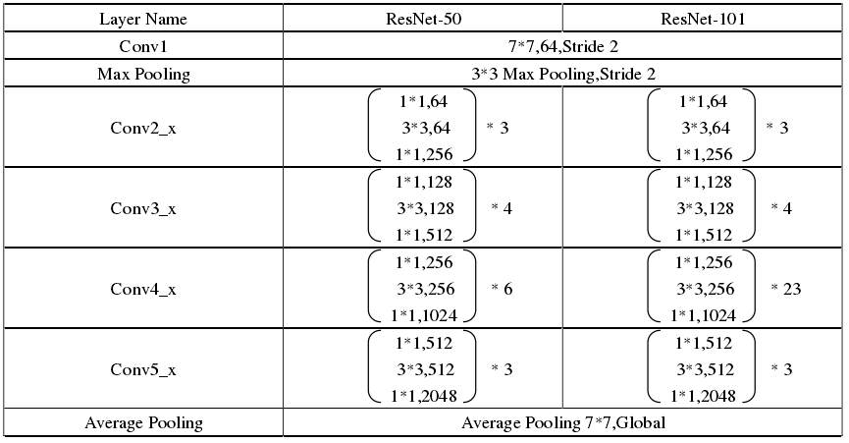
Figure.4-5 ResNet network structure
The residual network adds an identity mapping, which directly transmits the current output to the next layer of the network (all 1:1 transmission, no additional parameters), which is equivalent to taking a shortcut and skipping the original in layer operation, this direct connection is named "skip connection". At the same time, in the backward propagation process, the gradient of the next layer of the network is directly passed to the upper layer of the network, which solves the problem of the disappearance of the gradient of the deep network. Residual network does not have a direct advantage in model characterization, and ResNet cannot better characterize a certain aspect of the feature, but ResNet allows more models to be characterized layer by layer. The residual network makes the feedforward backpropagation algorithm go very smoothly. To a great extent, the residual network makes it easier to optimize the deeper model.

4.4 Classification of benign and malignant lung nodules based on ResNet-50
In this paper, ResNet-50 is used as the backbone network to extract features. According to the actual situation of the nodule centred in the input image, the feature interception and jump connection are used to improve it to extract features that are more focused on the nodule. Fig.4-6 shows the two residual learning units used in ResNet-50, where 1×1 represents the size of the convolution kernel. ReLU is the activation function of the convolution layer: x represents the input feature map, and F(x) is the feature map output of x after three convolutional layers. When the scale of the feature map of x and F(x) is the same, as shown in Fig.4-6(a), directly output x+F(x); when the scale of the feature map is inconsistent, as shown in Fig.4-6(b), roll x first and the product operation obtains the feature map Wx consistent with the scale of F(x), and then outputs Wx+F(x).
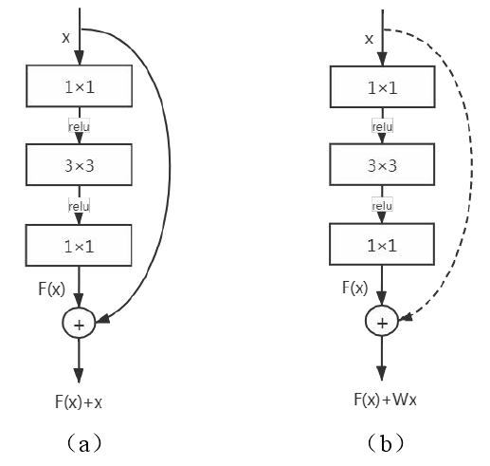
Fig.4-6 Schematic diagram of ResNet-50 residual learning unit
The advantages of using this design for the residual learning unit include: (1) In the worst case, the network learns an identity mapping, that is, the stacking of the residual learning unit does not make the performance of the network worse. So that the depth of the network can be stacked to a very deep level; (2) The residual learning unit F(x) learns the remaining residuals of the previous network learning. Therefore, by continuously stacking the residual blocks, the network can learn the effect which is getting better and better. ResNet-50 includes 5 convolution modules, of which the first convolution module has only 1 convolution layer, and the remaining 4 modules contain 3, 4, 6, and 3 residual learning units, each of which contains three convolutional layers, each convolutional layer is followed by a batch normalization layer. The ResNet-50 architecture is shown in Figure 4-7, where "Res2a" is the residual learning unit, "maxpool" is the maximum pooling layer, and "avgpool" is the average pooling layer. The basic model of this article is shown in Fig.4-8, where the backbone network is used to extract features, pre-training and output the nodule category after training.
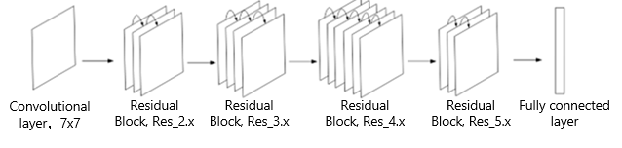
Fig.4-7 ResNet-50 architecture diagram
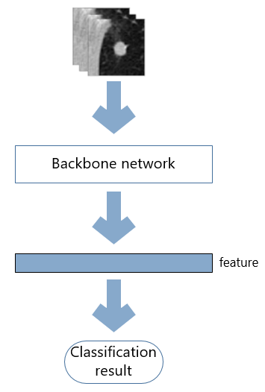
Fig.4-8 Model architecture
In CNN, Receptive Field (RF) refers to the size of the corresponding area in the input image of a feature value in the output feature map of the convolutional layer. The corresponding area refers to the feature value according to the pixel value of the area. It is calculated that when the width and height of the convolution kernel or pooling window are the same, the number of the input image is set to 0, and then the number of the feature map output by each network layer is incremented, and the convolutional layer or the pooling layer is changed from 1 starts numbering. The calculation method of the width or height of the receptive field of the i-layer feature map is shown in the formula (4-1). The formula (4-2) is a recursive formula, formula (4-3) is the initial condition, and $S_{1}$ represents the first step size of the convolutional layer or the pooling layer, $K_{1}$ represents the width or height of the convolution kernel of the first convolutional layer or the pooling window of the pooling layer, and $R_{i,0}$ represents the feature map of the i-layer. The feature value at the 0th layer is the width or height of the corresponding area on the input image, that is, the width or height of the desired RF.
$R_{i,0}=\left(R_{i,1}-1\right)∙S_{1}+K_{1}$ （4-1）
$R_{i,k}=\left(R_{i,k+1}-1\right)∙S_{k+1}+K_{k+1},i≤k≤0$ （4-2）
$R_{i,0}=1$ （4-3）
According to the above formula calculation, the receptive field of the feature map output by the last convolutional layer of ResNet-50 is 483×483, which covers all the images. It can be understood that the pixel value of the entire image participates in the calculation of each last feature value, but there are multiple targets of nodules and other lung tissues in the network input images, and the significance of other lung tissues in some images is significantly higher than that of the nodules, which will affect the representativeness of the final features to the nodules. Therefore, the method proposed to ResNet-50 Improvements to alleviate the above problems.
From the concept of RF, it can be understood that the feature values ​​in the feature map correspond to some areas in the input image, and each pixel value of the input image has its own influence range in the feature map. The influence refers to the pixel value participating in the calculation of the feature value. From the calculation method of the receptive field, it can be seen that for a network with a stack of convolutional and pooling layers, as the number of network layers becomes deeper, the receptive field of the output feature map of each layer continues to grow, so in the shallow feature map. The key influence range of each target in the deep feature map is more inclined to overlap, and the characteristic value is more inclined to be affected. In summary, this paper proposes to combine the sub-feature maps in the key influence range of the nodules in the shallow and deep feature maps to form the final feature. The shallow sub-feature maps can improve the representativeness of the nodules, and the deep sub-feature maps are better-integrated lung nodules and their surroundings. Combining the fact that the nodule is at the centre of the input image, the method uses the method of central feature interception to obtain the sub-feature map. The operation method of the central feature interception is: for the feature map of w×w size, set the output scale to k×k, then the $\frac{w-k}{2}+1$ point from top to bottom and from left to right of the original feature map is intercepted as the upper left corner of the sub-feature map. For example, for a 4×4 feature map, the process of outputting a 2×2 size b-feature map is shown in Fig.4-9.
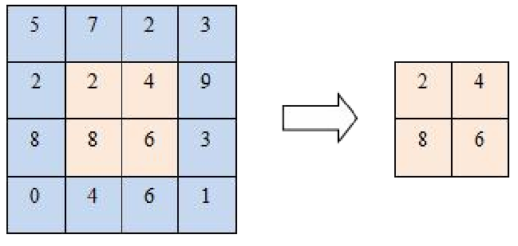
Fig.4-9 Schematic diagram of central feature interception
This chapter selects the 56×56, 28×28, 14×14, and 7×7 feature maps output by the second, third, fourth, and fifth convolution modules in ResNet-50 to intercept and combine them. Firstly, an input image with a size of 224×224 and a channel number of 3 is established. In the experimental data, the minimum diameter of the nodule is 3 mm, which corresponds to 14 pixels in the input image, and the 14×14 size matrix in the middle of the input image (determine the position of the matrix according to the central feature interception method). The pixel value in the matrix position determined by the interception method is filled with 1, and the rest are 0; then the ResNet-50 parameters are randomly initialized and the input image is received, and the feature maps output by the second, third, fourth, and fifth convolution modules are obtained. Analyse the feature maps generated by the above process, consider simplifying the process of combining sub-feature maps, and determine that the sub-feature maps of the same scale 7×7 size can be obtained by the central feature interception method on the four feature maps, and then directly use the method of splicing combine. The modified ResNet-50 can reduce the interference of non-nodular targets, and extract features that are more representative of nodules.

4.5 Experimental design and result analysis

4.5.1 Experimental environment and settings
In this chapter, Nvidia 2080Ti GPU is used as the model training acceleration device in the experiment of the benign and malignant classification method of lung nodules based on ResNet-50, the classification model is built with TensorFlow and Keras framework, and the programming language is Python. During the training process, some hyperparameters are set as follows: the batch size is set to 32, the maximum training round is 200, and the learning rate is set to an initial value of 0.0005 with a certain learning rate attenuation to achieve the best training effect. The optimizer chosen is Adam. The experiment image is cut out the image slice of size 32x32 with the lung nodule with the original image pixel of 512x512 as the center, and then the image is scaled to 224x224 and input into the backbone network to extract features. This experiment also uses other diagnostic results of nodules marked by doctors in the LIDC-IDRI data set introduced in the previous chapter. These diagnostic results are also the average value marked by 4 doctors and rounded up. The decay formula of learning rate (4-4) is as follows:
$η\left(t\right)=\frac{η\left(0\right)}{1+10^{-2}t}$ （4-4）
Among them, $η$ is the learning rate, and t is the training round.

4.5.2 Evaluation standard
In this paper, the performance of the model is mainly evaluated through two indicators of accuracy, ACC and AUC. In the two-classification problem, the samples can be divided into positive and negative examples. After the model is classified, the samples can be divided into four categories: true positives (TP), false positives (FP), and true negatives (TN), False Negatives (FN).
(1) TP: The number of positive samples that are correctly divided, that is, the number of positive samples that are actually positive samples and are also divided into positive samples by the network, which is called true cases.
(2) FP: The number of positive samples that are incorrectly classified, that is, the number of positive samples that are actually negative samples and are also classified by the network, which is called false positives.
(3) TN: The number of negative samples that are correctly divided, that is, the number of negative samples that are actually negative samples and are also divided into negative samples by the network, which is called true-negative example.
(4) FN: The number of negative samples that are incorrectly divided, that is, the actual number of positive samples that are also divided into negative samples by the network is called false negatives.
Generally, malignant lung nodules are expressed as positive, and benign lung nodules are expressed as negative. The classification of benign and malignant pulmonary nodules is essentially a binary classification problem. For a binary classification problem, the commonly used evaluation index is the accuracy of classification (ACC).
$Accuracy=\frac{TP+TN}{TP+TN+FP+FN}×100\%$ （4-5）
However, the classification accuracy rate cannot fully and accurately summarize the classification ability of a classifier, and even if only the classification accuracy rate is concerned, it will lead to mis-judgment of the classification performance. In the medical field, the ability to recognize positives is more concerned. True positive rate (TPR), also known as sensitivity. Sensitivity is the recognition rate of positive data and also reflects the classification ability of the classifier. Negative rate (FNR), also known as missed diagnosis rate. The higher the sensitivity, the lower the missed diagnosis rate and the better the classification ability of the classifier. In the classification of pulmonary nodules, the missed diagnosis rate represents the probability of incorrectly classifying malignant nodules as benign nodules. True Negative Rate (TNR), also known as secifity, is the probability that a negative is correctly identified. False Positive Rate (FPR), also known as the misdiagnosis rate. In the diagnosis of lung nodules, if benign nodules are mistakenly judged as malignant nodules, it will cause unnecessary waste of the patient's economy and the hospital's manpower and material resources. The calculation formulas are as follows:
$TPR=\frac{TP}{TP+FN}×100\%$ （4-6）
$FNR=\frac{FN}{TP+FN}×100\%$ （4-7）
$TPR=\frac{TP}{TP+FN}×100\%$ （4-8）
$TNR=\frac{TN}{TN+FP}×100\%$ （4-9）
$FPR=\frac{Fp}{TN+Fp}×100\%$ （4-10）
In two classification problems, the receiver operating characteristic (ROC) curve and the area under the ROC curve (AUC) are often used. In the ROC curve coordinate system, the abscissa represents the false positive rate, and the ordinate represents the true positive rate. AUC is a more comprehensive evaluation standard. The value range is [0,1]. The larger the value, the better the model classification effect: when AUC is equal to 0.5, the model classification effect is equivalent to random classification; when AUC is greater than 0.5, Model classification effect is worse than random classification; when AUC is less than 0.5, model classification effect is not as good as random classification. The higher the AUC value, the better the classification performance of the network. Conversely, the smaller the AUC value, the worse the classification effect of the algorithm and the lower the recognition rate.

4.5.3 Analysis of training process
In order to objectively and accurately evaluate the performance of the ResNet-50-based pulmonary nodule classification method model built above, this paper uses a five-fold cross-validation method to evaluate the performance of the model. First, the above-mentioned data set is divided equally into five parts by random sampling without replacement. In each training process, one of them is selected as the test set, and the remaining four are used as the training set for model training. Repeat the above process five times so that each piece of data is selected as a test set, so that after five trainings, five models are obtained. Use these models to test on the pre-divided test set and find the average of the test results as the final accuracy estimate of the model, and as the performance index of the model under the current five-fold cross-validation. The process is shown in Fig.4-10.
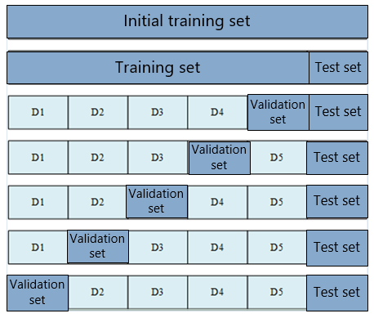
Fig.4-10 Five-fold cross-validation data set partition method
In the model training process, due to the size of the data set and in order to reduce the over-fitting phenomenon, this paper uses the data enhancement technique introduced in Chapter 3 to expand the initial data set and enhance the generalization ability of the model. Data enhancement includes a series of techniques used to generate new training samples. These techniques are implemented by applying random geometric transformations to the original image data or adding noise while keeping the class labels unchanged. These techniques include random cropping of images, flip, rotate, zoom, pan, etc. In the training process, an early stopping strategy is also adopted, that is, when the loss of the training set is still declining and the loss of the verification set no longer decreases, the training of the model is stopped. Usually in different training rounds, it is rare that the loss of the verification set is exactly the same. Therefore, before the maximum training round is reached, as long as it is ensured that within a certain training round, the loss of the model on the verification set is reduced by more than a threshold. At the same time, the loss on the training set keeps decreasing, and it is considered that the model is under-fitting during the training process, and the model can be continued to be trained. On the contrary, within a certain training round, the loss of the model on the training set keeps decreasing. But in the validation set, the loss on the validation set is less than the threshold or the loss on the validation set increases instead, it is considered that the overfitting phenomenon has begun to appear in the training process, and the training is stopped. The training process is shown in Fig.4-11 below. The five-fold cross-validation method divides the data set into five parts, and each piece of data is trained, and finally five changes in training and verification loss values ​​are obtained. It can be seen that the overall loss value of each training showed a slow downward trend, and finally stabilized at about 0.04.
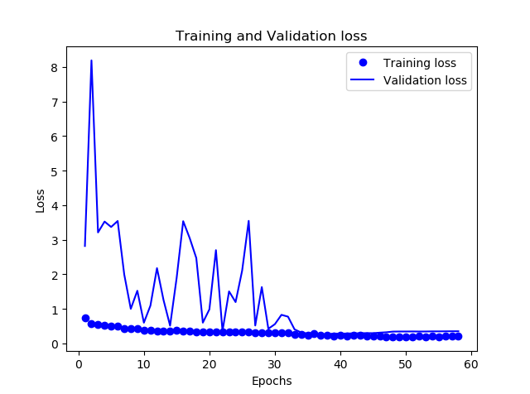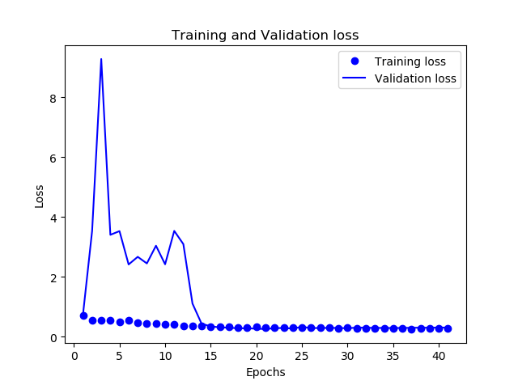
(a) (b)
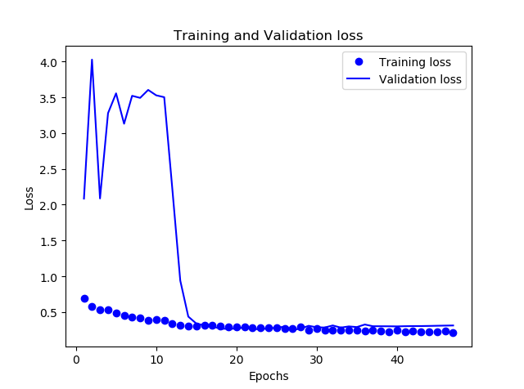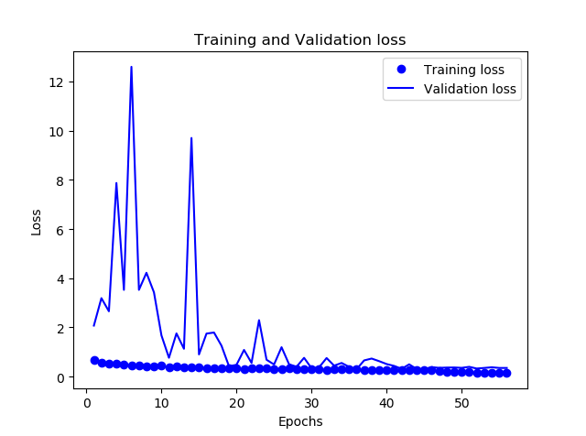
(c) (d)
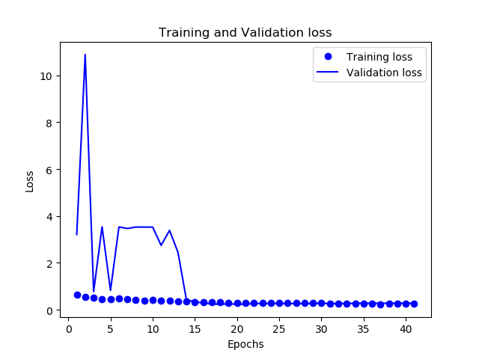
(e)
Fig.4-11 During the training process, the change of the loss value
From the analysis of the above training process, the loss value of the classification training process of the backbone network can converge to a very low level. In general, the model has a strong learning ability, and the loss value tends to converge after a certain number of Epochs.

4.5.4 Analysis of results
This section analyzes the experimental results of the model, which mainly includes two aspects: the analysis of the experimental results of the model and the comparative analysis of other models.
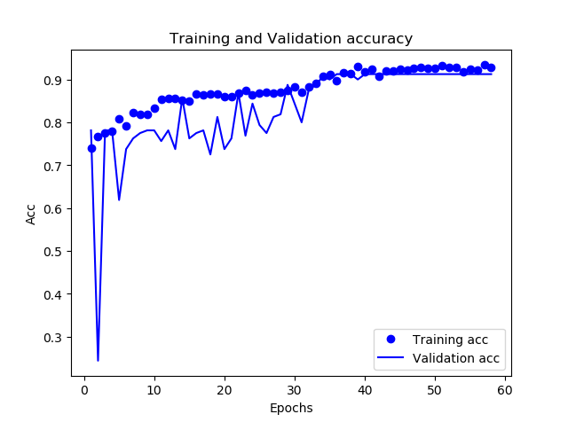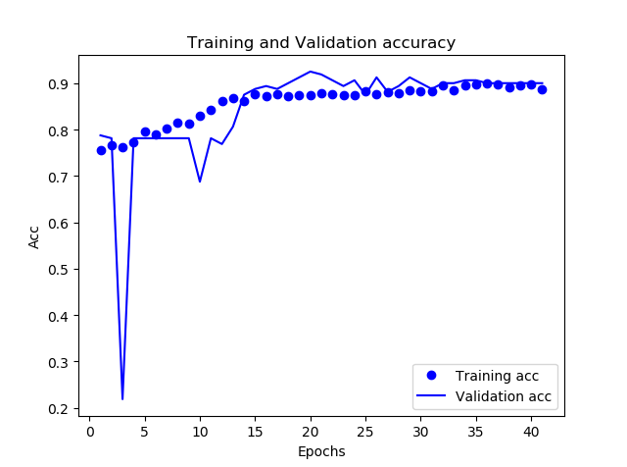
(a) (b)
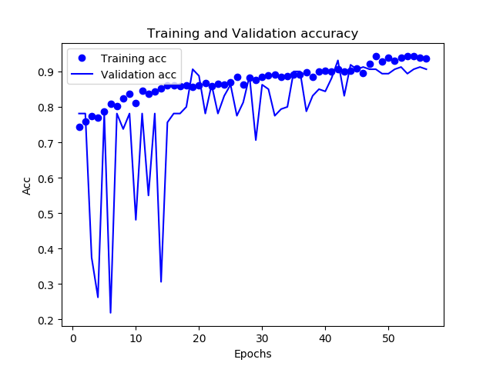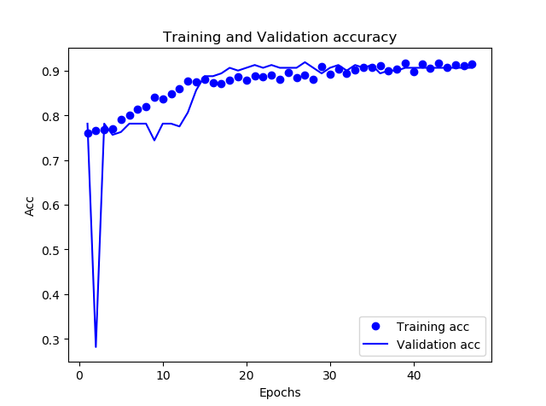
(c) (d)
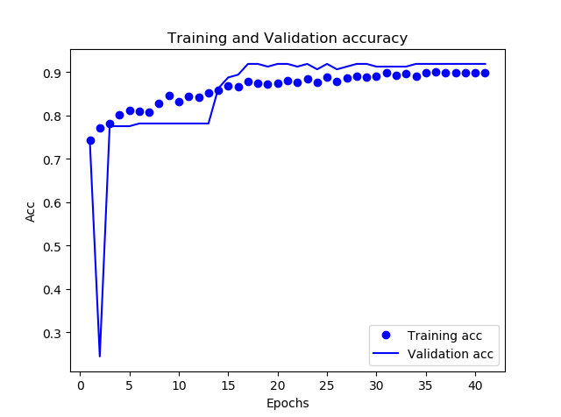
(e)
Fig.4-12 Training accuracy
The accuracy rate obtained through training in this article is shown in Fig.4-12. The two curves represent the training accuracy rate and the verification accuracy rate respectively. It can be seen that the overall trend is increasing, then it tends to converge, and finally stabilizes at a certain value. After the five-fold cross-validation method, the results of the five groups of experiments are shown in Table 4-1. Finally, the average value of the five groups of models is used as the final evaluation index. The classification accuracy of benign and malignant lung nodules is 90.884%, and the AUC value reaches 96.026%.
Table 4-1 Training accuracy rate
Model | ACC (%) | AUC%
The first group of models | 91.25 | 96.35
The second group of models | 90.65 | 95.73
The third group of models | 90.65 | 95.72
The fourth group of models | 90.00 | 95.46
The fifth group of models  Mean | 91.87  90.884 | 96.87  96.026
In order to further illustrate that the network proposed in this chapter has good performance in the classification of benign and malignant lung nodules, the method in this chapter is compared with other methods in recent years. The results are shown in Table 4-2. Most of the comparison methods and classification networks have been briefly explained in the previous chapters. As can be seen from the table, this paper compares the two convolutional neural networks of LeNet-5 and AlexNet in terms of accuracy and AUC value, which are better than these two networks. Compared with other methods, the accuracy and AUC value of this method are much higher. Overall, the classification effect of benign and malignant lung nodules is higher than other methods and other classic image classification networks, which can verify the effectiveness of the method in this chapter.
Table 4-2 Experimental results of this article and other methods
Method | ACC (%) | AUC%
LeNet-5^{[47]}  AlexNet^{[48]}  Wang et al^{[50]} | 76.30  83.40  81.94 | 73.00  82.10  75.33
Abdelrahm et al^{[51]} | 82.62 | 89.25
Shen et al^{[26]} | 84.20 | 85.60
Xue et al^{[52]}  This paper method | 85.47  90.884 | 89.38  96.026

4.6 Chapter summary
This chapter introduces the CNN classification process and several classic models, including LeNet, AlexNet and ResNet. A ResNet-based classification method for benign and malignant lung nodules is proposed. The deeper ResNet-50 is selected as the backbone network for extracting features, and the corresponding problems are improved. The five-fold cross-validation method is used as the training method, and the selected data set is selected. Divide equally into five portions. In each training process, one of them is selected as the test set, and the remaining four are used as the training set for model training. After five trainings, five models are obtained, and the average of the training results is taken as the experimental result. Experimental results show that this method has a high classification effect. Compared with other methods and classification networks, the effectiveness of this method is verified.

5. SUMMARY AND FUTURE EXPECTATIONS

5.1 Summary
With the continuous increase in the incidence of lung cancer, the high mortality rate has made lung cancer CAD research one of the most popular researches in the field of medical imaging. CAD technology for lung cancer based on CT images is an important method for early screening of lung cancer, and it is critical to improve the cure rate of lung cancer and the living standards of patients. Because nodules are one of the early signs of lung cancer in imaging, the lung tissue structure is very complex, and the proportion of nodules in the lung tissue is too small, and the visual manifestations are also different, which increases the need for radiologists’ challenge. Therefore, it is very important to use the CAD system to provide radiologists with second opinions in order to reduce the workload of doctors and increase the diagnostic detection rate.
This paper studies the classification task of benign and malignant lung nodules in CT images. Considering various problems in designing traditional features, threshold segmentation is used to segment lung CT images and extract ROI. At the same time, the data is pre-processed and propose a ResNet-based classification method for benign and malignant lung nodules. The main research work of the thesis is as follows:
(1) In view of the traditional segmentation method, there are too many manual segmentations or only the lung parenchyma, but the lung parenchyma still has more tissues remaining. This paper proposes a lung ROI segmentation method. First, the histogram equalization method is used to enhance the original lung CT image, which improves the clarity and recognizability of the image, which is beneficial to the next step of lung parenchymal segmentation. Then combine the threshold method and morphology to segment the lung parenchyma. Finally, the ROI is extracted from the lung parenchymal image, which reduces the interference of irrelevant noise. This paper chooses LIDC-IDRI as the data set of this article, uses the data enhancement method of adjusting brightness, pictures flip and rotation to pre-process the data, and then uses it as input to the classification network for training, and gets the experimental results.
(2) The deep learning method is applied to the classification of lung nodules, and a ResNet-based classification method of benign and malignant lung nodules is proposed. The backbone network of the method model is constructed based on ResNet-50 and improved according to the problem situation. The main classification network is trained with the malignant degree of the nodules as the supervision information, and the five-fold cross-validation method is used for training. The specific data is the data in the data set. Divide into five groups for training, and finally get the average of the five groups of training results as the experimental results. Finally, the accuracy and AUC value of the experimental results were 90.884% and 96.026%, respectively, which verified the validity of the experiment. These experimental results fully highlight the advantages of deep learning in the field of image classification: automatic extraction of learned features, avoiding manual extraction of features, and more objective and accurate classification results.

5.2 Future expectations
In this paper, the CNN technology in deep learning is applied to the field of lung CT image classification, and it has achieved certain results in identifying benign and malignant lung nodules. However, due to limited personal abilities, there are still some problems. The research directions in the future are as follows:
(1) Further improve the accuracy of the classification of benign and malignant nodules. The classification method of benign and malignant lung nodules belongs to CAD technology. The classification results will be used as a reference for doctors' diagnosis. It can help reduce the problems of missed diagnosis and misdiagnosis. Therefore, its classification accuracy is very important and may directly affect the life and health of patients. For researchers, it is very necessary to further improve the accuracy of nodule benign and malignant classification methods.
(2) The problem of classification of benign and malignant lung nodules is developed into a multi-classification problem. This thesis focuses on the problem of dividing nodules into benign and malignant two classification problems, but in some cases, doctors need to diagnose the nodules based on the degree of malignancy. At this time, it is a multi-class problem, and the nodules are classified as benign and malignant. Research on multi-classification problems can meet the needs of more doctors for diagnosis. The complete malignant nodule detection system includes two parts: nodule detection and nodule benign and malignant classification. It needs to receive the original CT image of the patient as input and output the position of the malignant lung nodule in the CT image. Researchers need to establish a complete system and put it into use.
(3) The current models with good classification performance are mostly based on three-dimensional networks. This is because lung nodules are three-dimensional sphere-like structures in lung CT images. The use of three-dimensional network models can effectively consider the three-dimensional information of the image, which is natural for leaflets. Semantic images are unattainable, which also shows that the use of three-dimensional networks to analyse medical images is one of the research hotspots in the future.

6. REFLECTION
In the process of writing papers in the past few months, I have learned a lot of knowledge and completed the topics and experiments I have chosen. From choosing the right topic to consulting the literature, to completing the experiment, and finally completing the writing of the paper, the success of each stage is the result of my own efforts and attempts. In this process, I have gained a lot. Under the guidance of Professor Terry Walcott, I began to look up relevant information, learn about deep learning and gradually improve my thinking.
At the beginning, although the topic I decided was related to deep learning, the scope was too wide and I needed to choose a small goal. After that, I selected the image processing topic that I was more interested in. And under the guidance of the teacher, I learned some knowledge of image processing and related books. I also searched the Internet for some learning materials that were helpful to me, to have a deeper understanding of image processing, and to decide on my own subject. Finally, I chose the study of the classification method of benign and malignant lung nodules based on deep learning as my research topic.
The problem I encountered at the beginning was how to choose a suitable data set. After comparing the LIDC data set and the LIDC-IDRI data set, I chose the LIDC-IDRI data set as the data set of this paper. LIDC-IDRI is a 1018 scan that extends LIDC to 1010 patients, improving early detection of lung cancer. Because it involves deep learning, it is necessary to choose a suitable CNN as the backbone network for training, so choosing a suitable CNN has become the second problem I encountered. Due to the lack of large-scale training data at that time and the computing power of the computer, LeNet-5 was not ideal for handling complex problems. For AlexNet, although its processing power is better, if one convolutional layer is removed, the entire AlexNet network will be degraded, which will have a great impact on the result. While ResNet allows more models to be characterized layer by layer in depth, the ResNet makes the feedforward backpropagation algorithm work very smoothly. To a large extent, the ResNet makes it easier to optimize the deeper models. So, I chose ResNet-50 as the backbone network for data set training. Finally, in order to objectively and accurately evaluate the performance of the model based on the ResNet-50 benign and malignant classification of lung nodules, I used a five-fold cross-validation method to evaluate the performance of the model, which was able to obtain better accuracy and the AUC value. Compared with other methods, this method had better results, also successfully achieved my goal, completed the classification of benign and malignant lung nodules.
Through this experiment, I learned the relevant knowledge of deep learning and neural network. At the same time, I have a deeper understanding of image processing, which provides experience for my future study and research.

7. REFERENCE
[1] Bray F, Ferlay J, Soerjomataram I, et al. Global cancer statistics 2018: GLOBOCAN estimates of incidence and mortality worldwide for 36 cancers in 185 countries[J]. CA: A Cancer Journal for Clinicians, 2018, 068(006): 394-424.
[2] Zheng Rongshou, Sun Kexin, Zhang Siwei, et al. Analysis of the prevalence of malignant tumors in China in 2015[J]. Chinese Journal of Oncology, 2019, 041(001): 19-28.
[3] Collins L G, Haines C, Perkel R, et al. Lung cancer: diagnosis and management[J]. American family physician, 2007, 75(1): 56-63.
[4] Allemani C, Matsuda T, Di Carlo V, et al. Global surveillance of trends in cancer survival 2000–14 (CONCORD-3): analysis of individual records for 37 513 025 patients diagnosed with one of 18 cancers from 322 population-based registries in 71 countries[J]. The Lancet, 2018, 391(10125): 1023-1075.
[5] Soubani A O. The evaluation and management of the solitary pulmonary nodule[J]. Postgraduate medical journal, 2008, 84(995): 459-466.
[6] Ji Guohua. Research on segmentation and classification of solitary pulmonary nodules based on PET-CT[D]. Taiyuan University of Technology, 2016.
[7] R. Yuan, P. M. Vos, P. L. Cooperberg. Computer-Aided Detection in Screening CT for Pulmonary Nodules[J]. Ajr Am J Roentgenol. 2006, 186(5): 1280-1287.
[8] Wang Shuyan, Zhou Mingquan, Geng Guohua. Research on the method of mining association rules for medical images [J]. Computer Applications, 2005, 25(6): 1408-1409.
[9] Chu Yun. Significance analysis of CT detection of benign and malignant pulmonary nodules in patients with lung cancer[J]. Chinese and Foreign Medicine, 2015, 034(032):187-188.
[10] B. Sahiner, H. P. Chan, L. M. Hadjiiski, et al. Effect of CAD on Radiologists\" Detection of Lung Nodules on Thoracic CT Scans: Analysis of an Observer Performance Study by Nodule Size[J]. Academic Radiology. 2009, 16(12): 1518-1530.
[11] Qiao Hongtao. Research progress and development trend of modern medical imaging[J]. Chinese Health Industry, 2017, 014(006):189-190.
[12] Guo Lili, Ding Shifei. Research progress of deep learning[J]. Computer Science, 2015, 42(5):28～33.
[13] V. A. Gurumurthy. Encoder-Decoder based CNN and Fully Connected CRFs for Remote Sensed Image Segmentation[J]. 2019: 4-14.
[14] Wang Xiaohua, Ma Daqing. Application progress of computer-aided diagnosis in pulmonary nodules[J]. Chinese Journal of Radiology, 2006,040(004): 443-445.
[15] V. Osuna-Enciso, E. Cuevas, H. Sossa. A comparison of nature inspired algorithms for multi-threshold image segmentation[J]. Expert Systems with Applications. 2013, 40(4): 1213-1219.
[16] Krewer H., Geiger B., Hall O., et al. Effect of texture features in computer aided diagnosis of pulmonary nodules in low-dose computed tomography[J]. IEEE international Conference on Systems, Man, and Cybernetics, 2013.
[17] Wu C., Cheng T., et al. Correlation between CT signs and pathological differentiation of peripheral lung adenocarcinoma[J]. Chinese Computed Medical Imaging, 2014.
[18] Madero H., Vergara O., Cruz G., et al. Automated System for Lung Nodules Classification based on Wavelet Feature Descriptor and Support Vector Machine[J]. Bio-Medical Engineering, 2015.
[19] Lagervist B., Samuelsson B., et al. Computer aided diagnosis of pulmonary nodules using a two-step approach for feature selection and classifier ensemble construction[J]. Artificial Intelligence in Medicine, 2010.
[20] Han F., Wang H., et al. Texture feature analysis for computer aided diagnosis on pulmonary nodules[J]. Journal of Digital Imaging, 2015.
[21] Dhara K., Mukhopadhyay S., et al. A combination of shape and texture features for classification of pulmonary nodules in lung CT images[J]. Journal of Digital Imaging, 2016.
[22] Shen W, Zhou M, Yang F, et al. Multi-scale Convolutional Neural Networks for Lung Nodule Classification[C]. IPMI, 2015: 588-599.
[23] Zhao X, Liu L, Qi S, et al. Agile convolutional neural network for pulmonary nodule classification using CT images[J]. International Journal of Computer Assisted Radiology and Surgery, 2018, 013(001): 1-11.
[24] Zhang B, Qi S, Monkam P, et al. Ensemble Learners of Multiple Deep CNNs for Pulmonary Nodules Classification Using CT Images[J]. IEEE Access, 2019, 007: 110358-110371.
[25] Kumar D, Wong A, Clausi D A. Lung Nodule Classification Using Deep Features in CT Images[C]. CRV, 2015: 133-138.
[26] Shen S, Han S X, Aberle D R, et al. An Interpretable Deep Hierarchical Semantic Convolutional Neural Network for Lung Nodule Malignancy Classification[J]. Expert Systems with Applications, 2019, 128: 84-95.
[27] Xie Y, Xia Y, Zhang J, et al. Knowledge-based Collaborative Deep Learning for Benign-Malignant Lung Nodule Classification on Chest CT[J]. IEEE Transactions on Medical Imaging, 2019, 038(004): 991-1004.
[28] Xie Y, Xia Y, Zhang J, et al. Transferable multi-model ensemble for benign-malignant lung nodule classification on chest CT[C]. International Conference on Medical Image Computing and Computer-Assisted Intervention. Springer, Cham, 2017: 656-664.
[29] Lin Z, Wang G, Fu Q, et al. Benign and Malignant Classification Model of Pulmonary Nodules Based on Residual Neural Network[C]. 2019 International Conference on Big Data, Electronics and Communication Engineering (BDECE 2019). Atlantis Press, 2019: 164-167.
[30] Wang W, Chakraborty G. Evaluation of Malignancy of Lung Nodules from CT Image Using Recurrent Neural Network[C].2019 IEEE International Conference on Systems, Man and Cybernetics (SMC). IEEE, 2019: 2992-2997.
[31] Tian Zhongqing. The principle and detection of medical CT[J]. China Metrology, 1999(002): 50-51.
[32] Peng Wenxian, Peng Tianzhou, Ye Xiaoqin, et al. The effect of CT scanning parameters on the CT value of human tissues[J]. Chinese Journal of Radiological Medicine and Protection, 2010, 030(001): 79-81.
[33] Li Huimin, Xiao Xiangsheng. CT imaging evaluation of lung nodules[J]. Chinese Journal of Medical Computer Imaging, 2001, 007(001):30-41.
[34] Sun Zhijun, Xue Lei, Xu Yangming et al. Survey of deep learning research[J]. Application Research of Computers, 2012, 29(8):2806-2810.
[35] Zhou Zhihua. Machine learning[M]. Beijing: Tsinghua University Press, 2016: 97.
[36] J. Liu, Y. Li, J. Ke, et al. Synergically Improving Light Harvesting and Charge Transportation of Ti O2 Nanobelts by Deposition of MoS2 for Enhanced Photocatalytic Removal of Cr(VI)[J]. Catalysts. 2017, 7(12): 30.
[37] L. Chen, G. Papandreou, I. Kokkinos, et al. DeepLab: Semantic Image Segmentation with Deep Convolutional Nets, Atrous Convolution, and Fully Connected CRFs[J]. IEEE Transactions on Pattern Analysis & Machine Intelligence. 2017: 1.
[38] S. Yi, X. Wang, X. Tang. Deep Learning Face Representation by Joint Identification-Verification[J]. Advances in neural information processing systems. 2014, 27.
[39] K. Fritscher, P. Raudaschl, P. Zaffino, et al. Deep Neural Networks for Fast Segmentation of 3D Medical Images[C]. 2016, 34: 1123-1168.
[40] C. Jacobs, E. M. Van Rikxoort, T. Twellmann, et al. Automatic detection of subsolid pulmonary nodules in thoracic computed tomography images[J]. Medical Image Analysis. 2014, 18(2): 374-384.
[41] D. F. Jeffrey, J. R. Ledsam, R. P. Bernardino, et al. Clinically applicable deep learning for diagnosis and referral in retinal disease[J]. Nature Medicine. 2018, 15: 1822-1857.
[42] K. Men, J. Dai, Y. Li. Automatic segmentation of the clinical target volume and organs at risk in the planning CT for rectal cancer using deep dilated convolutional neural networks[J]. Medical Physics. 2017, 44.
[43] Niu Lujie, Jia Boqi, Zhang Mengshi, etc. Automatic recognition of corneal morphology in rabbit eye coherent optical tomography based on morphological denoising[J]. Beijing Biomedical Engineering, 2017, 36(5): 459-464.
[44] Armato III S G, McLennan G, Bidaut L, et al. The lung image database consortium (LIDC) and image database resource initiative (IDRI): a completed reference database of lung nodules on CT scans[J]. Medical physics, 2011, 38(2): 915-931.
[45] He K, Zhang X, Ren S, et al. Deep Residual Learning for Image Recognition[J]. 2015:770～778.
[46] Fukushima K. Neocognitron: A self-organizing neural network model for a mechanism of pattern recognition unaffected by shift in position[J]. Biological Cybernetics, 1980, 36(4):193.
[47] Lecun Y, Boser B, Denker J S, et al. Backpropagation Applied to Handwritten Zip Code Recognition[J]. Neural Computation, 1989, 1(4):541～551.
[48] Krizhevsky A, Sutskever I, Hinton G E. ImageNet classification with deep convolutional neural networks[C]. International Conference on Neural Information Processing Systems. Curran Associates Inc. 2012:1097～1105.
[49] Simonyan K, Zisserman A. Very Deep Convolutional Networks for Large-Scale Image Recognition[J]. Computer Science, 2014.
[50] Wang Q, Cheng J Z, Liu Z, et al. Multi-order Transfer Learning for Pathologic Diagnosis of Pulmonary Nodule Malignancy[C]. BIBM, 2018: 2813-2815.
[51] Abdelrahman S A, Abdelwahab M M, Sayed M S. Pulmonary Nodule and Malignancy Classification Employing Triplanar Views and Convolutional Neural Network. MWSCAS, 2019: 594-597.
[52] Xue Yujing. Research on the Classification of Benign and Malignant Pulmonary Nodules Based on Convolutional Neural Network[D]. Nanjing University, 2020.

Appendices

