Assignment 1 - Swansea Mumbles Road Development

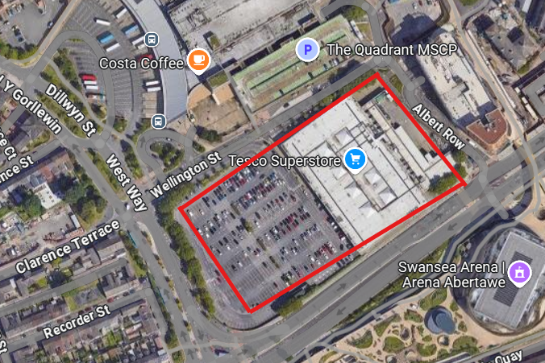
Figure 1 - Aerial photograph showing the site location (Google Maps, 2025)

2500099 – Harkeerat Johal

Contents
Page 1 – Front Cover
Page 2 – Contents
Page 3 – Introduction
Page 3 – On site historical land use
Page 4- On site historical land use
Page 4 – Surroundings
Page 5 – Surroundings
Page 5 – Environmental – Radon
Page 6 – Environmental – Asbestos
Page 6 – Environmental – Borehole Log
Page 7 – Environmental - Landscaping
Page 7 – Environmental - Foundation solution
Page 7 – Environmental - Insight Report
Page 8 – Electric
Page 9 – Gas
Page 10 – Drainage
Page 11 - Drainage
Page 12 – Drainage
Page 13 – Future works
Page 14 – References

Introduction
In this assignment I will be undertaking a desktop study for a proposal to demolish the existing Tesco superstore on mumbles road Swansea, and to construct a new 5 storey hotel consisting of 400 rooms. This development will also consist of a new restaurant, leisure centre, bar, and a conference centre.
The proposal does come with a few issues such as transporting materials into site as it is a very busy road and can be quite tight however, there are solutions to this such as expanding the width of the road and potentially proposing a new wider entrance.
As the proposal is to demolish and construct a new development, a section 80/81 will need to be in place with the local authority (Swansea Council). This is a legal requirement under the 1984 Building Act.
On site historical land use
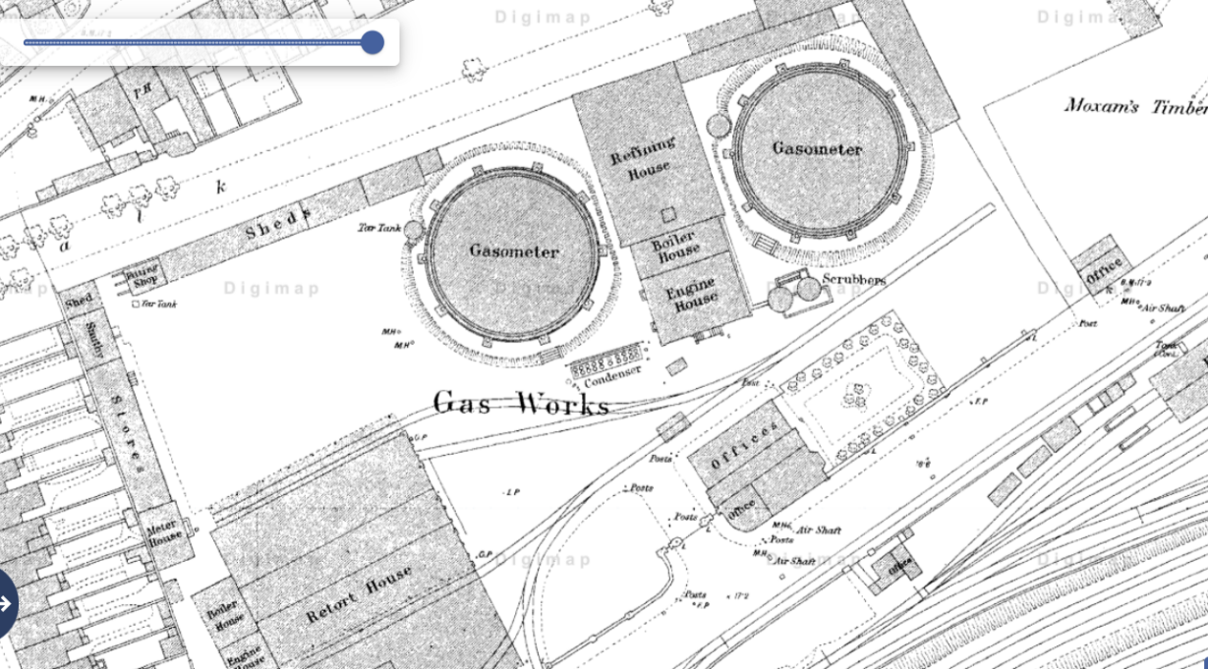
As mentioned in the introduction, the site currently holds a Tesco superstore which was constructed in the year 2000 for C. £13.5 Million. The earliest maps (1880) show that the site previously had a gas factory. It was then sold for a record sum by selling agents Cooke and Arkwright. The gas factory that was previously on site housed 2 Gasometers, Boiler House, Engine House, refining house and residential houses as shown in the image Engine House, refining house and residential houses as shown in the image below
Figure 2 – Extract taken from Digimaps showing historical Gasometers (2025)
A substantial point to take into consideration will be whether all the Gas mains underground had been disconnected or whether the ground still holds Gas mains.
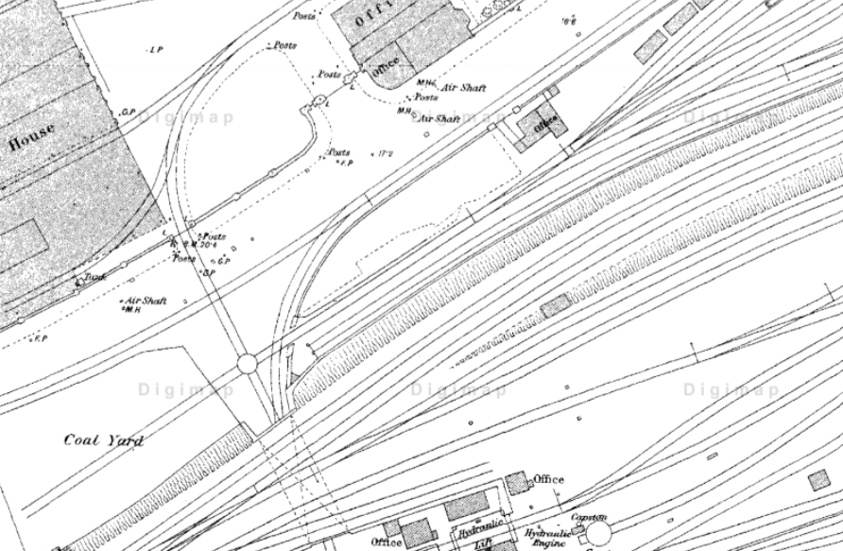
Also, with reference to the below image, you can see there was a railway track adjacent to the site, this is another thing that should be looked at to establish and ensure it doesn’t run across the proposed development. As this railway is no longer in use and is historic, a formal BAPA with national railway will not be required.

Figure 3 – Image taken from Digimaps showing historic railway line (2025)

Surroundings
Currently around the proposed development, there are Highrise buildings which contain mostly offices. The proposed development is situated on Oystermouth Road, which is used by thousands of people a day meaning high foot fall which could lead to restricted delivery times, e.g. can’t deliver during 8am-9am, however this could also be an opportunity to consider night time working subject to approval from Swansea council.
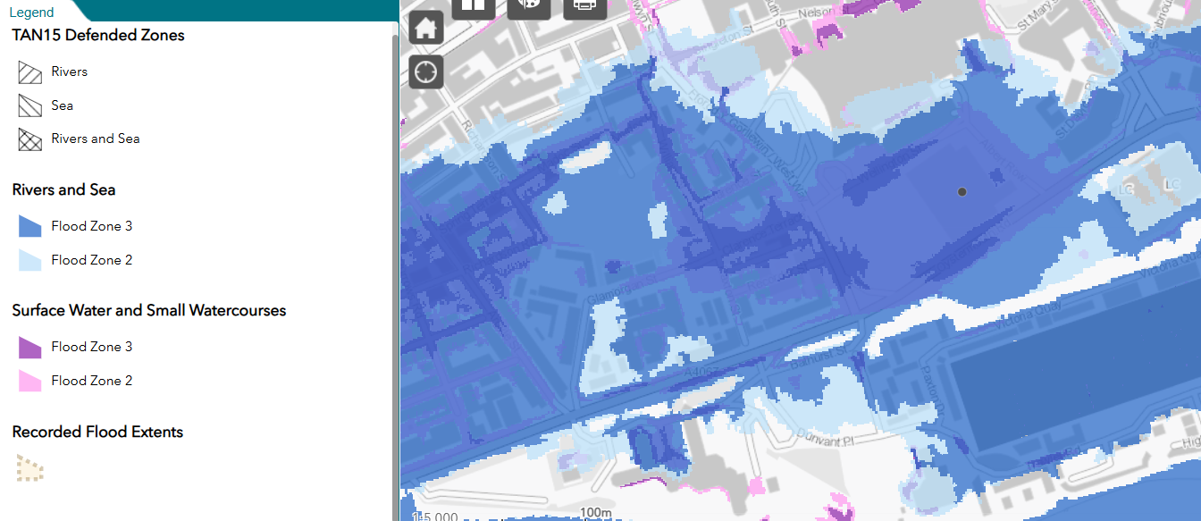
This development is also situated close by the sea, however with reference to the map below taken from National Resources Wales, it is situated in a flood zone 3, which means the risk of flooding is low.
Figure 4 – Image taken from National Resource Wales (2025)

Environmental
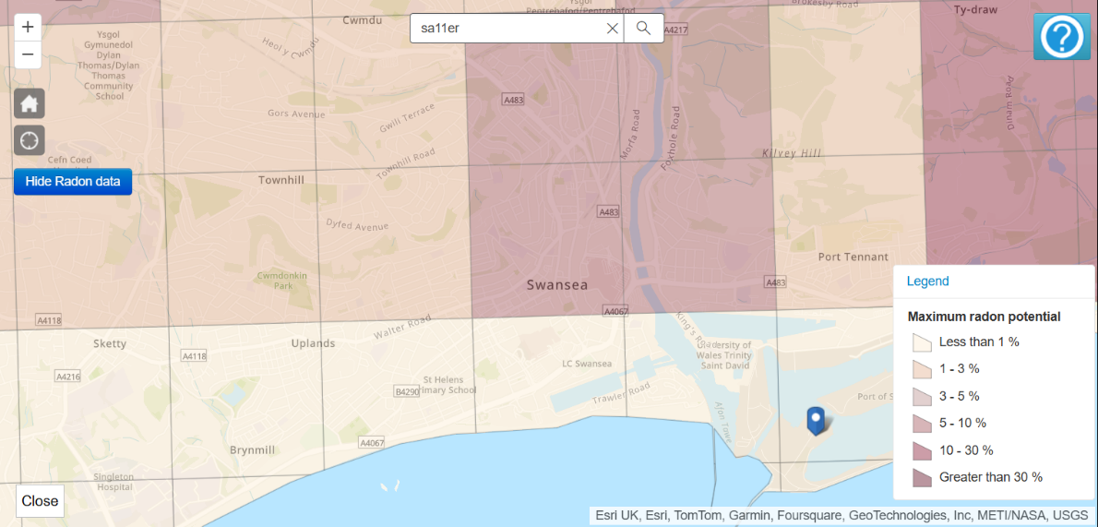
Radon
Figure 5 – Image taken from UK radon (2025)
With regards to the above extract, the radon level for this development is less than 1%. However, a radon test can be undertaken to establish the exact amount that is in the current building.

Asbestos
It is recommended that an asbestos survey should be carried out to establish and ensure no asbestos is on site before demolition. This can be arranged via an external asbestos removal/testing company. The survey that would be required would be a R&D Survey (Refurbishment and Demolition Asbestos Survey) if asbestos is identified, it will then need to be removed by a licensed company and then disposed of by a licensed waste carrier and disposed of at an appropriately licensed asbestos waste facility.
Once asbestos is fully removed (if identified) you can then proceed with the demolition, subject to a section 80/81 being approved, as mentioned in the introduction.
It is also recommended that trial pits and window samples are constructed at site to determine the nature of the strata and allowing the collection of soil samples that can then be tested in the lab to identify whether any asbestos is present.

Borehole Log
I have managed to obtain an old borehole log containing a significant amount of information however, an updated one is recommended to be instructed.
The borehole I have obtained shows that 0.50m down is made ground consisting od ashes. 1.50m down is made ground consisting of loose, light grey pine – medium sand. 2.55m down is made ground consisting of grey sand with layers of soft sandy clay. 3.50m of made ground consisting of soft red – brown sand clay with brick shale. 4.95m down is made ground consisting of dense bricks, ashes, sand and clay. 7m down is very dense brown gravel with traces of sandy clay. 7.95, down is very dense brown with the same gravel. 11m down is stiff grey, brown gravelly boulder clay. 18.60m down is very stiff grey gravelly boulder clay. 22.0m down is grey mudstone.

Landscaping
Currently on site there is very little to no landscaping, however this could be changed with the intention of rain gardens to support your SuDS application and ensure you are capturing rainwater & surface water.

Foundation Solution
With the above given information, the foundation solution that I would recommend would be piles. The reason for this is that piling would be the only suitable option for a development of this size. Piles are usually made from steel or reinforced concrete and driven into the ground. The specific type of piles I would recommend would be bored piles, bored piles are drilled into the ground, removing the soil and then filling the hole with reinforced concrete. Advantages of bored piles are as follows:
- Minimal vibration, putting little risk of disturbance to nearby properties.
- Made to suit areas with sensitive structures.
- Low noise
There are however disadvantages to using bored piles, please see below:
- Time consuming
- Water table challenges

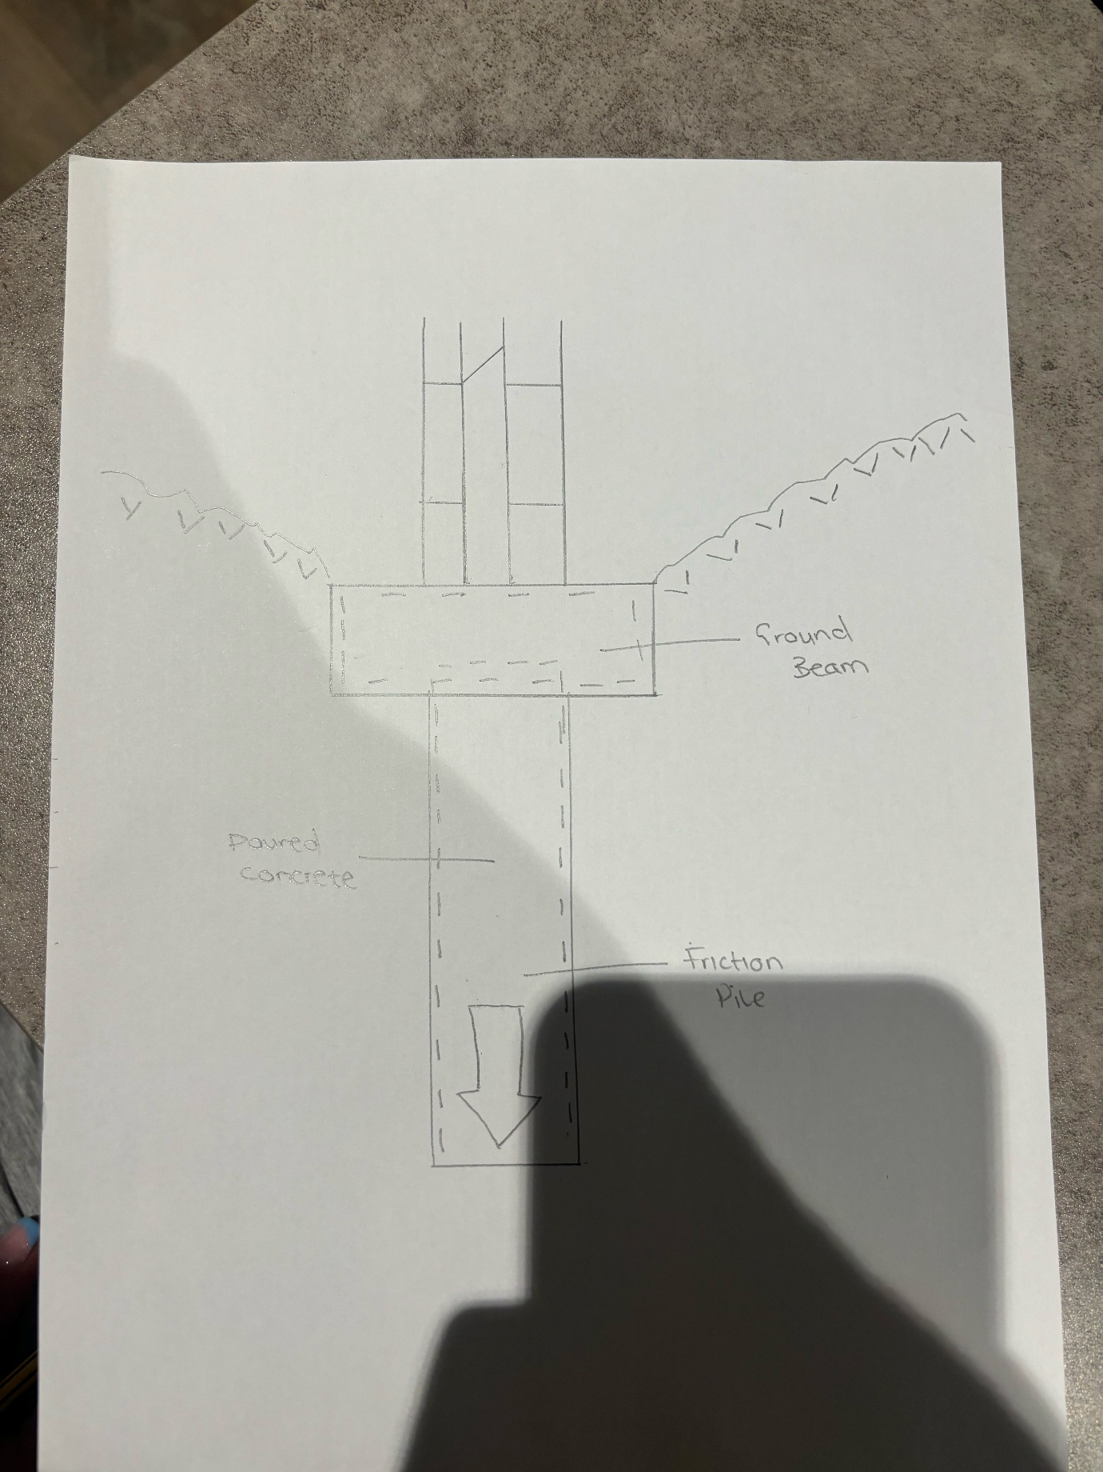

Figure 9 – Drawing produced by myself detailing foundation solution

Insight Report
Please see below insight report:
- Historic Landfill – Nothing identified
- Landfil - Nothing identified
- Current land use – Tesco Superstore
- Former uses – Supermarket & Gas Factory
- Flooding – Low Risk
- Natural Hazards – Nothing Identified
- Mining – Very low risk

Services
Electric
With reference to the below extract taken from Line Search Before you Dig, you can see that the site is mostly clear from National Grid’s apparatus. There is however 2 incoming 11Kv supplies to the Northeast of site currently feeding into Tesco. This will have to be disconnected with a request to National Grid as you will not be allowed to obtain a licence to demolish without the supply being disconnected and capped outside of the site. Another point to take into consideration would be the current apparatus surrounding the site, as there are mains located to the North and South of the development, this will need to be considered for future digging works.
Additionally, given the current apparatus and the proposal, it is likely that a new substation will have to be installed to feed the hotel with sufficient capacity. I would also recommend that budget estimates are requested from the statutory authorities e.g National Grid & UKPS. This will then give more insight into the proposals that would be offered and would give you an idea on costs as for a substation it will be costly, from initial looks, it doesn’t seem that a wayleave/easement will be required as the connection can be made to the existing apparatus however a budget estimate would also identify this. This is an advantage as a wayleave typically takes 3-6 months, possibly longer.
When the construction stage begins and demolition has been completed, a temporary builders supply will have to be installed to power the site, this can be installed by National Grid and then metered via your chosen supplier.
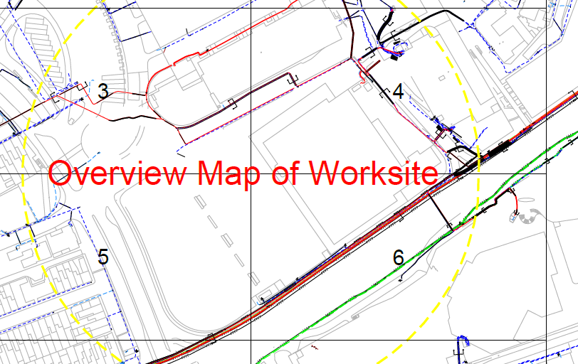
Figure 6 – Extract taken from Line Search Before You Dig (2025)

Gas
With reference to the existing Gas layouts also obtained from line search before you dig, you can see the site is clear in regard to gas being on site at the moment. There are however 2 incoming pipes, Low Pressure (LP) 21mbar – 75mbar and Intermediate Pressure (IP) 2bar – 7bar. This will need to be taken into consideration and disconnected before any demolition works take place.
As mentioned in the site history, this is to be heavily considered and could mean extensive works to be carried out due to the previous gas factory, which could mean existing mains in the ground. This can be investigated using trial holes, permission to dig trial holes and a licence may need to be in place to do these works from Swansea Council. The statutory authority that will need to be contacted will be Wales West Utilities. As per map below.

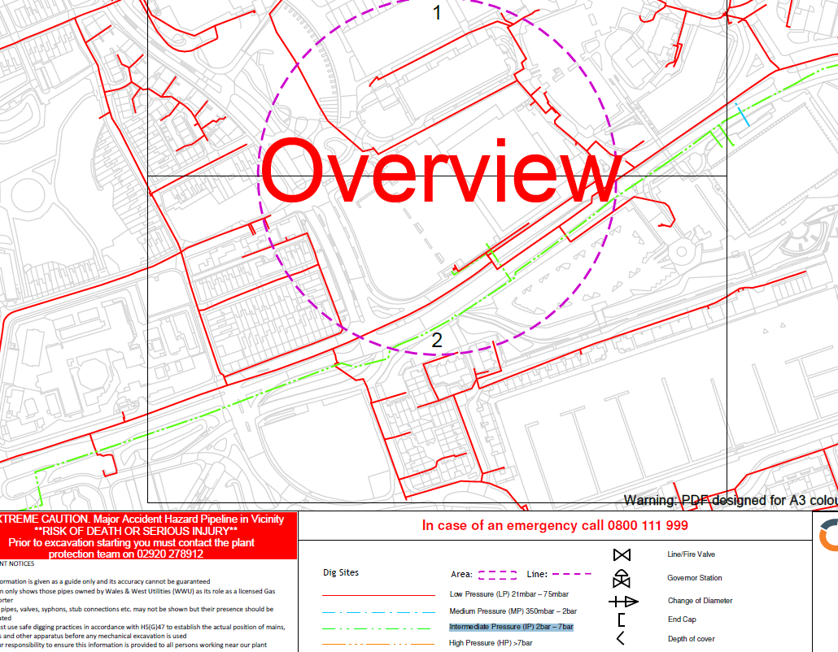
Figure 7 – Extract taken from Line Search Before You Dig (2025)
Drainage
With reference to the existing Welsh Water Map below, no water mains or sewerage system owned by Welsh Water are shown. However, this will not be the case as the current supply is coming from somewhere and is also being discharged.
This can be identified in various ways such as CCTV surveys to see where the drainage is being discharged to and trial holes to establish depth of drainage.
Also, another point to take into consideration would be the current apparatus that surround the site. As there are mains and sewer lines located North (900mm) and South of the site (305mm) any digging works would need a diversion done. Additionally, a section 104 & a section 106, may be required.
When considering the current apparatus and whether there is sufficient capacity within the vicinity, it is recommended that a pre planning application is submitted. This is a process where Welsh Water can give you an insight whether there is enough capacity to accommodate your development in terms of sewerage and clean water. If not, they will also advise steps from there on forward.
Section 104 – This is an agreement that would be in place with Welsh Water which agrees the adoption of sewers or sewerage disposal. A section 104 will require drawings produced by a civil engineering specialist and would then have to be submitted to Welsh Water for approval. In conclusion, the drainage system must be built to Welsh Water’s standards for them to adopt.
Section 106 – A section 106 agreement will also need to be in place if your intentions are to connect onto the public sewer. This application will need to be submitted to Welsh Water and inspections would need to be carried out before the works commence and when works are completed. As well as the application, an access to assets form would also have to be submitted. Access to assets is a mandatory form that needs to be completed to gain access to Welsh Water’s apparatus. Information that will have to be provided is as follows:
- Sewer Location
- Whether other parties are affected
- Contact details as well as out of hours contact
- Will the work interfere with the sewer location?
- Details of the connection, e.g. Bring upstream manhole, final connection works, anticipated duration 3 days.
- Date access required
You will also have to have a metered standpipe/temporary supply entering site to accommodate the development during the construction phase, subject to Welsh Water approval. An application would have to be submitted in order to receive approval.

SuDS
Suds is a Sustainable Drainage Approval Body (SAB), that is responsible and making sure that sustainable drainage systems have been used. Any development with a construction area of 100m2 or more must include SuDS. You must submit drainage plans to the SAB department within the council before any construction works start. This can be a very long progress especially when you are submitting a SAB pre – app before your full application. The purpose of this agreement is to prevent water runoff, improve water quality, and enhance biodiversity and surface water through green spaces like raingardens. Once your plans have been submitted to the council for approval the SAB authority will then review the plans and come back with comments (if any) and then approve/disapprove. It’s important to note that SAB approval will be required before any construction work commences. Some of the SuDS features that you could include in this development would be;
- Permeable paving – Permeable paving is a type of surface material that allows water to pass through it (rain water/surface water) reducing runoff and helping manage it. Permeable paving can be used on the car parking spaces. Once the water soaks through typically it would discharge to a attenuation tank.
- Rain gardens – Rain gardens are landscaped areas that capture, store and filter the rainwater runoff from surfaces like roofs, driveways or roads.
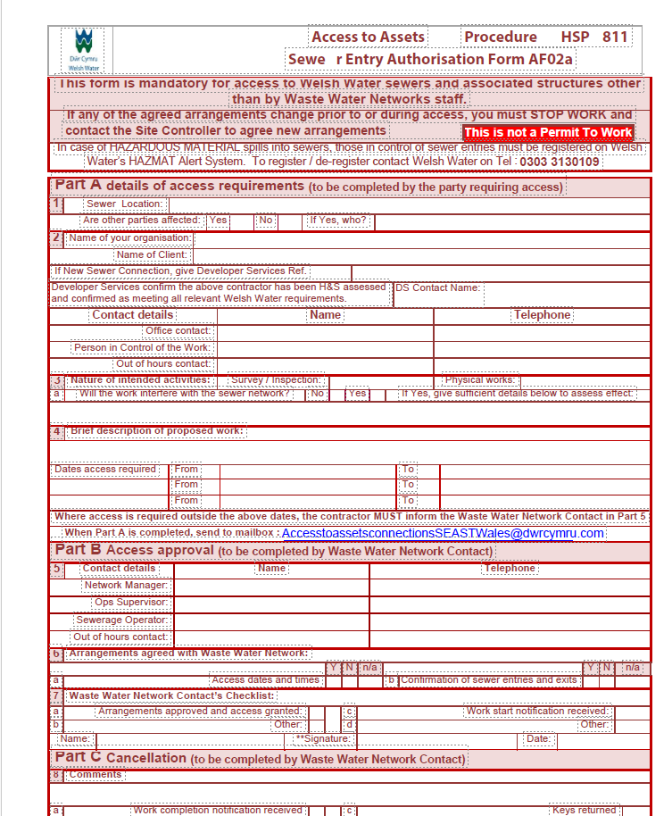
An example of this form can be seen below;
Figure 8 – Extract obtained from Welsh Water (2025)
When applying for the potable water connections, you will have to liaise with your M&E contractor to select the right supply and ensure you have a sufficient supply to accommodate the hotel.

Future works
The next steps for this development would be to undertake a topographical survey to establish ground levels showing whether the site is fairly flat or uneven/sloping, existing features such as manholes and gulleys (It would also be recommended to pick up invert levels on the topographical survey too), boundaries. A topographical survey will be used to support architects and engineers with their designs, establish whether there are any potential challenges and ensure that the construction is designed to fit in the boundary. In short, a topographical survey will be the base of the construction in terms of designs.
A geotechnical survey to establish ground conditions, investigate the soil, rock and groundwater conditions and also your foundation solution. A geotechnical survey will ensure that the land is not contaminated and additionally, it will save costly problems later down the line.
As mentioned above in the services section, electric and gas disconnections will need to be made to proceed to demolition. Without the disconnections being made, demolition would not be able to proceed.

References
- Figure 1 - Google Maps 2025, [Accessed 01/01/2025] - https://google.com/maps/@51.6167223,-3.9443714,557m/data=!3m1!1e3?entry=ttu&g_ep=EgoyMDI1MDEwNi4xIKXMDSoASAFQAw%3D%3D
- Figure 2 - Digimaps 2025, [Accessed 02/01/2025] https://digimap.edina.ac.uk/roam/map/historic
- Figure 3 - Digimaps 2025, [Accessed 02/01/2025] https://digimap.edina.ac.uk/roam/map/historic
- Figure 4 – National Resource Wales 2025, [Accessed 02/01/2025] https://flood-map-for-planning.naturalresources.wales/
- Figure 5 -
- Figure 6 – Line Search Before You Dig 2025 [Accessed 02/01/2025] https://onecall.linesearchbeforeudig.co.uk/ngen.web/#/
- Figure 7 – Line Search Before You Dig 2025 [Accessed 02/01/2025] https://onecall.linesearchbeforeudig.co.uk/ngen.web/#/
- Figure 8 – Dwr Cymru Welsh Water 2025, previous application submitted.

