Task 1
Introduction
For my business project, I chose to start a children’s clothing business, mainly focusing on baby and toddler clothes. The idea behind my business is to provide comfortable, affordable, and eco-friendly clothing for young children. I wanted to find out what customers are really looking for when they buy children’s clothes, and if there are any gaps in the market that my business could fill. I also wanted to know what makes people choose one shop over another, and whether they are interested in extra offers like bundles or subscription deals. To help with this, I carried out some market research in the form of a questionnaire. This allowed me to collect opinions and feedback from real people who might be interested in buying from a business like mine in the future. By doing this research, I was able to better understand what is important to parents and carers when buying clothes for their children. It also helped me spot trends and patterns that I can use to help shape my business idea, from the products I sell to the way I present them online.

Methodology
To collect my data, I designed a questionnaire with a range of different questions about shopping habits, product preferences, and I collect opinions on eco-friendly materials. The questions were supposed to be clear and simple, and included a mixture of multiple-choice questions and open-ended responses to allow people to share more detail. I shared the questionnaire with a small group of people, mainly parents or carers of young children, using online messaging and social media.
In total, I received 8 responses to my questionnaire. Even though this is a small number, it still gave me useful insights into what people are looking for when they buy baby clothes. The responses helped me pick out the most important things to focus on for my business, especially in terms of product design, marketing, and how I can stand out from other clothing businesses.
One of the most important questions in my questionnaire asked people where they usually buy baby clothes from. This question helped me understand who my competitors are and what type of shops people already use. The most common answers were high street stores like Primark and H&M, along with supermarkets such as Tesco and Asda. This shows that people often choose to shop for children’s clothes in places where they can see and feel the products before buying them. However few people also mentioned online stores like Shein, but overall, I found that in-store shopping was more popular in my results.

For my clothing business, this result shows that while physical stores are still the first choice for many people, there is also potential for online shopping. especially if I can make my products stand out by offering great quality, good photos, and easy returns. Research shows that comfort is very critical in parents clothing choice for children, as soft, breathable fabrics can help prevent skin irritation (Dogby, 2015). This will help build trust with customers who might be unsure about buying baby clothes online.
Another key question in my survey asked what people look for most when buying baby clothes. Almost every person mentioned comfort as the most important thing. Other popular answers included organic materials, nice designs, and affordable prices. This clearly shows that parents and carers want their children to wear clothes that are soft, gentle on the skin, and good quality, but they also care about how the clothes look and how much they cost. Therfore for my business, research combined with my results suggests that I should focus on making sure my products are comfortable first, stylish second, and fairly priced (Burk et al., 2021). I can also use this in my marketing by making sure I talk about the softness of the materials I use, the care taken in making the clothes, and why they are a good choice for children. This also help me build a positive image for my business online (Koronaki et al., 2020).
I also asked if people are be interested in bundle deals or subscription boxes for baby clothes. The answers to this question were a mix of “yes”, “no”, and “maybe” but more people seemed open to the idea than against it. This is helpful I think because it shows that bundle deals could be better way to help attract more customers, especially those who like saving money by buying more in one go. According to Shopify things like product bundles increases the average order value, helping businesses grow their sales faster (Shopify, 2023).
Subscription boxes might not be good for everyone, but offering bundles or maybe stuff like 3 for 2 deals could work really well. Based on this result, I could create bundle offers on my website, where customers can mix and match different items for a special price. This would encourage people to spend more in one order and could also make shopping easier for busy parents who want to get everything they need in one go.

Another very important question I asked was how much people usually spend on children’s clothes each month. This helped me see what kind of prices people would expect to pay. 38% of people said they spend between £20 and £50 a month, and 13% said under £20. This shows that parents want nice clothes for their children, but they also like to keep costs low and prefer clothes that are good value. Research by Statista (2023) shows that the average UK household spends around £410 a year on children’s clothing, meaning my pricing needs to stay in the affordable range if I want to attract customers. Offering good quality at fair prices will help me stay competitive. Although I do consider this statistic may be out of date as it is from 2023.
This result is really helpful for my business because it shows that I need to keep my prices affordable. If my products are too expensive, people might choose to shop somewhere cheaper, like Primark or supermarkets (Wahyuni et al., 2023). But because other answers showed that comfort and eco-friendly materials are really important to people, I know that I can charge a bit more if I explain why its worth it. I will make sure that I highlight the quality, softness, and eco-friendly fabrics I use. I will also use bundle deals to help people feel like they’re getting good value for their money, which could help them spend closer to the top of their usual budget.

WEBSITE DESIGNS
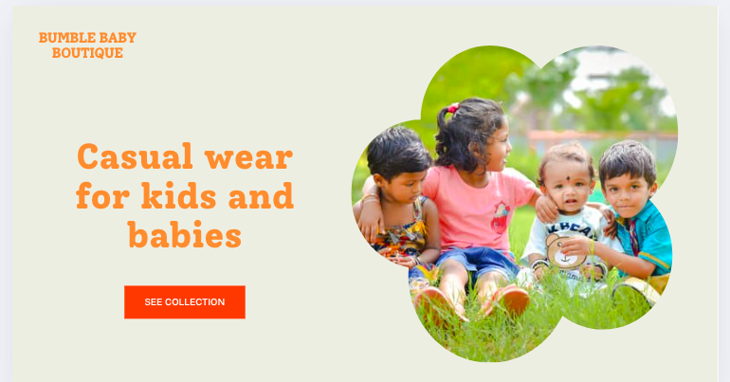

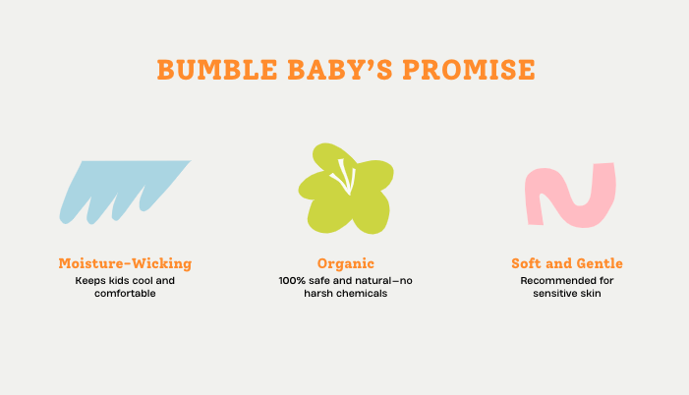

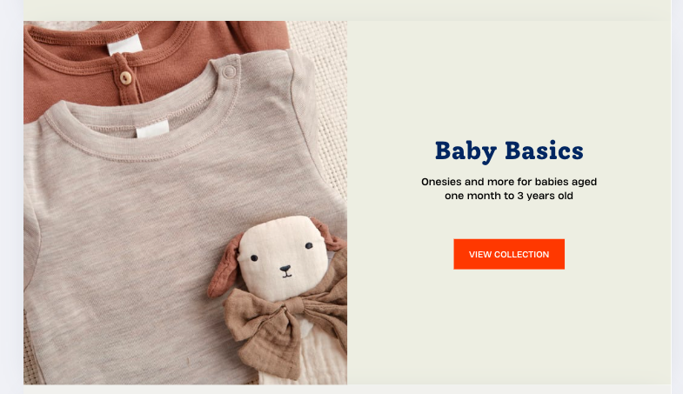

TASK 2: TABLE OF COSTS OVER A 1 YEAR PERIOD

Item Category | Item Description | Quantity | Unit Cost (£) | Total Cost (£) | Notes
Materials | Organic cotton fabric | 100 | 5 | 500 | For baby clothes range
Materials | Thread and accessories | 500 | 2 | 1000 | Buttons, zippers, trims
Materials | Dyes and printing materials | 50 | 3 | 150 | For designs and prints
Manufacturing | Sewing labour hours | 160 | 15 | 2400 | Total hours for workers
Manufacturing | Quality control inspection | 20 | 12 | 240 | Hours for Quality Control staff
Manufacturing | Packaging labour hours | 40 | 12 | 480 | Packing finished goods
Marketing | Social media ad campaigns | 1 | 700 | 700 | Initial advertising push
Marketing | Website development | 1 | 1500 | 1500 | One-time cost
Marketing | Promotional advertisements online | 3 | 250 | 750 | Trade shows, fairs
Shipping | Packaging materials | 200 | 2 | 400 | Boxes, labels
Shipping | Delivery costs | 200 | 3 | 600 | To retailers or customers
Overheads | Factory rent (monthly) | 1 | 1200 | 1200 | Rent for production facility
Overheads | Utilities (electricity, water) | 1 | 300 | 300 | Monthly cost
Overheads | Equipment maintenance | 1 | 200 | 200 | Sewing machines, tools
Administrative | Staff salaries (admin) | 1 | 1800 | 1800 | Monthly salary
Administrative | Office supplies | 1 | 150 | 150 | Stationery, printing
Miscellaneous | Contingency fund | 1 | 500 | 500 | Unexpected expenses
GRAND TOTAL = 12, 870

The Importance of Microsoft Excel in the Digital Age
Currently, Microsoft Excel proves to be one of the most widely used and relied-upon tools. There has been rise in recent years over various platforms and applications, such as Google Sheets for example, however, Excel continues to remain one of the most popular due to its accessibility for new users, and powerful features.

A Tool for Every Industry
Excel’s usefulness and the ability to apply it in various different areas of life, such as work, personal use and in different industries makes it a highly favoured tool. Different industries include finance, healthcare, education, marketing, and business management. According to Acuity Training (2025), over 66% of office workers in different businesses continue to use Excel in daily operations. This range from basic data entry to advanced financial modelling. Even in highly digitised environments, Excel serves as an important tool for organising and analysing data.
The great flexibility means anyone may use it, for example students, or businesses who want to manage budgets, or tracking employee attendance. The grid layout, familiar interface, and intuitive formulas make it accessible even for those who have little technical experience (Microsoft, 2023).

Managing and Analysing Data
In today’s society, data is very necessary to analyse, but if we do not possess the correct tools it can become hard to find meaningful insights. Excel helps people from simple ways to advanced ways, like cleaning, sorting, or analysing large amounts of data efficiently. Common functions such as SUM, AVERAGE, IF, and VLOOKUP are used when processing and interpreting data in real-time.
More advanced features like pivot tables, slicers, and conditional formatting allow for more in-depth analysis without needing programming skills. According to a report by McKinsey and Company (2018), the ability to quickly turn raw data into insights is a major asset in decision-making, and currently Excel still remains one of the top tools to do just that.

Enhancing Productivity Through Automation
Additionally, one of the best uses of Excel is in automation. tasks like calculating totals, updating monthly budgets, or generating reports can be automated using formulas, templates, or macros. Visual Basic for Applications (VBA), Excel’s built-in programming language, allows users to build custom tools that save time and reduce human error (Alvarado, 2020).
This functionality is very helpful at work, where streamlining tasks can lead to increased productivity. LinkedIn’s 2020 Workforce Report, Excel is one of the most requested digital skills in job postings across industries, so it is not only for data professionals, but for general administrative and project roles as well.

Integration With Other Platforms
Excel can connect with other tools and this also adds to its strength. It works very easily with Microsoft Office apps like Outlook, Word, and Powerpoint. It can also take data from databases, websites, and cloud platforms, making it a practical base for managing information (Microsoft, 2023). Moreover, Excel works well with more advanced platforms such as Power BI, letting users make dashboards and visual reports from spreadsheets. For users with programming experience, Excel files can also be used with languages like Python or R for more sophisticated analysis (Datacamp, 2022).

Cloud-Based Collaboration and Accessibility
New versions of Excel, particularly through Microsoft 365, allow for real-time collaboration and cloud storage. Multiple users can now work on the same file simultaneously, whether they’re in the same office or across the globe. This has become especially valuable in remote work environments (Gartner, 2021). If I needed to work with colleagues on a specific piece of work, this can be really helpful in seeing what everyone does at the same time. The cloud-based version also ensures that changes are saved automaticaly and that files are easy to get from any device. These features can help my team to stay aligned and reduce the risk of data loss.

Lifelong Learning and Career Development
Learning Excel is not just useful it is very important especially for business development. Excel is frequently listed as a required skill in job descriptions, even for beginner jobs. The good news is that it’s also one of the most teachable tools. There are thousands of online courses, tutorials, and certifications available to help users at all levels develop their Excel skills (Coursera, 2023).
A study by Burning Glass Technologies (2020) found that digital tools like Excel are among the top five skills associated with career advancement across all industries. It’s no longer a “nice to have”, it’s a must.
Using Excel in my Business
In my clothing business, Excel will play an important role in helping me manage and organise many different parts of the work. One of the main ways I can use Excel is to keep track of my stock. I can create spreadsheets that show how many items I have in each size, colour, and style, so I always know when I need to order more. This will help me avoid running out of popular items or wasting money on stock that isnt selling well (Alvarado, 2024). Excel will also help me keep record of all my sales, so I can easily see which products are making the most money and which ones not doing as well. Another way I will use Excel is to help with managing my business finances. I can create clear organised tables showing how much I spend on materials, how much I sell each item for, and how much profit I make after taking away costs like packaging and delivery (Mckinsey and Company, 2018). This will help me make better decisions about pricing my products in the future. I can also use Excel to set budgets for marketing, new designs, or business events, helping me stay on top of my spending.
As my business grows, Excel will also be great for keeping track of customer orders, delivery dates, and contact details, so I can provide a better service and keep customers happy. I can even use charts and graphs in Excel to help me see patterns in my sales over time. For example, noticing if certain clothes sell better at certain times of the year. Overall, Excel is a really powerful tool that will help me stay organised, save time and grow my clothing business in a smart, professional way (Gartner, 2021).

Conclusion
Excel’s simplicity, power and adaptability make it a fantastic tool. From small business owners and students to analysts, Excel provides a reliable way to manage data, make decisions, and improve productivity (Gartner, 2021). In an age where information is key, Excel remains one of the most valuable digital skills anyone can learn and I look forward to using it in my business.

References
Excel. (2025) Excel Statistics: Facts & Figures [Original Research]. Retrieved from https://www.acuitytraining.co.uk/news-tips/new-excel-facts-statistics/
Microsoft. (2023) What’s New in Excel. Retrieved from https://techcommunity.microsoft.com/blog/excelblog/whats-new-in-excel-november-2023/3971789
McKinsey & Company. (2018). Analytics Comes of Age. Retrieved from https://www.mckinsey.com/~/media/McKinsey/Business%20Functions/McKinsey%20Analytics/Our%20Insights/Analytics%20comes%20of%20age/Analytics-comes-of-age.ashx
Alvarado, J. (2024). How to Connect Linkedin to Excel. Retrieved from https://coefficient.io/linkedin-to-excel
Dogby, R. (2015). The Effect of Fabrics and Designs on the Physical Comfort of Children Clothes in the Accra Metropolis. Arts and Design Studies, Volume 30. Available at: https://core.ac.uk/download/pdf/234685965.pdf
LinkedIn. (2020). LinkedIn Workforce Report. Retrieved from https://learning.linkedin.com/resources/workplace-learning-report-2020
Gartner. (2021). The Future of Remote Work. Retrieved from https://www.gartner.com/en/articles/the-future-of-remote-work
Burning Glass Technologies. (2020). The Human Factor Report. Retrieved from https://www.burning-glass.com/research-project/human-factor/
Coursera. (2023). Excel Skills for Business Courses. Retrieved from https://www.coursera.org/specializations/excel
Datacamp. (2022). Using Excel with Python. Retrieved from https://www.datacamp.com/blog/integrating-python-with-excel
Shopify (2023). The Psychology of Product Bundles. Available at: https://www.shopify.com/blog/product-bundles
Statista (2023). Average household spending on children's clothing in the UK. Available at: https://www.statista.com/statistics/
Burk, F., Cao, W., & Che, J. (2021). A review: Sustainable material selection for children’s wear. Journal of Textile Science & Fashion Technology. Available at: https://www.researchgate.net/publication/360651902_A_Review_Sustainable_Material_Selection_for_Children%27s_Wear

Wahyuni, I. S., & Nugroho, A. A. (2023). Analysis of factors affecting parents' purchase intention on eco-friendly baby clothing products in Indonesia. Indonesian Journal of Multidisciplinary Science. Retrieved from https://www.researchgate.net/publication/372870498_Analysis_of_Factors_Affecting_Parents%27_Purchase_Intention_on_Eco-Friendly_Baby_Clothing_Products_in_Indonesia
Koronaki, E., Theodoridis, P., & Panigyrakis, G. (2020). Consumer behavior and preference regarding children's clothing in Turkey. Journal of Business Research. Retrieved from https://www.researchgate.net/publication/242342550_Parental_Influence_on_the_Purchase_of_Luxury_Brands_of_Infant_Apparel_An_Exploratory_Study_in_Hong_Kong

