Script, Rehearsal and Performance Process Workbook

Katie Mitchell
Katie Mitchell is a director, and it is her work we will be using and referring to when in rehearsals. When rehearsing, we used a lot of her methods to help us figure out more about our character, the location, the relationships, and the time frame of the play. One of the first things we worked on was looking at the non-negotiable information we picked out from the material, and we also looked at the questions that came forward when reading the script, as there was some information that wasn’t made quite clear. We went through each chapter of the play and wrote out everything we could find and think of. Luckily, some of our questions had been answered in later chapters, but others, not so much. This is where our next method came in. We made a timeline for a character so that we could get a better understanding of her life, her personality, why she did the things she did, her values, etc. As this character, Rosemary, is not alive in the play, we don’t exactly know a great deal about her, so making the timeline of her life helped us all the figure out how she lived before she died.
There were also quotes at the beginning of the play, and it went into detail about the house, its interior, exterior, the location. Mitchell, K (2009) says that “Research helps you know the play better”, and even though the quote only shows up at the beginning, I researched into Emily Dickinson, and why her quote specifically was put into the play. During my research, I was able to find out that Emily Dickinson shared a similar life to that of one of the characters, Storm, and was immediately able to figure out why her quote had been put into the play.
Another method I performed was looking at the past 24 hours before Chapter 4 of the play. Despite the play being executed in less than 2 days, we have no idea what happened before the play started. Gathering the knowledge we had gotten on each character from the given material, we made our own timeline of the past 24 hours before Chapter 4 and wrote out what each character did within that time. This exercise helped us to get a better understanding of the characters and how their mood from the day before could be affected when the play is performed.
Something else me and my fellow actors did which was another method was eventing. It is when we break apart the script into all the different events that happen within the play. This method helped us with the characters emotions and reactions to different topics that were brought up within the play, and we would then know how to act when something new happened.
One of the last method’s my peers and I did was improvisations. Mitchell, K (2009) says “The aim of improvisations is to build pictures of the past that will support what the characters do and say in the present action of the play”. I knew the relationships between all the characters, but I did not know how deep their feelings went. They could be saying something about a character but mean something completely different in their head. The character I will be playing in the performance is Granny, and I decided to do small improv scenes with the person playing Rosemary, and the person playing Luke. The play shows memories with Rosemary and her daughters, but we never saw what Granny and Rosemary’s relationship was like. They were mother and daughter, but did they have a good relationship? Or was it strained? Gathering the information I knew from the play, me and Rosemary played around with different scenarios until we stuck with one that felt right. Similarly, with Luke, it seemed to me that Granny and Luke had a closer relationship than that of Luke and any other character, so me and Luke wanted to show how far that relationship went and show how much Luke seemed to trust Granny.

Viewpoints
When we were developing the performance for our Mythfits pieces, we worked with the 6 viewpoints in order to discover the movements for our performance. While we were first getting started with the viewpoints, my lecturer got us all familiar with them, and then told us to use what we have learnt, and then make up movements in reference to the play. She also put music on in the background which I did find to be quite helpful, as not only would it begin to set the atmosphere, but it would also help us with knowing what movement comes where. Even though my peers and I made up the movements, I wasn’t too sure if our movements even went together with the script. Hunter, T (2019) says “The Viewpoints are used to clarify the story. The idea is that all these things are integrated.” Despite that, it is up to the audience’s interpretation on how they view our movements. We could have done a certain movement to mean something, but the audience could think that it would mean something different, and it would still work. A viewpoint I always kept on forgetting about was levels, so I made sure to remember it and always apply that specific one to my work. Viewpoints helped us all to make different shapes depending on the script and show the audience the bigger picture of the words through our movements.

Monologue
For my monologue, I had originally chosen a monologue from the play ‘5th of July’ by Lanford Wilson, the monologue done by a character called Shirley. I liked that monologue as it allowed me to go into freshminting, and I felt that with how the monologue was written, I could go a bit crazy with it. It was also comedic which I do enjoy. But in my time outside of rehearsals, I could not find a script for the play. I then also found out that the play was part of a trilogy, and I decided that I would need to read the entirety of the trilogy, so I knew the context for everything. Luckily, I had found another monologue when I was originally looking for one, and with all the complications that came with the first one, I decided to eventually choose the second one. The monologue I ended up choosing in the end was from the play ‘An Ideal Husband’ by Oscar Wilde, my character being Mabel Chiltern. This monologue I also liked as I feel like it was something I could have fun with, and that it could be played in a variety of different ways. A good thing too was that I was able to find the whole script for the play this time and I was able to read it, so I could know the context of my monologue and also find out the personality of the character I would be playing, so I can play Mabel as she was written.

Staging
For the performance, we used a thrust stage. Using a thrust staging was useful as it helped us by “creating an immersive experience for theatregoers” (Snyder, 2024). It is also helpful for the actors, as others may think that we just perform with a stage where the audience is in front of us, but using a thrust stage helps us to make sure we show all angles of our character. It also allows us to develop in out creativity and interact with the objects around us. Something to remember is that no audience member will have a bad view of the performance, and that with a thrust stage, they should be able to see everything we are performing.

Evaluation
To conclude the module, I think the overall performance went well. Some feedback I kept giving myself was to get better with my lines, even though I did know my lines, I suppose I just kept doubting myself, and then I would get confused, and then completely forget my next line. But a goal I set for myself before the show was to not doubt myself and to just carry on if I did somehow manage to mess up again, as the audience won’t know any different, and think that what I am saying is part of the script. Unfortunately, I mixed up 2 of my lines. Luckily, the person in the scene with me noticed and we were able to salvage the scene without any of the audience noticing. Overall, I do think I was able to do well for the performance, and since we had a bit of an audience, I felt all my nervous energy turn into energy for the performance.
Something I would improve on when doing this show again, would be time management. I believe that if I had managed my time better, I could have learned my lines earlier, and then maybe I wouldn’t be doubting myself so much on my lines and then messing them up. If I had also managed my time better, I would have been able to read the whole script in my own time, and then worry about developing on my performance during rehearsals, except of worrying about my performance in my own time as well.

Bibliography
BBC. (2023). Selecting a Practitioner. Available at: https://www.bbc.co.uk/bitesize/search?q=selecting+a+practitioner&d=BITESIZE [Accessed 12 December 2024].
Bogart, A. Landau, T. (2005). The Viewpoints Book. New York: Theatre Communications Group.
Hunter, T. (2019). Understanding Viewpoints. Available at: https://dramatics.org/understanding-viewpoints/ [Accessed 11 December 2024].
Mitchell, K. (2009). A Director's Craft. Oxford: Routledge.
Snyder, C. (2024). What is a Thrust Stage?. Available at: https://ppt.org/blog/what-is-a-thrust-stage [Accessed 12 December 2024].

AI
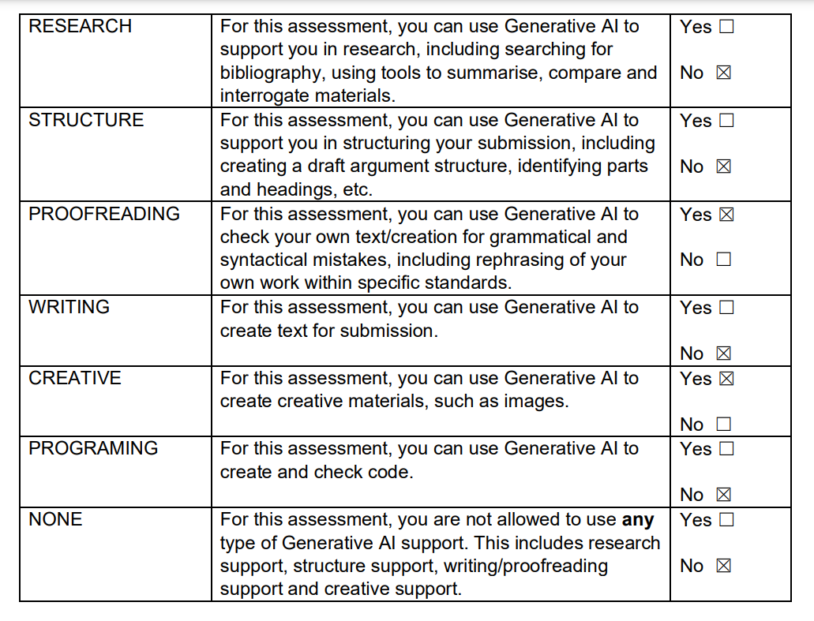

I confirm that I have not presented any Al generated text as my own work. I confirm I have copies of my drafts, notes, and other resources I used before, and after the use of Al tools which I may be asked to provide in evidence.

