

Module: Leadership and Management Theory and Practice
Module code: LCBB6003

Component 1: Coursework: Essay

Module Leader: Dr Faizu Edu
Lecturer: Dr Piyumika K. Gamage
Student Name: Oleksandra Chebotareva
Student ID: 2247384
Table of content:
1. Introduction 3
2. Main body. 4
3. Conclusion 10
References: 11

Introduction
In today’s business world, things change very fast and are hard to predict. Well performed management is very important for a company to be successful. The main jobs of a manager are planning, organizing, leading, and controlling. Many people do not think controlling is important, but it is very necessary for a company to do well for a long time. This essay therefore discusses the four functions of the management and further investigate the importance of controlling function for organizations. It will also explore the problems associated with controlling and how managers can solve these problems. The claims will be supported by industry examples mainly from Toyota and Volkswagen. (Zhou, Lyu and Chen, 2024)
To effectively explore the critical role of the controlling function in management, this essay will investigate its application within the automotive industry, focusing on a comparative analysis of Toyota Motor Corporation and Volkswagen AG. These two industry giants were strategically selected to provide a balanced evaluation: Toyota exemplifies an organization renowned for its exemplary operational control systems, which have been integral to its success and continuous improvement philosophy. In clear contrast, Volkswagen serves as a warning case study due to the profound control failures exemplified by the 2015 Diesel gate scandal. By examining these different examples, this essay will investigate how resilient controlling mechanisms are indispensable for achieving organizational goals and encouraging future resilience, while also analysing the severe repercussions including significant financial and reputational damage that can appear from its absence. Ultimately, this analysis will underscore why controlling is not only about error detection but is a fundamental management function for strengthening an organization’s long-term sustainability. (Coulter, Randel & Robbins, 2021)

Main body.
As a salaried position managers are mainly handling four functions at workplaces.
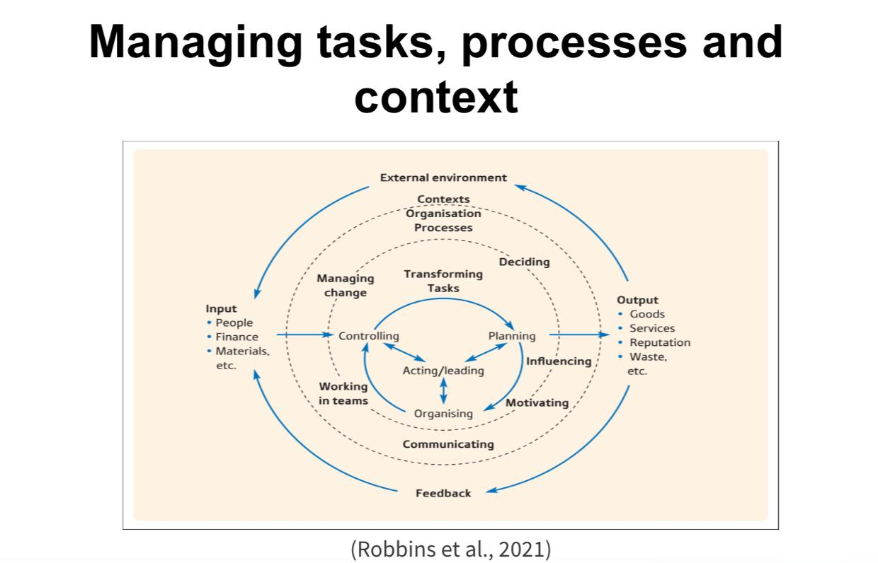
One of these functions is planning. Planning is the core management function of setting organizational objectives and developing a systematic strategy to achieve them. (Coulter, Randel & Robbins, 2021). It provides direction, reduces uncertainty, and serves as a blueprint for all future activities, ensuring resources are used effectively to bridge the gap between the present and the desired future. This essential function requires managers to engage in systematic vision and strategic decision making. This methodological approach provides clear direction, reduces operational instability, and ensures all organizational resources are coordinated toward common objectives. Without detailed planning, an organization lacks strategic clarity and similar with a vessel navigating without coordinates, vulnerable to market fluctuations and internal inefficiencies. (Nared, 2020). For example, Toyota strategic planning for its production system involves detailed production targets and just in time inventory management, which has made it a global leader in automotive manufacturing efficiency. (Toyota Global, n. d)
Second function is organizing. Organizing is a managerial function that focuses on arranging the workplace by distributing tasks, set them into specific units or departments, and allocating resources effectively to complete the organizations objective. (Rinku & Verma, 2025). For example, to execute a new product launch, managers must organize functional teams, set up budgets, and coordinate the supply chain. (Keathley & Harrington, 2020)
This principle is evident in Amazon coordination of global delivery centres and specialized teams, which allows it to handle millions of daily deliveries efficiently. Ultimately, effective organization ensures that resources are used efficiently and all activities are synchronized with strategic goals. (Owen, 2020)
Third is leading. Leading in management involves guiding, encouraging, and influencing employees to realize the objectives of the organization. Unlike other functions, leading addresses the human factor directly through effective communication, appropriate delegation, and conflict decisions. An effective leader inspires trust and creates a work environment that stimulates commitment and initiative. Research demonstrates that organizations with developed leadership practices show superior performance and lower staff turnover rates. (Sims, 2021). For instance, Microsoft under Satya Nadella leadership demonstrates effective leading through its cultural transformation towards a progressive mindset, which has cultivated innovation and increased employee engagement across the organization. (Chavatte, n.d.)
Fourth process is controlling, it’s the process of observing performance, evaluating it against set standards, and implementing corrective measures to make sure organizational objectives are met. (Keohane, 2010)
This process ensures activities align with planned objectives and provides feedback mechanisms for continuous improvement. Toyota exemplifies an effective control system through its production system, which permit immediate identification and correction of quality deviations. In contrast, Volkswagen Diesel gate scandal highlighted severe deficiencies in control mechanisms, leading to significant financial and reputational implications. (Alvinius, 2017)
The application of robust controlling mechanisms proves indispensable for organizational sustainability across all sectors, serving as a critical feedback spiral that exceeds ordinary numerical verification. Effective controlling systems provide complex benefits that basically contribute to strategic goal achievement and operational excellence. Furthermore, controlling facilitates early problem identification and resource optimization. By systematically monitoring performance indicators, organizations can detect deviations before they escalate into crises. When production costs gradually increase, effective controlling systems immediately flag this trend, allowing proactive interventions that protect profitability. At the same time properly implemented controlling positively influences employee behaviour by setting up clear performance expectations while providing constructive feedback. Research indicates that employees typically respond positively to monitoring when considered as developmental rather than disciplinary, increasing engagement and accountability. (Bennett, 2023).
A main function of controlling is to ensures organizational activities remain aligned with strategic objectives. Netflix exemplifies this principle through its data driven control systems that carefully track viewer engagement and content performance. (Organimi, 2025). This allows the company to make informed strategic decisions on content creation, acquisition, and retention strategies, ensuring its resources are allocated to projects that maximize subscriber growth and satisfaction. This sophisticated control mechanism demonstrates how data informed oversight is crucial for maintaining competitive advantage in a dynamic industry. (Matos et al., 2021). For example, in the automotive industry, Tesla closely monitors its battery supply chain and production output to ensure it meets electric vehicle delivery targets. (Singhal, 2023).
However, deficient controlling systems can provoke severe organizational consequences. The Wells Fargo scandal serves as a severe case study in control failure. Thousands of Wells Fargo employees falsified bank records, forged customer signatures, opened more than 2,000 unauthorized checking or savings accounts for non-consenting customer. (“Recovering Trust After Corporate Misconduct at Wells Fargo”, n.d.). Bank system was extremely focused on aggressive sales targets and quantitative metrics, yet it critically missed ethical and cultural controls to prevent misconduct. This failure allowed employees to create millions of fraudulent accounts to meet unrealistic goals, resulting in massive fines, reputational damage, and a crisis of trust. This example highlights the necessity of designing control systems that balance performance incentives with strong ethical oversight.
Contemporary organizations face particular controlling challenges in dynamic environments. Rapid technological innovation necessitates continuous monitoring systems adaptation, while global supply chains introduce complex compliance requirements. Additionally, balancing control autonomy presents an ongoing challenge excessive restriction limits innovation, while insufficient supervision risks significant compliance breaches. (Smith, 2022)
The application of robust controlling mechanisms proves indispensable for organizational sustainability across all sectors. Effective controlling systems provide complex benefits that fundamentally contribute to strategic goal achievement and operational excellence. In addition, controlling facilitates early problem identification and resource optimization. By systematically monitoring performance indicators, organizations can detect deviations before they amplify into crises. (Mikes & Kaplan, 2014).
Implementing effective organizational control systems faces several critical and integrated challenges. A primary issue is the selection of unsuitable performance metrics, where organizations often prioritize easily measurable quantitative data, such as production volume, while neglecting qualitative aspects like product quality. This imbalance can motivate counterproductive behaviours, where employees sacrifice long term value for short term targets. Furthermore, control systems often induce employee resistance when viewed as repressive or corrective surveillance. This perception can erode trust, encourage problem hiding, and restrain the transparency that effective control requires. Overcoming this barrier necessitates redefining control as a supportive, developmental tool, encouraging psychological safety and applying emotional intelligence (Wang, 2017).
A primary issue is selecting unsuitable performance metrics. The significant financial cost of strong systems, such as ERP software, also presents a major barrier, particularly for small and medium sized organization, which may need to begin with more affordable solutions. Finally, resistance to change from employees adapted to established workflows can erode new systems, necessitating inclusive change management and extensive training for successful adoption. (McKee et al., 2018).
The financial load of sophisticated systems like ERP software also limits implementation, especially for smaller firms. Organizations should adopt phased approaches using affordable cloud based tools or spreadsheets for initial controls. Excessive control inhibits innovation, particularly in creative departments. The solution involves situational control applying strict process controls in manufacturing while granting creative units autonomy focused on results. Resistance to change from permanent employees requires inclusive change management: training, clear communication of benefits, and involving staff in control design. Effective mitigation strategies include the Balanced Scorecard for balanced metrics and transforming control into a coaching function. Microsoft cultural shift to a "learn it all" mentality empowered employees to report issues without fear, creating team based control. (Taylor, 2024). Ultimately, the contrast between Microsoft cultural success and Siemens corruption scandal shows that effective control requires ethical supervision and transparency, serving as a system for continuous improvement rather than simple restriction. (Venard, 2018)
Importance of controlling is vital for long term success. Toyota uses it to maintain quality and efficiency in its production system, while Netflix relies on data driven controls to decide which shows to keep or cancel, ensuring resources are well spent. Challenges however, controlling faces issues like irrelevant metrics, as seen at Wells Fargo, where a focus on sales targets directed to fraud. There is also often employee resistance to being monitored, and systems can be costly for smaller companies to implement. (Gardiner et al., 2024)

Conclusion
This extensive analysis has showed the fundamental role of management functions in organizational success, with particular priority on the critical importance of controlling. The examination of planning, organizing, leading, and controlling has revealed their interconnected nature as an integrated system essential for achieving strategic objectives. Throughout this essay, multiple corporate examples have demonstrated the crucial role of effective controlling. Toyota's Production System and Volkswagen's Diesel gate scandal initially illustrated the severe contrast between quality focused controls and ethical failures. Further analysis introduced Netflix data driven strategic controls and Wells Fargo, Tesla sales motivation breakdown, highlighting how controlling systems must balance measurable metrics with ethical considerations. The discussion culminated with Microsoft cultural transformation and Siemens compliance failures, focus on that successful controlling requires both technical systems and cultural integration. The investigation confirmed that controlling faces significant challenges including uneven KPIs, employee resistance, and cost limits. However, strategic approaches such as Balanced Scorecard implementation, caring leadership, technological adaptation, and situational control provide effective control pathways. These solutions transform controlling from a restrictive mechanism into an encouraging tool for continuous improvement. Ultimately, this essay establishes that controlling rise above its traditional monitoring function to become the foundation of sustainable organizational excellence. When properly implemented as an ethical, balanced, and integrated system, controlling ensures not only present goal achievement but also long term endurance in an increasingly complex business environment. (Western, 2008)

References:
Alvinius, A. (2017) Contemporary Leadership Challenges, pp 45-48
IntechOpen. Available at: https://whelf-uwtsd.alma.exlibrisgroup.com/leganto/public/44WHELF_UWTSD/citation/5942410100002421?auth=SAML (Accessed: 03.11.2025).
Bennett, M. (2023). Managerial Discretion, Market Failure and Democracy. J Bus Ethics 185, 33–47 Available at: https://doi.org/10.1007/s10551-022-05152-8 (Accessed: 01.11.2025).
Chavatte, L. (n. d.) How Microsoft became an Intelligence Driven Organization – and how your business could do the same. Microsoft Pulse. Available at: https://pulse.microsoft.com/en/transform-en/na/fa1-how-microsoft-became-an-intelligence-driven-organization-and-how-your-business-could-do-the-same/ (Accessed: 17.11.2025).
Coulter, M., Randel, A., & Robbins, S (2021) Management, chapter 1, pp 5-9. 15th global ed. Harlow, England, Pearson Education. Available at: https://whelf-uwtsd.alma.exlibrisgroup.com/leganto/public/44WHELF_UWTSD/citation/11231726090002421?auth=SAML (Accessed: 06.11.2025).
Gardiner, R. A., Fox-Kirk, W., Elliott, C. J. & Stead, V. (eds) (2024) Genderwashing in Leadership: Power, Policies and Politics. Emerald Publishing. Available at: https://books.google.com/books/about/Genderwashing_in_Leadership.html?id=XO4aEQAAQBAJ (Accessed: 17 November 2025).
Keathley, J. D. & Harrington, H. J. (2020) Structuring Your Organization for Innovation. Milwaukee: Quality Press. Available at: https://books.google.com/books/about/Structuring_Your_Organization_for_Innova.html?id=VOuiEAAAQBAJ (Accessed: 19.11.2025).
Keohane, N.O. (2010) Thinking about Leadership, p. 45 Princeton, NJ :, Princeton University Press. Available at: https://whelf-uwtsd.alma.exlibrisgroup.com/leganto/public/44WHELF_UWTSD/citation/5942409480002421?auth=SAML (Accessed: 03.11.2025).
Matos, F., Ferreiro, M. d. F., Rosa, A. & Salavisa, I. (eds) 2021. Proceedings of the 16th European Conference on Innovation and Entrepreneurship, ECIE 2021. Vol. 1. Online. Available at: https://books.google.com/books/about/16th_European_Conference_on_Innovation_a.html?id=xBhPEAAAQBAJ (Accessed: 11.11.2025).
McKee, A., Achor, S. & Goleman, D. (2018) Everyday emotional intelligence: big ideas and practical advice on how to be human at work, pp. 72-75. Boston, Massachusetts, Harvard Business Review Press. Available at: https://whelf-uwtsd.alma.exlibrisgroup.com/leganto/public/44WHELF_UWTSD/citation/11541369950002421?auth=SAML (Accessed: 02.11.2025).
Mikes, A. & Kaplan, R. S. (2014) Towards a contingency theory of enterprise risk management. Working Paper 13-063, Harvard Business School. Available at: https://www.hbs.edu/ris/Publication%20Files/13-063_5e67dffe-aa5e-4fac-a746-7b3c07902520.pdf (Accessed: 19.11.2025).
Nared, J. (2020) Participatory Research and Planning in Practice. 1st ed. 2020. Edited by Janez. Nared and David. Bole. Cham: Springer Nature. Available at: https://doi.org/10.1007/978-3-030-28014-7. (Accessed: 11.11.2025).
Organimi, (2025). Netflix’s Organizational Structure [Interactive Chart]. Available at: https://www.organimi.com/organizational-structures/netflix/ (Accessed: 11.11.2025).
Owen, J. author (ed.) (2020) The leadership skills handbook: 100 essential skills you need to be a leader, pp 15-18. Fifth Edition. New York, Kogan Page Ltd. Available at: https://whelf-uwtsd.alma.exlibrisgroup.com/leganto/public/44WHELF_UWTSD/citation/11486557290002421?auth=SAML (Accessed: 02.11.2025).
“Recovering Trust After Corporate Misconduct at Wells Fargo” (n.d.) Harvard Business School Faculty & Research. Available at: https://www.hbs.edu/faculty/Pages/item.aspx?num=58343 (Accessed: 19.11.2025).
Rinku & Verma, V., (2025). Management Process & Organisational Behaviour: e-Book for MBA, p.8, 1st Semester, Haryana NEP. Karnal: Thakur Publication Private Limited. Available at: https://www.google.co.uk/books/edition/MANAGEMENT_PROCESS_ORGANIZATIONAL_BEHAVI/tKtUEQAAQBAJ?hl=en (Accessed: 11.11.2025).
Sims, R.R., (2021). Leadership, Leaders and Leading, p.6. Charlotte, NC: Information Age Publishing. Available at: https://books.google.com/books/about/Leadership_Leaders_and_Leading.html?id=79QeEAAAQBAJ (Accessed: 11.11.2025).
Singhal, S. (2023) Startup to Stardom. 1st edn. BFC Publications. eBook. ISBN: 9789359928692. Available at: https://books.google.com/books/about/Startup_To_Stardom.html?id=HJPqEAAAQBAJ (Accessed: 17.11.2025).
Smith, D., (2022). Fraud and Corruption: Cases and Materials. pp. 73-138, Cham: Springer Nature. Available at: https://books.google.com/books/about/Fraud_and_Corruption.html?id=BfiVEAAAQBAJ (Accessed: 11.11.2025).
Taylor, P., (2024). Why is Microsoft still so successful?. Available at: https://www.paultaylor.associates/2024/07/13/why-is-microsoft-still-so-successful/ (Accessed: 11.11.2025).
Toyota Motor Corporation (n.d) Production System – Vision & Philosophy. Available at: https://global.toyota/en/company/vision-and-philosophy/production-system/index.html (Accessed: 01.11.2025).
Toyota (n. d.) Origins of the Toyota Production System: Just-in-Time. Toyota Motor Corporation. Available at: https://www.toyota-global.com/company/history_of_toyota/75years/text/taking_on_the_automotive_business/chapter2/section4/item5.html (Accessed: 17.11.2025).
Venard, B., (2018). Lessons from the massive Siemens AG corruption scandal one decade later. The Conversation. Available at: https://www.theconversation.com/lessons-from-the-massive-siemens-corruption-scandal-one-decade-later-108694 (Accessed: 11.11.2025).
Volkswagen Group (2024) Goals and strategies – Group Management Report. Available at: https://annualreport2023.volkswagen-group.com/group-management-report/goals-and-strategies.html (Accessed: 01.11.2025).
Wang, V.C.X. (2017) Encyclopedia of strategic leadership and management, p. 223 Hershey, Pennsylvania:, Business Science Reference. Available at: https://whelf-uwtsd.alma.exlibrisgroup.com/leganto/public/44WHELF_UWTSD/citation/5942409640002421?auth=SAML (Accessed: 02.11.2025).
Western, S. (2008) Leadership [electronic resource] : a critical text, p.203. Los Angeles :, Sage Publications. Available at: https://whelf-uwtsd.alma.exlibrisgroup.com/leganto/public/44WHELF_UWTSD/citation/5942408880002421?auth=SAML (Accessed: 01.11.2025).
Zhou, W., Lyu, Z. and Chen, S. (2024) Mechanisms Influencing the Digital Transformation Performance of Local Governments: Evidence from China. Systems, 12(1), p. 30.
Available at: https://www.mdpi.com/2079-8954/12/1/30
(Accessed: 02.11.2025).

