Module Name: Understanding and Engaging in the Customer Experience
Module No.: BMSK5003
Student Name: Nadira Chowdhury
Student Number: 1605413
Lecturer: Tanja Nathan

Table of Contents
Introduction 3
Task 1 4
Factors that influence Unilever’s ability to maximize customer value. 4
Definition of Customer Value 4
Factors that Influence Unilever’s ability to Maximize Customer Value:: 4
Desired Value of Customers 5
Diversification 6
Continuous Innovation 7
Perceived Value 9
Customer Centricity 11
Ethical Considerations of Unilever 11
Task 2 13
A critical understanding of Unilever’s quality processes and its effectiveness in meeting customer requirements. 13
Reporting of Incidents 13
Effectiveness in fulfilling Customer Requirements 14
Standardization 14
Effectiveness in Meeting Requirements 15
Quality Process of Environmental Management System 16
Unilever’s Sustainable Living Plan & Environmental Management System 16
Continuous Improvement 18
Standardization of Environmental Management 18
Quality Assurance 18
Internal & External Auditing 18
Effectiveness in meeting Customers’ Requirements 18
Conclusion 20
Bibliography & References 21

Introduction
The assignment titled ‘Understanding and Engaging in the Customer Experience’ was prepared on the Unilever, a British-Dutch consumer goods company which mainly deal with food & beverage products as well as skin care and other products. The company was established in 1930 and in 2017 it is the seventh most valuable company in the UK. Unilever currently offers products of more than 400 brands. In 2017, the total turnover of Unilever was 53.7 billion euros which were 1 billion euro higher than the previous year. The companies headquarter is in Rotterdam of the Netherlands (Unilever global company website. 2018). In the assignment, the factors which influence the customer value have been analyzed. Also, the actions of Unilever on the basis of these factors were evaluated. In the second task, the quality processes of Unilever were evaluated. Unilever has established quality processes in manufacturing products, marketing and distribution in order to eliminate defects in the products and make its operations environmentally sustainable. Unilever successfully implemented TQM, continuous improvement, standardization and other techniques to develop the quality of operations over time.

Task 1

Factors that influence Unilever’s ability to maximize customer value.
The idea of trading a product between two persons was generated when a person felt the necessity of using a product/ commodity of another person. This means the idea of business was also initiated based on the fact that products owned by one person have specific value to other people. Customers’ value, therefore, is the core reason why businesses are established.

Definition of Customer Value
Customer’s Value can be defined as the element or attribute of a product/ service for which a customer wants to purchase/ incur a cost. A customer’s value can be generated in various ways. There are different types of people in a market/ region who generate different expectations. Some of the customers want to get the best product of the market or some want to save cost (Gilmore and Pine, 2010). Customers’ value can be delivered by providing the best products to the customers, or providing the products at a cheaper cost or providing services (sales related or others).
Customers’ value is of two types. One is the customers’ desired value and another is a customer’s perceived value. Before purchasing a product, a customer generates expectations that they may get specific advantages from a product which influence them to make a purchasing decision. This is a customer’s desired value. After purchasing a product, they get the facilities attributed to the products. This is the perceived value (Lax and Mau, 2013). The goal of a business is to maximize the customer's value in different dimensions and gaining success.

Factors that Influence Unilever’s ability to Maximize Customer Value::
Unilever is a fast moving consumer goods company which deals with food & beverage products as well as skin care and other products. After the establishment, Unilever only offered oil and fat products. But with a greater focus on the customers’ value, the company increasingly diversified its products & increased the production to reach the products to greater geographical regions. The reason for the continuous growth of the company and the current leading position is its utilization of the factors which influence a company’s ability to maximize customers’ value (Sasser, 2014). Following, these factors will be analyzed from the viewpoint of Unilever:

Desired Value of Customers
Unilever is operating for many years and has served to different generations of people in different geographic regions. The company has the objective of making a sustainable position and it observes the change in people’s demand, needs, tastes and preferences over time and across different regions. Observing the behavior of the people, Unilever not only formulated marketing strategies according to the behavior of target customers but also influenced and shaped the behavior of customers with their innovative strategies. Unilever has unique ways of market research which are cost and time efficient as well as effective in case of acquiring accurate information about people’s choices. In Youtube, Unilever has a channel named All Thing Hair in which Unilever give the floor to the people to share their idea, opinion, and problems regarding haircare products.

Figure 1: Logo of the YouTube Channel of Hair Products of Unilever (Gale, 2018)
Their comments provide the R&D team of the Unilever background data to make improvements in the healthcare products such as Shampoos. As the providers of consumer goods offer almost the same products, the products of the companies with good brand reputation are usually preferred by the people as they think products with good brands ensure good quality. Unilever has made a strong brand reputation and with its popularity, it influences the desires of people with effective marketing strategies. The team of the Axe Brand planned a video campaign and created 10,000 short films based on William Shakespeare’s ‘Romeo & Juliet’ which were different on the basis of the personal preferences of the viewers. The campaign made the new brand popular and they also had built expectations about the newly released deodorant products by Axe. Thus Unilever gradually reached the position of shaping and fulfilling the desired value of the customers.

Diversification
In the early twentieth century, the number of companies dealing with consumer goods was very little. There wasn’t much competition and much focus on innovation. There were an only a limited number of products the attributes of which didn’t vary much in different companies as every company used to produce products with the same formulas (Knecht, 2014). In the early years of operations, Unilever mainly provided products made of oil and fat ingredients. The factories used to have similar production process and facilities. But gradually, with the increasing competition, advancement of technology, people’s growing demand and other reasons, the companies increased their number of product offerings. They have innovated new products with better features than the previous versions. Unilever has diversified its business in several ways. Firstly, it diversified its product areas and besides offering skincare products, it began to offer food and beverage, cleaning agents and other products. There are several global brands in every product segment of Unilever and every product brand is popular for different use. For an example, among food and beverage products, Knorr provides soups and Lipton provides tea products. Among the personal care and skin care products, Axe is a popular perfume brand, dove, lux, lifebuoy are popular skin care brands and close-up is a brand for toothcare products. Among homecare products, Surf is a brand for cloth washing and Pureit products purify the water (Unilever global company website. 2018). One of the reasons for the huge turnover of Unilever is its product diversification in different product segments & sub-segments and the popularity of its brands.
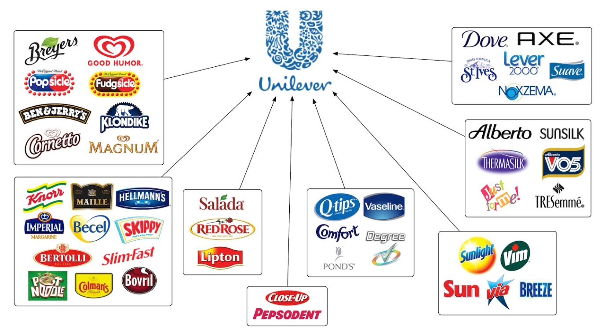
Figure 2: Product Diversification of Unilever (Unilever global company website. 2018)
Secondly, Unilever not only made its operations and distribution limited to a geographical area rather it reaches its products to the people living worldwide. Currently, people living in 190 countries have the access to the products of Unilever. Thus the company established global popularity & helped it to achieve a competitive advantage over its major competitors such as Nestle.
Despite these two effective diversification strategies, Unilever also extended its business by making contracts with different suppliers, merging its operations with famous companies and acquiring different firms. For an example, to facilitate growth in personal care products, Unilever acquire Sara Lee Corporation in 2009-2010 (Unilever global company website. 2018).

Continuous Innovation
In the current era, the necessity of innovation has increased a lot. Due to the increase in the competition among companies in the market, the consumer goods companies are always trying to offer something new. The advancement in technology also facilitated continuous innovation. As a global pioneer of consumer goods, Unilever is always innovating new products with the contribution of its smart and skilled R&D division.
Unilever currently has more than 6,000 skilled members in its R&D unit globally (Unilever global company website. 2018). The R&D division of Unilever is also highly diversified. There are six R&D factories which are located in different regions: USA, United Kingdom, Netherlands, India, and China. In these factories, the scientific research is conducted for making product development. The R&D division consists of people with different professional background and expertise. There are scientists who use scientific processes and conduct researches for preparing a better product with new ingredients. There are also hairdressers, chefs and other people who regularly acquire knowledge about the change in demands and preferences of customers from their professional experiences and assist the company to develop the brand equity by making changes in products or innovating a completely new product.
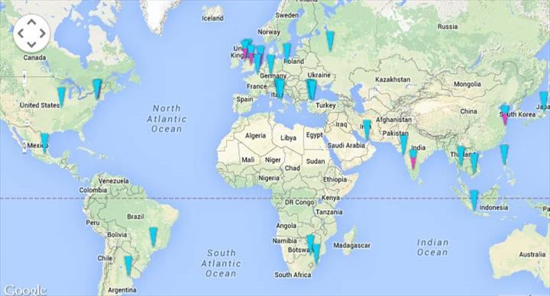
Figure 3: R&D Locations of Unilever (Unilever global company website. 2018)
Before introducing Dove, a hair and skincare brand of Unilever, the R&D team observed the change in the trend of the market and concluded that the women don’t want to become fair or make their hair straight. Rather they want to feel good about what they are. The development of self-respect among the women have been observed by the researchers and they have released different types of hair care products which are suitable for curly and straight hair. The Dove franchise also innovated their marketing strategies and sent e-mails and text messages to the female customers in the target area conveying the message, “You are beautiful in your own way.” This strategy attracted the women and they became interested in using products of Dove.

Figure 4: Creative Promotional Campaign of Dove (Gale, 2018)
Innovation not only helps to introduce a new product, it also helps to make changes in the process, elements/ ingredients of the products to make the product better in terms of quality or price. The Surf-Excel is a washing powder product. In India, Unilever faced a problem with this product that Surf Excel caused more rinsing and it used to take four buckets of water minimum to wash the clothes with a packet of Surf Excel. Also, people heavily used Surf Excel for washing hands. So, the R&D team worked for solving the Rinsing problem and innovated Surf Excel Quick Wash which would take two buckets of water instead of four buckets. This innovation has led to the betterment of the living standard of people as well as contributed to the popularity of Unilever.

Perceived Value
The perceived value of a customer is his realized benefits from the products. A customer purchases a product for getting a particular set of benefits. After sacrificing his costs, what value adds for the customers is the perceived value for them from the products (Malik, 2012).
Perceived value is the main reason why customers want to purchase a product. They use different products and finally settle for/ become loyal for those brands which provide products with maximum perceived value. Unilever currently competes globally with Nestlé and Procter & Gamble. To beat the major competitors and acquire the maximum number of customers, Unilever has to maximize the value obtained by the customers. To know if the customers have obtained proper value or not, every company requires feedback from them about the products. Unilever has had the experience of getting feedback from customers using different methods. Currently, the company uses traditional methods of getting feedback as well as the online media for collecting information about the experience of customers regarding Unilever products.
Unilever’s employees collect direct feedback from customers in different regions. While conducting market research on new products, Unilever’s employees collect data from the people directly. In the previous example where people of India faced problems while using Surf Excel, the R&D team collected feedback from people directly. There are also other ways of collecting feedback. The customers can call the helpline numbers of Unilever in a particular region and inform their problems/ complaints. Again, Unilever has launched different websites for different global regions as well as has a presence in social media platforms which help the people to connect with the people at Unilever and share their experiences. There are different e-commerce sites which conduct research on the popularity of different Unilever brands and also evaluate different attributes of Unilever products. A famous Data-analytics platform BrandIQ introduced a voice tool and performed customer review on the four popular brands of Unilever based on five product categories.
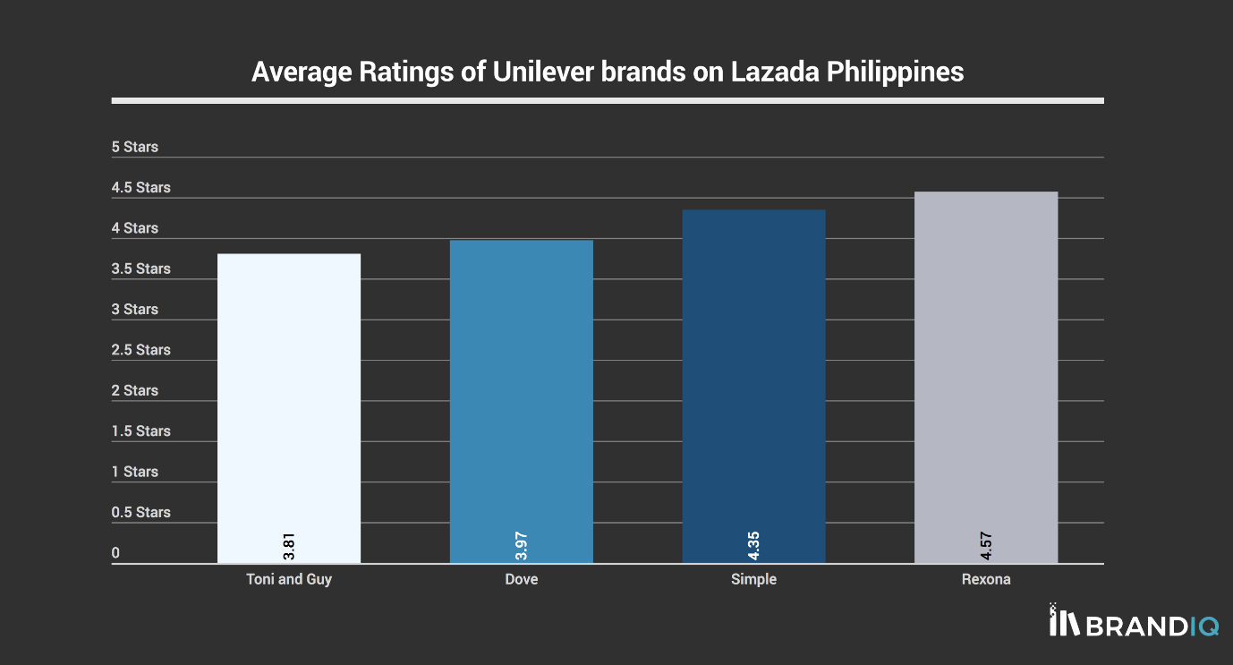
Figure 5: Result of Survey Performed by BrandIQ (Brandiqinc.com. 2018).
Among the four products, Tony & Guy and Dove had lower average ratings while Rexona had a highest average rating by the reviewers (Brandiqinc.com. 2018). People mainly provided their reviews on the core product.

Customer Centricity
In current days, the sustainability of the companies is highly dependent on how much the company is involved with the customers’ how quickly and frequently it can connect to the target customers (Gummesson, 2017). Unilever, with its long years of operations; have developed different tactics to be central to the customers. The personnel of the company stay close to the people, develop relationship with them which influence people to purchase their products. A example, before releasing Axe, the marketing team of Axe decided to pass a night with the students in a University in the USA so that they can know about their demand, taste, and preferences about the perfume products. As a global producer and distributor of Fast Moving Consumer Goods, Unilever has an active presence on social media. It has its verified pages on Facebook and Twitter- two of the leading social media sites of the world. Unilever not only has a central global page but also has separate Facebook pages for regional divisions & different brands. Unilever’s global Facebook page has 3.7 million followers and Unilever Career’s Facebook Page has 1.7 million followers which prove that Unilever is well connected to its customers as well as the people who want to establish their career in Unilever (Unilever global company website. 2018).

Ethical Considerations of Unilever
At present, customer value isn’t limited in the product or service attributes. Now, customers demand more things from a company. Due to better awareness & education, people know about different aspects of a company and know that the company can act in a fair way and contribute to the people of society by making the world sustainable.
As a company operating throughout the world, Unilever shouldn’t confine itself in only profit-generating activities. Rather, it has broader responsibilities to help towards establishing a better world for the people with the assist of its stakeholders. The company is engaged in sustainable operations and consider ethical aspects of operations. The company currently recruits more than 160,000 people and the company is working very hard to create a friendly working environment where every employee is treated fairly and equitably & progress of every employee is ensured. As a part of the society, Unilever has a huge responsibility to make good things to the society. It provides quality products to the people of society, comply with laws and pay taxes to the governments and make its operations environmentally sustainable. The company has a target to meet the Sustainable Development Goals (SDGs). Unilever is planning to minimize carbon usage and wastes in operations. In the workforce, the company is regularly diversifying and is planning to ensure 50% female officials in the management before 2020 (Unilever global company website. 2018). PureIt is an approach by the Unilever to achieve its goal of providing pure water to the general mass of developing as well as developed countries.

Task 2

A critical understanding of Unilever’s quality processes and its effectiveness in meeting customer requirements.
Unilever launched diversified products from more than 400 brands. The company wants to ensure that people are benefitted with the good quality and healthy products of Unilever. To offer quality products to the people, the company requires an operations management system which is effective by the successful implementation of different quality management approaches. Quality management is a process using which an organization can generate output and benefits which can fulfill the expectations of its stakeholders and serve the purposes of the organization properly. As a global organization dealing with various consumer goods, Unilever’s management successfully implemented different quality management techniques in its production, marketing, and distribution processes so that it can properly meet the requirements of the customers and other stakeholders.
Unilever uses a range of widely used quality management techniques in its different processes. The quality processes of Unilever are discussed below:

Reporting of Incidents
Unilever’s first priority is its customers. The company wants to provide its customers with the good quality products with minimized defect about which it assures the customers. The management wants to ensure that people purchasing Unilever products are having good experience with the products. The management also wants to ensure that products are safe for the health of the customers. The products are manufactured by complying with the health and safety laws. Yet, there can be defects which may be overlooked by the manufacturers or can be experienced by the consumers. Hence, Unilever established Safety & Environmental Assurance Centre (SEAC) which works with Unilever’s employees of different regional teams across the world. The team has the responsibility of collecting feedback from the customers. The customers inform the incidents about when they identified any safety issue of the product; if the product has a defect which might question its quality or there is any contamination of raw materials or the ingredients labeled in the packet weren’t actually used in the product (Russell, Russell and Taylor, 2018).
In the reporting of incidents process, the employees of Unilever communicate with the customers in different regional parts. The customers can inform their complaints easily to the local branch of Unilever. After knowing of the incidents, Unilever classifies the incident if the product is causing safety issues or quality issues. Based on the classification, Unilever’s researcher team works for identifying the root cause of the problem occurred and finding a solution by continuous study & research on the ingredients, manufacture process or any part of the value chain. Thus Unilever solves addressed issues in a systematic process.

Effectiveness in fulfilling Customer Requirements
The reporting of incidents have brought success for the company. After introducing the system, Unilever now knows about the demands of the customers better and can manufacture better products for them. By manufacturing products with fewer defects and increased quality, the company has ensured that the customers are more satisfied than ever. In comparison to last few years, the company has minimized the reporting of incidents by 54% which means people have fewer issues/ complaints with the Unilever products. This means the reporting of incidents have brought success for the company.
In 2017, there were only two incidents reported by the customers. One was about the food allergens and another one was about the microbiological spoilage. The good thing was, no customer was reported harmed by these two incidents. Unilever has made a goal to minimize the reporting incidents by 50% in 2018 (Unilever global company website. 2018). Also, the company aims at achieving zero-defect best quality products for the customers which mean, the customers won’t report incidents anymore.

Standardization
Standardization refers to the quality process in which a company wants to manufacture products on the basis of specific size, quality, and other measures. Standardization is effective in a way that it provides the standard measure of every measure related to a product. There are different organizations which work on standardizing the products based on the ingredients used or amount (Pullum, 2018). The International Organization of Standardization or ISO is the global standard-setting organization which works with the regional standard-setting organizations and set and revise the standards of different products over different periods. There are two major types of standardization. The industrial standardization is about determining the measures of the raw materials of products, manufacturing process to be used and other industry-related issues so that the companies can maintain the minimum standard of the industry and there is a balance of quality among the products offered by different companies in an industry. On the other hand, commercial standardization is related to the specification of the size of the products to be distributed and the quality of the products. Commercial standardization is needed to protect the interest of the consumers.
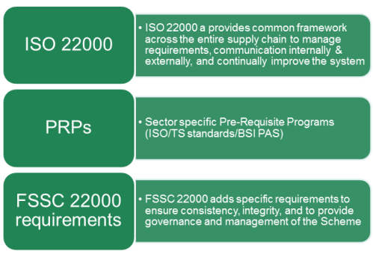
Figure 6: Components of FSSC-22000 (Fssc22000.com. 2018).
As a global organization, Unilever has to maintain the globally accepted ISO standards as well as regional industry and commercial standards. There are 140 food and refreshment sites of Unilever globally and all of these are certified according to the FSSC 22000 (Food Safety System Certification Scheme), the benchmark of a Global Food Safety Initiative (Fssc22000.com. 2018). Moreover, for developing the home products as well as personal care products, the British Standards Institute and other industry partners assist Unilever for ensuring the standards of these products. Unilever has developed its own standard for the home and personal care products-PAS420 which complies with the global and regional standards (Unilever global company website. 2018).

Effectiveness in Meeting Requirements
The standardization technique helps a company to operate in a disciplined way. The implementation of the standardization approach has enabled Unilever factories to be properly regulated and controlled. By meeting the minimum standards, Unilever can manufacture good quality, sufficient products which meet the demand of its customers in different regions of the world.
Standardization not only helps to meet the customer requirement but also it helps Unilever to comply with the laws and regulations of the company. For an example, standards of food & beverage, home, and personal care products in Britain are established based on the Health and Safety Act 1974 and other relevant laws (Gov.uk. 2018). Therefore, the company following the standards can also meet the regulatory requirements and can avoid the violation of laws in these countries.

Quality Process of Environmental Management System
Unilever is operating globally for more than 80 years. In recent years, the increasing pollution of the environment made people and governments aware of the environment. The environmental awareness is increasing day-by-day and it also affects the way how companies operate. The companies have to redesign their work processes and formulate new strategies so that the environmental pollution caused by their operation can be minimized. Unilever also focused on this particular issue and established its environmental management system to ensure develop the quality of its work process and increase environmental protection measures.

Unilever’s Sustainable Living Plan & Environmental Management System
Unilever’s Sustainable Living Plan includes the minimization of Greenhouse gases, minimization of water usage, reduction and recycling of wastes, sustainable packaging and sustainable sourcing pillars. EMS works with different parties to achieve the environmental objectives and address new environmental issues and take actions.

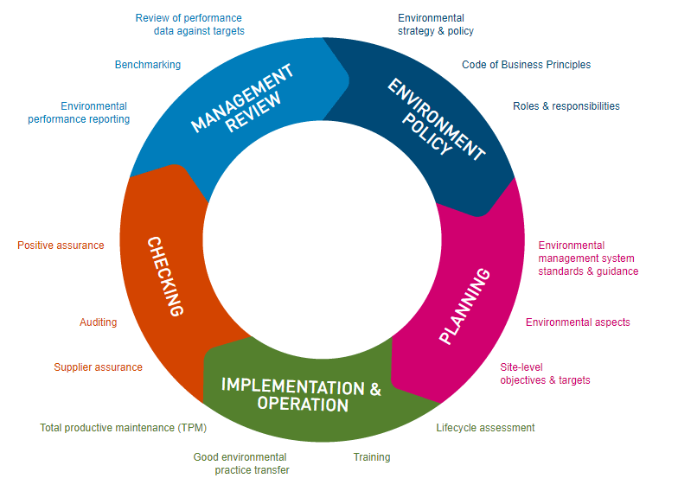
Figure 7: The Environmental Management System of Unilever (Unilever global company website. 2018)
The EMS of Unilever follows several quality management approaches to improve the quality of their operations to make it environmentally sustainable. The EMS engages every stakeholder in minimizing the bad impact on the environment. Unilever makes contracts with the suppliers who produce the crops used as raw materials for Unilever products in a sustainable way. Also, the company arranges training for its suppliers to educate them about the bad impacts of pesticides and provide necessary materials. Today, 50% of the ingredients in Knorr’s products are sustainably sourced. Also, 98% of the top 13 vegetables used in the manufacturing of Knorr products are the result of sustainable agriculture. The Lipton brand supports the farmers financially so that they can earn their livelihood yet after spending much on manufacturing products in a sustainable way (Stump and Beal, 2018). Unilever also engages its customers and promotes awareness messages on the packages of Unilever products, mobiles, TV, social media, and other mediums.

Continuous Improvement
The environmental management system of Unilever focuses on Continuous Improvement of its operations to make it environmentally sustainable. The EMS wants to improve step-by-step to make its manufacturing sites/ factories capable of meeting the targets of the Unilever Sustainable Living Plan (Weinstein, 2017).

Standardization of Environmental Management
EMS follows the standardization approach to comply with the environmental standards globally. The company complies with the local environmental protection laws. Also, the company has developed Unilever Occupational Safety, Health and Environmental Care (SHE). Under this standard, all area of operations and manufacturing sites of Unilever must comply with the ISO 14001 standards. Among the Unilever sites, 36% of the manufacturing sites solely achieved certification of ISO 14001 standards. Also, 33% of the sites are certified by the involvement of third parties and other sites were internally certified (Unilever global company website. 2018).

Quality Assurance
The operating units of Unilever around the world conduct a review annually and submit a report to the corporate risk management committee of the company to ensure the quality is assured in every work process and the environmental risks and workplace hazards have been minimized. The objective is to meet the nine commitments of the Unilever Sustainable Living Plan.

Internal & External Auditing
To ensure the sustainability of every single manufacturing site of Unilever, the management performs an audit program for the sites which are not certified under ISO-14001 standards. According to Environmental Care Framework Standards, the auditors employed by Unilever visit the manufacturing sites once in every three years, collect data on the standards of operations, maintenance of safety procedures and validate the data by careful inspection (Tomas, 2016). Regular audit helps to maintain every manufacturing site safe and protected.

Effectiveness in meeting Customers’ Requirements
The continuously improving quality measures for environmental protection have made a huge impact on the customers. A research showed that, at present, one-third of the people purchase the products which are produced in a sustainable process. Also, a survey showed that 21% of the people will prefer a product of a company if it clarifies its position in environmental sustainability. This is a big opportunity for the environmentally sustainable companies to achieve competitive advantage. People have highly appreciated the move of the brands such as Lipton and Knorr to produce the environmentally sustainable products. In the year 2017, Unilever introduced Hellmann’s Red and Green Tomato Ketchup in which it used a combination of sustainably produced red and green tomatoes as ingredients instead of using traditional unsustainably produced ingredients. Consumers who tasted both types of sauces had opined that there was no change in taste (Unilever global company website. 2018). Thus Unilever fulfilled the customers’ demand and taste as well as went with the trend of ensuring environmentally sustainable operations.
The focus on developing a quality process of environmental sustainability operations not only helped to meet customers’ expectations, it also helped the company to get benefits in other ways. The company invested 43 million euros in projects of saving energy & water and reduction of CO2 emission. The programs conducted helped to reduce the carbon emission by 4.4%, use of energy by 3.8% and usage of water by 3.4% (Weinstein, 2017).
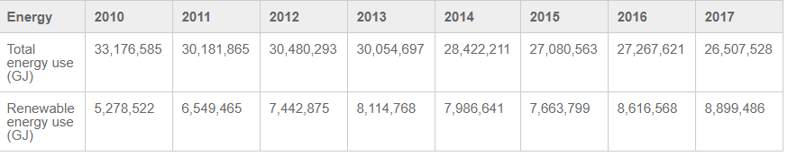
Figure 8: Increase of Renewable Energy Source in Unilever Factories (Unilever global company website. 2018)
The focus on renewable energy helped the company to establish a positive brand image for the people of the society and the governments which will help it to sustain for a longer period. After 2017, 107 sites of the company used renewable energy source for the electricity. Also, the 82% factories, distribution centers and other offices in Mexico used wind power for manufacturing electricity (Unilever global company website. 2018).

Conclusion
For the long years of operations, Unilever has created a strong position by continuously meeting the demands of its consumers. The company protects all of its stakeholders in every situation and always working hard to make the earth a better place for all the people who are directly and indirectly involved with the company. The changed value, belief, and attitude of the company over periods, establishing a position to contribute more than a corporate company and bigger sense of responsibilities helped it to maximize customer values in diversified ways. In the upcoming days when the amount of non-renewable resources will be diminished, the transformation of the business processes to the renewable sources of energies will help Unilever to sustain for a long period. The management should stick to the philosophy of continuous improvement, research and innovate new products to maximize customer value and build a strong position by being a part of the daily life of the people worldwide.

Bibliography & References
Brandiqinc.com. (2018). BrandIQ | Brand IQ - Employee gift ideas in Webster, United States. [online] Available at: http://www.brandiqinc.com/ [Accessed 23 Aug. 2018].
Fssc22000.com. (2018). Food Safety System Certification 22000. [online] Available at: http://fssc22000.com/en/ [Accessed 23 Aug. 2018].
Gale, B. (2018). Managing customer value. [Place of publication not identified]: Free Press.
Gilmore, J. and Pine, B. (2010). Markets of one. Boston, Mass.: Harvard Business School Press.
Gov.uk. (2018). Welcome to GOV.UK. [online] Available at: https://www.gov.uk/ [Accessed 21 Aug. 2018].
Gummesson, E. (2017). Extending the service-dominant logic: from customer centricity to balanced centricity. Journal of the Academy of Marketing Science, 36(1), pp.15-17.
Knecht, M. (2014). Diversification. Springer Fachmedien Wiesbaden.
Lax, A. and Mau, N. (2013). Customer Value and Value for Customer – Retail Sector’s Need for Transformation. Journal of Marketing Research and Case Studies, pp.1-12.
Malik, S. (2012). Customer Satisfaction, Perceived Service Quality and Mediating Role of Perceived Value. International Journal of Marketing Studies, 4(1).
Pullum, T. (2018). Standardization. The Hague: International Statistical Institute.
Russell, R., Russell, R. and Taylor, B. (2018). Operations management. 1st ed. Upper Saddle River: Prentice Hall.
Sasser, W. (2014). Value profit chain. [Place of publication not identified]: Free Press.
Stump, R. and Beal, D. (2018). Total Quality Management. 1st ed. Dearborn: Society of Manufacturing Engineers.
Tomas, S. (2016). Continuous improvement. Frederick, MD: Aspen Publishers.
Unilever global company website. (2018). Unilever global company website | Unilever Global. [online] Available at: https://www.unilever.com/ [Accessed 23 Aug. 2018].
Weinstein, A. (2012). Superior customer value. Boca Raton, Fla.: CRC Press.

