Name – Moshiur Rahman

Student ID- 1814025

Programme- BA (Hons) Leadership and Management Skills for the Workplace

Assignment title: Change Management Portfolio

Module: Leading and implementing workplace change

Module code – BMSW6103

Lecturer- Prof Dennis Pepple

Submission Date- 08/08/2022

Table of Contents
Introduction 3
Question 1 4
Question 2 7
Question 3 13
Conclusion 17
Recommendations 18
Reference list 18

Introduction
An organisation is run by a certain structure where chain of commands and direction is sought from certain level. According to Powell and Tilt (2017) that power and politics in an organisation are used for determining the role of individuals in terms of managing people. This report will present power and politics manifested in the case. Argument will be determined indicating how the employees are using power and politics in the organisation. The workers have decided to go for the strike which is effecting the situation and the context will be covered in this report. Moral issues in this case will be covered as well. According to Pattanaik (2014), stakeholders are the important part of an organisation and for determining the fact, two relevant stakeholder analysis model will be used in this report which will be critically identified. Interrelationship of the model in the evaluation of critical stakeholders will be explained in this report as well. Limitations of the model will be presented in this report. The report will reflect Thomas Kilman’s Conflict resolution model through determining critical evaluation of different conflict resolution approaches. Appropriate approach will be suggested for resolving conflict. Dispute resolution will be discussed in this report as well through recommending different ways in which resolution can be met.

Question 1
Critical evaluation of the meaning of organisation power and politics and explanation of how these are manifested in the case

Power
According to Ujjainia (2013), power is the ability of the related individuals to influence the attitude, behaviour of others in an organisation. Zgrzywa-Ziemak (2015) argues that organisational power is denoted as the context through which the individual can influence to get the work done by others as the individual like. It would be otherwise if the individual did not have the power. In the form of an organisational perspective, a stakeholder is dependent on others who exert power (Piercy, 2015). Power is sought from six sources which are as follows:
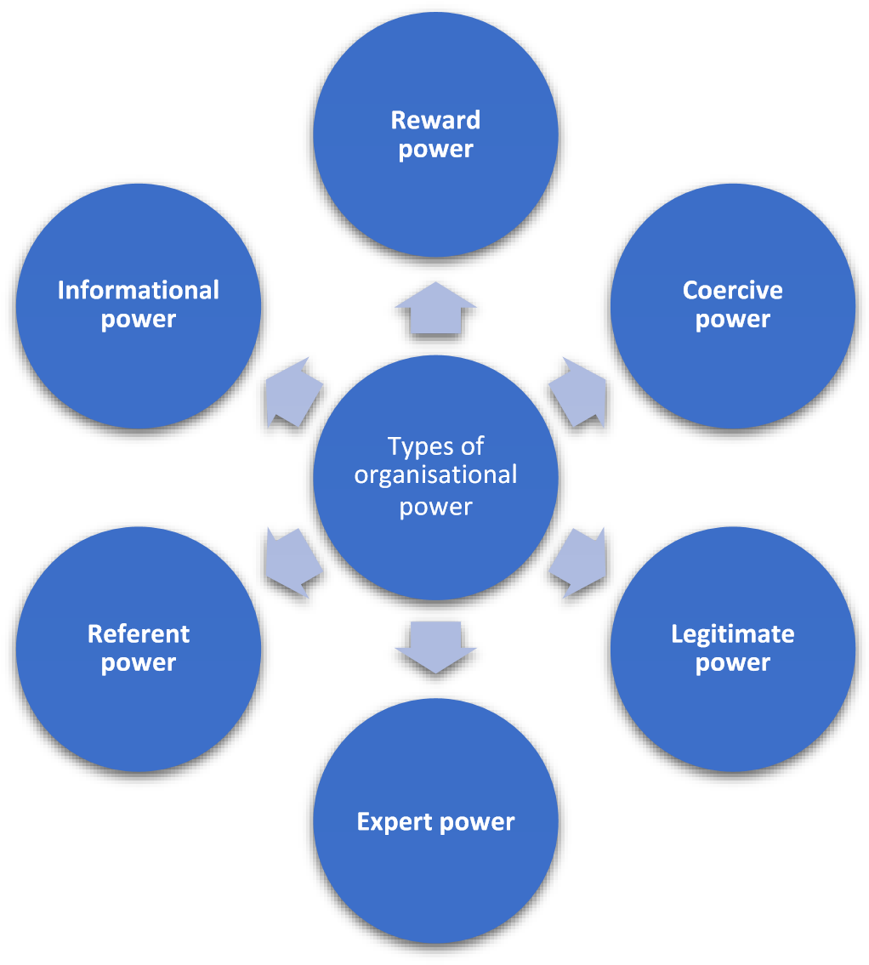
Figure 01: Types of power
Source: (Own-made)
Reward power: Ujjainia (2013) mentions that it is the ability to give reward and organisational value to others through compensating, promoting and even financial benefits if the assigned task is performed properly.
Coercive power: Coercive power is denoted as the ability to punish others deriving the infliction as painful outcomes. Withholding intrinsic and extrinsic value, suspension, firing and so on are the outcomes of coercive power.
Legitimate power: According to Zgrzywa-Ziemak (2015) that legitimate power is tended on the individual as delegated rights that comes as a legal structure of the organisation. The individual obtains rights to direct and run the individuals working under the individual. (Robbins and Judge, 2019) argue that the individual obtains rights to distribute rewards and sanctions as well for achieving this power.
Expert power: Expert power is sought from the attainment of special skills, knowledge and attributes. Such sort of power helps the organisation to determine the growth functions properly (Robbins and Judge, 2019).
Referent power: This is arguably found from the study of Buelens, Sinding and Waldstrøm (2011) that referent power is tended on the individual which comes from the positive impression towards the related person. The person gains admiration of others for which the administrative body is encouraged to offer managerial and leadership power to get individuals.
Informational power: Such power is reflected by the updated knowledge and information provided by the individual. People working under the individual get influenced to change their decision and perception according to the information provided by the person (Buelens, Sinding and Waldstrøm, 2011).

Politics
Politics is devoted to obtain certain goal by using power. According to the organisational point of view, politics is denoted as the agenda and self-interest of a related individual who intends to achieve personal goal having no concern about the impact on the objective (Heimstädt and Dobusch, 2017). It involves authority and power determining self-serving human behaviour and the interactions with others. Holyoak (2019) argues that politics in an organisation is denoted as the unexpressed process of exerting pert for obtaining personal goals and values. Provis (2017) mentions Influencing tactics are used in this case to ensure personal control in the workplace. It has been acknowledged that in several cases employees use organisational politics to gain personal interest, misuse power and so on. However, Kanta and Srivalli (2018) argue that the result of organisational politics mostly derives negative results for which productivity of the firms gets decreased. However, organisational politics does not necessarily seem to negative at all S it is required to maintain balance between workplace harmony and power. Relationships between the individuals are managed through determining organisational politics.
Individuals tend to perform organisational politics for some certain reasons. One of the main reasons is denoted as unwillingness to work hard. According to Vigoda-Gadot and Talmud (2010) People may intend to look-out for an easy way to perform task. In this case, they exert power in a negative way for obtaining their personal goal. For dealing with such activity, negative image of the individual is tended towards the individuals.
Individuals or employees may not be ready to accept change to cope with the situation. There are employees who do not want to adjust change for which they prefer to use their power to obtain personal gains. In most of the cases, organisational politics gets derived from personal relationship. The related individual may be encouraged to maintain good relationship with specific persons to i obtain expected goals (Graetz, 2016).
Manipulation is one of the prior reasons for which organisational politics is ascertained. Individuals may intend to manipulate data for providing wrong information. In this case, organisational politics is used by the person for pertaining personal goal and interest.
According to Heimstädt and Dobusch (2017), power and politics in an organisation determine the role of individuals of an organisation within the business environment. Organisational tasks are allocated to the employees where the immediate person in the leading role exerts some power. Power is legally entailed as per the organisational structure and the related person enjoys this to run and lead a specific team. Piercy (2015) argues that power is structured as it sets boundary for the individuals to lead a group of people. On the other hand, politics is an informal way of using authoritative power for leading a group of people. Even politics is determined for obtaining interests of the related group as well. Politics is not structured and it is seemed that this informal way of determining power may lead to an unacceptable orientation to the individuals. Thus, the context of power and politics is very significant to determine effective functionalities of the organisation.
From the case, it has been obtained that the employees of Post Office are going for a one-way strike in a dispute over pay. In this case, it can be stated that the employees are using legitimate power for achieving their goal. Every organisation in UK are bound to pay a minimum level of payment to the employees under the law of UK. So it is found here that employees of Post office are having power to raise their voice against to the politics of organisation when they got lower than standard payment. Under the employment tribunal act (EAT) of UK these employees claim their rights. They have achieved the power from Members of the Communication Workers Union (CWU) through which they raise their voice against the authority over a pay freeze and less rise of salary. The issue is posing negative impact as the situation is not good for serving the UK customers. Failure to meet demands of the workers impacted them to go for a strike.
Post Office said in a statement that the strike does not damage its work as there are 11,500 branches from where customers can undertake their services. So, it can be states that the-24hour strike will not affect the activities of Post Office. However, it damages the image of the organisation. The strike will represent a negative attribute towards the customers for which Post Office may suffer in the long run. Although 114 branches are not seeming to affect 11,000 branches, the issue is subjected to disrupt moral views. Because of it is the moral obligation or the organisation to understand and meet demands of the employees. At the same time, closure of branches will suffer the customers of Post Office which is also breach of moral values.

Question 2

Critical identification of the stakeholders through using two relevant stakeholder analysis model and explanation of interrelation of the chosen mode in the evaluation of critical stakeholders
According to Weiss (2014), stakeholders are the persons who have interests on the organisational activities and their roles influence the decision making process of the firm. This is arguably found from the study of Azarovа (2018) that it is necessary to identify the key stakeholders and ascertain their relationship within the business. The context can be determined through using stakeholder analysis model. Here, Salience Model and Power Interest Matrix Model are going to be demonstrated for identifying key stakeholders.

Salience Model
This model is applied to understand what do matter from the activities of the stakeholders. It is often difficult for the project manager to identify the right stakeholders. This model helps to choose and map the significant stakeholders through determining clarity (Dertwinkel-Kalt, Frey and Köster, 2020). According to Owusu, Antwi and Kendie (2021) that power, legitimacy and urgency are assessed to determine salience of the stakeholders. The project manager can understand the degree of intensity through which the project manager focus on identifying stakeholders through determination of competing stakeholders’ claims. Stakeholders are mapped with power, urgency and legitimacy in seven different classes.
Dormant stakeholders: Such stakeholders have power but do not have urgency of legitimacy. As a result, the manager does not need to plan for determining their communication needs (Feris, Jr., 2021). According to the case, Post Office does not need to make plans for the investors as present situation is urgent for the employees.
Discretionary stakeholders: This is found from the study of Lee and Sweeney (2014) that discretionary stakeholders have legitimacy but do not have power and urgency. Such stakeholders are not determined as giving much attention by the manager. Auditors of Post Offices can be stated as discretionary stakeholders.

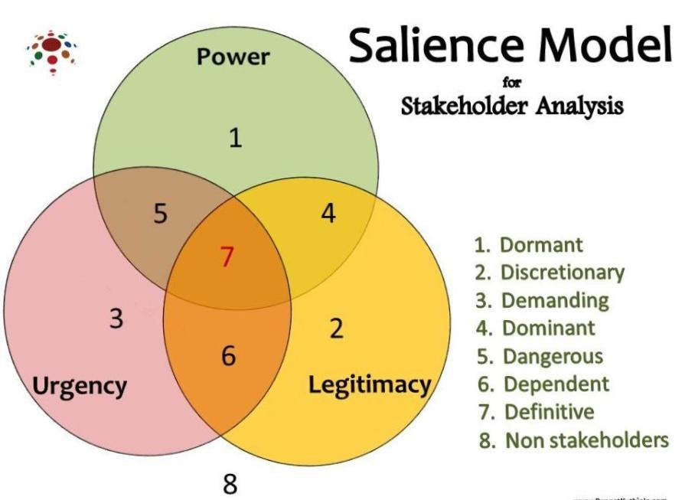
Figure 02: Salience model
Source: (Feris, Jr., 2021)
Demanding stakeholders: Demanding stakeholders have urgency and needs of them have to be met immediately (Wethal, 2017). According to the case, employees of Post Office are the demanding stakeholders.
Dominant stakeholders: Dominant stakeholders have both power and legitimacy. They influence and undertake the decisions as they have authoritative power (Cordery and Sim, 2017). Administrators of Post Office can be denoted as dominant stakeholders.
Dangerous stakeholders: Such stakeholders have the mix of power and urgency which make them useful for the related project (Jackson-Fossett et al., 2011). For example, Tarde Union can be denoted as dangerous stakeholders in this case.
Dependent stakeholders: The firm may not be interested in focusing on the interest of such stakeholders. They have legitimacy and urgency but do not have power (Ditlev‐Simonsen and Wenstøp, 2013). The firm needs to keep them informed about the organisational activities.
Definitive stakeholders: Such stakeholders are the most significant category of stakeholders as they have the mix of power, legitimacy and urgency (Ditlev‐Simonsen and Wenstøp, 2013). Such stakeholders have to be kept informed all the time for making them satisfied.
Shareholders of the firm are denoted as definitive stakeholders.

Power Interest Matrix Model
Stakeholders are the key groups of the firm and it is necessary to understand their needs and demands properly. In this case, categorising of stakeholders is necessary and the prospect can be determined through power and interest (Maqbool, Rashid and Ashfaq, 2022). Power Interest Matrix Model is denoted as an effective model of identifying the stakeholders through determining their interest on the related project (Li, 2019).
The model describes a grid of power-interest on which priority is given to the stakeholders accordingly.

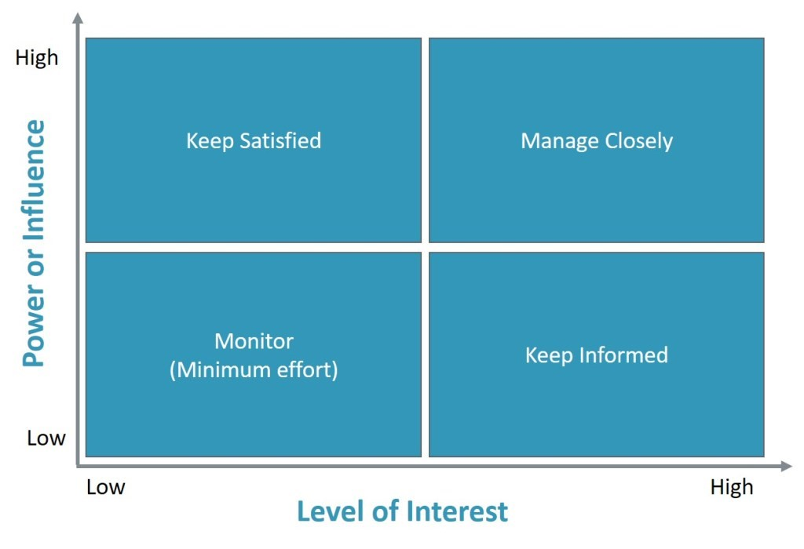
Figure 03: Power-interest stakeholder matrix
Source: (Maqbool, Rashid and Ashfaq, 2022)
High power-high interest: According to Gangl et al. (2022) that those stakeholders are the most influential on organisational decision making process as they determine significant impact for succeeding the project. Such stakeholders have to be kept informed, close and satisfied their expectations. Shareholders of the firm are denoted as such stakeholders. Because of they are the owner of the firm and they hate direct influence on the organisational decision making process.
High power – low interest: Such sort of stakeholders has power but impose low interest on the organisational performance and outcomes of project. Nevertheless, the firm needs to deal with such stakeholders properly as they have power (Li, 2019). If they are unsatisfied with the activities, they may determine negative outputs to the firm or project. Gangl et al. (2022) argues that government auditor can be stated as such stakeholders because of they do not have intensified interest on organisational performance like others but possess high power.
Low power-high interest: Such stakeholders have to be kept informed about the organisational performance and significant events although they have low power (Maqbool, Rashid and Ashfaq, 2022). However, Gangl et al. (2022) argue that they have high interests on the organisational performance and they can help deriving success to the firm properly. According to the context, employees, investors and so on are denoted as such stakeholders.
Low power- low interest: The firm does not need to give much interest and spend time on such stakeholders as they do not pose power and also have less interest on the organisational performance. Communities can be denoted as such stakeholders of the grid (Gangl et al., 2022).
This is found from the study of Nyukorong (2017) that organisational decision making process depends highly on ascertaining the interests of the stakeholders. Because of the stakeholders influence the decision making process of the firm for which it is necessary to understand the relevancy and interests of the stakeholders. Stakeholders have certain interests on the organisation.
Power Low High
H:L= Employees | H:H = Owner
L:L= Government | L:H = Investor
High
Low

Interest
Owner: Agreeing with the study of Gangl et al. (2022) that shareholders or owner of the Post office are regarded as the most significant stakeholders as they are the owners of the firm. They have voting power and the Board of Directors is formed from the shareholders. They have high interests on the organisational activities and at the same time they have power as well. They influence the decision making process of the management of the firm.
Investors: Investors have high interests on the organisational activities as they want to understand how efficient the firm is to use their invested money and make effective return on their investment (Maqbool, Rashid and Ashfaq, 2022).
Creditors: Creditors have high interests as well on the organisational performance. They evaluate the financial efficiency of the firm before going for providing credits to the fir.
Government: Agreeing with the study of Holyoak (2019) that government provides rules and regulations for the businesses through which the financial activities and other sort of functions are monitored. They also influence the organisational planning process and execution of strategies of the firm.
Employees: Employees intend to understand the growth and development of the firm to acknowledge their opportunity for improving professional career (Holyoak, 2019).
Consumers: Consumers intend to understand the quality of products and services of the firm as well as organisational value. So, they have interests as well and influence the decision making process of the firm.

Limitations of Salience Model
Salience Model is useful and widely applied to categorise stakeholders of the firm through which the form can meet the needs of different stakeholders. However, it has been ascertained that Salient Model has some limitations for which the purpose may not be achieved appropriately. Limitations of such model are going to be demonstrated here:
Time consuming: It is acknowledged that conducting stakeholder analysis through maintaining Salience Model is very time consuming. The manager needs to determine much effort in this case which consumes time.
Issue of biasness: The manager keeps stakeholders in the circle according to the subjective orientation. There are possibilities of being biasness. As a result, the firm may not be able to determine influence and efficiency of the stakeholders.
Difference of attributes: There are differences of attributes of the stakeholder’s matrix according to Salience Model which are influenced from different scenarios.

Limitations of Power Interest Matrix Model
Although Power Interest Matrix Model helps to identify the right stakeholders, it is affected by certain limitations. The model includes a visualisation process of grid through which the firm can understand who are the most significant stakeholders and what activities are needed to satisfy them. Heterogeneity within stakeholders and pressure groups affects the context of the model where the model offers a differentiation into certain categories of stakeholders.
However, all the stakeholders are not homogeneous and they ignore heterogeneity (DertwinkelKalt, Frey and Köster, 2020).
Multiple inclusion of stakeholders of the model is another sort of limitation of Power Interest Matrix Model. There are stakeholders who can be placed on different groups of the grid. As a result, the category of stakeholders cannot be determined in an appropriate way through following this model.

Question 3

Critical evaluation of different conflict resolution approaches through reflecting on Thomas Kilman’s Conflict resolution model and suggestion of the appropriate approach for resolving the conflict
According to Obeso (2018), conflict of interest is a common issue in any organisation and it can be occurred within the workplace when people disagree between themselves. Conflict or dispute between indivisible is the outcome of values, perceptions, desires, motivations and so on (Batton, 2002). Conflict has to be resolved for the purpose of ensuring productivity within the firm as conflicts damage workplace productivity and efficiency (Shakoor, 2020). Organisations follow different ways to solve conflict of interest among the individuals. There are certain models through which conflicts of interests can be resolved.

Thomas Kilman’s Conflict Resolution Model
Thomas Kilman’s Conflict Resolution Model is one of the most significant models for resolving issues of conflict. The model is applied on two dimensions of managing conflicts- assertiveness and empathy. The first dimension assertiveness determines the prospect of having the ability of standing by own opinions. The context can be performed through both positively and negatively (McGrath and Bates, 2017). Assertive behaviour may seem aggressive but it is an effective way of expressing the individual. The second dimension empathy determines the prospect of understanding point of view of another person. The aspect deals with the process that conflicts of interest can be solved easily when the individual empathise with other individuals (Sarfaraz, 2012).
According to the model, there are five different approaches of managing conflict having certain strengths and weaknesses. Under specific circumstances, the best approach is determined.
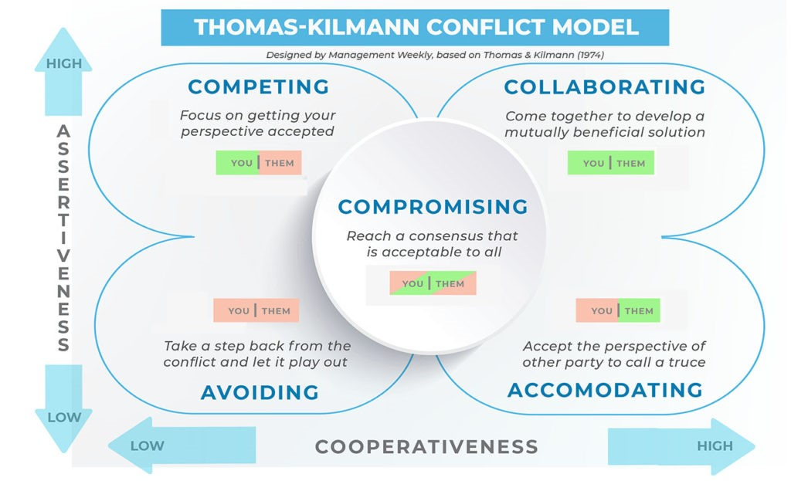
Figure 04: Thomas Kilman’s Conflict Resolution Model
Source: (McGrath and Bates, 2017)
Competing: According to McGrath and Bates (2017), this approach determines high assertiveness and low empathy. Competing as a conflict resolution approach applied when the individual becomes aggregate and uncooperative with the opponent. Here, each individual thinks that the other is not right for gaining advantage than the other. It is regarded as the first strategy to deal with conflict. Read, Read and Baillie (2021) argue that it is regarded as an effective approach to resolve conflict when one is in a commanding position. Even if the individual has limited time and resources, such approach works well. Competing helps to obtain individual goals. However, competing is not always good. The aspect leads to negative emotions while dealing with others such as frustration, aggression, anger, hostility and so on. Such approach cannot value relationship with others because of each of the individuals does not listen to others. In addition, such approach damages the scope for conducting future activities with the individual as the opposition does not have the intensity to work with the person in future (Sagel-Grande, 1999). Moreover, we stop cooperating with the other side. Contrary to popular belief, this tactic is not inherently bad. This strategy might be more effective when we are in a position of authority and time is of the essence in finding a solution.
This technique must also be used when we must make difficult judgments.
Avoiding: Avoiding is the approach of conflict resolution which determines low assertiveness and low empathy. In this case, the individual does not asset own position and even does not emphasise on the point of view of others. It is denoted as the second strategy to deal with conflict (Sagel-Grande, 1999). This conflict management strategy is used when the individual does not seem it relevant to confront another. The individual may be encouraged to avoid the conflict entirely as well and remain silent. Because of the individual thinks that the conflict can be solved by not participating in it. However, Sarfaraz (2012) argues that the approach is not deemed as an effective approach to sort out the best deals. Because of ignoring conflicts is denoted as passive and weak approach. However, the individual may find happiness by not being in the conflict which is also a positive thing. This strategy entails avoiding the argument and keeping one's thoughts and feelings to oneself. This tactic is also used when dealing with a disagreement is more expensive than just accepting it.
Accommodating: Such sort of approach denotes to the fact of low assertiveness and high empathy. It is regarded as the third strategy for dealing with conflict. It is the way of making concessions and working as the other person implies. The individual leaves argument in this case and agrees to do or work according to the request of the individual (ACCORD, 2010). It is regarded as an effective way to manage conflict when the individual lacks power. Because of it helps to make a positive impression and relationship with the individual for resolving the issue. However, Sarfaraz (2012) arguably stated that the approach has drawbacks as well. One can lose control over own agenda by dealing with accommodation of the conflict. Even the opposite party may think and understand the weakness of the individual. According to the Thomas and Kilmann Conflict Mode Scale, people in this mode are more cooperative than aggressive. To make the other side happy, we are willing to compromise on our own position.
Collaboration: According to Kim and Lee (2010) that collaboration is the approach of dealing with high assertiveness and high empathy. This is one of the major approaches of solving issues between the individuals. In this case, individuals are seen collaborating with each other to solve the related issues. It is denoted by Colbry, Hurwitz and Adair (2014) as a moderate approach to solve problems where the individuals try to make a balance between them. It can be possible to do so when the individuals have common ground and intention of working together for achieving a shared goal. It is regarded as an effective approach of resolving conflicts when the parties are committed to reach a mutual agreement. They reach to a mutual agreement when objectives of both parties are met. Their main purpose is to reach an agreement with each other for the prospect of obtaining success from the scenario. However, the context may not be easy at all. Because of the individuals have to share personal feelings and opinions which can result in an unsuccessful orientation. Trust is required between the parties where both parties have to value each other. If there is no trust between the individuals, the context may not derive effective output.
Compromising: Compromising is denoted as the fifty strategy of the model which is the middle of assertiveness and empathy scales. The approach stands on the basis of win and win situation. Because of both parties acknowledge the opposing views and agree to specific terms and conditions. They give up certain items to obtain others and have the higher intention to resolve conflicts (Colbry, Hurwitz and Adair, 2014). And the approach is effective in the form of solving conflicts in a proper manner. Because of both parties have to be flexible and determine a balancing situation to solve conflicts appropriately. However, Sarfaraz (2012) argues that the individual should demonstrate all the factors and outcomes so that the opportunity cost can be effective. Issue of poor evaluation and demonstration prevails here for which expected outcomes may not be determined.
According to Holyoak (2019) that approaches of solving conflicts of interest have been discussed above where all the approaches have strengths and weaknesses. Application of each approach depends on the factor of having differences of projects, organisational settings and so on. Conflicts are common and these can be happened within the organisation on regular basis. However, the best approach of solving conflicts can be denoted as collaboration (Ononogbu, 2015). The approach is denoted as the context of dealing with high assertiveness and high empathy. According to Colbry, Hurwitz and Adair (2014) Collaboration is deemed as the most appropriate way of solving issues between the individuals because of people are determined in collaborating with each other to solve the related issues. It is termed as a strategic approach to solve problems where the individuals try to make a balance between them. It can be possible to do so when the individuals have common ground and intention of working together for achieving a shared goal. It is regarded by Colbry, Hurwitz and Adair (2014) as an effective approach of resolving conflicts when the parties are committed to reach a mutual agreement. They reach to a mutual agreement when objectives of both parties are met. Their main purpose is to reach an agreement with each other for the prospect of obtaining success from the scenario. The approach is denoted as win/win situation. Although it is complex way to manage differences, collaboration helps to understand the scenario and determine an effective balance to solve the issue. The approach helps to build relationship with others. Because of it deals with trust and commitment on all sides through which a complete solution of the issue by getting heart of the topic can be acknowledged. Individuals empathise and intend to understand situation of each other. As they are successful in solving issues through a balancing way, they can continue their relationship for a long time (Ditlev‐Simonsen and Wenstøp, 2013).
Dispute resolution is the context of resolving a conflict or dispute which may not need to go to court often. The issue can be solved through negotiation, mediation, arbitration and litigation. Negotiation is denoted as the fact of solving issues through finding common ground. Here both parties make agreement between themselves by discussing over the issue (Colbry, Hurwitz and Adair, 2014). Mediation is regarded as the prospect of solving disputes by having presence of an independent person. Arbitration is the process of formal legal attributes where an independent arbitrator makes decisions by evaluating information of all the parties. When a dispute resolution solicitor is enlisted to resolve the dispute, it is denoted as litigation.
The conflict of Post Office with its employees can be solved by using the collaborative approach Thomas Kilman’s Conflict Resolution Model. In this case, negotiation process has to be determined to solve the issue as well. However, the dispute can be solved as per the following recommendations:
Post Office should not ignore the conflict. Rather, the firm has to define the problem and accommodate the issue properly to solve the dispute resolution. Neutral ground has to be used in that case to solve the issue. Negotiation should be carried with Members of the Communication Workers Unions to understand their demands over the issue. If needed, the context of arbitration has to be determined in this case.

Conclusion
Functions of a firm are operated by a certain structure where chain of commands and direction is sought from certain level. Power and politics in an organisation are used for determining the role of individuals in terms of managing people. This report has presented power and politics manifested in the case. Argument has been determined indicating how the employees are using power and politics in the organisation. The workers have decided to go for the strike which is effecting the situation and the context has been covered in this report. Moral issues in this case have been covered as well. Stakeholders are the important part of an organisation and for determining the fact, two relevant stakeholder analysis model have been used in this report which has been critically identified. Interrelationship of the model in the evaluation of critical stakeholders has been explained in this report as well. Limitations of the model have been presented in this report. The report has reflected Thomas Kilman’s Conflict resolution model through determining critical evaluation of different conflict resolution approaches. Appropriate approach has been suggested for resolving conflict. Dispute resolution has been discussed in this report as well through recommending different ways in which resolution can be met.

Recommendations
The report has presented power, politics, stakeholder analysis model and dispute resolution. The report has covered the conflict between Post Office and the employees of the organisation.
Some recommendations are going to be made here to solve the issue between the parties:
Post Office should determine its power and politics in a positive way so that there can maintain a balance within the scenario. There has been a moral breach against the rights of the employees. In that case, the organisation should evaluate the stakeholder analysis model for acknowledging high interest on the employees. Because of employees are the key stakeholders who help to obtain organisational goal appropriately.
Post Office should deal with collaborative approach of solving conflict with the employees. Proper negotiation has to be determined in that case so that a mutual agreement can be determined and the issue can be solved as well.

Reference list
ACCORD (2010) African Journal on Conflict Resolution, Google Books, ACCORD.
Azarovа, I. B. (2018) Identification of project stakeholders based on system analysis, Transport development, (1(2)), pp. 5–11.
Batton, J. (2002) Institutionalizing conflict resolution education: The Ohio model, Conflict Resolution Quarterly, 19(4), pp. 479–494.
Buelens, M., Sinding, K. and Waldstrøm, C. (2011) Organisational behaviour, New York, B Mcgraw-Hill Higher Education ; ‡A London.
Colbry, Hurwitz and Adair (2014) Collaboration Theory, Journal of Leadership Education, 13(4).
Cordery, C. J. and Sim, D. (2017) Dominant stakeholders, activity and accountability discharge in the CSO sector, Financial Accountability & Management, 34(1), pp. 77–96.
Dertwinkel-Kalt, M., Frey, J. and Köster, M. (2020) Optimal Stopping in a Dynamic Salience Model, SSRN Electronic Journal.
Ditlev‐Simonsen, C. D. and Wenstøp, F. (2013) How stakeholders view stakeholders as CSR motivators, Social Responsibility Journal, 9(1), pp. 137–147, [online] Available at: https://www.deepdyve.com/lp/emerald-publishing/how-stakeholders-view-stakeholders-ascsr-motivators-tWgdKhrbx9.
Feris, Jr., I. (2021) The Dormant Monster: Florida’s Intrastate Marijuana Regulation and Its Susceptibility to Dormant Commerce Clause Challenge, FIU Law Review, 15(2).
Gangl, K., Seifert, M., Abstiens, K., Walter, A., Spitzer, F., Kirchler, E., Karmasin, S. and Kimmich, C. (2022) Power and Interest in Sustainability Transitions: Combining Behavioral Insights with Stakeholder Analysis, SSRN Electronic Journal.
Graetz, F. (2016) Managing organisational change, Milton, Qld., John Wiley & Sons Australia.
Heimstädt, M. and Dobusch, L. (2017) Politics of Disclosure: Organizational Transparency as Multiactor Negotiation, Public Administration Review, 78(5), pp. 727–738.
Holyoak, L. (2019) Organisational Culture: Organisational Change?, Leadership & Organization Development Journal, 23(6), pp. 354–355.
Jackson-Fossett, C., Skinner, L., Irvine, D. and Amaya, C. (2011) Dangerous Liaisons: How Stakeholders can Make or Break Your Wastewater Projects, Proceedings of the Water Environment Federation, 2011(17), pp. 759–778.
Kanta, K. N. M. and Srivalli, P. (2018) Moderation Effect of Organisational Politics on Organisational Commitment and Teaching Effectiveness, International Journal of Management Studies, V(4(1)), p. 117.
Kim, D. and Lee, R. P. (2010) Systems Collaboration and Strategic Collaboration: Their Impacts on Supply Chain Responsiveness and Market Performance*, Decision Sciences, 41(4), pp. 955–981.
Lee, W. E. and Sweeney, J. T. (2014) Use of Discretionary Environmental Accounting Narratives to Influence Stakeholders: The Case of Jurors’ Award Assessments, Journal of Business Ethics, 129(3), pp. 673–688.
Li, F. (2019) Testing for the Diffusion Matrix in a Continuous-Time Markov Process Model with Applications to the Term Structure of Interest Rates*, Journal of Financial Econometrics.
Maqbool, R., Rashid, Y. and Ashfaq, S. (2022) Renewable energy project success: Internal versus external stakeholders’ satisfaction and influences of power‐interest matrix, Sustainable Development.
McGrath, J. and Bates, B. (2017) The Little Book of Big Management Theories: ... and How to Use Them, Google Books, Pearson Education Limited.
Nyukorong, R. (2017) Conducting Market Research: An Aid to Organisational Decision Making, European Scientific Journal, ESJ, 13(10), p. 1.
Obeso, J. A. (2018) Ghost writing and conflict of interest - Editor’s comments, Movement Disorders, 33(9), pp. 1509–1509.
Ononogbu, I. (2015) Transformation of Dispute Resolution in Africa, International Journal on Online Dispute Resolution, 2(1).
Owusu, E., Antwi, J. and Kendie, S. B. (2021) Disaster Risk Management: The Exercise of Power, Legitimacy and Urgency in Stakeholder Role in Ghana, International Journal of Environment and Climate Change, pp. 17–33.
Pattanaik, S. S. (2014) Federalising India’s Neighbourhood Policy: Making the States Stakeholders, Strategic Analysis, 38(1), pp. 31–48.
Piercy, N. (2015) Marketing organisation : an analysis of information processing, power and politics, Abingdon, Oxon, Routledge.
Powell, L. and Tilt, C. (2017) The examination of power and politics in a conservation organisation, Accounting, Auditing & Accountability Journal, 30(3), pp. 482–509.
Provis, C. (2017) Ethics and organisational politics, Cheltenham, Edward Elgar.
Read, E. K., Read, M. R. and Baillie, S. (2021) Veterinary Clinical Skills, Google Books, John Wiley & Sons.
Robbins, S. P. and Judge, T. A. (2019) Organizational behavior, 18th ed, New York, New York, Pearson.
Sagel-Grande, I. (1999) Models of Conflict Resolution, Google Books, Maklu.
Sarfaraz, A. (2012) A Fuzzy Conceptual Design Selection Model Considering Conflict Resolution, International Journal of Engineering and Technology, 4(1), pp. 38–45.
Shakoor, R. (2020) Workplace Conflicts and its Effect on Employee Productivity: A Mediating Role of Workplace Politics, International Journal of Psychosocial Rehabilitation, 24(3), pp.
2774–2783.
Ujjainia, G. (2013) Personality, Attitude, Power and Politics Affecting Organisational Behavior, SSRN Electronic Journal.
Vigoda-Gadot, E. and Talmud, I. (2010) Organizational Politics and Job Outcomes: The Moderating Effect of Trust and Social Support, Journal of Applied Social Psychology, 40(11), pp. 2829–2861.
Weiss, J. W. (2014) Business ethics : a stakeholder and issues management approach, San Francisco, Berrett-Koehler Publishers.
Wethal, U. (2017) Passive Hosts or Demanding Stakeholders? Understanding Mozambique’s Negotiating Power in the Face of China, Forum for Development Studies, 44(3), pp. 493–516.
Zgrzywa-Ziemak, A. (2015) The Impact of Organisational Learning on Organisational Performance, Management and Business Administration. Central Europe, 23(4), pp. 98–112.

