Project Management

ACCC5005

Lecture: Student:
Koushik Modak Adrian Alexescu
1807627

Table of Contents

Introduction 3
Client description 3
Aim 3
Methods 4
WBS (Work Breakdown Structure) 4
Gantts Chart 5
Migrating data and training users 5
Risk Management for Japher Motors 6
Website Description 8
References 12

Introduction

Client description
Japher Motors is a small business auto mobile service company which have as main daily activities repairing and creating bookings. Company have as members Mr Japhet which is company owner, one receptionist and 3 other staff members. Company want to change the way how they are operating their daily activities into a new software website, website which will be used only by the members of Japher Motors.

Aim
In this report, our aim is to achieve our client request, to transform their old software system, into a new system website, which should reach our client expectation with a minimum capital and resources invested, using different methods of planning and evaluation.

Methods

WBS (Work Breakdown Structure)
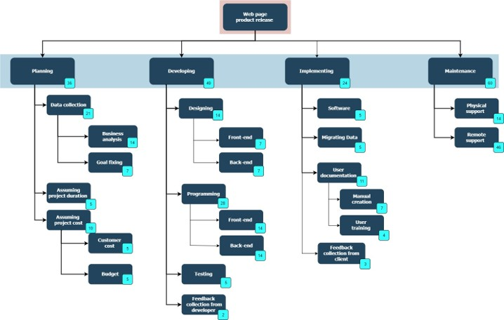
Figure 1 Created by student
We start planning by dividing our project into smaller tasks, as Planning, Developing, Implementing and Maintenance, which exactly in same way we split them in smaller components (Feng, 2009).
Most essential task in our project or in any other, is to gathering data, to understand exactly which are our client requirements, how much capital he is available to invest in this project and how much time is needed for our project to be implemented successfully. We assume that our project will take 109 days to be implemented successfully and because step 1 is most essential, we allocated 36 days only to collect data from our client and planning (Fig 1).
Once step 1 is finished, we can start designing and coding our front-end (interface used by the company members only, because their end project will be used only by company members) and back-end (interface used only by us, developers, for building the website and for maintenance). We will have daily meetings inside of our team, to check our project status, what were tasks the day before and if we accomplish them, tasks for current day and if we are on track with our project delivery time. After designing and coding, we will test our beta project version and changes will be made after collecting feedback from developer. At this point, our beta project version is ready to be implemented.

Gantts Chart

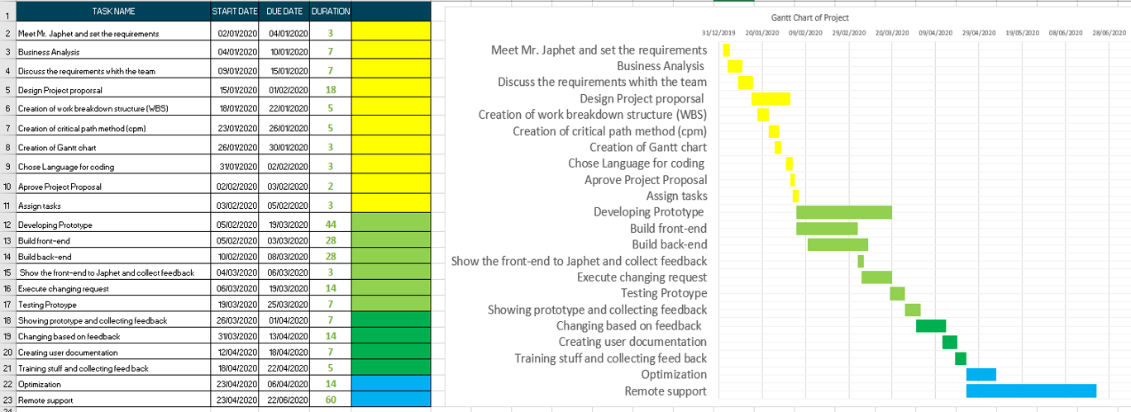
Figure 2 Created by student

A very important tool in scheduling and planning our project is Gantt Chart, which will help us to keep on track all our small sub-tasks created on work breakdown structure and to share our project status with Mr Japhet, the owner of Japher Company (Lawrence, 2006).
Our next step after Developing, is Implementing, step which will include installing hardware components and software website to our client location (Fig 2).

Migrating data and training users

To ensure that all old data been migrated successfully and to minimise risks on this field, we need to follow few important tasks, such as: data transformation, data cleaning, data validation and data loading. Data transformation will mean that, old data need to have a different structure to be successfully implemented into new database; data cleaning will allow us to eliminate any corrupted data and duplicated records; data validation will test our new implementation of our new records and will ensure a good response on our user action; and data loading is our last step which means that we will move all records, which will end with a final test confirming that our data have been successfully implemented.
Because training users is a very essential step for a successfully implementation of our website, Mr Japhet decided that, he will need an advance training for website, because he will need to check stock availability, order parts missing or in low stock, and also to be able to train any other new staff for his company if that will be required. For all the other staff, we will use a normal training, using our user manual and examples with explanations will be given using Japher Motors laptops to run all queries and to be sure, that, every member of staff will have all information need it.

Risk Management for Japher Motors

We can divide our project risk management into four big processes which need to be monitoring (Al-Rousan, 2009):
- Detect risks that may occur in our project;
- Analyse, prioritise and communicate risks;
- Planning risks starting with the highest one;
- Monitoring risks and keep searching for eventually new risks that may appear.
Can be many factors which may try to stop or delay our project, and therefore is
important to detect them from beginning, in case they will appear, we can easily “cover” them with back-ul plans.
We are having only one Project Manager in charge; he will be responsible with taking decisions for the entire project and with communications between client and developers. In case he will not be available for different reasons, team leader which proved so far with his high skills is next in line to take his duties as project manager. In this way, all members involved in project or stakeholders will know with who to talk in case any issues occur outside or inside of project plan.
Example of risks they may appear in our project:
Risk | Probability | Effect | Measures
Customer do not know exactly what he really needs for his company after coding started already | High | Huge waste of time and finance and disappointing from both side, client and developer | Project Manager clarifying from beginning of project all the details of what exactly our client project will look like and planning any additional queries to our client project
To change any requirements in his project with high impact on project design | High | Time wasted and finance | Project Manager will define from beginning within contract any small fees to cover developer loses
Customer do not be agree with all costs or any other costs which can appear while project been build | High | Delays in project delivery and disappointing our client. Also, time wasted for our staff | Setting project budget from beginning and additional costs which will intervene for all project duration
After launching project, customer will have always issues regarding website appearance, software malfunction, staff incapacity to accomplish daily activities through website | High | Time wasted for developer trying to fix any problems with client project, negative advertisement for developer company in future projects | Clearly setting website parameters and appearance of our project from initial phases. Permanent communication between client and developer is required, even after project been delivered, helping them in any ways possible, this is why all projects have always a high maintenance time after project been implemented successfully. In our case, we set project maintenance at 6 months after project been delivered, due to lower website complexity
While designing and coding, one of our staff may get sick or to have some personal issues | Medium | Several delays in delivering project in time | Many of our staff can cover each other due to their high individually skills, also our team leader can help them while supervising them
Due to technical issues, database cannot be accessed on cloud, no internet access | Medium | Delaying client activity creating discomfort and loose of money | Back-up copy of our online client database with clients and daily activities on a local device by synchronising every hour
After physically designing network, one customer equipment does not work properly | Low | Delaying client activity creating discomfort and loose of money | All hardware equipment will be new with 1 extra for each set of it

Website Description

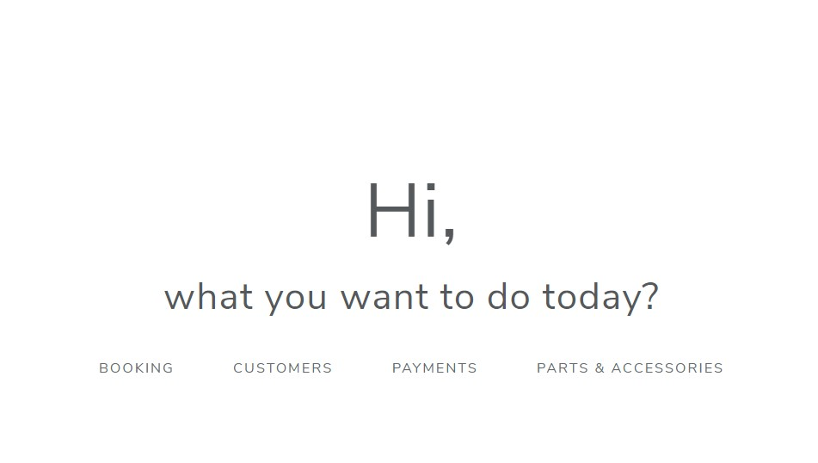
Figure 3 Created by student

Main page (Home Page) have been designed with a friendly interface which interacting with user (staff member), a simple version with few options for a easy way to be accessed giving options to choose option like: booking, customers, payments, parts & accessories (Fig 3).
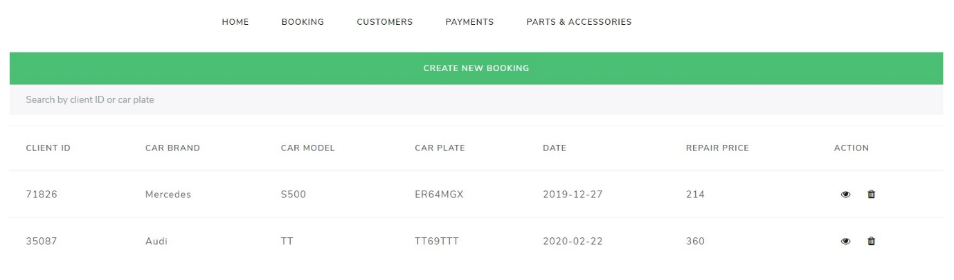
Figure 4 Created by student

Booking tab will allow user to view all bookings, or to select an individually booking for viewing booking details or to delete that booking (in case that customer does not want anymore to attend his appointment to the garage) (Fig 4).
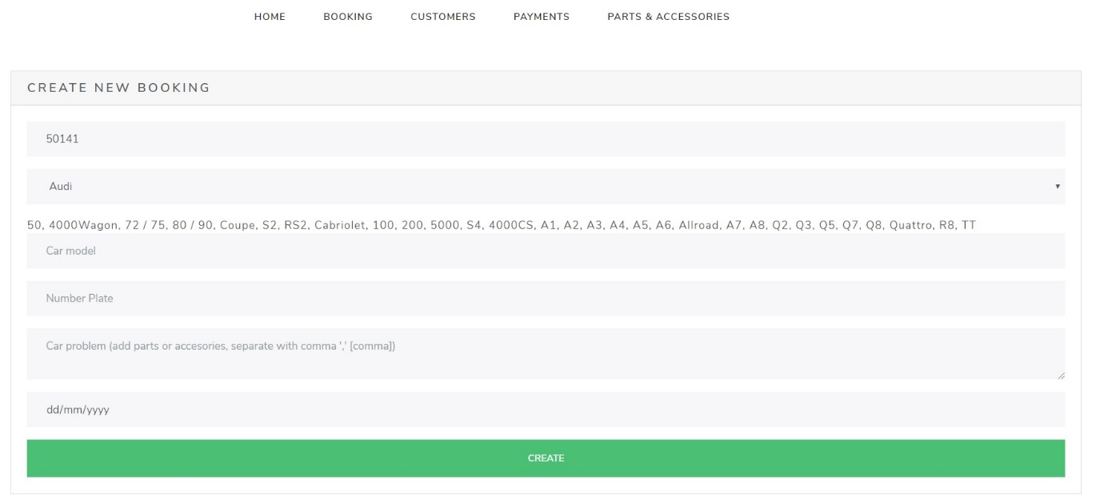
Figure 5 Created by student
Also, user can create a new booking, where he can fill the form with all details about car, about car problems and booking date (Fig 5).
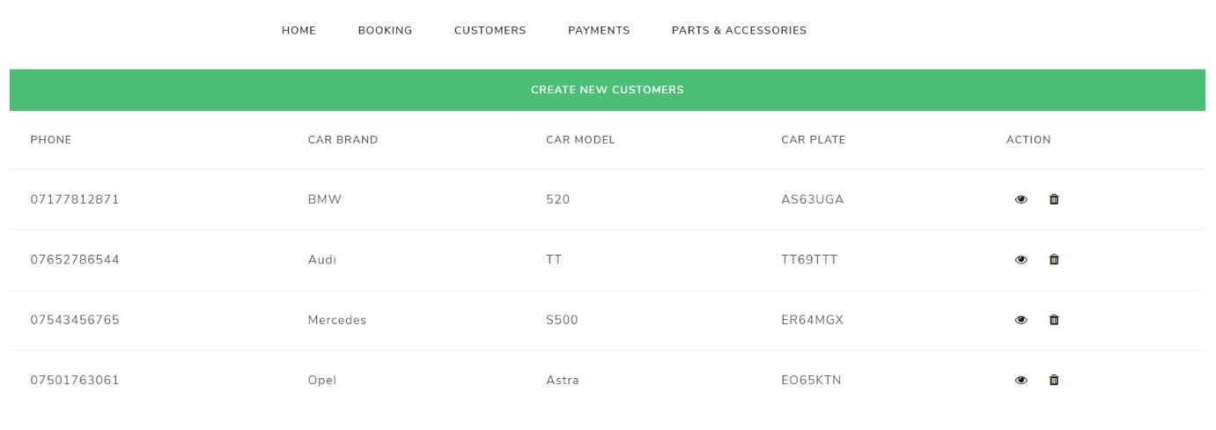
Figure 6 Created by student

Customers tab will allow user to view all existent customers, to delete from them and to create new ones by clicking button Create New Customers (Fig 6).
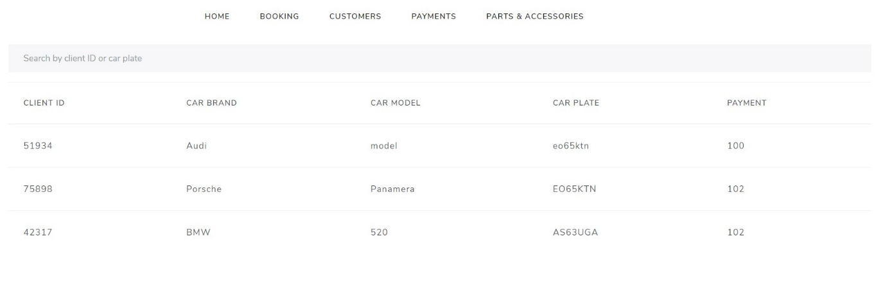
Figure 7 Created by student
In payments tab, we can view all the payments which have been made, in a descendent order, or you can search for a payment by client ID or car plate (Fig 7).
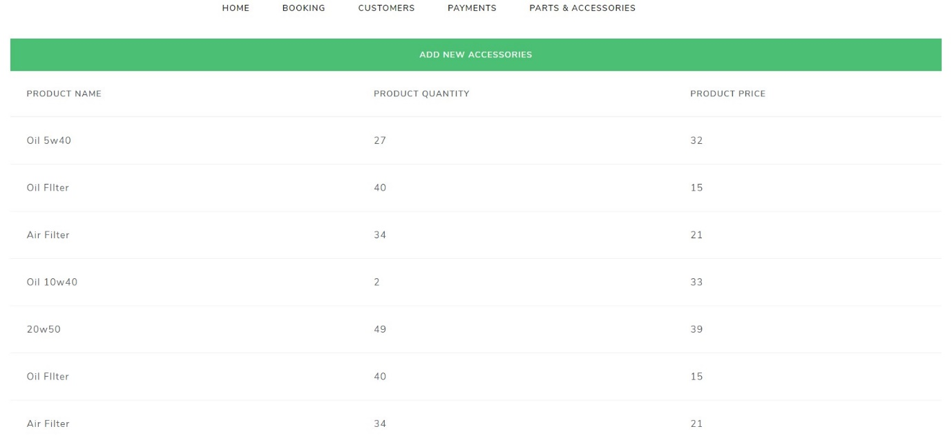
Figure 8 Created by student
Last tab will show to user the real available stock (will update automatically whenever any new bookings will be created by using any parts from stock availability) and prices for each one of them, but also will help Mr Japhet on monitoring a real available stock, helping him in managing new orders for company, adding new accessory if need it (Fig 8).

References

Al-Rousan, T. S. S. a. S. R., 2009. Risk analysis and Web project management. Volume 4(6), pp. 614-621.
Feng, J. Z. F. a. L. M., 2009. Research on Work Breakdown Structure of IT Project. In 2009 International Conference on Management and Service Science (pp. 1-5). s.l.:s.n.
Lawrence, D. a. T. S., 2006. Balanced website design: optimising aesthetics, usability and purpose (pp. 93-96). s.l.:Springer Science & Business Media.

