Student Name: | Andrea Mileva
Student ID: | 1812394
Module No: | BMSK4003
Module Title: | Digital skills and research methods
Lecture: | Balendran Kandasamy

DIGITAL SKILLS AND RESEARCH METHODS

Table of Contents
INTRODUCTION 4
PART 1 4
1. Implementation of web-based emails for the business 4
2.1 Comparison of two different Smart Phones 5
3: Recommendation web-based emails 6
3.1: Recommendation (Smart phones) 7
Part 2 8
1. Facebook as marketing tool 8
CONCLUSION 11
Part3 Evidence of my Accounts: 12

INTRODUCTION
Health and care services in UK are improving day by day. The annual assessment of health and care of UK is done by Care Quality Commission. It has improved the quality and safety of health care by inspecting the organisations providing it regularly. Digital technology is developing and progressing and is changing at a rate where it can break messages and signals by using codes. It makes it easy for the company to attract more customers with innovation and creativity. The report will be consisting of information about how digital technology helped in improving health and care services. It includes definition of web-based emails and also how it benefits the business of health and care. It includes comparison of Gmail and yahoo and then includes recommendations about how performance of the business can be improved.

PART 1

1. Implementation of web-based emails for the business
In this section I will be exploring two web-based mails:

Web-based emails uses website as portal to open email of different people. It is pretty convenient and by using just one web browser any other person can visit to read and send the email online to others. For this an internet connection is required an if the internet cannot connect then email is not accessible to the person (Digital marketing techniques 2018). The emails are stored at one place so if any technical error arises, all email get lost. The benefit it gives to business of health and care is that it provides convenience to the business and help in storing the important messages and information in the mail by storing them centrally and can access it from anywhere. The other benefit is cost benefit as the big providers of webmail services are usually free which increases the efficiency of the company in providing health and care services. The other benefit is that it helps the company in storing large data as they provide storage in gigabytes and the company does not need to delete the data which saves their time and efforts (Ginter, 2018).
2. Comparison of different web mails
GMAIL is net based email subject to Google created in 2004
Many businesses prefer to work with Gmail

YAHOO is net based email subject to Yahoo. This net based email is gratis with paid variant as well, carry interface from 2012
(Baris,2016)
Here are the differences between both net based Mails (Baris2016):

FEATURES | GMAIL | YAHOO MAIL
FREE SPACE | 10GB | UNLIMITED
FASTENING SIZE | 25GB+10GB GOOGLE DRIVE | 25GB
MAIL ENTRY | IMAP AND POP | IMAP AND POP
SELF-ACTIVATING | CARRY | ONLY TO YAHOO MAIL
MAILS FROM OTHER LOCATIONS | CARRY | CARRY
UPHOLD | NOT CARRY | NOT CARRY
ACCOUNT  TERMINATION | 9 MONTHS | 8 MONTHS
MAIL DESIGN | NOT CARRY | ‘PLUS’ MEMBERS ONLY
CHARGE | FREE (FEE FOR MORE SPACE) | FREE (FEE FOR ‘PLUS MEMBERSIP’)

2.1 Comparison of two different Smart Phones
In this section I will explore the different between Samsung Galaxy Note8 and Lenovo K8 Note
(Gsmarena.com,2018)
FEATURES | SAMSUNG GALAXY NOTE8 | LENOVO K8 NOTE
PUBLISH | 2017, AUGUST | 2017, AUGUST
GPRS | YES | YES
CELERITY | 1024/150 Mb/PS | 300/50 Mb/PS
MEASURE | 162,5x74.8x8.6 mm | 154.5x75.9x8.5 mm
HEAVINESS | 195g | 180g
CONSTRUCT | BOTH SIDES GLASS/ ALLUMINUM CORPOSE | ALLUMINUM TRUNK
DOUBLE SIM SLIT | YES | YES
TOUCH SCREEN | YES | YES
PROPORTION OF SCREEN | 16M COLOURS | 16M COLOURS
MEASURE OF SCREEN | 6.3 inches | 5.5 inches
CONSTANCY | 1440x2960 pixels | 1080x1920 pixels
SAFETY | GORRILA GLASS 5 | GORRILLA GLASS 3
RECOLLECTION | 64/128/256MB,6GB RAM | 64GB, 3/4/32 GB RAM
EXTRA SPASE (SD) | UP TO 512GB | UP TO 256GB
CAMERA | 12MP/2x zoo/LED FLASH | 13MP/DOUBLE FLASH
SPEAKERS | YES | YES
BLUETOOTH | YES | YES
INFRARED | NO | NO
TRANSMITER | NO | YES(FM)
SENSORS | YES | YES
SPEAKING TIME | 22 HOURS | 25 HOURS
DEFEND | NO | 378HOURS (3G)
MELODY PLAYER | 74 HOURS | UNCNOW

3: Recommendation web-based emails
- The company should create a friendly website that can drive more traffic to the website and can attract more patients who can avail various services.
- The company should use social engine marketing in which advertisements about the company will be available to large base of customers.
- The company can use effective inbound content which will provide right content to users and will produce effective results. Company should use healthcare CRMs to collect patient data from different sources which will help company to make different strategies.
- The company can use Facebook, Instagram and Twitter to engage with patients and support physicians and to improve outcomes of population. Physicians and doctors use social media to share their knowledge and information to improve care for patients.
- The young generation are turning to online resources to treat themselves therefore, company can provide different solutions to them for health and care (Chaffey, 2019).
- The company should work on establishing efficient social media presence as digital marketing method will get more and more customers as everyone has internet connection and its access. It will expand the business as well as help patients in dealing with their problems and diseases while staying at home as well as will create efficient flow of communication with the existing and new customers.
- Digital marketing needs new ideas and innovations which will include search engine optimization which will help the company in improving its ranking in terms of services and in order of occurrence. The company should use google ad word tool to help with list of
keywords. The company should keep adopting new technologies and innovations.

From my side I like to use Gmail, because is easy for me to use, I have account from around 8 years and using it very common. I can do everything what I need with my account- send email, picture and other files if is need.

About the Yahoo I have to create account to speak from my opinion.

3.1: Recommendation (Smart phones)
From what I found in my research look like Lenovo K8 Note have some extras than Samsung Galaxy Note 8, and the cost of Lenovo is greater than Samsung. The Lenovo K8 Note is lighter weight than Samsung Galaxy8 Note, the power is better, but there is a button on the screen that makes it smaller than Samsung Galaxy8 Note.
From my opinion I recommend Samsung, because I am using it for 2 years now and I am really happy with all the apps the coming with. I am with Samsung S8+ and can use it Office packet on, have space for all of my documents and files. All the picture of my son from his birth are there and saved in Google Drive. I am sure they are on safe place.
About the Lenovo I have some friends which are happy with this brand of Smart phone, but they said that the system is not so strong and coming with fabric defects. Can not speak from my own opinion about this branch of Smart phone.
Always will have persons which is like or dislike some kind of technologies, but I want to say that I nowadays everything is in your pocket size modern technology and we are lost without it. You can use so many apps for free which make your life much easier.

Part 2

1. Facebook as marketing tool
Facebook gives the most obvious benefit to home care services which allow doctors and experts of medical to connect with patients. It helps them in connecting with people which build relationship with them. Facebook can link many people as everyone have access to internet. It increases awareness among patients as it provides trusted information on immunization, therapies etc. Facebook helps in monitoring public health and by the use of hashtags it helps in revealing the different diseases to people and aware them about its symptoms and precautions. Facebook offers advantage over traditional data sources as it includes real time data, easy access and reduced cost. It allows customers or viewers to ask and answer questions, give feedbacks and monitor public health (Galati, and et.al., 2017).
Facebook groups are also, consider to be a great place for healthcare professionals and it allows patient to interact with each other. This give support to patient and increases the willpower. There is a privacy concern when patient discuss their health online and therefore Facebook have secret groups which does not show search results and users get invited to join in and their privacy does not get violated. It offers an opportunity to understand demographics of social media which uses keywords to target social media ads and opportunity to connect with survey participants.
Recent study showed that almost three quarter of patients search their doctor from online reviews. The patients who leave positive reviews on Facebook tend to attract more new patients from the positive reviews. When patient gives negative review, it is important that doctor respond to it else it will create negative image of the heath and care institute (Decarolis and Rovigatti, 2017).
Facebook offers Facebook ads that appear in side column of the site and are referred commonly as marketplace ads. Implementing this strategy can increase customer base and reach. Facebook advertising includes ad testing which compares design of ad and set up. To increase home services of the institution Facebook can increase brand awareness by hosting contests on Facebook which may include survey or questionnaire on health and issues facing by the patients or their knowledge about certain diseases which will increase their awareness and safety concerns as well.
Facebook present new opportunities for patients that are seeking for help and can help in sharing important information on health and care. Most important benefit it allows is to give 24 hours access to the patient or anyone who is seeking for help. It helps in communicating with public, improving patients experience by giving them efficient feedbacks. Facebook ensures compliance with health and care industry's regulations.
In short Facebook is an efficient digital marketing tool which is growing with innovations at an increasing speed. It allows individuals to have better services and knowledge with the help of various doctors and physiologists. It is cost efficient method and is accessible to all and captures wide range of public and increase institution's reputation (Google Books, 2016).

Like example here is how UK Homecare pages looks like (Domiciliary Care)
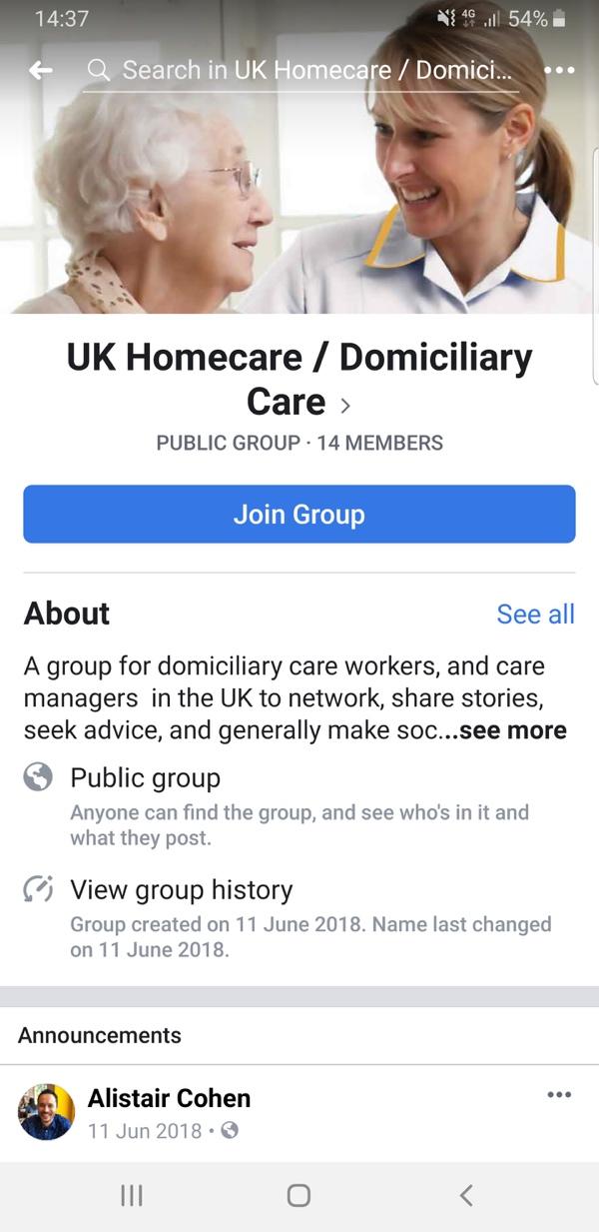
You have to join the group to see all the hide information
They got 14 members which can interact each other, to change information and opinion, post any recommendation or promotions and feedbacks
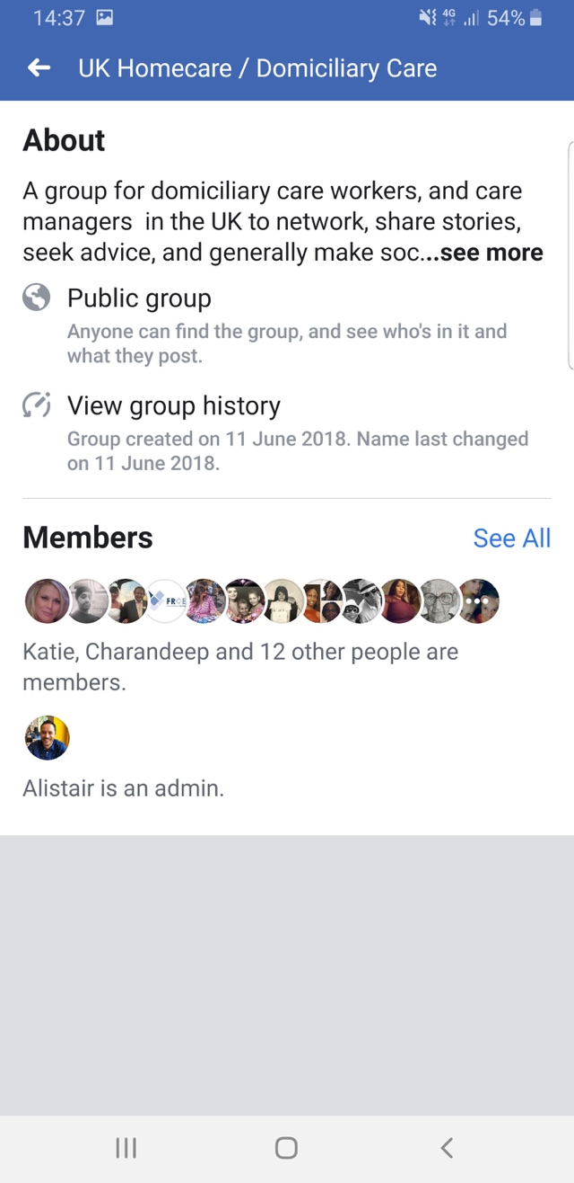

CONCLUSION
The report mentioned the importance of digital skills and how it has adopted by many companies to increase their sales and reach. It included the slight difference between Gmail and Yahoo mail and summarised the use of Facebook as a marketing tool which is cost efficient as well as easily accessible to the customers.
If looking for recommended Homecare can look the pages for reviews and feedback. You can find in there pages all the information that you need to choose the Best one for your needs (for family member). Most of the Homecare pages in Facebook are recommended by personal opinion of the users.

The modern technologies are total part of our live without them we not will can do it what we do now. The smart phones are our pocket measure computer and all of us is inside. They are our navigators and make our daily life easier.

Part3 Evidence of my Accounts:

This my Facebook profile created in 2009
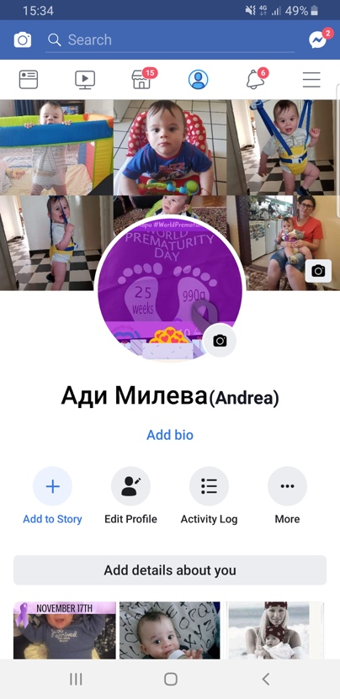
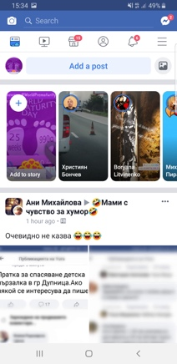 With link: https://www.facebook.com/tursqte

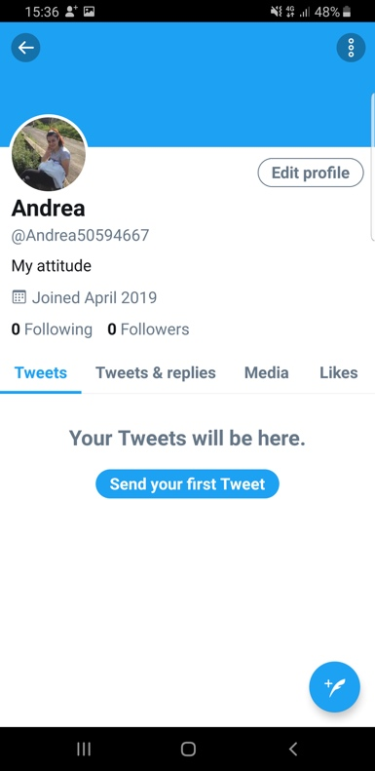
Create 2019

With link: https://twitter.com/AndreaMileva

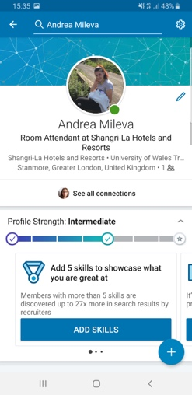
My LinkedIn profile: Create 2019

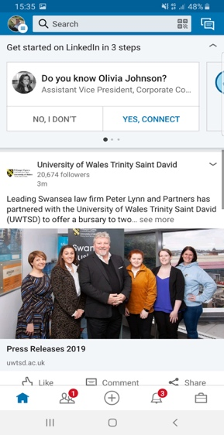

Link: https://www.linkedin.com/in/andrea-mileva-501b30113?lipi=urn%3Ali%3Apage%3Ad_flagship3_profile_view_base_contact_details%3Bz2TBe1i1Q2Gng%2FlvUS4nSQ%3D%3D

REFERENCES
Books and journals
Chaffey, D. and Ellis-Chadwick, F., 2019. Digital marketing. Pearson UK.
Drummond, M.F., and et.al., 2015. Methods for the economic evaluation of health care programmes. Oxford university press.
Galati, A., and et.al., 2017. Social media as a strategic marketing tool in the Sicilian wine industry: Evidence from Facebook. Wine Economics and Policy. 6(1). pp.40-47.
Ginter, P.M., Duncan, W.J. and Swayne, L.E., 2018. The strategic management of health care organizations. John Wiley & Sons.

Bibliography: Decarolis, F. and Rovigatti, G. (2017) Online Auction and Digital Marketing Agencies. Available at: https://www.cabdirect.org/cbdirect/abstract/20163119611 [access at 16/04/19]

Online
Baris, P. (2016). Difference Between Hotmail vs Gmail vs Yahoo- Quick Comparation | Tec jaws
-SEO, Computer Security, Technology. [online] Google.com. Available at: https://www.google.com/amp/s/www.techjaws.com/differences-hotmail-vs-gmail-vs-yahoo/ [access 12/04/19]
Chaffey, D. and Ellis-Chadwick, F., 2019. Digital marketing. Pearson UK. Available at: https://catalogue.pearsoned.co.uk/educator/product/Digital-Marketing/978129224159.page [access 18/04/90]
Digital marketing techniques 2018. [Online]. Available through: https://www.digitalvidya.com/blog/five-types-of-digital-marketing/ [ access 08/04/19]
Drummond, M.F., and et.al., 2015. Methods for the economic evaluation of health care programmes. Oxford university press. Available at:
https://www.oupjapan.co.jp/en/node/8281?languege=en [10/04/19]
Galati, A., and et.al., 2017. Social media as a strategic marketing tool in the Sicilian wine industry: Evidence from Facebook. Wine Economics and Policy. 6(1). pp.40-47. Available at : https://www.sciencedirect.com/science/article/pii/S2212977417300054 [access 10/04/19]
Ginter, P.M., Duncan, W.J. and Swayne, L.E., 2018. The strategic management of health care organizations. John Wiley & Sons. Available at: https://www.wiley.com/en-us/The+Strategic+Management+of+Health+Care+Organization,+8th+Edition-p-9781119349709 [access 09/04/19]

Google Books. (2016). Sub-National Democracy and Politics Through Social Media. [online] Available at: https://books.google.co.uk/books?id [access 06/04/19]
Gsmarena.com. (2018). Compare Samsung Galaxy Note8 vs Lenovo K8 Note-GSMArena.com. [online] Available at: http://www.gsmarena.com/compare.php3?idPhone1=8505&idPhone2=8794 [access 26/04/19]

