Community Engagement
LCBB4002
Assessment 2

Karolina Kwiecien
2113036

09/05/2022

Table of Contents
Introduction 1
Gibbs Reflective Model 2
Description 2
Feelings 3
Evaluation 3
Analysis 4
Conclusion 4
Action Plan 5
Conclusion 6
References 7

Introduction
Community engagement is a crucial component of addressing challenges impacting the well-being of a community and collaborating with and working through groups of individuals who are linked together by common interests, geography, or other circumstances (Head, 2007). As a strong tool for influencing environmental and behavioral change, it has the potential to enhance health outcomes for the whole community. Collaboration and coalitions are important tools for achieving these goals because they assist to mobilize resources, influence systems, transform relationships between stakeholders, and function as initiators of policy, program, and practice alterations. Organizations may use community engagement as a powerful tool for product and service promotion (Li, 2006). Also, it may be used to spread the company's mission and vision. A favorable corporate culture and strong ties to the local community are fostered when businesses regularly participate in community service.
This report is based on the reflective review of my previous assessment. At my last evaluation, I was required to write an in-depth report on how I had engaged with the local community. Reflective review was conducted using Gibbs reflective cycle. Previously, Dementia UK, a non-profit located in the UK, Wales and Scotland, was included in the prior report. It is dedicated to helping those who suffer from dementia. Volunteers from all around the country are banding together to assist those who are sickened by dementia even in the Covid-19 outbreak. Various approaches and philosophies of community participation will be included in this paper.

Gibbs Reflective Model
A reflective model of my selection will be used to describe my learning. Reflection models abound, including the Gibbs reflective cycle, the Kolb reflective cycle, the Driscoll model, and the Johns' Model for Structured Reflection, among others. The Gibbs reflective model will be the tool I use to examine and synthesize everything I've learned so far. Reflection on a certain scenario, event, or action is made easier using the Gibbs Reflective Cycle (Adeani et al., 2020). Phases are used as a framework for reflecting on my past and the lessons I've learned from it. A lot of the time when I do this, it helps me reflect on my own conduct and learn how I might do things differently in the future.
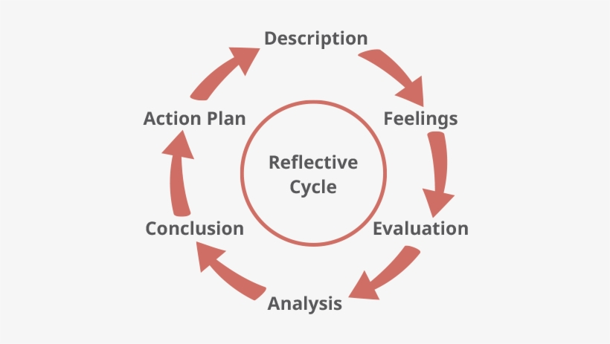
Figure: Gibbs Reflective Cycle

Description
This course has helped me get a better understanding of numerous facets of community involvement, which I will discuss in this reflective report. I learned a lot about community involvement theory in this module, and I also learned about several related models and ideas. During the first few weeks, I was able to lay a solid foundation for community participation by learning about the idea, its significance, and its advantages. Participation in non-segregated communal activities may help individuals gain new abilities or hone existing ones (Paul, 1987). During the creation of my previous assessment, I have gathered knowledge about community engagement standards, principals and how stakeholders benefited from engaging with community. As I have selected Dementia UK for my assessment purpose, I have learned real and practical knowledge about how an organization maintain relationship with the community and how they serve the community. Many companies and people who are involved with Dementia UK's success donate money on a monthly and annual basis, which helps the charity's mission to continue to thrive. I have been able to have a better understanding of the importance of community participation while studying and understanding about the report on community engagement that I was perusing. As a result of this module, I gained an understanding of the interpersonal skills and talents needed by workers and volunteers of an organization to be effective in community engagement, as well as the external elements that could provide a barrier to community engagement for organizations.

Feelings
The program grabbed my attention since I've always wanted to help improve society. In the past, however, I never had the chance to acquire theoretical knowledge or learn how to use different models and tools. As a result, I was intrigued by the idea of community participation from the start. Community participation was more difficult than I expected. It was challenging for me to comprehend what community engagement is and how it can be conducted, and what sort of organization performs community engagement, after I had introduced the concept. Choosing a community involvement organization to include in my research report was also a challenge for me. Community involvement has the power to reshape a neighborhood. Fair, egalitarian, and long-term results are made possible by increased public involvement in initiatives that have societal ramifications (Midgley et al., 1986). As time went on, I was able to investigate and analyze more about community participation, which provided me a better understanding of the subject matter. I was apprehensive about writing the report. In order to have my questions answered, I turned to a few of my close friends for assistance. It made me happy to learn about Dementia UK after I finished the paper since it is a genuine charity. My ambition to contribute to society's well-being has been bolstered as a result of this experience.

Evaluation
I had a great time learning about community participation. As a result of this experience, I have gained a better knowledge of the necessity of community involvement. Activities that bring individuals together to work together for the good of the community by considering all aspects of society are called community engagement. The fact that I had to do a lot of studying and study on the subject of Dementia UK has given me excellent research skills, which I value much. An important research talent is the capacity to do thorough study on a subject and to synthesize the findings into a single conclusion. Furthermore, I've learned issue solving and choice making abilities because anytime I discover a problem, I investigate it on my own to get aid from others, and I've resolved the issue, which has made decision making easy for me. Additionally, I learned how to raise money for a community engagement fund, which involves volunteers to volunteer as well as solicit contributions from a wide range of people, organizations, and businesses. A big portion of a charity's revenue comes from fundraising, but it's not just about the money. In addition to promoting a charity's message and aims, fundraising may also encourage others to join in and spread the news (Webber, 2004). Because I had to speak with my tutor, classmates, friends, and seniors to learn about the many types of community participation in the society, I was able to enhance my verbal and writing communication skills, as well as my ability to think critically and creatively. This study has not only taught me new skills, but it has also inspired me to become involved in the community and assist those in need, both of which I believe are vital to society as a whole. Whenever a problem in the community arises, I can better prepare myself for committee work by learning how to involve the community and developing the necessary skills and tactics needed by volunteers.

Analysis
It was an excellent chance for me to have a greater understanding of how I may contribute to the advancement of society, and I believe the module went well. When it comes to my understanding of community participation, the presentation was a huge assistance in that regard. Initially, I had a hard time comprehending some of the models and ideas, but I turned to internet resources that helped me a great deal. Dementia UK's report on community participation also helped me discover how the techniques and concepts I learned in the curriculum may be put into practice. For example, I've learned about a variety of community involvement tools and platforms, such as social media, going live, community mapping, and so on. Due to their popularity and low cost, social media platforms are a great method to connect with others today's young adults and those in the generations following them (Kasemsap, 2019). It's also important to note that Dementia UK makes good use of social media platforms like Facebook and Instagram to connect with those who wish to contribute money or volunteer their time. In order to carry out their duties successfully and efficiently, such organizations need a high level of expertise and experience among its staff and volunteers. Interpersonal skills can only be improved via formal education and training.

Conclusion
For me, it was a memorable opportunity. I've never had to write an assignment like this before, and this module helped me learn a new subject that may be vital to a student's future. Understanding the importance of community participation and its role in society has helped me to better understand my own position and obligations as a human being in the world. As a result of this experience, I've realized that I need to become more skillful and informed so that I can handle such situations better in the future. In order to deal with the bad aspects of the experience, I need to be more upbeat and seek out assistance from people if I run into difficulties. Because of my recent experiences, I've been able to strengthen my skills and decrease my flaws in light of the new possibilities that have opened up for me. A student's life is a process of learning and growth, and a comparable module in the future will assist me to better myself and become more effective as an employee.

Action Plan
An action plan is a written document outlining the procedures necessary to attain a specified objective. In order to achieve a certain objective, an action plan outlines what resources are needed, what actions need to be accomplished, and when they need to be finished (Do, 2009). In order to achieve my professional goals, I need a strategy for improving my deficiencies and acquiring new abilities that will benefit me when I apply for jobs. It's imperative that I be better prepared in the event that a similar circumstance arises in the future. There is still room for development, despite the fact that I've gained so many new abilities through the experience.
To begin, I need to improve my research and analytical abilities so that I can better comprehend the ideas and models. That's why I'm going to employ a variety of trusted web resources to help me out. As a result, I want to pay greater attention to the professor and address any questions I may have. By engaging more with others, rehearsing public speaking, and engaging in extracurricular activities, I want to improve my communication abilities. The best way to gain problem-solving and decision-making abilities is through interacting with people in my own neighborhood and helping them solve their difficulties. I want to join a nonprofit organization in order to learn more about community involvement and to help improve the world around me. So, I'll sign up for training and development programs to help me get there. My self-confidence and interpersonal skills will improve, allowing me to more effectively participate in community service.
Having these abilities will help me develop my other competences, such as flexibility, creativity, and leadership, which will open me a wide range of job options. Employees that are able to mold themselves in a hard scenario and make the best judgments for the company's objectives are preferred by most employers. My Action Plan will focus on improving my time management, negotiating, leadership, problem-solving, and analytical abilities. Developing these abilities will help me deal with similar circumstances in the future and enhance my employability, both of which are advantageous to me.

Conclusion
Every person has a duty to help the community and establish a better society. Working as a team with a group of volunteers may make it possible for a person to alter and contribute to the committee. As a result of this course, I now have a better understanding of how to assist others in my community who are in need. Having a positive impact on the lives of others may provide a sense of fulfillment that can lead to happiness. As I prepared this report, I drew on my previous experience working with the organization to include the community in the process. The module has described the information and abilities needed for community participation, as well as the importance of managing such duties. To be a part of the social life of the society, people need to be able to communicate and engage with one other. Such volunteer activities have been promoted by social media platforms in order to foster communication among those who are prepared to put their time and effort into charitable causes. Improve my communication skills and become involved in volunteer work if I want to increase my community involvement.

References
Head, B.W., 2007. Community engagement: participation on whose terms?. Australian Journal of Political Science, 42(3), pp.441-454.
Adeani, I.S., Febriani, R.B. and Syafryadin, S., 2020. USING GIBBS’REFLECTIVE CYCLE IN MAKING REFLECTIONS OF LITERARY ANALYSIS. Indonesian EFL Journal, 6(2), pp.139-148.
Paul, S., 1987. Community participation in development projects. Washington, DC: World Bank.
Midgley, J., Hall, A., Hardiman, M. and Narine, D., 1986. Community participation, social development and the state. Methuen.
Webber, D., 2004. Understanding charity fundraising events. International Journal of Nonprofit and Voluntary Sector Marketing, 9(2), pp.122-134.
Kasemsap, K., 2019. Professional and business applications of social media platforms. In Social entrepreneurship: Concepts, methodologies, tools, and applications (pp. 824-847). IGI Global.
Do, W.Y.C., 2009. Action plan. City.
Zakus, J.D.L. and Lysack, C.L., 1998. Revisiting community participation. Health policy and planning, 13(1), pp.1-12.
Li, W., 2006. Community decisionmaking participation in development. Annals of tourism research, 33(1), pp.132-143.

