Enhancing Awareness and Engaging the Community
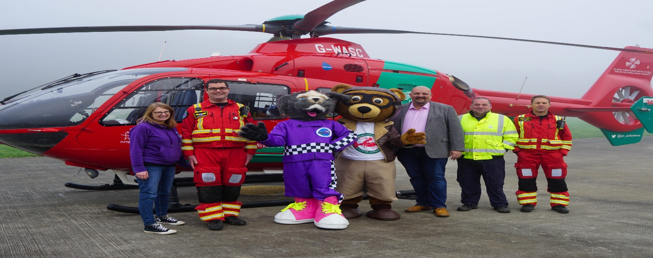

Raising awareness for causes like the Welsh Air Ambulance is not just about spreading information, it is about sparking engagement within the community. Our team recognized this and began a multifaceted awareness campaign, employing creative strategies to captivate and inform.
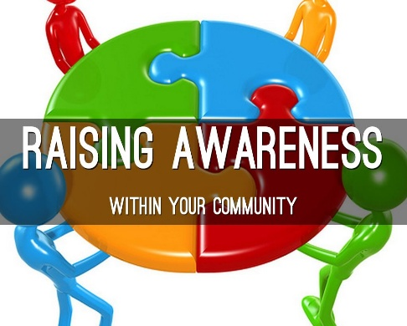

One of our primary tactics was creating and distributing compelling promotional materials. From vibrant flyers to engaging social media graphics, we ensured that our message was not only informative but also visually appealing. These materials served as the frontline in our mission to raise awareness.

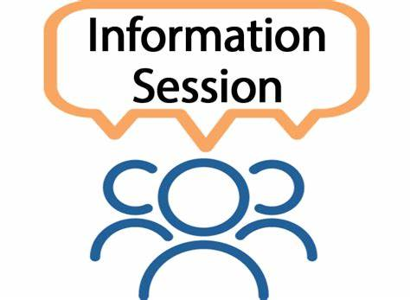In addition to the digital realm, we took our campaign to the grassroots level by organizing informational sessions at community centers. Here, we had the opportunity to interact directly with individuals, sharing insights into the invaluable work of the Welsh Air Ambulance.

Integral to our campaign's success was the meticulous planning facilitated by the Work Breakdown Structure (WBS). “A Work Breakdown Structure (WBS) is a key visual project tool functioning as an obligation in managing projects, due to playing a crucial role from planning to execution” (Putro, 2022, pp. 1291-1299). This hierarchical decomposition of tasks ensured that every aspect of our campaign was thoroughly considered and accounted for, from designing promotional materials to organizing community sessions.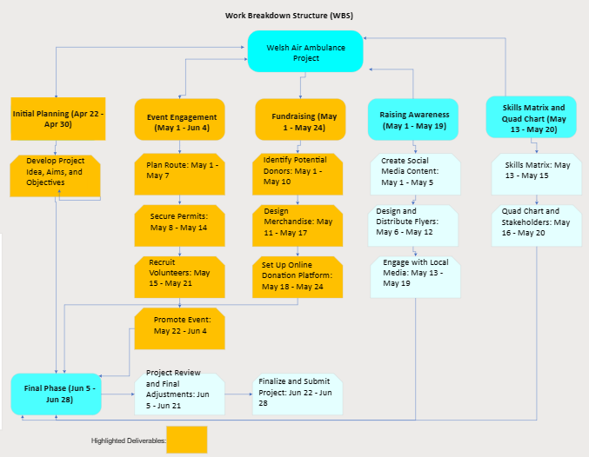

Moreover, our commitment to excellence extended to risk analysis, where we proactively identified potential challenges and developed mitigation strategies. By preemptively addressing concerns such as logistical hurdles or communication barriers, we were better equipped to navigate the complexities of our awareness campaign.
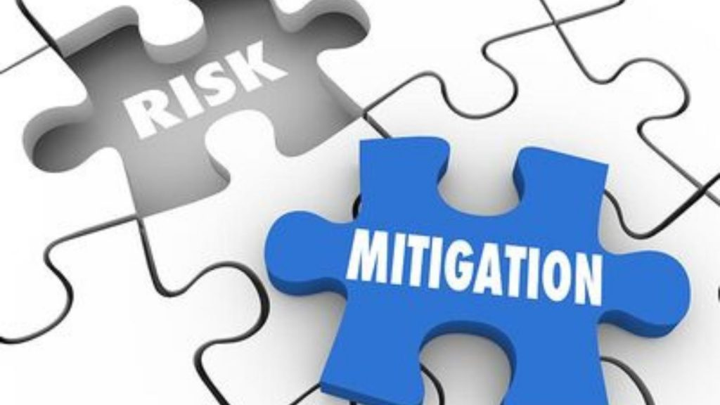

Our journey to enhance awareness and engage the community in support of the Welsh Air Ambulance was characterized by creativity, adaptability, and meticulous planning. Through strategic use of promotional materials, informative sessions, and dynamic team roles, we succeeded in not only spreading awareness but also fostering a deeper connection with our cause within the community.

  - Reference list
Putro, A., Latief, Y., Nursin, A. and Soepandji, B.S., 2022. Development of Work Breakdown Structure for Stadium Work as Project Guideline and Standard. International Journal of Engineering, 35(7), pp.1291-1299.

