bSc Health & Social Care Health, Wellbeing and Sustainable Development report (BMHP6021 BIRM)

Student Name: Shilpi Begum Student Number: 1810998
Lecturer: Chloe Harries/Joanne Davies

Content Page
Introduction ……….……….………………………………………………………………….
What is Health ……………………………………………………………………………….
Why is it Important ……………………………………………………………………………
What is Well-being …………………………………………………………………………...
Why is it Important ……………………………………………………………………………
What is Sustainable Development ………………………………………………………….
Why is it Important ……………………………………………………………………………
What are Sustainable Development Goals ………………………………………….…….
Why are the SDG’s Important ………………………………………………………………
No Poverty Goal 1 ……………………………………………………………………………
Strategy/ Programme: 1 Tackling Rural Poverty & Social Isolation ………………….…
Benefits of TRPSI .….…………………………………………………………………….….
Challenges and Considerations …………………………………………………………….
Summary ...…………………………………………………………………………………...
Strategy/ Programme: 2 Living Wage Implementation ………………………………......
Benefits ………………………………………………………………….…………………….
Challenges and Considerations …………………………………………………………….
Summary………………………………………….………………….….…………………….
Zero Hunger Goal 2 ………………………………………………………………………….
Strategy/ Programme: 1 National Food Strategy for England ……………….………….
Benefits ………………………………………………………………………….…………….
Challenges and Considerations …………………………………………………………….
Summary……….……………………………….…………………………….……………….
Strategy/ Programme: 2 School Meal Programme ……………………………………….
Benefits ………………………………………………………….…………………………….
Challenges and Considerations …………………………………………………………….
Summary .…………………………………………………………………………………….
Progress by UK Government ……………………………………………………………….
Challenges in Implementing Goals …………………………………………………………
Recommendation …………………………………………………………………………….
Conclusion …………………………………………………………………………………….
References List ……………………………………………………………………………….

Introduction:
This report is for the NHS chief, and it looks at the establishment of Sustainable Development Goals (SDG’s) , their purpose, how and why they were brought into existence. On the 1st of January 2016 the 17 Sustainable Development Goals (SDG’s) of the 2030 Agenda were adopted by world leaders and in September 2015 at a historic UN summit, this officially came into force for all member countries. These new goals were to be applied universally over the following 15 years by all countries involved to help end poverty, tackle climate changes, and fight inequalities ensuring no one was left behind. The SDG’s are also known as Global Goals which were built on the success of the Millennium Development Goals (MSGs) the aim of which was simply to end all forms of poverty (UN, 2023a; WHO, 2023). The leaders of 193 countries came together to face the future and what was witnessed was frightening. War, Famine, Drought, Plague, Poverty in their own cities, towns, villages and not just in faraway places, and even though there was enough food to feed all, it wasn’t getting shared which led to a call for universal action to end poverty, protect the planet and to ensure all individuals enjoy peace and prosperity (UNDP, 2022; WHO, 2023).
The SDG’s are about ending poverty together with strategies that build economic growth addressing a variety of social needs, including health, education, social protection, job opportunities, while tackling climate changes and addressing environmental protection. Although SDGs are not legally binding none the less government is expected to take possession and establish framework for the achievement of the 17 Goals (UN, 2023). Sustainable development is defined as “development that meets the needs of present without compromising the ability of future generations to meet their own needs” (IISD, 2023; UN, 2023a).
Definition of Concepts
The following section will provide definitions of important concepts integral to this report and discuss and evaluate these.
What is Health:
The NHS uses a “broad definition of health that encompasses both physical and mental health, including wellbeing”, meaning they are not only interested in whether people are ill or have health issues, but also how well or healthy they are (Department of Health, 2010). According to the World Health Organisation (2023d) “health is a state of complete physical, mental and social well-being and not merely the absence of disease or infirmity”. Being able to attain the highest standard of health is a fundamental right of every human being without distinction of religion, race, political belief, economic or social condition (Sartorius, 2006; WHO, 1946f). According to Merriam – Webster dictionary (2023), the meaning of health is, sound mind body, or spirit especially: freedom from physical disease or pain of overall condition of the body.
Why is it Important:
Health is very important as it affects a person’s physical, mental, and emotional wellbeing and therefore it is extremely vital to be proactive about health, taking measures to prevent illness and disease (Downtown Medical Group, 2024).
Being healthy should be part of an individual’s overall lifestyle, as living this way of life can help prevent chronic diseases and long-term illnesses and feeling good about themselves and taking care of their health is crucial for a person’s self-esteem and self-image ( The Foundation for Peripheral Neuropathy, 2022).
Eating the right food, and keeping fit will help the body to remain strong, help to cope with stress and fight illness, staying physically healthy can help people to stay healthy emotionally (Childline, no date). Being healthy has positive impact on relationships as well as better overall health, good quality life, living longer and this leads to reduction to the health care system as prevention is the key (NHS UK, 2023).
What is well-being:
Wellbeing has been defined as combination of feeling good and functioning well: positive emotions like happiness and fulfilment, having control over one’s life, having purpose in life and positive relationships (Ruggeri et al., 2020; My Health Devon, 2024). According to WHO (2023b) “well-being encompasses quality of life and the ability of people and societies to contribute to the world with a sense of meaning and purpose”. Simons and Baldwin (2021) states that wellbeing is a state of positive feeling and meeting full potential in the world as a member of society, inclusive, free from cultural bias and this can be measured subjectively and objectively using an autogenic approach. Wellbeing is a complex combination of an individual’s mental, physical, emotional, and social health which are strongly linked with life satisfaction (VSGA, 2021). Wellbeing is feeling good, an individuals experience of their life; and comparison of life circumstances with social values, norms and this can be measured subjectively and objectively (Department of Health, 2014).
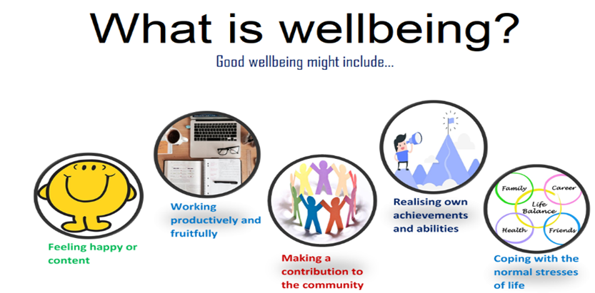
Beckfoot Oak bank School (2023)
Why is it important:
Wellbeing is crucial to health as it adds years to life, helps to improve recovery illness, association to positive behaviour in children and adults leading to broader positive outcomes, a great influencer of good mental health, this leads to reduction in the demands on the health care system (Department of Health, 2014). Wellbeing is very important as it’s not only illness or disease that makes us unwell, it is also how we feel, think, act. The way we recognise ourselves and other plays a major factor in our overall wellbeing, and this is linked to improved general mood and happiness, research has proven, good wellbeing adds years to life, recovery from illness is much better due to a positive mind set, and also has positive influence on others close to us (My Health Devon, 2024).
What is sustainable Development:
“Sustainable development is development that meets the needs of the people present time without compromising the ability of the future generations to meet their needs”, sustainable development is about finding better ways of doing things for both present and future (SDC, 2023, Circular Ecology, 2023). Sustainable development seeks to achieve social and economic progress in ways which will not exhaust earths finite natural resources, thus looks for ways to develop to meet needs of current and future generations (IISD, 2023). Sustainable development is a broad term to describe investments, policies and projects that provide benefits today without sacrificing environmental, social and personal health in the future (WHO, 2023c).
Why is it important:
Sustainable development is crucial to human survival for now and the future, conserving resources, keeping balance between the environment and development while meeting the necessary demands. It must protect the environmental degradation for better economic growth (Your Article Library, 2023). Sustainable development ensures preservation of our planet and its natural resources like air and water, supporting long term goals with the implementation of systems framework ensures support from global, national and local entities and building sustainable future, cultivating sustainable ways of living will lead to reduction in pollution and protect the planet by integrating economic growth, social well-being and environmental protection (UN, 2023). Sustainability is our society’s ability to exist and develop without depleting all natural resources needed to live in the future.
United Nations 17 Sustainable Goals (SDG’s)
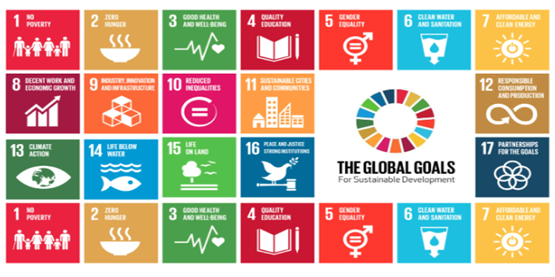
(United Nations, 2015).
What are sustainable Development Goals
Above are the 17 Sustainable Development Goals, which are the result of Brundtland Report, this was named after the commission’s chairwomen Gro Harlem Brundtland, which stated that critical global environmental problems were primarily results of enormous poverty (Brundtland Report, 1987). Above are the 17 sustainable development goals (SDG’s) which were adopted to “end poverty, protect the planet, and ensure prosperity for all” , the agenda 2030 emphasises the SDG’s are interlinked, and recognises the significance of ensuring integration across all the sectors of research (Cernev and Fenner, 2020).
The SDG goals were adopted by all united nations member state in year 2015, a shared blueprint for prosperity and peace for countries developed and developing in a global partnership, ending poverty and disparities must go hand in hand with strategies that enhance health, education, economic growth, reduce inequalities while tackling climate change as well as preserving forest and oceans (United Nations, 2023).
Why are the SDG’s Important:
SDGs are very important to end poverty, and inequality, protection of the very planet we reside on as well as preserving it for the future generations, and ensure that all people enjoy health, prosperity, justice as it’s critical that no one is left behind (WHO, 2023e). SDG’s guide help to meet the required development goals economically, socially while ensuring environmental sustainability globally (IMF, 2023). It is extremely vital to meet the targets of SDG’s goals to reduce the global risk, the impact of the non-achievement could possibly expose humanity to global catastrophic risk and existential risk (Cernev, and Fenner, 2020: , Chams and Garcia-Blandon, 2019).

No Poverty : Goal 1
A basic definition of poverty is when a person’s resources (mostly material resources) are not sufficient to meet their minimum needs including social participation, simply meaning unable to meet the minimum needs that deemed reasonable by the standards of society (JRF, 2014). Poverty is a state or situation in which a individual or a group of people don’t have enough to meet their basic need, hunger and malnutrition, limited access to education and other basic services, social discrimination, exclusion, lack of participation in decision making (UN, no date).
Below is the Maslow’s Hierarchy of Needs, at the bottom of the pyramid shows the very basic need of individual which must be meet, Physiological needs are biological requirements for human survival such as food , water, shelter, clothing, warmth, sleep the most basic need must be met to motivate individuals’ behaviour (Simple Psychology, 2024).
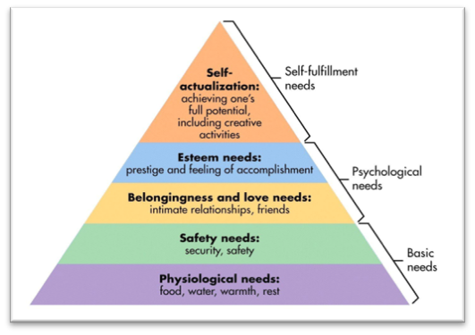
(Simply Psychology, 2024).
Strategy/ Programme 1: Tackling Rural Poverty & Social Isolation
An initiative to Tackling Rural Poverty and Social Isolation (TRPSI) this is led by the Department of Agriculture and Rural Development (DAERA) and aim of this programme is to tackle social isolation and poverty in rural areas by working in connection with other organisation in partnership, designing and implementing measure targeting the needs of vulnerable people ((DAERA, 2023).
The new TRPSI Framework is 3rd in series of anti – poverty initiatives put forward by Department of Agriculture, Environment and Rural Affairs (DAERA) , and builds on the achievement of two previous initiatives, the Anti – Poverty and Social Inclusion Framework (APSI) 2008 – 2011 (DAERA, 2023).
Benefits of TRPSI:
The benefits of TRPSI Framework is very unique focusing on the needs of the most vulnerable groups in rural areas, It seeks to maximise the benefits from the TRPSI funding at DAERA’s disposal and to promote the sharing, learning and expertise as well as combine and utilise tools such as financial resources, staff resources, legislation including resources and expertise of other public sector bodies and the local knowledge and skills provided by the rural community sector, is a tremendous benefit which is gained through collaborative approach that can lever additional resources for the benefit of rural communities (DAERA, 2023).
The framework provides a cohesive and effective structure to the approach to be taken by government policy and a direction of travel for other public stakeholders and private investors (RTPI, 2021).
Benefits of these programs is to develop infrastructure in rural communities, supporting rural groups and dwellers tackling issues like isolation, inclusion, and rural poverty by enhancing communities as well as employment (DAERA, n. d.). Providing opportunities for people to come together and build local connections leading to improved wellbeing as well as reducing isolation and loneliness, as prevention has the potential to strengthen communities and improve lives (TNLCF, 2019).
Challenges and Considerations:
There are many challenges that rural communities face, like climate change and environmental sustainability, access to public services like health, education, social service, transportation and infrastructure, employment, mobile phone connectivity / broadband and many more (RTPI, 2021).
A report by the International Development Committee highlights the stark challenges the world faces in meeting SDG1, all countries involved agree that this is due to Covid-19, conflicts and climate change which is undermining the progression towards eliminating extreme poverty and also stating that there is no quick fix as the world is not on track to achieve the SDG1 by 2030 (UK Parliament, 2023).
Summary:
A joint effort from all departments involved including the government, with responsibilities to provide services in rural areas, supporting the effective delivery of local services in rural areas are managed effectively to ensure they meet the needs and are delivered as efficiently as possible, specially access to employment, housing, reliable transport services as poverty and deprivation in rural areas tend to be “hidden” which can result in a reduced focus on rural area (RTPI, 2021).
Strategy /Programme 2: Living Wage Implementation:
The National Living Wage was introduced in April 2016 for workers aged 25 and over and has already directly benefitted over a million hard-working people across the UK. A voluntary pay rate paid by UK employers, and this is based on cost of living ( Trust for London, no date).
The living wage is an hourly rate of pay required to provide workers and their dependents with a “basic but acceptable standard of living”, according to cost of living in the UK and this is defined by leading advocate in the UK (Horton and Wills, n. d.). The UK national living wage scheme designed to be higher than the minimum wage, this applies to workers over the age of 23, which currently is £10.42 and in London it is £13.15, paying a living wage is crucial step towards tackling poverty (Personio, 2023; Baker, 2023; GOV UK, no date).
Benefits:
Overall, raising the national minimum wage towards the living wage would raise the income of the poorest tenth of households by an estimated 12 per cent (Hood et al. 2014). According to Pettinger (2012) living wages reduces inequality in society increases labour productivity motivating and boosting staff morale and reduces labour turnover rate. This also reduces sick leave and absenteeism and having effective workforce leads to better staff retention and recruitment (Greater London Authority, 2023; Living Wage Foundation, no date). Living wage improves employers brand it highlights better work ethics and 93% of living wage businesses have stated that they have benefited from accreditation this has majorly impacted positively on employees mental health, relationships, living standards and many more (Living Wage Foundation, no date). living wage campaign has empowered people to end work poverty by reducing wage disparities contributing to greater economic fairness (Trust for London, 2023). London Economics (2009) stated that almost 70% of both suppliers and buyers felt that the living wage had increased consumer awareness of their organisation’s commitment to be an ethical employer.
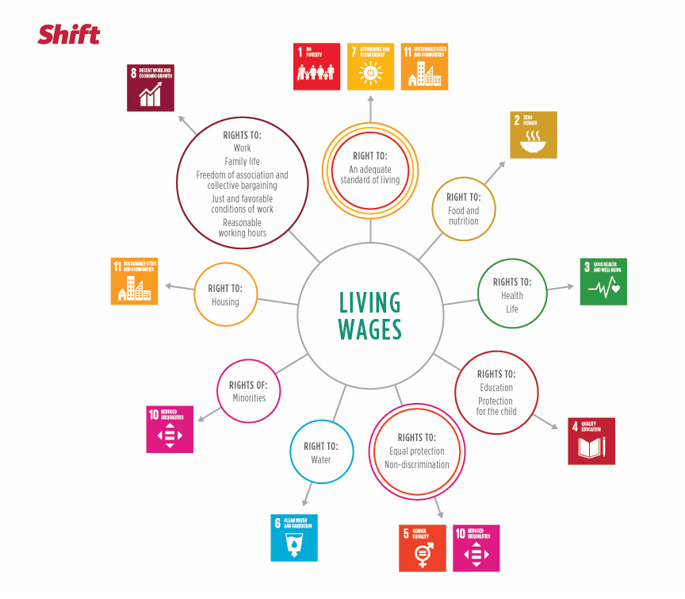
(Shift, 2018).
Challenges and Considerations:
While there are immense benefits of living wage there is also disadvantages too, as more people want to work for higher pay rate, but businesses want to employ fewer workers, this essentially leading to excess supply of labour – unemployment, increase in inflation as businesses try recoup loss for increased wage cost by increasing prices (Study Mind UK, no date).
The pandemic has produced the biggest surge in income equality, high cost of food and fuel impacting the poorest, whilst creating new billionaires essentially this has led to millions into extreme poverty (Romis, 2022). To ensure work pays government has announced 10% increase on living wage, the largest ever cash increase this is due to the rising cost of living which has hit the lowest paid workers the hardest (GOV UK, 2023).
Summary:
The living wage strategy is extremely invaluable in addressing poverty in the UK by directly increasing the income of low paid workers, as this provides a foundation for tackling inequalities, but this may not address the underlying causes of their economic marginality (Horton and Wills, no date).
Zero Hunger Goal 2:
According to the Food and Agriculture Organization of the United Nation (2024) hunger is an uncomfortable or painful physical sensation which is caused by insufficient consumption of daily recommended calories. Hunger is defined as a craving or urgent need for food, or a specific nutrient as described by Marriam-webster (2024). Action Against Hunger (2024) states that hunger is more complex than just empty stomach; it is an interconnected issue of inequality, poverty, climate change, conflict, gender discrimination, weak government and health care system play a major part in driving hunger. Zero hunger is about creating a world free of hunger, which is a global issue and food insecurities has been on the rise since 2015 due to combination of factors like conflict, climate change, pandemic and deepening inequalities, it is estimated that 9.2% or 735 million people of the world population find themselves in a state of chronic hunger which is an increase compared to year 2019 (NG, 2023; UN, 2023c). Blesh et al (2019) states that around 815 million people undernourished many others suffer malnutrition and the reason is the critical worldwide agriculture threat of crop production and the aim of the SDG2 Zero Hunger looks to simultaneously address the worldwide environmental sustainability and the food security challenges.
Strategy / Programme 1: National Food Strategy for England:
The National Food Strategy for England will help to deliver a prosperous agri-food and sea food while ensuring its sustainability, healthier, secure food supply and affordable diets for all, as well as addressing the Sustainable Development Goal 2 (Gov UK, 2022). The transformation of the food system will combat multiple crises in the cost of living, climate change, rocketing obesity, and nature loss while supporting sustainable agriculture practice (Sustain, 2024).
Benefits:
The National Food Strategy takes on wholesome approach to policy making across food and drink, as well as tackling various factors of food security and nutrition all while helping the most disadvantaged families to eat well, maintaining, and protecting the UK’s high food standard (Dimbleby, 2021). This strategy plays a pivotal role in promoting and producing sustainable healthy food for all including better livelihood in food industry, while supporting environmentally friendly fishing and farming that is sustainable for long-term production (Dalmeny, 2021).
Challenges and Considerations:
Affordability is a major factor in low-income families rather than the healthy or good quality food due to limited budget and other costs are needed to be meet restricting food choices and quality which is unfair but that is not the same for high income households (Hopkins Van Mil, 2021). Rising inflation is impacting just to meet the basic needs on everyday items like bread, pasta, tea, milk, oil, chips, frozen vegetables and is expected to increase, addressing the cost of living is critical along with better targeted policies, procedures and its implementation given the complexity of the food system is crucial for the success of National Food Strategy particularly for those facing poverty and food insecurity (Food Standard Agency, 2023; Office of National Statistics (ONS), 2023).
Education and awareness campaigns is needed to combat poor eating habits and behaviour changes. Climate change is a crucial factor which can negatively affect and hamper the commitment of the national food strategy for England locally, nationally, and internationally as its all interlinked with all the SDG’s, any environmental impacts are a great threat for sustainable food production (Hopkins Van Mil, 2021; The World Bank, 2023). Investments in local communities, charitable foundation is beneficial as they too have made major contribution in encouraging healthy eating (GOV UK, 2022).
Summary:
In concluding, the National Food Strategy for England is an encouraging strategy to address the Sustainable development goal 2 by transforming the food system secure access to safe nutritious, and sustainable food for all.
Strategy/ Programme 2: School Meal Programme:
The UK’s School meal programme strategy is well designed, efficient intervention and most impactful programme that benefits the entire communities by supporting children’s healthy development, enhancing education and providing broad societal benefits such as social protection for families, boosting social cohesion, supporting local agriculture, fighting climate change and equality (International Parliamentary Network for Education, 2021).
Benefits:
School meal programme have contributed to a healthier overall diet for those student living in socioeconomically disadvantaged households promoting equal access to quality nutritious food reducing disparities in educational settings, an effective policy that improves diet and reduces food insecurity (Local Government Association, 2024; Cambridge University Press, 2024). School meal programme has proven to be a success in supporting children’s health and education, having access to balanced nutrition diet enhances cognitive learning addressing malnutrition and promoting healthy development (International Parliamentary Network for Education, 2021). Evidence suggest that school meal programmes have improved children’s attention and academic performance from low-income background, programme such as this is a crucial component in supporting the low-income families in tackling health inequalities and addressing the rising food insecurity (Local Government Association, 2024). Balanced meal improves children’s behaviour, motivation, ability to learn and achieve, improving attendance, participation and equip children with knowledge and skills to maintain their mental health and wellbeing (Parliament. UK, 2010).
The Toolkit below shows the return on investment that school meal can make to 7 important areas:
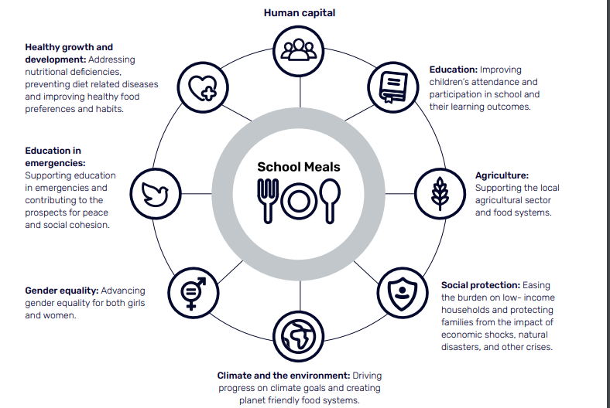
(International Parliamentary Network for Education, 2021).
Challenges and Considerations:
School meal programme is limited as it only addresses food certainty during school hours which leaves evenings, weekends and holidays as possible period of food insecurity for many children especially from less disadvantage background as more people are using food banks than ever before and this due to rising food cost figures by The Trussell Trust reveals that 1.5 million emergency food parcels were provided to people between April September 2023 by the charities wider network increase of 16% same period in 2022 and 65% of those parcels went to families with children an alarming fact which the government must acknowledge and address the root cause which is damaging the nation’s health and its people (The Trussell Trust, 2023). Poor nutrition, childhood obesity is known to negatively impact children’s mental and physical health and social consequences which is related to food insecurity, it’s imperative that children are shielded from food insecurity especially those from disadvantaged backgrounds, government must protect people from increasingly severe hardship and commit to better legislations that protects people (Cambridge University Press, 2024; The Trussell Trust, 2023). The rising inflation is tremendous stress on the food system including challenges brought by Covid and Brexit is extremely strenuous making it difficult to ensure meals meet nutritional standards and are of high quality, and expanding and maintaining school meal programme will very costly challenge this will require appropriate budget and guaranteed funding in line with inflation (Cambridge University Press, 2024). Eligibility criteria will push the most vulnerable children at risk, which ‘means one in three children living in poverty, and over 25% of children with very low food security are not eligible for a free school meal’ leaving them without crucial support (Cambridge University Press, 2024). Parental engagement and awareness are the key factor in supporting healthy eating habits outside of school hours is essential for the programme’s effectiveness.
Summary:
The school meal programme is a crucial strategy in addressing SDG 2 in the UK, reducing hardship and hunger for disadvantaged children, these programmes provide children with much needed nutrition during school hours, which leads to significant long-term health and socio-economic benefits (Local Government Association, 2024).
Progress by the UK Government:
The progress UK government has made so far for the SDG2 is that it has passed world-leading legislation to protect environment through the Environment Act 21, and its aim is to halt biodiversity loss, enhance water quality, cut pollution and halve waste (GOV UK, 2024). The Environmental Improvement Plan (EIP) 2023 is the first of its kind which builds on previous vision working with landowners, businesses and communities to deliver on improving the environment, interim targets to measure progress, action like this will assist in restoring nature, increase prosperity by reducing environmental pollution (GOV UK, 2023b). A significant improvement has been made in sustainable agriculture production practices, this includes public investment, labour productivity, and reducing risk and usage of pesticides (Eurostat, 2024).
Challenges in Implementing Goals:
Economic and poverty distress can make it difficult for individuals to meet basic needs increasing vulnerability to disease and prevent them from leading healthy and productive lives (University of California Press, 2024). The growing level of obesity and diet related disease are amongst the household with food insecurity, and these challenges are underpinned by the food system struggling to provide healthy, diverse sustainable diets for everyone in the UK (House of Common, 2019). Effective implementation of strategies, accountability cost effective means of integrated implementation, which is incompatibility between SDGs and statistics (BMJ Global Health, 2020).
Recommendations:
The UK government must continue its leadership on grant-based climate finance to help countries in adapting to climate change without provoking and exacerbating debt crisis’s (House of Common , 2023).
Government and civil society organisations are doing their part involvement of businesses and private sector are the key to success as they have power to incorporate SDGs into their business strategies and this will contribute to achieving the SDGs (Tunley Environmental 2023).
General public can also make a great difference in addressing SDG 1 by donating old unwanted or unused clothing, footwear, food supplies, toiletries, sanitation etc local charities, as public support and awareness will make significant towards eradicating poverty (The Global Goals, no date).
Organic farming could potentially help cut down on various health related issues like obesity as this remains serious public health concern, limiting environmental impact sensible use of energy, natural resources, maintain or enhance biodiversity, preserve ecological balance, enhance soil fertility and water quality, and improve capacity to adapt to climate change but this could be very tricky as tremendous amount of money and investment is needed (Eurostat, 2024).
Government must do more in eradicating poverty especially for those living in vulnerable situations, increasing access to services, and basic resources as well supporting communities affected by conflict and climate related disasters (Joint SDG Fund, no date).
The government must have sustainable food production system and implement resilient agricultural practices that expands production and productivity that help maintain ecosystems that strengthen capacity for adaption to adverse weather, climate change, drought, flooding and other disasters, as well as ending hunger, ensure access for all people especially the vulnerable and poor situation, including infants, safe nutritious and sufficient food (Bond, 2022; UK Parliament, 2024; GOV UK, 2021).
Enhance resilience agriculture, fishing, food and drinks sector and increase biosecurity at the border, support humanitarian needs, promote human rights and democracy (GOV UK, 2021).
Conclusion:
In concluding rural poverty is complex and inter-related , and for that reason all areas of needs must be tackled to ensure long-term sustainability leading improved health and well-being, housing, education, employment, transport (Powell et al., 2018). Poverty eradication must be mainstreamed into the national policies and actions in accordance with the internationally agreed development goals (UN, no date).
Paying a living wage instead of minimum wage could enable workers not only to meet their basic living needs, but also to save, to become more resilient to shocks, improving their prospects as well as help tackle global poverty and achieve the sustainable development goals (ROMIS, 2022). Living wage should be considered as a broader set of policies and initiatives as they strengthen businesses through employee productivity and engagement leading to increasing consumer purchasing power – uplifting millions out of poverty an important step to healing the inequalities of the fractured society (Barford et al, 2022).
Successful implementation of overcoming challenges connected to policies execution given its complexity, economic consideration, adapting and maintaining the strategy over the course of time will be crucial to achieving the goal as well aiding to a more sustainable and food secure future for the UK (GOV UK, 2022).
Tackling food poverty is connected to better health outcomes in class and improved diet leads to reduction in diet- related health inequalities like obesity, the programme contributes positively to overall health and wellbeing of children, including educational attainment. The programme is to limited school day, maintaining and expanding high quality meals is a challenging, eligibility criteria is still an issue as certain percentage does not meet need essentially losing out, appropriate funding is much needed to maximise the impact of the programme, this strategy is a significant effort in addressing SDG 2 and promoting healthy eating habits in and out of school.

Reference List:
Action Against Hunger. (2024). ‘What is the definition of hunger?’ Available at:
https://www.actionagainsthunger.org/the-hunger-crisis/world-hunger-facts/what-is-hunger/. (Accessed: 14 July 2024).

Amy Horton and Jane Wills. (no date). ‘Impacts of the living wage on in-work poverty’. Available at: https://discovery.ucl.ac.uk/id/eprint/10052060/1/HORTON%20and%20WILLS%20Living%20Wage.pdf. (Accessed: 10 November 2023).

Barford, A., Gilbert, R., Beales, A., Zorila, M. and Nelson, J. (2022). The case for living wages: how to improve business performance and tackle poverty .London: Sage.

Blesh, J., Hoey, L., Jones, A.D., Friedmann, H. and Perfecto, I. (2019). Development pathways toward “zero hunger”. World Development, 118, pp.1-14.

Bond. (2022). ‘SDG 1: Progress, gaps and recommendations for the UK’. Available at: https://www.bond.org.uk/wp-content/uploads/2022/09/bond_sdgsreport2022execsum.pdf. (Accessed: 19 July 2024).

Cernev, T. and Fenner, R. (2020). The importance of achieving foundational Sustainable Development Goals in reducing global risk. Futures, 115, p.102492.

Chams, N. and García-Blandón, J. (2019). On the importance of sustainable human resource management for the adoption of sustainable development goals. Resources, Conservation and Recycling, 141, pp.109-122.

Childline. (no date). ‘Staying Healthy’. Available at: https://www.childline.org.uk/info-advice/you-your-body/my-body/staying-healthy/#:~:text=Staying%20healthy%20physically%20can%20help,good%20health%20later%20in%20life. (Accessed: 25 October 2023).

Close The Gap Foundation. (2023). ‘Zero Hunger’. Available at: https://www.closethegapfoundation.org/glossary/zero-hunger. (Accessed: 2 October 2023).

CISL (2024) A living wage increases economic productivity while reducing poverty Available at: https://www.cisl.cam.ac.uk/news/blog/living-wage-increases-economic-productivity-while-reducing-poverty. (Accessed: 19 July 2024).

Circular Ecology. (2023). ‘Sustainability and Sustainable Development - What is Sustainability and What is Sustainable Development?’. Available at:
https://circularecology.com/sustainability-and-sustainable-development.html. (Accessed: 11 November 2023).

Department of Health. (2010). ‘Our Health and Wellbeing Today’. Available at:
https://assets.publishing.service.gov.uk/media/5a7b9e86e5274a7318b8fd71/dh_122238.pdf. (Accessed: 10 September 2023).

Department of Health. (2014). ‘Wellbeing Why it matters to health policy’.
Available at: https://assets.publishing.service.gov.uk/media/5a7ba1d6ed915d4147621a24/Narrative__January_2014_.pdf. (Accessed: 11 November 2023).

Department of Agriculture, Environment and Rural Affairs (DAERA). (2023). ‘Tackling Rural Poverty & Social Isolation – A New Framework’. Available at:
https://www.daera-ni.gov.uk/articles/tackling-rural-poverty-social-isolation-new-framework. (Accessed: 21 October 2022).

Department of Agriculture, Environment and Rural Affairs (DAERA. (2022). ‘Rural Micro Capital Grants Scheme (RMCGS) 2022’. Available at: https://www.daera-ni.gov.uk/services/rural-micro-capital-grants-scheme-rmcgs#:~:text=This%20Scheme%2C%20funded%20under%20the,the%20recovery%20and%20reset%20of. (Accessed: 10 November 2023).

Department of Agriculture, Environment and Rural Affairs (DAERA). (no date). ‘2014 - 2020 Rural Development Programme’. Available at: https://www.daera-ni.gov.uk/articles/2014-2020-rural-development-programme. (Accessed: 5 September 2023).

Department of Agriculture, Environment and Rural Affairs (DAERA). (2022). ‘Initiatives to Tackle Rural Poverty and Social Isolation (TRPSI’. Available at: https://www.daera-ni.gov.uk/articles/initiatives-tackle-rural-poverty-and-social-isolation-trpsi. (Accessed: 5 September 2023).

Department of Health, State Government of Victoria, Australia (2021). ‘Wellbeing’. Available at: https://www.betterhealth.vic.gov.au/health/healthyliving/wellbeing. (Accessed: 10 October 2023).

Dimbleby, H. (2021). ‘The Plan’. Available at: https://www.nationalfoodstrategy.org/. (Accessed: 17 October 2023).

Downtown Medical Group. (no date). ‘YOUR health is the most important thing in your life!’ Available at: https://www.downtownmedical.com/blog/your-health-is-the-most-important-thing-in-your-life. (Accessed: 9 July 2024).

Eurostat. (2024). ‘SDG 2 - Zero hunger’. Available at: https://ec.europa.eu/eurostat/statistics-explained/index.php?title=SDG_2_-_Zero_hunger. (Accessed: 20 July 2024).

Food Standard Agency. (2023). ‘Food System Strategic Assessment: Trends and issues impacted by UK economic condition’. Available at: https://www.food.gov.uk/research/food-system-strategic-assessment-trends-and-issues-impacted-by-uk-economic-condition (Accessed: 23 March 2024).

Food and Agriculture Organization of the United Nation. (2024). H’unger and food insecurity’. Available at:
https://www.fao.org/hunger/en/#:~:text=What%20is%20hunger%3F,normal%2C%20active%20and%20healthy%20life. (Accessed: 21 May 2024).

GOV UK. (no date). ‘The National Minimum Wage and Living Wage’. Available at: https://www.gov.uk/national-minimum-wage#:~:text=The%20minimum%20wage%20a%20worker,if%20they're%20over%2023. (Accessed: 8 October 2023).
GOV UK. (2021). ‘Corporate report Implementing the Sustainable Development Goals’. Available at:
https://www.gov.uk/government/publications/implementing-the-sustainable-development-goals/implementing-the-sustainable-development-goals--2. (Accessed: 28 July 2024).

GOV UK. (2022). ‘Government food strategy’. Available to: https://www.gov.uk/government/publications/government-food-strategy. (Accessed: 1 November 2023).

GOV UK (2023a). ‘Chancellor backs business and rewards workers to get Britain growing’. Available at: https://www.gov.uk/government/news/chancellor-backs-business-and-rewards-workers-to-get-britain-growing. (Accessed: 19 October 2023).

GOV UK. (2023b). ‘Environmental Improvement Plan 2023’. Available at: https://www.gov.uk/government/publications/environmental-improvement-plan. (Accessed: 20 July 2024).

GOV UK. (2024). ‘Climate change and sustainability strategy’. Available at:
https://www.gov.uk/government/publications/climate-change-and-sustainability-strategy-moj/climate-change-and-sustainability-strategy. (Accessed: 20 July 2024).

Greater London Authority. (2023). ‘What is the London Living Wage?’. Available at:
https://www.london.gov.uk/programmes-strategies/business-and-economy/london-living-wage. (Accessed: 30 September 2023).

Hopkins Van Mill, H. (2021). The Public Dialogue Report. ‘The Findings Report’. Available at: https://www.nationalfoodstrategy.org/wp-content/uploads/2021/09/HVM-National-Food-Strategy-Public-Dialogue-report-Sep21.pdf. (Accessed: 5 November 2023).

Health & Safety Executive (HSE). (2018). ‘Mental health conditions, work and the workplace’. Available at: https://www.hse.gov.uk/stress/mental-health.htm. (Accessed: 8 November 2023).

House of Common. (2023). ‘Extreme poverty and the Sustainable Development Goals: Government response to the Committee’s Fifth Report of Session 2022–23’. Available at: https://committees.parliament.uk/publications/34227/documents/188330/default/. (Accessed: 21 July 2024).
International Institute for Sustainable Development (IISD). (2023). ‘Sustainable Development’. Available at: https://www.iisd.org/mission-and-goals/sustainable-development. (Accessed: 17 October 2023).

International Monetary Fund. (2023). ‘The IMF and the Sustainable Development Goals’. Available at: https://www.imf.org/en/About/Factsheets/Sheets/2023/IMF-Sustainable-development-goals-SDGs. (Accessed: 17 September 20230).

International Parliamentary Network for Education. (2021). ‘Supporting parliamentary action for school meals’. Available at: https://www.ipned.org/schoolmeals. (Accessed: 12 July 2024).
Joseph Rowntree Foundation, Goulden, C. and D'Arcy, C. (2014). ‘A definition of poverty’. York: Joseph Rowntree Foundation.

Joint SDG Fund. (no date). ‘Goal 1 No Poverty’. Available at: https://jointsdgfund.org/sustainable-development-goals/goal-1-no-poverty. (Accessed: 20 July 2024).

Living Wage Foundation. (no date). ‘The real Living Wage is good for people’. Available at: https://www.livingwage.org.uk/good-for-people#:~:text=Paying%20a%20real%20Living%20Wage,staff%20and%20attract%20new%20staff. (Accessed: 5 September 2023).

Local Government Association. (2024). ‘Westminster Hall Debate, Provision of Free School Meals, 7 May 2024’. Available at: https://www.local.gov.uk/parliament/briefings-and-responses/westminster-hall-debate-provision-free-school-meals-7-may-2024. (Accessed: 11 July 2024).

London Economics (2009). ‘An independent study of the business benefits of implementing a Living Wage policy in London’. Available at: https://www.london.gov.uk/sites/default/files/gla_migrate_files_destination/archives/mayor-economic_unit-docs-living-wage-benefits-summary.pdf

McGuire, R., Longo, A. and Sherry, E. (2022). Tackling poverty and social isolation using a smart rural development initiative. Journal of Rural Studies, 89, pp.161-170.

Merriam – Webster. (2023). Health. Available at: https://www.merriam-webster.com/dictionary/health#:~:text=1-,a,overall%20condition%20of%20the%20body. (Accessed: 21 May 2024).

Merriam – Webster. (2024). Hunger. Available at :https://www.merriam-webster.com/dictionary/hunger#:~:text=Synonyms%20of%20hunger-,1,by%20the%20lack%20of%20food. (Accessed: 21 May 2024).

Monica Romis. (2022). ‘Paying the Living Wage isn’t Just Good for the World – its also Good for Business. Here’s how to do it’... Available at https://views-voices.oxfam.org.uk/2022/07/paying-the-living-wage/#:~:text=Paying%20a%20living%20wage%20instead,achieve%20the%20Sustainable%20Development%20Goals. (Accessed: 9 November 2023).

My Health Devon. (2024). ‘ What is Wellbeing?’. Available at:
https://myhealth-devon.nhs.uk/local-services/health-lifestyle-wellbeing/health-and-wellbeing. (Accessed: 10 July 2024).

Norman Sartorius. (2006). ‘The Meanings of Health and its Promotion’. Available at:
https://www.ncbi.nlm.nih.gov/pmc/articles/PMC2080455/. (Accessed: 15 October 2023).

National Health Service (NHS) UK. (2023). ‘Treating and preventing ill health’.
Available at: https://www.longtermplan.nhs.uk/areas-of-work/prevention/treating-and-preventing-ill-health/. (Accessed: 25 August 2023).

National geographic. (2023). ‘Sustainable Development Goal: Zero Hunger’. Available at: https://education.nationalgeographic.org/resource/sustainable-development-goal-zero-hunger/. (Accessed: 2 October 2023).

Parliament. UK. (2010). ‘Behaviour and Discipline in Schools’. Available at: https://publications.parliament.uk/pa/cm201011/cmselect/cmeduc/writev/behaviour/we23.htm. (Accessed: 13 July 2024).

Personia. (2023). ‘National Minimum Wage Rates for 2023/24 (UK)’. Available at:
https://www.personio.com/hr-lexicon/uk-minimum-wage/. (Accessed: 11 November 2023).

Powell, J.R., Keech, D., Reed, M. and Dwyer, J.C. (2018). ‘What works in tackling rural poverty’. (Accessed: 11 October 2023).

Royal Town Planning Institute (RTPI). (2021). ‘Rural Policy Framework for Northern Ireland’. Available at: https://www.rtpi.org.uk/media/9042/rural-policy-framework-response-for-website.pdf. (Accessed: 22 October 2023).

Ruggeri, K., Garcia-Garzon, E., Maguire, Á., Matz, S. and Huppert, F.A. (2020). Well-being is more than happiness and life satisfaction: a multidimensional analysis of 21 countries. ‘Health and quality of life outcomes’, 18(1), pp.1-16.

Simply Psychology. (2024)‘Maslow’s Hierarchy Of Needs’. Available at: https://www.simplypsychology.org/maslow.html. (Accessed: 15 July 2024).

Shift Projects. (2018). ‘The Human Rights Opportunity’. Available at: https://shiftproject.org/resource/the-human-rights-opportunity-in-collaboration-with-wbcsd/living-wages/. (Accessed: 22 September 2023).
Simons, G. and Baldwin, D.S. (2021). A critical review of the definition of ‘wellbeing ‘for doctors and their patients in a post Covid-19 era. ‘International Journal of Social Psychiatry’, 67(8), pp.984-991.

Statics Netherlands. (2023). ‘SDG 2 Zero hunger’. Available at: https://www.cbs.nl/en-gb/dossier/dossier-well-being-and-the-sustainable-development-goals/monitor-of-well-being-and-the-sustainable-development-goals-2023/the-sustainable-development-goals-in-the-monitor-of-well-being/sdg-s/sdg-2-zero-hunger. (Accessed: 4 October 2023).

Study Minds UK. (no date). ‘National Minimum Wage - A-Level Economics’. Available at: https://studymind.co.uk/notes/national-minimum-wage-a-level-economics. (Accessed: 23 October 2023).

Sustainable Development Commission (SDC). (2023). ‘What is sustainable development’. Available at: https://www.sd-commission.org.uk/pages/what-is-sustainable development.html. (Accessed: 9 July 2024).

Sustain (2024). ‘National Food Strategy’. Available at: https://www.sustainweb.org/national-food-strategy/. (Accessed: 9 July 2024).

Pettinger, T. (2012). Question: ‘What are the pros and cons of a living wage in the UK’? https://www.economicshelp.org/blog/4824/economics/living-wage-uk. (Accessed: 13 October 2023).

The Foundation for Peripheral Neuropathy. (2022). ‘Maintaining a Healthy Lifestyle’. Available at: https://www.foundationforpn.org/living-well/lifestyle/#:~:text=Being%20healthy%20should%20be%20part,is%20right%20for%20your%20body. (Accessed: 20 October 2023).

The World Bank. (2023). ‘What is Food Security’?. Available at:
https://www.worldbank.org/en/topic/agriculture/brief/food-security-update/what-is-food-security#: (Accessed: 6 November 2023).

The Stevenson / Farmer review of mental health and employers. (2017). ‘Thriving at work’. Available at: https://assets.publishing.service.gov.uk/government/uploads/system/uploads/attachment_data/file/658145/thriving-at-work-stevenson-farmer-review.pdf. (Accessed: 8 October 2023).

The National Lottery Community Fund (TNLCF). (2019). ‘Loneliness and social isolation’. Available at: https://www.tnlcommunityfund.org.uk/insights/loneliness-and-social-isolation. (Accessed: 12 October 2023).

The Global Goals. (no date). ‘No Poverty’. Available at:
https://www.globalgoals.org/goals/1-no-poverty/. (Accessed: 20 July 2024).

Tim Baker. (2023). ‘National living wage increasing to £11.44 per hour from April - a £1.02 rise’. Available at: https://news.sky.com/story/national-living-wage-increasing-to-11-44-per-hour-13012913. (Accessed: 10 October 2023).

Tunley Environmental. (2023). ’11 Ways You Can Contribute to The Sustainable Development Goals’. Available at: https://www.tunley-environmental.com/en/insights/contribute-to-the-sustainable-development-goals. (Accessed: 20 July 2024).

Trust for London. (2023). ‘What is the Living Wage’. Available at: https://trustforlondon.org.uk/what-we-do/work/london-living-wage. (Accessed: 28 October 2023).

The Global Goals. (no date). ‘2 Zero Hunger’. Available at:
https://www.globalgoals.org/goals/2-zero-hunger/. (Accessed: 1 September 2023).

UK Parliament Committee. (2024). ‘The UK Government’s work on achieving SDG2: Zero Hunger’. Available at: https://committees.parliament.uk/work/7967/the-uk-governments-work-on-achieving-sdg2-zero-hunger. (Accessed: 19 July 2024).

UK Parliament. (2023). ‘Extreme poverty and the Sustainable Development Goals: Government response to the Committee’s Fifth Report of Session 2022–23’. Available at: https://publications.parliament.uk/pa/cm5803/cmselect/cmintdev/1177/report.html (Accessed: 18 September 2023).

United Nations (UN). (2023a). ‘The Sustainable Development Agenda’. Available at: https://www.un.org/sustainabledevelopment/development-agenda/ (Accessed: 11 October 2023).

United Nations Development Programme (UNDP). (2023b). ‘What are the SDG’s? The Sustainable Development Goals’. Available at: https://shop.undp.org/pages/what-are-the-SDG’s-the-sustainable-development-goals. (Accessed: 15 October 2023).

United Nations (UN). ( 2023c). ‘Goal 2 Zero Hunger’. Available at: https://www.un.org/sustainabledevelopment/hunger/#:~:text=Goal%202%20is%20about%20creating,climate%20change%2C%20and%20deepening%20inequalities. (Accessed: 13 October 2023).

United Nations (UN). (2015). ‘Sustainable Development Goals kick off with start of new year’. Available at:
https://www.un.org/sustainabledevelopment/blog/2015/12/sustainable-development-goals-kick-off-with-start-of-new-year/#. (Accessed: 25 October 2022).

United Nations.(no date). ‘Department of Economic and Social Affairs Poverty’. Available at: https://www.un.org/development/desa/socialperspectiveondevelopment/issues/poverty-eradication.html. (Accessed: 22 August 2023).

United Nations. Report of the World Commission on Environment and Development (1987). ‘Our Common Future’. (Brundtland Report). Available at: https://www.are.admin.ch/are/en/home/media/publications/sustainable-development/brundtland-report.html#:~:text=It%20developed%20guiding%20principles%20for,and%20production%20in%20the%20North. (Accessed: 20 October 2023).

University of California Press. (2024). ‘Ending Poverty—SDG 1’. Available at: https://online.ucpress.edu/agh/pages/ending_poverty_sdg_1. (Accessed: 12 July 2024).

World Health Organization (WHO). (2023a). Sustainable Development Goals. Available at:
https://www.who.int/europe/about-us/our-work/sustainable-development-goals. (Accessed: 20 September 2022).

World Health Organization (WHO). (2023b). Promoting Well-Being. Available at:
https://www.who.int/activities/promoting-well-being (Accessed: 10 November 2023).

World Health Organization (WHO). (2023c). ‘Sustainable Development’. Available at:
https://www.who.int/health-topics/sustainable-development#tab=tab_1
(Accessed: 7 October 2023).

World Health Organization. (2023d). ‘Constitution’. Available at: https://www.who.int/about/accountability/governance/constitution.
(Accessed: 12 September 2023).

World Health Organization (WHO). (2023e). ‘Sustainable Development Goals’. Available at: https://www.who.int/europe/about-us/our-work/sustainable-development-goals#:~:text=Section%20navigation&text=The%20Sustainable%20Development%20Goals%20(SDG’s,enjoy%20health

WHO. (1946f). ‘Preamble to the Constitution of the World Health Organization as adopted by the International Health Conference, New York’. Available at: https://apps.who.int/gb/bd/PDF/bd47/EN/constitution-en.pdf (Accessed: 9 July 2024).

Your Article Library. (2023). ‘What is the Importance of Sustainable Development’?. Available at: https://www.yourarticlelibrary.com/environment/what-is-the-importance-of-sustainable-development/9910. (Accessed: 23 October 2023).

