University of Wales Trinity Saint David


Item | Description
Student Name: | Salah Mheidean
Student ID: | 2109425
Module: | International Business Concepts
Module Code: | LCLM7034
Lecturer: | Syed Murshed xxxxxx
Title: | Assessment component: Financial performance and management

Contents
Introduction 1
2. Industry and Country Overview-see Appendix-I 1
a. The Renewable Energy (Solar PV) Industry in Vietnam 1
b. Size, scope, and economic importance 2
3. Applying Porter’s Diamond Model to Vietnam’s Solar PV Industry- See Appendix-II 4
4. Critical Evaluation of Sharp Energy Solutions Corporation’s Operations in Vietnam’s Solar PV Industry 6
5.0 Conclusion 12
Section 2: Reflective Account of the Research and Analysis Process 14
References 17
Appendixes 21
Appendix-I- The Renewable Energy (Solar PV) in Vietnam 21
Appendix-II Vietnam’s Solar PV Industry 24
Appendix-III List of companies in Solar Industry 25


The Renewable Energy (Solar PV) Industry in Vietnam

List of Figures
Figure 1 Porter's Diamond: Sharp Energy Solutions in Vietnam 12
Figure 2 Solar deployment (GW) per year of COD in Vietnam 21
Figure 3 Job creation in project development, services, and O&M expected from Vietnam’s 12 GW solar PV target, 21
Figure 4 Manufacturing jobs expected to be created by achievement of Vietnam’s 12 GW solar PV target, 2017–30 22
Figure 5 Provinces and potential installed solar 22
Figure 6 Zones with very good solar PV irradiation 23
Figure 7 Floating solar PV potential 23

Report

Introduction
The Vietnamese solar photovoltaics (PV) industry represents a pertinent case of quickly moving to a renewable energy system with a policy-driven shift to the new model in an emerging economy (IEA-PVPS, 2025). In this report, I have provided a stringent analysis of the industry development, industry rivalry and the strategy environment. It starts with an evaluation of the size, scope and economic relevance of the sector in the national energy policy. This is followed by analysing the competitive environment, major domestic and international companies, and using the Diamond Model by Michael Porter in assessing the pillars of international competitiveness in solar PV in Vietnam (Mordor Intelligence, 2026; Porter, 1990). The report then provides a specific analysis of a foreign multinational company Sharp Energy Solutions Corporation, in which a PESTLE-C framework. This study is based on the concept of Technology Spillovers. Nguyen-thanh and colleagues (2025) other conceptualize technology spillovers created by foreign direct investment as the gains obtained by local firms when they work together with multinational companies to produce intermediate goods, which increases the technological capacity of the host country as a result of backward linkage. Technology spill overs are associated with the fact that the innovations or superior practices of a given firm end up benefiting other parties unwillingly. It occurs when the local competition obtains knowledge through the observation of new technological applications (the demonstration effect), finds the personnel that were trained by the foreign company (labor mobility), or even has to become innovative due to increased competitive pressures.

2. Industry and Country Overview-see Appendix-I

a. The Renewable Energy (Solar PV) Industry in Vietnam
Vietnam has emerged as a global leader in renewable energy with its solar photovoltaic industry becoming the bible of the national energy plan (International Trade Administration, 2022). This strategic focus is supported by the fact that Vietnam is committed to sustainable development and the need to meet the growing domestic demand of electricity, which is attributed to the increasing urbanisation and the growth of the industry (Markets and Data, 2026). Following its attendance at the 26th United Nations Climate Change Conference (COP26), Vietnam has proved to be a serious political player concerning its energy sector and solar power has been taken as its centre stage (International Trade Administration, 2022). The country has high technical potential of solar energy, and it is estimated that the total resource of solar energy is up to 1,646 GW, with an estimated 386 GW potential to be developed at large scale energy production (International Trade Administration, 2022; Markets and Data, 2026).

b. Size, scope, and economic importance
The Vietnamese PV market alone had a valuation of USD 1.51billion in 2022; the growth rate of the market is projected to be 8.3 per cent per year (Markets and Data, 2026). This expansion has been driven by aggressive capacity additions; the sector added roughly 17.6 GW of new capacity in 2021 alone, solidifying Vietnam’s leading position in solar development within ASEAN (International Trade Administration, 2022). There are a variety of components that are included in the industry, such as utility-scale farms, commercial and industrial installations as well as a fast-growing rooftop segment. The most notable one is the 600MW Dau Tieng Solar Power Complex in Tay Ninh Province, the largest solar power station in Southeast Asia (International Trade Administration, 2022). The rooftop segment recorded an explosive growth of doubling capacity 189MW in 2019 to a high of 378MW in 2020 (Markets and Data, 2026).
The economic importance of the solar PV industry is multi‑faceted. First of all, it promotes the national energy security and ensures long-term economic development as it offers a source of domestic renewable energy (Markets and Data, 2026). The large-scale investment has been achieved by government policies like the now-terminated Feed-in-tariff (FIT) scheme that offered a rate of 6.67 to 10.87 US cents per kWh (International Trade Administration, 2022; Markets and Data, 2026). Technological growth and employment at the value chain such as manufacturing to project development and maintenance are also triggered by the sector. In addition, it opens possibilities of international collaboration, because the government is interested in foreign solutions of the high-level PV modules, energy storage system, and sun-tracking technology (International Trade Administration, 2022). The use of pilot direct bilateral power purchase agreement (PPA) between consumers and private generators is an indication of a maturing market that aims to increase flexibility and further investment by the privates (Markets and Data, 2026).
Major Companies-See Appendix-III
The Vietnamese solar energy market is quite dynamic and relatively fragmented with a heterogeneous combination of large domestic companies and global corporations (Mordor Intelligence, 2026). The landscape helps to create strong competition and innovation in industry segments. The number of companies involved in the active installation of solar systems is more than 215, which speaks to the development of the service sector (ENF Ltd., n.d.).
Major Domestic Firms: The Vietnamese companies that are the leaders often integrate manufacturing and huge project development. In the case of Vietnam Sunergy Joint Stock Company, the company is a major domestic player operating in the development of solar technology and implementation of large-scale projects under the support of good relations with world technological partners (Mordor Intelligence, 2026). The solar power company Song Giang Solar Power JSC specialises in the local installation and engineering service and has achieved a reputation in the market (Mordor Intelligence, 2026). All other leading Vietnamese conglomerates, including the Trung Nam Group and the BIM Group, also build large-scale solar parks and incorporate renewable energy into their portfolio (Mordor Intelligence, 2026).
Major Multinational Firms: Foreign companies are bringing with them international skills, technological know-how and huge financial capabilities. One of the companies that can be singled out as offering sophisticated solar technology and end-to-end energy solutions is Sharp Energy Solutions Corporation and TATA Power Solar Systems Ltd (Mordor Intelligence, 2026). The approaches used usually focus on utility-scale projects and seek to consolidate distribution networks to be able to enter the market (Mordor Intelligence, 2026). Moreover, such multinational companies as First Solar Inc., Canadian Solar Inc., and Longi Green Energy Technology Co. Ltd also operate as the major producers and financiers, providing the efficient modules and financing the major projects (Mordor Intelligence, 2026).
Relative Positioning and Strategies: These firms are competitive in their position depending on their focus. The aspects of technological innovation, global supply chain, and funding of extremely large-scale projects are all typical of multinational corporations competing (Mordor Intelligence, 2026). In my opinion, the main domestic companies use their extensive local market awareness, existing government and local community relations, and combined business models encompassing all aspects, including panel manufacturing to plant construction and operation (Mordor Intelligence, 2026).The market is not monopolised by one player, and the situation allows companies that use special approaches, like Berkeley Energy Commercial & Industrial Solutions that focuses on the development of tailored solar and energy management systems to organisations, to thrive in certain niches (Mordor Intelligence, 2026).

3. Applying Porter’s Diamond Model to Vietnam’s Solar PV Industry- See Appendix-II
The Diamond Model of Michael Porter is a powerful instrument used to examine the national competitive advantage of a country through the examination of four determinants interrelated, and these are; factor conditions, demand conditions, related and supporting industries and firm strategy, structure and rivalry (Porter, 1990).
Factor Conditions: A Robust but Evolving Foundation
The original competitive advantage of Vietnam on solar PV was conclusively formed by solid, primitive factor conditions, especially favourable costs of production and geographically favourable strategic location. The industry has a large and affordable labour force to work in the manufacturing sector, as well as a coastline enabling the importation of raw materials and the exportation of finished modules (IEA-PVPS, 2025). This pillar has helped Vietnam to become a strategic hub of the global solar PV supply chain, where foreign direct investment in manufacturing plants has poured with the leading manufacturers in the world (REI, 2024). Although the manufacturing base is strong, the domestic capabilities to develop next-generation PV technologies (e.g. high-efficiency tandem cells) or advanced manufacturing machinery remain low in comparison with the leaders in innovation, e.g., China, the United States, or Germany (IRENA, 2019; IDOS, 2019). In turn, the future development of this industry rests on the ability to increase these human and technological resources and climb up the pyramid of values between assembly and production to the actual innovation.

Demand Conditions: Strong Growth Tempered by Policy Volatility
Nature of the domestic demand is a strong force of competitiveness. The demand of solar power within Vietnam has been nothing less than explosive hence making the country an excellent example of the market in Southeast Asia. A combination of fast developing economies, increased use of electricity and government goals to use renewable energy sources have resulted in a gigantic and urgent market (IEA-PVPS, 2025). The government's Feed‑in‑Tariff (FiT) schemes, particularly those implemented in 2019‑2020, acted as a potent catalyst, precipitating a historic surge in installations and underscoring the market's immense responsiveness (IEA‑PVPS, 2025). Nevertheless, this requirement has been defined by boom-and-bust waves that are directly linked to the policy deadlines, which have spawned grid-integration issues and uncertainty regarding investments after FiTs went out of action (IDOS, 2019). To transform demand into a provider of sustained high end competitiveness, demand should shift to more advanced and stable drivers.
Related and Supporting Industries: A Developing Ecosystem
Most importantly is the existence of related and supporting industries which are competent and international. The picture is not clear in this respect in the solar PV sector of Vietnam. On one hand, the powerful supporting manufacturing base has been established with a large scale production capacity of the main components of solar cells, modules and inverters, which are integrated at the global supply networks (REI, 2024). Conversely, it is the ecosystem that is lacking depth in other key upstream and downstream sectors. The production of polysilicon, wafers and sophisticated manufacturing equipment is still not much localised, therefore, becoming dependent on imported materials and equipment (IRENA, 2019; REI, 2024).

Firm Strategy, Structure, and Rivalry: Intense Competition in a Fragmented Arena
The environment that companies are established, run and compete in influences how companies approach the world market. The solar sector in Vietnam can be described as being marked with a high level of competition in a fragmented industry. There is also a high level of competition in the market which includes large state-owned utilities, new domestic private conglomerates (e.g., Trung Nam Group and BIM Group), and subsidiaries of major multinational corporations (IEA-PVPS, 2025; Mordor Intelligence, 2024). Such competition is based mostly on cost-competitiveness, project-implementation pace and gaining favourable treatment by the regulatory authorities. Although this is efficient, strategic intent has been a major focus on volume-based expansion and capitalising on available policy incentives as opposed to differentiated and technology-led strategies. The majority of the firms, especially those based in the domestic market, are yet to be known internationally in terms of unique intellectual property or innovative business models. To attain a greater degree of sustained advantage, major companies need to develop more unique strategic competencies, including the prowess of large-scale project finance, the art of floating PV or agrovoltaics, or the creation of digital platform infrastructure of distributed energy.
The Role of Government and Chance: Catalysts and Disruptors
Porter does not ignore the impact of a government and random happenings. The Vietnamese government has been driving the industry to the top unambiguously with the bold policies like the FiTs and the ambitious Power Development Plan VIII (PDP8) (IEA-PVPS, 2025). However, the government policy may be considered a central challenge, too; the uncertainty of regulations and sudden policy changes may discourage long-term, quality-oriented investment (IDOS, 2019). The beneficial impacts of chance events include global trade tensions that have driven the diversification of the supply chain to some countries outside China (China+1) strategies, which have significantly benefited Vietnam in terms of shifting manufacturing investment to other locations (REI, 2024). On the other hand, international price changes of the major materials and political unrest are external risk factors that have the capacity to affect the cost set up and market entry of the industry.

4. Critical Evaluation of Sharp Energy Solutions Corporation’s Operations in Vietnam’s Solar PV Industry
4.1 Introduction to the Chosen MNC and Industry Context
Sharp Energy Solutions Corporation (SESJ) is a subsidiary company of the Japanese multinational conglomerate Sharp Corporation, which has a leading role in the world market in the field of high-capacity solar technology and integrated energy solutions (Mordor Intelligence, 2026). The strong global brand name and the selection of photovoltaic (PV) technology that the company has makes it a relevant foreign investor in the fast-growing solar-energy industry in Vietnam (Mordor Intelligence, 2026). The solar power market in Vietnam has undergone a radical change and is becoming one of the top countries in the Association of Southeast Asian Nations (ASEAN) after a surge of solar power development fueled by favourable government policies (International Trade Administration, 2022). This paper critically analyses the factors that can pose a threat to the success of the operations of Sharp Energy Solutions in Vietnam using a holistic PESTLE-C (Political, Economic, Social, Technological, Legal, Environmental, and Cultural) framework that allows the systematic evaluation of the overall attractiveness of the market and present strategic opportunities and potential challenges faced by the business.
4.2 Political Factors
Vietnam political climate is a strong but conflicting driver of foreign solar business. A strong desire to adopt renewable energy has been demonstrated by the national authorities, primarily through the ambitious Power Development Plan VIII (PDP8), and the global ambition to reach net-zero carbon emissions by 2050 (International Trade Administration, 2022). Such a high-level order sets a basic requirement of solar technology and indicates the market potential in the long term that directly correlates with the core competence of Sharp (IEA-PVPS, 2025). Traditionally, Feed-in Tariff (FiT) schemes, introduced by the government, played a central role in the Vietnam solar boom by making available appealing and guaranteed rates on grid-connected power and evidence of the ability of the state to mobilise the rapid growth of industries in case of policy mechanisms being clear and financially enticing (International Trade Administration, 2022). However, the progressive change towards no longer using FiTs and more of an auction-based system has presented a phase of regulatory insecurity and adaptation which could slow investment and make planning of projects more complex to all stakeholders in the market, including the established multinationals (IEA-PVPS, 2025).
One of the major political and operational aspects is the prevalence of state-owned enterprises, especially Vietnam Electricity (EVN), which controls the national transmission grid and is the only off-taker of utility-scale projects (Markets and Data, 2026). This centralised arrangement makes it easy to negotiate power-purchase as one company but at the same time, counterparty risk is concentrated. Project developers even foreign companies working on major installations are exposed to grid congestion and curtailment action by EVN which can impact negatively on project bankability and returns (IEA-PVPS, 2025). In addition to this, the Vietnamisation policy of the government, aimed at creating manufacturing capacities and leaving more economic value in the country, can also be reflected in the future policies whereby the local content is preferred. Although Sharp has a current approach of promoting the high-efficiency modules and solutions, a long-term change of operation towards local manufacturing or more intense technology collaboration might become more beneficial or even mandatory to maintain the favourable market access (Renewable Energy Institute [REI], 2024). The way forward on this terrain is to ensure that Sharp takes the initiative to engage governmental stakeholders on how its innovative technology and experience in the international market can play a part in the overall energy-security and industrial-development goals in Vietnam, keeping the corporate goals in line with the national political goals.
4.3 Economic Factors
The economic environment in Vietnam has presented a compelling growth storey to the solar industry as it is supported by strong macroeconomic fundamentals and industry specific dynamics. The continued high GDP growth, industrialisation, and accelerated urbanisation have created a stable high growth of electricity demand with an estimated annual growth of about 10 percent before the pandemic (Markets and Data, 2026). This is the backbone of the economy that has guaranteed an ongoing and growing demand of new generation capacity, where solar PV is projected to be part of the national energy approach (IEA-PVPS, 2025). The size of the photovoltaic market is huge, and the scope of the Vietnam photovoltaics market is expected to grow 8.3 percent per annum and attain USD 2.86 billion in 2030 (Markets and Data, 2026). In the case of Sharp, it would mean a huge and growing size of its addressable market to its collection of solar modules and solar energy solutions.
The competitive economic environment, however, is fierce and is typified by high price sensitivity. It is a fragmented market, with many players in it, such as low-cost manufacturing mammoths of China and agile local conglomerates that enjoy lower-cost of operation and strong local connexions (Mordor Intelligence, 2026; REI, 2024). In as much as the brand Sharp is linked to high quality and technological stability, it would be difficult to compete with others in the mass market on the basis of price when dealing with standard modules. Therefore, the economic success of Sharp is probable to be dependent on the strategy of product and market segmentation. The competitive economic environment, however, is fierce and is typified by high price sensitivity. It is a fragmented market, with many players in it, such as low-cost manufacturing mammoths of China and agile local conglomerates that enjoy lower-cost of operation and strong local connexions (Mordor Intelligence, 2026; REI, 2024). In as much as the brand Sharp is linked to high quality and technological stability, it would be difficult to compete with others in the mass market on the basis of price when dealing with standard modules. Therefore, the economic success of Sharp is probable to be dependent on the strategy of product and market segmentation. By targeting premium commercial, industrial, and utility‑scale segments where advanced module efficiency, durability, and integrated smart solutions deliver superior lifetime value, Sharp can justify a price premium (Mordor Intelligence, 2026). Furthermore, the strategic location of Vietnam in the global system of supply-chain diversification of the type China +1 offers a significant economic prospect (REI, 2024). Sharp can use its worldwide brand and technology to create or build high-technology production plants in Vietnam, not only to sell to domestic customers, but also as an export centre to the larger ASEAN region and the world in general, thus capitalising on incentives to foreign direct investment in hi-tech manufacturing.
4.4 Legal and Regulatory Factors
The legal and regulatory environment of Vietnam energy sector is dynamic, multifaceted and presents one of the largest challenges of operation to foreign investors. One of the main legal challenges presented by the current framework of Power Purchase Agreements (PPAs) that EVN provides is that it tends to be viewed by international financiers as having non-business risks, including the lack of termination rights and vague force-majeure provisions (International Trade Administration, 2022). This perceived risk may increase the cost of capital of projects using foreign debt and it may further complicate financial closure of large scale developments that Sharp could embark on in cooperation with local organisations. A significant setback is the slow nature of the creation and adoption of an effective framework of Direct Corporate Power Purchase Agreements (DPPAs), as a system that would allow the generators to source and distribute electricity to individual commercial and industrial buyers (Markets and Data, 2026). The effective implementation of DPPAs would create a profitable new market niche of Sharp, which would enable it to serve multinational corporations and large local manufacturers who are interested in stable and clean power via more bankable customer contracts.
The issue of regulatory clarity and consistency is still a concern. Although the overall objectives of PDP8 are well defined, the specifics of its implementation can be changed and interpreted by different ministries and provincial authorities by altering the implementing regulations, technical standards and grid codes (IEA-PVPS, 2025). This complexity in the form of bureaucracy may result in project delays, high administrative expenses and confusion. In the case of a technology-oriented firm like Sharp, local legal and compliance expertise is needed on specific issues such as finding the way through equipment certification, customs protocols of importing high-tech parts and ensuring that everything is installed to fit current Vietnamese standards. Moreover, protection of intellectual property, despite the improvement, is one of the areas where attention should be paid. The competitive advantage of Sharp is the proprietary technologies of solar cells and modules; strong internal procedures and legal protection is necessary to maintain this IP in case of the joint venture or licencing agreement in Vietnam.
4.5 Socio-Cultural Factors
Vietnam has a socio-cultural environment that significantly impacts the way business is carried out, stakeholders involvement, and managing human resources, which is a subtle area that requires a sensitive approach to foreign MNCs success. The business culture of the Vietnamese is essentially the relationship-based (guanxi) with the focus on the long-term trust, personal relations, and respect among hierarchy (Mordor Intelligence, 2026). To Sharp, this implies that they cannot do a successful market entry and project implementation based on technical superiority or competitive pricing. A precondition of sustainable operations is the establishment of effective, trusted relations with the leading local partners, whether they are distributors, engineering-procurement-construction (EPC) companies, provincial governments, or potential joint-venture partners (Mordor Intelligence, 2026). This can be a huge drain on time through face to face meetings, learning the local business etiquette and showing an interest in the Vietnamese market beyond immediate profits.
In terms of consumer and social considerations, there is a high awareness of solar technology and acceptance of it especially after the apparent success of the rooftop solar boom (Markets and Data, 2026). The market is however getting more critical too. Due to the increasing experience of the consumers, their demand is not focused on the installation but on quality of the system, long-term reliability and After sales support. The fact that Sharp has a history of producing quality durable products that suit this trend is also a good thing, and this should be communicated and supported by a stable local service and maintenance system. Moreover, Vietnam also has a young, highly qualified, and more technologically advanced workforce that serves as a great opportunity to Sharp to have local engineering, sales, and technical support teams (IEA-PVPS, 2025). By investing into the development of the talent and localisation of management functions, it is possible not only to increase the efficiency of the operation but also to increase the social licence of the company to operate and its knowledge about the unique needs of the Vietnamese market.
4.6 Technological and Environmental Factors
The value proposition of Sharp is based on technological and environmental aspects, which are strongly connected to the local market trends in Vietnam. Its traditional strength has been the high-efficiency monocrystalline silicon PV modules technology, which is gaining prominence in the world in terms of its high-performance (IRENA, 2019). With the Vietnam market beyond the earliest FiT-induced land rush, levelled cost of energy (LCOE) and optimal utilisation of space which is often limited, like rooftops of industrial premises, is of increasing concern among project developers and the large consumers (IEA-PVPS, 2025).
The solar adoption factor in Vietnam is an environmental crisis. There are severe air pollution issues in large cities of the country and increasing international demands to decarbonise its coal-intensive electricity grid (IEA-PVPS, 2025). One of the key pillars towards tackling these issues is solar PV in the national strategy. Sharp can use this environmental force by focusing on the carbon displacement and sustainability value of its products. In addition, the second stage of the energy transition in Vietnam will involve grid stability and flexibility solutions, which will be technologically based. This is a strategic chance where Sharp can also venture out of supplying modules to offering integrated solutions (like solar-plus-storage systems and smart energy management solutions).
Figure 1 Porter's Diamond: Sharp Energy Solutions in Vietnam

5.0 Conclusion
The solar photovoltaic (PV) sector in Vietnam has had a very pronounced, policy-based upward trend and it has emerged as a leader in the region and a strategic hub in the global manufacturing. The current paper concludes that the competitive edge of the industry as conceptualised via the Diamond framework by Porter is currently based on a solid foundation of fundamental elements including affordable labour force and strategically favourable geographical location, in combination with a historically dynamic upward trend in domestic demand. However, to obtain a long-term, innovation-based competitive advantage, Vietnam needs to enhance its advanced factors, sophisticate the demand in the country, not based on feed-in-tariff systems, and to future-proof its industrial ecosystem. In the case of a multinational company like Sharp energy solutions there is a significant opportunity in the market, due to the congruence of political goals and the growing energy demands. The key issue with these opportunities is that they can only be exploited successfully by navigating through a complex environment that is defined by regulatory uncertainty, stiff competition in terms of price, and relational business culture.

Section 2: Reflective Account of the Research and Analysis Process
This reflective writing serves to apply the Gibbs Reflective Cycle in order to critical review the operation of the research, analysis and writing of the above sections of this report on international business in Vietnam in solar photovoltaics (PV) industry (Gibbs, 1988). The way the cycle is structured into Description, Feelings, Evaluation, Analysis, Conclusion and Action Plan provides a solid structure to the methodological experience and deriving some lessons to use in the future practise (University of Edinburgh, 2024).
Description: Defining the Task and Initial Actions
The initial task involved the creation of an overall industry discussion and a competitive analysis of a multinational corporation (MNC) based on the Porters Diamond model and a strategic audit of the company (Gibbs, 1988). The initial step was to find and synthesise the data of the given source materials, such as the market reports of Mordor Intelligence (2026), policy analysis of the International Trade Administration (2022), and the technical publications of the IEA-PVPS (2025) and IRENA (2019). To make these sources more credible, a parallel flow of self-research was necessary, especially to get certain financial data, company-specific approaches, and up-to-date regulatory changes, so that the analysis carried out in the report is based on current and valid information (Cottrell, 2019).
Feelings: Apprehension, Engagement, and Frustration
Initially, the size and technicality of certain sources, including the in-depth strategy reports of the World Bank, caused certain feelings of fear about the capacity to reduce their essence of relevance in a condensed manner (Cottrell, 2019). But this sentiment shifted to interest, and concentration on finding evident patterns in the data, including the storey of the explosive development of Vietnam since the introduction of the Feed-in-Tariff and the difficulties of integrating the grid (IEA-PVPS, 2025). The inherent constraints of the secondary market reports were a major source of frustration in the form of high-level information being presented without revealing their methodological rigour or primary data sources, which put a strain on the usefulness and the demand to treat the reports as academic output (Saunders et al., 2019).
Evaluation: Assessing Strengths and Shortcomings
One of the main strengths of the process was the triangulation of sources between types of institutions, which strengthened the validity of the results; an example of this is the fact that the support of market growth statistics by commercial organisation (Markets and Data, 2026) with independent policy analysis by the intergovernmental organisation (IEA-PVPS, 2025) was a more solid evidence basis (Saunders et al., 2019). The major weakness was that primary data, including interviews with executives of the industry or confidential corporate financials, were inaccessible, which limited the MNC analysis to publicly reported strategies and deduced positioning, potentially excluding subtle internal challenges (Johnson et al., 2017).
Analysis: Making Sense of the Experience
Digging deeper, the experience highlights the basic necessity of critical source evaluation in international business research (Cottrell, 2019). The differentiation between a promotional industry snapshot and a critical and evidence-based policy paper was a crucial procedure to build an analysis that was optimistic but realistic regarding the market obstacles, including grid constraints and PPA bankability concerns (IEA-PVPS, 2025). Moreover, it demonstrated the interpretive character of the strategic framework implementation; the Porters Diamond, in particular, is not a checklist, but a heuristic tool whose usefulness is in asking thought-provoking questions about the interactions within the system, like how factor conditions in Vietnam affect and are affected by the supporting and related industries (Porter, 1990). Conclusion: Key Learnings and Insights
In conclusion, two significant lessons arise out of this process of reflection. To start with, successful international business analysis is not about gathering information per se but rather about putting it into place and critiquing it in relation to sound theoretical and comparative constructs (Johnson et al., 2017). Second, a researcher should take the initiative to identify the weaknesses of his or her methodology and openly declare them, whether it is the dependence on sources, language, or the availability of data as such because when this is done, it enhances the credibility of the report because the results are put into context (Saunders et al., 2019).
Action Plan: Strategies for Future Professional Practice
In order to promote future research and analysis rigour, a tangible and evidence-based action plan is suggested. To begin with, every future professional endeavour should be preceded by the methodical audit of sources that will match the data with the necessary analytical fields, thus, actively discovering any data gaps, including those that are culturally specific or that are informed by the local partners, and will help the task of seeking other forms of verification, which may be through expert networks or translated reviews of local media (Cottrell, 2019). Secondly, the issues of a limitation and assumptions will be included in the dedicated subsection to clearly define the boundaries of the analytical process when using such frameworks as PESTLE-C, thus demonstrating methodological rigour and avoiding the problem of over-claiming (Saunders et al., 2019). Lastly, there will be a long-term desire to oversee industry trends after the submission of the report, but more specifically the adoption of the direct PPA mechanism of Vietnam and the advancement of domestic investments of Sharp; this will turn the now academic exercise into a viable base of steady professional competence in the field of renewable-energy (IEA-PVPS, 2025).

References

- Agarwal, A. (2024). Vietnam. Available at: https://www.pvknowhow.com/solar-report/vietnam/. (Accessed 4 February 2026).
- Achieving Inclusive Competitiveness in the Emerging Solar Energy Sector in Morocco. (no date). Available at: https://www.idos- research.de/uploads/media/Studies_79.pdf (Accessed 5 Februry 2026).
- Cottrell, S. (2019) The Study Skills Handbook. 5th edn. London: Red Globe Press.
- Cornieti, et al (2018). Vietnam: Achieving 12 GW of Solar PV Deployment by 2030 An Action Plan Analysis and Report by the World Bank Energy Team. Available at: https://documents1.worldbank.org/curated/en/225381584425186495/pdf/Vietnam-Achieving-12-GW-of-Solar-PV-Deployment-by-2030-An-Action-Plan.pdf.
- ENERGY PROFILE. (no date) Available at: https://www.irena.org/-/media/Files/IRENA/Agency/Statistics/Statistical_Profiles/Asia/Viet-Nam_Asia_RE_SP.pdf. (Accessed 2 February 2026).
- ENF Ltd. (no date) Solar System Installers in Vietnam. Available at: https://www.enfsolar.com/directory/installer/other_apac?country=176 (Accessed: 4 February 2026).
- Enfsolar.com. (2018). Available at: https://www.enfsolar.com/directory/installer/other_apac?country=176
(Accessed: 5 February 2026).
- Framework Assessment for the Promotion of Solar Energy in Viet Nam A Market Survey and Stakeholder Mapping of the Vietnamese Solar Energy Sector Funded by the Renewable Energy Support Program (RESP) in Cooperation with GIZ and in Partnership with the General Directorate of Energy (GDE) of the Vietnamese Ministry of Industry and Trade (MoIT). (no date). Available at: https://www.esp.org.vn/wp-content/uploads/Framework-Assessment-for-the-Promotion-of-Solar-Energy-in-Vietnam-1.pdf (Accessed 5 February 2026).
- Gibbs, G. (1988) Learning by Doing: A Guide to Teaching and Learning Methods. Oxford: Further Education Unit.
- IDOS. (2019) The Future of Solar PV. German Institute of Development and Sustainability. Available at: https://www.idos-research.de/uploads/media/Studies_79.pdf (Accessed: 4 February 2026).
- Định, G. (2021). The eight current solar panel factories in Vietnam - EHCMC. [online] Ehcmc.com.vn. Available at: https://ehcmc.com.vn/en/the-eight-current-solar-panel-factories-in-vietnam/ (Accessed 5 Feburrey 2026).
- International Energy Agency Photovoltaic Power Systems Programme [IEA-PVPS] (2025) Snapshot of Global PV Markets 2025. Available at: https://iea-pvps.org/wp-content/uploads/2025/04/Snapshot-of-Global-PV-Markets_2025.pdf (Accessed: 5 February 2026).
- International Renewable Energy Agency [IRENA] (2019) Future of Solar Photovoltaic: Deployment, investment, technology, grid integration and socio-economic aspects. Available at: https://www.irena.org/-/media/Files/IRENA/Agency/Publication/2019/Nov/IRENA_Future_of_Solar_PV_2019.pdf (Accessed: 5 February 2026).
- International Trade Administration (2022) Vietnam Solar Power Sector. Available at: https://www.trade.gov/market-intelligence/vietnam-solar-power-sector (Accessed: 4 February 2026).
- IRENA (2023). Solar Energy. Available at: https://www.irena.org/Energy-Transition/Technology/Solar-energy.
- IEA (2022). Vietnam - Countries & Regions. Available at: https://www.iea.org/countries/viet-nam. (Accessed: 1 February 2026).
- IEA (2023). Solar PV. International Energy Agency. Available at: https://www.iea.org/energy-system/renewables/solar-pv. (Accessed: 1 February 2026).
- IRENA (2019). FUTURE OF SOLAR PHOTOVOLTAIC Deployment, investment, technology, grid integration and socio-economic aspects A Global Energy Transformation paper About IRENA. Available at: https://www.irena.org/-/media/Files/IRENA/Agency/Publication/2019/Nov/IRENA_Future_of_Solar_PV_2019.pdf. (Accessed: 6 February 2026).
- Johnson, et al (2017) Exploring Strategy: Text and Cases. 11th edn. Harlow: Pearson.
- Kenresearch.com. (2023). KSA Quick Service Restaurants (QSR) Market, Demand Forecast, Geographic Expansion 2030. Available at: https://www.kenresearch.com/industry-reports/vietnam-photovoltaics-market (Accessed: 5 February 2026).
- Markets and Data (2026) Vietnam Photovoltaics Market Size, Share & Forecast 2030. Available at: https://www.marketsandata.com/industry-reports/vietnam-photovoltaics-market (Accessed: 4 February 2026).
- Mordor Intelligence (2026) Vietnam Solar Energy Companies - Top Company List. Available at: https://www.mordorintelligence.com/industry-reports/vietnam-solar-energy-market/companies (Accessed: 4 February 2026).
- Marketsandata (2016). Vietnam Photovoltaics Market Size, Share & Forecast 2030. Marketsandata.com. Available at: https://www.marketsandata.com/industry-reports/vietnam-photovoltaics-market. (Accessed:1 February 2026).
- Mordor Intelligence. (2024). Vietnam Solar Energy Companies - Top Company List. Available at: https://www.mordorintelligence.com/industry-reports/vietnam-solar-energy-market/companies (Accessed: 1 February 2026).
- Mordor Intelligence. (2024). Vietnam Solar Energy Companies - Top Company List. Available at: https://www.mordorintelligence.com/industry-reports/vietnam-solar-energy-market/companies (Accessed: 5 February 2026).
- Porter, M.E. (1990) The Competitive Advantage of Nations. New York: Free Press.
- Renewable Energy Institute [REI] (2024) Solar PV Supply Chain 2024. Available at: https://www.renewable-ei.org/pdfdownload/activities/REI_SolarPVsupplychain2024_en.pdf (Accessed: 5 February 2026).
- Saunders, M., Lewis, P. and Thornhill, A. (2019) Research Methods for Business Students. 8th edn. Harlow: Pearson.
- Special Report on Solar PV Global Supply Chains. (no date). Available at: https://iea.blob.core.windows.net/assets/4eedd256-b3db-4bc6-b5aa-2711ddfc1f90/SpecialReportonSolarPVGlobalSupplyChains.pdf. (Accessed: 5 February 2026).
- Solar Rooftop Strategy Report Public Disclosure Authorized Public Disclosure Authorized Public Disclosure Authorized Public Disclosure Authorized. (2020). Available at: https://documents1.worldbank.org/curated/en/622141624619234916/pdf/World-Bank-Developing-Sustainable-Rooftop-PV-in-Vietnam-Danang-Solar-Rooftop-Strategy-Report.pdf. (Accessed: 3 February 2026).
- Snapshot of Global PV Markets 2025 Task 1 Strategic PV Analysis and Outreach PVPS. (no date). Available at: https://iea-pvps.org/wp-content/uploads/2025/04/Snapshot-of-Global-PV-Markets_2025.pdf. (Accessed 3 February 2026).
- The World Bank Vietnam Renewable Energy Accelerating Change (REACH) (P174460) Project Information Document (PID). (2020). Available at: https://ewsdata.rightsindevelopment.org/files/documents/60/WB-P174460.pdf (Accessed: 5 February 2026).
- University of Edinburgh (2024) Reflective Toolki. Available at https://reflection.ed.ac.uk/ (Accessed: 5 February 2026).
- Viet, in (2025). Executive summary – Achieving a Net Zero Electricity Sector in Viet Nam – Analysis - IEA. Available at: https://www.iea.org/reports/achieving-a-net-zero-electricity-sector-in-viet-nam/executive-summary. (Accessed: 3 February 2026).
- Worldbank.org. (2025). Open Knowledge Repository. Available at: https://openknowledge.worldbank.org/entities/publication/a6d4a5d3-54b3-5f20-81d7-4ab83387c543. (Accessed: 4 February 2026).
- Worldbank.org. (2017). Available at: https://documents1.worldbank.org/curated/en/821141584422214541/txt/World-Bank-Developing-Sustainable-Rooftop-PV-in-Vietnam-HCMC-and-Danang.txt (Accessed: 5 Februay 2026).

Appendixes

Appendix-I- The Renewable Energy (Solar PV) in Vietnam
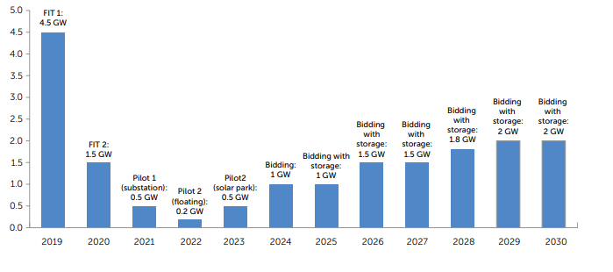
Figure 2 Solar deployment (GW) per year of COD in Vietnam
Source; https://openknowledge.worldbank.org/server/api/core/bitstreams/d519c878-b529-5245-ac8c-298ca623a05d/content
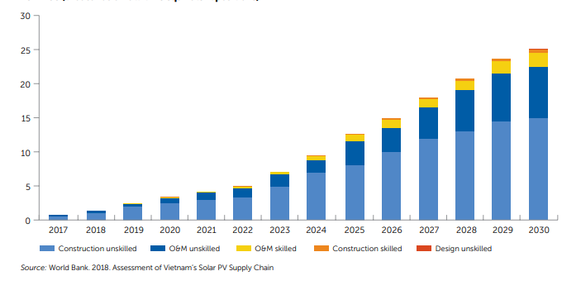
Figure 3 Job creation in project development, services, and O&M expected from Vietnam’s 12 GW solar PV target,
Source; https://openknowledge.worldbank.org/server/api/core/bitstreams/d519c878-b529-5245-ac8c-298ca623a05d/content
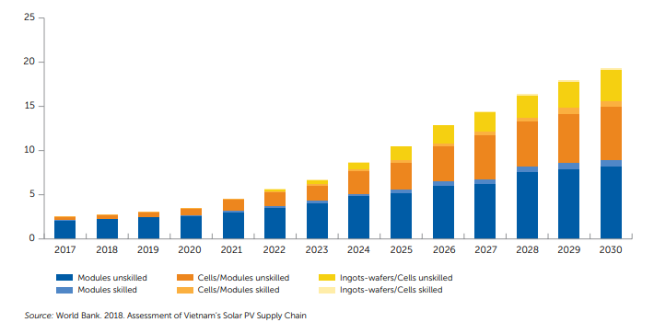
Figure 4 Manufacturing jobs expected to be created by achievement of Vietnam’s 12 GW solar PV target, 2017–30
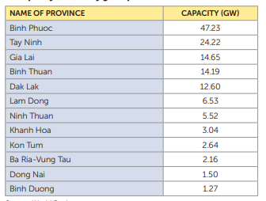
Figure 5 Provinces and potential installed solar
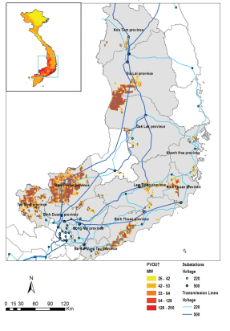
Figure 6 Zones with very good solar PV irradiation
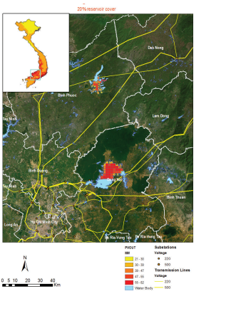
Figure 7 Floating solar PV potential

Appendix-II Vietnam’s Solar PV Industry

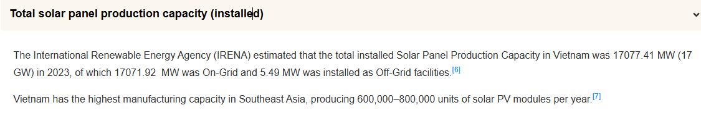
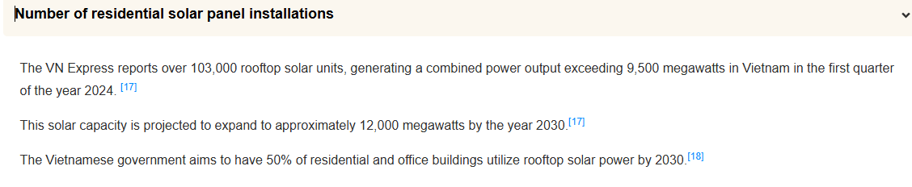
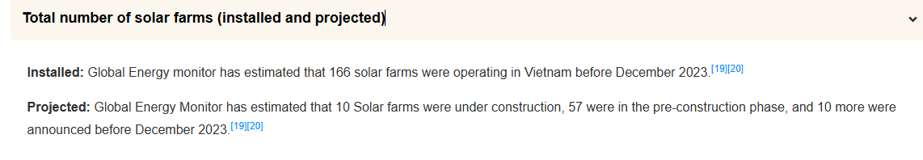
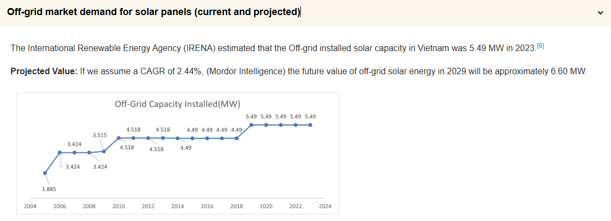
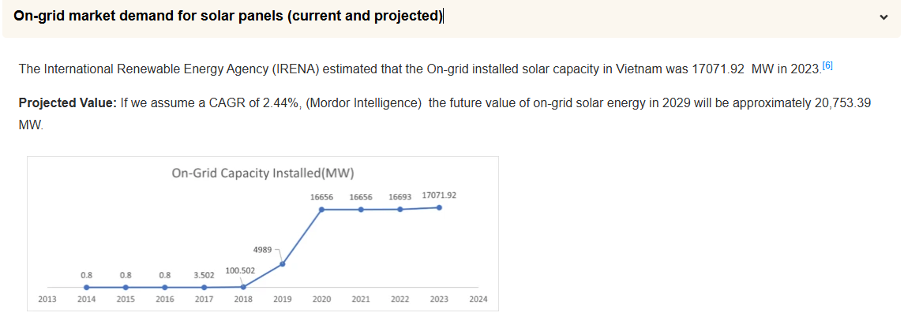
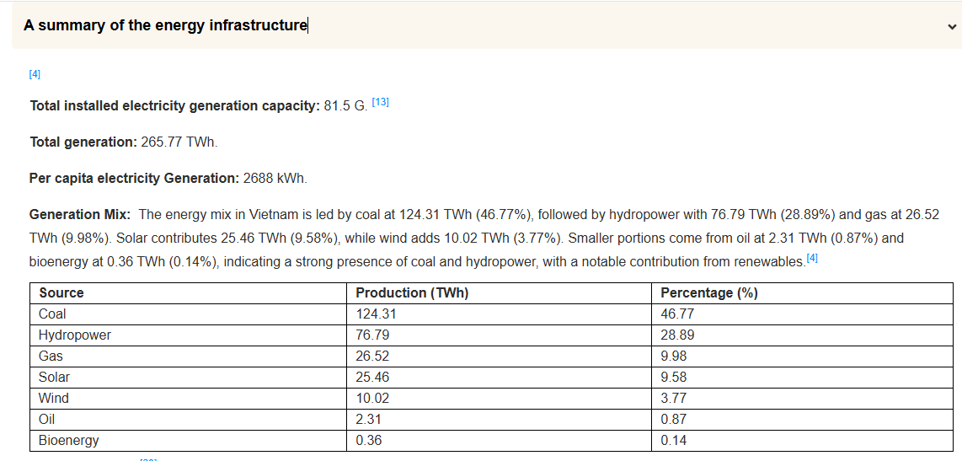
Source; https://www.pvknowhow.com/solar-report/vietnam/

Appendix-III List of companies in Solar Industry


