

LOCATION: CARMARTHEN / Birmingham/LAMPETER /Swansea/cOLEg sIR gAR | LLEOLIAD: CAERFYRDDIN/ Birmingham/ LLAMBED/abertawe/cOLEG sIR gAR
LEVEL 4 | LEFEL 4
EXAMINATION PERIOD | CYFNOD ARHOLIADAU
January 2024 | IONAWR 2024
MODULE CODE: acma 4009
APPLIED ANALYTICS
TIME: 1.0 HOURS
answer all questions

Equipment or materials required.
Formula booklet
Cyfrifiannell/Calculator

ANSWER ALL QUESTIONS

Consider each of the following problems and answer all questions.
Total marks (40) which constitutes 100%

TIME ALLOWED 1.0 HOUR

You are required to submit your solutions, along with all workings by ‘TURNIT IN’ VIA THE MOODLE WEBSITE.

- Given that Pressure is defined as;

$$Pressure=Force/Area$$

Derive the base units of Pressure. [5]

- A body of mass 4kg rests in limiting equilibrium on a rough inclined plane, which is at an angle of 60⁰ to the horizontal.

a) Calculate the maximum magnitude of frictional force. [4]

b) State which of the other forces are equal and give a reason why you can state this without calculation. [2]

c) Calculate the magnitude of the normal reaction to the surface. [2]

3. Solve the following Quadratic equations by factorising:

i) $x^{2}-7x+6=0$ [3]
ii)$x^{2}+4x=-4$ [3]
iii) $2x^{2}+3x+1=0$ [3]

4. Solve the following (to 2d.p’s) by using the quadratic formula:

$x^{2}-x-1=0$ [5]

5. Solve the following simultaneous linear equations:

(i) 2x + 4y = 10
3x + 2 y = -1
[5]

6. For the following electrical circuit(below) :

Find:

a) The current, I
b) The power supplied by the cell.
[8]

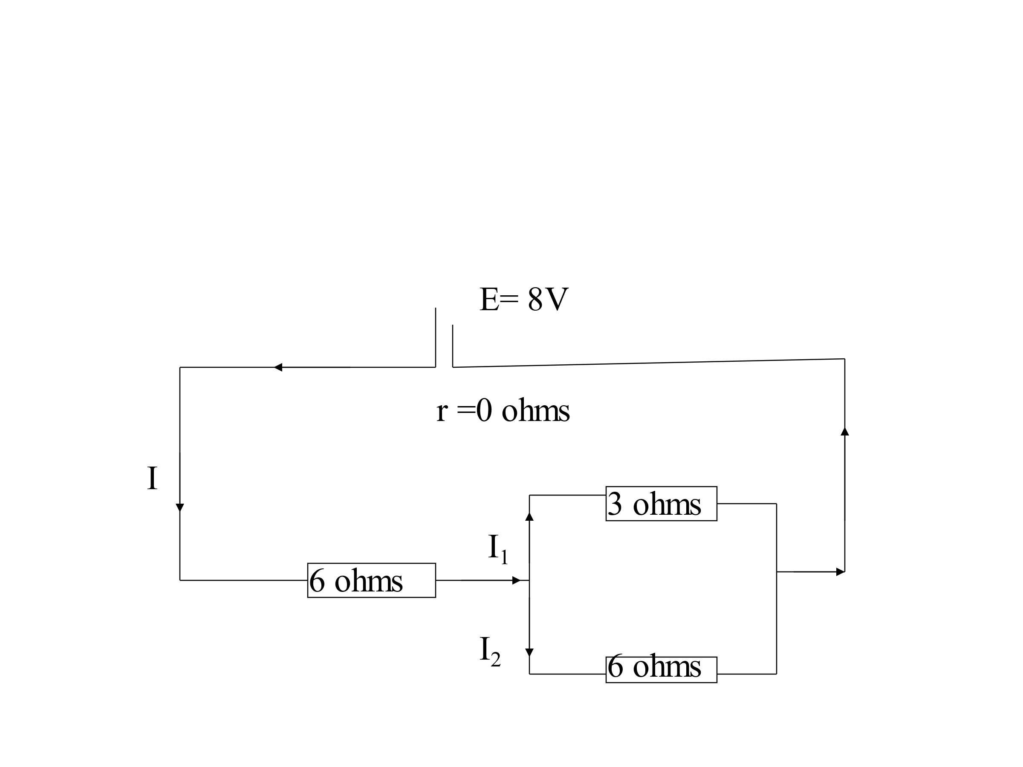

Diwedd/End

.

