Applying a range of critical theorises, identify, discuss an artwork of your own choosing.
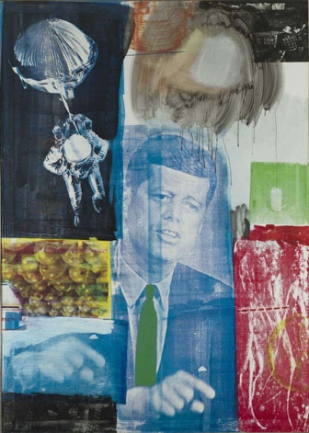

The painting above shows the work called Retroactive one painted in 1963 an apart of one his painting series that he completed 1962 and 1964 by an artist called Robert Rauschenberg. Rauschenberg was born in the peace era between the first and Second World War on the 22 of October 1925. This had an impact in the way that his art is created in such as he was born after the brutalism of the First World War and the world thought there would be peace and this affected the topics he wanted to share with people through his mediations. In this essay I look at the work of Robert Rauschenberg and his influence in the postmoderism era of the artworld and how he showed his work through using mediations and applying critical thinking skills to it.

Critical thinking involves participation from the audience in approaching ideas about the work for us to create a better understating of the art work and how it relates to the themes and understanding deeper themes to the work as a whole and not just the obvious truths. Robert Rauschenberg did this by creating a piece that was centred around imagines available to the public as the audience would be able to understand the deeper meaning to them as they are in the public and not just imagine that some other artist uses which are closely guarded or not available to the pubic in which art should be. Art was created to share idea and thought and feeling and to make people think about certain topics that they may have not thought about in there day to day lives especially in the political era of the postmodernism era.

During the period of the postmodernism art world photography plays an important part in creating works. As a medium it is more readily available and is accessible to the public. Rauschenberg was able to connect to the public through his art and uses pictures that were readily available to the public like the moon landing as a screen print. “Modernism is about stripping art back to the most fundalistic form. While post modernism is about torn to shreds and how there is no universal truths and that the world was a very messy place” quoted from the collector article about what postmodern art work is, and is shown through artworks but as art works can be deciving so can photography’s.

Photographs can be used to manipulate someone’s emotions and perception of an event or the artist themselves can manipulate the images to change a person’s perception to their liking rather than the truth. The image of JFK can change how people think about him as in the silk screen print to make him look more like one of the people or the images of the image of the space race in showing how America is strong and was able to beat the Soviet union (Ussr) As quoted from the book regarding the pain if others by Susan Sontag “photographs of the victim of war are themselves a species or rhetoric. They reiterate. They simplify. They Agitate. “the simplification of the space race between the USA and the Soviet Union is shown in the art he created as it just shows almost the end of the space race but not the years building up to it the training, the building of the ships. He oversimplified a very complicated process to show a certain rhetoric of the USA and how they won.

This piece of work represents a lot of things from the politics and the society at the time when he was completing these pieces. As shown on the piece there is a screen printing of john f Kennedy being the front and centre of the work and when Rauschenberg was completing this piece he wasn’t sure if he should add the screen print of john f Kennedy as it was after his death but did it as to Rauschenberg Kennedy thought that his “social activism made him a hero” so he used it anyway. Although this is a mediation of j f Kennedy with a silkscreen print on the canvas but this is also a mediation to us as the picture we are seeing is not the original piece it is just a scanned in version of that is available to on the internet. Also, Rauschenberg took photos from popular press images and uses those to create the artwork with JFK. Rauschenberg was also fascinated with space and uses images of space in his work.

With this piece being a mediation of the original piece by Rauschenberg it is not a natural way to look at the or the true reality of this painting “an image is a sight which has been recreated or reproduced. It is an appearance or a set of appearances which has been detached from time and place” from the ways of seeing by John Berger’s. This is especially prevalent with Rauschenberg’s work as he collected images, used screen prints, across years so there is certain detach between the pictures he had and how much they would have affected the public or himself. This painting is now not available to the public making it unavailable for us to view in a reality and only be shown mediation of the piece but for Robert Rauschenberg to create this painting he would have to gathered visual information from around him to be able to create his piece so he took inspiration from the social and political views at the time and how society was around him with the assassination of john f Kennedy and the American space race and he transformed them in to his collection of painting.

Included in retroactive one a screen print of a work that was complete by Andy warhol. It was a work the was featured in “the week that I was” and it contained imagines from the media of before and after he assinantion of John F Kennedy and the horror the first lady had to go through. And Andy Warhol quoted that “What bothered me was the way the television and radio were programming everyone to feel so sad” which even further perpetuates the violence that is included in art and the way it can change someone’s perception of the reality around us and others. imagines like this can numb us and create a lack of empathy with us.

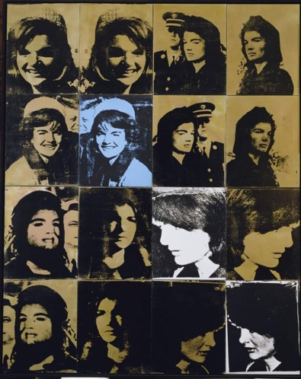
Being overly saturated with war images with grotesque and violent subjects can lead us to be numbed to anything that is created in violence is just seen as “normal” and the lack of empathy is shown by the lack of care for Jackie Kennedy as there are photography’s of her husband JFK while she is still covered in his blood. ” the hunt for more dramatic images drives the photographic enterprise and is part of the normality of a culture” from Susan Sontag, the normality of violence has become so present in modern day society that even after the assassination she was televised to have her bloody outfit on still covered in her husband blood and the photographers did not care about her just to get a good picture.

After thorough examination of Robert Rauschenberg work using critical thinking skills and themes of violence and how empathy or there a lack of can influence the artworks. Perception of people’s thoughts through his screen print, feelings perpetuated by the photographs he gathered. By analysing retroactive one by Rauschenberg his contributions to the post modernistic world of art is that of a great deal. His contributions to the art world can be helpful to show the multifaced layers of the post-modern art world by using commercial photography.to move forward from this we can conclude that violence plays a massive role in art and how we can uses the violence that we see and use is to perpetuate a new modern era in which that such grotesque works wouldn’t have to exist to create stir about topics that this world should not be experiencing in the first place.

References

1.Berger. JB. john (1972) ways of seeing, digital copy pdf. Page 9

2.Sontag.SS. Susan (2003) regarding the pain of others. Pages 5,20

3.Robert Rauschenberg Foundation. (2020), retroactive I (Online). (6 November 2023) Available from: https://www.rauschenbergfoundation.org/art/art-context/retroactive-i

4.Archive (1998). Retroactive I (1964) Robert Rauschenberg (online). (6 November 2023) available from:
https://www.artchive.com/artwork/retroactive-i-robert-rauschenberg-1964/

5.Lesso. RL. Rosie . The Collector (2022) What is Postmodern Art? (online). (11 December 2023) Avalible from: https://www.thecollector.com/what-is-postmodern-art/

6.SFMOMA .(2023) Robert Ruashenberg (online). (11 Decmeber 2023) Avalible from :https://www.sfmoma.org/artist/Robert_Rauschenberg/

7.The Museum of Modern Art,(2022) Robert Rauschenberg. Retroactive I 1964 (Online) . (11 December 2023) Available from: https://www.moma.org/audio/playlist/40/653

