
Ask for/Gofynnwch am |  | Lynne Richards
Our Ref/Ein Cyf |  | NCC2016-017
Your Ref/Eich Cyf
Tel/Ffôn
Direct Dial/Rhif Union
Fax/Ffacs
DX
E-Mail/E-Bost |  | Lynne.richards@newport.gov.ukl

Civic Centre/Canolfan Ddinesig
Newport/Casnewydd
South Wales/De Cymru
NP20 4UR

10th June 2016

Dear Sirs / Madam,

NCC 2016 – 017 Visitor Experience Destination Management Project

You are invited to submit an offer for the above, in accordance with the invitation to tender and the standard terms and conditions of Newport City Council (see www.newport.gov.uk/procurement). A set of documents is enclosed, and must be returned, using the Sell2Wales portal, no later than 12 Noon Wednesday 22nd June 2016

Your attention is drawn to the closing date for receipt of this tender. It is essential that this is complied with, since late offers will not be considered in any way. A faxed or e-mailed return is not acceptable.

Yours Sincerely

Lynne Richards

Lynne Richards
Tourism Officer

NEWPORT CITY COUNCIL

ON BEHALF OF

THE LIVING LEVELS LANDSCAPE PARTNERSHIP



LIVING LEVELS LANDSCAPE PARTNERSHIP
Visitor Experience Destination Management Project

CLOSING DATE FOR TENDERS: 12 noon on 22 nd June 2016

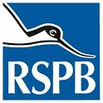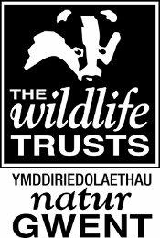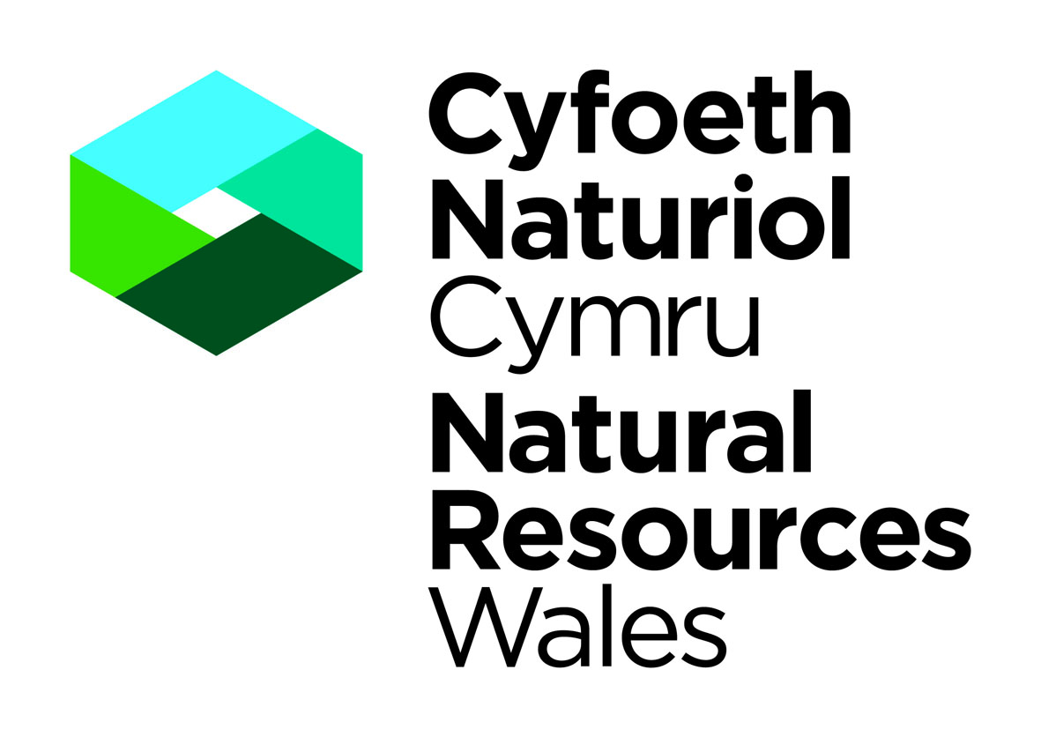

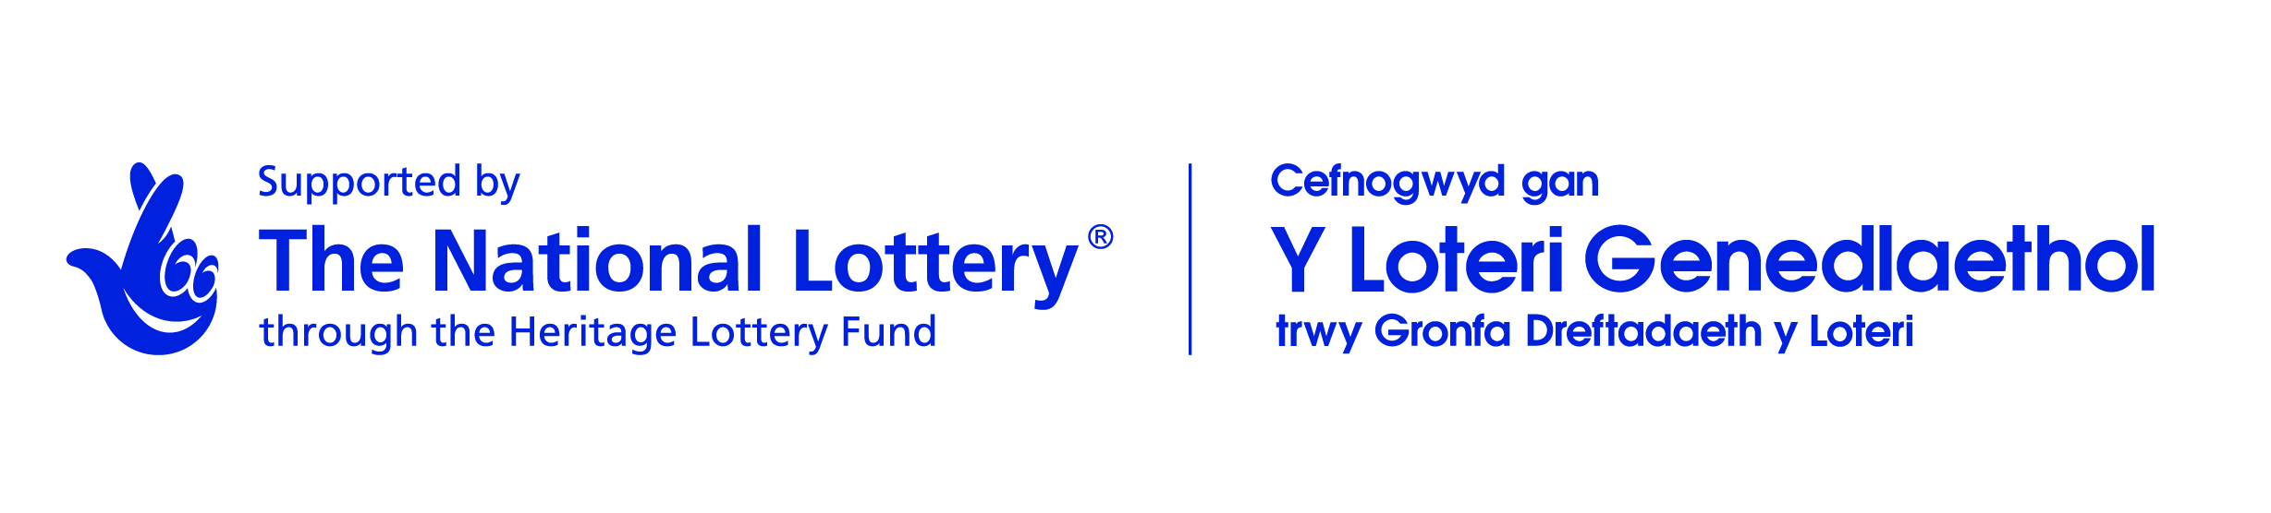

CONTENTS

1 SCOPE OF THE COMMISSION

2 BACKGROUND

3 OBJECTIVES OF THE STUDY

4 REQUIREMENTS OF THE STUDY

5 PROJECT OUTPUTS

6 TIMESCALE AND BUDGET FOR THE STUDY

7 REPORTING PROCESS

8 CONTENT OF THE WRITTEN QUOTATION

9. INTERPRETATION AND CLARIFICATION

10. SUBMISSION

11. COSTS

12. ACCEPTANCE OF TENDER

13. CONFIDENTIALITY

14. TENDER SUBMISSION

15 AWARD OF CONTRACT EVALUATION CRITERIA

16 PAYMENT

17 CONTACTS

Project Brief

- Scope of the Commission

1.1 The brief sets out the requirements for the development of a Visitor Experience Destination Management Delivery Plan for the Living Levels Landscape Partnership area from Chepstow across to Cardiff. (Appendix 1 – Living Levels National Landscape Character area) The scope of this project is to bring together four main components.

1. Telling the story of the Gwent Levels in its broadest sense.
2. Creating an interpretation and signage Plan for the area
3. Development of a Visitor Access Plan
4. Creation of an integrated Marketing Plan for the Living Levels partnership area.

The aim of the commission is to prepare and work up the delivery action plans for the proposed implementation of the integrated schemes for phase two of the Heritage Lottery Fund (Wales) Living Levels Heritage Lottery bid. Whilst the individual Local Authority areas and stakeholders have their own strategies and plans, there is a need to create an overarching Destination Management Plan for the Living Levels area. This will be to integrate the ‘sense of place’ and telling the story of the area, with the interpretation, signage and visitor access plan, as well as the destination marketing strategy. The estimated timeframe for the HLF delivery phase is from mid-2017 to December 2020. There is considerable background information and previous work that has been done is expected to support this commission.

1.2 This commission is being funded as part of the development phase of the Living Levels Landscape Partnership Scheme which must meet the timetable for a stage 2 submission and therefore requires work to be completed within the timescales set out in the brief. The total scheme, not just this commissions’ aspect, has a worth of around £3.9 Million over its lifetime depending on match funding and approvals.

Key policies to address throughout this are appropriate use of the Welsh language for consultations and reporting for this commission as well as delivery plans , DDA compliance, accessibility, and sustainability. There is also a need to embrace the Well Being of Future Generations (Wales) Act.
As part of the wider Living Levels scheme all the work should feed into the Landscape Conservation Action Plan. (LCAP) As such the study needs to incorporate the guidelines and criteria of LCAP which can be seen here: -

www.hlf.org.uk/landscape-conservation-action-plan.

There are nine key HLF Landscape partnership outcomes:

Outcomes for heritage:
Heritage will be: better managed, in better condition, identified/recorded

Outcomes for people:
People will have: developed skills, learnt about heritage, volunteered time

Outcomes for communities:
Negative environmental impacts will be reduced, more people and a wider range of people will have engaged with heritage, your local area/community will be a better place to live, work or visit.

Consideration of benchmarking, monitoring and evaluation needs to be considered in the delivery plans.

2. Background

2.1 The Living Levels Landscape Partnership

The Living Levels landscape partnership brings together like-minded but potentially disparate stakeholders to develop and deliver projects that will re-connect people, who live, and work in the Gwent Levels with their landscape. The Landscape Partnership aims to address one of the key threats to the landscape: people’s disconnection from the multitude of community activities that has shaped the unique landscape we see today. The aim of the Living Levels Landscape Partnership is to reconnect people and communities to their landscape and provide a sustainable future for this historic and vibrant place.

We will do this by:
1. Forging a strong partnership, with the community at its heart;
2. Recapturing and enhancing the natural and historic heritage;
3. Celebrating its stories;
4. Providing new opportunities for learning, developing skills, participation and investment;
5. Encouraging and providing access for all; and
6. Building capacity and resilience for the long-term.

As a result of this scheme:
• The Living Levels Landscape will be better managed; in better condition and better recorded;
• People will have developed skills; learnt about the landscape and its heritage and will have got involved;
• A greater diversity and number of people will be participating; and
• The local area will be a better place to live, work or visit.

Partners include:
- Royal Society for the Protection of Birds (RSPB)
- Gwent Wildlife Trust (GWT)
- Natural Resources Wales (NRW)
- Newport City Council (NCC)
- Monmouthshire County Council (MCC)
- Cardiff City Council (CC)
- Cardiff Story Museum,
- National Trust
- Bumblebee Conservation Trust
- Buglife
- Gwent Archives

The partnership is not a lobbying group; however it may need to recognise possible development proposals.

2.1.2 The Gwent Levels is an iconic, estuarine landscape of International Significance bordering the Severn Estuary in South Wales. This unassuming, yet appealing landscape of high skies, low horizons and a geometric patchwork of watercourses between fertile fields are recognised as one of the finest examples of a landscape hand-crafted by the communities that have lived here since their reclamation from the estuary starting in Roman times.

2.1.3 This remarkable landscape, ranks alongside Snowdonia in its “landscape value” but does not have the same recognition amongst its resident, local populations or potential visitors. We believe the main threats to the landscape are:

1. An increasing disconnection by growing sections of the community (including the necessary centralisation of government) leading to the reduction in traditional management and loss of knowledge and skills from within the community; and

2. An under-developed “vision” and “sense of place” for the long-term future of this landscape. This is leading to inappropriate development; missed opportunities for tourism and inward investment; and increased negative impacts from local conurbations, such a fly-tipping and litter.

3. The scheme will be a catalyst for partners to set a long-term vision for the Gwent Levels and to create the management structures and working relationships that will ensure the restoration and survival of this landscape for future generations.

4. This area of land has recently been opened up by the Wales Coast Path attracting visitors from around the world. The RSPB Newport Wetlands Centre and NRW Reserve are now maturing, and other attractions along the coast here, include the heritage attractions of the Transporter Bridge and the new National Trust product, Tredegar House nearby. As such there are already visitors coming into the area.

2.1.4 The Living Levels area is also the ‘garden’ to the large St Modwens housing development at Llanwern which over the next few years will bring nearly 9500 new residents to the edge of this landscape.

2.1.5 As such now is the time to manage the area in terms of its Visitor Experience, its image, sense of place and standing, bringing added value for the investments made.

2.1.6 Considerable work has already been achieved through previous studies, and there are informative policies on the area, which can be used to inform this overarching piece of work. Also a workshop is being proposed for June 21st 2016 to help consultation and coordination with interested parties and stakeholders.

2.2 Key Support Documents Include: -

Newport LDP (Newport CC website)
http://www.newport.gov.uk/en/Transport-Streets/Transport-and-Streets.aspx
Monmouthshire Local Transport Plan
http://www.monmouthshire.gov.uk/local-transport-plan
Active Travel Plan Newport CC and Monmouthshire CC
Visitor Experience Development Plan – Newport Gwent Levels 2014
Interpretation and Access Plan – Monmouthshire CC
Monmouthshire Visitor Experience Development Plan
Interpreting the Newport Transporter Bridge – Wales Coast Path 2014
Partnership for Growth – Visit Wales strategy to 2020 (Visit Wales on line)
Newport Gwent Levels – Sustrans Cycle network 2014
Newport Wales Coast Path Gwent Levels report April 2014
Newport Pillgwenlly Wales Coast Path report 2014
Monmouthshire Countryside Access Design Guide 2011
Monmouthshire Destination Development Plan 2012
Monmouthshire Walking Product Development Strategy 2013
Monmouthshire Wales Coast Path Sustainable Transport Study 2013
Monmouthshire Wales Coast Path Signage and Interpretation Plan 2013
Monmouthshire Community Engagement Walking Toolkit 2013
Wales Coast Path Bridleway Feasibility Study 2015
Newport City Council Rights of Way Improvement Plan 2007
Newport City Council and Countryside Access Management Ltd – Improvement
of Routes for Horse Riders 2013
Newport City Council Community Links and Development programme for the Wales
Coastal Path 2014
Newport City Council and Sustrans - Newport Active Travel Network Study 2013
Newport Active Travel Existing Routes Network cycling and walking audits
plans consultation and consultation report 2016
Newport City Council Accessible Natural Greenspace – various reports 2009-2015

- OBJECTIVES OF THE STUDY

This is the Development phase of a Heritage Lottery funded Landscape Partnership Scheme The work done in this study will give detail of the action plan and costs for delivery in phase two , to form the basis of the application for the second round of funding. As such it will need to be robust and practical. – the budget for the second round application has been approved by HLF during the first application round and as such, the suggested costs for delivery need to stay within the overall budget limits.

The main objectives of the study are to raise the awareness of the Living Levels Landscape heritage, its value and unique offering. This will be for local communities and an increased number of visitors and broader audience. The image of the area needs to be improved with a better ‘sense of place’ to encourage respect, and to benefit the Landscape Partnership area as a desirable place in which to live, work, study and visit. The area needs to be better managed in terms of visitor and community use, as well ensuring a better visitor experience. An integrated marketing plan will encourage more people to visit the Gwent Levels and thus support the local visitor economy. Whilst considerable work has been done towards this especially the Visitor Experience Development Plan for the Wales Coast path , Newport , these disparate pieces of work now need to be pulled together to cover a larger area across different Local Authorities .

4. REQUIREMENTS OF THE STUDY

4.1 Telling the story of the Gwent Levels

4.1.1 This project needs to pull together in a coherent way, the story of the heritage and character of the area, addressing and balancing the different strands: geographical, geological, archaeological, and cultural and socio – economic, as well as ecological heritage. Coherent content with key themes and messages need to be identified, all supported by and linked to the actual resource, and source.

4.1.2 There are many stakeholders who will have their own versions and views. The stories will range from those of the local communities and individuals, to those associated with its global context. The content ‘story board ‘created needs to be done in such a way as to consider all the different audiences from leisure to educational recognising the stakeholders in this partnership .

4.1.3 The work will inform Sense of Place aspects, picking up on any links to colloquial language, specific foods or drinks, as well as landscape and landmarks.

4.1.4 This scoping work will begin to identify ‘branding’ options from a bottom up approach that will inform the interpretation and marketing in the delivery phase. This approach should seek to unify existing destination and community branding across the Levels so as to present visitors and local users with a more coherent approach whilst retaining local diversity and community distinctiveness.

4.2 Consideration of the future story should also be addressed.

4.2.1 The content outputs from this project should also identify image sources, and the original resource supporting the key themes and messages.

4.3 Interpretation

4.3.1 There is a requirement for an overarching interpretation plan for the Living Levels area. This will take into account the different stakeholder’s agendas, current feasibility studies and strategies and existing interpretative provision. Much good work on interpretation has been done in the region, for example on the history of fishing in the area. Rather than duplicate this, the project should embrace work already done where relevant.

4.3.2 The full range of interpretation needs to be considered across the whole Landscape Partnership area including how the sense of place and story is told via businesses, local venues, the community, volunteers and other options, as opposed to only at key central attractors. Any developed visitor interpretation should also be inclusive of the local community as engaging those people in the development of information will potentially help to create Ambassadors for the area. A Community Engagement Officer has been employed by the partnership to lead this during the Development Phase. Therefore coordination with the partnership community engagement programme would be required.

4.3.3 All methods of delivery and media , including existing digital provision need to be considered e.g. The Wales Coast Path App. An audit of digital access across the Living Levels Landscape partnership area needs to be addressed in order to inform the delivery plan for interpretation, information provision and marketing. Support information is available.

4.3.4 The scope of interpretation should consider physical models, themed tours, demonstrations of skills and crafts, Ambassador Training, oral history, local events, and any other.

4.3.5 Understanding and respect for the nature and culture of the landscape that people are coming to visit is important, so there is a challenge of how the messages get across. Innovation and creativity are to be encouraged.

4.3.6 The plan should address any planning issues, sustainability, life expectancy and maintenance.

4.4 Access and Signage

4.4.1 A review of existing information and surveys of rights of way networks including information already explored on key routes and gateway will be required to help define the key routes and gateways across the area for visitors and communities. Key information and recommendations can be obtained from the Living Levels LCA and Green Infrastructure study being done in advance and concurrently of this work. Some feasibility work into Gateways, cycle and bridle way projects have already been done especially along the Wales Coast Path area. This review will address the differing levels of information across the Landscape partnership area, including strategic links beyond the boundaries with inland routes, as well as the broader national Wales Coast Path.

4.4.2 Based on the review an improvement access plan is required, taking into account the overall visitor experience including parking availability, public transport, loops and links, key routes (public rights of way, cycle routes, bridleways, viewpoints) with consideration of different accessibility levels . An assessment of the impact of additional visitors or improved access on the Levels’ natural and historic features should be done , and proposals include mitigation measures if necessary.

4.4.3 The signage at different levels will need to be reviewed, building again on recent work already done, as well as plans and policies across the local authority areas. Signage needs to work at different levels to manage visitor and residential movement around the area, from Gateway (Highways signage) and main interpretation hubs to local community facility information. How these interlink and work with the walks, cycle and bridle ways across the area will be important. Much work has been done to look at this but in varying capacities across the Landscape Partnership area.

4.5 Creation of an Integrated Marketing Plan

4.5.1 The Living Levels requires an overarching integrated marketing plan.

4.5.2 The aim is to create awareness of the Living Levels as a destination in which to stay and spend time, learn and appreciate. A destination for activity and education; a destination where you can stroll and be relaxed, or a destination where things happen too – an exciting Living Landscape with events and activities. This is also to support the local economy as a key outcome.

The study will require an audit of the current stakeholders’ marketing activities, identifying their specific audiences. An audience development plan for the destination should be developed, identifying gaps as well as overlap audiences. This should be clearly linked to the strategy. There should be a bottom up approach from work done on identifying the Story of the Levels to brand identities which should resonate with target audiences. There will be other audiences for the Living Levels project including the local community, volunteers, landowners and businesses that need to be considered, and embraced.

The strategy should embrace the current activities of individual stakeholders, but consider improvement through potential joint marketing activities. The added value of supporting each other, sharing of customer or visitor information, research, and collective marketing for the Living Levels as a destination should be encouraged.

The marketing strategy needs to take into account monitoring and evaluation of activity with specific measures clearly identified, linking back to HLF outcomes and LCAP as identified in the beginning. This might include visitor surveys, measuring or monitoring visitor satisfaction, visitor experience improvements, advocacy and levels of repeat visits.

Results based accountability methods might be considered that can feedback into the life of the project. There will be a broader overarching monitoring and evaluation scheme for the Living Levels project as a whole, of which this will form a part.

All relevant media should be included. Critical is a clear exit strategy or legacy method for when the delivery project itself finishes.

Local communities, and volunteers could get involved potentially upskilling in Website content input or design, or building the capacity for a marketing association.

5. PROJECT OUTPUTS

Outputs will need to reflect the study requirements above and will work together. These will be used to support the second round application for grant funding from the Heritage Lottery Fund Wales in 2017. All the following therefore will require a phased and costed delivery plan over three years. These should be easily understood explaining scope and time using graphic formats such as Gantt Charts, maps and excel spreadsheets to support explanations. Succinct reporting and approaches will be appreciated and is requested for funding applications Resources and projects cash flow for delivery should be clearly identified, broken down into cash , staff /volunteer time including match funding sources . As this is for delivery then it is not expected that further broad research and feasibility studies are part of these delivery plans. The broader visitor experience destination management approach should also consider in the delivery plan, any skills development opportunities for businesses, volunteers and the community to add to the capacity and resilience of the area. Coordination and consultation with partners of the Living Levels Landscape partnership will be important to ensure coordination with approaches being developed across the partnership for the Delivery phase of the programme.

The expected outputs are:

- A foundation document for telling the broad themes of story of the Gwent levels or Landscape Partnership area, encompassing the full scope of topics as described. Sources and reasons to support this along with image and resource information will be required .This will inform the interpretation plan, branding options, sense of place and strategic marketing approaches.

- An integrated Access, Interpretation and Signage Improvement Plan.

a) A detailed and costed Access Improvement Plan for the whole Landscape partnership area. This should have all consents in place where necessary, be clearly mapped and address the suitability for different groups. This will include public include public / and community transport.

b) A detailed and costed signage Improvement Plan for the whole Landscape Partnership area. This will look at the different levels of signage from highways to local community facilities to support the visitor experience . This will need to integrate with walks, cycle and bridle routes which may have their own brands, and work at wider or more local scales.

c) A detailed and costed Interpretation Plan for the Landscape Partnership area that recognises and embraces the interpretation agendas of key stakeholders , and different communities , whilst recognising the gaps and need to pull this to another level for the destination as a whole. This will need to work across different media and via different methods.

3. A detailed and costed integrated Marketing Strategy for the Living Levels.

The aim will be to raise awareness of its importance and significance amongst local communities as well as to increase visitor numbers in a sustainable way.

It is of note that as this are phases one of a two part project. Indicative budgets have already been outlined for delivery, and so consultants are expected to work with these as a guide.

This scheme recognises that there are proposals in the area for major development schemes, but this should not prevent a delivery plan moving forward.

The outputs should identify how this delivery plan will mean that more people and a wider range of people, will have engaged with the heritage of the Living Levels. Expected outcomes for the above should be identified.

6. Timetable for the study and Budget

6.1 The budget available is up to £45,000 excluding VAT to cover all costs, except any planning consent costs.

6.2 The outline timetable for the study is set out below:
Deadline for submission of quotations | 22 June 2016
Interviews | 27 June 2016
Award of project | 29 June 2016
Interim reports  Interim reports  Draft Final reports  Presentation of final reports | September 2016  November 2016
  January 2017
  February 2017
7. Reporting process

7.1 Newport City Council’s Tourism Service will manage this commission on behalf of the Living Levels landscape partnership. Meetings will be held with the client group on a regular basis (to be specified in the submission) throughout the project, to consider and discuss the methodology, progress, interim reports if required, and, any matters arising.
7.2 The consultants will provide 5 hard copies of the final reports, together with 1 electronic version in both Microsoft Word and Adobe Acrobat. A version needs to be also done in Welsh. The copyright of these documents should be vested in Newport City Council on behalf of the Living Levels Landscape Partnership. Consultants are also expected to produce an executive summary for each, and then an overall Destination Management report as to how each works together.

8. CONTENT OF THE WRITTEN TENDER

8.1 Tenders are invited on a fixed price basis to include all disbursements and other expenses (including the cost of obtaining information, but excluding VAT) the award of contract will be made on the basis of the criteria in Section 9.

8.2 Please submit your tender outlining the approach to this project clearly indicating the full cost, and how this is broken down into the anticipated work streams or output headings .i.e. Interpretation plan development, destination marketing planning. This should clearly outline your methodology giving indications of any consultation necessary and client meetings, additional research. The methodology should reflect the work over time to ensure that the deadlines are achieved for the second round of funding.

The tender should clearly demonstrate that you have the personnel with relevant knowledge, skills and experience to take on this development phase. This should evidence the recent experience in the relevant fields and how they can bring practical understanding for delivery. We would like to know about the people, how management of the different aspects will happen, and that capacity over time has been considered.

Please submit an outline of your understanding of the key aspects of the brief, what the work will entail, the issues that might arise and any mitigating activity that may be needed. In this section please can you give a brief outline what you see as being included in the costed delivery action plan which will form the basis of the application to HLF in round two. For example Capital cost of surfacing cycle routes, Interpretation board manufacture and installation, digital content creation .

8.3 Tenders should demonstrate the compatibility of the consultants’ software systems with those of Newport City Council.

8.4 Tenders should include a schedule of costs and activity in tabular form.

8.5 Tenders should include a copy of the consultants’ Professional Indemnity Insurance.

8.6 All tenders must include the name and address of the tenderer and the date of tendering and be signed by the tenderer's authorised representative.

9. INTERPRETATION AND CLARIFICATION

9.1 Persons proposing to submit a quote are advised to read the Tender Document carefully to ensure they are fully familiar with the nature and extent of the obligations to be accepted by them if their tender is accepted.

9.2 Should any person proposing to submit a quote be in doubt as to the interpretation of any part of the quotation document, all queries must be submitted through the Sell2Wales question & answer portal relating to the quotation notice, www.sell2wales.gov.uk

10. SUBMISSION

10.1 The submission of an offer by a Bidder is deemed to mean that they have understood the nature and extent of the provision required. No claim founded on a Bidders failure to obtain interpretation of the provision prior to submission of their offer will be considered.

11. COSTS

11.1 The Council will not be responsible for any costs or expenses incurred by the tenderer in connection with either the preparation or delivery or in the evaluation of the offer.

12. ACCEPTANCE OF TENDER

12.1 By issuing this invitation the Council is not bound in any way and does not have to accept the lowest or any offer.

13. CONFIDENTIALITY

13.1 Persons receiving these documents shall not disclose the terms and conditions to any other party, or use the information contained in this document without the written authority of the Council, likewise, all information included by Bidders in their offers will be treated in confidence.

13.2 After the contract has been awarded, unsuccessful firms must direct any queries in writing to the council’s contract administrator as detailed in the document.

13.3 All information contained in the document shall be regarded as confidential to the Council.

14. TENDER SUBMISSION

14.1 If on receipt of any tender an error shall be apparent in the schedule of costs , the tenderer will be given notice of such and will be allowed 3 working days from receipt of that notice in which to withdraw their tender or to confirm in writing that they wish their tender to stand as submitted.
.

14.2 Tenders must remain open for acceptance for a minimum period of 90 days from the return date specified.

14.3 All Tenders must include the name and address of the Tenderer and the date of bidding and be signed by the Tenderer's authorised representative.

14.4 One copy of the completed tender must be submitted in a PDF format through the Post Box on the www.Sell2Wales.gov.uk Website relating to the quotation notice no later than 12(NOON) on 22nd June. Quotations received after this date and time will not be considered in any way.

14.5 Tenders must be returned complete with all supporting and any additional information in accordance with the Newport CC procurement regulations.

14.6 Gellir darparu’r ddogfen hon yn Gymraeg os bydd angen.

15. AWARD OF CONTRACT EVALUATION CRITERIA

15.1 The partnership has allocated a budget of up to £ 45, 000 for this project. It will be seeking, however, a study that is fit for purpose; the selection of the successful Consultant therefore shall be on the basis of the following evaluation criteria and not on cost alone:

Understanding of and recent experience of either delivery of outputs for the project scope, or creation of similar delivery plans that have been actioned
40%

Quality of tender proposal, process, methodology, showing understanding of the brief of sustainability and risks, with mitigation 30%

Evidence of Value for money throughout – for example what you can bring to the table for the study , knowledge of the area , and value that can be achieved for outputs for the delivery phase 30%

Price vs Quality 30% / 70%

15.2 Interviews of a short list of consultants may be used to assist in the selection process.

16. PAYMENT

16.1 Newport City Council will be the commissioning agency for this project on behalf of the Living Levels landscape partnership and the contract will be appointed according to the Council’s standard conditions for consultancy services

16.2 Consultants will be appointed on a fixed price contract for this work. Payment will be made in up to four stages as agreed with the consultant: [

- Inception 20 %
- 2 X Midterm draft reports @ 30 % each
- Final report sign off 20 %

16.3 A fee quotation, including disbursement and other expenses (including the cost of obtaining information, but excluding VAT) is to be submitted for this commission covering all the Objectives and Requirements listed in this Brief.

16.4 In addition, staff day and hourly rates are to be supplied to allow the calculation of fees for any additional duties instructed by the Client not covered in this Project Brief.

16.5 The Council reserves the right to withhold payment for work considered to be unsatisfactory in quality.

17. CONTACTS

Key contacts for the project will include

Nicola Edwards Tourism and Food Manager Monmouthshire CC
Mark Underhill RSPB Senior Project Management officer
Alison Boyes Living Levels Project Manger
Matthew Lewis Countryside and Green Infrastructure Manger Monmouthshire CC
Joanne Gossage Green Services Manager Newport City Council
Lynne Richards Tourism Officer Newport City Council

Other contacts will be provided for the project once commissioned .

To: NEWPORT CITY COUNCIL (Hereinafter referred to as NCC)
1. Having examined the contract to provide the above mentioned products and or services we offer to perform and complete the said, in conformity with the said contract.
2. We undertake to complete and provide the products and or services comprised in the contract for the prices set out in the Pricing Schedule.
3. We agree that the insertion by means of any conditions qualifying this Tender or any unauthorised alteration to any tender documents shall not affect the contract and may cause the tender to be rejected automatically.
4. We confirm all the information given in response to this Invitation to Tender and to the best of our knowledge is true and accurate.
5. We understand that acceptance of the whole or part offer will be made by a letter from the council.
6. We understand that you are not bound to accept the lowest or any tender you may receive and you will not pay any expenses incurred by us in connection with the preparation and submission of this tender.
7. In recognition of the principle that the essence of selective tendering is that NCC shall receive bona fide competitive tenders from all those tendering.
WE CERTIFY THAT:-
a. The tender submitted herewith is a bona fide tender intended to be competitive.
b. We have not fixed or adjusted the amount of the tender by or under or in accordance with any agreement or arrangement with any other person.
c. We have not done and we undertake that we will not do at any time before the hour specified for the return of the tender any of the following acts:-
i. communicating to any other person other than NCC the amount or approximate amount of the proposed tender (except where the disclosure, in confidence, of the approximate amount of the tenders was essential to obtain insurance premium quotations required for the preparation of the tender).
ii. entering into any agreement with any other person that he shall refrain from tendering or as to the amount of any tenders to be submitted; and
iii. offering, paying or giving or agreeing to give any sum of money or valuable consideration or causing or having caused to be done in relation to any other tenders or proposed tenders any act or thing of the sort described above.
8. We agree that this tender shall remain open to be accepted or not by NCC and shall not be withdrawn for a period of four months after the date fixed for receipt of tenders and thereafter unless and until written notice of the withdrawal of the tender has been given by us to NCC.

Completed this _____________________day of __________________________ 20___

Signature __________________________ in the capacity of ______________________

Please Print Name _______________________________________________________________________

For and on behalf of _______________________________________________________________________

Full Postal Address _______________________________________________________________________

_______________________________________________________________________

Tel No: ___________________________ Mobile No:____________________________

E.mail: ___________________________ Fax No: ______________________________

