
Energy Efficiency in Buildings
Case study of The Dylan Thomas Building

April 2, 2019
University of Wales Trinity Saint David
Alex Morgan 1808368

Table of Contents

1.0 - Introduction 2
2.0 - Aims and objectives 2
2.1 - Aims 2
2.2 - Objectives 2
3.0 - Literature review 3
3.1 - Smart sensors 3
3.2 - Sensor locations 3
4.0 - Methodology 3
4.1 - Stage 1 – building survey 4
4.2 - Stage 2 – room investigation 4
4.3 - Stage 3 – sensor location 4
5.0 - Results 5
5.1 - Room survey (stage 1 & 2) 6
5.2 - Stage 3 - Sensor location 9
5.3 - Test room 1 & 2 9
6.0 - Restrictions 10
7.0 – Conclusion 10
8.0 - Recommendations 10
9.0 - References 11

Table of figures

Figure 1. wireless sensor network. (Othman and Shazali, 2012) 5
Figure 2. 21-7A (test room 1 location) (Author, 2019) 7
Figure 3. 1-32 (test room 2 location) (Author, 2019) 7
Figure 4. 1-32 (test 2 room layout) (Author, 2019) 8

1.0 - Introduction
Smart sensors are tools used to gather data in working buildings of how specific areas are used. If these sensors are part of a ‘Smart Building Management System then the data compiled can be used to dictate when to turn on/off certain services. For example; if a room is only occupied for 2 hours on a Monday, the sensors will recognise this and only activate the lighting and HVAC systems for that period. This not only maximises the comfort levels of that room but in turn reduces the energy consumed. The locations of the sensors whether they are monitoring movement, temperature, humidity or light are crucial to the room functioning to as part of a ‘Smart building’ and to maximise its energy efficiency potential. New buildings are benefitting from smart technology and it is becoming easier to implement the systems during the construction phase. It’s not our new buildings where the problem lies, our current stock of old, outdated and inefficient buildings needs addressing. If smart technology can function in our new buildings then why not in our old? By retro fitting certain elements of the building to allow the smart systems to function and adapt with the users we can utilise the buildings we already have, lower energy consumptions whilst still maintaining acceptable levels of comfort for the users.
For this report two rooms were identified and selected for the test rooms. The location of these rooms, their use and the fabrics used in construction was crucial when deciding their suitability. The test rooms were fitted out with sensors that recorded various sets of data over a specific period of time. The different sensors were located dependant on their specification and their individual function.
The building in question was the Dylan Thomas building, being originally constructed in 1825 the building fell into disrepair and closed its doors in 1982. 1n 1995 it received a much needed renovation including a large extension. I will aim to prove with this report that the location of the sensors and the data they collect will very much depend on the location of the room within the building envelope, the building materials and its individual usage.

2.0 - Aims and objectives

2.1 - Aims
- To survey the Dylan Thomas building and identify two suitable test rooms to install smart sensors.

2.2 - Objectives
- To investigate the building structure and fabric used.
- To identify two test rooms suitable to house the different sensors.
- To map out services, room functions and layout.
- To identify any local variables that could affect the locating of the sensors.

3.0 - Literature review

3.1 - Smart sensors

The benefits of smart sensors are increasing along with the development of the technology. Dener and Bostancıoğlu (2015)(Pg. 2) talk about the why it is easy to monitor almost any environment. The function of a smart sensor is to detect and communicate, with the potential to do this 24 hours a day, the sensors need to be energy efficient. The individual sensors are inexpensive to purchase and as demand increases the cost should decease. They need to be wireless and battery powered for ease of installation and maintenance. The sensors produce nothing that is harmful to the environment and have very low power consumption. It was also discussed how intelligent systems can learn and predict, when no activity has been detected the sensor will automatically switch to sleep mode. This helps to conserve energy and extend the life of the sensor.

3.2 - Sensor locations

There is a stalemate between optimal comfort and reduced energy consumption, in theory the lower the energy levels the lower the comfort of the user. To optimize the comfort of the occupant whilst trying to reduce energy consumption it is important to choose the correct of sensor and to locate it accurately. Sembroiz et al. (2019) talk about clustering of sensors to help organize and assist with energy saving. If the clustering has been planned correctly, the sensor network will work around a cluster head which will detect which sensor head has been activated. In this circumstance all other sensor will turn into sleep mode.
To obtain optimal levels of light in a room a motion sensor and brightness sensor can be installed. Zhou et al. (2015) discusses how the brightness sensors should be placed near the work surface but unfortunately these sensors would be interfered with via human contact. Alternatively the light sensor could be placed on the ceiling which will limit the negative effect through human contact. Considerations must be given to reflectance levels from objects in the room, these can also have an impact on the brightness sensors. The motion sensor will only detect movement, if someone is in the room the sensor will turn the lights on and vice versa in the room is empty the lights will switch off.

4.0 - Methodology

The case study for this investigation is the Dylan Thomas building, to fulfil our aims and objectives the building and its use needed further inspection. As we needed access to the whole building I had to secure access fobs and arrange a tour of the building. Initially a member of the estates team was interviewed and any corresponding documents that could help with the report was requested. The information gathered would be used to design a building layout to ascertain where rooms A and B are located within the main plans. The on-site Health & Safety file should contain various documents ranging from M & E plans to condition surveys and with this information one could confidently predict the materials used in construction. By gathering historic data on the building, it would give an understanding of any changes to the building over the years. The plans should include details of the refurbishment works in 1995. After the historic research into the building, a walk over survey would be completed to give a detailed overview of the building and assist when deciding on the test rooms. The rooms required for this investigation should be occupied on a regular basis so that the sensors can collect real time data.

4.1 - Stage 1 – building survey

The building was surveyed and all facilities areas were investigated. A decision was made as to which rooms to choose and the location within the building envelope.
- Building layout
- Room plan and usage
- Solar orientation
- Building services
The meeting at Dylan Thomas building was arranged for Tuesday 12/03/2019, attendees included myself Chris House, Simon Downes and Thomas Williams (estates and facilities manager). At the meeting we made our way to the building manager’s office where we obtained the Health and Safety site file. Once the files were looked at, the survey was completed and all relevant areas were looked at, we had a closer look at the plans to locate the test rooms. As well as the potential test rooms, facilities areas were looked at, specifically the plant room to help identify the type of services and facilities used throughout the building.

4.2 - Stage 2 – room investigation

- Occupancy – room use
- The amount of radiators/heaters used and their locations
- Any mechanical or natural ventilation
- Type of lighting and their locations
When deciding on which rooms to choose for the test rooms, all the contributing factors from the list above were investigated. To identify the room use, the rooms and their surroundings gave some obvious indicators and the on-site staff confirmed who occupied the rooms. The services and facilities were identified during the initial survey.

4.3 - Stage 3 – sensor location

- Choice of sensors
- Recommended installation specification
- Location diagram
The sensors (nodes) being used in this investigation are wireless and need to connect to an Ethernet gateway to allow for the transfer of data. The Ethernet gateway is in turn connected to the monitoring system. This data will be stored and the user can be notified of any changes in the conditions within a specific area or room, Figure 1 shows an example of a wireless sensor network. The technical specification in table 1 & 2 Appendix contains details referring to wireless ranges and installation guidelines for the various sensors. This information is needed when locating the sensors to allow the system to function as it should. The different sensors record varying sets of data and need to be located with that in mind.

Figure 1. wireless sensor network. (Othman and Shazali, 2012)

5.0 - Results

- Results from survey
- Room choices and why?
Prior to completing the survey, estates and facilities manager Thomas Williams met us on site where he answered some questions about the building. It immediately became apparent that a lot of mandatory information was missing from the file. The only information we were able to gather were some current M & E plans and some old structural plans of the building. The As Built structural plans contained information within them regarding the material used in the wall construction. Thomas then took us around the building giving us access to all areas. On entering the plant room on the second floor was it was clear to see the concrete block and steel frame construction. In all the rooms surveyed, attempts were made to ascertain the internal wall material by lifting the ceiling tiles.

5.1 - Room survey (stage 1 & 2)

The table below includes the results from stage 1 & 2 of the methodology.

Room | 21-7A | 1-32
Room use | Staff canteen | Staff office
Construction (walls external) | 380mm Oolitic limestone(Bath stone) block(constructed 1825)  *see appendix 1, Pic. 1 | 140mm reconstituted stone leaf  100mm air cavity  50mm insulation board  140mm concrete block inner leaf  *see appendix 1, Pic. 2
Construction (walls internal) | 100mm internal concrete block partition  *see appendix 1, Pic. 3 | Single ply plasterboard office partition  *see appendix 1, Pic. 4
Construction (floors) | Metal profile decking with concrete slab  *see appendix 1, Pic. 5 | Metal profile decking with concrete slab  *see appendix 1, Pic. 6
Construction (windows) | 1 large and 1 small single pane timer frame window  *see appendix 1, Pic. 7 | 3 x small single pane timber frame windows  *see appendix 1, Pic. 8
Room location | 1st floor south facing, behind stairs (03) to staff area | Ground floor west facing, adjacent to stairs (02) to staff area
Solar orientation | South facing | West facing
Heating | 1 x 2 panel, single fin hot water fed radiator (1200 x 300)  *see appendix 1, Pic. 9 | 1 x short multi fin hot water fed radiator (3000 x 150)  *see appendix 1, Pic. 10
Ventilation | No mechanical, only manual(doors, windows) | Mechanical – 2 x air extraction vent  *see appendix 1, Pic. 11
Lighting | 4 x 600 x 600 L.E.D panel lighting  *see appendix 1, Pic. 12 | 6 x 600 x 600 L.E.D panel lighting  *see appendix 1, Pic. 13
Room location | Figure 2. | Figure 3
Room layout | Figure 4 | 1 x square table with 4 chairs, 1 x 2400 worktop with kitchen appliances.

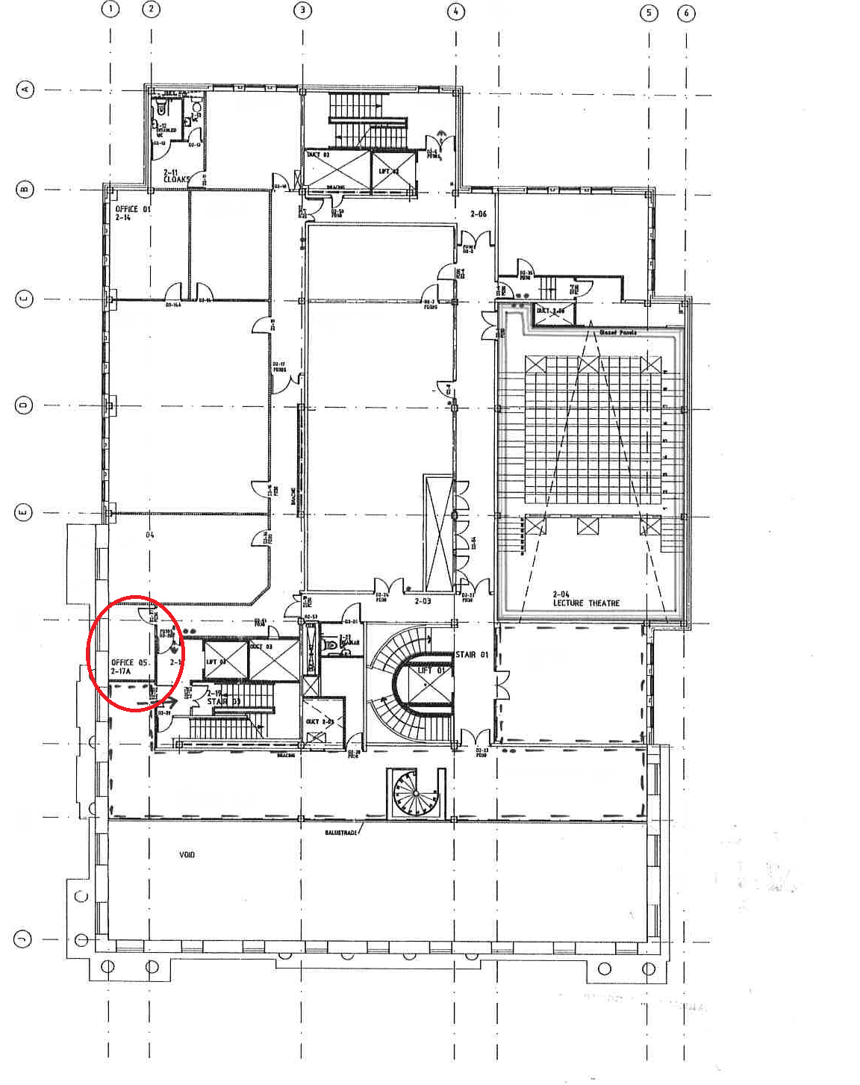
Figure 2. 21-7A (test room 1 location) (Author, 2019)
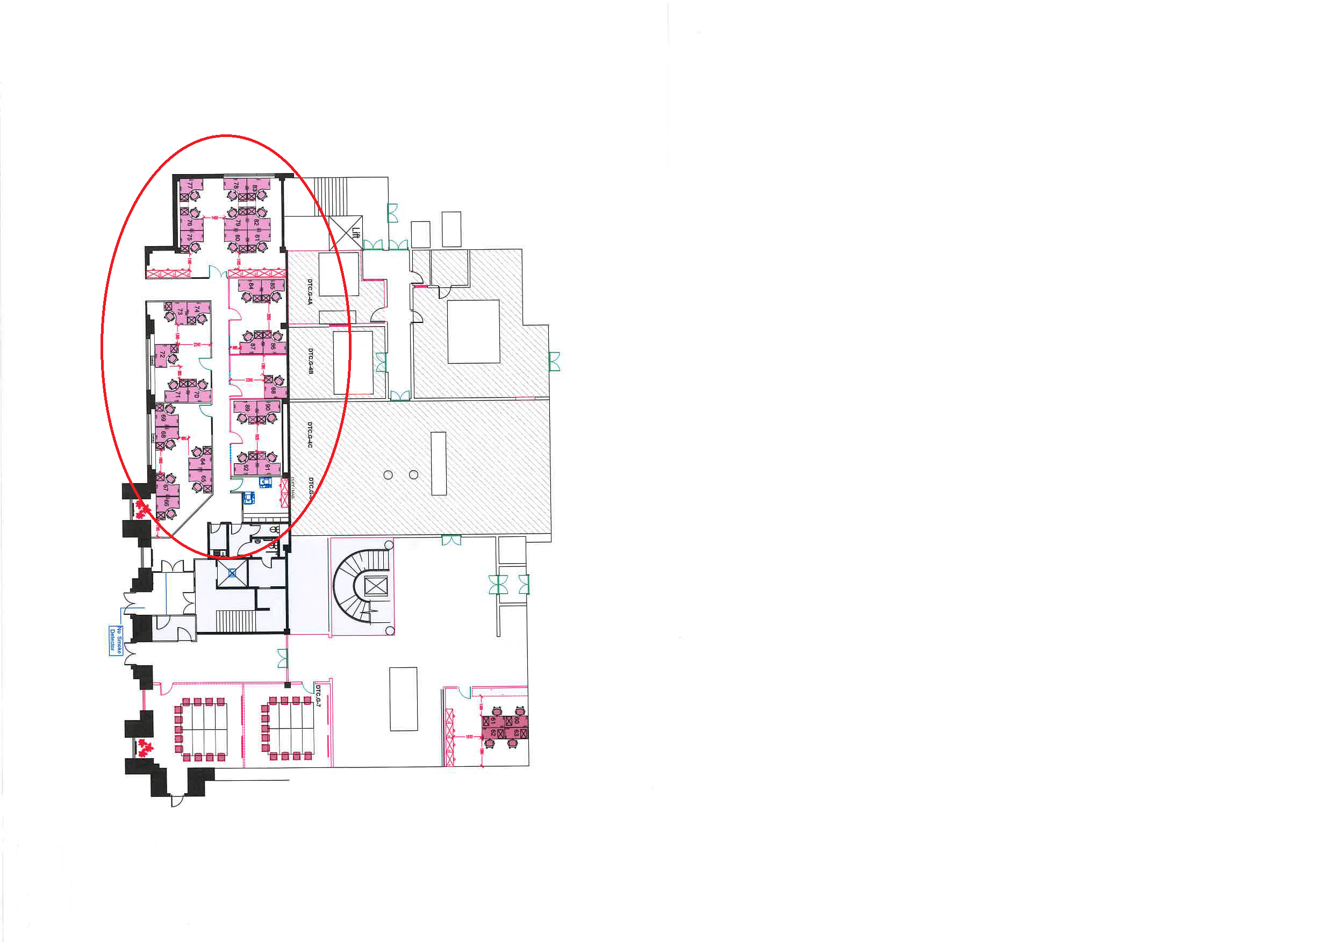
Figure 3. 1-32 (test room 2 location) (Author, 2019)

Actual Room

L.E.D Lighting

heater
windows

Figure 4. 1-32 (test 2 room layout) (Author, 2019)

5.2 - Stage 3 - Sensor location
When locating the rooms, there were a few important factors to think about before a decision was made. Connectivity and signal for the sensors was paramount, therefore the rooms needed to be externally facing and near I.T services to connect. The rooms also need to be occupied or used on a regular basis to obtain enough data for the analysis at a later stage. The services were investigated and recorded, any restrictions were discussed in the results.
Although not a lot of information was given in the technical specification on where exactly to locate the sensors it was suggested that to relay optimal performance the antenna should be directed vertically. As there was no suggestions to where the sensors should be located within the room, they would have to be strategically placed. An example of potential restrictions would be for a temperature sensor not to be located near a heat source or door/window.

5.3 - Test room 1 & 2
The results from the survey and the detailed plans suggest there is little remaining of the original building. Other than the outer skin on three external walls, the remaining building was predominantly constructed during the 1990’s refurbishment. It was decided that to give a good comparison of data the materials used in construction should differ within the rooms chosen. The materials used within the room could restrict the wireless signal transmitted. When surveying room 21-7A, it was discovered to be almost a complete concrete box with the walls, ceiling and floors being of solid concrete construction and only the door being timber. If the sensor network could function and relay the data outside that room then we could assume the network could function anywhere within the building. Room 21-7A is currently being used as a staff canteen and one can safely assume the use of the room will be consistent enough to produce enough data to be analysed, this be used as test room 1.
To provide a good comparison room 2(1-32) was chosen within the staff office area, being predominantly constructed using thin office stud partitions. These partitions should carry little if any restrictions to the software used in the sensor network.

6.0 - Restrictions
When carrying on the survey of the Dylan Thomas building it was immediately clear that any historic information on the building was not available and that most of the information needed would have to be gathered from visual inspections. All areas of the building were accessible, but the internal wall materials could only be seen above the ceiling voids. In the test room 2, the ceiling were too high to ascertain the materials used. The As Built plan drawings contained some information on construction materials used in the wall construction. The main restrictions for the installation of the sensor network would be not in the installation but in the connectivity of the sensors. As previously discussed, communication between the sensors and the gateway is paramount. During installation connectivity monitoring should be completed at different stages. If this project progresses to the retro fitting stage the lack of insulation within the walls will need to addressed.

7.0 – Conclusion
This report was completed by researching the building and carrying out surveys of the building whole and rooms within the building. The rooms were chosen to provide a good comparison between different materials used in construction. The location of the sensors will depend on the type of sensor used. The main issues raised during this report was the connectivity of the sensors and the ability to transmit the data within a solid structure. There are various techniques to help reduce energy consumption in buildings, smart sensors are the future in monitoring how our buildings function. The question put forward in this report is can we adapt our older housing stock and create smart buildings? The outcome of this report has brought to light some restrictions that need further researching, Could the building house the mechanical adaptations to make it smart? Would the cost of the retro fitting outweigh the environmental impact? These are Questions that cannot be answered in this report

8.0 - Recommendations
For this project to be successful in its entirety more information would need to be gathered on the suitability for the systems discussed to be adapted to the building. To know if the retro fitting of a building and its systems will have a positive impact on the environment every element of the building would need close inspection and researching. On completion of the network installation the monitoring of the rooms will commence. The sensors will begin to collect data and relay the information for analysis. The results from the data analysis will dictate what the next step will be for the proposal to retro fit the building.

9.0 - References
Dener, M. and Bostancıoğlu, C. (2015). Smart Technologies with Wireless Sensor Networks. Procedia - Social and Behavioral Sciences, 195, pp.1915-1921.
Monnit.com. (2019). Product Search | Monnit Corp.. [online] Available at: https://www.monnit.com/ProductManagement/FilterResult/?productCategoryID=1&firmwareBaseID=1 [Accessed 19 Feb. 2019].
Othman, M. and Shazali, K. (2012). Wireless Sensor Network Applications: A Study in Environment Monitoring System. Procedia Engineering, 41, pp.1204-1210.
Sembroiz, D., Careglio, D., Ricciardi, S. and Fiore, U. (2019). Planning and operational energy optimization solutions for smart buildings. Information Sciences, 476, pp.439-452.
Zhou, G., Yi, T., Zhang, H. and Li, H. (2015). Optimal sensor placement under uncertainties using a nondirective movement glowworm swarm optimization algorithm. Smart Structures and Systems, 16(2), pp.243-262.

Appendix 1
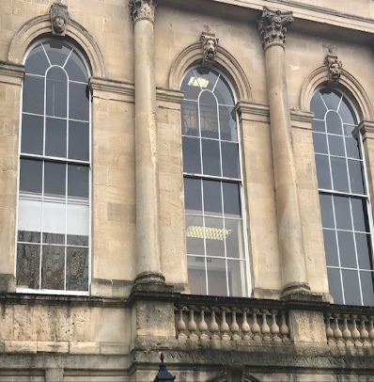

Pic. 1 - Sand stone block construction
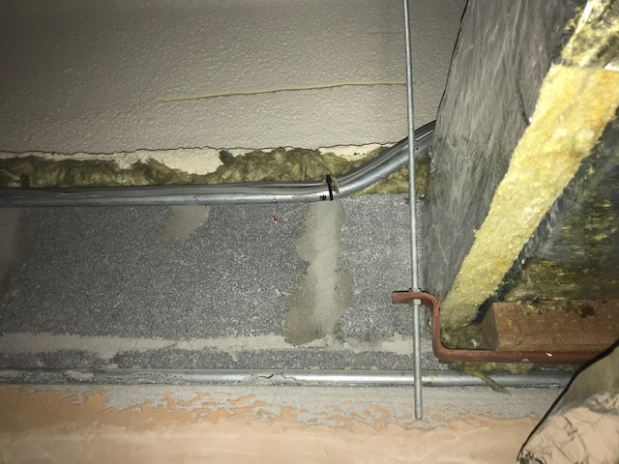
Pic. 2 – Insulated cavity wall construction
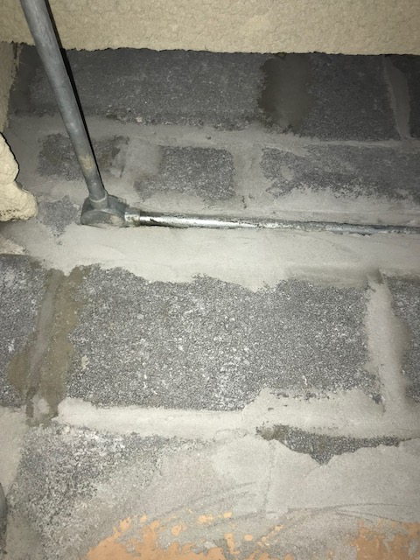
Pic. 3 – Internal concrete block partition (supporting)
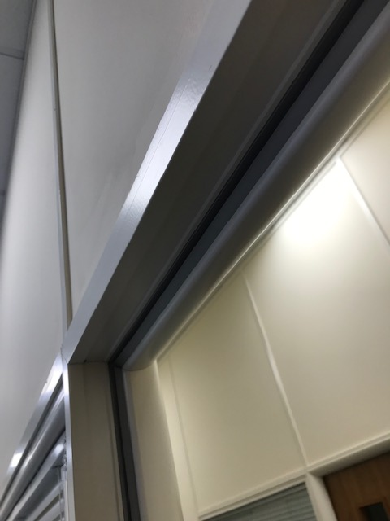
Pic. 4 – Internal plasterboard partition (non-supporting)
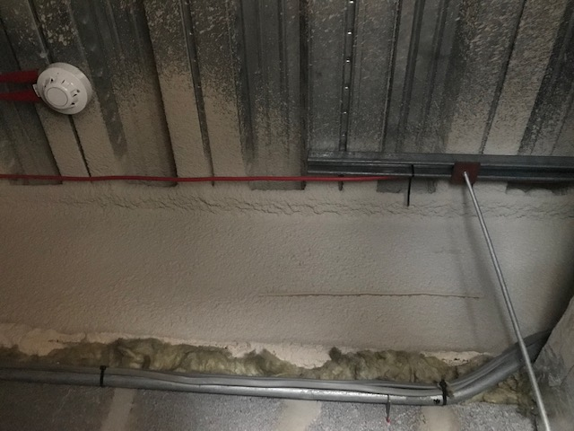
Pic. 5 – Metal profile decking with concrete slab
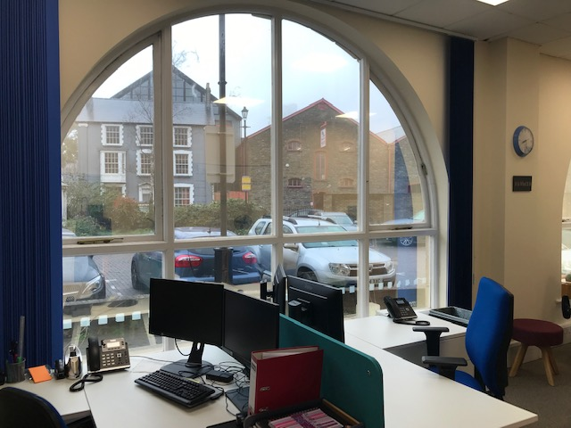
Pic. 6 – Large single pane, arched window with timber frame
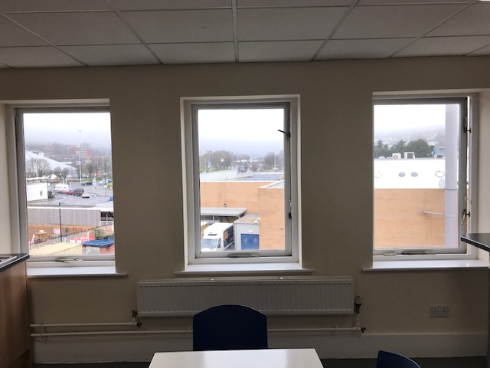
Pic. 7 – 3 x small single pane windows with timber frame
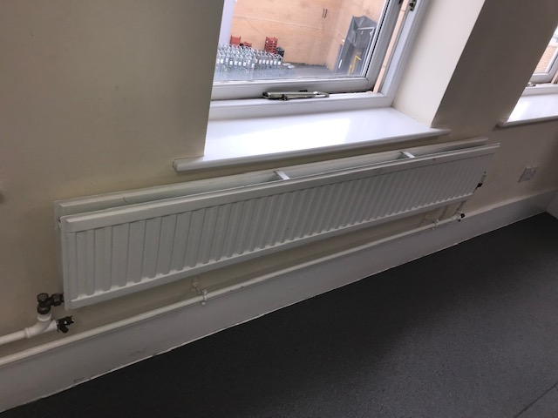
Pic. 8 – 2 panel, single fin radiator
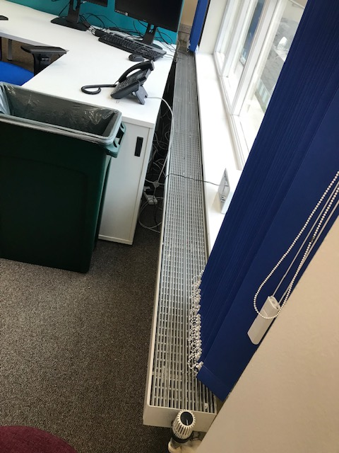
Pic. 9 - Short multi fin radiator
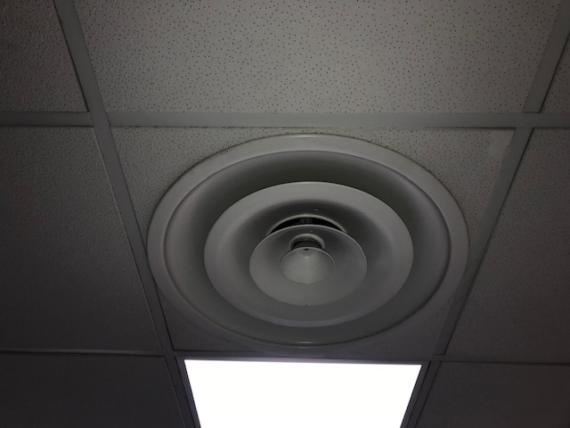
Pic. 10 – Air extraction vent
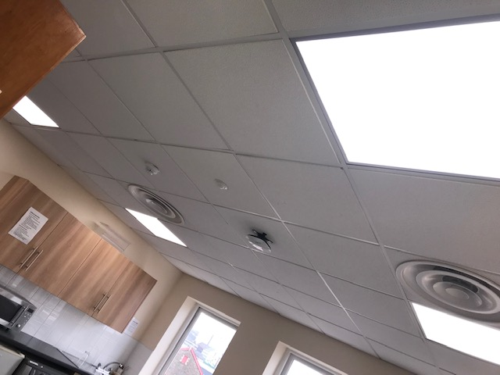
Pic. 11 – L.E.D panel lighting
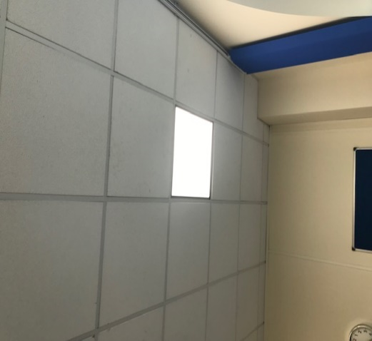
Pic. 12 – L.E.D panel lighting

Appendix 2

Technical Specification for Wireless temperature (AA) Sensor
Supply Voltage | 2.0 - 3.6 VDC (3.0 - 3.6 VDC Using Power Supply) *
Current Consumption | 0.7 µA (sleep mode)  2 mA (radio idle/off mode) 2 mA (measurement mode) 25 mA (radio RX mode)  35 mA (radio TX mode)
Operating Temperature Range (Board Circuitry and Batteries) | -18°C to 55°C (0°F to 130°F) using alkaline  -40°C to 85°C (-40°F to 185°F) using lithium **
Optimal Battery Temperature Range (AA) | +10°C to +50°C ( +50°F to +122°F )
Thermistor Temperature Range (Thermistor Only) | -40°C to +125°C ( -40°F to +257°F )  (Limited to Main Unit Circuitry, -7°C to +60°C  Unless thermistor leads are being used.
Accuracy @ 25°C | +/- 1% (1° C or 1.8° F)
User Calibrated Accuracy | +/- 0.25° C (± 0.45° F)
Time Constant @ 25°C | 15 sec max
Weight | 3.6 oz. (3.7 oz w/ 3’ probe)
Wireless Range | 250 - 300 ft. (Through walls, ceilings and floors) Range may vary according to environmental variables
Table 1 - Technical specifications for temperature sensor (Monnit.com, 2019)

Technical Specifications for Wireless Humidity (RH) Sensor
Supply Voltage | 2.0 - 3.6 VDC (3.0 - 3.6 VDC Using Power Supply) *
Current Consumption | 0.7 µA (sleep mode)  2 mA (radio idle/off mode) 2 mA (measurement mode) 25 mA (radio RX mode)  35 mA (radio TX mode)
Operating Temperature Range (Board Circuitry and Batteries) | -18°C to 55°C (0°F to 130°F) using alkaline  -40°C to 85°C (-40°F to 185°F) using lithium **
Optimal Battery Temperature Range (AA) | +10°C to +50°C ( +50°F to +122°F )
Accuracy | ± 3% under normal conditions ( 10% - 90% RH )
RH Operating Range | 0 – 100% RH
RH Response Time | 8 sec ( tau 63% )
Weight | 3.7 Ounces
Wireless Range | 250 - 300 ft. (Through walls, ceilings and floors)  Range may vary according to environmental variables
Table 2 - Technical specifications for humidity sensor (Monnit.com, 2019)

