Module name: Management & Organisational Behaviour
Module Code: BMIH5004

Lecturer: Dale Clarke

Student name: Sayeda Laila Yeasmine
Student ID: 2119793

Table of Contents
Executive Summary 1
Introduction 2
Organisational Overview and Critical Evaluation 3
Organisational Structure 3
Organisational Culture 4
Organisational Goals 5
Evaluation of the Change Initiatives, Impacts and Management 6
Change Initiatives 6
Impacts of the Change Initiatives 7
Management of Change Initiatives 8
Evaluation of Strategic Direction and Business Performance 10
Strategic Direction 10
Business Performance 10
Conclusion and Recommendation 12
Conclusion 12
Recommendations 12
References 13
Table of Figures
Figure 1: Divisional Organisational Structure 3
Figure 2: 2030 Goal of Hilton Hotel 6
Figure 3: Triple Bottom Line Model 7
Figure 4: Kurt Lewin Model 9
Figure 5: Business Growth of Hilton Hotel 11

Executive Summary
The hospitality industry has crucial significance in relation to the global economy and the Hilton Hotel is one of the notable businesses in the industry. With its divisional structure along with the fostered culture of employee centrism and inclusivity, Hilton Hotel aims to achieve further growth in the international premise and create values for the stakeholders. Addressing the changes in the environment, the organisation has shifted emphasis on technological integration and environmental sustainability that has been adopted in the culture. With the appropriate strategies, the organisation has been exhibiting robust business performance.

Introduction
The key organisational aspects include the organisational structure, culture, its operations among many others. For an organisation to be successful, all these aspects must be aligned with each other. Hilton Hotel is a highly prominent name in the global hospitality industry operating in over 124 countries around the globe. The organisational structure, culture, and goals along with the implementation of its various initiatives for changes throughout the years are the key factors behind the success of the organisation. An audit of the key aspects of the business of Hilton Hotel can provide a deeper comprehension of its success.

Organisational Overview and Critical Evaluation

Organisational Structure
An organisational structure can be defined as the strategically formed relationship among all the individuals within the organisation that also outlines their specific roles and responsibilities (Brown and Clow, 2015). Organisational structure specific to an organisation is highly essential to maintain the effective and seamless execution of all essential organisational functions.
Hilton Hotel is one of the largest hotel chains in the world that operates in various geographical locations around the world. While the core leadership of the organisation is centralised to the C-suit of the organisation, the properties of the organisation are divided and spread across the world and are managed individually.
The properties of Hilton Hotel in different locations are managed individually as separate entities with control over their resources. The separate divisions of the organisation have independent teams for its value chain activities that are liable to the specific divisions (Yusof, 2019). With these factors and characteristics, the organisational structure of Hilton Hotel is the divisional structure which is very common and effective for such large organisations.
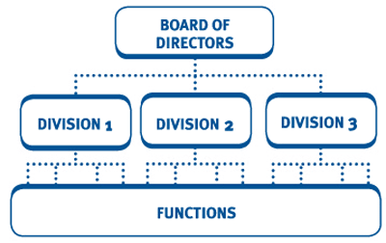
Figure 1: Divisional Organisational Structure
Source: (Ravishankar, 2019)
Considering the market focus of the organisation, the divisional organisational structure of Hilton Hotel can be divided into two more structures, namely, geographic divisional structure and market-based divisional structure.
With the regional divisional structure, the properties of Hilton Hotel are divided according to different market segments and customer types (Gajjar and Okumus, 2018). Along with that, the geographic divisional structure is more obvious from its spread of independent properties managed across different geographic locations.
A major competitor of the Hilton Hotel is the Marriott Hotel which is one of the most renowned hotel chains in the world. The organisation employs a combination of the matrix structure and functional structure with regional executives managing the various properties across different locations. The matrix structure is effective in maintaining uniformity globally (Nene and Pillay, 2019). Hilton Hotel can also employ the matrix structure to ensure the uniformity of quality across all its properties.

Organisational Culture
Organisational culture includes the core beliefs and values fostered within the organisation which is essential to create the core identity and function of the organisation. In defining the culture of Hilton Hotel, a number of key aspects can be identified.
Core emphasis on superior hospitality is an inseparable part of the organisational culture at Hilton Hotel. With the belief in achieving excellence in providing hospitality services, the brand maintains consistency throughout the brand portfolio (Hilton, 2019). With its portfolio ranging from luxury, and premium to budget-friendly hospitality service, the brand always puts customer satisfaction first.
Another core aspect of organisational culture at the organisation is employee-centric values (Hilton, 2019). The organisation believes in employee satisfaction which is evident from its employee development programs, employee opportunities and involvement of the employees.
Hilton Hotel also believes in diversity and inclusion which is evident from the appreciation of unique and varying perspectives from guests, employees and all other stakeholders (Hilton, 2019). The welcoming nature of the brand towards diverse groups of guests and employees suggests the effectiveness of inclusive values fostered by the brand. The brand provides equal opportunities to all employees and addresses the needs of all guests for its inclusive culture.

Organisational Goals
Organisational goals are the definition of a unique direction for organisational operations (Baligh, 2018). The organisational goals divided into specific objectives direct the organisational operations and functions towards the perceived success of the organisation.
Hilton Hotel aims to achieve and maintain market leadership through expansion in size and market reach all over the world. The brand currently operates with over 6500 properties across 124 markets around the world (Hilton, 2023). Close competitors of the organisation include Marriot Hotel and Inter-Continental Hotel Group. Considering the number of properties Marriot has better reach covering a larger number of markets. To achieve its goal of becoming the market leader, Hilton needs to be constantly on the lookout for new opportunities in new markets for expansion.
The brand creates value for the customers by ensuring quality and consistency of service and in the process improves its profitability to create value for the employees and shareholders while contributing to the development of the local and global economy.

Evaluation of the Change Initiatives, Impacts and Management

Change Initiatives
Organisational change is a complex yet crucial process for ensuring the continuation and sustainable growth of an organisation. All business organisations are required to operate within a specific business environment impacted by a number of different factors (Holyoak, 2022). The factors are highly volatile and have the tendency to change very frequently resulting in changes in the business environment.
Responding to the changes in the global hospitality industry and the overall business environment, several change initiatives have been adopted by Hilton Hotels. A major change initiative is the digital transformation which is a response to the technological advancement of the global world (Đurić, 2019). The change initiative involves the integration of digital tools in the various value chain activities of the organisation to improve customer satisfaction and convenience.
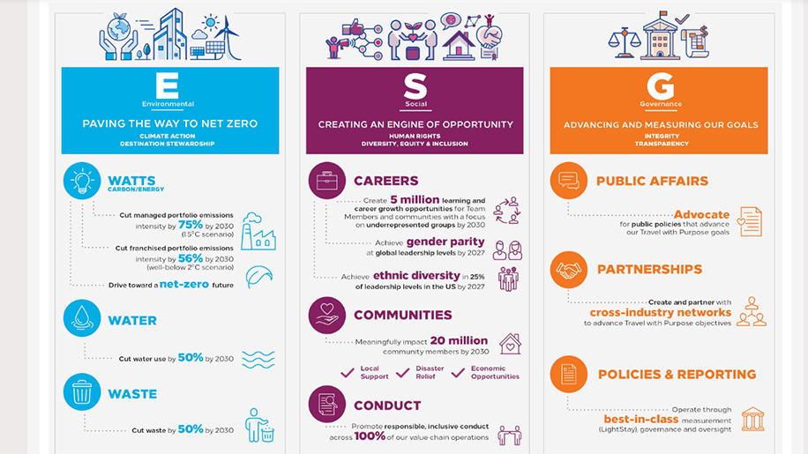
Figure 2: 2030 Goal of Hilton Hotel
Source: (Hilton, 2022)
Another notable change initiative of Hilton Hotel is the shift towards environmental sustainability. The businesses in the hospitality industry are notorious for their impact on the environment through the over-consumption of resources as well as the generation of waste. Hilton Hotel has recently taken an initiative to become greener and reduce wastage, emission and consumption of resources. With its 2030 goal, the organisation intends to reach net zero by 2030 (Hilton, 2022). This initiative is more aligned with the triple bottom-line model of business ethics which describes concern for people, the environment and profitability as metrics for measuring business success.
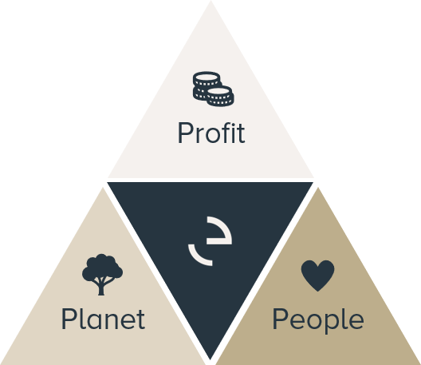
Figure 3: Triple Bottom Line Model
Source: (Siltaloppi, Rajala and Hietala, 2020)
While Hilton Hotel has been a customer-centric as well as an employee-centric organisation along with being profitable, the shift towards environmental sustainability aligned the organisational goals with the triple bottom line model.

Impacts of the Change Initiatives
The change initiatives adopted by Hilton Hotel are responses to the changes in the business environment. While the changes can be a long process, the progress in the change initiatives has been impactful in various aspects.
With the integration of digital tools in various value chain activities, the organisation has achieved greater efficiency. With the use of digital media, the marketing activities of the organisation have become more effective enabling the organisation to achieve greater customer reach and increase customer engagement (Nikolskaya, 2021). The data-driven decision-making enabled by the integration of digital tools has enabled the organisation to achieve and competitive advantage in the industry. The brand is also enabled to implement customisation for customers resulting in the increasing of customer satisfaction.
The environmental sustainability practices implemented by the organisation have impacted the environment and customer perception positively. According to the report published by Hilton Hotels, the organisation has managed to reduce emissions by 47.1% in managed hotels and 44% in all hotels. The organisation has also reduced the consumption of electricity by using LED bulbs and established the use of LED bulbs as the global standard (Wang et al., 2020). The collaboration with Schneider Electric has also contributed significantly to the development of renewable energy.

Management of Change Initiatives
Change management can be a very complex process and people are generally resilient to changes. The leaders and managers at Hilton Hotel have exhibited significant capabilities in managing the change initiatives considering the Kurt Lewin model of change management.
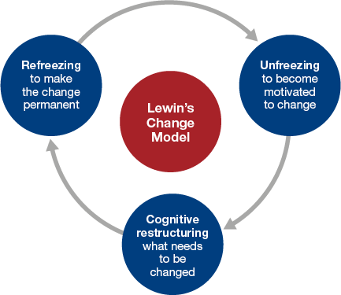
Figure 4: Kurt Lewin Model
Source: (Kiitam, McLay and Pilli, 2016)
With the rising need for digital transformation and environmental sustainability, the managers at Hilton Hotel have identified the required change appropriately. For the unfreezing stage, the managers have effectively developed an urgency for these changes among the employees by communicating unambiguously regarding the need for changes and the outcomes that can be achieved (Diefenbach, 2022). For the changes, the managers have developed a specific and time-bound vision and communicated the vision clearly with the employees. In this stage, the involvement of the employees in the decision-making has been an effective approach by the managers to reduce employee resilience (Chathoth and Olsen, 2020). The upskilling and reskilling programs for the employees to cope with the changes were crafted appropriately to provide necessary support during the transition process. As a part of the refreezing stage, the changes in the organisation were adopted in the values and culture of the organisation providing employees with positive reinforcement resulting in effective management of the change initiatives.

Evaluation of Strategic Direction and Business Performance

Strategic Direction
The strategic direction of an organisation generally refers to the approaches required to be implemented for the attainment of the overall goal of the organisation (Birkinshaw, 2020). As mentioned in the prior sections, the overall goal of Hilton Hotel is to achieve further expansion in the market while creating value by increasing profitability.
The change initiatives employed by the organisation are specific strategies for the organisation to attain its goal. With the digital transformation, the organisation is improving its market reach to occupy a larger share of the market. It also offers customisation and personalisation according to the specific needs and preferences of the customers using the digital tools integrated into the value chain activities to improve customer satisfaction and attract more customers (Wang et al., 2021). Another strategy implemented by the organisation is the enrichment of the brand portfolio by increasing the range of services to address the customers of different income groups.
The sustainability initiative of the organisation is another strategy for achieving overall goals (Dodds and Holmes, 2018). As customers are growing more aware of environmental sustainability and developing preferences for environmentally sustainable brands, Hilton Hotel is developing a reputation as a sustainable brand to align with customer interest and broaden its market share.

Business Performance
Hilton Hotel has been immensely profitable and has a historical record of robust business performance. Over the years, the organisation has achieved immense growth in terms of scale and profitability. While the performance of the brand declined due to the impact of the pandemic, Hilton Hotel has been recovering effectively which is evident from the growth of revenue in the post-pandemic period. In the last quarter of 2022, the brand has opened 108 new hotels which suggests a significant growth in business scale.
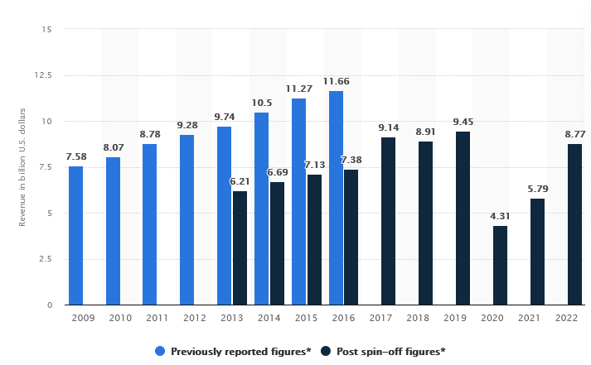
Figure 5: Business Growth of Hilton Hotel
Source: (Statista, 2023)
The $8.77 billion revenue generated worldwide in 2022 exhibits significant growth in revenue compared to the $5.79 billion generated in 2021 (Statista, 2023). Aside from that, the brand has been achieving steady growth in revenue over the years until the recent decline due to the impact of the pandemic. Considering the difference in business scale between Hilton Hotel and its close competitor Marriott, the percentage of revenue growth of Hilton Hotel is considerable. With the effective implementation of the strategies, Hilton Hotel can achieve further growth and become the market leader in achieving its strategic vision.

Conclusion and Recommendation

Conclusion
Understanding the organisational aspects and factors of success is essential for ensuring the sustainability of growth and development. Organisational structure, culture and goals are the key factors that direct the organisational functions. Strategies and approaches aligned with the culture and goals enable an organisation to maintain sustainable growth of business. Hilton Hotel has a unique culture and goals and the brand has maintained consistency in crafting effective approaches and strategies aligning with its structure, culture and goals. The organisation has also managed to keep up with the changing environment by implementing appropriate initiatives. These factors have enabled Hilton Hotel to achieve significant success and occupy a strong position in the industry.

Recommendations
- Hilton Hotel should consider combing the matrix structure to improve control and quality of the properties.
- The organisation should focus on employee convenience and opinions in initiating changes.
- The organisation should invest in the development of tourism infrastructure at underdeveloped potential tourist attractions.

References
Baligh, H.H. (2018). Organization Structures : Theory and Design, Analysis and Prescription. New York, Ny: Springer Us.
Birkinshaw, J.M. (2020). Strategic Management. Northampton, Ma: Edward Elgar Pub.
Brown, B.J. and Clow, J.E. (2015). Introduction to business. Columbus, Oh: Mcgraw-Hill Education.
Chathoth, P.K. and Olsen, M.D. (2020). Organisational Leadership and Strategy in the Hospitality industry. Journal of Service Research, 2(1), pp.5–29.
Diefenbach, T. (2022). The Managerialistic Ideology of Organisational Change Management. Journal of Organizational Change Management, 20(1), pp.126–144. doi:https://doi.org/10.1108/09534810710715324.
Dodds, R. and Holmes, M. (2018). Is There a Benefit from Being Green? Assessing Benefits from Marketing Sustainability by North American Hotels. Journal of Hotel & Business Management, 05(02). doi:https://doi.org/10.4172/2169-0286.1000145.
Đurić, M. (2019). ‘Hilton’ hotel: Innovative Spatial and Technological Intervention in the Belgrade’s Urban Fabric. Arhitektura I Urbanizam, 69(48), pp.60–65. doi:https://doi.org/10.5937/a-u0-22119.
Gajjar, T. and Okumus, F. (2018). Diversity management: What Are the Leading Hospitality and Tourism Companies reporting? Journal of Hospitality Marketing & Management, 27(8), pp.905–925. doi:https://doi.org/10.1080/19368623.2018.1465505.
Hilton (2019). Learn More about Hilton Culture. [online] Hilton.com. Available at: https://jobs.hilton.com/us/en/culture.
Hilton (2022). 2030 Goals. [online] Travel with Purpose | Hilton ESG. Available at: https://esg.hilton.com/2030-goals/.
Hilton (2023). Our Hotel Brands - Learn More about Our Brands. [online] Hilton. Available at: https://www.hilton.com/en/brands/.
Holyoak, L. (2022). Organisational Culture: Organisational Change? Leadership & Organization Development Journal, 23(6), pp.354–355.
Kiitam, A., McLay, A. and Pilli, T. (2016). Managing Conflict in Organisational Change. International Journal of Agile Systems and Management, 9(2), p.114. doi:https://doi.org/10.1504/ijasm.2016.078575.
Nene, S.W. and Pillay, A.S. (2019). An Investigation of the Impact of Organisational Structure on Organisational Performance. Financial Risk and Management Reviews, 5(1), pp.10–24.
Nikolskaya, E.Y. (2021). The Impact of Digital Technologies on the Transformation of the Tourism and Hospitality Industry. Revista Gestão Inovação E Tecnologias, 11(4), pp.623–632. doi:https://doi.org/10.47059/revistageintec.v11i4.2133.
Ravishankar, P.K. (2019). Organisational Structure of MNCs. Delhi: Pacific Publication.
Siltaloppi, J., Rajala, R. and Hietala, H. (2020). Integrating CSR with Business Strategy: a Tension Management Perspective. Journal of Business Ethics, 174(3), pp.507–527. doi:https://doi.org/10.1007/s10551-020-04569-3.
Statista (2023). Hilton Worldwide Holdings Inc.: Revenue 2019. [online] Statista. Available at: https://www.statista.com/statistics/297760/revenue-of-hilton-worldwide-holdings-inc/.
Wang, T.-C., Huang, C.-Y., Huang, S.-L. and Lee, J.-Y. (2021). Priority Weights for Predicting the Success of Hotel Sustainable Business Models. Sustainability, 13(24), p.14032. doi:https://doi.org/10.3390/su132414032.
Wang, X., Wu, N., Qiao, Y. and Song, Q. (2020). Assessment of Energy-Saving Practices of the Hospitality Industry. Sustainability, 10(1), p.255. doi:https://doi.org/10.3390/su10010255.
Yusof, N. (2019). Organisational Symbols: Reflections of Organisational Culture? International Journal of Management Studies, 1(1). doi:https://doi.org/10.32890/ijms.16.1.2009.9961.

