

BA International Hotel Management
Module: Food & Beverage Operations
Module code: BMIH4002
Assignment Title: Assignment 2 Menu Engineering (Practical Task)
Student ID: 2243598
Word count: 411 words

Table of Contents
1 PART 1: Restaurant Concept 3
1.1 Introduction 3
1.2 Restaurant concept 3
1.3 Target audience 3
1.4 Reasoning 3
1.5 Conclusion 4
2 PART 2: Menu Design 5
3 References 6

PART 1: Restaurant Concept

Introduction
In regard to this report, mainly menu engineering will be done in order to support the menu activity mainly. Therefore, Menu engineering is defined as a framework to examine and optimize restaurant menu pricing and create a profitable menu. Therefore, this will help in order to design a new menu for Hotel Trinity (Linassi et al., 2016; Bergman et al., 2021; Kulturel-Konak et al., 2023).

Restaurant concept
The central restaurant concept is to mainly consider the Halloween festival as it is upcoming with a fire of French food on the menu in the Hotel Trinity. Hence, it will help in order to support the menu engineering. Therefore, this idea showcases the discount, which will be mentioned in the menu. Therefore, French cuisine is defined as the most popular in the whole world; as a result, the menu will be grasped and made from that point of view. The central restaurant concept is to provide plate dining with cooking at the same time as ordering (Stojilkov, 2017; Harris and Giuffre, 2015).

Target audience
The primary target audience in regard to French Cuisine and the Halloween theme is local people in order to celebrate the festival with tourists. Hence, individuals, groups and lovers can also come and enjoy the best dining experience with the Hotel Trinity. Therefore, the idea is to attract people who also love food and spend quality time with their family, relatives and close individuals in a calm and fresh environment with their favourite food. As a result, the target audience will mainly occupy the place in regard to dining in and enjoying nature, food and festivals (Barclay and Miller, 2018; Carroll and Kovács, 2021; Del Moral, 2020).

Reasoning
The main reason behind this concept of French cuisine and Halloween with some discounts is that people love discounts; hence, they will come to the hotel and restaurant in order to enjoy the food. Therefore, the main reason behind this concept is to be new in the market. Hence, it will help the restaurant to lure people to come and enjoy their favourite dishes as the discount is provided (Mercier-Laurent and Edvinsson, 2021; Viau-Quesnel et al., 2019).

Conclusion
In conclusion, the main idea behind the new menu is to engineer with the help of a new concept. Therefore, Halloween festivity is mainly highlighted with French cuisine. Hence, menu engineering is done in order to mainly lure new people and target audiences with locals and tourists.

PART 2: Menu Design
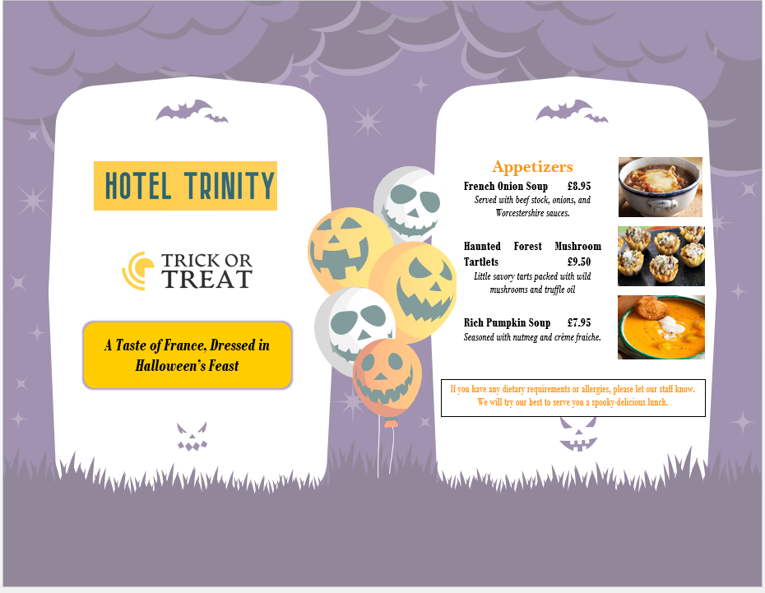
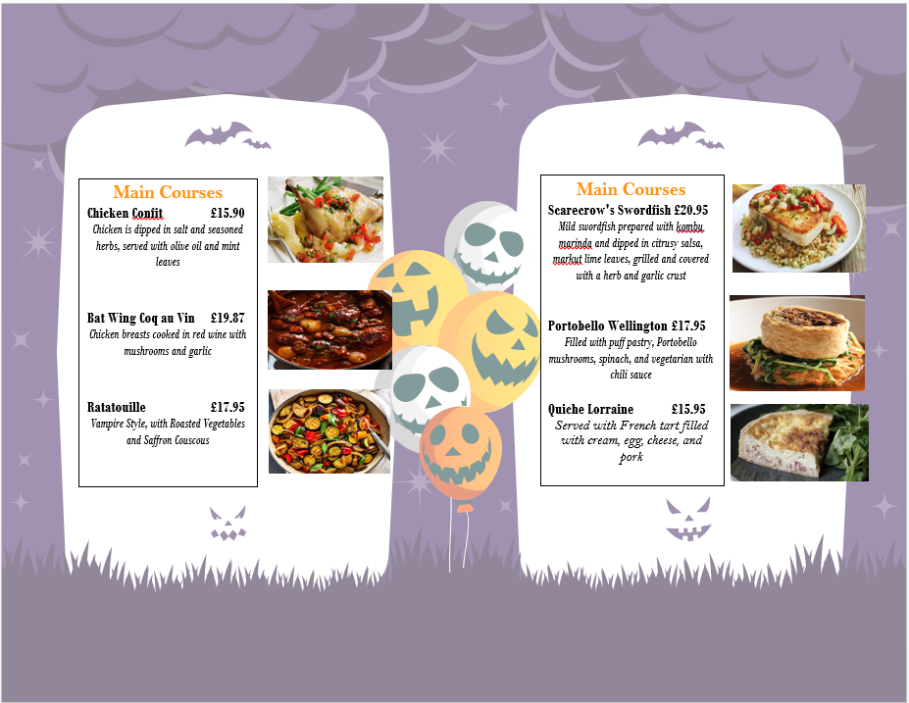
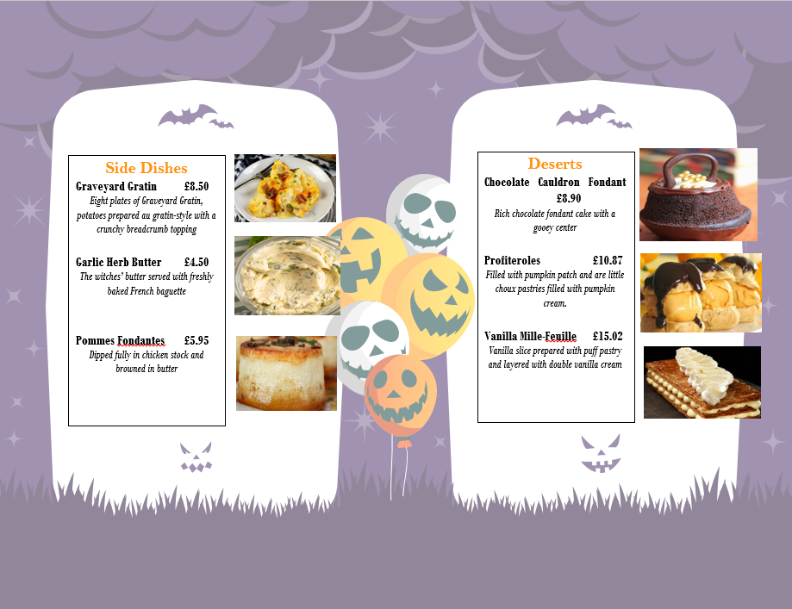
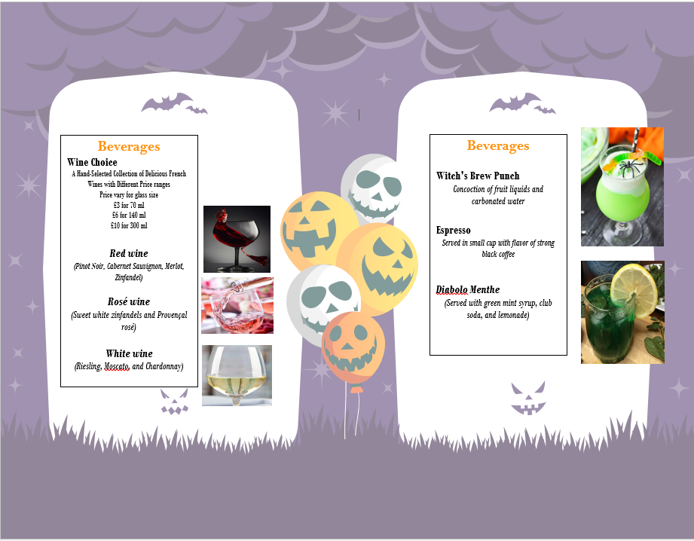

References
Barclay, K. and Miller, A., 2018. The sustainable seafood movement is a governance concert, with the audience playing a key role. Sustainability, 10(1), p.180.
Bergman, C., Tian, Y., Moreo, A. and Raab, C., 2021. Menu engineering and dietary behaviour impact on young adults' kilocalorie choice. Nutrients, 13(7), p.2329.
Carroll, G.R. and Kovács, B., 2021. Authenticity: Meanings, targets, audiences and third parties. Research in Organizational Behavior, 41, p.100149.
Del Moral, RG, 2020. Gastronomic paradigms in contemporary Western cuisine: from French haute cuisine to mass media gastronomy. Frontiers in nutrition, 6, p.192.
Harris, D.A. and Giuffre, P., 2015. Taking the heat: Women chefs and gender inequality in the professional kitchen. Rutgers University Press.
Kulturel-Konak, S., Konak, A., Jakielaszek, L. and Gavirneni, N., 2023. Menu engineering for continuing care senior living facilities with captive dining patrons. INFORMS Journal on Applied Analytics, 53(3), pp.218-239.
Linassi, R., Alberton, A. and Marinho, S.V., 2016. Menu engineering and activity-based costing: an improved method of menu planning. International Journal of Contemporary Hospitality Management, 28(7), pp.1417-1440.
Mercier-Laurent, E. and Edvinsson, L., 2021. French Cuisine: Combining Technology, Imagination, Vision, and Ambition. In World Class Cooking for Solving Global Challenges: Reparadigming Societal Innovation (pp. 13-26). Emerald Publishing Limited.
Stojilkov, A., 2017. TRANSLATING CUISINE, TRANSLATING CULTURE: THE HOGWARTS MENU IN BRITAIN AND SERBIA. Komunikacija i kultura online, 6(6), pp.223-247.
Viau-Quesnel, C., Savary, M. and Blanchette, I., 2019. Reasoning and concurrent timing: a study of the mechanisms underlying the effect of emotion on reasoning. Cognition and Emotion, 33(5), pp.1020-1030.

