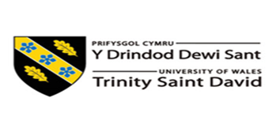

Certificate of Higher Education Skills for the work

STUDENT NAME: Khairuzzaman Rob

STUDENT ID NUMBER: 1915327

MODULE: Effective team working and communication

MODULE CODE: BMSW4002

LECTURER: Melanie squire

ASSIGNMENT TITLE: teamworking and communication within the workplace

SUBMISSION DEADLINE: Report- 03/07/2020

INTRODUCTION

WORKING IN A CAFE IS CONSIDERED AS WORKING IN A FAST MOVING ENVIROMENT AND REQUIRES PEOPLE TO THINK AND ACT SWIFTLY FOR ANY UPCOMING SITUATIONS AND ALSO BE ABLE TO MAKE RAPIID DECISIONS. THE CAFÉ ACTVITIES REQUIRE AN INTERACTIVE RELATION BY MEANS OF GOOD COMMUNICATION BETWEEN STAFF AND CUSTOMERS AND ALSO AMONGST THE STAFF THEMSELVES. THE FLOW OF THE COMMUNICATION BETWEEN THE STAFF AND CUSTOMERS IS DENSLEY BUILT UP WITHIN THE CAFÉ ACTIVITIES INCLUDING:
-TABLE BOOKINGS
-HOSTESS RECEIVING RESERVATIONS
- WELCOMING GUESTS
-DINERS PLACING ORDERS
-ORDERS TRANSFERRED TO THE KITCHEN
-FOOD SERVED TO CUSTOMERS
-FEEDBACK SENT AND RECEIVED
EACH ERROR HAPPENING AT ANY STAGES OF FLOW MAY CAUSE AND LEAVE THE CUSTOMERS DISSAPOINTED AND UNSATISFIED. WHICH CAN LEAD TO DECREASING THE CAFÉS REPUTATION WHICH MAKE IT LESS WELCOMING FOR CUSTOMERS. THIS IS WHY THE WHOLE COMMUNICATION SYSTEM OF THE CAFÉ REQUIRES THE UTTERMOST EFFICIENCY.
THAT IS TO SAY, EFFECTIVE COMMUNICATION IN THE WORKPLACE PLACES A SIGNIFICANT IMPACT ON THE SUCCESS OF A BUISSNESS ORGANISATION. IT STRENGTHENS THE REPORTS BETWEEN INDIVIDUALS IN THE ORGANISTAION, AND GAINS THE LOYALTY FROM EMPLOYEES, AND IMPROVES THEIR ENGAGEMENT AND PRODUCTIVITY.

HOW THE APPLICATION OF THEORIES (TUCKMEN AND BELBIN) CAN IMPROVE TEAMWORK IN THE ORGANISATION

COMMUNICATION BETWEEN THE STAFF IS VERY IMPORTANT SO IN ORDER FOR THEM AND NEW STAFF MEMBERS TO FEEL WELCOMED AND BE PART OF THE TEAM, THE STAFF MEMBERS MUST BE POLITE AND RESPECTFUL TOWARDS ONE ANOTHER AND BE ABLE TO RECOGNISE EACH OTHER’S STRENGTHS AND WEAKNESSES. TO MAKE THE STAFF MEMBERS WORK MORE EFFECTIVELY AND EFFICIENTLY. THEY MUST HAVE A LEADER TO DEPEND ON FOR DIRECTIONS AND GUIDANCE SO THAT THEY KNOW WHAT THEY ARE DOING. ALSO A CO-ORDINATOR CAN HELP BRING THE TEAM TOGETHER AND RECOGNISE HOW EACH PERSON CAN CONTRIBUTE TO THE TEAM.

FIRST IMPRESSIONS
ANY BUISNESS THAT INCLUDES CUSTOMER SERVICE RELIES ON A GOOD FIRST IMPRESSION. WHEN A CUSTOMER ENTERS A CAFÉ THEY WOULD FIRST JUGDE THE APPEARANCE OF THE PLACE, THE PLACE SHOULD BE TIDY, CLEAN, WELCOMING AND SHOULD HAVE A GOOD HYGENIE RATING. THEY WOULD ALSO JUGDE THE APPEARANCE, POSTURE AND ATTITUDE OF THE STAFF MEMBERS. THESE FACTORS COMMUNICATE A MESSAGE TO THE GUEST HOW THE BUISSNESS IS RUN . BUT FOR THE BUSINESS TO BE SUCCESSFUL IT NEEDS A GOOD TEAM. THE FORMATION OF A TEAM CAN BE DAUNTING PROCESS FOR BOTH YOU AND YOUR EMPLOYEES. IT IS UNPREDICTABLE, UNRELIABLE AND A BIG RISK FOR ANY BUSINESS TO TAKE. YOU WILL ASK YOURSELF MANY QUESTIONS , WILL THE TEAM SUCCEED ? WILL THE TEAM CLICK? DO I HAVE THE RIGHT EMPLOYEES TO DO THE JOB OR TASK WELL? WILL THEY MAKE IT ? OR WILL THEY FAIL?

IN 1965 , BRUCE TUCKMAN PROPOSED FIVE STAGES OF TEAM DEVELOPMENT: FORMING , STORMING, NORMING, PERFORMING AND ADJOURNING . THESE MODEL DISCRIBES 5 STAGES THAT EVERY TEAM GOES THROUGH DURING ITS DEVELOPMENT. BY UNDERSTANDING THIS MODEL IT WILL HELP TAKE AWAY THE UNPREDICTABILITY OF FORMING TEAMS AND ALLOW YOU AND YOUR TEAM A BETTER CHANCE AT TEAM SUCCESS. AFTER CHOOSING A LEADER .

THE LEADER SHOULD…………….
STAGE 1 (FORMING)
. PLAY A DOMINANT ROLE SO THE EMPLOYEES KNOW WHO IS THE LEADER
.ESTABLISH CLEAR GOALS AND OBJECTIVE FOR THE WHOLE TEAM AND EACH INDIVIDUAL
. ALLOW FOR OPEN COMMUNICATION SO THE TEAM MEMBERS CAN GET TOGETHER AND KNOW EACH OTHER
STAGE 2 ( STORMING)
. BE SPECIFIC AND CLARIFY GOALS
. REMAIN POSITIVE
. ENSURE THAT YOU DON’T OVERLOAD THE MEMBERS WITH THE WORK
. ENSURE THAT YOU SUPPORT YOUR TEAM MEMBERS , AND ENSURE THAT THEY SUPPORT EACH OTHER ; BUILDING TRUST IS VERY IMPORTANT AT THIS STAGE
. EXPLAIN THE TUCKMANS THEORY TO THE TEAM SO THEY KNOW WHAT TO EXPECT.
. USE PERSONALITY TEST SO ALL WORKERS UNDERSTAND EACH OTHERS WORK AND PERSONALITY
STAGE 3 (NORMING)
. PROVIDE FEEDBACK, BOTH POSITIVE AND NEGATIVE
. ALLOW YOUR TEAM TO TAKE RESPONSIBILITY TOWARDS GOAL
. INCORPORATE TEAM BUILDING EXERCISES TO STRENGTHEN THE UNITY AND TRUST WITHIN THE TEAM.
STAGE 4 ( PERFORMING) AT THIS POINT RELATIONSHIPS ARE FORMED AND THERE IS A CLEAR AND STABLE STRUCTURE . THE TEAM IS MATURE, ORGANSIED AND HAS A SENSE OF CONSENSUS AND COOPERATION. PROBLEMS AND CONFLICT WILL ARISE BUT THEY WILL BE DEALT WITH EFFECTIVLY . THE PRIME FOCUS OF THE TEAM IS ON PROBLEM SOLVING AND MEETING GOALS ; EFFECTIVENESS IS AT ITS PEAK.
. DELEGATE WORK EVENLY AND FAIRLY FOCUS ON THE DEVELOPMENT OF INDIVIDUAL TEAM MEMBERS ALLOW PEOPLE TO JOIN OR LEAVE THE GROUP AS IT WILL NOT AFFECT THE GROUP PERFORMANCE
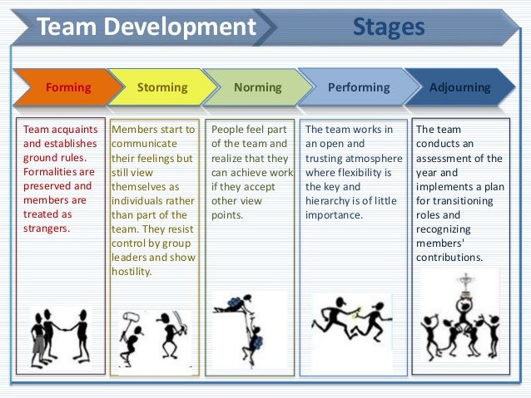
STAGE 5 ( ADJOURNING) ALLOW FOR CELEBRATION GIVE GUIDENCE AND SUPPORT FOR FUTURE PLANS.

BY USING THIS MODEL AND IMPLEMENTING IT TO THE CAFÉ TEAM AND ALSO USING BELBIN TEAM ROLES MODEL
(SHAPER, CO-ORDINATOR , PLANT, COMPLETER FINISHER, MONITOR EVALUATOR, RESOURCE INVESTIGATOR, TEAM WORKER, IMPLEMENTER AND SPECIALIST)

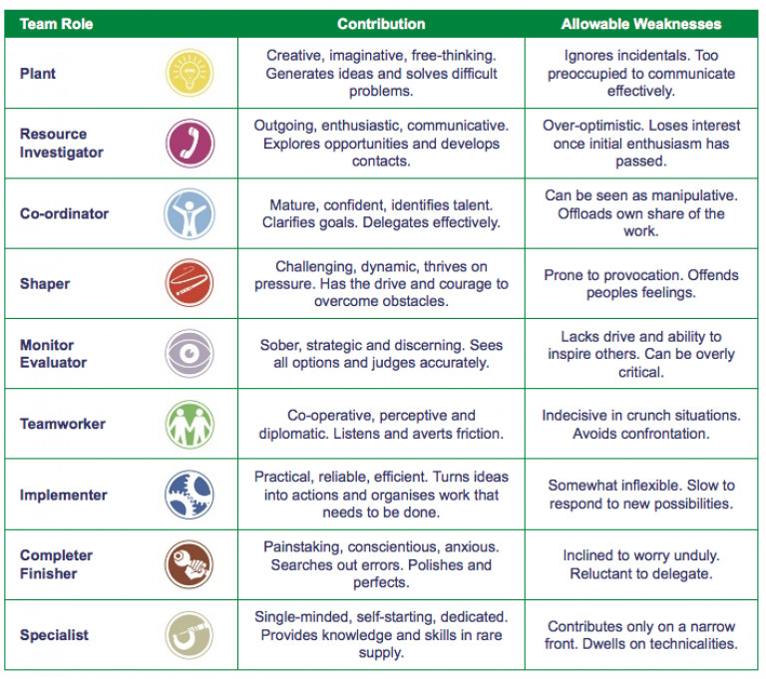

IN THE FIRST THREE STAGES OF TUCKMANS FIVE STAGE OF GROUP DEVELOPMENT MODEL , THE ROLES YOU USE FROM BELBINS TEAM ROLE INVENTORY COULD MAKE A MASSIVE DIFFERENCE TO THE TEAM SUCCESS AND EFFECTIVENESS .
IN THE FIRST TWO STAGES OF TUCKMANS MODEL (STORMING AND FORMING) SHAPERS ARE A GOOD ADDITION TO THE TEAM BECAUSE THEY PROVIDE A GOOD BALANCE AND ENSURE THAT DISCUSSION ARE TURNED INTO RESULTS . SHAPERS SHOULD BE APPLIED WITH GREAT CAUTION AS THEY MAY BECOME TOO COMPETITIVE AND THIS COULD LEAD TO THEM BECOMING AGGRESSIVE AND CONFRONTATIONAL, WHICH WILL BE NEEDED TO BE ADDRESSED OR BAD RELATIONSHIPS WILL FORM.
IF BOTH TEAM ROLES ARE IMPLEAMENTED ( TUCKMAN AND BELBIN) CORRECTLY THE TEAM WILL BECOME SUCCESSFUL AND EFFECTIVE !

PART 2 WHY COMMUNICATION IS VERY IMPORTANT ?

STAFF TURNOVER IS A BIG PROBLEM IN THE CATERING INDUSTRY BE IT A CAFÉ OR RESTAURANT. WHAT IF YOU COULD REDUCE TURNOVER ( AND IMPROVE PRODUCTIVITY) BY INVESTING MORE TIME AND RESOURCES IN WORKPLACE COMMUNICATION?
GREAT COMMUNICATION HELPS TEAMS WORK TOGETHER SEAMLESSLY DURING THOSE CHAOTIC SHIFTS . IT HELPS YOU UNDERSTAND WHATS REALLY GOING ON IN YOUR CAFÉ , IF ITS TO DO WITH YOUR GUESTS , EMPLOYEES, OR ANYTHING ELSE . WHEN YOUR COMMUNICATING IN A GOOD AND POLITE MANNER WITH YOUR TEAM IT WILL BE EASIER FOR THEM TO STAY AROUND .
WHEN YOUR BUSY AND ITS ANOTHER THING TO ADD TO YOUR ALREADY LONG TO DO LIST , BUT A BIT OF COMMUNICATION CAN GO A LONG WAY IN KEEPING THE TEAM AFLOAT.
AS TECHNOLOGY IS DEVELOPING THERE IS SO MUCH ACCESS TO IT, FROM SMARTPHONES TO THE INESCAPABILITY OF WIFI , IT MAKE PEOPLE WONDER: WHY IS COMMUNICATION AN ISSUE AT ALL?
WE HAVE SO MANY WAYS TO GET IN TOUCH WITH EACH OTHER, HOWEVER, THERE ARE MANY DEVICES AND COMMUNICATION CHANNELS THAT ARE DESPERATE FOR OUR ATTENTION. TO PREVENT THIS HABIT YOU NEED TO ADAPT YOU INTERNAL STAFF ACTION AND TAKE A MORE HANDS-ON APPROACH TO TEAM COMMUNICATION.
ALSO, WITH DIFFERENT SHIFTS AND NEW STAFFS JOINING AS WELL AS OTHER STAFF LEAVING, CAFÉ STAFF ARE UNLIKELY TO START AND END A SHIFT AT THE SAME TIME TOGETHER, WHICH CAN BE DIFFICULT TO FORM LONG TERM COMMUNICATION HABITS WITH COWORKERS. THIS LEAVES YOU NEEDING CLEAR PROCESSES AND EXPECTATIONS AROUND COMMUNICATION.
HOW TO BOOST TEAM COMMUNICATION IN CAFÉ
HAVE REGULAR EMPLOYEE CHECK INS- MOST CAFÉ MANAGERS ONLY HAVE A REAL QUICK ONE-TO-ONE CHAT WITH EMPLOYEES WHEN FIRING OR HIRING THEM. HOWEVER, TALKING TO EMPLOYEES REGULARLY CAN INCREASE THEIR MOTIVATION AND IMPROVE COMMUNICATION ACROSS THE WHOLE TEAM. SCHEDULE A WEEKLY OR MONTHLY CHECK IN MEETINGS WITH YOUR DIFFERENT EMPLOYEES BEFORE OR AFTER THEIR SHIFT.
YOU SHOULD THINK ABOUT HOLDING THE MEETING SOMEWHERE ELSE INSTEAD OF THE WORKPLACE SO THAT THE EMPLOYEE CAN CHAT OPENLY TO YOU WITHOUT THE INFLUENCE OF THE WORKPLACE OR COWORKERS.
A FEW THINGS YOU CAN DO TO DURING THE STAFF CHECK IN:
-SEE HOW THEY ARE AND IF THEY ENJOY WORKING IN THE CAFÉ AND ARE HAPPY WITH THEIR ROLE.
-ANSWER ANY QUESTIONS THEY HAVE
-ENCOURAGE THEM TO SHARE ANY IDEAS THEY MIGHT HAVE. CHANCES ARE THEY HAVE IDEAS TO HELP IMPROVE THE SYSTEM.
GET THE TEAM TOGETHER AND GO OUT FOR A STAFF MEAL- STAFF MEALS ARE AN AMAZING WAY OF GETTING THE TEAM TOGETHER IN AN INFORMAL SETTING AND COMMUNICATE WITHOUT HAVING TO STRESS ABOUT THE WORK. HAVING A MEAL ONCE A MONTH WITH THE TEAM MEMEBERS WOULD BE ABLE TO MAKE THE TEAM RELATION STRONGER.
USE A MANAGER LOG BOOK- USING A MANGER LOG BOOK CAN HELP YOU TO KEEP TRACK OF YOUR TEAM NOTES DURING THE SHIFTS. THIS CAN HELP YOU BUILD AN OBSERVATION OF WHERE YOUR TEAM CAN MAKE IMPROVEMENTS.
USE A WORK-SPECIFIC GROUP COMMUNICATION TOOL- MOST PEOPLE HAVE A CELLPHONE WHICH THEY CAN USE. SO USING A PHONE CAN ALSO BE USED TO COMMUNICATE WITH YOUR TEAM MEMBERS. YOU CAN USE A MOBILE PHONE TO SEND IMPORTANT INFORMATION LIKE UPDATES, SCHEDUELES , EVENTS AND MORE.
COLLECT AND ENCOURAGE ANONYMOUS FEEDBACK- EMPLOYEES WILL NOT ALWAYS FEEL COMFORTABLE SHARING THEIR FEEDBACK DIRECTLY TO THE CAFÉ MANAGEMENT. SOMETIMES THEY WOULD FEEL MORE COMFORTABLE BRINGING UP A MORE CHALLENGING SUBJECT WITHOUT A FACE TO FACE CONVERSATION.
“TO EFFECTIVELY COMMUNICATE, WE MUST REALIZE THAT WE ARE ALL DIFFERENT IN THE WAY WE PERCEIVE THE WORLD AND USE THIS UNDERSTANDING AS A GUIDE TO OUR COMMUNICATION WITH OTHERS”(Tony Roberts)
COMMUNICATION IS WHEN INFORMATION FROM ONE PERSON IS TRANSFERRED TO ANOTHER PERSON. WORKING IN AN AREA SUCH AS A CAFE WILL INVOLVE A LOT OF COMMUNICATION WITH STAFF AND CUSTOMERS. HAVING GOOD COMMUNICATION SKILL WILL HELP YOU GO A LONG WAY, HELPING YOU TO DO YOUR JOB MORE EFFECTIVELY AND EFFICIENTLY.
COMMUNICATION IS NOT JUST ABOUT SPEAKING, IT INVOLVES THE TONE OF YOUR VOICE, YOUR BODY LANGUAGE AND LISTENING. NINETY PERCENT OF COMMUNICATION IS NON VERBAL AND THE TEN PERCENT IS WHAT WE ACTUALLY SAY. ALSO, THE WAY WE SAY WHAT WE SAY IS VERY IMPORTANT. THE TONE WE USE WILL IMPACT ON THE MESSAGE WE WANT TO GET ACROSS.
TO AVOID ANY MISUNDERSTANDING ALWAYS SPEAK CLEARLY AND IN A CALM TONE. LISTEN CAREFULLY AND WATCH FOR NON VERBAL CLUES.
GOOD COMMUNICATION DEPEND ON THE FOLLOWING:
-LISTEN CAREFULLY AND BE PATIENT
-REPEAT IF NECESSARY
-SPEAK CLEARLY AND SLOWLY WHEN ASKING OR ANSWERING QUESTIONS.
-SPEAK FORMALLY AND AVOID SLANG
-WRITE DOWN COMPLEX INFORMATION

IF YOU CAN SPEAK MORE THAN ONE LANGUAGE YOU SHOULD CONSIDER USING IT IF YOU THINK THAT THE CUSTOMER WILL APRECIATE YOUR EFFORT,AND A GOOD RELATIONSHIP WITH CUSTOMERS CAN INCLUDE A SENSE OF RESPECT AND WARMTH. GREETING A GUEST CAN HELP BUILD A GOOD RELATION AND PROVIDING GOOD CUSTOMER SERVICE WILL LEAD THE CUSTOMERS GIVING GOOD FEEDBACK.
ACTIVE LISTENING IS ESSETIAL AS GUESTS WANT TO BE LISTENED TO AND NOT JUST HEARD. ACTIVE LISTEING INVOLVES:
-HAVING A SUITABLE FACIAL EXPRESSION
-KEEPING A SMILE ON YOUR FACE WHILE TALIKING TO GUESTS
-EYE CONTACT
-GOOD BODY POSTURE
-AVOID INTERUPTING
NON VERBAL COMMUNICATION
NON VERBAL COMMUNICATION INCLUDES:
FACIAL EXPRESSION - A FROWN OR A SMILE
GESTURE - MOVEMENT OF HAND OR BODY TO EMPHASIZE OR EXPLAIN A MESSAGE
BODY POSTURE – HOW WE STAND OR SIT
ORIENTATION – WAY WE FACE THE PERSON OR TURN AWAY
EYE CONTACT – WHEN WE LOOK AT THE OTHER PERSONS EYE WHEN TALKING
BODY CONTACT – A HANDSHAKE
HEAD NODS – TO ENCOURAGE THE OTHER PERSON OR A SIGN OF AGREEMENT
NON VERBAL ASPECT OF SPEECH – PITCH AND TONE OF VOICE
APPEARANCE- HOW THEY LOOK/ GRROMING AND DRESS

CONCLUSION
AFTER EXPLAINING AND SHOWING ALL KIND OF THEORIES( TUCKMAN AND BELBIN) AND HOW TO IMPLEMENT THEM KAREN AND SIMON PHILIPS NOW WILL NEED TO DECIDE WHO WILL BE THE MAIN MANAGER OR BOTH BE MANAGERS ON DIFFERENT SHIFTS AND WILL NEED TO HAVE A SUPERVISOR OR 2 SUPERVISOR ON DIFFERENT SHIFTS WHO THEY BOTH CAN LAISE WITH . THEY WILL NEED TO DO A ROTA ON WHICH ALL SHIFTS ARE COVERED BY MANAGERS AND SUPERVISORS . THE ROTA SHOULD BE DONE WEEKLY IN ADVANCE SO EVERYONE WORKING WILL BE AWARE OF THEIR SHIFTS . MANAGERS WILL COMMUNICATE ONLY WITH SUPERVISOR AND THEY WILL DISCUSS WHAT NEEDS TO BE DONE AND HOW . SUPERVISORS WILL COMMUNICATE WITH THE REST OF THE STAFF WHICH WILL LEAVE THE MANAGERS FREE TO BE WITH THE MOST IMPORTANT PART OF ANY BUSINESS …. THE CUSTOMERS . LIKE A MEMBER OF STAFF IS SICK AND NO ONE KNOWS WHY THE STAFF HAS NOT TURNED UP SO THE MANAGER WILL LAISE WITH THE ON DUTY SUPERVISOR WHO WILL NOTIFY ALL THE OTHER STAFF SO EVERYBODY IS AWARE ONE STAFF SHORT TODAY SO WE WILL ALL NEED TO COVER OUR AND SHARE THE OFF DUTY STAFFS WORK TOO . THAT WAY THE PLACE WILL RUN SMOOTHER. ALL STAFF FROM TOP DOWN TO BOTTOM WILL NEED DAY TO DAY INFORMATION AND THAT INFORMATION MUST BE SHARED AMONGST ALL STAFF THROUGH GOOD COMMUNICATION . EACH MORNING AND ON EACH SHIFT MANAGERS MUST HAVE A SMALL BRIEFING WITH THE SUPERVISOR ON TODAYS DUTIES AND WORK THAT NEED TO BE DONE . IE. STOCK ORDERS OR DRINKS ORDERS , WHICH STAFF IS OFF SICK OR WHICH NEW STAFF WILL NEED TRAINING . THE TRAINING WILL BE DONE BY THE SUPERVISOR ONE TO ONE AND THE MANAGERS WILL DO A FOLLOW UP ON HOW THEY ARE DOING . KITCHEN .. HEAD CHEF WILL BE IN CHARGE HE WILL HAVE A SECOND CHEF WHO HE WILL DELEGATE ALL THE DAY TO DAY RUNNING OF THE PLACE SO THE CHEF ONLY NEEDS TO SEE THE MANAGER AND THE ON DUTY SUPERVISOR SO THAT WAY THEY WILL HAVE A NICE WORKING BALANCE AND THE PLACE WILL RUN SMOOTHLY AND EFFICENTLY ..

