Michael Oldham (2235684)
2235684@student.uwtsd.ac.uk
HTML & CSS Web Development
L4 - Introduction to Web and Database Concepts
15/05/2023

Requirements

My website is about Rhodes in Greece. It is a website to provide information to perspective visitors to the country. And to show off a few photos of the area as well as things to do.

I have chosen to do my website on Rhodes as this is where me and my wife got married in May 2022. As it is such a beautiful place and I have such a passion for the island, it helped make my choice a lot easier.

The website is aimed at people planning on visiting the island/Greece and provides an enquiries section for any questions.

Implementation

Home Page
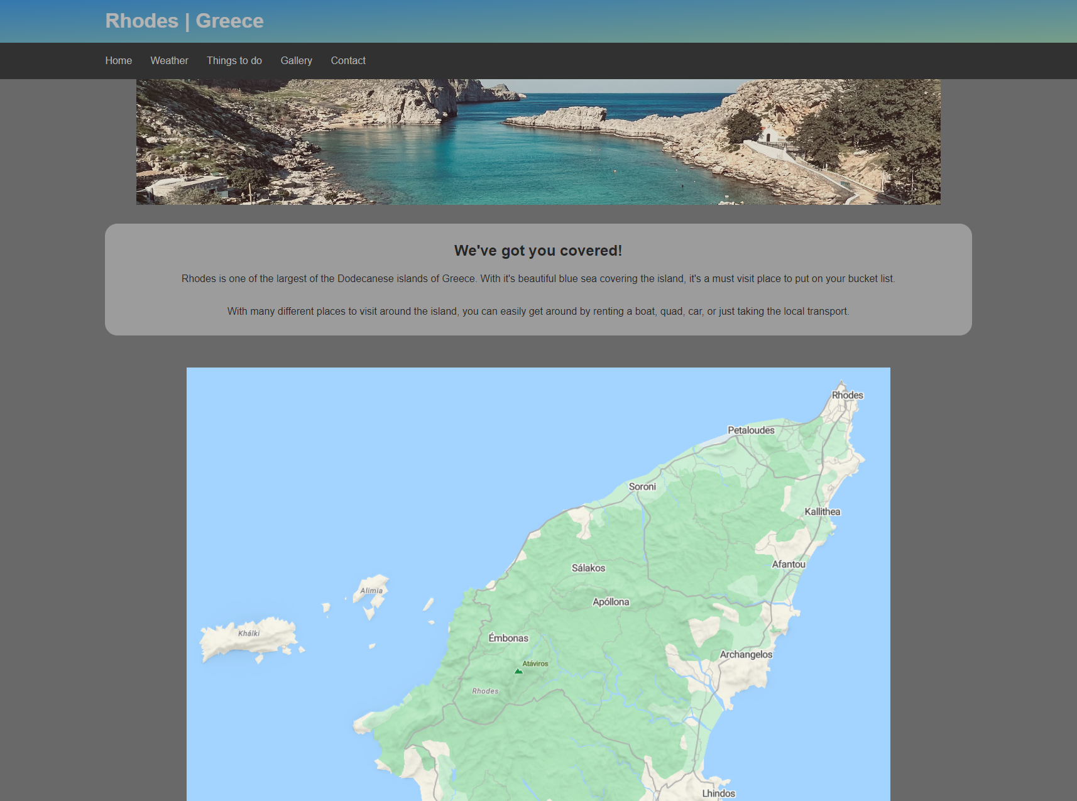

Weather

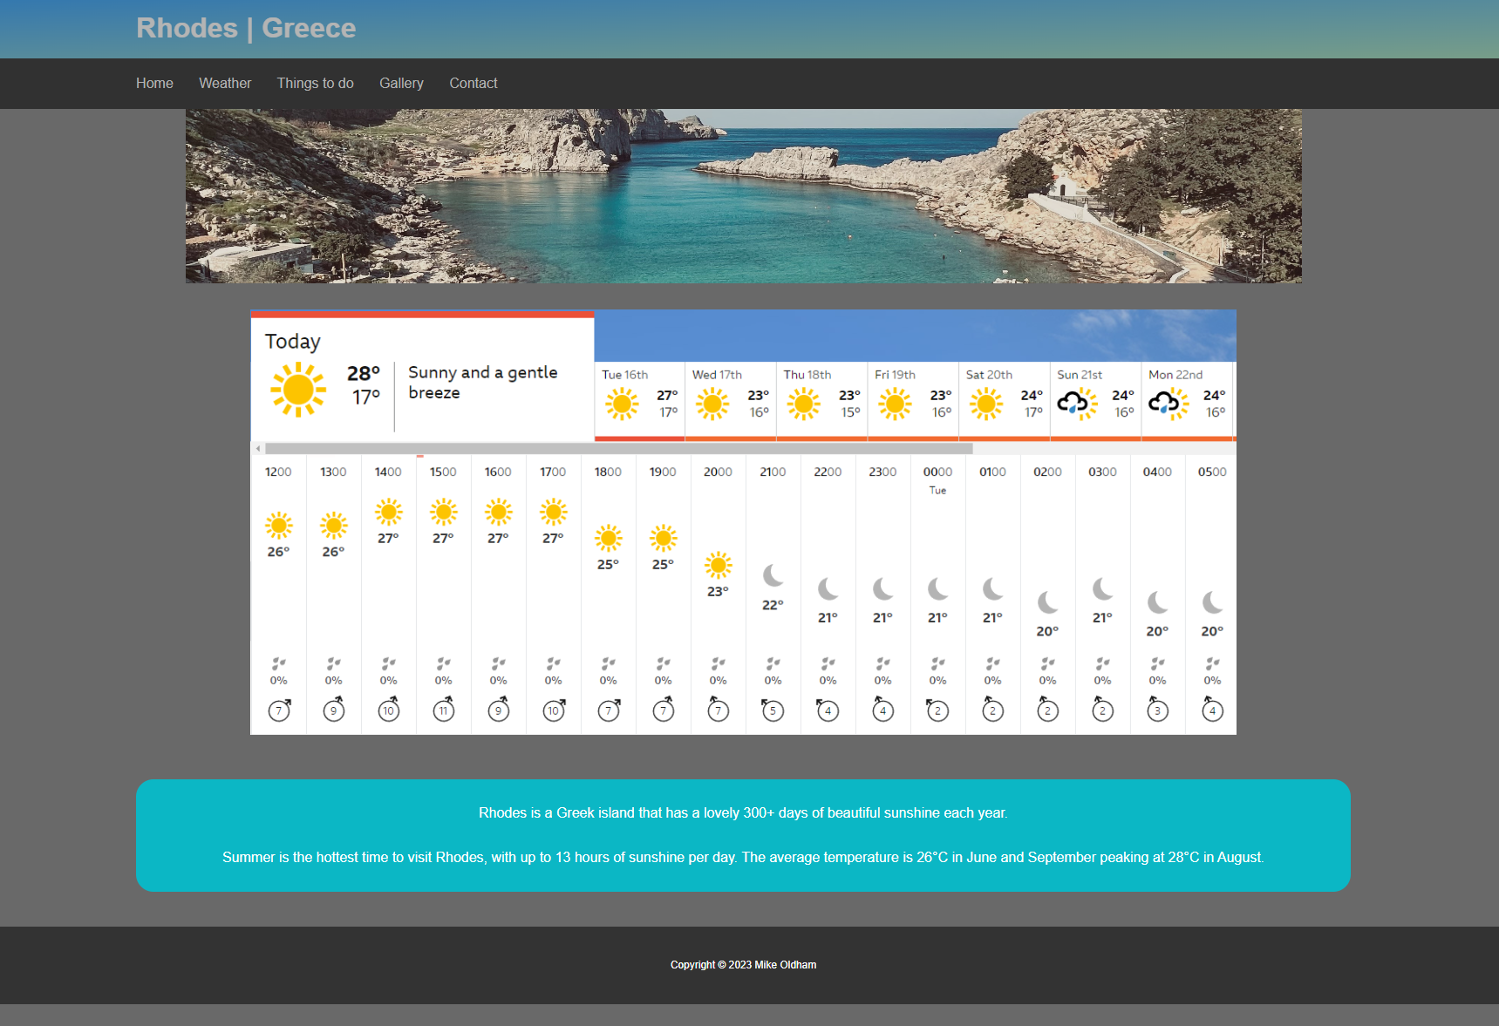

Things to do
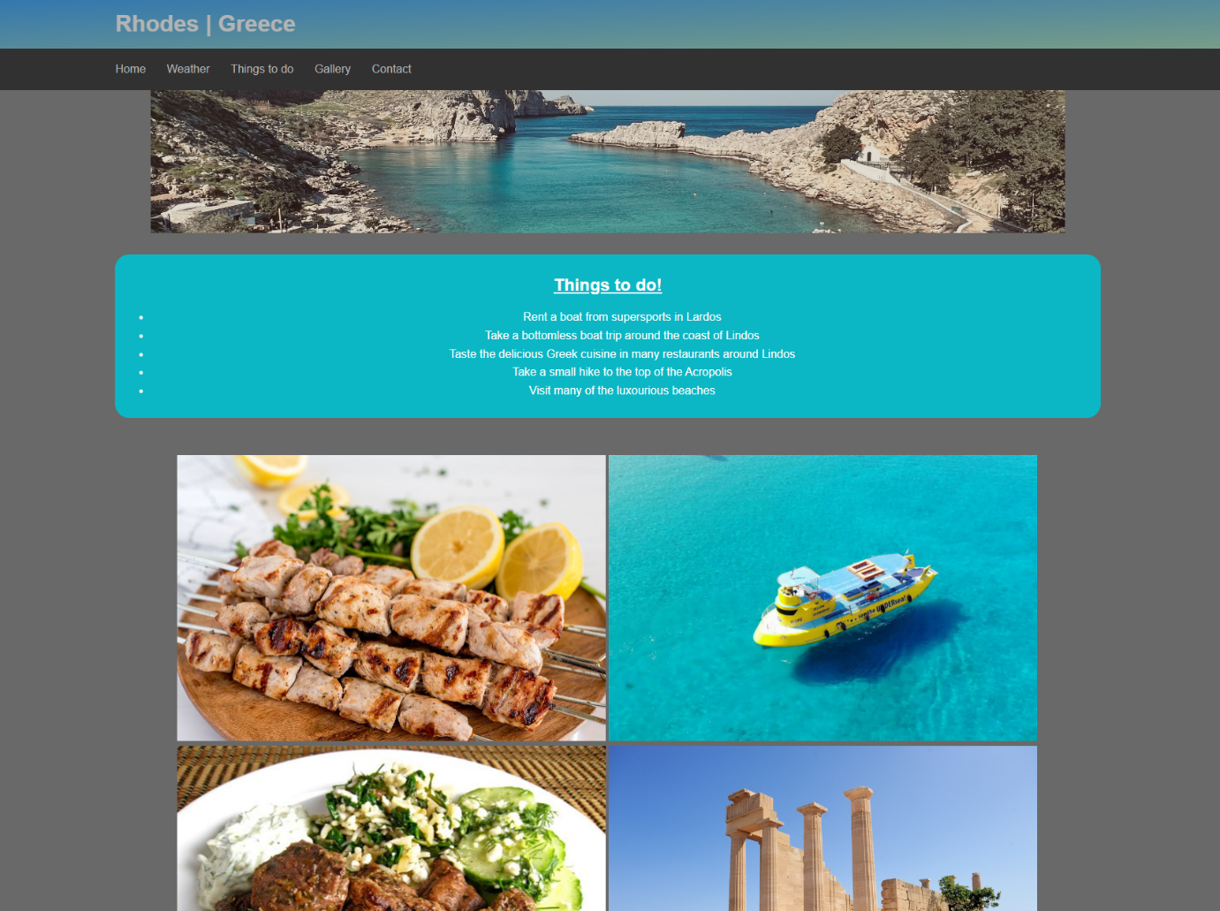

Gallery
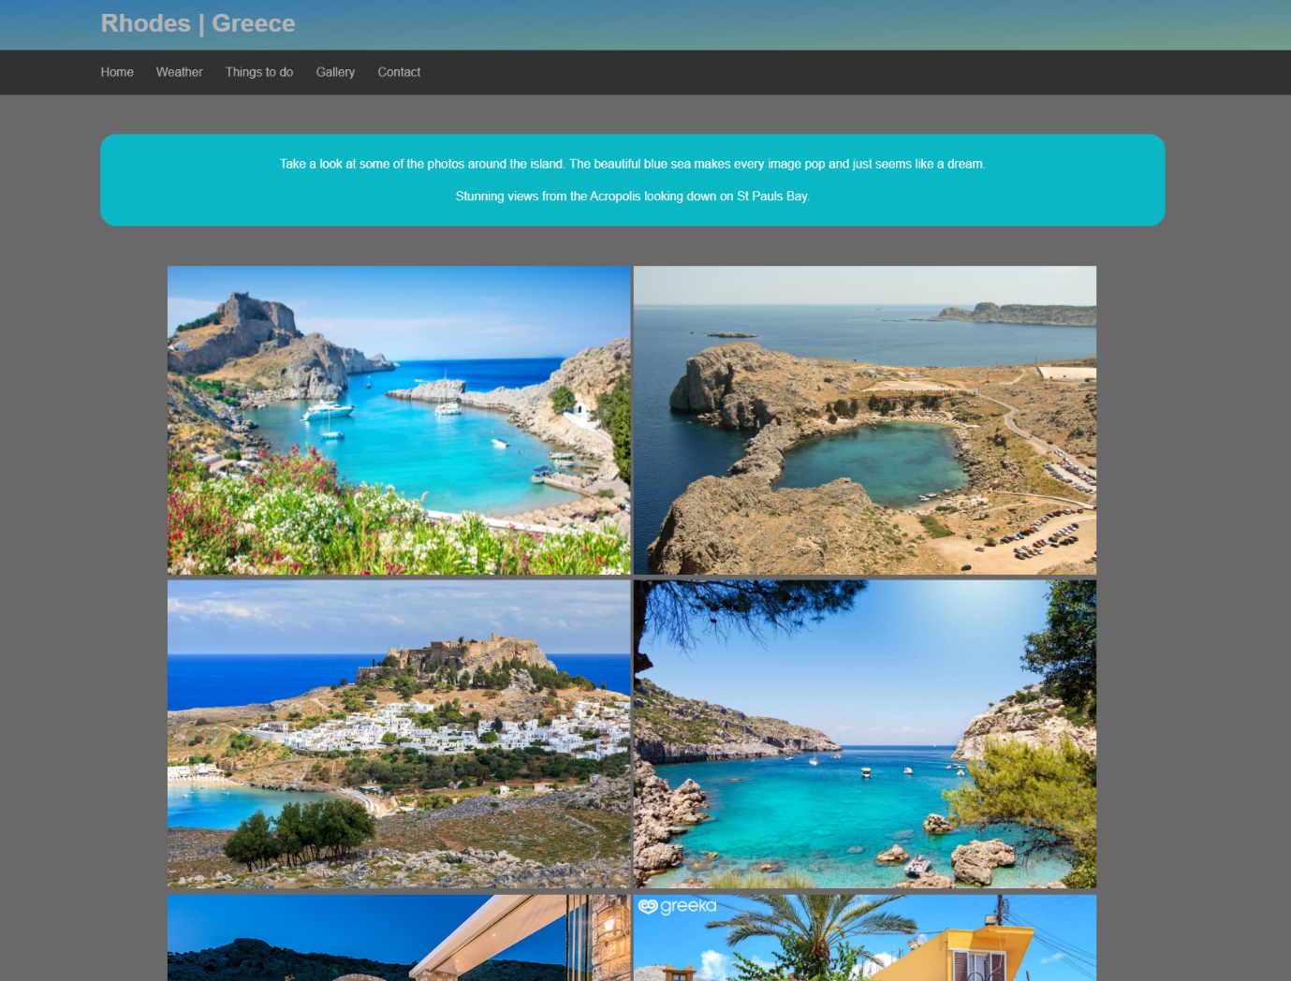

Contact
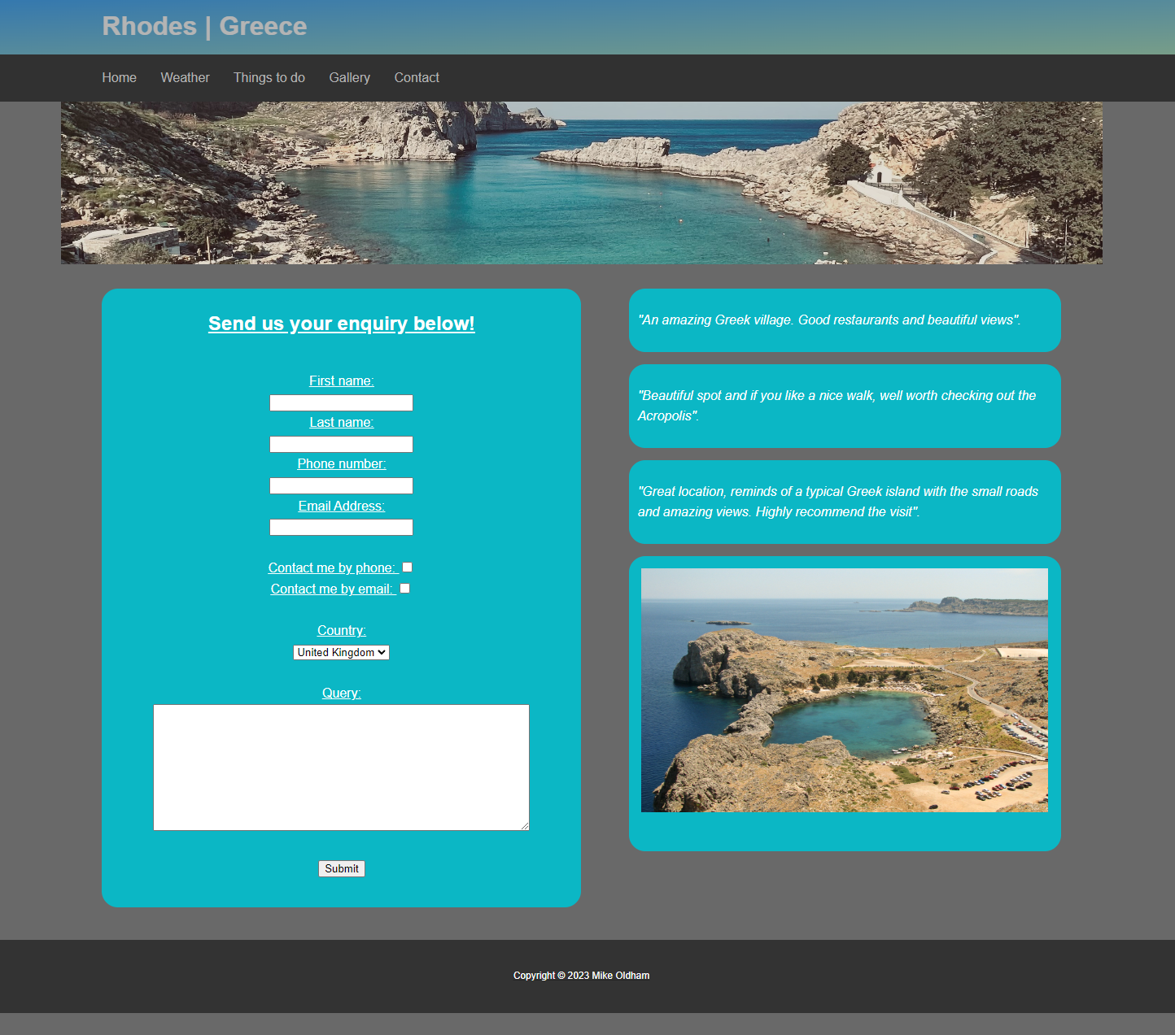

Validation

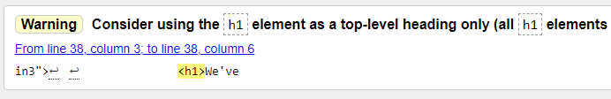

Line 38 updated:
Changed to a H2 heading instead of H1

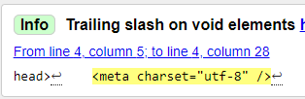

Line 4 updated:
Removed unnecessary forward slash

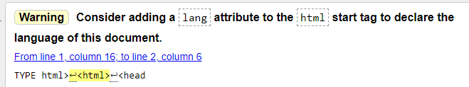

Line 2 updated on each sheet:
Language added to HTML doc

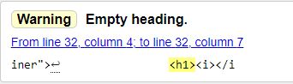

Line 32 updated on weather.html
H1 heading removed.
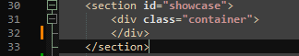

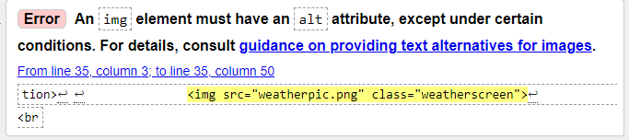

Updated line 35:
Alt added to photo

CSS Validation:



No errors found in CSS file.

Evaluation

- Usability – Website usability includes how easy it is to understand the structure of a website, its functionality, the interface, and all the contents within. It also helps when the user can find what they are looking for in a timely manner. [1]

Accessibility – Website accessibility is extremely and particularly important for elderly people and people with disabilities. This usually includes people who are blind, visually impaired, motorically challenged, deaf, hard of hearing and dyslectic. It helps the user view the content more comfortably regardless of any limitations they may have. [2]

Search Engine Optimisation – SEO is a collection of strategies that are used to improve a website’s presence and visibility on search engine results. The aim of this is for the higher rated and more frequently visited websites will appear closer to the top. The majority of people will always choose one of the first few websites that appear when entering an internet search on engines such as Google. [3]

- My website Evaluation

Usefulness (usability and utility) – I would say that my website is fairly simple for the users. The look is quite modern but not overly complicated. I believe that the majority of users would look at my top bar and understand that they are clickable buttons to get to different pages on the site. When hovering over the words ‘Home’ ‘Weather’ ‘Things to do’ ‘Gallery’ and ‘Contact’ the text also becomes lighter and the cursor changes to a hand with a finger pointing. This also indicates that it can be clicked.

The contact page also has fields(boxes) which the user can fill out with their details. This is also self-explanatory and the user would have the automatic assumption that you can click in the boxes to type. Along with the labels of each box, it becomes more obvious. The tick boxes are also self-explanatory and users would be used to the same concept from other websites and forms.

References

[1] | D. Belanche, L. V. Casalo and M. Guinaliu, "Website usability, consumer satisfaction and the intention to use a website: The moderating effect of perceived risk," Journal of retailing and consumer services, 2012, Vol.19 (1), p.124-132, vol. 19, no. 1, 2012.
[2] | K. Krol and D. Zdonek, "Local Government Website Accessibility—Evidence from Poland," Administrative sciences, 2020, Vol.10 (2), p.22, vol. 10, no. 2, 2020.
[3] | D. Giomelakis and A. Veglis, "Investigating Search Engine Optimization Factors in Media Websites: The case of Greece," Digital journalism, 2016, Vol.4 (3), p.379-400, vol. 4, no. 3, 2016.

Appendices

Index.html

<!DOCTYPE html>
<html lang="en">
<head>
<meta charset="utf-8">
<title>Visit Rhodes</title>
<link rel="stylesheet" type="text/css" href ="stylesheet1.css">
</head>

<body>
<header id="main-header">
<div class="container">
<h1>Rhodes | Greece</h1>
</div>
</header>

<nav id="navbar">
<div class="container">
<ul>
<li><a href="index.html">Home</a></li>
<li><a href="weather.html">Weather</a></li>
<li><a href="ttd.html">Things to do</a></li>
<li><a href="gallery.html">Gallery</a></li>
<li><a href="contact.html">Contact</a></li>
</ul>
</div>
</nav>

<div class="container">
<section id="showcase">
</section>
</div>

<div class="container3">
<section id="main3">

<h2>We've got you covered!</h2>

<p>Rhodes is one of the largest of the Dodecanese islands of Greece. With it's beautiful blue sea covering the island, it's a must visit place to put on your bucket list.<br><br>
With many different places to visit around the island, you can easily get around by renting a boat, quad, car, or just taking the local transport.
</p>
</section>
</div>

<br><br>

<img src="rhodesmap.png" alt="rhodesmap" class="mapphoto">

<footer id="main-footer">
<p> Copyright &copy; 2023 Mike Oldham</p>
</footer>

</body>
</html>

Weather.html

<!DOCTYPE html>
<html lang="en">
<head>
<meta charset="utf-8">
<title>Visit Rhodes</title>
<link rel="stylesheet" type="text/css" href ="stylesheet1.css">

</head>

<body>
<header id="main-header">
<div class="container">
<h1>Rhodes | Greece</h1>
</div>
</header>

<nav id="navbar">
<div class="container">
<ul>
<li><a href="index.html">Home</a></li>
<li><a href="weather.html">Weather</a></li>
<li><a href="ttd.html">Things to do</a></li>
<li><a href="gallery.html">Gallery</a></li>
<li><a href="contact.html">Contact</a></li>
</ul>
</div>
</nav>

<section id="showcase">
<div class="container">
</div>
</section>

<img src="weatherpic.png" alt="weather" class="weatherscreen">
<br><br>

<div class="container2">
<section id="main">
<p>Rhodes is a Greek island that has a lovely 300+ days of beautiful sunshine each year.<br><br>
Summer is the hottest time to visit Rhodes, with up to 13 hours of sunshine per day. The average temperature is 26°C in June and September peaking at 28°C in August.
</p>
</section>
</div>

<footer id="main-footer">
<p> Copyright &copy; 2023 Mike Oldham</p>
</footer>
</body>
</html>

Ttd.html

<!DOCTYPE html>
<html lang="en">
<head>
<meta charset="utf-8">
<title>Visit Rhodes</title>
<link rel="stylesheet" type="text/css" href ="stylesheet1.css">

</head>

<body>
<header id="main-header">
<div class="container">
<h1>Rhodes | Greece</h1>
</div>
</header>

<nav id="navbar">
<div class="container">
<ul>
<li><a href="index.html">Home</a></li>
<li><a href="weather.html">Weather</a></li>
<li><a href="ttd.html">Things to do</a></li>
<li><a href="gallery.html">Gallery</a></li>
<li><a href="contact.html">Contact</a></li>
</ul>
</div>
</nav>

<section id="showcase">
<div class="container">
</div>
</section>

<div class="container2">
<section id="main">
<H2><u>Things to do!</u></H2>
<ul>
<li>Rent a boat from supersports in Lardos</li>
<li>Take a bottomless boat trip around the coast of Lindos</li>
<li>Taste the delicious Greek cuisine in many restaurants around Lindos </li>
<li>Take a small hike to the top of the Acropolis</li>
<li>Visit many of the luxourious beaches</li>
</ul>

</section>
</div>

<br><br>

<section>

<div class="ttdphotos1">

<a target="_blank" href="souvlaki.jpg">
<img src="souvlaki.jpg" alt="souvlaki" width="600" height="400">
</a>
<a target="_blank" href="yellowsub.jpg">
<img src="yellowsub.jpg" alt="boat" width="600" height="400">
</a>
</div>

<div class="ttdphotos2">

<a target="_blank" href="lambsouv.jpg">
<img src="lambsouv.jpg" alt="lambsouv" width="600" height="400">
</a>
<a target="_blank" href="acropolis.jpg">
<img src="acropolis.jpg" alt="acropolis" width="600" height="400">
</a>
</div>
</section>

<footer id="main-footer">
<p> Copyright &copy; 2023 Mike Oldham</p>
</footer>
</body>
</html>

Gallery.html

<!DOCTYPE html>
<html lang="en">
<head>
<meta charset="utf-8">
<title>Visit Rhodes</title>
<link rel="stylesheet" type="text/css" href ="stylesheet1.css">

</head>

<body>
<header id="main-header">
<div class="container">
<h1>Rhodes | Greece</h1>
</div>
</header>

<nav id="navbar">
<div class="container">
<ul>
<li><a href="index.html">Home</a></li>
<li><a href="weather.html">Weather</a></li>
<li><a href="ttd.html">Things to do</a></li>
<li><a href="gallery.html">Gallery</a></li>
<li><a href="contact.html">Contact</a></li>
</ul>
</div>
</nav>

<br><br>

<div class="container2">
<section id="main">
<p>Take a look at some of the photos around the island. The beautiful blue sea makes every image pop and just seems like a dream.
</p>

<p>Stunning views from the Acropolis looking down on St Pauls Bay.
</p>
</section>
</div>

<br><br>

<section>
<div class="ttdphotos1">

<a target="_blank" href="spbay.png">
<img src="spbay.png" alt="stpaulsbay" width="600" height="400">
</a>
<a target="_blank" href="lindos.jfif">
<img src="lindos.jfif" alt="lindos" width="600" height="400">
</a>

</div>

<div class="ttdphotos2">

<a target="_blank" href="ldostown.jfif">
<img src="ldostown.jfif" alt="lindostown" width="600" height="400">
</a>
<a target="_blank" href="aqbay.jpg">
<img src="aqbay.jpg" alt="aqbay" width="600" height="400">
</a>

</div>

<div class="ttdphotos3">

<a target="_blank" href="pefkos.jpg">
<img src="pefkos.jpg" alt="pefkos" width="600" height="400">
</a>
<a target="_blank" href="lardos.jpg">
<img src="lardos.jpg" alt="lardos" width="600" height="400">
</a>

</div>

</section>

<footer id="main-footer">
<p> Copyright &copy; 2023 Mike Oldham</p>
</footer>
</body>
</html>

Contact.html

<!DOCTYPE html>
<html lang="en">
<head>
<meta charset="utf-8">
<title>Visit Rhodes</title>
<link rel="stylesheet" type="text/css" href ="stylesheet1.css">

</head>

<body>
<header id="main-header">
<div class="container">
<h1>Rhodes | Greece</h1>
</div>
</header>

<nav id="navbar">
<div class="container">
<ul>
<li><a href="index.html">Home</a></li>
<li><a href="weather.html">Weather</a></li>
<li><a href="ttd.html">Things to do</a></li>
<li><a href="gallery.html">Gallery</a></li>
<li><a href="contact.html">Contact</a></li>
</ul>
</div>
</nav>

<section id="showcase">
<div class="container">
</div>
</section>

<div class="container">
<section id="contactform">

<form action="#">
<H2><u>Send us your enquiry below!</u></H2><br>

<label for="fname">First name:</label><br>
<input type="text" id="fname" name="fname" value=""><br>
<label for="lname">Last name:</label><br>
<input type="text" id="lname" name="lname" value=""><br>
<label for="phone">Phone number:</label><br>
<input type="text" id="phoneno" name="phoneno" value=""><br>
<label for="emailadd">Email Address:</label><br>
<input type="text" id="emailadd" name="emailadd" value=""><br><br>

<label for="phone">Contact me by phone:</label><br>
<input type="checkbox" id="phone" ><br>
<label for="email">Contact me by email:</label><br>
<input type="checkbox" id="email" ><br><br>

<label for="country">Country:</label><br>
<select name="country" id="country">
<option value="United Kingdom">United Kingdom</option>
<option value="Greece">Greece</option>
<option value="France">France</option>
<option value="Spain">Spain</option>
<option value="Vietnam">Vietnam</option>
</select>
<br><br>

<label for="query">Query:</label><br>
<textarea id="query" name="query" rows="10" cols="60"></textarea><br><br>
<input type="submit" value="Submit">
</form>
<br><br>
</section>

<aside id="sidebar1">
<p><i>"An amazing Greek village. Good restaurants and beautiful views".</i></p>
</aside>

<aside id="sidebar2">
<p><i>"Beautiful spot and if you like a nice walk, well worth checking out the Acropolis".</i></p>
</aside>

<aside id="sidebar3">
<p><i>"Great location, reminds of a typical Greek island with the small roads and amazing views. Highly recommend the visit".</i></p>
</aside>

<aside id="lindossmall">
<img src="lindos.jfif" alt="lindos" style="width:500px;height:300px"><br><br>
</aside>

</div>

<footer id="main-footer">
<p> Copyright &copy; 2023 Mike Oldham</p>
</footer>
</body>
</html>

CSS Stylesheet

body{
background-color:#696969;
color:#262626;
font-family:Arial, Helvetica, san-serif;
font-size:16px;
line-height:1.6em;
margin:0;
}

.container{
width:80%;
margin:auto;
overflow:hidden;
}

.container2{
width:80%;
margin-left: auto;
margin-right: auto;
overflow:hidden;
}

.container3{
width:80%;
margin-left: auto;
margin-right: auto;
overflow:hidden;
}

#main-header{
background-image: linear-gradient(to bottom right, #0087F5, #87d2a8);
opacity:0.5;
color:#fff;

}

#navbar{
background-color:#313131;
color:#b3b3b3;
}

#navbar ul{
padding:0;
list-style:none;
}

#navbar li{
display:inline;
}

#navbar a{
font-size:16px;
padding-right:25px;

}

a{
color:#b3b3b3;;
text-decoration: none;
}

a:hover{
color:white;

}

#main-footer {
background:#333;
color:#fff;
font-size:12px;
text-align:center;
padding:20px;
margin-top:40px;
}

#main{
float:left;
width:100%;
background:#0bb7c5;
color:#fff;
border-radius:20px;
padding:10px;
box-sizing: border-box;
text-align:center;
}

#main3{
float:left;
width:100%;
background:#9c9c9c;
border-radius:20px;
text-align:center;
padding:10px;
box-sizing: border-box;
}

#contactform {
float:left;
width:50%;
background:#0bb7c5;
color:#fff;
text-align:center;
border-radius:20px;
padding:10px;
box-sizing: border-box;
}

.mapphoto {
display: block;
margin-left: auto;
margin-right: auto;
width: 65%;
}

#lindossmall {
float:right;
border-radius:20px;
width:45%;
background:#0bb7c5;
color:#fff;
padding:15px 15px 15px;
box-sizing: border-box;
}

.yellowboat {
display: block;
margin-left: auto;
margin-right: auto;
width: 65%;
}

.souvlaki {
display: block;
margin-left: auto;
margin-right: auto;
width: 65%;
}

.ttdphotos1 {
display: block;
margin-left: auto;
margin-right: auto;
width:70%;
overflow:hidden;

}

.ttdphotos2 {
display: block;
margin-left: auto;
margin-right: auto;
width:70%;
overflow:hidden;

}

.ttdphotos3 {
display: block;
margin-left: auto;
margin-right: auto;
width:70%;
overflow:hidden;

}
.weatherscreen {
display: block;
margin-left: auto;
margin-right: auto;
width: 65%;
}

#sidebar1{
float:right;
border-radius:20px;
width:45%;
background:#0bb7c5;
color:#fff;
padding:10px;
box-sizing: border-box;
margin-bottom: 15px;
}

#sidebar2{
float:right;
border-radius:20px;
width:45%;
background:#0bb7c5;
color:#fff;
padding:10px;
box-sizing: border-box;
margin-bottom: 15px;
}

#sidebar3{
float:right;
border-radius:20px;
width:45%;
background:#0bb7c5;
color:#fff;
padding:10px;
box-sizing: border-box;
margin-bottom: 15px;
}

#showcase{
background-image:url("stpaulsbay.jpg") ;
background-size: 1280px;
opacity:0.8;
background-position:center center;
background-repeat:no-repeat;
min-height:200px;
margin-bottom:30px;
text-align:center;
}

#showcase h1{
color:#fff;
font-size:30px;
text-shadow: 0 0 5px black;
line-height:1.6em;
padding:40px;
}

@media(max-width:600px){
#main{
width:100%;
float:none;
}

#sidebar{
width:100%;
float:none;
}

#navbar li{
display:block;
}

}

.row {
display: flex;
}

.columns {
flex: 33.33%;
padding: 5px;
}

