

Student name: Catherine Chinwendu Okonyia
Student ID: 2418938
Module name: Changemakers Creativity And Value Creation
Module code: BMHP5014_LON
Lecturer name: Dr Sadiq Soban

Introduction .............................................................................. 4
Background ............................................................................... 5
Innovation Description ............................................................. 6
Enhancing Quality of Care
Improving Access
Supporting Staff
Contributing to the Common Good
Impact on Health and Social Care .............................................7
Public and Stakeholder Involvement ......................................... 7
Public Engagement
Mental Health Awareness and Education
Co-Production with Service Users
Advocacy Efforts
Policies, Services and Professional Links ...............................8
Conclusion ............................................................................... 9
References .............................................................................. 10

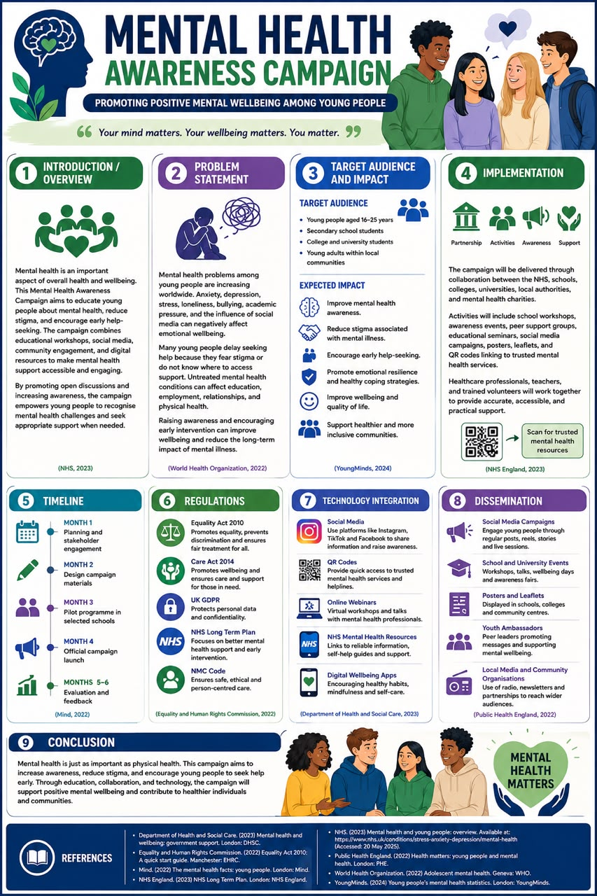

Introduction
Mental health is our emotional, psychological, and social well-being. It helps us think, feel, act, handle stress, talk to others, and make good choices. As defined by the World Health Organization, it is a state of well-being where a person realizes their own abilities and copes with normal life stress. Mental health awareness is the ongoing effort to understand psychological well-being, spot signs of mental illness, and talk openly to reduce social stigma. Rethink Mental Illness, Zeva Health. This innovation helps address and solve mental health awareness this campaign targets and benefit youths. Mental health matters to youths because it shapes brain development, protects overall physical wellness, and dictates future life success. Good emotional health helps young people handle daily stress, build strong friendships, and do well in school. Groups like the Capital Youth. NHS (2023).

Background
According to the World Health Organization (WHO, 2022), mental health conditions account for a substantial proportion of illness among young people, with anxiety and depression being among the most common disorders. Similarly, reports that increasing numbers of children and youths are using mental health services, spotlighting the growing demand for early intervention and support.
Over the past 15 years, substantial investment has been made in the UK to improve public awareness and understanding of mental health. National public health organisations, charities, employers, universities, and schools have implemented a wide range of awareness initiatives designed to educate the public about mental health and wellbeing. These campaigns commonly focus on increasing recognition of mental health symptoms, challenging stigma surrounding specific mental health conditions, emphasising the prevalence of mental health difficulties across the population, and encouraging individuals to seek professional support when required. In addition to these organised initiatives, social media has become an important platform through which both mental health professionals and members of the public disseminate similar educational content. Collectively, these efforts are intended to normalise conversations about mental health by reinforcing the message that mental health difficulties can affect anyone, and that seeking help should be viewed as an acceptable and positive response rather than a source of shame. Https://www.Cambridge.com.
Early intervention is widely recognised as one of the most effective and easy ways to improve mental health outcomes. Increasing awareness through education and community engagement enables young people to recognise the signs of mental health difficulties, seek appropriate support, and develop healthy coping strategies. This campaign addresses these challenges by promoting open discussions, reducing stigma, and improving access to trustworthy mental health information through both face-to-face activities and digital platforms.

Innovation description
Mental health awareness is newer and better because it reduces shame, encourages early help, and treats the mind with the same care as the body. [1, 2, 3]
Enhancing Quality of Care:
•⁠ ⁠Better focus: Clear minds make fewer errors and practice safer care.
•⁠ ⁠More empathy: Providers listen better and show true kindness.
•⁠ Stronger trust: Patients feel safe and respected by calm workers. [1]
Improving Access
•⁠ Primary care links: Putting mental health in local clinics helps people get help faster.
•⁠ ⁠Lower cost: Early treatment stops small problems from growing big and expensive.
⁠Less shame: Open talk makes people willing to ask for help. [1, 2, 3, 4]
Supporting Staff
•⁠ ⁠Less burnout: Rest and counseling stop heavy work stress.
•⁠ ⁠Safe spaces: Workplaces that value feelings keep good workers on the job.
•⁠ ⁠Good teamwork: Healthy teams help each other through hard tasks. [1, 2, 3, 4]
Contributing to the Common Good
•⁠ ⁠Stronger comm Policies, Services and Professional Links
•⁠ ⁠Less loss: Prevention saves lives and reduces public crisis costs.
•⁠ Fair society: Equal care for the mind creates a fair world for all.
You can read more about workplace approaches through the World Health Organization.

Impact on health and social care
Prioritizing mental health enhances quality of care, improves access to treatment, supports staff well-being, and contributes to the common good. Addressing mental health needs builds resilient, compassionate, and functional communities. [1, 2]
Co-Production with Users: Peer support: Individuals with first-hand recovery experience act as peer workers to guide and help others. Shared decisions: Users help shape research and mental health tools from start to finish instead of being passive subjects. [1, 2, 3, 4, 5, 6]
Advocacy Efforts
Advisory panels: Lived experience groups guide policies and push for systemic change in healthcare. Human rights focus: Advocates fight to treat mental health care as a basic human right. Grassroots networks: Local groups lobby government bodies to make mental health systems more responsive to real community needs. [1, 2, 3, 4, 5]

Public and stakeholder involvement
Public Engagement
School screening: Programs introduce basic mental health checks and talks in schools and colleges. Stigma reduction: Open discussions help change how the public views mental disorders, creating supportive environments. [1, 2, 3, 4]
You might take your mental health for granted when things are going well. But being aware of symptoms and treatment options can prepare you to face any unexpected challenges and support those around you.
According to Dr. William La Valle, a clinical psychologist and psychology educator at Southern New Hampshire University (SNHU), argues that mental health is frequently neglected despite its essential role in overall health and daily functioning. He suggests that individuals often fail to prioritise their psychological wellbeing, which may increase their susceptibility to negative outcomes. A lack of awareness of one's mental state can contribute to difficulties such as reduced concentration, irritability, and decreased engagement with everyday activities. Consequently, regularly monitoring mental wellbeing is important for recognising changes in psychological functioning and facilitating timely intervention when necessary. Mental can also be defined as an increased understanding of how to protect and support mental health and the range of issues affecting it.

Policies services and professional links:
The Mental Health Awareness Campaign supports several UK laws, policies, and professional standards that promote health, equality, and wellbeing. The Equality Act 2010 ensures that all young people have equal access to information and services without discrimination, while the Care Act 2014 promotes individual wellbeing and early intervention where support is needed. The campaign also aligns with the NHS Long Term Plan, which prioritises improving mental health services and increasing access to early support.
Healthcare professionals, including mental health nurses, school nurses, counsellors, social workers, and voluntary organisations, play a very important role in delivering the campaign. Their knowledge and experience make sure that information is evidence-based, person-centred, and responsive to the needs of young people.

Conclusion
The Mental Health Awareness Campaign provides a practical and innovative approach to improving the mental wellbeing of young people. By combining education, technology, community engagement, and partnership working, the campaign increases awareness, reduces stigma, and encourages early help-seeking. Through collaboration between healthcare professionals, educational institutions, and community organisations, the campaign has the potential to improve individual wellbeing while contributing to healthier and more supportive communities.

Reference

Department of Health and Social Care. (2023) Mental health and wellbeing: government support. London: DHSC.

Equality and Human Rights Commission. (2022) Equality Act 2010: A quick start guide. Manchester: EHRC.

Mind. (2022) The mental health facts. Young people. London: Mind.

NHS England. (2023) NHS Long Term Plan. London: NHS England.

NHS. (2023) Mental health and young people: overview. Available at: https://www.nhs.uk/conditions/stress-anxiety-depression/mental-health (Accessed: 20 May 2025).

Public Health England. (2022) Health matters: young people and mental health. London: PHE.

World Health Organization. (2022) Adolescent mental health. Geneva: WHO.

Young Minds. (2024) Young people's mental health statistics. London: Young Minds.

