LCBB5014

Data Handling & Business Intelligence

A2: Individual Report
2000 words
Hicham Chaibi
Student ID - 2423821
Lecturer: Dr Xavier Matieni
Due date: 2nd May 2026

Business Intelligence Analysis of Film Popularity and Viewer Behaviour Using the Letterbox Dataset
Contents
Business Intelligence Analysis of Film Popularity and Viewer Behaviour Using the Letterbox Dataset 2
1. Introduction 3
2. Data Cleaning and Preparation 3
2.1 Missing values and inconsistency checks 3
2.2 Standardisation and preparation for analysis 3
3. Descriptive Statistics and Summary 4
3.1 Numerical variables 4
3.2 Categorical variables 5
4. Trend Analysis and Visualisation 6
4.1 Genre and language trends 6
4.2 Popularity and engagement patterns 7
5. Statistical Analysis using SPSS 8
5.1 Independent samples t-test 8
5.2 Correlation analysis 8
5.3 Regression analysis 8
6. Insights and Recommendations 9
6.1 Key insights 9
6.2 Recommendations and limitations 9
7. Conclusion 10
References 11

1. Introduction
Business intelligence helps organisations in transforming data into evidence to aid in planning, performance monitoring and decision-making (Haque Sazu and Akter Jahan, 2022). This report is a review of the Letterbox Movie Classification Dataset with a view to studying the ratings of movies, genres, languages, watches, likes, fans and runtime (LCBB5014 Module Team, 2026). The report employs the Excel and SPSS to clean, describe audience behaviour, trend, t-tests, correlation and regression to understand the behaviour pattern and factors associated with the popularity of a movie.

2. Data Cleaning and Preparation

2.1 Missing values and inconsistency checks
The first inspection was done in Excel to ensure that key fields of analysis were filled and could be used. No gaps in the main variables needed in the report such as average rating, runtime, original language, watches, likes, fans and total ratings were detected. This minimised the imputation requirements and cleaning was also required since business intelligence requires consistent and accurate and usable input data (Fu et al., 2024). List-style text was used to store the original genre and studio fields, so they were converted to standardised fields to allow sorting, filtering and charting. This also facilitated the interpretation of the data by non-technical business users.

2.2 Standardisation and preparation for analysis
Genres were standardised into readable categories and a key variable of genre was developed such that each film was categorised into a single key analytical category. The runtime was transformed to a numeric clean field and engagement variables including watches, likes and fans were stored as numerical variables to be used in descriptive and statistical analysis. The original language variable was also left and applied to develop an English/non-English comparison to be applied later to test the hypothesis. This was critical since the absence of data, irregular or improperly structured data may undermine the validity of subsequent statistical interpretation (Alam et al., 2023). The filtered data formed a better foundation of the Excel visualisation, SPSS testing and BI-driven recommendations.
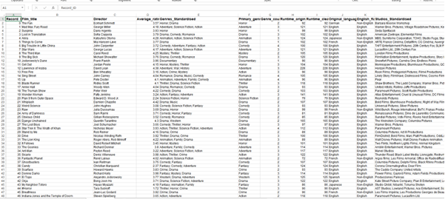
Figure 1: Cleaned dataset sample and preparation summary.

3. Descriptive Statistics and Summary

3.1 Numerical variables
The SPSS and Excel gave Descriptive statistics to give an overview of the scale and distribution of the most important numerical variables. This information consisted of 10,000 films, with the mean of rating 3.27 out of 5 and 3.31 on average. This means that most of the films received a rating in the middle to higher range of the rating scale instead of the extremes. The mean run time was 103.17 minutes, yet the largest run time of 907 minutes suggests that there were some abnormally long records. Caution is to be taken with these outliers because extreme values can affect averages and further statistical associations. There was also very skewed participation by viewers. The mean was 170,315, and the median was 29,750 only implying that there were a few movies that were watched a lot and made the average higher. This was the same case with likes with the mean of 43,735 and a median of 6,060. The fans concentration was even greater as the mean was 1,653 and the median was 85. Therefore, median values are useful along with averages as they show a more realistic central tendency of skewed engagement variables.
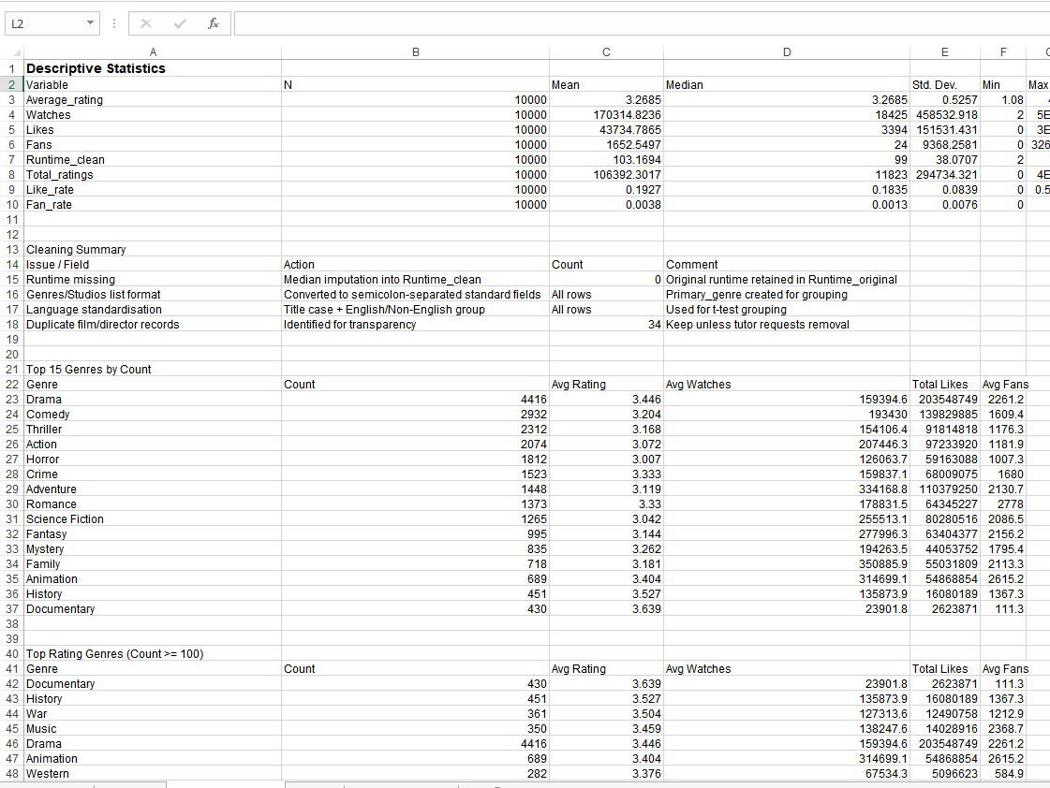
Table 1: Descriptive statistics for key numerical variables.

3.2 Categorical variables
The categorical summaries indicated that Drama was the biggest primary genre with 2,232 films, Comedy with 1,423 films, Horror with 867 films and Thriller with 802 films. The spread of this genre is beneficial to business intelligence, as it can compare the performance of films by the categories of the audience and not only on the level of the dataset. The use of data visualisation is especially significant in the BI since charts enable decision-makers to discover the patterns that would be less apparent in the raw tables (Attar-Khorasani and Chalmeta, 2024). The original language was English, with 8,074 films, while Italian, Japanese and French being the other dominant language groups. But increased volume did not necessarily result in increased rating. For example, the average rating in both Japanese and French movies was 3.60, compared to English-language movies with 3.21. This implies that audience appreciation and audience volume might work in different ways hence either the latter trend and SPSS sections look at rating quality and popularity of engagement. This kind of analysis helps to make evidence-based decisions since BI is the most useful when the results of descriptive analysis are related to practical business perception (Ragazou et al., 2023).
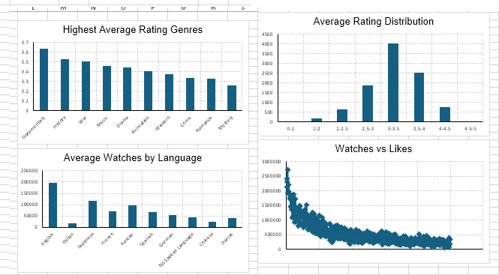
Figure 2: Chart ratings

4. Trend Analysis and Visualisation

4.1 Genre and language trends
Trend analysis was conducted on ratings, watches and engagement patterns by genre and by language. This complements business intelligence since visual comparisons assist organisations to detect audience segments and can make quicker decisions using extensive datasets (Attar-Khorasani and Chalmeta, 2024). The analysis of genres reveals that certain smaller or more specific genres have higher average ratings, and Drama, Comedy and Action took the lead in the dataset in terms of numbers (LCBB5014 Module Team, 2026). In the case of media businesses, recommendation systems must then not just drive-up common genres, but such categories that correlate with higher viewer satisfaction. The importance of movie recommender is that they assist users in navigating vast collections of content and locating movies that suit them (Jayalakshmi et al., 2022).
Audience behaviour can also be found through language trends. The greatest number was English-language films, whereas a larger mean average rating was observed in the cleaned analysis of non-English films (LCBB5014 Module Team, 2026). This can imply that there is a higher quality perception of non-English films, but unequal groups of participants imply that the outcome should be considered closely. Empirical studies indicate that language, geography and platform visibility, i.e. non-English content can be successful when the accessibility is lowered by the presence of subtitles and discovery mechanisms (Ribke and Wayne, 2025).
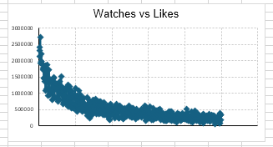

4.2 Popularity and engagement patterns
The variables of engagement demonstrate that popularity is not evenly spread through the films. Watches, likes and fans are concentrated over fewer films that are more visible, which implies that the audience attention is not distributed equally on the catalogue (LCBB5014 Module Team, 2026). This is important to BI as customer behaviour analytics can assist organisations to predict preferences and prioritise content, promotion and recommendation strategies (GhorbanTanhaei et al., 2024). The positive relationship between watches and likes is evident in the scatter plot as the films that have more watches tend to have more likes (LCBB5014 Module Team, 2026). However, it does not imply that watches make likes.
This trend is practical to film and entertainment organisations. When likes are growing with the number of watches, likes may become a kind of engagement indicator in the evaluation of the film visibility, the viewers satisfaction, and the effectiveness of promotion. As Ofcom demonstrates, UK viewers are becoming more and more involved with screen content on various platforms, which is why audience data is significant to comprehend the viewing behaviour and competition (Ofcom, 2024). The BFI also emphasizes the economic role of film and high-end television and justifies the necessity of the data-based content planning and targeting (British Film Institute, 2025).

5. Statistical Analysis using SPSS

5.1 Independent samples t-test
Independent samples t-test was used to test the differences in the average ratings between English and non-English movies. This test was appropriate since it would be comparing a continuous variable between two independent groups. The mean rating of English-language films was 3.21 and the mean rating of non-English films was higher at 3.51 (LCBB5014 Module Team, 2026). Welch t-test was significant t = -24.88, p < -.001, indicating that there was a significant difference between the two groups. The outcome must be viewed with caution since the English group was significantly bigger, where 8,074 films were matched with 1,926 non-English films (LCBB5014 Module Team, 2026).

5.2 Correlation analysis
Correlation analysis was done to identify whether the variables of engagement were moving together. Predictive analytics assists organisations to understand past trends and make predictions based on preferences of the audience (GhorbanTanhaei et al., 2024). Watch and likes had the highest correlation with Pearson's r = 0.95, having a very strong positive correlation (LCBB5014 Module Team, 2026). There were also strong positive relationships between fans and likes, r = 0.80 and weak relationships between runtime and watches, r = 0.15, and fans, r = 0.09 (LCBB5014 Module Team, 2026). It implies that likes are directly related to popularity, whereas runtime is not a powerful engagement metric.

5.3 Regression analysis
Regression analysis was conducted to determine which of engagement and film characteristics predicted average rating. BI and analytics have the potential to enhance the performance of managers because organisations can utilise data models to aid a decision and not just intuition (Hurbean et al., 2025). The model comprised of the log-transformed watches, likes and fans and combined these with runtime to forecast average rating. It described 67.4% of rating difference, R²= 0.674, which means that it has a high power to explain this dataset (LCBB5014 Module Team, 2026). The coefficients of likes, fans and runtime were positive and the coefficient of watches was negative in the combined model. It implies that the quality of engagement could be crucial, rather than just the volume.
Streaming research indicates that visibility contributes to shape popularity, geography and audience discovery systems, aside from content quality (Wayne and Ribke, 2024). Therefore, the regression should only be considered as evidence of decision support as opposed to being a statement of causality.

6. Insights and Recommendations

6.1 Key insights
As the analysis reveals, film popularity and film quality must be considered linked yet distinct BI measures. There was a very high relationship between watches and likes, indicating that popular films tend to generate more active interactions, though not average rating was attributed to popularity (LCBB5014 Module Team, 2026). The fact that the mean rating was higher in case of non-English films also indicates that language diversity can facilitate the satisfaction of the audience, and they can find appropriate content. This is important since descriptive patterns, statistical testing, and the audience context of data prove more effective in creating data-driven decisions than a single metric (Haque Sazu and Akter Jahan, 2022).

6.2 Recommendations and limitations
BI dashboards should be applied by film and entertainment organisations to track ratings, watches, likes, fans, language and genre altogether. Issues that have a high average rating would be more actively promoted, although they have fewer issues, which could enhance the satisfaction of the audience and catalogue discovery.
There should also be subtitles and more explicit sorting and recommendations of the non-English films since an access to a language and a presence on the platform is what determines global streaming viewers (Wayne and Ribke, 2024). The results are constrained by the fact that the dataset does not cover marketing expenditure, release date, platform positioning or the demographics of the viewer. These variables should be included in future analysis to enhance predictive accuracy and relevance to business.

7. Conclusion
In conclusion, Excel and SPSS were applied in cleaning, summarising and analysing the Letterbox Movie Classification Dataset in this report. The results indicate that watches, likes and fans are significant engagement factors, and average rating represents another dimension of quality. Films not in English had higher average ratings, and regression indicated that the variables of engagement can be used to explain the variance in rating. Overall, when the limitations of data usage are identified, BI analysis can help to promote films better, to recommend and make decisions based on the audience.

References
Alam, S., Ayub, M.S., Arora, S. and Khan, M.A. (2023) ‘An investigation of the imputation techniques for missing values in ordinal data enhancing clustering and classification analysis validity’, Decision Analytics Journal, 9, 100341. https://doi.org/10.1016/j.dajour.2023.100341

Attar-Khorasani, S. and Chalmeta, R. (2024) ‘Internet of Things data visualization for business intelligence’, Big Data, 12(6), pp. 478–503. https://doi.org/10.1089/big.2021.0200

British Film Institute (2025) Official BFI statistics for 2024 reveal £5.6 billion film and high-end television production spend in the UK. London: British Film Institute. Available at: https://www.bfi.org.uk/news/official-bfi-statistics-2024

Fu, Q., Nicholson, G.L. and Easton, J.M. (2024) ‘Understanding data quality in a data-driven industry context: Insights from the fundamentals’, Journal of Industrial Information Integration, 42, 100729. https://doi.org/10.1016/j.jii.2024.100729

GhorbanTanhaei, H., Boozary, P., Sheykhan, S., Rabiee, M., Rahmani, F. and Hosseini, I. (2024) ‘Predictive analytics in customer behavior: Anticipating trends and preferences’, Results in Control and Optimization, 17, 100462. https://doi.org/10.1016/j.rico.2024.100462

Haque Sazu, M. and Akter Jahan, S. (2022) ‘Can big data analytics improve the quality of decision-making in businesses?’, Iberoamerican Business Journal, 6(1), pp. 4–27. https://doi.org/10.22451/5817.ibj2022.vol6.1.11063

Hurbean, L., Militaru, F., Munteanu, V.P., Danaiata, D., Fotache, D. and Muntean, M. (2025) ‘Assessing the influence of business intelligence and analytics and data-driven culture on managerial performance: Evidence from Romania’, Systems, 13(1), 2. https://doi.org/10.3390/systems13010002

Jayalakshmi, S., Ganesh, N., Čep, R. and Senthil Murugan, J. (2022) ‘Movie recommender systems: Concepts, methods, challenges, and future directions’, Sensors, 22(13), 4904. https://doi.org/10.3390/s22134904

LCBB5014 Module Team (2026) Data Sheet – C2: Letterbox Movie Classification Dataset. London: London College of Business / Module Data Sheet.

Ofcom (2024) Media Nations 2024: UK. London: Ofcom. Available at: https://www.ofcom.org.uk/media-use-and-attitudes/media-habits-adults/media-nations-2024

Ragazou, K., Passas, I., Garefalakis, A. and Zopounidis, C. (2023) ‘Business intelligence model empowering SMEs to make better decisions and enhance their competitive advantage’, Discover Analytics, 1, 2. https://doi.org/10.1007/s44257-022-00002-3

Ribke, N. and Wayne, M.L. (2025) ‘Deconstructing streaming global audiences: Netflix’s global top 10 as a geo-political, economic, sociolinguistic construct’, The Communication Review, 29(1), pp. 1–21. https://doi.org/10.1080/10714421.2024.2442207

Wayne, M.L. and Ribke, N. (2024) ‘Loved everywhere? Netflix’s top 10 and the popularity of geographically diverse content’, Convergence: The International Journal of Research into New Media Technologies, 30(4), pp. 1348–1364. https://doi.org/10.1177/13548565241265504

