

Postgraduate/Distance Learning
Assignment coversheet & feedback form

THIS SHEET MUST BE THE FIRST PAGE OF THE ASSIGNMENT YOU ARE SUBMITTING (DO NOT SEND AS A SEPARATE FILE)

For completion by the student:
Student Name: Cheryl Abraham

Student University Email: 2510780@student.uwtsd.ac.uk
Module code: HPCA7016  Module title: Research in Contemporary Cosmologies | Student ID number:  2510780 |  |  | Educational support needs:
Assignment title: Research Project in Contemporary Cosmologies

Assignment due date: 30/04/2026
This assignment is for the 1st 2nd 3rd 4th 5th 6th module of the degree
Plagiarism declaration
I confirm that this is my original work and that I have adhered to the University policy on plagiarism.

Artificial Intelligence (AI) declaration

I confirm that I have not used any AI tools in the research and creation of this assignment. I confirm that I have not presented any AI generated materials as my own work. I confirm I have copies of my drafts, notes, and other resources I used, which I may be asked to provide in evidence.

Signed: Cheryl Abraham
Date: 30/04/2026

Assignment Mark
1st Marker’s Provisional mark
2nd Marker’s/Moderator’s provisional mark
External Examiner’s mark (if relevant)
Final Mark

NB. All marks are provisional until confirmed by the Final Examination Board.

For completion by Marker 1 :
Comments:

Marker’s signature: |  |  | Date:
For completion by Marker 2/Moderator:

Comments:

Marker’s Signature: |  | Date:
External Examiner’s comments (if relevant)

Research Project in Contemporary Cosmology
Cheryl Abraham, 2510780
Word count: 5233.

- Introduction
This essay explores the personal cosmologies of individuals who report out-of-body experiences (OBEs), also described as astral travel or projection. While some participants use these terms interchangeably, others distinguish between them. Here, “out-of-body experience” is used as the main term for clarity, while terms such as “astral travel” are retained where they reflect participants’ own language. OBEs generally refer to experiences in which individuals perceive themselves as separate from their physical body, often observing it from an external perspective.
The focus lies on how these individuals describe and interpret their experiences, and how such interpretations are integrated into broader understandings of reality and consciousness, through which personal cosmologies are formed. The central research question guiding this study is: How do contemporary astral travellers describe and interpret their experiences, and what kind of personal cosmology emerges from these accounts? By “personal cosmology,” this essay includes Campion’s interpretation of “a meaning-system,” linked to spiritual or religious views, but extends this to include the ways individuals construct frameworks about the nature of the self, the structure of reality, and the relationship between mind, body, and non-physical realms.
As noted by Asprem in 2017, “astral travel is one of the most influential experiential categories that emerged from the late-nineteenth century occult revival,” and situates it within esoteric traditions. More recent work addressed the experiential dimensions of such phenomena. For example, Jack Hunter’s edited volume The Deep Weird (2023) includes Samantha Treasure’s chapter “Out-of-Body Experiences in the Screen Age,” which explores how contemporary practitioners describe and engage with these experiences. However, less attention has been given to how individuals themselves interpret these experiences in ways that contribute to the personal cosmologies or worldviews. This study addresses that gap through qualitative fieldwork.
The data consists of five semi-structured interviews with individuals who have the conscious, deliberate, and repetitive experience of practice-based out-of-body experiences. These accounts provide insight into their experiences, interpretations and their personal cosmologies that emerge from lived experience.

- Reflexivity
According to Haynes, reflexivity involves being aware of the researcher’s role in shaping both the research process and its outcomes. My interest in the topic began in my teenage years, when I encountered accounts from three individuals who described similar OBEs. What stood out was not only the consistency in their descriptions of leaving the body and observing it from above, but also the presence of a guiding figure. At the same time, one of these individuals did not interpret the experience in spiritual terms, which contradicted my own assumptions, and led me to question how such experiences are evoked and understood.
Years later, I had a brief OBE myself while under the influence of psychedelics. Although short-lived, this reinforced my curiosity. Additionally, my academic background is in religious studies, which places me in a position that is neither fully external nor internal to the subject. As King notes, scholars of religion occupy different points on a spectrum between emic and etic perspectives. While I am not an experienced practitioner, my personal engagement informs both my interest and my sensitivity to participants’ accounts , and my academic training creates a degree of distance from truth claims.
This may incline me to take participants’ accounts seriously and seek to understand their experiences rather than question them, which I remained aware of during analysis. I recognise that the analysis is shaped through both their accounts and my own interpretation.

- Methodology
This study adopts a qualitative, exploratory design and is informed by a phenomenological approach. The focus is on participants’ lived experiences and the meanings they attach to them. The analysis therefore focuses mainly on participants’ accounts, while literature is used to provide a conceptual framework.
  - Data collection
A short online survey was distributed within online astral projection communities to gather initial insights into how individuals describe and interpret their experiences. In total, six responses were collected, of which three were also interview participants. The survey consisted of 12 questions, combining both open-ended and closed formats. It served to identify participants and highlight recurring themes. The focus is primarily on the interviews, while the survey data (see Appendix 2) is only referred to briefly in the analysis.
Five semi-structured interviews, guided by a set of open-ended questions (see Appendix 1), were conducted with individuals recruited through purposive sampling within online astral projection communities, primarily via a Reddit page and its associated Discord channel. The study focused on individuals with repeated and intentional experiences, excluding those with only limited, spontaneous or substance induced experiences, as well as individuals under the age of 18. Four of the five participants were identified through responses to a Discord post outlining these criteria and were approached directly. The fifth participant was recruited through direct contact via her own astral travel organisation. All participants were based in the United States, aged between 23 and 61, including three men and two women.
The interviews were conducted online via Discord or Zoom, allowing for a flexible format in which participants could describe their experiences and views in their own terms. Interviews were recorded and transcribed for analysis. Interviews lasted approximately 40-60 minutes.
  - Analytical approach
The collected data was analysed thematically, with attention to patterns across four aspects: the description of the experience itself, encounters with entities, the interpretation of its meaning, and the ways in which these interpretations contribute to broader cosmologies. These aspects were identified through the analysis and correspond to the main themes that emerged across participants’ accounts. Due to the small sample size and qualitative nature of the study, the findings are not intended to be generalisable but to provide in-depth insight into participants’ experiences.
  - Ethical considerations
All participants took part voluntarily, were provided with a Participant Information Sheet, and gave informed consent prior to participation. They were informed about the purpose of the study, had the possibility to withdraw at any time, and were free to decline to answer any questions. Anonymity has been maintained, and identifying details have been removed. Given the personal and sometimes sensitive nature of these experiences, care has been taken to represent participants’ accounts respectfully. The data has been stored securely throughout the research process on offline, password-protected hardware.

- Literature review
One of the most influential first-person accounts of OBEs is Robert Monroe’s Journeys Out of the Body. In this work, Monroe describes a series of spontaneous and later intentional OBEs. He develops a detailed account of non-physical environments and interactions. His work has been widely circulated within contemporary astral projection communities and has contributed to shaping how such experiences are understood and described.
To conceptualise astral travel as an experience, this study draws on Ann Taves’s approach, which focuses not on defining “experience” in general, but on examining the kind of experience under study. The analysis therefore relies on participants’ descriptions of their experiences, while also interpreting these accounts in relation to the research questions.
To then understand how such experiences are produced and interpreted, this study draws on Luhrmann’s concept of interpretive drift. Luhrmann describes this as a gradual and often unacknowledged shift in how individuals interpret events as they become increasingly engaged in a particular practice. This leads them to perceive and respond to experiences in new ways. This concept is particularly relevant for understanding how repeated engagement with astral practices may shape the interpretation of subjective experiences and contribute to the development of personal cosmologies.
Asprem develops this further through his discussion of kataphatic practices, understood as techniques that involve the deliberate use of imagination, visualisation, and sensory focus. He argues that such practices do not only produce a “drift of interpretations,” but may also involve the “rebuilding of the practitioner’s experiential world.” Through specific techniques, practitioners learn to pay attention to mental imagery and bodily sensations in ways that can result in “entirely novel kinds of experience.” From this perspective, astral travel is not simply a spontaneous event, but shaped through techniques, expectations, and repeated practice.
To further situate the notion of personal cosmologies, Mathews’ work is briefly drawn on to emphasise that such cosmologies are shaped by broader social and environmental contexts.

- Analysis
  - The experience
Participants commonly describe the onset of the experience as marked by distinct bodily sensations and shifts in awareness. These include tingling or vibrating sensations, changes in auditory perception, and a detachment from the physical body. This process is deliberately induced through techniques such as relaxation and focused attention, while in others it emerges more spontaneously.
Nihal (25), who began practicing OBEs deliberately after first encountering the concept online, describes his first experience as:
“In the middle of the night I felt a tingling sensation spreading through my body, starting at my toes and moving up to my forehead. I thought it might be the vibrational state people talk about after projection, so I focused on it. The sensation intensified, and a faint ringing turned into a loud noise, like being between two jet engines. When the noise stopped, I knew it was time for the separation movement.”
Similarly, Anna (39), who was introduced to lucid dreaming at a young age by her mother and began experiencing OBEs at the age of 14, describes initiating the experience through a process of relaxation and shifting awareness:
“I relax and shift my awareness to what some call an etheric or energy body. Once I feel sufficiently detached, I visualize rolling out of my physical body and standing up in the astral space. The surroundings usually resemble the waking world, allowing me to explore, fly, and interact with any characters or entities present.”
Anna also reflects on how she distinguishes between different types of experiences, particularly between out-of-body experiences and lucid dreams. She explains:
“I would have to go directly from my waking consciousness into the out-of-body experience with no interruption and consciousness in between and the sensation of the separation alongside that so that that's what I would call a true out-of-body experience however I do personally think that astral projection or astral travel can be possible in other altered states of consciousness that would include dreams or lucid dreams.”
A central feature in these accounts is a distinct moment of separation, in which awareness is experienced as leaving the physical body. This is often described as a deliberate movement, such as sitting up or rolling out, followed by the perception of the body from an external perspective. Nihal explains:
“I sat up, opened my eyes, and found myself looking at my own body sleeping in the bed. Seeing myself in the third person was certainly a bit of a strange feeling. The movement felt like I was really clumsy, but my vision wasn’t bobbing around and falling. I was still moving straight. It felt clumsy, like I was walking for the first time.”
While Nihal deliberately induced the experience, Ravi (38) began having these experiences at random moments in his childhood, he describes an near-death-experience following an asthma attack. “I was so tired of struggling that I stopped breathing and then I could see myself I could see my little child self just standing there looking up at me and I'm looking down I'm not breathing.” Afterwards, he started having OBEs spontaneously and did not understand what was happening.
“As an adult I began reading about astral travel online. I saw people describing experiences that sounded like what I’d felt, but I wasn’t sure. The only way to check was to follow the techniques they recommend and try to induce it deliberately.”
Joshua’s (23) experiences also started in childhood. Around the age of 17 he had his first OBE. Below is one of his experiences in detail:
“I flew out of my house, aimed for the Sun, and after leaving Earth’s atmosphere I was pulled toward something unknown. I kept going, passing stars, until I reached what seemed like the edge of the universe, a black void that rippled like water. There I met someone who gave me a ball of energy. As soon as I touched it, a flood of information poured into me, images about the brain that I couldn’t comprehend. It was overwhelming, like a bright light turned into a torrent of data. I immediately said, “I can’t take it,” and returned to my body.”
Participants describe moving through environments that often resemble the physical world, but can also extend into more expansive and unfamiliar spaces. Maya (61), who has spent many years studying and writing about out-of-body experiences, had her first experience at the age of 9, but started having OBEs regularly at the age of 22. She suggests that the experience can involve a wide range of different environments, extending beyond a single, fixed space, these spaces are not empty but inhabit many different entities.

  - Encountering entities
Encounters with entities form a central aspect of the experiences and range from guiding figures to ambiguous or even threatening presences. Several participants describe recurring, relational entities that take on instructive roles. For instance, Ravi states that:
“When I was with a specific person – a figure I later named Toby – I would have more vivid episodes. Toby appears like a guardian-angel figure; his form changes, and we communicate without words, just by understanding each other.”
Anna describes many of the entities as family, but also recounts a more uncontrolled experience of being “pulled out of body” by an entity that initiated a physically painful kundalini process. In this account, the kundalini process is described as an externally initiated activation of energy moving through the body’s chakras, experienced as intensely painful and occurring outside the individual’s control, and framed as part of a longer process of energetic development.
Nihal describes a negative encounter with “shadowy figures” that evoke “a very instinctual… primal fear,” though these are sometimes interpreted as possible “subconscious manifestations” rather than autonomous beings.
Maya’s account presents a more structured understanding of entities. She describes interactions with “spiritual teachers, masters, [and] guardian angels” who guide the experience through different stages of spiritual development and self-understanding. Her early experiences already involved such entities, including the presence of “three angels on either side,” which she links to intentional practices such as prayer. At the same time, Maya emphasises the importance of discernment. She explains that the astral plane contains a wide range of entities, including “wandering spirits,” “ghosts,” and potentially “demonic spirits.” In this sense, encounters are not only relational but also require discernment, as the experiencer must distinguish between different types of entities and their intentions.
Joshua explains that during periods of “a very low, negative state of mind,” he finds himself in a “low astral realm” populated by “bad entities that can attack you,” although he emphasises that they do not actually harm him. He links their presence to his own internal state, saying that “when you’re in that negative mindset… you attract entities that feed off that negativity.” This suggests that entities are not experienced as completely separate, but are somehow connected to the experiencer’s emotional state. At the same time, these entities are said to influence behaviour in everyday life and can “set you up for failure,” which blurs the distinction between internal or external. Encounters with entities seem to reflect aspects of the self, but also feel like something outside of it.
Across accounts, entities are not understood in the same way, but they are consistently described as distinct presences. They may appear as guiding or protective figures, as negative or even “demonic” presences that feed on energy, as familiar figures such as family members, or as projections shaped by the experiencer’s own mind. In some cases, they also act on the experiencer, for instance by initiating or influencing the experience itself.

  - Interpreting the experience
While the previous sections focused on the experience itself, participants differ in how they interpret these events. Some have clear ideas about what these experiences mean, while others are less certain and keep their interpretations open.
Maya describes how, over time, she began to recognise patterns in her experiences, noting that “I started writing them down in a journal and noticed a pattern developing – a progression that took time to recognize. It required a lot of research and patience.” She explains:
“Over time, the journals showed a clear path of how the experiences unfolded – not only the mechanics, such as what I saw, heard, and how I learned to move through objects and the astral plane, but also a spiritual unfolding I call the “path of purification.”
In this framework, OBEs are not experienced as isolated events, but as part of a longer process of spiritual development, where the individual is guided through different stages and confronted with aspects of themselves that require transformation. The experiences are therefore understood as having meaning and purpose, and as forming part of a broader trajectory that may extend across lifetimes.
Nihal’s interpretation of his OBEs is shaped by his first successful experience, which he describes as very impactful. Initially, he approached the phenomenon from a more scientific and logical perspective, assuming it could be explained within “typical science parameters.” However, this view shifted after his first experience, which occurred following an intense emotional moment in which he told his parents he did not want to continue his studies. He understands this as the removal of an emotional block. As he explains: “I had been trying the exact methods that everyone else was telling me […] and I was getting nowhere and it wasn't until I had this very intense emotional experience…”
This leads him to reconsider his earlier view, suggesting that psychological states may play an important role in enabling OBEs. At the same time, he does not reject a scientific explanation. He suggests that the experience might still be explainable, but that he “doesn’t have the words” for it yet. This keeps his interpretation open.
Nihal’s account differs from Maya’s more structured framework. Rather than organising his experiences into an elaborate system of meaning, he appears to be in an ongoing process of interpretation, moving between different explanatory models.
A similar emphasis on inner states can be seen across participants. While Nihal describes the removal of an “emotional block” as enabling his first experience, Joshua argues that emotional control is necessary for maintaining a positive projection:
“You have to control your emotions. If you want a good astral projection, don’t be so negative. If you focus on things that don’t matter, that negativity will spill over into your projections. Not only will you suffer in your life, but you will also suffer in your astral experiences.”
Maya’s notion of a “path of purification” places self-transformation at the center of the experience. Taken together, these accounts suggest that OBEs are not understood as random events, but closely linked to the individual’s inner state. Emotional, psychological, and moral conditions are seen as shaping both the occurrence and the quality of the experience.
Anna suggests that these experiences “are subjective and defined by how you perceive them,” and deliberately keeps her interpretation open. Ravi takes a similar approach, resisting fixed explanation and instead allowing for multiple frameworks at once. As he puts it, he tries “not to put like a definitive” interpretation on the experience, suggesting that “maybe it all can be true.”
This openness is also reflected in how he explains the environments he encounters. For instance, after describing a visit to the moon populated by beings, he does not conclude that this is literally the physical moon, but proposes that it could be a different “dimension” or “version” of reality that is normally not perceptible. At the same time, he acknowledges uncertainty about his own interpretations, noting that he sometimes questions whether the experiences are “just in [his] head.” Overall, Ravi’s account is characterised by flexibility and ambiguity, as he moves between different explanatory models without settling on a single, coherent system.
Participants also differ in how they understand the reality of these experiences. While some describe them as coherent and therefore real, others remain uncertain, suggesting that they may be shaped by the mind or involve a different “dimension” of reality. Rather than settling on a single explanation, participants often move between these possibilities.
A similar ambiguity can be seen in how the astral realm is defined. In the survey, all six survey participants gave different answers to the question of what the astral realm is, describing it as a real place, an umbrella term for different dimensions, more real than physical space, a combination of extrasensory data and subconscious influence, something that can include the mind, or something else entirely. Notably, none of the survey participants selected the options “mental or psychological space” or “spiritual dimension.”
This suggests that survey participants do not adopt fixed or conventional categories, but instead draw on multiple and sometimes overlapping ways of understanding the experience. While some participants, such as Maya, develop more stable and coherent frameworks, others leave the nature of the astral realm open and unresolved.

  - Constructing cosmologies
Cosmology, in its broadest sense, refers to how individuals understand the structure, origin, and meaning of reality. Rather than being fixed or abstract systems, cosmologies are actively constructed through experience and interpretation. As noted by Matthews, cosmologies do not exist in a vacuum, “they are conditioned by many and various historical, environmental, technological, psychological and social factors.” In the case of astral travellers, these cosmologies emerge through a continuous interaction between prior worldviews, their lived experiences of OBEs and those of others with either OBEs or near-death experiences. These both challenge and reshape assumptions about reality.
A first important pattern is the reconfiguration of religious or spiritual backgrounds. Several participants were raised within Christianity but moved away from it over time. Anna describes being raised Methodist and initially holding on to this framework, but eventually abandoning it when it failed to support her during the kundalini experiences. After exploring pagan and Buddhist worldviews, she adopts a more nuanced position: “I don’t really have a belief system; I just have a set of experiences.” Her cosmology remains open-ended, what she can say for sure is that there are “layers of reality” inhabited by different kinds of entities.
In contrast, Maya’s experiences lead her toward a more structured framework, and a conversion to Catholicism. However, even here, traditional doctrine is reinterpreted through experiential knowledge, for instance by incorporating reincarnation and karma into her framework.
A shared patterns across participants is the belief in reincarnation or life after death. Monroe mentioned that “any acknowledgment of the existence of the Second Body immediately demands the question mankind has pondered since the day he leaned to think: Do we live on? Is there life beyond the grave?” Participants frequently interpret their abilities and experiences as extending across multiple lifetimes. Joshua explicitly frames astral projection as a skill developed over previous incarnations, suggesting a model of spiritual progression: practices undertaken in one life carry over into the next. This idea is echoed in Maya’s account, where repeated lifetimes form part of a longer “path of purification,” and in Ravi’s reflections, where astral experiences alleviate existential fear. He mentioned that: “I didn’t really understand why, but I’m in kindergarten and I’m worried I’m going to die tomorrow. But once I started to have those experiences, I don’t have that existential dread anymore or the fear of dying.” Anna adds “that the energy body lives on and reincarnates into suitable vessels and that those vessels can hold consciousness but I don't think that after death most memories persist because if you enter into another physical vessel you lose that and we know that because none of us almost none of us have any kind of memory of any kind of past life.”
Nihal mentioned that:
“The way I think about death has certainly changed before that I identified as agnostic I was like who really knows when you die it's probably just lights out you stop thinking, but now I'm relatively confident that we have some type of soul that endures past the death of our physical body and that it goes on to one of these dimensions and that maybe it you know reincarnates on earth at some time so that's definitely something that I’ve been led to believe through my experiences.”
Nihal initially identified with an atheist worldview, later agnostic, but then his experiences made him more receptive to spiritual worldviews. This suggests a gradual shift in how he interprets these experiences, which can be related to what Luhrmann describes as the interpretive drift. However, as Asprem argues this shift is not only interpretive, deliberate techniques shape the experience itself, as practitioners learn to attend to internal sensations and imagery in new ways.
A second shared element concerns the structure of reality itself. Many participants describe a layered or multidimensional cosmos. These layers are not always clearly defined, but they are often understood as different realms with distinct properties. For some, such as Anna, these realms follow consistent rules akin to physical laws, suggesting an ordered but not yet fully understood system. Others, like Ravi, emphasise the coexistence of multiple dimensions, and the possibility of transitioning from 3D to 4D. At the same time, while participants generally agree that these experiences follow certain patterns and suggest an underlying structure, they often express uncertainty about how to define it.
Another important aspect of participants’ cosmologies concerns how they understand the relationship between the body, soul, and consciousness. Several participants describe consciousness as something that is not limited to the physical body. For instance, Joshua suggests that the soul originates from outside the universe, while the body has its own form of mind, including the ego and other impulses. In his view, the self is not a single unified entity but a kind of interaction between body and soul. Similarly, Anna uses a more technical analogy to explain this relationship, comparing the body to a computer, memories to a hard drive, and the soul or “energy body” to electricity. In this model, consciousness can continue to exist even if the physical body ceases to function, although memory may not fully transfer. These kinds of explanations show that participants often move away from purely materialist understandings of the self and instead develop models in which consciousness can exist independently of the body.
Closely related to this is the role of consciousness in shaping reality. Several participants suggest that the astral environment is at least partially constructed or influenced by the mind. Ravi and Anna describe the possibility of creating environments or objects, or encountering spaces generated by collective or individual consciousness. Similarly, Nihal interpret certain encounters with entities as filtered through human perception, meaning that their appearance may not reflect their actual form. This introduces a reflexive dimension to their cosmologies: reality is not simply discovered but co-created.
These ideas are not only theoretical but can also translate into practice. For example, Ravi describes having negative experiences with entities in the astral realm and wanting them to stop. In response, he performed a ritual known as the lesser banishing pentagram, “invoking all the angels and the names of God to banish everything. After that, I didn’t have any out-of-body experiences for a while.” This suggests that astral experiences can lead participants to adopt ritual practices, which in turn reinforce a worldview in which such rituals are understood to be effective.
Another recurring theme is the idea of purpose or direction. While not all participants articulate a clear teleology, many express a sense that human life is oriented toward something beyond ordinary experience. For some, this takes the form of spiritual growth or moral refinement, as seen in Maya’s “path of purification.” For Joshua, however, it is less about progression and more about origin, as he describes astral projection as a way of understanding “the source of where I come from.”
All six survey participants indicated that their experiences influenced their understanding of the nature of reality. Five reported changes in their views on death and the afterlife, four in their spirituality, and three in their sense of life purpose. However, one participant noted that their worldview was shaped more strongly by exposure to others’ accounts of near-death experiences and astral projection than by their own experiences. This suggests that cosmologies are shaped not only through direct experience, but also through engagement with existing narratives and communities surrounding these practices.
However, participants’ cosmologies remain strongly shaped by their own experiences. Rather than following a single established system, they tend to construct flexible frameworks that combine personal experience with diverse ideas, often remaining open to uncertainty. At the same time, recurring elements such as reincarnation, layered realities, and the importance of consciousness provide a shared basis across accounts.

- Conclusion
This essay set out to examine how contemporary astral travellers describe and interpret their out-of-body experiences, and what kinds of personal cosmologies emerge from these accounts. Drawing on qualitative data from interviews and survey responses, the analysis has shown that while certain experiential features recur, their interpretation varies across participants. Some develop more structured frameworks, in which experiences form part of a broader process of spiritual development, while others keep their interpretations more open ended.
At the same time, a number of shared patterns appear. Participants often describe reality as layered or multidimensional, understand consciousness as not limited to the physical body, and refer to ideas such as reincarnation or continuation after death. These elements suggest that reality is not seen as purely material, but as something more complex.
Importantly, these cosmologies are shaped not only through direct experience, but also through engagement with existing narratives and practices. While participants draw on different influences, their views remain strongly grounded in lived experience and can change over time. Overall, astral experiences seem to play a key role in how individuals rethink their understanding of reality.

Bibliography
Asprem, Egil, ‘Explaining the Esoteric Imagination: Towards a Theory of Kataphatic Practices’, Aries, 17.1 (2017), pp. 1–32.
Campion, Nicholas, Astrology and Cosmology in the World’s Religions (New York and London: New York University Press, 2012).
Haynes, Kathryn, ‘Reflexivity in Qualitative Research’, in Qualitative Organizational Research: Core Methods and Current Challenges, ed. by Catherine Cassell and Gillian Symon (London: SAGE, 2012), pp. 72–89.
King, Richard, ‘The Copernican Turn in the Study of Religion’, Method and Theory in the Study of Religion, 25 (2013), pp. 137–159.
Luhrmann, Tanya M., Persuasions of the Witch’s Craft: Ritual Magic in Contemporary England (Cambridge, MA: Harvard University Press, 1991 [1989]).
Matthews, Freya, The Ecological Self (London: Routledge, 1991).
Monroe, Robert, Journeys Out of the Body (New York: Harmony Books, 1977 [1971]).
Taves, Ann, Religious Experience Reconsidered: A Building-Block Approach to the Study of Religion and Other Special Things (Princeton, NJ: Princeton University Press, 2011 [2009]).
Treasure, Samantha, ‘Out-of-Body Experiences in the Screen Age’, in The Deep Weird: The Varieties of High Strangeness Experience, ed. by Jack Hunter (August Night Press, 2023).

Appendix 1: Interview questions

- Can you tell me how you first became interested in astral travel?
- How would you describe your experience level?
- Do you use specific techniques or practices?
- What does a typical experience look like for you?
- Can you describe one of your experiences in as much detail as possible?
- How do you experience space, time, or movement during it?
- How do you understand the place or state you enter?
- Do you see it as real, symbolic, or something else?
- Do you think it is structured or ordered in some way?
- Has astral travel influenced how you see the universe/world?
- Do you believe the cosmos has a purpose or meaning?
- Do you think there are other beings or entities?
- How do you understand the relationship between body, soul and consciousness?
- How do you personally interpret these experiences?
- Has your understanding changed over time?
- Is there anything important about your experiences that we haven’t discussed?

Appendix 2: Survey data
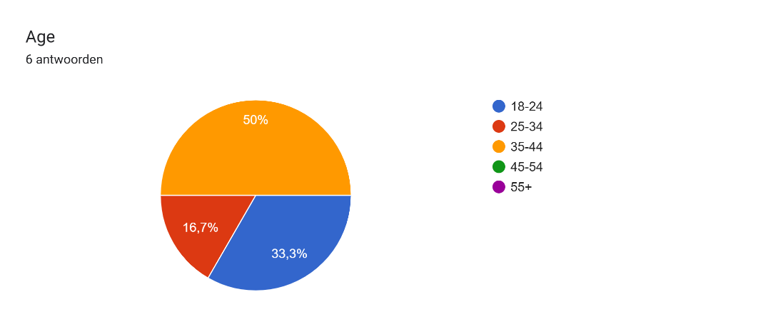
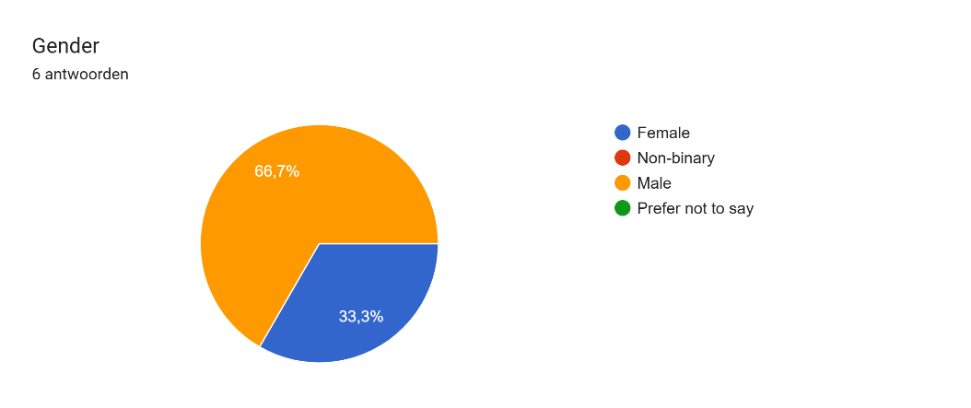
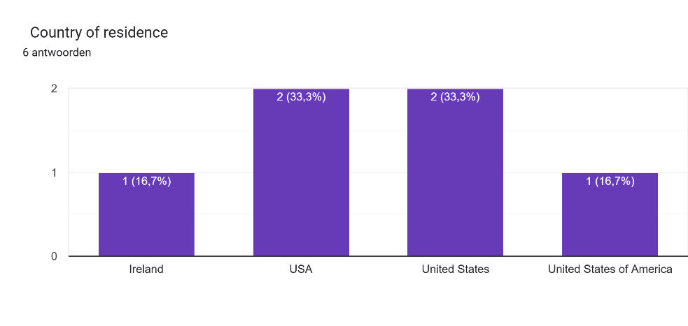
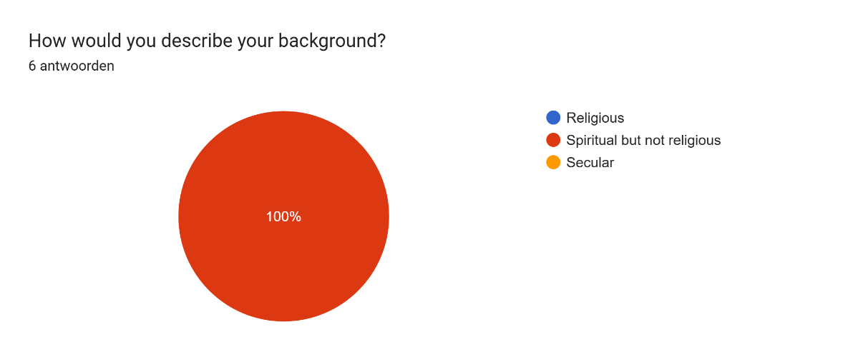
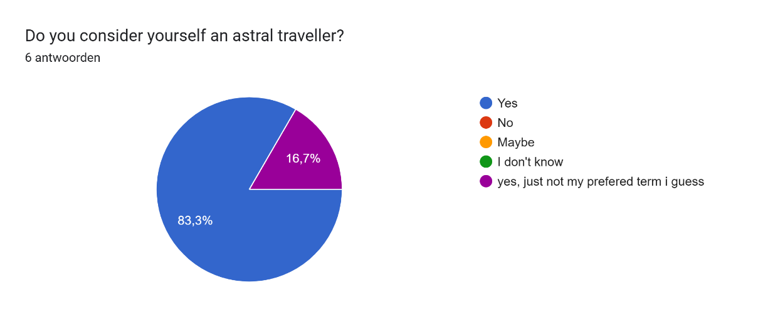
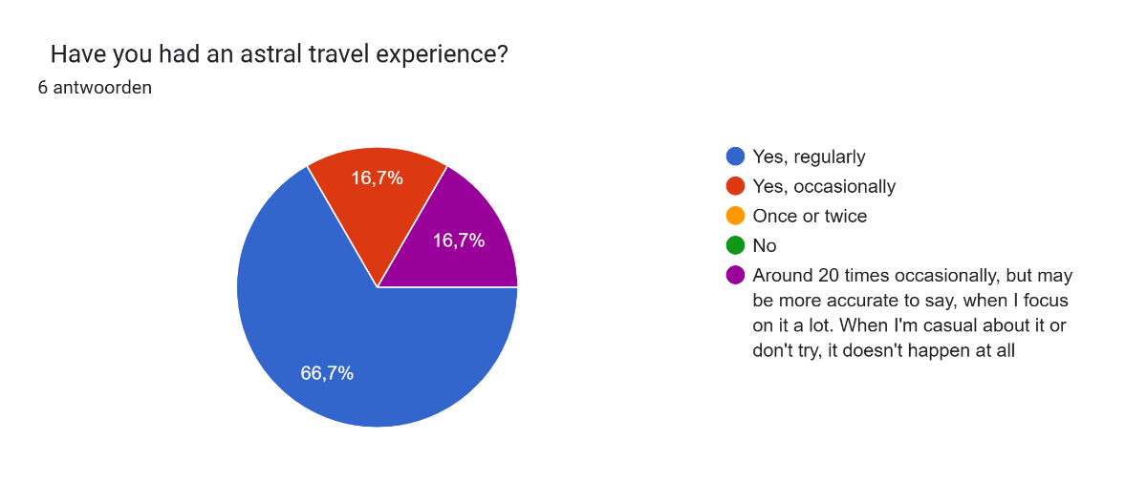
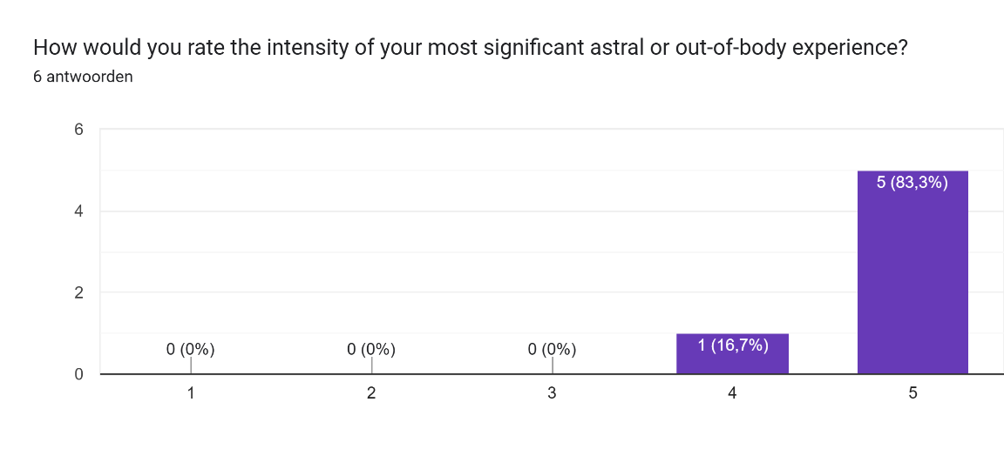
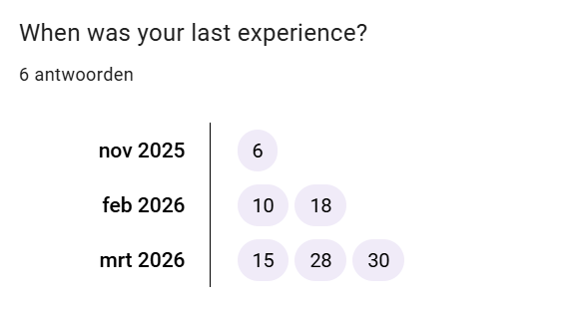
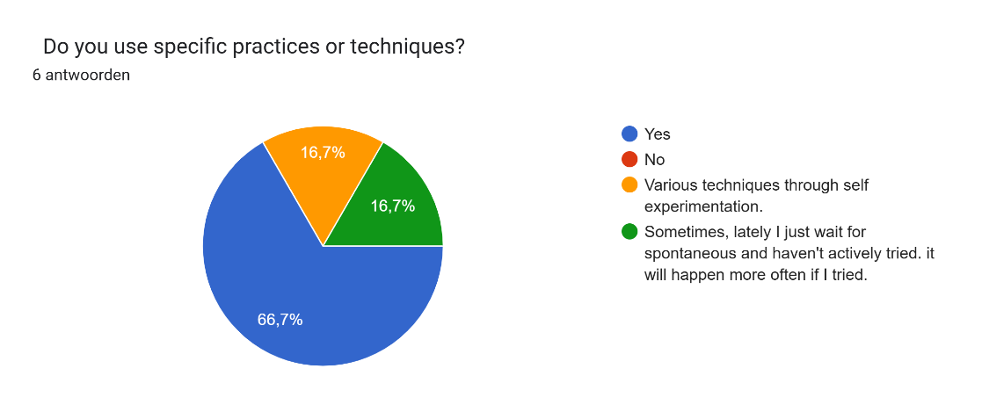
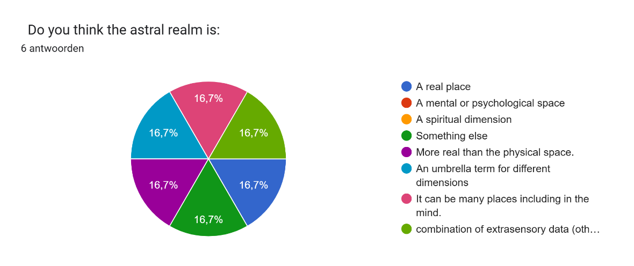
*Combination of extrasensory data (other dimension) and subconscious influence (mental)
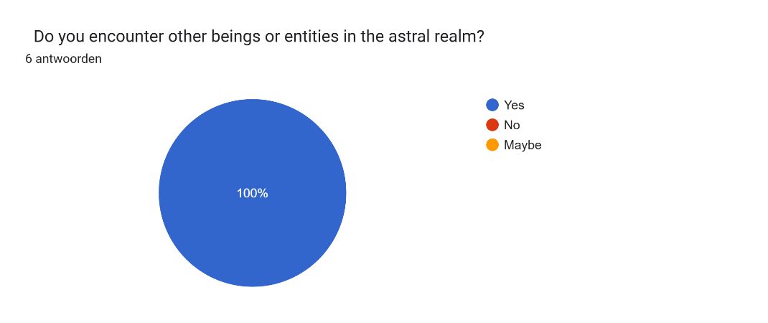
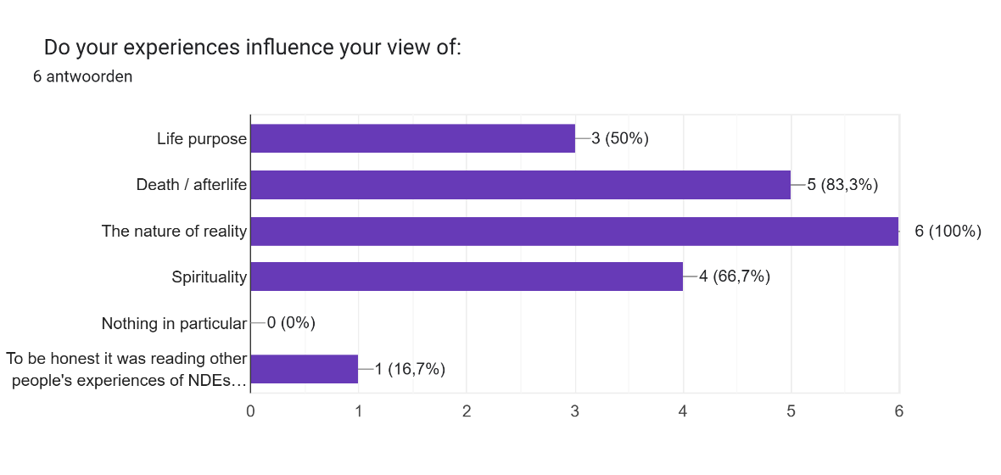
*To be honest it was reading other people’s experiences of NDEs and astral projection that influenced my worldview and purpose the most, which motivated to try myself. But my personal experiences influenced my view of how astral projection works, how to do it, and the practical and scientific challenges associated with it.

Nicholas Campion, Astrology and Cosmology in the World’s Religions (New York: New York University Press, 2012), p.1.
Egil Asprem, ‘Explaining the Esoteric Imagination: Towards a Theory of Kataphatic Practice’ (unpublished manuscript, 2017), pp.17-18.
Samantha Treasure, ‘Out-of-Body Experiences in the Screen Age’, in The Deep Weird: The Varieties of High Strangeness Experience, ed. by Jack Hunter (August Night Press, 2023).
Kathryn Haynes, ‘Reflexivity in Qualitative Research’, in Qualitative Organizational Research: Core Methods and Current Challenges, ed. by Catherine Cassell and Gillian Symon (London: SAGE, 2012), p. 72.
Richard King, ‘The Copernican Turn in the Study of Religion’, Method and Theory in the Study of Religion, 25 (2013), p. 139.
Reddit, ‘r/AstralProjection’, https://www.reddit.com/r/AstralProjection/ [accessed 27 April 2026].
Robert Monroe, Journeys Out of the Body (New York: Harmony Books, 1977 [1971]).
Ann Taves, Religious Experience Reconsidered: A Building-Block Approach to the Study of Religion and Other Special Things (Princeton, NJ: Princeton University Press, 2011 [2009]), p.59.
Tanya M. Luhrmann, Persuasions of the Witch’s Craft: Ritual Magic in Contemporary England (Cambridge, MA: Harvard University Press, 1991 [1989]), pp.307-323.
Asprem, ‘Explaining the Esoteric Imagination,’ p.5.
Freya Matthews, The Ecological Self (London: Routledge, 1991), pp.1-30.
Interview 4.
Interview 1.
Interview 1.
Interview 2.
Interview 3.
Interview 2.
Interview 1.
Interview 4.
Interview 5.
Interview 3.
Interview 5.
Interview 5.
Interview 4.
Interview 3.
Matthews, The Ecological Self, p.5
Interview 1.
Monroe, Journeys Out of the Body, p.101.
Interview 2.
Interview 1.
Interview 4.
Luhrmann, Persuasions of the Witch’s Craft, p.312.
Asprem, ‘Explaining the Esoteric Imagination,’ p.5.
Interview 1.
Interview 1.
Interview 5.
Interview 3.

