Chapter 4 – Findings (2000)

4.1 “Evaluate public perceptions on the ACR in England and Wales.”

4.2 Introduction
The purpose of this chapter is to present the findings from the primary data that was collected with the survey. The survey was created using Google Forms to allow participants to easily access the survey which was posted across social media. The survey included 17 questions and accumulated 37 responses. Before the participants completed the survey, a briefing introduction statement was provided to ensure the participants possessed sufficient information to achieve informed consent. This included explaining to participants what the survey would involve, how their participation and data within the survey was going to be used, their anonymity and data was secure and assured and contact information was provided in the case that emotional harm was caused or to withdraw from the research.
Within this chapter, the data from the survey will be analysed and examined to evaluate the public’s perceptions surrounding the ACR. This data will provide more insight into the thoughts and opinions of the public and will also be used in comparison to the secondary data that was evaluated within the literature review.

4.3 Findings: Description of Data Analysis and Results
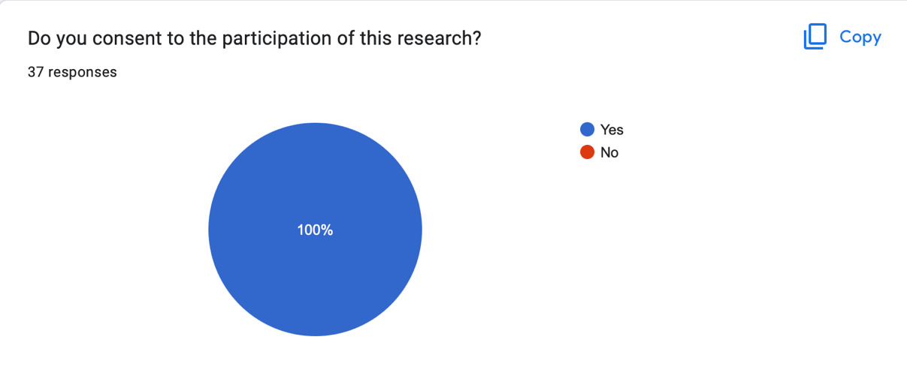
The first question as part of the survey was used to achieve formal consent from the participants. This insured that the briefing introduction was read and gave the participants the option to not take part within the research. This question was also included to avoid the survey from becoming unethical. According to the University of Surrey (2007) human participants have a right to privacy, and it could be considered that the public’s opinions are their own private information and to use this information as part of the research project without formal written consent would be a violation of the code of ethics. All 37 participants consented to the participation and the use of their data within the research.

1.

As explained within the briefing information to obtain the participants privacy and anonymity, if the participants wished to withdraw from the research, the participants were asked to provide a unique 4-digit code to include when emailing the contact information. This was asked as part of the second question of the survey to ensure that the participants data could easily be removed.

The third question of the survey asked what age category represented the participants to provide context to the qualitative open questions that would later be included within the survey. The age categories provided ranged from 18 – 60+ with the majority of participants aged 18 – 24 (19 participants, 51.4%) and the fewest participant age category (2 participants from each category, 5.4%) being 25-31, 32-38 and 53-59.

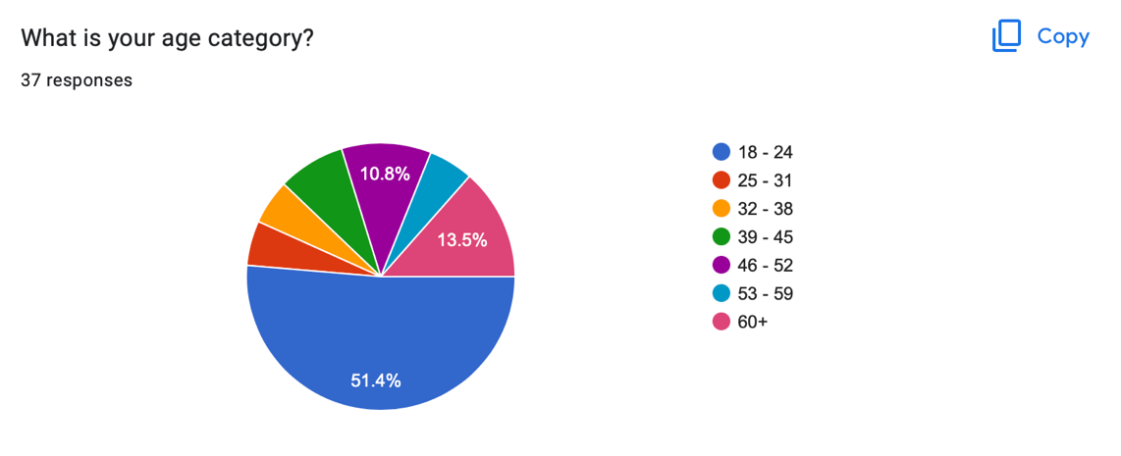
3.

The fourth question of the survey was to determine the gender of each participant. The purpose of this question when analysing qualitative open questions later included, was to compare the contents of the participants response and if this had a relationship to the gender of the participant. 62.2% of participants (23 participants) identified as female, 35.1% of participants (13 participants) identified as male and 2.7% of participants (1 participant) identified as non-binary.
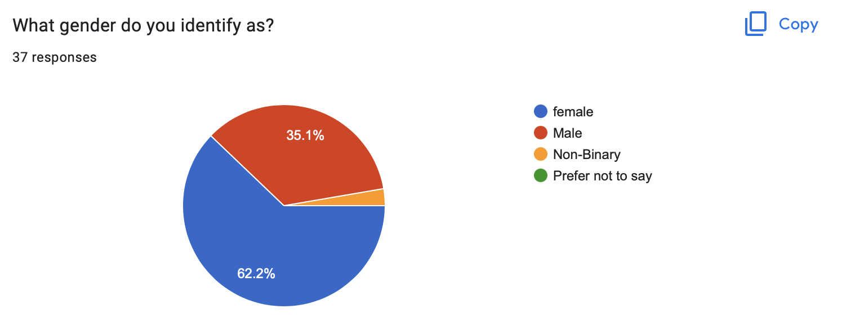
4.

The purpose of the fifth question of the survey was to determine if the participants were responsible for a child under 18. This was asked to compare and analyse the responses of participants with children and without children. Out of 37 participants, 75.5% of participants (28 participants) responded ‘no’ to this question and 24.3% of participants (9 participants) responded ‘yes’ to this question.

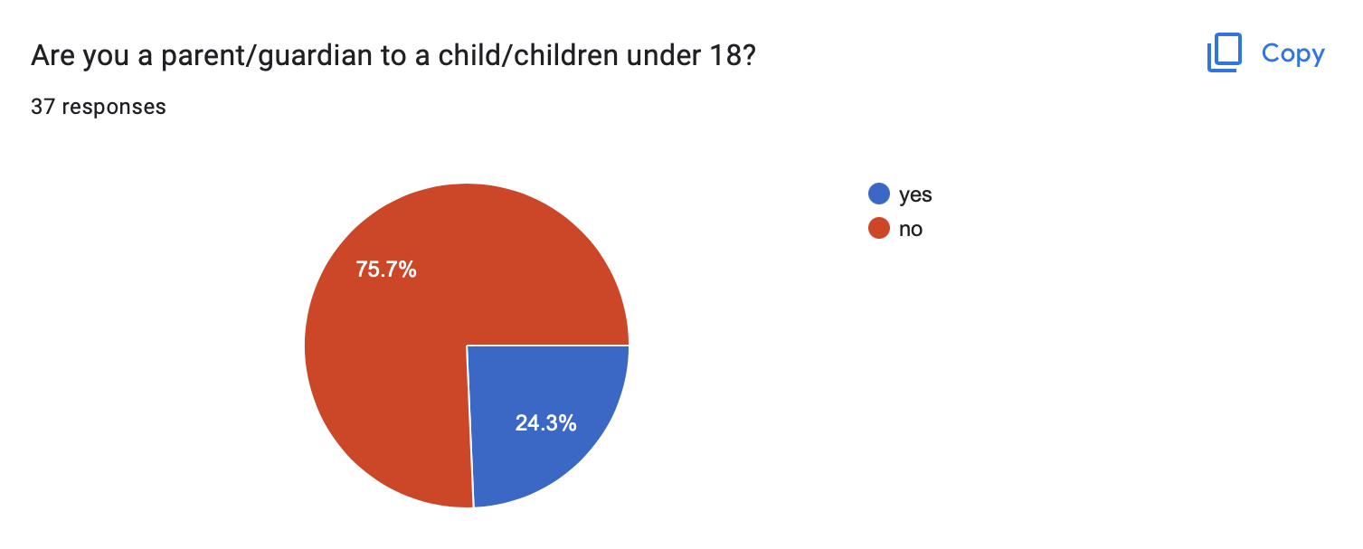
5.

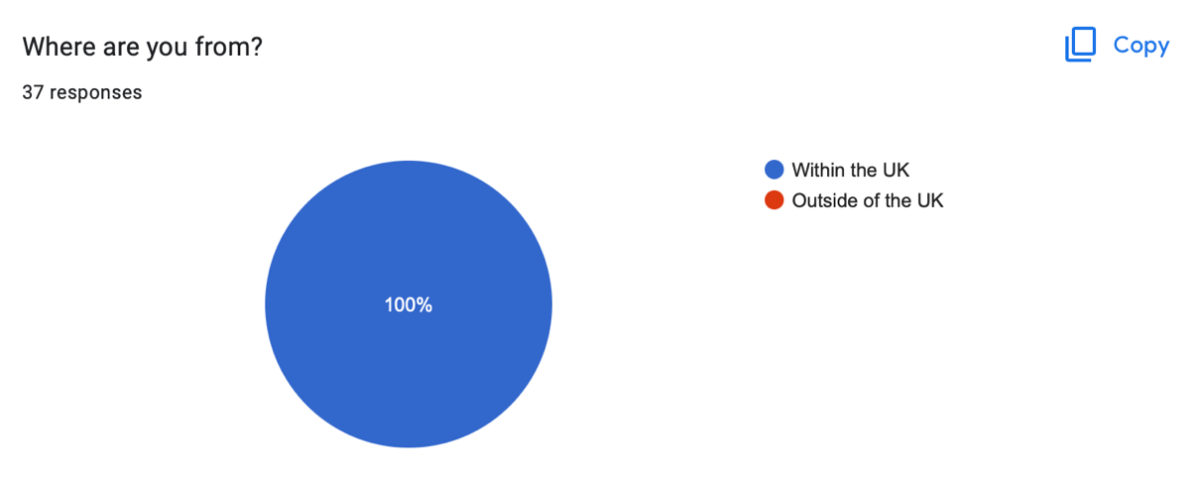
The purpose of the sixth question of the survey was to understand if anyone from outside of the UK participated within the research. This was important to the research as the UK (Northern Ireland, England and Wales) has the lowest ACR in Europe (Queens University Belfast Research Portal, 2022). 100% of participants responded with ‘within the UK’.

6.

The purpose of the seventh question of the survey was to reveal how much knowledge the public already had on the ACR. The results from the survey showed that 32.4% of participants responded that they didn’t know, whereas 67.2% of participants responded that they did know what the ACR is. However, when looking at the eighth question of the survey which asked, “At what age do you think the UK Government deems a person to be criminally responsible and why?”, out of the 25 respondents that claimed they knew what the ACR was, only 16 were correct. Through the combination of these questions, the more accurate representation shows that 56.8% of participants didn’t know what the ACR is and 43.2% of participants did know. A graph presented, also shows the responses in relation to the gender of the participants, of the 56.8% of participants that didn’t know what the ACR is, 66.7% of responses were female participants and 33.3% of responses were male participants. In the context of the participants who had children, 19.1% of the participants who did not know what the ACR is are responsible for a child or children under 18. Whereas 31.3% of participants who did know what the ACR is are parents/guardians of 1 or more children under 18.

7.

The eighth question of the survey asked:
“Under the UK Government, the age of criminal responsibility is when a person can be criminally charged and sentenced at court. At what age do you think the UK Government deems a person to be criminally responsible and why?”
A range of different answers were achieved however, only 51.4% (19) of respondents gave justifications for their answers. 43.2% (16) of respondents correctly answered that the ACR was 10 years old, with 6 participants including their reasoning for their answers and 1 of these participants was a parent/guardian to a child. The justifications for 5 of the participants (including the parent/guardian) justified their answers responding this is the age that children “should” or are “capable” of knowing right from wrong. The remaining participant responded that the ACR is “to reduce offending and prevent further criminal activity as an adult”.
Of the participants that did not know the ACR, the majority of participants (24.3% , 9 participants) had responded with 16 years old. 5 of the participants that thought the ACR was 16 justified their answer because it’s the “age of consent”, it’s “the legal age”, when “a child leaves school” and when “a child understands the depth of their actions”.

4.4 Synthesis of Findings with Literature Review

