

Master of Business Administration
Marketing Management (LCMB7024)

Marketing Environment Analysis

Student Name: Asif Mahmud Emon
Student ID: 2439438
Wordcount: 2750

Table of Contents
1.0 Introduction 1
2.0 Macro Marketing Environment Analysis 2
2.1 Overview of the Macro Marketing Environment 2
2.2 External Macro Factors Affecting Tesla 3
2.3 External Macro Factors Affecting Jaguar Land Rover (JLR) 5
3.0 Strategic Responses of Pioneering and Follower Organisations 8
3.1 Tesla’s Strategic Response 8
3.2 Jaguar Land Rover’s Strategic Response 9
3.3 Comparative Evaluation of Strategic Responses 10
3.4 Marketing Strategies to Maintain Competitiveness 11
4.0 Conclusion 13
5.0 References 14

1.0 Introduction
The car industry, in particular, the electric vehicle (EV) industry, is changing due to the emergence of new technology, interest in the environment, and customer preferences (Spanier, 2025). Owing to this, companies within this industry are forced to undergo rapid adjustment to the market trends. According to this report, the strategies of Tesla as an innovative player in the industry of electric cars of the UK and Jaguar Land Rover (JLR) as a follower switching to electric are critically reviewed. Tesla is a company that has established self-driving cars, battery technologies, as well as environmental accountability (Tesla, 2021). JLR is a traditional luxury car manufacturer. Its Reimagine plan is on electric transportation. This paper will discuss the ways in which every organisation has managed to manage the technical and economic side of marketing and how their strategic aims and objectives influence their competitive standings. Their placement, marketing, distribution and promotions of their products will also be considered on how successful both companies are competing within an oversaturated market. A comparison of techniques and future predictions will be the end of the report.

2.0 Macro Marketing Environment Analysis

2.1 Overview of the Macro Marketing Environment
Larger forces impact the company's market dynamics in the macro marketing environment. These influences may benefit or harm businesses. Six categories are commonly used: Political, Economic, Social, Technological, Environmental, and Legal (Kotler and Armstrong, 2018). Tesla and Jaguar Land Rover (JLR) are heavily influenced by the macro environment, notably in the fast-changing electric vehicle (EV) market. The PESTEL research for both companies tells them what external factors and trends to watch to remain competitive.
Table 1 PESTEL analysis.
Factor | Tesla | Jaguar Land Rover (JLR)
Political | Government EV subsidies and zero-emission regulations are vital, but infrastructure delays and Brexit trade concerns hurt supply (Liu, 2021). | Brexit hinders exports, notably to the EU. UK manufacturing benefits JLR, but tariffs imperil exports.
Economic | Inflation and the cost of living reduce luxury car sales. | JLR profits from luxury market stability, while semiconductor shortages and economic concerns hinder manufacturing and sales (Williment, 2025).
Social | UK green consumption is booming, but consumers demand affordability. Service delays and BYD-Polestar competition impacted brand image (Young, 2025). | JLR must adapt to luxury and EV environmental criteria while preserving its British heritage (Davis, 2017).
Technological | Tesla rules AI and autonomous driving. Complete self-driving regulatory certification is delayed—lack of charging infrastructure in the UK limits adoption outside cities (Mahmoud et al., 2023). | JLR is investing in EV platforms, but behind Tesla in software and autonomy. Digital retailing improves (SDS, 2024).
Environmental | Solid support for UK net-zero goals, but battery production sustainability and recycling difficulties (Brand Finance, 2025). | JLR's 2039 net-zero emissions goal matches UK environmental goals, while older diesel vehicles face regulations.
Legal | UK automobile data and AI laws may affect Tesla. | JLR's FY25 cyber incident improved data security. Compliance with emission standards is hard (Mjikane, 2025).

2.2 External Macro Factors Affecting Tesla
Technological factors
Tesla has been a forefront to the development of EV technology. Particularly, it is so with battery-powered, self-driving, and AI-powered devices. In the UK, regulations pose a challenge to Tesla's technological advantage (Ross, 2025). Tesla is currently awaiting approval to launch its full self-driving (FSD) technology that can make it stand out in the EV industry. Tesla is not able to sell its self-driving cars in the UK as it is not licensed. This constrains one of its major consumer advantages. Another technological problem is the charging infrastructure (Mahmoud et al., 2023). There are various Superchargers in Tesla, however, the fast-charging network of the UK and, in particular, rural regions is not well-established (Brand Finance, 2025). A significant issue with electric vehicle buyers is range anxiety, especially in rural areas where there are limited charging stations.
Economic factors:
The operation of Tesla in the UK is reliant on the economy (Oliver, 2025). The rising interest rates, inflation, and cost of living have affected consumer spending, particularly in Tesla. Due to luxury products being more prone to the economic downturn and reduced income levels, the market of high-end electric vehicles in the UK has been damaged. The problems of the Berlin Gigafactory affected Tesla in the early months of 2025, when it struggled to produce products on time. These production delays impacted the production of deliveries in the UK, increasing economic strains and reducing by 1.3% market share of Tesla in the UK in the first half of 2025 (Young, 2025).
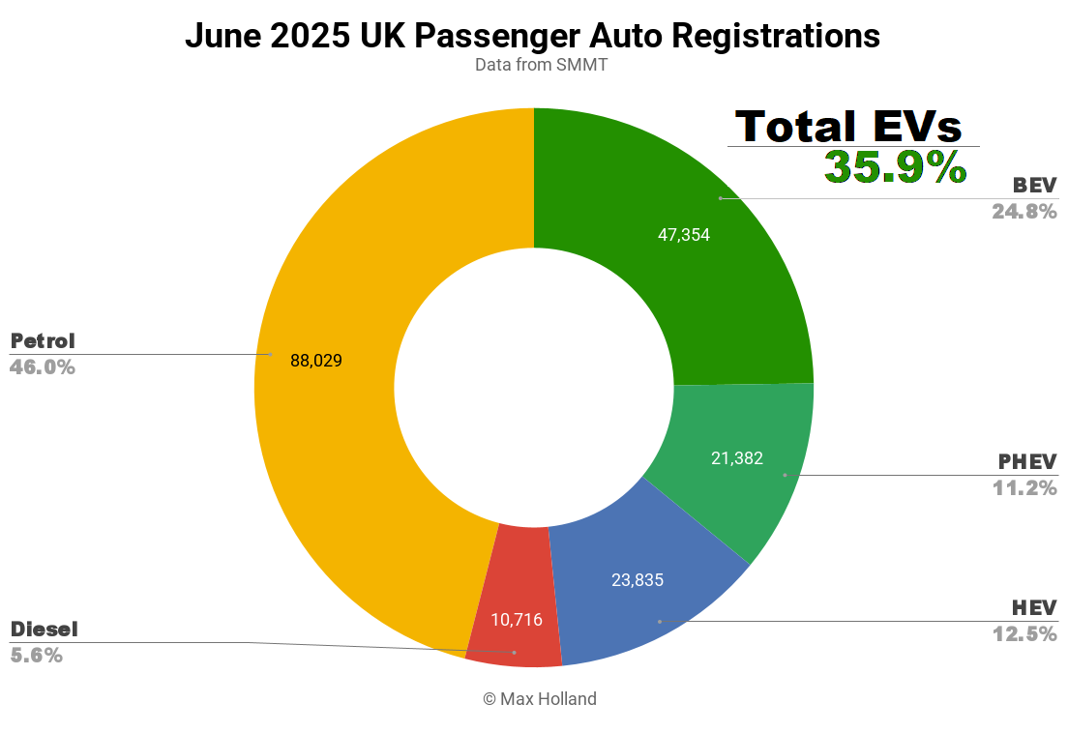
Figure 1 UK EV market sales (Holland, 2025).
The emerging technology and the green objectives set by the government of the UK can help Tesla expand. Nevertheless, the market position of the company may also be jeopardised as a result of regulatory clearance delays and heightened competition (Brand Finance, 2025). In order to be competitive, Tesla should continue lobbying to have its self-driving features approved by regulators, and its charging infrastructure should also be improved.
Table 2 Opportunities and Threats for TESLA.
Opportunities | Threats
- With legal authorisation for complete self-driving, battery and autonomous driving investment offers development potential (The Strategy Story, 2023).  - Expanding the UK's charging network might boost Tesla uptake, especially in rural locations (Mahmoud et al., 2023).  - Tesla benefits from UK green measures like EV subsidies.  Producing more cheaply might boost Tesla's UK pricing competitiveness (Oliver, 2025). | - UK regulatory hurdles for self-driving technology may restrict Tesla's competitive edge (Liu, 2021).  - BYD and Polestar's inexpensive EVs challenge Tesla's market supremacy (Nezhadkian and Zho, 2024).  - Rising borrowing rates and the cost-of-living issue may diminish demand for Teslas and other luxury cars (Jolly, 2025).

2.3 External Macro Factors Affecting Jaguar Land Rover (JLR)
Technological factors
Electric vehicles are included in the Reimagine strategy as JLR is a pioneer in the premium internal combustion engine (ICE) cars. Tesla is also ahead of its competitors in the field of AI-driven solutions and autonomous cars, and JLR is lagging behind (Liu, 2021). The company has developed the Range Rover I-PACE and is committed to going electric, although it does not have Elon Musk's software features and over-the-air upgrades. The reliance of powertrains used in JLR is hindered by the use of old-fashioned technology, as well as the high prices of the production of electric vehicles (Jolly, 2025). JLR is enhancing technical advancements in batteries and collaborating with additional businesses to develop electric powertrains that are quicker.
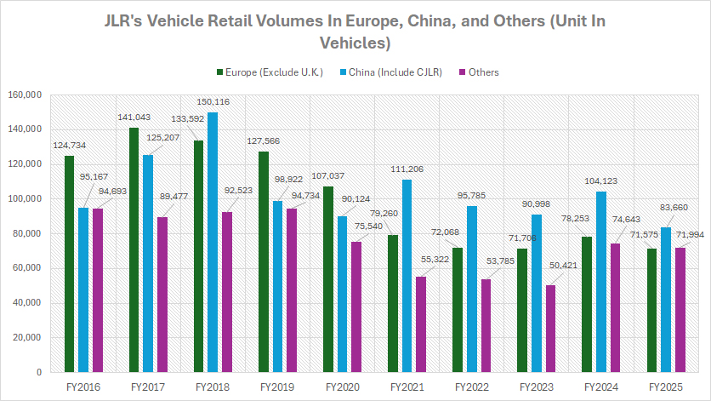
Figure 2 JLR EV sales (Chan, 2024).
Economic factors
The sales of JLR are dependent on the economy of the UK and the rest of the world. Tesla is more exposed compared to JLR since the latter enjoys a superior market (SDS, 2024). Defender and Range Rover are still favourites among customers. JLR has had difficulties in meeting demands because of the world supply chain and the shortage of chips. This was impacting the global retail sales and increasing the expenses. This economic uncertainty and high cost of living have been detrimental to the target market of JLR since luxury cars are more sensitive to the economic dynamics (Williment, 2025). JLR did not see an increase in revenues in FY25, although the company had a robust net cash position. This is an indication that even the high-end nature of the company does not shield it against economic challenges at the sector level.
Table 3 Opportunities and Threats for JLR.
Opportunities | Threats
- JLR's electrification strategy might profit on the premium EV market (Mjikane, 2025).  - Recycled materials and sustainable production may help JLR attract eco-conscious customers.  - In unpredictable economic times, Range Rover and Defender sales bring stability (Tabahriti, 2025).  - JLR invests in online configurators and virtual showrooms to boost customer interaction and online growth. | - Tesla outpaces JLR in autonomous driving and sophisticated software development.  - JLR's worldwide sales are hurt by semiconductor shortages and transportation issues.  - JLR's diesel cars are under pressure from pollution rules and the UK's net-zero emissions goal.  - JLR may struggle financially due to the high expense of switching to electric powertrains and building new EV platforms.

Electric cars and market strength in the luxury segment are good pointers to growth in JLR, especially as more buyers choose environmentally friendly premium vehicles (Davis, 2017). The chain is yet to recover, and the company is not as technologically savvy as Tesla. To compete in the UK market, JLR needs to start adopting electric cars faster and retain its elite brand image.

3.0 Strategic Responses of Pioneering and Follower Organisations
Over time, Tesla, the pioneer electric vehicle (EV) company and Jaguar Land Rover (JLR), a follower company have failed to plan on how to cope with the emerging technology, heightened competition, and altered market demands. Tesla is an innovator that specializes in technology and was the first to introduce electric cars (EVs). Nevertheless, JLR is going to switch the ICE-based luxury to a sustainable electric future.

3.1 Tesla’s Strategic Response
Technological Leadership and Innovation
Tesla spends a lot of money on AI, batteries, and self-driving vehicles. Tesla, being a pioneer in the EV industry, has an edge over its competitors in terms of product development and thus product offering in the EV market. Regardless of the UK regulatory prohibitions that have affected the innovation, this innovation is a key aspect of Tesla's product strategy, as it has placed emphasis on the real product level by incorporating modern technology in its vehicles (AFP, 2025). The Tesla Supercharger network, which emerged in the United Kingdom and throughout the global community, offers Tesla owners rapid and secure charging to upgrade the product level of augmentation. This infrastructure is required to make the Tesla products more accessible, especially in rural regions, where the existence of a shared set of public charge stations is still minimal (Nezhadkia and Zho, 2024). The company has laid down the infrastructure for charging Tesla brands according to its general product strategy, solely in that it keeps on developing and nurturing the actual product (the EVs themselves) and the services (such as charging stations) that are offered to complement the experience of owning the product.
Global growth and entering new markets
Tesla has always prioritised growth and global reach. Tesla sold 1.79 million vehicles worldwide in 2024. This is down from 1.81 million in 2023. However, this dip merely indicates production issues like Berlin Gigafactory delays, not a drop in demand (Ross, 2025). Even though it sold 22,700 vehicles in the UK in the first half of 2025, a 1.3% reduction from the previous year, Tesla needs it. Tesla's direct-to-consumer sales model is upending dealerships (Young, 2025). The company keeps higher profits and controls the consumer experience. Tesla benefits from this business model's simpler and cheaper shipping.
Environmental and sustainability branding
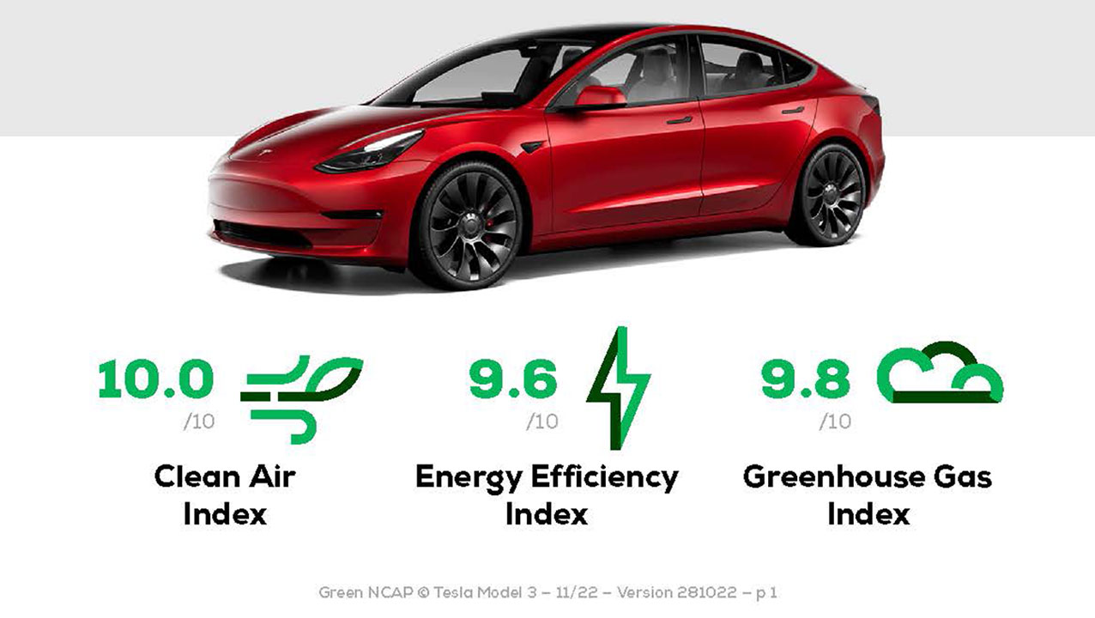
Figure 3 TESLA's net-zero goals (Tesla, 2025).

Tesla's success is due to its green image. The company prioritises sustainability in all it does, from manufacturing to recycling. Environmentalists admire Tesla because it supports the UK's net-zero goals (Tesla, 2024). Tesla's initiatives to enter solar energy and battery storage solutions expand its green agenda by expanding its revenue streams.

3.2 Jaguar Land Rover’s Strategic Response
EV Transition and Reimagine Plan
The Reimagine method explains how JLR is switching from ICE to EVs. A complete plan to alter the company's product line focuses on making luxury automobiles more environmentally friendly and electrified. JLR sold 428,854 units globally in FY25, including 108,232 in Q4. This was 5.1% lower than last year (JLR, 2025). The I-PACE, JLR's most significant electric car, was its first premium SUV. It still faces Tesla and Polestar. By 2039, JLR plans to have 0% emissions and all its vehicles electrified. JLR must work hard to match Tesla's technological advantage.
Technology and online commerce investments
JLR is expanding in the electric vehicle (EV) category, yet Tesla has self-driving vehicles and AI implementation, which are better (Gain, 2025). JLR spends a significant amount of money on online shopping, battery solutions, and EVs. The ability to have a JLR car customised online without a visit to a car showroom directly relates to the augmented product base, in which the online configurator and virtual showrooms enhance the customer experience in relation to the real product (Reuters, 2025). This characteristic, which gained additional importance during the pandemic, provides more opportunities to achieve brand-consumer contact because the process of customisation becomes much more convenient and individual. The fact that JLR has managed to integrate EV technologies with the liberty of its core product, a limber of luxury and heritage, would enable it to retain its British luxurious status. Prioritising the augmented product level, JLR can remain in the highest luxury market position, providing iconic vehicles such as the Defender and integrating digital innovations which will comply with the various dynamics in consumer expectations.

3.3 Comparative Evaluation of Strategic Responses
Tesla is the best regarding self-driving cars, AI, and battery. The company is experiencing hurts in the UK due to legislative delays and economic problems, yet the demand is being fueled by its direct-to-consumer sales and emphasis on the environment. JLR is attempting to retain its high-end brand and adopt emerging technology. Sales of EVs are on a level (Gupta, 2022). Reimagine is an amazing beginning of going electric, yet the technical innovation of Tesla along with EV infrastructure will be difficult to rival. Tesla presents itself as a technological trendsetter and brand. The firm uses groundbreaking products and green communications to help it appeal to greener customers (Zhou, 2023).
Table 4 Strategic Response for TESLA and JLR
Strategic Element | Tesla | Jaguar Land Rover (JLR)
EV Transition | Focus on scalability and global market penetration with Gigafactories. | Reimagine strategy focuses on electrification, with I-PACE as a key model (Reuters, 2025).
Sustainability | Strong green brand with a focus on solar energy and battery storage. | Committed to net-zero emissions by 2039 with a focus on recycled materials.
Market Positioning | Positioned as premium, but also affordable, with a focus on technology. | Positioned as luxury, emphasizing heritage and sustainability (Spanier, 2025).
Sales Performance | Slight decline in 2025 UK sales, but global sales continue to grow. | Flat year-on-year sales, 5.1% decline in Q4 FY25 sales (JLR, 2025).
Challenges | Facing competition from BYD and service delays. | Struggling with the transition to EVs and legacy diesel models.

3.4 Marketing Strategies to Maintain Competitiveness
The marketing strategy that JLR will adopt lies in its luxury automotive history and its environmental objectives. It targets its luxurious electric vehicles as vintage and modern (Davis, 2017). Being the pioneer EV company, it has an advantage. But more competition and government interruptions plague it. Jaguar Land Rover (JLR) is making the transition to electric vehicles that are based on luxury, sustainability and heritage. Being technologically backward JLR is a leading manufacturer of luxury vehicles whose beliefs include a mixture of old-fashioned beauty and green technologies.
Table 5 Marketing Approach for TESLA and JLR.
Marketing Element | Tesla’s Approach | JLR’s Approach
Product Strategy | Focus on technological innovation, particularly autonomous driving, battery tech, and sustainability (Lei, 2025). | Focus on luxury and heritage, blending traditional British style with modern EV technology (Sindi and Roe, 2017).
Pricing Strategy | Use of penetration pricing in some markets while maintaining a premium pricing strategy for high-end models (Fu, 2024). | Premium pricing strategy for luxury models like Range Rover and Defender (Spanier, 2025).
Distribution Strategy | Direct-to-consumer sales model with an expanding network of Superchargers and digital engagement. | Traditional dealership model, with emphasis on customer experience and digital retailing through online configurators (Nolan, 2025).
Promotional Strategy | Social media marketing, word of mouth, and high-profile figures like Elon Musk are used to promote the brand’s aspirational appeal (Zhou, 2023). | Focus on heritage and luxury with event sponsorships and collaborations with high-end lifestyle brands.

4.0 Conclusion
Both Tesla and Jaguar Land Rover (JLR) are dealing with the UK EV market problems differently. Tesla is a market leader with JLR coming in second. Tesla is the powerhouse in the EV industry, which concentrates on novel technology. It is leading on self-driving cars and battery technologies. Direct-to-consumer sales and long-term IT brand makes it stronger. It is struggling, as it is experiencing issues with regulatory authorization of the use of self-driving vehicles and possesses new international rivals like BYD. Nevertheless, JLR is using its Reimagine strategy to make it a pioneer in electric vehicles. JLR lagged behind Tesla regarding technology, however, their luxury label, environmental awareness, and devotion to EV give them a well-prospective problem in growing. The dominance of luxury markets by JLR will help it to avoid economic problems; however, it needs to increase technology development speed in order to rival Tesla. Both organisations have to deal with the changes in macro marketing environment and their opportunities and challenges.

5.0 References
AFP (2025). Tesla arm applies to supply electricity in UK: Regulator. [online] The Economic Times. Available at: https://m.economictimes.com/news/international/business/tesla-arm-applies-to-supply-electricity-in-uk-regulator/articleshow/123243826.cms [Accessed 15 Oct. 2025].
Brand Finance (2025). Tesla’s green reputation crashes as its sustainability perceptions value falls by over $7 billion | Press Release | Brand Finance. [online] Brand Finance. Available at: https://brandfinance.com/press-releases/teslas-green-reputation-crashes-as-its-sustainability-perceptions-value-falls-by-over-7-billion [Accessed 15 Oct. 2025].
Chan, K. (2024). Jaguar Land Rover (JLR) Global Sales And Sales By Country | Fundamental Data And Statistics For Stocks. [online] Stockdividendscreener.com. Available at: https://stockdividendscreener.com/auto-manufacturers/jlr/jaguar-land-rover-global-sales-and-sales-by-country/ [Accessed 16 Oct. 2025].
Davis, M. (2017). Effective vehicle attribute delivery at Jaguar Land Rover : innovation report. [online] wrap.warwick.ac.uk. Available at: https://wrap.warwick.ac.uk/id/eprint/114061/ [Accessed 15 Oct. 2025].
Fu, R. (2024). Innovative Business Analysis and Marketing Strategies: Unraveling Teslas Success in the Digital Age. Advances in Economics, Management and Political Sciences, 137(1), pp.57–62. doi:https://doi.org/10.54254/2754-1169/2024.18597.
Gain, E. (2025). JLR extends UK factory closure, union warns of job loss: How Tata-owned carmaker is tackling cyber attack impact. [online] mint. Available at: https://www.livemint.com/companies/news/jlr-extends-uk-factory-closure-union-warns-of-job-loss-how-tata-owned-carmaker-is-tackling-cyber-attack-impact-11758018562474.html [Accessed 16 Oct. 2025].
Gupta, N. (2022). Cross Border Merger & Acquisition a wealth creating proposition: An exploratory case study of Tata Motors and Jaguar Land Rover. [online] norma.ncirl.ie. Available at: https://norma.ncirl.ie/5819/ [Accessed 16 Oct. 2025].
Holland, D.M. (2025). EVs Take 35.9% Share In The UK — Tesla Back On Top - CleanTechnica. [online] CleanTechnica. Available at: https://cleantechnica.com/2025/07/14/evs-take-35-9-share-in-the-uk-tesla-back-on-top/ [Accessed 16 Oct. 2025].
JLR (2025). JLR DELIVERS ON NET CASH POSITIVE TARGET AFTER STRONG FY25 SALES | JLR Media Newsroom. [online] Jaguarlandrover.com. Available at: https://media.jaguarlandrover.com/news/2025/04/jlr-delivers-net-cash-positive-target-after-strong-fy25-sales [Accessed 15 Oct. 2025].
Jolly, J. (2025). Jaguar Land Rover cyber-attack: what’s the latest news? [online] the Guardian. Available at: https://www.theguardian.com/business/2025/sep/29/jaguar-land-rover-cyber-attack-whats-the-latest-news [Accessed 15 Oct. 2025].
Kotler, P. and Armstrong, G. (2018). Principles of marketing. 17th ed. Harlow: Pearson Education Limited.
Lei, C. (2025). Analysis of Tesla International Strategies. Studies in big data, pp.237–246. doi:https://doi.org/10.1007/978-3-031-83911-5_21.
Liu, S. (2021). Competition and Valuation: a Case Study of Tesla Motors. IOP Conference Series: Earth and Environmental Science, 692(2), p.022103. doi:https://doi.org/10.1088/1755-1315/692/2/022103.
Mahmoud, A., Mahmoud, R., Masoud, R. and Abdelaziz, A. (2023). Assessing the Transformative Impact of Tesla’s Strategic Change Interventions and Technology... ResearchGate. [online] doi:https://doi.org/10.13140/RG.2.2.14984.39684.
Mjikane, S. (2025). The Economic Footprint of JLR in the UK. [online] Oxford Economics. Available at: https://www.oxfordeconomics.com/resource/the-economic-footprint-of-jlr-in-the-uk/ [Accessed 16 Oct. 2025].
Nezhadkian, M. and Zho, W. (2024). Leveraging AI and IoT for Industry Transformation: A Case Study of Tesla’s Technological Integration and Strategic Innovation. [online] Information Sciences and Technological Innovations. Available at: https://isti.reapress.com/journal/article/view/29 [Accessed 15 Oct. 2025].
Nolan, S. (2025). Reimagine Strategy Drives Record Revenue for JLR. [online] Evmagazine.com. Available at: https://evmagazine.com/news/reimagine-strategy-drives-record-revenue-for-jlr [Accessed 16 Oct. 2025].
Oliver, M. (2025). Tesla’s UK sales plunge by £500m as drivers boycott Elon Musk. [online] The Telegraph. Available at: https://www.telegraph.co.uk/business/2025/09/26/tesla-suffers-500m-uk-sales-hit-as-drivers-boycott-elon-mus/ [Accessed 15 Oct. 2025].
Reuters (2025). JLR to invest $80 million to meet demand for custom luxury car colours. Reuters. [online] 27 Jan. Available at: https://www.reuters.com/business/autos-transportation/jlr-invest-80-mln-meet-demand-custom-luxury-car-colours-2025-01-27/ [Accessed 15 Oct. 2025].
Ross, D. (2025). The Latest Tesla Statistics. [online] Honest John. Available at: https://www.honestjohn.co.uk/the-latest-tesla-statistics/ [Accessed 15 Oct. 2025].
SDS (2024). Jaguar Land Rover Car Sales Figures And Breakdown By Country | Fundamental Data And Statistics For Stocks. [online] stockdividendscreener.com. Available at: https://stockdividendscreener.com/auto-manufacturers/jaguar-land-rover-car-and-vehicle-sales-figures/ [Accessed 15 Oct. 2025].
Sindi, S. and Roe, M. (2017). Testing and Implementing the Strategic Supply Chain Model. Strategic Supply Chain Management, pp.223–247. doi:https://doi.org/10.1007/978-3-319-54843-2_8.
Spanier, G. (2025). Four agency groups in race to win Jaguar Land Rover global marketing account. [online] Campaignlive.co.uk. Available at: https://www.campaignlive.co.uk/article/four-agency-groups-race-win-jaguar-land-rover-global-marketing-account/1927920 [Accessed 15 Oct. 2025].
Tabahriti, S. (2025). JLR’s UK factory stoppage from cyber attack stretches to three weeks. Reuters. [online] 16 Sep. Available at: https://www.reuters.com/en/jlrs-uk-factory-stoppage-cyber-attack-stretches-three-weeks-2025-09-16/ [Accessed 16 Oct. 2025].
Tesla (2024). Impact Report 2024. [online] Tesla. Available at: https://www.tesla.com/impact [Accessed 15 Oct. 2025].
The Strategy Story (2023). Jaguar Land Rover PESTEL Analysis - The Strategy Story. [online] The Strategy Story. Available at: https://thestrategystory.com/blog/jaguar-land-rover-pestel-analysis/ [Accessed 15 Oct. 2025].
Williment, C. (2025). JLR’s Circularity Drives More than US$133m in Reuse Projects. [online] Sustainabilitymag.com. Available at: https://sustainabilitymag.com/articles/jlrs-circularity-drives-more-than-us-133m-in-reuse-projects [Accessed 15 Oct. 2025].
Young, J. (2025). Tesla sees UK sales rebound in June as EV market accelerates. [online] Business Matters. Available at: https://bmmagazine.co.uk/news/tesla-uk-sales-june-2025-ev-market-growth/ [Accessed 15 Oct. 2025].
Zhou, Z. (2023). Tesla Marketing Analysis. Academic Journal of Business & Management, [online] 5(2), pp.171–177. doi:https://doi.org/10.25236/ajbm.2023.050225.

