

Saving Energy Usage and Costs in the Home Using Internet of Things
by
Simon Peter Thomas

Supervisor: Dr Kapilan Radhakrishnan
Second Marker: Carlene Campbell

Project submitted as part of the requirements for the award of BSc (Hons) Computer Networks and Cybersecurity

April 2018

DECLARATION

I, Simon Peter Thomas declare that I am the sole author of this Project; that all references cited have been consulted; that I have conducted all work of which this is a record, and that the finished work lies within the prescribed word limits.

This work has not previously been accepted as part of any other degree submission.

Signed: .............................................

Date: ...............................................

FORM OF CONSENT

I, Simon Peter Thomas hereby consent that my Project, submitted in candidature for the B.Sc. (Hons) Computer Networks and Cybersecurity degree, if successful, may be made available for inter-library loan or photocopying (subject to the law of copyright), and that the title and abstract may be made available to outside organisations.

Signed: .............................................

Date: ...............................................
Abstract
In the current era of Smart Homes, which are advanced technological systems that give the average home the capability of automation with typical domestic tasks, these systems are developing at a rate much higher than the industry can currently comprehend. As it is now there are abundant technologies and applications that can be utilised in a home to make it “Smart”. The technology is typically small low powered devices that has wireless communication capabilities that allows communication between the home appliances and the user. The point of this communication is it allows for monitoring and control of the appliance via user commands or the systems programmed intelligence.
The concept of a Smart Home is widely looked upon by the industry and consumers, alike this is due to its increased popularity over the past few decades. This interest and appeal to Smart technology comes from how acceptant humanity has become with technology overall and with the implementation of this technology it allows for an enhanced lifestyle for the resident within the property. This experimental report will look at the current state of IoT both from a technologic view point, focusing on Smart Home application and the relevant fields of study. This being a background basis on the technology such as it unstructured setup, but still allowing for route path for communication. This report will go on to act on a proposed Smart Home design with the utilisation of the IEEE 802.11.4 standard, to be implemented in a physical location, utilising protocols and standards especially for this type of network such as Zigbee and 6LoWPSN. The proposed system will be tested and evaluated with prior research to determine if the Smart Home system is efficient in reducing the energy consumption of the appliances used in a smart home. On the success of the test finding future research is discussed on what recommendation will be useful taking a project like this one forward in terms of research and development.

Table of Contents
List of Figures 6
List of Abbreviations 7
Glossary 8
Chapter 1 - Project Introduction 9
1.1 Introduction 9
1.2 Aim 9
1.3 Objectives 10
1.4 Structure of the Project 10
Chapter 2 – Research & Review of Literature 12
2.1 Introduction 12
2.2 Internet of Things 12
2.3 Wireless Sensor Network (WSN) 15
2.3.1 Wireless Sensors 16
2.3.2 Wireless Sensor Network Technology 18
2.3.3 Wireless Sensor Network Standards 19
2.3.4 Wireless Sensor Network Topology 20
2.3.5 Design Issues 21
2.3.6 WSN Security 22
2.4 What is a Smart Home 24
2.4.2 Home Security 26
2.5 Home Energy Usage 28
2.5.1 Energy Usage 28
2.5.2 Energy Cost 29
2.6 Internet of Things for Energy Management 30
2.6.1 Climate Change 31
2.7 Related Work 32
2.7.1 Design and Implementation of a Smart Home System [77] 32
2.7.2 Smart Home Energy Management System using IEEE 802.15.4 and Zigbee[78] 33
2.7.4 Design of a Home Automation System Using Arduino [79] 34
2.8 Conclusion 35
Research Methodology – Chapter 3 36
3.1 Introduction 36
3.2 Research Method 36
3.2.1 Research Philosophy 37
3.2.2 Research Approach 37
3.2.3 Research Strategy 37
3.2.3 Research Choice 38
3.2.4 Research Time Horizon 38
3.2.5 Research Techniques 38
3.3 Research Design and Process 39
3.3 Conclusion 40
Design & Implementation – Chapter 4 41
4.1 Introduction 41
4.2 Physical Design 41
4.2.1 Design Parameters 41
4.2.2 Original Design 42
4.2.3 Revised Design 43
4.4 Physical Implementation 46
4.4.1 Open Source Energy Monitoring 47
4.6 Conclusion 48
Testing and Evaluation – Chapter 5 49
5.1 Introduction 49
5.2 Physical Model 49
5.2.1 Overview of Parameters 49
5.2.1 Review of Findings 49
5.3 Conclusion 51
Chapter 6 – Conclusion and Future Work Recommendations 52
6.1 Conclusion 52
6.2 Future Work for Project 53
Chapter 7 – Reflection 55
Chapter 8 – References 59
Appendices 65

List of Figures
Figure 1 | Internet of Things Ecosystem diagram[10] 12
Figure 2 | The Internet of Things status established[12]. 13
Figure 3 | IoT Units Installed Base by Category (Millions of Units)[22] 14
Figure 4 | IoT Endpoint Spending by Category (Millions of Dollars)[22] 15
Figure 5 |“Hardware structure of a WSN sensor node”[34]. 17
Figure 6 | Diagram showing the deployment of a Wireless Sensor Network[99]. 20
Figure 7 | Secure wake-up radio[52]. 23
Figure 8| TechTarget diagram of home automation capabilities[58]. 25
Figure 9 | “Home Gateway firmware updates by country”[67]. 27
Figure 10 | “Home Gateway security” and “Measures taken to secure the home gateway”[67]. 28
Figure 11 | Average Electricity usage per household annually. 28
Figure 12 | Chart displaying the standard annual tariff for UK Energy suppliers. 29
Figure 13 | Average annual standard bill based on consumption of 3,800kWh/year[72]. 29
Figure 14 | Diagram of the Research Onion[80]. 36
Figure 15 | Block Diagram for Smart Home Network. 42
Figure 16 | Block Diagram for Arduino Light Sensor. 43
Figure 17 | Table Showing IoT Control per Room. 44
Figure 18 | Layout of the Ground Floor Wireless Sensor Network and Home Gateway. 45
Figure 19 | Layout of the 1st Floor Wireless Sensor Network. 45
Figure 20 | Setup of Hue Lighting System with Smartphone Software. 46
Figure 21 | Images of the Google Home Interface. 47
Figure 22 | Installation of the EmonPi. 48
Figure 23 | Table showing an Average weekly Schedule for Residents. 49
Figure 24 | Table showing the setting of each Hue Motion Sensor 49
Figure 25 | Daily Kilowatt Hour Usage during Test Week. 50
Figure 26 | Daily Electricity Cost during Test Week. 51
Figure 27 | Original Gantt Chat from Project Proposal 57
Figure 28 | Revised Gantt chart. 58

List of Abbreviations

Technical Terms
DOS – Denial of Service
GPS – Global Positioning System
IoE – Internet of Everything
IoT – Internet of Things
I/O – Input/ Output
ISP – Internet Service Provider
kWh – Kilowatt Hour
LED – Light-Emitting Diode
Mbps – Megabits per Second
MEMS – Microelectromechanical Systems
RF – Radio Frequency
RFID – Radio Frequency Identification
TSP – Trust, Security and Privacy
WLAN – Wireless Local Area Network
WMAN – Wireless Metropolitan Area Network
WPAN – Wireless Personal Area Network
WSN – Wireless Sensor Network
WWAN – Wireless Wide Area Network
Organisation, Institutions and Companies

BI – Business Insider
DTI – Department of Trade and Industry
IBSG – Cisco Internet Business Solutions Group
IEEE – Institute of Electronic and Electrical Engineers
IETF – Internet Engineering Task Force
MIT – Massachusetts Institute of Technology
NASA – National Aeronautics and Space Administration
ISO – International Organization for Standards

Glossary
Internet of Things (IoT)
Is a reference to the connection of physical devices that have been embedded with electronic sensors and software which enables interoperation and data exchange with similar devices on an existing internet infrastructure with the purpose of intelligent decision making based on said data.
Single-board Computer
Is defined as a complete computer architecture that is built on a single circuit board with microprocessor, memory and input/ output (I/O) along with other features required of a computer. An example being the Raspberry Pi.
Microprocessor board
Is a simple circuit board consisting of a microprocessor, power jack, console port and I/O pins, the pins are used for connecting sensors and other devices to the board. Its purpose is to process simple programs to complete set task and is not a computer. An example would be the Arduino Uno.
Wireless Metropolitan Area Network (WMAN)
WMANs are based on the IEEE 802.16 standard. WMANs can attain effective transfer speeds of 1 to 10 Mbps within the range of 4 to 10 kilometres.

Wireless Personal Area Network (WPAN)
A low-range wireless network which covers an area of only a few dozen metres. Typically using standards in the IEEE 802.15 such as Bluetooth
Wireless Wide Area network (WWAN)
Wireless Network that provides communication services to a geographic area larger than a single region. The most utilised type of wireless networks.
Wireless Sensor Network (WSN)
A self-organizing, multi-hop network using multiple sensor nodes, used to monitor and control physical attributes.
Zigbee
Is a high-level communication protocol in the IEEE 802.15.4 standard which is used to create Wireless Personal Area Networks (WPAN) with small low power digital radios for the use of home automation such as home energy management.
6LoWPAN
Is a low power wireless area network protocol created by the IETF to define encapsulation and header compression so that IPv6 packets can to be sent and received over the IEEE 802.15.4 standard.
Kilowatt Hour
Set as a unit of energy, it is commonly used to calculate cost of energy usage when delivering energy to consumers by Utility Providers.

Chapter 1 - Project Introduction

1.1 Introduction
Wireless Sensors Networks (WSN) [1] have been implemented within the variable sectors of industry, corporate and commerce with it being considered as one of the most important and impactful technological advancement of the modern age [2]. This was made possible with the advancement in microelectronics and wireless communication that has happened over the past few decades, this technological advancement has been given the name Internet of Things (IoT). That led to the creation of smaller cost efficient and intelligent sensors with the capacity to be deployed in multiple physical locations worldwide, including harsh and/ or hazardous environments that would be considered dangerous for humans.
The need for this project comes from a leading and impactful issue that is facing the economy of this planet and that of humanity, firstly the constant demand for energy and the impact of that demand on Climate Change. The leading contributor to this dangerous change is the burning of fossil fuels for energy and the mind-set of governments, housing developers and residents using energy as it is provided and not taking the initiative to help themselves save the energy usage which in turn will save both money and help with the impact of climate change.
Internet of things is a recent addition in technology to the home but it has been changing the mind-set of corporation for much longer, in 2015 corporations of technology Apple[3], Microsoft[4] and Google[5] announced that their data centres and other buildings will rely more on renewable energy with many promising to be 100% renewable [6]. At the end of 2017 Google, Microsoft and Apple all published their environment report stating that their data centres are on 100% renewable energy. A factor that allowed this to happen was the infrastructures within each company’s buildings, the use of wireless sensor networks allowed the centres to run efferent using the energy provided by wind and solar farms[7].
As with most technology it starts off being used at an industry and corporate level as it is where it usually must highest impact within a short time. Once the technology has been proven successful and useful, it is then adapted by technology companies and manufacturers such as Phillips Hue[8] to be sold to and then used by consumers. It is at this point currently that smart home can be created using technology that is easily purchased and simple to set up within a home to save energy and in doing so cost.

1.2 Aim
The aim of this project was to development of a Wireless Sensor Network that can be used to monitor and automate an average family home, for the purpose to save energy usage based on the attributes i.e. residents and lighting.

1.3 Objectives
As a requirement to achieve the aim of the project objectives set as stages have been thought of to assist in ensuring the project is accomplished. The objectives are:
- To complete research in to the key aspects that surround this project which is Wireless Sensor Networks, as well as areas that are seen relevant to the project. Some examples include Internet of Things, types of sensor nodes and home layouts.
- To analyse the different topologies of a network and their corresponding functions and determine the best choice for this project’s aim. This will be using sources from the previous stage as well as additional research into practical uses of Wireless Sensor Networks.
- To design a Wireless Sensor Network using the information gathered from the previous two stages and build the projects Wireless Sensor Network within a test environment.
- To use the design of the previous stage to purchase the hardware for the Wireless Sensor Network and implement it within the designated physical location. Tests will be carried out in accordance to the aim of the project to overview a Wireless Sensor Network in the home environment.
- Final objective is to accumulate the information from the previous stages as well as the data created from the test environment and use it to evaluate the use of a Wireless Sensor Network within the home environment to control utility. This result and summary will lead to recommendations for future improvements and implementations.

1.4 Structure of the Project
This major project report is the culmination of three parts. To start with is the research this is the theoretical work which underpins the overall project, this theoretical work relates to content that was learnt within the studies at the university as well as content that was self-learnt. The second part is made of chapters that will detail the practical aspect of the project, this would include the design and the creation of the practical experiment. The final part details the findings of the Wireless Sensor Network experiment and evaluates the results which will be used to modify and recommend any changes for possible future work.
This report will be structured and separated in the following chapters;
Chapter One – Introduction to the project, the aim of the project and the objectives that will need to be achieve for the project to be a success as well as the layout of the project report structure.
Chapter Two – Research in to the background of Internet of Things and Wireless Sensor Networks, as well as look in the range of application that WSNs are used for with the purpose of bettering understanding the field of the project. This is done before to provide better knowledge when it come to the design of the home Wireless Sensor Network.
Chapter Three - This chapter will be on Research Methodology and will provide a breakdown on using the correct methods to undertake a project can insure its authenticity in integrity and levels of reliable research.
Chapter Four – Address the problem of designing a Wireless Sensor Network, the designs of the physical and simulated architecture and their respected implementations.
Chapter Five – Contains the documentation of testing the physical and simulated modals of the Wireless Sensor Networks and the evaluation of the finding that are gathered from the test data.
Chapter Six - Is the final chapter of the undertaken project, consisting of a summary of how the project when overall as well as a conclusion to it. This chapter will also contain recommendations for future work and fields of study.
Chapter Seven – This chapter is a self-reflexion discussing to what scope the aim and objectives of this project has been achieve. It reflects how well the objectives have been achieved and what could have been done to deal with any limitations.
Chapter Eight – References in IEEE Format

Chapter 2 – Research & Review of Literature

2.1 Introduction
In this chapter of the report, it will include the undertaking of what the project is about and the settings for how the project aim and objectives will be completed. For this will contain the recent literature surrounding the WSN and IoT as well as the research that relates to the areas included within the project field. This research has been carried out over the time frame in which the project has been set in and to cover the areas that were identified as necessary to complete the project with a true understanding of it.

2.2 Internet of Things
The Internet of Things, also referred to in some cases as the Internet of Everything is the name of the concept that has every electrical device connected to the internet. It is considered the next stage in the evolution of the internet, how from its introduction back in 1980s[9] the internet revolutionised the industries of science, business and technology. Internet of Things will have the same effect now as it has already, with its ability to gather, analyse and distribute data, IoT can turn that data into information and knowledge that can ultimately assist with most aspects of everyday living be it for a single person or a large organisation.
In 2016 a report was published by Business Insider’s industry research service BI Intelligence, in this report the authors John Greenough and Jonathan Camh write about how the IoT ecosystem (Figure 1). Could be the next Industrial Revolution or the next phase of the internet, this is supported by industry experts and technology enthusiasts alike and is seen to be the case of how IoT is becoming more and more the future way for businesses, governments, and consumers to interact with the physical world[10].
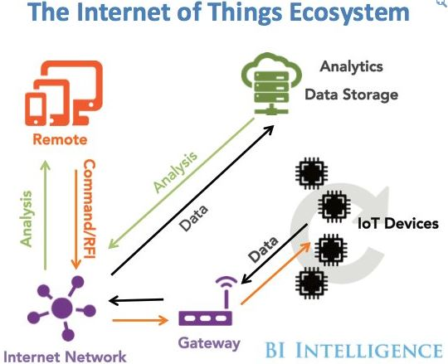
Figure 1 | Internet of Things Ecosystem diagram[10]

As with most of the new concepts in the field of information technology, the origins of Internet of Things can be pointed back to the Massachusetts Institute of Technology (MIT), from the work that was being carried out at the time within the Auto-ID Centre[11], [12]. Started back in 1999 the centre was established to work in the fields of networked radio frequency Identification (RFID) and other technology around the concept of wireless sensors. The centre has changed its name to Auto-ID Labs and is now focused on the research and development of Internet of Things and continues its work on the previously mentioned research topic[12].
As mentioned before Internet of Things is considered a newest technology, even with the vast number of mobile devices, advertisement and marketing, IoT has yet to reach out to everyone and achieve its full potential. A review done at MIT Sloan management presented that only 13 percent of organizations have been actively using the technology of IoT for over 2 years[13].
According to the Cisco Internet Business Solutions Group (IBSG), a simple way to define Internet of Things is the point in time when there are more “Things” that are connected to the internet than there are people[12], [14]. In 2003, there were roughly 6.3 billion people living on the planet and 500 million devices that were connected to the internet[15]. So, by dividing the number of internet enabled devices by the world population Cisco along with other companies found that there was less than one (0.08) device for each person[15], [16].
Based on the previously stated definition, IoT did not exist in 2003 due to the number of devices being insufficient. This is due to smart phone and tablets still being in the development stage, it wasn’t until the start of 2007 where the CEO at the time Steve Jobs revealed the first iPhone at the annual Macworld conference that the term “Smart” properly entered the consumer market[17]. With this sudden surge in smart and stylish technology of smart phones and tablets there were 12.5 billion devices connected to the internet by 2010, while the human population also grew to 6.8 billion. This made the number of devices per person over one (1.84) which was the first time this had happened[16].
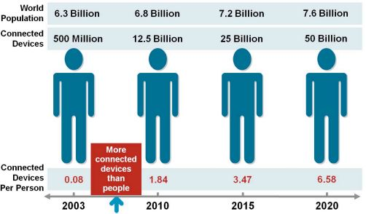
Figure 2 | The Internet of Things status established[12].
With the understanding of these numbers Cisco IBSG estimates that the status IoT was truly established between 2008 and 2009 (Figure 2)[12], the current expansion in the IoT market is extensive. Back in 2011 at the early stages of research and development in to the Internet of Things, Cisco estimated that there would be 25 billion connected devices in 2015.
They also estimated that the number of devices would double in an additional 5 years, making the number 50 billion by 2020 which will mean that there would be six (6.58) connect devices for every person on this planet. Other research organisations agreed at the time with how extreme the growth of IoT would be stating the similar or higher numbers of IoT devices by 2020[18], at Ericsson[19] a telecommunication company the CEO at the time Hans Vestburg also stated to his stockholders at a press conference that there will be 50 billion connected devices by 2020[20].
Soon after IBM[19] forecasted in a press conference that there would be 1 trillion connected devices by 2015[21], this number was seen crazy by many other market researchers and was proven true with Gartner showing that there were 6.3 billion devices connected in 2016 with the market mostly being in the consumer section [22].
Category | 2016 | 2017 | 2018 | 2020
Consumer | 3,963.0 | 5,244.3 | 7,036.3 | 12,863.0
Business: Cross-Industry | 1,102.1 | 1,501.0 | 2,132.6 | 4,381.4
Business: Vertical-Specific | 1,316.6 | 1,635.4 | 2,027.7 | 3,171.0
Grand Total | 6,381.8 | 8,380.6 | 11,196.6 | 20,415.4
Figure 3 | IoT Units Installed Base by Category (Millions of Units)[22]
In the past few years along with Gartner, the other research organisations are also agreeing with the lower and more attainable numbers. Dave Evens currently the CTO of Stringify[19] who wrote the Cisco business paper in 2011 now expects 30 billion connected devices which is 20 billion less than originally researched. Ericsson has also changed their projection stating that they now believe the number of connected devices will be 28 billion by 2021[22]. other firms have also adopted similar numbers IHS Markit[23] has projected 30.7 billion IoT devices for 2020 and Gartner expects 20.8 billion by the same year [18].
Internet of Things isn’t only proving to be the latest technology trend sweeping over the world, it is also shown to be a profitable one for any company or organisation that is directly part of the IoT industry. Gartner also mentioned in the press release paper that while consumers purchase more products so too will the business sector in 2017, the combined business IoT expenses represent 57 percent of the total IoT Spending in 2017[22]. In terms of hardware spending, the use of connected things among consumers will drive $725 billion in the same year (Figure 4 on next page). Consumer applications will amount to $1.496 trillion in 2020 which makes up over 50 percent of the combined market, which is a staggering $2.9 trillion[22].

Category | 2016 | 2017 | 2018 | 2020
Consumer | $532,515 | $725,696 | $985,348 | $1,494,466
Business: Cross-Industry | $212,069 | $280,059 | $372,989 | $567,659
Business: Vertical-Specific | $634,921 | $683,817 | $736,543 | $863,662
Grand Total | $1,379,505 | $1,689,572 | $2,094,881 | $2,925,787
Figure 4 | IoT Endpoint Spending by Category (Millions of Dollars)[22]
The future of IoT is still uncertain, but great new things always are and using all these interconnected devices and the big data they will generate it will open unlimited possibilities for organisations and not just within the technology sector. All organisations that utilises and rely upon data and a networking infrastructure will benefit from Internet of Things. The profit for these organisations comes from research and successful identification of the opportunities that IoT can offer them and having the knowledge of how to capitalise on the use of this latest technology.
Evident by the scale of growth and interest with Internet of Things, the concept of the technology has been changed and adapted so that it can be used in several different and unique situations due to IoT being simplistic and adaptable by design. To help better understand IoT, listed below are situations in which the technology is used to improve that area.

2.3 Wireless Sensor Network (WSN)
The implementation of Wireless Sensor Networks (WSN) has covered a variety of fields in industry as well as the consumer market and it is considered one of the most important technological advancements of the 21st century[2]. This possibility being achieved with the recent advancements in microelectronics and wireless communication, the sensors have become small, inexpensive and intelligent to the point where they can be deployed physically anywhere in the world even places deemed unsafe for humans. The concept of Wireless Sensor Networks was the start of Internet of Things[24], but since the recognition from the early 2000s of IoT they have been developed in parallel to one another in many circumstances being considered one and the same. This was due to both WSN and IoT being schemes with the purpose of developing an “internet-like” structure that is integrated and applied to everyday devices and objects[25] and as this technology matures the cost of its components as with all technology will drop dramatically and its application move from military to commercial. This is in coexistence of standards for WSN technology being developed such as Zigbee[26] and 6LoWPAN[27].
With how the infrastructure of internet is designed a Wireless Sensor Network can provide unparalleled opportunities for application in the areas of military, industry and consumer. As mentioned in the previous section the concept started in the military and is where it saw the drastic development, as the technology was provided the perfect surveillance tool that could be deployed anywhere even environments that military personal couldn’t remain at such as areas with high levels of radiation[25].
But with the evolution of IoT that is changing to consumer side with companies such as Nest[28], who are solely investing in the development of Internet of Things for the consumer and the advancement of the Smart Home. Notable from the other wireless communication networks including cellular systems and mobile ad hoc networks (MANETS)[29], WSN relies on having a certain uniqueness to them over the other communication networks. Some of these being able to consist in harsher levels of node deployment, advanced unreliability of sensor nodes as well as its energy computation and storage limitations[30], [31]. Wireless Sensor Networks has been a key field of research in the Information Technology industry for the past three decades, this has been to explore, determine and solve the limitations in the design and deployability so far, the application of WSNs has been limitless and has already revolutionised the way humanity lives, works and interacts with the physical world[32].
According to a Whitepaper done by the International Electrotechnical Commission the largest demand for Wireless Sensor Network comes from industrial organizations. “The Freedonia Group, the global market share of sensors for industrial use is 11 billion USD, while the cost of installation (mainly cabling costs) and usage is up to more than 100 billion USD. This high cost is the main issue hindering the development of industrial communication technology”[32]. But going from the information in the previous section with IoT on the rise the demand is quickly shifting over to the consumer side of the market. The use of Wireless Sensor Networks has allowed for an omnipresent awareness, over an entire process no matter the scale as well as a reliable security. These are not given by other monitoring technology due to the differences in cost that was stated above, another report confirms this stance.
On World an IoT market research company stated in a report that between 2011 and 2016 wireless devices that would be installed in fields of industry would increase by 553% this would equal 24 million wireless sensor devices added to a worldwide network[33]. From 2017 it is believed from IoT researchers that every organisation, business and consumer will use at least one form of wireless sensor network, the demand for this technology has been the same for the past few years. Currently new buildings are being constructed from office building to family homes with more construction companies implementing WSNs and the idea of Internet of Things directly in to the architecture of the building and not having it be implemented after by the tenants.

2.3.1 Wireless Sensors
A Wireless Sensor Network is typically created with the using sensor nodes that communicate to a gateway, these sensors are cheap, efficient, have multi-function capabilities and are capable of being deployed in large numbers. These sensors are typically small but have processing and communication capabilities due to the four hardware components that make a sensor node. Generally, the hardware in a sensor node Figure 3 [34] will include power/ power management, a sensor, a microprocessor and a wireless module. The power module as its name suggests offer reliable power needed for the node, the sensor is the bond of a WSN which can obtain the environment as well as the equipment status.
The embedded sensor is in control of collecting and transforming signals such as motion, light, humidity and chemical into electronic signals to then be sent to the microprocessor. The microprocessor receives the data from the sensor and processes it accordingly relative to the data. The Wireless Transceiver (RF Module) would then transfer the data to the controller or gateway that is on the network, which is then sent to an application which can allow physical realization of communication[34].
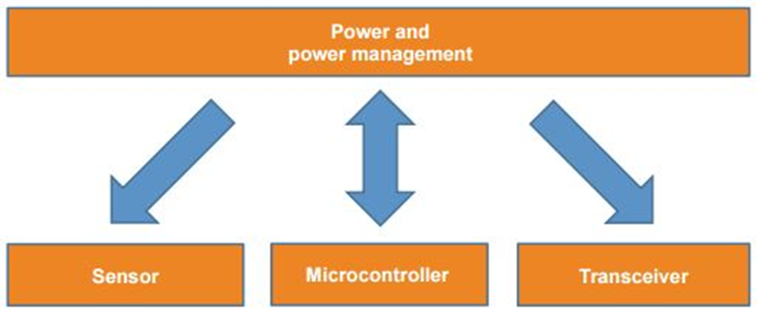
Figure 5 |“Hardware structure of a WSN sensor node”[34].
Compared to other wireless communication technology that was previously mentioned, Wireless Sensor Networks have the following distinctiveness and limitations[25], [30]:
- Dense Node Deployment – These sensor nodes are usually deployed in several fields of interest compared to MANET, the number of sensors contained within a network are capable of being several times higher in scale.
- Battery Driven Sensors Nodes – Most nodes that are used in a network are powered by battery, in a few situations the sensors are used in harsh or dangerous environments. This is useful in mobility but makes it difficult when the batteries need to be replaced or charged. These sensors are now commonly seen as part of Smart Home IoT.
- Self-Configurable – Wireless Sensors are usually deployed randomly without any predetermined plan or idea of engineering, once deployed the sensors will have to autonomously configure themselves in to a wireless communication network.
- Application Specific – Nodes are specific to the application they are running, this requires the network that holds the sensors to be designed for this purpose and if there are any changes to the application and network, the design will need to be changed.
- Data Redundancy – In most networks that use sensors they are deployed in large scale within areas of interest to collaborate, so that a common task can be completed. Consequently, the data that is picked up by multiple sensors will have a level of link or redundancy depending on the values of the situation.

2.3.2 Wireless Sensor Network Technology
As with any technology of this scale there are several forms of that technology, an example of this would be miniaturisation technology of sensor-based MEMS which the actual size of module being only 2.8 mm × 2.1 mm[35]. This technology has made noteworthy progress in recent years, the core aspect of this technology is to realise the combination of microelectronics, micromachining and the packing technology. Different level of micro-sensitive structures can be produced using this technology, which can be the miniature sensing element. These miniature sensing elements associated power supply and signal circuits can be integrated into a MEMS sensor. There are many types of MEMS sensors that was developed at the University of California Berkeley, including velocity, acceleration, pressure, strain and electricity to only name a few[35].
Another form is Access Network Technology, the range of this access network is anything from a few hundred meters to several miles and includes all the devices between the backbone network and user terminals. This part of the network is also called “the last mile” and because the backbone of a network usually uses optical fibre infrastructure with high transmission rate, the access network has become the bottleneck for the entire network system[34]. As depicted in the figure below, due to the open property of wireless channels conflicts will happen in time, space or frequency dimension when the channel is shared. The functionality of the access network technology is to manage and coordinate the use of wireless channels to ensure interconnection and communication of multiple users on the shared network channels[34].
The distance and speed of access technology can be categorised in to these four classifications, Wireless Local Area Network (WLAN), Wireless Metropolitan Area Network (WMAN), Wireless Personal Area Network (WPAN) and Wireless Wide Area Network (WWAN). Though the developing trend of high transmission rates is not suitable for the application requirements of WSNs, the main reasons for this are as follows.
The working environment for WSNs are typically quite severe, the bad environment with the narrow-band multi-frequency and interference can make the reliability of communication an urgent problem that needs a resolution. In terms of real-time capability and applications for WSN and IoT they have stricter requirements than the others, a small latency within this can lead to major misfortunes. Consequently, real-time communication must be guaranteed in many of its application of this technology, lastly low energy consumption is a key to support the long flow of independent battery-powered devices as well as to reduce the cost of maintenance.
This is also another requirement needed for WSNs and IoT application, especially for the devices with batteries that are difficult to replace ether due to the form of battery or where the device is located. Giving to the requirements specified for the current WSN application, the development of access network technology has already made noteworthy progression. The representative access technologies that are more systematic and noteworthy are Bluetooth 4.0 oriented towards medical WSN, IEEE 802.15.4e[36] oriented towards industrial WSN and WLAN IEEE 802.11[37] in view of the IoT.

2.3.3 Wireless Sensor Network Standards
To enable the development and applications of Wireless Sensor Networks worldwide, there is a necessity for engineering a large low-cost marketplace for the sensor products in the field. Out of this necessity it is vital to specify any relevant standards so that any sensor products that are manufactured with different companies have the capability to interoperate. Hard work has been made and are continuing to be in many standardisation organisations to combine the market, with this it would lead to low-costing interoperable devices as well as to avoid the possibility of profiteering of proprietary incompatible network protocols. In a certain way, the success of WSNs as a worldwide technology that is easily attainable will largely rely on the accomplishment of these standardisation efforts[30].
IEEE 802.15.4 Standard
Being developed by the Institute of Electronic and Electrical Engineers 802.15 Task Group 4 [38], this standard specifies the physical and MAC layers for low-rate WPANs. As defined in the Project Authorization Request, the goal of this Task Group is to provide a standard for the manufacturing of senor nodes including its components being described as “ultralow” as well as being capable of low-data rate wireless connectivity and being inexpensive. The release of this standard was in 2003 and was made freely accessible, being distributed on the Task Group 4 website[39]. This protocol stack of the standard is simple and flexible, not being restricted to any infrastructure. The standard features are as followed[39]:
- Data rates of 250 kbps, 40 kbps, and 20 kbps.
- Two addressing modes: 16 - bit short and 64 - bit IEEE addressing.
- Support for critical latency devices.
- CSMA - CA channel access.
- Automatic network establishment by the coordinator.
- Fully handshaking protocol for transfer reliability.
- Power management to ensure low - power consumption.
- Some 16 channels in the 2.4 - GHz ISM band, 10 channels in the 915 - MHz
The standards of IEEE 802.15.4 on the physical layer has been specified to coexist with other IEEE standards for wireless networks, including the standards IEEE 802.11 (WLAN) and IEEE 802.15.1 (Bluetooth). Features of the standard also include the capacity to active and deactivate the radio transceiver and the transmission of packets on the physical medium. The standard operates in one of the following licence free bands[39]:
- 868 – 868.6 MHz (e.g., Europe) with a data rate of 20 kbps.
- 902 – 928 MHz (e.g., North America) with a data rate of 40 kbps.
- 2400 – 2483.5 MHz (worldwide) with a data rate of 250 kbps.
The MAC Layer provides data and management services to the upper layers in the stack, as well as basic security mechanics. The data facility of this permits transmission and reception of MAC packets over the physical layer. The management services cover several things including, synchronisation, timeslot supervision and association of devices on to a network[38].
ZigBee Standard
With the IEEE 802.15.4 standard only defining the first two layers being the physical and MAC layer another standard needed to be develop on top of the previous layer to include upper layers. The Zigbee standard[40] was developed to include the upper layers being the Network and Application layer. The function of the network layer is that it provides network functionality for the different network topology and the application layer is to provide a framework for distributed application development and communication. These two protocol stacks can be combined to one another to support short-range low transmission speed communication within battery powered devices. It is these standards that are used in home automation including the Philips Hue lighting devices.
The Zigbee protocol stack was a concept at 2004 when it was proposed at the end of that year by the Zigbee Alliance, which is an association of companies that work together to enable a reliable monitoring sensor device that is based on an open worldwide standard. This protocol was also revised at the end of 2006, which introduced extensions to the standard as well as improvements both of these releases are available from the Zigbee website[40].

2.3.4 Wireless Sensor Network Topology
Wireless sensor networks have noticeable advantages over their wired sensor counterparts, they not only reduce the cost and time in deployability. They can also be deployed in to almost any environment, especially in situations where power supplies or communications can be cabled. Wireless Sensor Networks as with most technology was motivated for improvement by its military application, similarly as with most technology it is adapted from its military use to be used in commercial and civilian fields.
As stated previously a Wireless Sensor Network consists of a few sensor nodes, a gateway and a way to monitor and interact with the nodes typically this is done over the internet. When a Wireless Sensor Network is first deployed it usually follows a certain process, firstly the placed nodes will broadcast their status at the time to all local devices as well as receive the same from other nodes. Secondly, the network of sensors will organize autonomously in to a converged network based on a topology, such as Star, Tree and Mesh. Lastly, suitable data paths are established on the network ready for data transmissions of the sensed data[41].
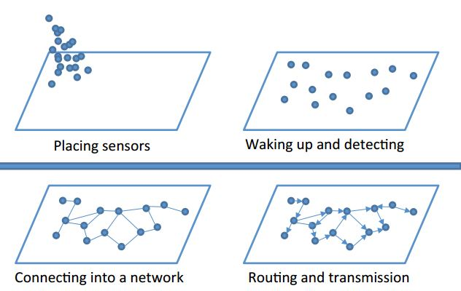
Figure 6 | Diagram showing the deployment of a Wireless Sensor Network[99].
In more recent times the use of Wireless Sensor Networks has been used in homes and offices, as part of the Internet of Things initiative and as it being an influenced trend. Due to how simplistic and inexpensive it is to implement WSN many smart devices such as lighting, heating and security are monitored with sensors. This has proved to be a sufficient way to lower cost, energy and human resources.
The technology of wireless communication is currently the most used for of technology, with Internet of Things (IoT) more and more objects are being given the upgrade to have it be connected to the internet. This project lies in the field of computer networking, which is the foundation at which Wireless Sensor Networks are implemented with. This field of networking is an interesting field that is necessary for the development of Internet of Things and other fields that require moderation. There are still fields that require the research and development of WSNs, for example there was a study done in 2015 and in 2016 for the use of wireless sensor networks to care for the elderly in smart homes[42], [43].

2.3.5 Design Issues
A lot of challenges come under the deployment of sensor networks, these issues supersede those typically found in wireless ad hoc networks. These sensor nodes wirelessly communicate over links with no infrastructure, an additional challenge to these relate to the limited and usually non-renewable energy source of the node[44].
For the networks lifespan to be maximized the protocol and standards need to be designed with the foresight of efficient energy management[31]. Wireless Sensor Network design issues are mentioned in several reports[45], [46] additionally the different platforms for simulation and testing are discussed in these papers[47]. Noteworthy issues are as followed[44]:
Scalability
Sensor networks have the capability to vary in scale from several nodes in relatively small areas to potentially several hundred thousand that could cover a region, additionally, the deployment density can also vary. For collecting high resolution data, it is possible for the node density to reach the level where a singular node has several thousand neighbours within its transmission range. The protocols deployed in sensor networks need to be scalable to these levels and be able to maintain adequate performance.
Fault tolerance
As stated previously, sensor nodes are frequently deployed in dangerous zones and are vulnerable to the environment. Nodes can fail for several reasons not limited to hardware problems, physical damage and loss of power. While it is expected that node failures are going to be higher than the ones used in wired or infrastructure based wireless networks, the protocols deployed on a sensor network should have the capability to detect these failures as soon as possible. The sensor should also be robust enough to handle large scale failure within the network while keeping the overall functionality of the network intact, this is especially relevant in routing protocol design for packet path rerouting with the different deployment options being considered for fault tolerance requirements.
Hardware Constraints
As mentioned earlier in this section every node is composed of four modules a sensor, a processor, transmission capability and a power supply. Optionally, a sensor node can have several additional devices connected such as a localisation system to enable location aware routing and other location-based services. These additional functions would come with an increase in both cost and power consumption and even possibly size depending on the case utilised by the node. Additional functionality must always be in the process when trying to balance function against cost and low-power requirements.

2.3.6 WSN Security
There have been many Hollywood films over the years that depict how the future will look and with Internet of Things many of what was seen on the silver screen has happened to some degree. A common themed that is shared by IoT and Hollywood is that the machines become imposing within a highly automated society. The query of privacy and security for the individuals within a society become more difficult as the complexity of creating a level of security is infinite and the overall level of security is always measured by its weakest part. With the implementation of IPv6 there is going to be enough IP address to support the next evolution of the internet and the billions of IoT devices that will be connected in the years to come[34].
The question that comes with IoT and WSN is to whether it is possible for it to be secured to a level that can ensure individual privacy rights and secure the networking systems from malicious attacks. Typically for network security standards the CIA Triad is used, which is designed to protect the confidentiality, integrity and availability of network data. Its purpose being to make a system reliable and protected against malicious attacks that can cause malfunctions and loss of information. As Wireless Sensor Networks have characteristics beyond a typical network additional protection is needed. These special requirements being Trust, Security and Privacy (TSP)[34].
Trust, Security and Privacy
Depending on the application scenario Wireless Sensor Networks may require security protection of integrity, availability, confidentiality, non-disclaimer and user privacy, its support systems are capable of integrity and reliability through protecting the system from malicious attack[34]. TSP Wireless Sensor Networks will always need to protect the nodes in the network against tampering, to protect the communication channel and the routing of the network layer[48]. TSP logging/ auditing functions are a necessary requirement to detect attacks. The technology that is used within TSP WSNs comprises of encryption, access control message authentication and identity authentication. The TSP necessities of Wireless Sensor Network may be categorized as the following: node security, crypto algorithms, key management, secure routing, data aggregation[49], [50].

Node Security and Sleep Deprivation
It is possible for a WSN node to be interfered with either via its logical interfaces or by directly attacking the physical device, it’s also within reason that the node can be relocated without authorization or in another description being stolen. A node will have built in security that can contain a secure wakeup and bootstrap, a low duty cycle is fundamental in ensuring a long lifespan for a node powered by a battery. There is a special kind of Denial of Service (DOS) attack that is named the Sleep Deprivation attack[51], this attack prevents the sensor node from going in to a sleep, decreasing the time in power saving mode and in doing so severely lowers the nodes lifespan[34].
The typical security standards such as message authentication and frame encryption do not protect from the mentioned attacked, the node is powered up and energy is spent for on data collection and processing. The attack is only detected when the battery has been drained of power, in the figure below it depicts a node that has the additional low power and wake up radio[34].
The wake-up radio listens on the channel when the sensor node is in sleep mode and is used to trigger a wake up on receiving a specific signal. To add security to sensor nodes wake up signal, that signal is encoded, this is due to the signal being unique only used once and specific for each node, it can be sent in clear when waking up a node[52].
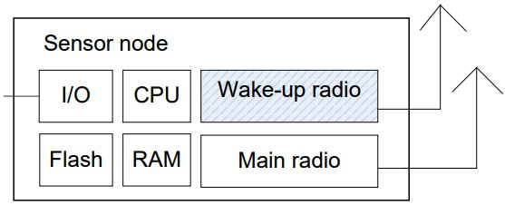
Figure 7 | Secure wake-up radio[52].
Crypto Algorithms
Encryption is a form of special algorithm that is used to change the information of the data sensor node from its original state to something that would make an unauthorized user not able to recognize that information even if the user had access to the encrypted information[34]. WSNs within the public infrastructure are inevitably unprotected to the scope of activities within the public, traditional message authentication code such as, symmetric encryption and public-key encryption have already showed their limitations[53], [54].
This meant that an encryption system, which is appropriate for WSNs was needed to be developed and proposed. In 2010 the Spanish company developed the Waspmote encryption libraries to secure the WSN data within the city of Barcelona, these libraries are designed with different encryption and consultation mechanism at the same layers used within Zigbee and IEEE 802.15.4 standards.

Secure Routing of WSNs
As Wireless Sensor Networks use multi-hop in data transfer and self-organising networking, each node must also require routing discovery, routing establishment, routing maintenance. Securing the routing protocol so that nodes may complete effective routing decisions are a prerequisite for aggregation and redundancy elimination from source node to sink node. There have been many secure routing networks that have been specifically designed for WSNs, these can be divided into three categories according to the WSN structure. flat-based routing, hierarchical based routing, and location-based routing[55].
Methods used for secure routing protocols can include procedures based on feedback information, location information, encryption algorithm, multipath selection method and hierarchical structures. Different secure routing protocols can be used to deal with different types of attacks[55] including, secure routing protocol that utilise feedback information that can contain delay, location and excess capacity in acknowledgment frame of the media access control (MAC) layer[34].
Even though not using encryption, this method of security can counterattack common attacks such as false routing information and wormhole. Currently most routing protocols will assume that the sensor node is in a fixed location, which means that newer routing protocol need to be developed to satisfy sensor node that require mobility[56].

2.4 What is a Smart Home
Smart Home[57], [58] also referred to as Home Automation is a term used to define Internet of Things within the home, much like how it is created in other fields a smart home is created by installing a Wireless Sensor Network that is a part of the standard home network. The WSN within a home is mainly used as a quality of life improvement, being able to control lighting, heating, doors and windows using “intelligent” devices. Back in 2003 when industry was recognising IoT technology the UK Department of Trade and Industry (DTI) decided on this definition for a smart home: "A dwelling incorporating a communications network that connects the key electrical appliances and services, and allows them to be remotely controlled, monitored or accessed”[59].
There have been many concepts of what the “home of the tomorrow” would be like, going all the way back to the late-1950s with companies like Disney and Ford motors building their versions of the “home of tomorrow”. Monsanto House of the Future located at Tomorrowland an area within Disneyland California[60]. The concept that was the most accurate was done by Microsoft in 1999, called the Microsoft Home it was a short video showcasing Microsoft’s idea on what a smart home can do[61], [62].
Many of the capabilities showed in the video have been developed from biometric locks to automated lighting, but there are build aspects that are different due to technology advancement. For example, the Microsoft home used a computer as the central hub for the house, these days a smart home hub is controlled or managed via an application installed on smartphone or possibly a tablet.
The origins of the smart home we have today came from a protocol that was developed by Pico Electronics in 1975 called the X10[63]. The protocol allowed for 120 kHz Radio Frequency (RF) bursts of digital information to be transmitted through a home’s existing electrical wiring to programmable outlets and switches. The information would contain commands that would control how and when a corresponding device is operated for example, a signal can be sent to tell a device to turn on at a specific time[58]. The X10 protocol had a few problems including its high vulnerability to interference and only being a one-way form of communication only allowing commands to be send. An update was developed to allow two-way communication but came at a much higher cost.
It wasn’t until 35 years later in 2005 that the home automation company Insteon introduced other technology that used both electrical wiring and wireless signals for communication. Since other protocol that are now common to IoT and Smart Homes were introduced including Zigbee and Z-wave, both protocols were developed to overcome the problems of X10 and are widely installed in to the latest smart devices as their communication protocol.
More home automation companies started around 2010 this included the company Nest this company released its first smart device the following year with a “Smart” thermostat and since has launched other devices including smoke detectors and security devices. Most recently large technology companies such as Apple, Google, Amazon and Microsoft have either purchased or developed a home automation department under their respected company.
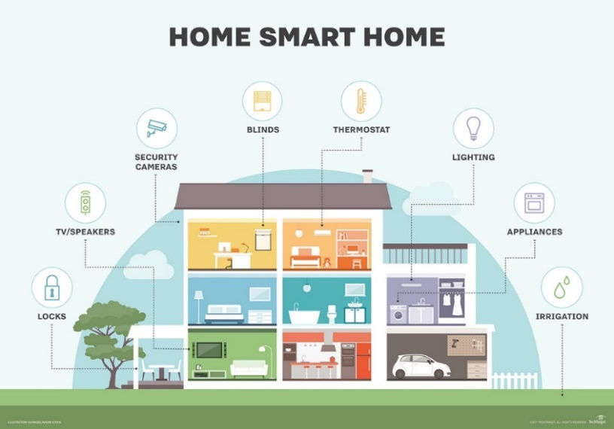
Figure 8| TechTarget diagram of home automation capabilities[58].

As shown in the figure above home automation technology has nearly covered every aspect of life, with the introduction of a smart home alternative the list below states the most well-known instances[58]:
- Smart TVs connect to the internet to access content through applications, such as on-demand video and music. Many modern smart TVs also include voice or gesture recognition.
- Smart lighting systems not only have the capability to be controlled remotely, the system can also detect when occupants are in the room and adjust lighting as needed. Smart lightbulbs can also regulate themselves based on daylight availability, a system that uses this is the Phillips Hue[8] smart lighting.
- Smart thermostats, such as Nest from Nest Labs Inc., is on the more expensive side of smart homes. Using integrated Wi-Fi, the thermostat can allow users to schedule, monitor and control home temperatures remotely. These devices are also developed to learn the homeowners' routine to automatically modify settings to provide residents with maximum comfort and cost efficiency.
A clear benefit of having a smart home is the peace of mind that the homeowner or tenant has using this technology, forgetting to turn off the heating or ensure the front door is locked can now be done just by checking your phone at any location be it at work or away on holiday.
Another benefit is improved efficiency the way smart homes were first advertised and are still now is this reason, being able to wake up in the morning and with a simple voice command, the lights would turn on, the tv or radio will turn to your chosen channel and the coffee maker will start brewing. This saving the person time in not needing to do it themselves, but these possibilities are limitless and capable of doing more than what this example states.

2.4.2 Home Security
For home automation systems to be truly effective, the devices must be interoperable no matter who is the manufacturer. This is by using the same protocol or minimum complementary one, the current market is quite promising, but there is no unified IoT standard for home automation yet with each manufacturer communicating with its own devices. However, standard alliances such as Zigbee are partnering with manufacturers and protocols to ensure interoperability and a seamless user experience. For example, the smart home assistants such as the Google Home can communicate with Phillips Hue lighting using voice commands instead of the Hue mobile app.
This lack of standards leads in the main downside to Smart Homes and while security for Wireless Sensors networks have already been talked about a major concern still for consumer is the security of their data that is collected within the smart home. A report that was done in 2016 by the Japanese system integration company NTT Data found that 80% of U.S. consumers are worried about the level of security for their smart home data. The concern comes from the base knowledge that a hacker with malicious intent could gain unauthorized control over the IoT network and in doing so gain control to the house including, lighting, heating and if installed having the possibility to unlock the front door. Hackers could also use the Smart devices to gain control of the home network leading to worse outcomes including the collection of personal data such as bank accounts. In late 2016 the Mirai IoT botnet[62] was able to bring parts of the internet using a Distributed Denial-of-Service attack using smart devices with bad security as entry points.
Furthermore, privacy is another worry for the consumer who has already or are looking in to installing IoT, the same report from the NTT Data report stated that 73% of consumers are worried about the privacy of the data that is being shared by their smart devices. While these smart home devices and their manufacturers collect data so that they can tailor new products and improve services, trust and transparency are necessary to manufacturers to build a trust with the customers[58]. This worry over privacy isn’t being helped when company’s like Facebook have been proven to share personal information on their users to a political consultancy[64].
While the same security measures are being used to secure a smart home as a standard home network via the use of firewalls and antivirus/ spyware software, there are certain cybersecurity companies that in recent years have developed hardware specifically for home that contain smart technology. The leading manufacturer is Bitdefender a cybersecurity company that created the Bitdefender box 2 which according to them the “Bitdefender BOX 2 is the innovative security hub for the connected home. It protects all internet-connected devices in your digital life, at home and on the go”.
The Bitdefender box is physical hardware that has built in anti-malware software, with these tools it scans the network for malicious activity and uses multiple layers of security including exploit prevention, anomaly detection and brute force protection along with local security software that is installed on the users smartphone[65], [66].
To continue with security aspect for Smart Homes another reports also done in 2016 by PRPL a computer industry company named the “Smart Home Security Report 2016" outright stated that smart home is not secure and that it is the residents lack of knowledge of technology focusing on the Gateway within the home. The graphs below are taken from the report and just show the extent that not only does the technology of smart home protection is needed but also the need to make the knowledge of home security common[67].
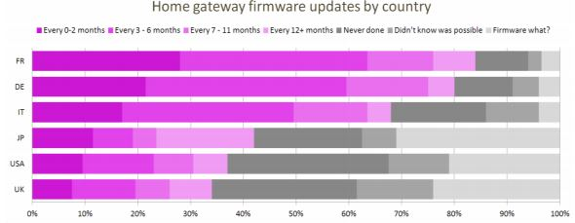
Figure 9 | “Home Gateway firmware updates by country”[67].
This graph shows how often if at all the firmware of a gateway is update, the firmware is responsible for basic functions of the gateway. Not updating the firmware can cause vulnerabilities that hackers can exploit, surprisingly only 57% of all the respondents said that they update their router at least once a year[67].
The next two graphs depict the level of security that is undertaken by respondents of this study, yet again there are high levels showing that mostly no action even basic has been done to the home gateway when an owner receives it and sets it up. This further showing that while advancing the technology for security is correct, the knowledge that goes with it even the basics should be communicated better to consumers[67].

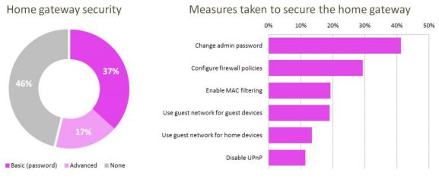
Figure 10 | “Home Gateway security” and “Measures taken to secure the home gateway”[67].

2.5 Home Energy Usage
As the aim of this project is to show that the Internet of Things can be used in the home to save energy usage and in doing so saves the cost for the residents, the following research will include what the is current average energy usage and cost for the past two years. This information is needed for a comparison after the smart home module has been tested, as the experiment will be done in a house located within the UK, that is what the research will focus on and any other data found in only for reference as a comparison for different countries.

2.5.1 Energy Usage
As the average energy usage is always changing it is difficult to find the definitive average of the annual kWh usage with companies and governments suggesting that since its lowest record back in 2014 little has changed. With many of the reports and guides in to home energy usage showing an average in the range of 2000 – 4600 kWh per year, with the UK government showing results of costs being based on a 3800kWh annual usage[68], [69]. The chat below compares the UK energy usage to other European countries and that the UK is the medium for the European energy usage. Using this it can be determined that the monthly average usage can be worked by simple dividing the annual usage by twelve, this would make the average monthly usage 325kWh.

Figure 11 | Average Electricity usage per household annually.

2.5.2 Energy Cost
For the energy cost it is a bit more difficult as every energy provider is having to change their tariffs on regular bases this is for two reasons, firstly is to ensure the company stays in business the company needs to ensure that its making the money required to keep itself running. The second is the customer’s need to return for business, companies change their tariffs to ensure that a customer stays with them as well as attract new customers. For this reason it was decided that the two sources for this information is going to be a nationally recognised comparison site Money Saving Expert[70] and the UK government’s Department for Business, Energy and Industry Strategy[71].

Figure 12 | Chart displaying the standard annual tariff for UK Energy suppliers.
The chart above shows the standard tariff cost for annual energy usage, the information was gathered from the money saving expert website which was last updated March 2018. While due to marketing schemes and other forms of attracting and retaining customers some of these prices can vary, these are the base cost that the companies quote when applying to be serviced by the respected company. In this last update it shows the OVO Energy is the cheapest with a cost of £1,109, but through negotiations and during times of marketplace sales other companies can compete or even charge a lower price.
The table below is populated with information that was provided by the UK government and shows the standard electricity bill for UK household consuming an average of 3,800kWh per year, as well as showing the change as a percentage between 2016 and 2017[72].
 | Standard Credit |  |  | Direct Debit
 | England & Wales | Scotland | Northern Ireland | England & Wales | Scotland | Northern Ireland
2016 | £569 | £573 | £525 | £569 | £573 | £525
2017 | £603 | £604 | £498 | £603 | £604 | £498
% Change | +6.1 | +5.4 | -5.0 | +6.1 | +5.4 | -5.0
Figure 13 | Average annual standard bill based on consumption of 3,800kWh/year[72].

2.6 Internet of Things for Energy Management
Challenged by the increased demand of energy and in turn the high energy costs as well as the constant limitations of energy resources such as fossil fuels, all the situations developed in the eyes of the public as well as on an expert and industrial level restraint both energy demand and Carbon Dioxide (CO2) emissions at a unified point make energy efficacy an absolute priority. In line with this the energy consumption of all buildings represents 40% of the total with Transportation and industry being 30% each within Europe, values of energy consumption can be seen in the previous section[41].
In recent years’ energy usage has been and still is taken very seriously with many public authorities in Europe this was done by countries adopting the Energy Efficiency Directive, which is a set of binding measurements to help the nations within the European Union set up national laws, so they can reach a 20% energy efficiency target by 2020. A few nations within this directive are on point to reach this goal and so has been updated to further improve efficiency to a target of 30% by 2030[73].
Within the IoT industry one of the areas that is developed is energy management, this development has lead a few IoT companies such as Phillips Hue and Nest to create a series of devices and applications. For some companies this area is their largest assortment of devices having the purpose of controlling energy output and lowering energy usage in the home. This development is assisted from collaboration project such as HOMES, which was a four-year program with the purpose of research and testing solutions to provide knowledge of using active control within buildings to optimise energy usage. This test along with other showed similar results that developed a few strategies to maximise building performance while making it smart grid compatible. With smart grids being a current development that can be seen if successful of a way to increase energy efficiency by utilising intelligence between the structure that require the energy and the infrastructure that provides it.
There are three protocols proposed by the programme[74];
- For maximizing the energy efficiency of a building, it is necessary to optimize the facilities rendered to the tenants, in other words at the level of a room or a zone in a tertiary building. Contributes to zone control, the residents can adapt the environment to his or her activities and comfort.
- To serve the needs of the residents of a building, it is necessary to optimize the supply of energy based on the economic and carbon costs. The supply and distribution of energy are then managed as a purpose of the total needs of individual location. Enabling control of the energy sources and the relationship with the ecosystem consisting of the postcode, city, counties etc. This approach is a preparation for when power grids are converted to smart grids when development is complete. This in turn creates a system where each level contributes to optimization at the next level, also developing the demand of management potential for energy in buildings.
- Information strategies must be applied that are customised to the specific needs of stakeholders/ owners and their responsibility for helping to take energy efficient decisions by looking in to all sources to develop an incremental action plan.

2.6.1 Climate Change
One of the most impactful issues facing humanity and one that has many governing bodies and corporations changing their infrastructure and policies is climate change due to global warming. The forefront of this issue is the burning of fossil fuels for energy and the mindset of simple using energy on demand instead of efficiently using only the energy that is required. Internet of Things is pushing the way to help improve energy efficiency with the developments in Smart buildings and the future development of Smart Grids. There are several signs of climate change is happening right now with NASA having a website dedicated to the topic, the website lists evidences stating that the global temperature and sea levels are rising and the decrease of the snow cover in the northern hemisphere as well as the ice sheets decreasing in mass in Greenland and the Antarctica[75].
There are three contributes to the environmental threats first is global warming through the high levels of CO2 emissions, while wasted water and garbage waste are main threats to the environment. In an infographic provided by Telefonica in 2018 it stated that IoT would be an important ally in reducing the impact of the previous mentioned threats one of the statement is that energy management utilising smart meters can reduce climate change impact by 16.5% by 2020. Other statements suggest that for agricultural IoT can save 50% of the water that would typically be wasted by using a high precision irrigation system, also for waste management it is expected that 4 billion would be expected to be saved using Smart Trash Cans, this is evidenced by the city of Barcelona that uses a system much like this[75].
Like with most tends in technology they start an industry and corporate level and work their way to consumers, with companies such as IBM, Microsoft and Google leading the way to utilising IoT to help fight against climate change utilising their own resources and development. For IBM they are utilising a recently created computer called IBM Watson this Artificial intelligence is used in several different fields with IoT being no exception. In the field of IoT IBM Watson is utilised to optimise a range of areas from reducing pollution by calculation efficient traffic route to lower congestion to weather data via satellite imagery to improve crop yield through soil and irrigation management[76]. With Microsoft they are utilising the Microsoft Azure platform to monitor and improve efficiency within company building. This platform can be implement in existing building and across multiple building improving performance not just locally but across a company’s infrastructure[76].
There are companies such as Apple that have already accomplished a state where a high level of energy efficiency is achievable, with Apple it was recently reported that the company is globally powered with 100% renewable energy. it was also stated that the management of energy through wireless sensor technology and the company’s creation of energy through renewable means, has made the Apple Headquarter energy efficient to the point where the comply is providing clean energy back to the power grid[75].
All these factors are helping the environment and as it stands it is still early in development, add to these changes what these companies like Google are doing with Home IoT and the use of managing and optimise residential energy usage, there is no limit to what these improvements can achieve in the improvement of this planet a place that human cannot exist without it.

2.7 Related Work
As this chapter has been for the initial research the areas that cover this project before the experiment part of this project is deigned, a key aspect of this part of the report is the analysis of work and reports that relate to the topic of this project. Due to Internet of Things being the forefront to many in technology research and engineering, the following selection of report are chosen due to their relevance and structure of this project.

2.7.1 Design and Implementation of a Smart Home System [77]
This report was done by Subash Luitel as their Engineering Thesis and was published by the Helsinki Metropolia University of Applied Sciences, the goal of this project was to design and implementation of a Smart Home system. This report is very detailed starting with an introduction that covers the viewpoint of where this report is coming from and noting the advancements in technology as well as the modern society of human behaviour that makes this experiment possible. One of the key points of this project was the use of a mobile phone and how the development of that technology has taken a pocket device that stated as a way of wireless communication to being used as a clock, calendar and recently a way to control a person’s home.
The report goes on the cover the theoretical background and hardware that was used in for the experiment, as this report was written by an engineer the hardware is discussed and explained in detail utilising block diagrams to discuss the hardware. The author of this report starts off with noting that this experiment was completed on the Arduino platform, employing an Arduino Uno which is an open source microcontroller as the central hub of the automation network. Using this microcontroller, the author was able simply attach a GSM/ GPRS module to the Arduino to provide mobile connectivity to the mobile phone using this method avoids the need of using a home’s gateway for internet connection. For the home automation sensors are cabled to the Arduino Uno, these sensors were temperature for heat, infrared for motion and magnetic for intrusion. Each of these sensors were discussed and explained to what they were, as well as what would be there use in the experiment.
After the background the design and development of the system was discussed it started with a brief explanation of the entire system with a visual assistance of a block diagram. Referencing that diagram the author was able to go through the design process bit by bit explaining at each point the responsibility of the hardware to the system and how it was connected to the microprocessor and how it would be integrated to the system through programming the board using the C-language written in the Arduino’s Integrated Development Environment. In addition, each of the sensors also had block diagrams to assist with the discussion of they were attached to the system, this made the design section of this report very easy to follow, without the need of high level engineering knowledge.
Once the system was finished being developed it was deployed and tested, it was noted that all components of the system were fully functional before testing started. But due to the scaling of the system each unit of the application was tested separately with the next unit not being tested until the prior unit giving the expected results.
This was explained as the best way to detect and troubleshoot bugs during testing as instead of having to work out first what unit was causing issues it would be clear as only one is being tested at a time. The last test was done for the GSM module as at this point the home automation system is up and running, this test for mobile communication was done using two phones a Samsung Galaxy S4 and HTC desire.
A terminal program was used to test mobile communication with a few screenshots being used to show a successful test of communication between the home automation and the mobile phones. The results were presented as a table that was sectioned to display each unit with the corresponding results, after the results were discussed and followed by the testing results of mobile communication which also used screenshots as evidence.
The conclusion of the report was informative going back over the goals of the project, the current viewpoint in terms of the systems applications and the understanding that the testing of the system was successful. Even going out to state the addition of what limitation the system has, such as the motion sensor not being able to tell the difference between an intruder to the property and a pet or animal gaining access.

2.7.2 Smart Home Energy Management System using IEEE 802.15.4 and Zigbee[78]
This report was published in the IEEE Transactions on Consumer Electronics and was written by Dae-man Han and Jae-hyun Lim. This report starts off with a similar statement about the technology moving towards the “Smart” management of energy usage and that the focus of the project, the introduction also discusses that the project will be built on the Zigbee platform utilising the IEEE 802.15.4 standard. It goes to give reasonable information on the background of Zigbee and its Home Area Network, it goes on to explain the design of the experiment using a diagram and that the application can be used in a home or light commercial environment.
Much like the current report, this report starts with research in the use of discussing other piece of work that relates to the work being done here, the related work is set out in two sections. Firstly, the section discusses briefly the sensing environment technology, what different sensors care and what they can be used for as well as note the benefits of some of the sensors. The second section discusses the Zigbee devices that will be used in the experiment and the data transfer model, the section outlines each build that will be use including the router and end devices. It then goes on to the three types of data transfer transactions that exist and use of the IEEE 802.15.4 LR-WAN standard and the collision avoidance method CSMA/ CA. the design part of the report is in much more detail, briefly providing a scenario for the experiment before going on to the system design. The system design details the use of the microprocessor that will perform the task of the Smart Home, including its size and how the node will be powered.
The sensors are explained and example of what the sensors are for, this section is accompanied by a diagram clearly outlining the setup of the Zigbee Home Network. The report then goes on the explain the routing protocol that will be utilised for the home control network, giving examples of its redundancy applications and it’s on demand approach to make routing paths. The final part of the design is the explanations and detailing of a device binding system which would allow connections of the endpoint devices to the endpoints of the control allowing user control over the network.
The next section of the discusses the development of the control system utilising the device binding systems management function which was explained in the design that uses ZigBee and open source software and hardware allows a system that is designed like this to be very flexible and simple to implement. The next part of this report is how the project will be investigated, unlike the report that was previously discussed this experiment was tested using the Daimtree sensor network analyser. This software seems quite detailed giving the user the ability to view using a visualiser tool to comprehend device behaviour as well as a device view that allows the network to be viewed in a real environment such as a home.
This report evaluates with a simple note of the ubiquitous home network has unlimited possibilities, that the project covered smart home control with the goal of making the home network intelligent and autonomies. It concludes on the statement that smart home does save money and energy creating an encouragement to build home with the idealising of it being a “Green home”.

2.7.4 Design of a Home Automation System Using Arduino [79]
This report was published in the International Journal of Scientific and Engineering Research and was written by Nathan David, Abafor Chima, Ugochukwu Aronu and Edoga Obinna. This report starts off with a brief introduction on the present state on security systems, noting its important role in protecting lives and investment. It goes on to clearly explain what a Smart Home is and its typical purpose of allowing a more efficient control of one home. It is followed up with detailing of home automation, with good examples of what the system could do.
The next section is an overview of a smart home with the assistance of a block diagram, the report goes on the detail a Smart Home with its integrated sensors and the automation to use them sensors to control the home within set parameters. It then goes on to the design of the system using the previous block diagram as a basis. The design explains that the system will be using an Arduino microcontroller as a central server for the home automation system, it then goes on to clearly explain the hardware module and how it will be built. This section shows the build in detail using diagrams to pin connections between boards and sensors, the format that has been used would be it simple with someone of little engineering knowledge to copy this build. Next the report goes on to explain the software implementation of the system using an integrated development environment the system can be used via a mobile phone on an android application as well as through a web browser. After the implementation the report ends with a simple conclusion, stating the purpose of the report and the proposed architecture.
The report then goes to conclude that the system can be used with any android based smart phone and that for future work the author would be looking in to incorporating SMS alerts and to reduce the wiring of the system during implementation by creating a wireless network for communication between the sensors and the home automation server.

2.8 Conclusion
In this section, the research has been outlined in terms of understanding of the field of Internet of Things and the technology that its used in the development of it this including wireless sensors networks and the standards of IEEE 802.11 and 802.15 along with the Zigbee protocol. It has outlined a foundation on the technology of Wireless Sensor Network and home security showing that it is currently not at the level it needs to be but is getting there. Through the related work section, it is shown that this topic has been the subject of research and development for many years and at this point no were near it limitation of what this technology can do. The reports found for this report have giving the author great insight in to how to go about this project as well as motivation to go in the field of software and electronic engineering after this course is completed.
These three reports were chosen as related work due to all of them using the propriety protocol of home automation Zigbee as well as using open source hardware mostly the Arduino microcontroller circuit board. The first thing of note in the relevant work is the use of block diagrams, every report used a block diagram to show the hardware of the home automation network. Two of the report had the author built the system and for this, diagrams showing circuit cabling were used, this made it easier to follow with little engineering knowledge.
The report done by Dae-man Han and Jae-hyun Lim was tested on a simulation and while the design and implementation were perfect, and the use of a simulated environment makes troubleshooting easier. Simulation cannot replace real world or real time testing due the simulation only following what it has been programmed and cannot simulated events such as people having a change in their schedule or the power being lost. So, from this it has been decided that the design and test will be a physical build using example from the report utilising the ZigBee protocol on open source hardware and software very likely being Arduino and Raspberry Pi.

Research Methodology – Chapter 3

3.1 Introduction
This chapter of the report will consider the research methodology and the development method that will be employed to reach the completion of this project. It will be taken in to consideration any ethical and legal issues that are connected to this project as well as calculate any risks and limitations that could affect the project and plan steps to prevent them. The final part of this section, it will be considered how to evaluate if the aim and objectives have been accomplished.

3.2 Research Method
Before the research of this project can be started, an appropriate research philosophy needs to be decided on. In Figure 14, it shows a diagram of the research onion layout, based upon the Saunders et al’s diagram from 2009[80]. This is used to identify the different layers of research which are philosophies, approaches, strategies, choices, techniques and procedures[81].
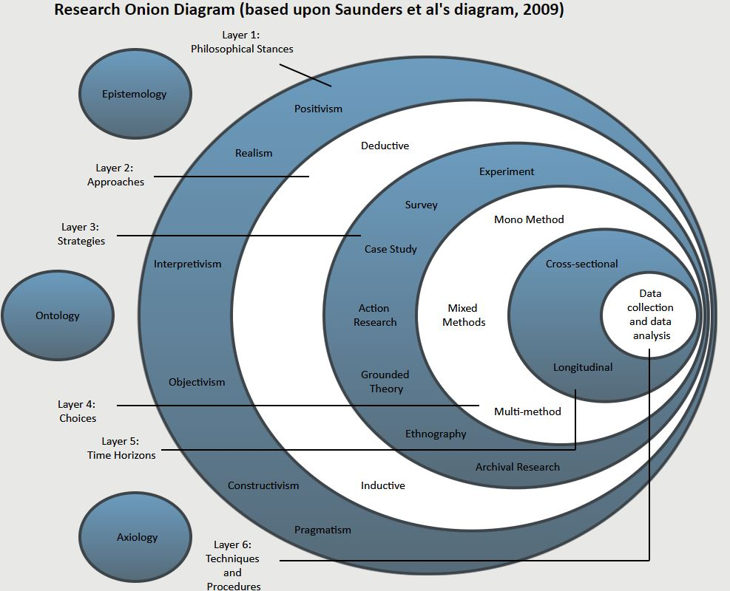
Figure 14 | Diagram of the Research Onion[80].

3.2.1 Research Philosophy
For this project which is designing and developing a Wireless Sensor Network, the philosophy that is best suited for the aim of this project is positivism. It is emphasized that this philosophy creates a hypothesis that can be researched and tested, which in turn will output data that can be measured as acceptable information in terms of its credibility and quantifiable.
Positivism also covers the architypes of objectivist, experimentalist and research that is based on facts rather than impressions and provides a structure for research that can be replicated by others to generate the same results. As this project is to show that energy can be saved in a home utilising Wireless Sensors Networks the outcome of the experiment should come to the same conclusion each time[25], [81].

3.2.2 Research Approach
An appropriate approach on how to proceed with the research now needs to be chosen that compliments the chosen philosophy. The two ways of research approach are deductive and inductive. The inductive approach is on building to create a theory, it takes a focus on what the researcher has as a working title over that of existing theories. In understanding the research of this approach goes from the research question to observation to analysis and then to the final theory. Consequently, if diminutive research exists on a topic then the inductive approach is the way to proceed.
The Deductive approach is the opposite, it is based on analytical using questions and sets on the research to answer those questions. The aim of this approach is to conclude with the direct response of yes or no, the questions can be statements or speculations about a topic that the researcher has confidence in it being answerable. The process of this approach goes from the research question to data collection to results of findings in terms of confirmation or rejection of the research question[25], [81]. This can then lead onto revisions of the research and then allowing the process to be recreated. As this project is aimed at collecting data through an experiment upon reaching the end the project can be confirmed or rejected and even revised based on the data collected during the first experiment, for this deductive will be the corrected approach.

3.2.3 Research Strategy
The project being undertaken can be considered an explanatory study as the aim is to set specific variables to produce quantitative data. Research strategy’s is the most populated section in the Research Onion as the strategies can be used as an individual or even several can be used together. For the project proposed the strategy that seems most appropriate is Experiment, although Archived Research could also be a considered partner or alternative strategy due to the nature of the projects aim and objectives[25].
Experimental design is seen to be the more inflexible and logical strategy giving the opportunity to allow a project to be repeated, this strategy is designed to generate data, and have it been analysed. The aim of this project is to collect data and analyse it to answer if energy usage can be lowered using Internet of Things. As stated previously Archive Research is a strategy that can be an alternative, the research in to Wireless Sensor Networks has been the priority topic in recent times. So, this would allow for exploratory, explanatory or descriptive analysis of changes tracked over this time frame. However, the accuracy and extensiveness of information available may be an issue, depending on the resources available to the researcher and as it is currently an experimental strategy is possible with the time and resources at hand[25], [81].

3.2.3 Research Choice
The data collection methods that will be used for this project is mixed method, this being the best option due to making use of both quantitative and qualitative methods in the study, data collection and analysis. It is noted that using this method can be used to offset and resolve any limitations in data by satisfying or predicting what could be missing through further research[25].

3.2.4 Research Time Horizon
The time horizon that will be employed during this project is longitudinal rather than using cross-sectional. This is to ensure that the testing can be done over a longer time frame, this would allow generation of reliable data and allow that data to be analysed. This will be crucial to show that the results of the experiment are accurate and the conclusion of the project more accurate[25].

3.2.5 Research Techniques
Research technician relate to data collection and analysis, these techniques are depending on the method that has been approached. This process used at this stage of research heavily contributes to the projects overall reliability and validity. Regardless of the approach to the research methodology of a project the types of data collection can be separated into two types those being primary and secondary[25].
Primary data is the data derived from first-hand sources. These sources can include historical first-hand sources and data derived from respondents to a survey or questionnaire or interview. However, it is not necessary that the data is generated by the research that is being undertaken, for example data collected from statistical collections such as a Census can constitute primary data. The difference of secondary data is that it is derived from work or research done by other personal, for example the conclusion of a research paper can constitute secondary data because it is information that has already been proceeded by another. With this however the data is better defined by its use rather than its inherent characteristics of the data[81].

3.3 Research Design and Process
To identify how the experiment is going to be undertaken, the requirement of how to perform the test and data collection will need to be planned. Firstly, this will require background knowledge of the topic, through reports and paper done by professionals of the technology. Secondly, is observation as stated Wireless Sensor Networks have been a priority topic of research and development over recent years, many companies having their own network product that rely on or are integrated with wireless networks. This observation and discussion will generate an initial understanding and motivate ideas that can be used to build the Smart Home.
Once the ideas have been generated on how to design a Wireless Sensors Network and how it can be utilised to control utility with the purpose of saving energy. The quantity data can then be used to generate results, these results can help find and determine conclusive statistical data that can be used to recommend a course of action. As the project is going to be an experiment the course of action after the results could require the researcher the need to go back for further discussion and observation and make the necessary changes to improve it to be the result match the planned outcome.
In research reliability is the outcome of the results being consistent, whilst data collection is taking place. However, no matter the circumstances there is always that chance the results of consistent with reliability can be destabilized. Taken from the book Real World Research[82], the four factors that can threaten reliability are subject or participant error, subject or participant bias, observer error and observer bias. Validity is the concern of whether the data that has been collected is accurately represented what had taken place in the project. Similarly, as with reliability there are a few reasons on why the validity of data can be threatened, going by the same book as before. They are history, testing, instrumentation, mortality, maturation and the ambiguity about casual directions.
Altogether these stated threats can affect the results that are returned, and a loss of validity would not only threaten the data collected but the worth of the entire project. Having determined beforehand to use the mixed method of using both qualitative and quantitative data, any possibility that the reliability and validity of the result are less that what is required is prevented.
There are few risks directly connected to the planning of the project and the build of the Wireless Sensor Network. The risks are as followed;
- Not allowing enough time to build the network
- Poor time management
- Choosing unsuitable sensors
- Choosing unsuitable monitoring software
- Not achieving project requirements
- Limited access to test environments
Microsoft Project will be used to create a Gantt chart, which can provide analysis that should assist in lowering the risks that surround time management through the setting of impractical goals. Using this process is likely to identify a critical path through the project progression to calculate the negatives, this should allow for a more productive time scale to be proposed[25].
The limitation for the project, comes from an absence knowledge and the ability to construct the wireless sensors and program them to communicate within a network. It is likely possible to attain the skills and knowledge in the time of undertaking the project, never the less this could influence the timescale of the project. So, the best option with the current circumstances is to self-learn the necessary skills before the proposed start date of the project or determine if hardware or software that is necessary is already available through purchase or open source[25].
The evaluation that will be done at the completion of the project will be done using a few methods, this will be to gain the most out of the collected data. Analyzation of the project will come during the testing of the experiment comparing the research collected prior to the experiment and the results of the experiment, with the comparison determine if the aim of the project was met. A second analysation will take place at the end of the report noting the entirety of this report and suggesting if the experiment failed, alteration that could be done in the future to resolve anything that could have wrongly influenced the test phase.

3.3 Conclusion
In this section, it has been discussed and chosen the specific research and development methods that will be used throughout the project. Any risks and limitations that can occur during the project time frame have been identified and considerations have been made on how the data collected and the results produced will be evaluated. This methodology process has been fundamental in outlining key areas of the research and going on the design and implementation of the experiment.

Design & Implementation – Chapter 4

4.1 Introduction
As shown in the research chapter of this report the topic of Internet of Things is one that has been heavily researched and developed, many of the trends in technology today are situated with in field of IoT by one or many connection forms. There were so much to choose from and many resources out there to help with this section of designing and implementing a Smart Home network. Due to IoT has a near unlimited use within a home, the aim of this project was focused on two aspects them being to save energy usage and cost, for that reason this part of the report will show what was considered in design the network and how it was implemented.
The design of this project was originally going to include a simulation and a physical model, it was discussed with the project supervisor and determined that the physical model would be more than sufficient in giving the data needed to conclude the projects aim being a success. The reasons for not using a simulation was also due to the difficulty in getting it to produce relevant data at this point the simulation would only be used as a proof of concept but the research and reports from Chapter 2 already show that understanding.

4.2 Physical Design
This section will discuss the designing of the home IoT network, using the research that was completed prior found in Chapter 2. As mentioned previously there is no simulation due to the foreseen limitations, it is also of note that the related work found for this report only one other researcher used simulation while all others used a physical model. Once it was decided that the experiment will use a physical model the hardware and software needed to be chosen, using the reports found through research it was noted that the Arduino platform was the go to hardware for designing and implementing IoT.

4.2.1 Design Parameters
The house that would be used is a 2-bedroom semidetached house, this house only gets in power through the electrical mains via the national grid. The rooms of the house needed to be evaluated and decided if they were going to be a part of the IoT network. After discussing with residents, the rooms that were chosen were rooms that people used on a daily basis. This would mean that for downstairs the kitchen, lounge, and toilet rooms and for upstairs the landing, master bedroom and second bedroom are going to be part of the network. Rooms that are not part of the network are the two storage rooms, the hallway due to its abundant natural light during the day and lighting from the three adjoining downstairs rooms in the night.
The bathroom was also chosen not to be included in the network due to concerns over safety. When the house electrics were renovated a few years ago the switch for the bathroom light was moved to outside of the room, this is due to high levels of water and water vapour in the air in a small space could deteriorate electrical circuits this would include any sensors that would be installed.

4.2.2 Original Design
The designing aspect of this project began as soon as the project did, due to a preference of practical work over theoretical. The initial thought of how to go about this experiment was the same as most other student that had also picked the area of Internet of Thing and that being to build the network using open source hardware and software. An initiation resource to the design of the experiment came from a Cisco Packet Tracer template called Home IoE Implementing. Going from this simulation design and the chosen rooms that would be a part of the IoT network a block diagram was set out using the design inspired by the related work as well as other reports found in Chapter 2.
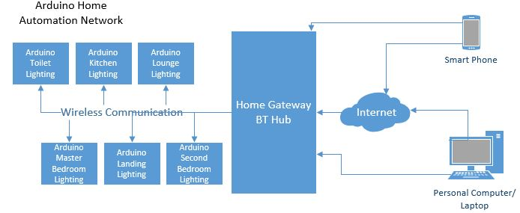
Figure 15 | Block Diagram for Smart Home Network.
From the inspiration taken by the research of this project a few sketches were made before deciding on using a block diagram for the initial Smart Home network layout which was drawn using Microsoft Visio software. As displayed in Figure 15 the diagram shows each sensor being connected wirelessly to the home gateway, this is the main part of the Wireless Sensor network mentioned in Chapter 2. For this project the gateway is a BT Hub version 5 that was provided by the ISP, as with current wireless technology there are 2 ways to have devices communicate to the home that is either direct connection to the local network or remote access through the internet. It is known that software allows for home automation within and out of the home and that was taken in to consideration during the planning.
With the idea of how the network layout is going to be the next step was deciding on the sensor design, as shown on the next page in Figure 16 it was decided that two sensor types would be used built on the Arduino platform. Both sensor types will be built on an Arduino Uno Microcontroller and each have a Wi-Fi Shield attached directly to the board, this would give the systems wireless communication capabilities. Both boards would also be fitted with a display to read out relevant information as well system status.
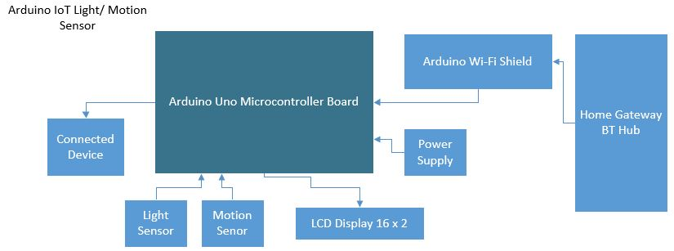
Figure 16 | Block Diagram for Arduino Light Sensor.
The light sensor board will be fitted in each of the chosen rooms and would utilise a light and motion sensor, these would be used to determine if the light in the room was needed. For example, if someone walked in to the room the motion sensor would detect this and turn the light on and if no motion is detected after 5 minutes the light would automatically turn off which is the energy saving aspect of the system. Another example with the light sensor is if the motion sensor picks up a person but the level of ambient light is sufficient for the room the light will not turn on as its not deemed necessary by the system. This system would be connected to the rooms light switch to provide control either with a direct link to the switch or an RF receiver.
This design started off well with components for the build being cheap and software being available to program the IoT home network building the network was planned to start a few months after the project began. When work on the build began it was clear the level of technical knowledge that was needed was high to attain, while the field of engineering was very interesting and at times a distraction from the project it did distinguish that the time frame to build this project was too short for the scope of the system intended. It was then decided that the project design will need to be revised for this situation.

4.2.3 Revised Design
It was discussed around a third in to the project time frame about utilising other means to get an effective IoT network in which the aim of this project could be achieved. Through these discussions it was decided that due to where technology is and the consumer market, that the wireless sensor network would be constructed of consumer-based products. With this change it was seen that the field is abundant with reports and papers from students and people of the industry who have built their own Smart Homes through open source technology. This doesn’t seem to be the case with consumer products especially now as products of this type have been strongly available the past decade from retail stores.
This design though will still need a way to monitor the system and collect the relevant data on whether the system is affective in its purpose and attaining the aim of the project. For that part of the project, it was decided that this part of the system would remain being built to show what has been learnt through this project’s time frame. This part of the experiment will be discussed more in detail in the implementation part of the project.
With this decision made changes to the experiment were needed, first the budget for the equipment was to be increased to £1000 due to the higher expected cost for consumer product over single IoT components. The next step was to look at each of the chosen rooms and pair them with the relevant IoT products, to where the aim of the project would be achieved. The following table was created based on prior knowledge of the market, due to an interest in this area of the industry and knowing those who have already started something like this on a smaller scale.
Room | Lounge | Kitchen | Toilet | Landing | Master Bedroom | Second Bedroom
Voice Control | X | X | X | X | X | X
Light/ Motion Sensor Control |  | X | X | X
Figure 17 | Table Showing IoT Control per Room.
For the utility control two devices were chosen for the home automation, these were the Philips Hue Smart lighting and the Google Home. The Philips Hue[8] was chosen due to its strong reliability and management over a large number of light fittings, while not the only manufacturer of Smart lighting. The Hue system uses a central bridge which acts as the processor for the lighting system utulising Zigbee (See Chapter 2) for communication between the bridge and any connected hue devices such as the Hue bulb and Motion sensor.
The Hue bridge supports up to 50 Hue bulbs which is sufficient for a 2 bedroom house, each of the Hue bulbs provide 806 Lumen and have an expected lifespan of 1000 days of constant use. While the hue supports traditional toggle and push switches for control, this system will use the wireless Hue Motion Sensor for control in a few of the rooms. The motion sensor is as named, once motion is detected the light will switch on and after a preset timer expires with no motion the light will switch off. The sensor is also assisted by a daylight sensor so even if motion is detect, but there is ample daylight in the room the light will not switch on saving energy.
While the IoT system can be controlled anywhere with internet access using the respected manufactures Smart phone software an alternative for the control was considered for certain situations. These were if a resident didn’t have their phone or if a guest and other residents didn’t have the software availible to them, this control would also allow the control of the IoT system anywhere in the house. With the growth of voice assisted home automation devices is was decided that a Google Home[83] would be installed throughout the house.
Same with all IoT products there are a variety to chose from Google home was chosen due to its provided services and considered higher level of intelligence over others on the market. Though its primary function is to provide ease of life through information provided such as weather, calender details and anything that can be asked to Google. The Google Home also has home automation fuctionality allowing for the devices to be synced with third party devices for vocal command based. The layout of the IoT system and relivent devices are shown on the next page in Figures 17 and 18.
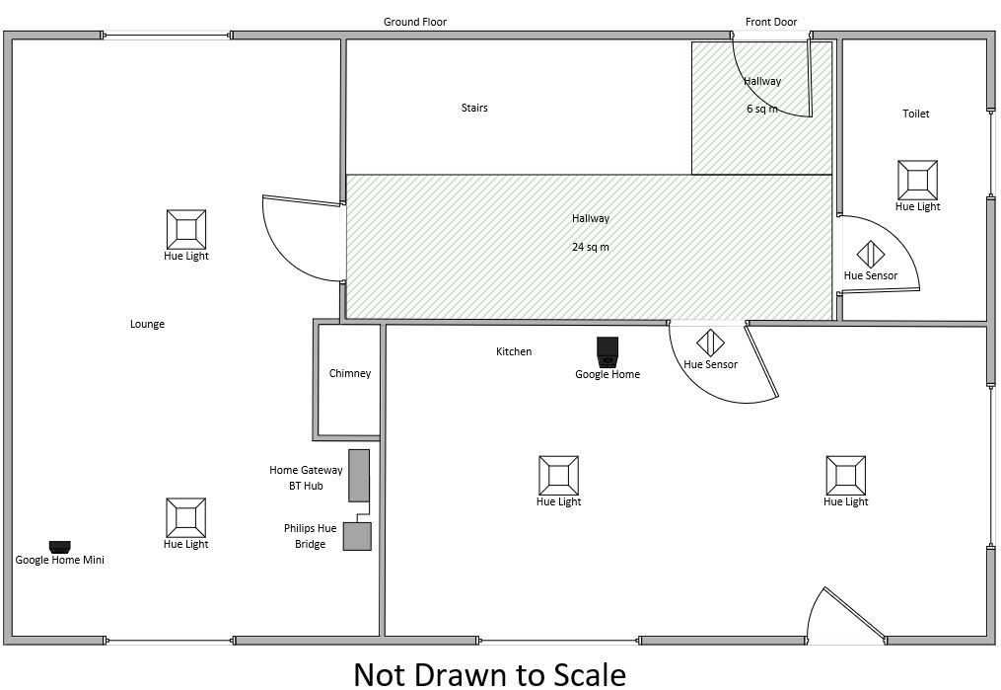
Figure 18 | Layout of the Ground Floor Wireless Sensor Network and Home Gateway.
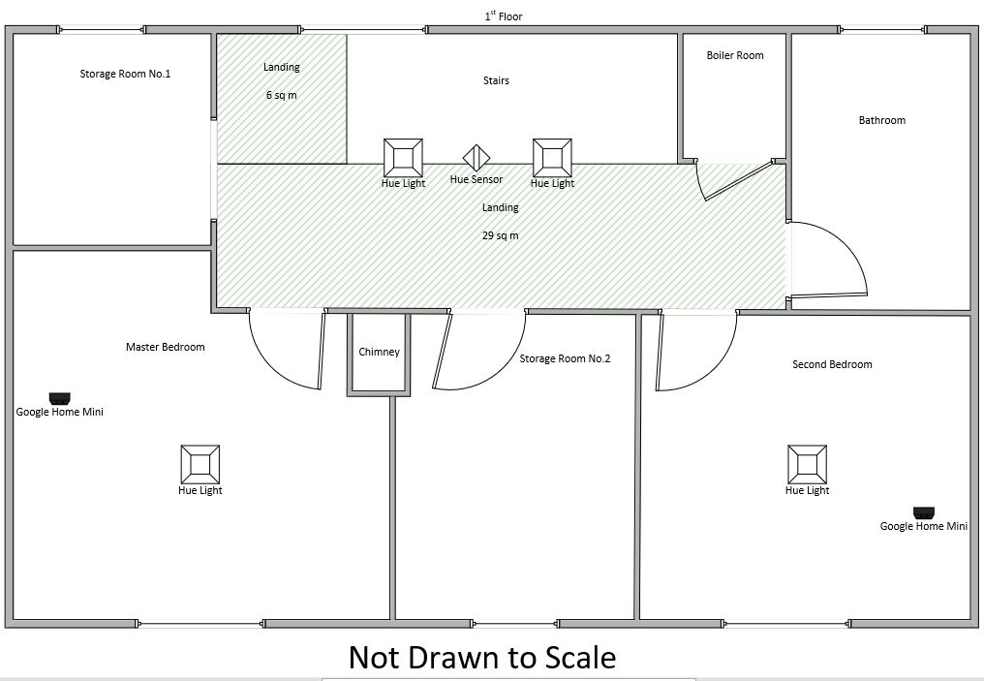
Figure 19 | Layout of the 1st Floor Wireless Sensor Network.

4.4 Physical Implementation
The implementation of this project started after the devices mentioned previously were bought, it took roughly three weeks to install the IoT devices around the house. This implementation time frame was dependant on the delivery times of each device, as a few retailers were used in purchasing the devices due to stock availibility and delivery times due to it being close to Christmas. The first set of devices to arrive were the Philips Hue starter kit, Hue bulbs and Hue sensors.
Following the layout design, each bulb was installed in its designated light fitting and the lights turned on. The Hue bridge was installed next to the Home Gateway and connected as instructed in the user manual via an ethernet cable. The software was installed as shown below and each of the bulbs were connected to the Hue Bridge and named, these names allow each bulb to be identifiable through the software and Google Home voice commands. These names also allow for organisation by listing each bulb in to pre set room groups, such as Kitchen and Landing as these rooms use two Hue bulbs.
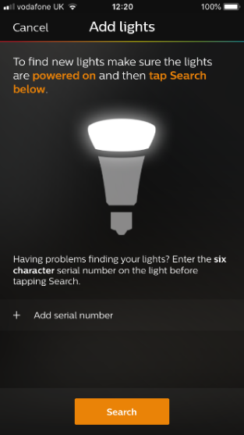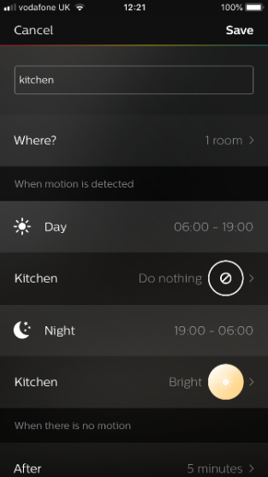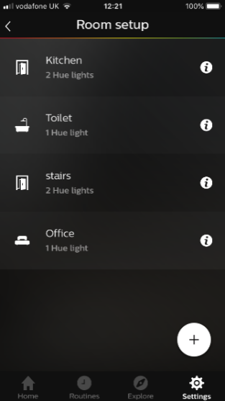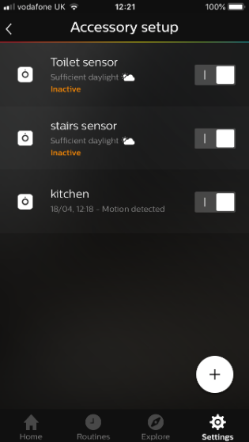
Figure 20 | Setup of Hue Lighting System with Smartphone Software.
After the bulbs were syncronised to the bridge via the Hue software shown above, the motion sensor were installed into their planned location. Each of the Hue motion sensor has a detection range of 5 meter and a 100 degree area of view, with this in mind the landing sensor was placed on the landing ceiling with the sensor facing straight down. The location of this sensor was off centered to include the stairs as part of the coverage, this would allow the landing lights to turn on if anyone is coming up the stairs, as well as cover the landing area.
The kitchen was placed above the kitchen door at a 45 degree angle, this was for two reasons, first it was done so that the kitchen lights will only turn on if someone enters the kitchen as the door frame prevents motion detection in the hallway. The second reason is so the sensor can have clear view of the back door which is situated on the otherside of the room, this allows for the kitchen light to be turned on for anyone entering through the backdoor. The last sensor was placed in the toilet on the ceiling to the side of the door, this was to ensure that the light would only switch on when someone enters the room ensuring that motion can’t be detected in the hallway.
The next devices to be installed was the Google Home following the designs they were places in each if the noted rooms. The setup of these devices was simple through the manufactures software and was easy to follow instruction on how to sync third party devices including the Philip Hue Lighting. The images below Figures 20 give an indication to how both IoT devices are set up and viewed by Google Home there is an additional page where user details are entered to sync accounts, for privacy reasons they are not included.
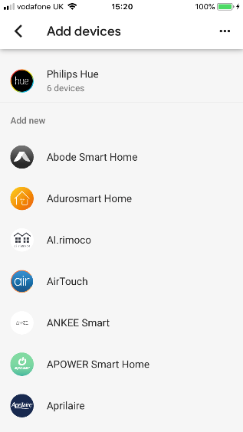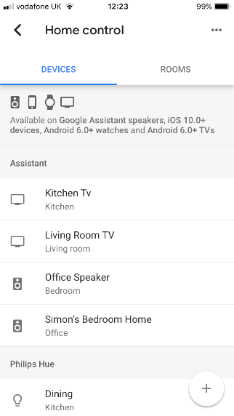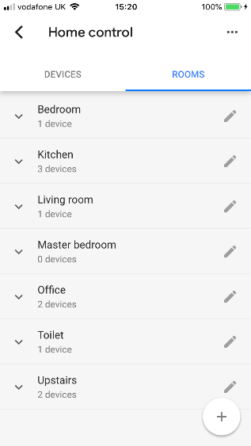
Figure 21 | Images of the Google Home Interface.
Note: Images of installation of IoT hardware are in Appendices.

4.4.1 Open Source Energy Monitoring
After the Home Automation was up and was confirmed to be running as configured, a way to monitor the home’s energy was needed to collect data for testing part of this project. As it was there are many manufacturers of energy monitoring including consumer bought and open source many through a Kickstarter campaign. It was decided that the OpenEnergyMonitor project [84] would be used to monitor the home energy, this was chosen for three reasons. First, it’s an open source project meaning that the hardware is customisable being built from a raspberry pi and Arduino both familiar to the author, second the software for the hardware is freely available from GitHub (See Appendices for Code). The third reason is where the company is based, the project is being developed in North Wales the author being Welsh was strong in wanting to support local projects.
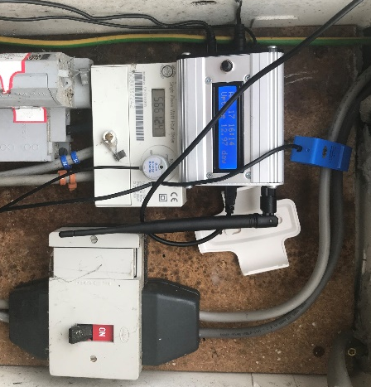
CT Sensor
EmonPi Energy Monitor
Optical Utility Meter
Figure 22 | Installation of the EmonPi.
As shown in the image above (Figure 28) the hardware named EmonPi was installed and connected to the mains live cable that provides power to the home. This hardware uses a Current Transformer sensor which clamps around the live cable and measures the alternating current that passes through the cable, as well as an Optical Utility Meter to provide the best calculation for the energy reading. This information is sent to the propriety software named Emoncms via the wireless capabilities of the Raspberry Pi to the local network, this allows for access on any computer with a web browser, the EmonPi was also programmed so the software and its data feeds can be accessed remotely.
Note: Screenshots of software configuration in Appendices.

4.6 Conclusion
To conclude this chapter discussed and covered the design and implementation of the experiment that will be carried out as part of this project. It was noted that the experiment changed from the typical expectation of how a student would handle this kind of project to be in the viewpoint of an everyday consumer. As it was seen that the current place of IoT devices in the market covers the aspects of a home network, but to keep an academic aspect to the project, and through the found interest of engineering the OpenEnergyMonitor project was used instead of prebuilt alternatives.

Testing and Evaluation – Chapter 5

5.1 Introduction
This chapter of the report will state the testing parameters for each of the IoT systems that are a part of the experiment. It will also review the findings of the testing following these parameters to determine if the project was successful, these results will be compared to the information researched in Chapter 2 Home Energy Usage section.

5.2 Physical Model

5.2.1 Overview of Parameters
For the purposes of testing the system to the best of the authors abilities each of the systems and the residents of the house were planned out Tables 5-6. Each of these tables represented the scheduling of the residents as well as the set-up configuration of the three Hue Motion Sensors. The tables show the settings for a typical week in the house and it should be noted that during the test the systems automation can change these setting to conserve energy usage.
Resident schedule | 5:00-7:59am | 8:00-16:59:pm | 5:00-22:59pm | 23:00-4:59pm
Monday | Wake Up/ Prepare for Work | Out of House | Cooking/ Relaxing | Sleep
Tuesday | Wake Up/ Prepare for Work | Out of House | Cooking/ Relaxing | Sleep
Wednesday | Wake Up/ Prepare for Work | Out of House | Cooking/ Relaxing | Sleep
Thursday | Wake Up/ Prepare for Work | Out of House | Cooking/ Relaxing | Sleep
Friday | Wake Up/ Prepare for Work | Out of House | Cooking/ Relaxing | Sleep
Saturday | Wake Up/ Prepare for Day | Day Off | Cooking/ Relaxing | Sleep
Sunday | Wake Up/ Prepare for Day | Day Off | Cooking/ Relaxing | Sleep
Figure 23 | Table showing an Average weekly Schedule for Residents.
Hue Lighting | Motion Sensitivity | Daylight Sensitivity | Day Time Brightness 6:00-19:00 | Night Time Brightness 19:00 – 6:00
Kitchen | High | 25% | No Lighting | 100%
Landing | High | 25% | No Lighting | 30%
Toilet | Medium | 25% | 100% | 30%
Figure 24 | Table showing the setting of each Hue Motion Sensor

5.2.1 Review of Findings
Following the set parameters mentioned, the test was running from the 7th of April 2018 to the 13th of April 2017. After the week had passed the data collected from the electric utility box via the OpenEnergyMonitor hardware was recorded and formatted to the graphs seen in Figures 23 and 24. From the graph below there is a clear indication of the daily kWh usage during the week, going by the curve of the bar chart it can determined that the system has functioned as expected. While the system was planned to follow the same weekday routine there are minor adjustments to the energy usage, comparing the results of Monday and Wednesday for example show a difference of 7.3 kWh. To emphasise this difference the calculated daily average by the home energy monitoring system and the energy provider is 14.4 kWh, this meaning that on Wednesdays the system is roughly able to save half a days’ worth of energy compared to a Sunday.
As stated previously relatives visit the home every Sunday which is defined by Sunday being the highest usage day, more people in a home typically means more electrical devices and appliances being used. Saturday is a high usage day as well due to the day being a set day off for the residents, this typically extends the time people are in the home and in conjunction energy usage. From the start of a week the energy usage should be noticeably lower, while that is the case, compared to the rest of the week it is still quite high. This anomaly occurred because of an unscheduled visit from relatives and while the energy usage increased is wasn’t to the degree of Sunday. The rest of the week seems to be more in view of the expected results with the daily usage fluctuating around 14 kWh, matching the estimated value presented on the bill sent by the energy utility supplier.

Figure 25 | Daily Kilowatt Hour Usage during Test Week.
The monitoring hardware is also able to provide an accurate value of the cost calculating the daily kWh by the unit value set by the energy utility provider, for this experiment the value was set to £0.14 per kWh. This value is set by the homes current energy provider Engie but, would be subject to change depending on the tariff contract and the energy provider. As mentioned in Chapter 2 the cost of energy can noticeably change due to competition from fellow energy providers as well as the impact of the current economy.
The next chart below has been populated with the data provided by the monitoring software, the first item of note is that the pattern of the chart closely follows that of the kWh chart above. This is good as it indicates that the monitoring systems is functioning as programmed and as such the value of cost reflect the amount of kWh energy used. With this information a comparison can be made using this data, the billing for this quarter and the bill from the same quarter last year.

Figure 26 | Daily Electricity Cost during Test Week.
Using this information from the graph an estimate for a month’s cost of energy can be calculated, using the testing week as an average and multiplying that by 4-week month the total cost would equal £66.40. Using a statement from the same period last year the cost of a month was £125.55, this would mean that the implementation of IoT has saved the household £59.15. It is worth bearing in mind that the energy was provided by Swalec last year and at that time the cost per kWh was £0.11, it is also the case that for a more accurate valuation the test would need to run for a complete month. As the monitoring software records in real time and would need the full month to accurately calculate as currently the system is calculating a monthly cost of £40 based on a £2.20 daily.

5.3 Conclusion
To conclude this chapter set about the testing environment for the project, it stated the set parameters for the test, but was seen difficult to maintain, unlike a simulation factor can easily change the patterns of the household. While the test seemed to be successful, the lack of evidence due to the limitation of the data will put in to question the success of this project. But evidence from the industry will strongly support how efficient a Smart Home can be and would be evident with the longer the home automation is functioning.

Chapter 6 – Conclusion and Future Work Recommendations

6.1 Conclusion
The aim of this project was to develop a Wireless Sensor Network that can be used to monitor and automate an average family home, for the purpose to save energy usage based on the attributes. This aim was achieved with this project, the utilisation of the Home automation network does forecast to save the household energy and cost. It is evident from the data that was collected there is a significant change in the energy cost, though it is now considered by the author that were a few better ways to test the system. The first being to run the test for two-weeks, one week with IoT and one week without. But due to the system requirements this couldn’t be done. The monitoring software required 4 days to collect enough data to start monitoring it accurate.
When starting the research, all areas on this topic were viewed on a basis of the technology including its origin and technicality was thought needed by the author. With Internet of Things being such a focus point for many in the industry there was no lack of information, this made it difficult in navigating what should be included in this report. Researching WSN showed how the field of engineering and networking have heavily progressed the advance of this technology. With areas in wireless communication seen advancements with new protocols for small low powered devices utilising Zigbee and 6LoWPAN, with this it does seem to be a new age of technology getting smaller. It is these factors that are making home automation possible, though through the research it was determined that the issue come from a lack of technical knowledge from household residents with high number showing a lack of basic security when it comes to the home gateway.
For the experiment itself, the design for it saw no changes even after testing the system seemed to be constantly improving itself to be efficient and flexible to be utilised at any home of similar size with little changes required. The flexibility of the network and ease of installation is an advantage to this format, it does come at a considerable higher price. The opposite can be said if implementing this experiment using open sourced devises, though are considerably cheap to buy, the technical knowledge needed to complete this level of automation is considerable. For the experiment itself the use of motion sensors has enable the three rooms to be efficient, the lighting only being on for a minimum of 2 minutes once motion is detected. The other lighting was controlled via a voice assistant or by the application software, both systems allowed for control outside of the given room so usually if a light if left on it is up to the resident to deem it necessary to go switch it off. For this they would need to have a strong mind set to manually conserve energy, but for Home Automation there are easier options. If for example the bedroom light was left on and the person had gone to the kitchen the person could either turn off the light using their smartphone or turned the light off using the nearby Google Home via voice commands.
While with the research and the related work it was previously imagined that the entire system would have been built using open source hardware and software, changing the direction to consumer-based devices has provided insight through the experiment that the industry is going in the right direction in terms of energy efficiency.
The biggest issue when it came to the testing part of the experiment was the human element. Even with a set schedule based on an average week there were still factors that effected outcome, the factors were from outside of the household being the change in weather due to the seasons changing and the sudden occurrence of visitors to the home on Monday.
Overall this project has combined the research in IoT, WSN and Smart Homes with the additional influence of the related work, was able to assist the author in developing home automation for the test location. Even though one of the reasons behind this project was to create an IoT house from a consumer’s point of view, it does heavily restrict what data can be monitored, the retail bought project while provided the same service and data collection as an industry device. The possiblility of collecting that data in the same detail isn’t possible.
The ideas and information that is presented in this report can be used to develop a Smart home system. Through the means of utilising consumer-based devices, the network was added to the consisting home network, which through testing had shown an improvement in efficiency. This concludes that the combined availability, flexibility and ease of installation of consumer based IoT is on the projected track stated by the industry with no indication of being a short time technology trend. But something that will change the industry for many years to come.

6.2 Future Work for Project
Throughout this project several ideas and concepts were thought of due to research and material being found that wasn’t necessarily related to this project provided inspiration for future work. Many of the found material was in the field engineering through hackathons and make projects, these have created a new hobby for the author which is reflected in the recommendations. The recommendation for future word are as followed;
To extend the testing time frame of the experiment, typical energy utility provider calculate use in quarters of the year and bill the household monthly. Having the experiment run for this time would provide improved data collection in which a more conclusive evaluation of energy efficiency can be determined.
To extend the IoT technology and energy efficiency to include Gas this would mean utilising a smart thermostat such as the Nest Learning Thermostat [8]. It would be a goal to test this device as it was researched into but not included in this project due to data collection limitations. The Nest Learning Thermostat is advertised on their website to have saved over 8 billion kWh of energy in homes worldwide and controls 60% of the household’s energy bill, this significant percentage is one of the reasons the device is able to provide this level of efficiency. It would be nice to put this system to the test combined with other energy saving IoT systems.
To develop skills in software and electronic engineering, to build a home automation to the specifications of the design in Chapter 4. This would be to better understand the level of automation provide by the consumer market over, a self-constructed system.
Create a simulation of the home automation network to determine how effective the system is based on pre-set parameters and environmental data. With the purpose of comparing it to the physical modal, to determine how much unaccounted for real world anomalies effect the systems capabilities at being energy efficiently.
With additional funds, a recommendation would be to extend the home automation, as stated before IoT has unlimited use. The two areas being considered are security and agriculture, both being widely available in terms of research and development. Security would provide observation capabilities using face and item identification cameras, being able to alert the home owner of anyone around the house that the systems doesn’t identify as authorised. Many homes have gardens with residents wanting grow fruit and vegetables but always find they don’t have the time the use of IoT, could remove the need for human overwatch after the system takes over. The system can monitor temperature as well as soil moister to determine what the plants need the system is able to control water depending to ensure the plants grow healthy.

Chapter 7 – Reflection
The aim of this project was to development of a Wireless Sensor Network that can be used to monitor and automate an average family home, for the purpose to save energy usage based on the attributes. To make this a success a series of objectives were set to ensure that the project would have been done to the best of the authors abilities.
The research part of the project was relatively straight forward, one of the reasons this topic was chosen by the author was due the abundant amount of resources available. While this has been a chosen topic for many reports throughout this three-year course, each time it has been researched new resources are always discovered, which impacts the amount of information. This report was quite difficult to write due to that as with so much information it was tough trying the information that the supervisor would see as relevant to the report. This concern of what should be in the report lead this Chapter 2 taking considerably longer than originally planned, this lead to much of the allotted amendment time being used to resolve this.
Going from this the second objective was to analyse the research and design a home automation network, this part of the report was helped heavily by the research and the related work. When deciding the location for the devices, most of them had been predetermined when the house was built such as the light fittings. The devices including the motion sensors were planned according to the manufacture recommendations, while Google Home was placed at location of convenience such as counter tops, coffee tables and shelving. The implementation was simple but due to the delays in shipping, the implementation was over a few weeks when it was hopefully that realistically it would only take a few days using the consumer devices.
The next objective was testing the design after its implementation, this proved to be the most difficult part of this project. The reasons that this part was difficult was the unaccounted time that the system needed to collect data become automated. Another problem came from the monitoring system being open source some of the requirements were unsure, it was thought of when the system arrived that a wireless USB drive was required for use. As it didn’t arrive with the hardware one was ordered without though it was realised a few days later when the system was being installed that the system was upgraded late last year with wireless built in. This was quite frustrating as it that the time frame was being affected, this did show ever that planning times in the project for amendments were effective in reducing the delay of the experiment.
The last objective was the evaluation of the experiment and so the project overall, this provided to be a true task for the author. It had pushed the author far beyond in this course in terms of working hours, while the data and information showed success proving that was more difficult than anticipated. It is felt by the author that the writing of this report has shown it is not their true strength had it has been a struggle towards the end, but this project has shown a love for the practically side of projects in terms of engineer that has interested the author. Not only to take up as a hobby but with expectation to add this to skills for career applications.
Overall at the end of the project there was a true sense of accomplishment the author has never completed a project to this scale, there were many lessons learnt from this experience. These were learnt through many sources including the supervisor and lecturers, online forums as well as the trip to Cisco Live. Which did show the importance and the utmost need to return to programming and get to a level of expertise that will benefit the author in the future be that getting a job or starting a business. While this project showed a lack of skill the push to stay another year and complete a MSc degree is still there with the expectation to go beyond current limits and improve from this project. A major factor with this project was time management, while the project was planned thoroughly using Microsoft Project it couldn’t recover from events of the past year that effected the scope and motivation for this project.
As mentioned before a Gantt Chart was utilised for the planning and progressing of this project from October 2017 – April 2018. At the end of the project the Gantt chart made in Microsoft Project was remade to show the changes between the initial thought of how the time management and scaling was seen to be by the author. The original Gantt chart (Figure 27) shown on the next page, displays the time management that was considered a few months before the start of the project. While the revised Gantt Chart (Figure 28) located on page 58 shows the revised chart created after the project completion. The only item of interest between the two charts is the removal of the simulation aspect of the project while it was proclaimed that this part of the project wasn’t gone through with. It was determined not necessary after discussion with the supervisor. While minor changes were made to dates of tasks these were minor only noting the implementation started over Christmas. As mentioned previously the use of the amendments times in the project planned were a crucial assistance to ensuring that this project was finished on time.


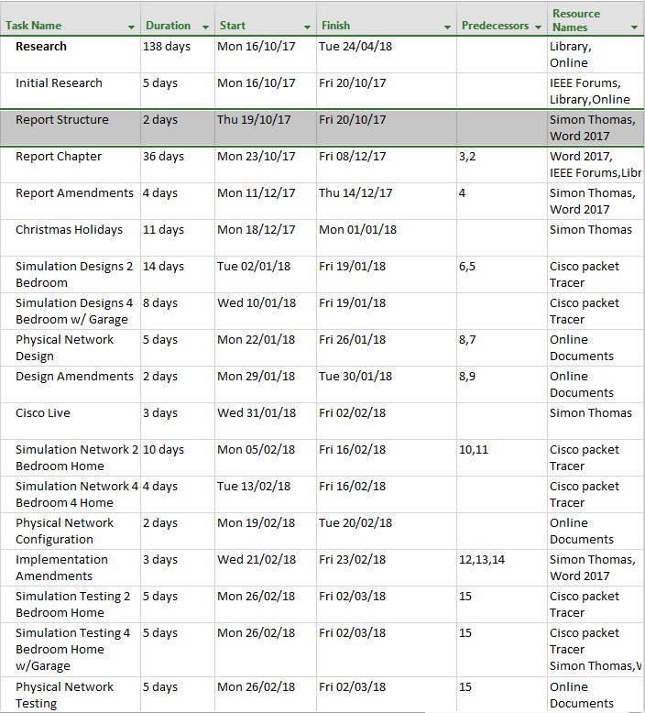
Figure 27 | Original Gantt Chat from Project Proposal

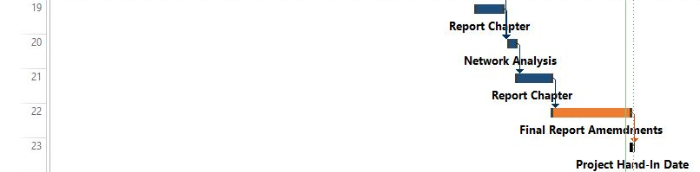
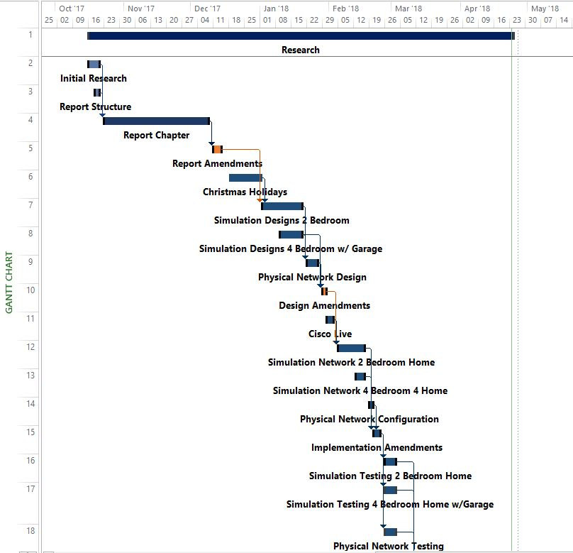
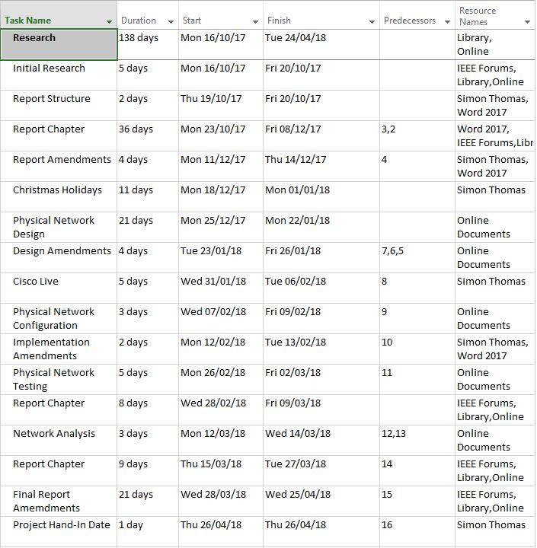
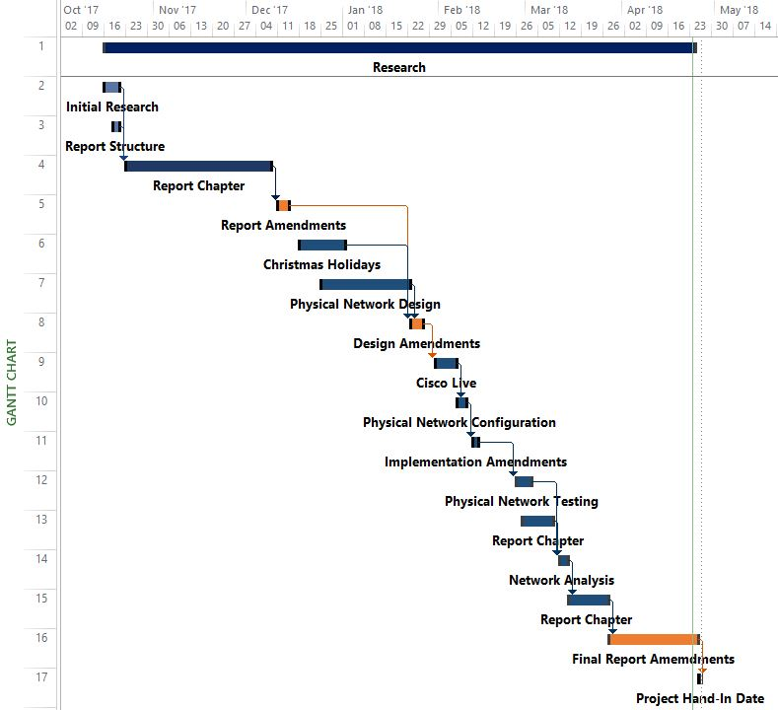
Figure 28 | Revised Gantt chart.

Chapter 8 – References
[1] I. F. Akyildiz and M. C. Vuran, Wireless Sensor Networks. John Wiley & Sons, 2010.
[2] “21 Ideas of the 21st Century,” Bus. Week, pp. 78–167, 1999.
[3] Apple, “Environment - Apple (UK).” [Online]. Available: https://www.apple.com/uk/environment/. [Accessed: 25-Feb-2018].
[4] Microsoft, “Corporate Environmental Sustainability | Microsoft Environment.” [Online]. Available: https://www.microsoft.com/en-us/environment. [Accessed: 25-Feb-2018].
[5] Urs Hölzle, “Enviroment Products,” 2018. [Online]. Available: https://environment.google/projects/announcement-100/.
[6] D. Lewis, “Will the internet of things sacrifice or save the environment? | Guardian Sustainable Business | The Guardian,” Guardian, 2016.
[7] B. Smith, “Greener datacenters for a brighter future: Microsoft’s commitment to renewable energy - Microsoft Green Blog,” 2016.
[8] Philips Hue, “About Hue - Meethue connected lighting | Philips.” [Online]. Available: https://www2.meethue.com/en-gb/about-hue. [Accessed: 17-Apr-2018].
[9] E. Andrews, “Who invented the internet?,” 2013.
[10] J. Greenough and J. Camhi, “Here are IoT trends that will change the way businesses, governments, and consumers interact with the world,” 2016.
[11] “The MIT Auto-ID Lab | autoid.” [Online]. Available: https://autoid.mit.edu/. [Accessed: 26-Feb-2018].
[12] D. Evans, “The Internet of Things How the Next Evolution of the Internet Is Changing Everything,” 2011.
[13] S. Ransbotham, “The Flood of Data From IoT Is Powering New Opportunites - For Some,” MITSloan Manag. Rev., 2017.
[14] Cisco, “Cisco Internet Business Solutions Group,” 2011.
[15] United States Government, “US Census Bureau.” [Online]. Available: https://www.census.gov/en.html. [Accessed: 26-Feb-2018].
[16] Statista, “Forecast on connected devices per person worldwide 2003-2020 | Statistic.” [Online]. Available: https://www.statista.com/statistics/678739/forecast-on-connected-devices-per-person/. [Accessed: 26-Feb-2018].
[17] N. Kerris and S. Dowling, “Apple Reinvents the Phone with iPhone - Apple,” 2007.
[18] A. Nordrum, “Popular Internet of Things Forecast of 50 Billion Devices by 2020 Is Outdated,” IEEE Spectr., 2016.
[19] Stringify, “Stringify | Change Your Life By Connecting Every Thing.” [Online]. Available: https://www.stringify.com/. [Accessed: 05-Mar-2018].
[20] V. Vestberg, “Ceo to shareholders: 50 billion connections 2020,” 2010.
[21] J. Iwata, “Making Markets: Smarter Planet,” 2012.
[22] R. van der Meulen, “Gartner Says 8.4 Billion Connected ‘Things’ Will Be in Use in 2017, Up 31 Percent From 2016,” 2017.
[23] IHS Markit, “Telecommunications Industry Solutions - Market Data, Analysis; Forecast Reports; Services | IHS Markit.” [Online]. Available: https://ihsmarkit.com/industry/telecommunications.html. [Accessed: 05-Mar-2018].
[24] K. Aston, “That ‘Internet of Things’ Thing,” RFID J., 2009.
[25] S. P. Thomas, “Utility Control Using Wireless Sensors,” 2017.
[26] Zigbee, “What is Zigbee? | Zigbee Alliance.” [Online]. Available: http://www.zigbee.org/what-is-zigbee/. [Accessed: 18-Mar-2018].
[27] Z. Shelby and C. Bornmann, “6LoWPAN: The wireless embedded Internet - Part 1: Why 6LoWPAN? | EE Times,” EE Times.
[28] Nest, “Nest | Create a Connected Home.” [Online]. Available: https://nest.com/uk/. [Accessed: 18-Mar-2018].
[29] Uppsala Universitet, “Introduction to Mobile Ad hoc Networks (MANETs).”
[30] J. Zheng and A. Jamalipour, “Introduction to Wireless Sensor Networks,” Inst. Electr. Electron. Eng., 2014.
[31] I. F. Akyildiz, S. Weilian, Y. Sankarasubramaniam, and E. Cayirci, “A Survay on Sensor Networks,” IEEE Commun. Mag., 2002.
[32] D. Estrin, K. Pister, D. Culler, and G. Sukhatme, “Connecting the Physical World with Pervasive Networks,” Pervasive Comput., 2002.
[33] M. HATLER, D. GURGANIOUS, and C. CHI, “Industrial Wireless Sensor Networks. A Market Dynamics Report,” On World, 2012.
[34] S. Yinbiao, “Internet of Things: Wireless Sensor Networks,” 2017.
[35] Y. Developpement, “MEMS technology: World’s Smallest Barometric Pressure Sensor,” Micro News, 2009.
[36] Institute of Electrical and Electronics Engineers, IEEE Standard for local and metropolitan area networks – Part 15.4: Low-Rate Wireless Personal Area Networks (LR-WPANs) Amendment 1: MAC sublayer. IEEE Press, 2012.
[37] Institute of Electrical and Electronics Engineers, “Wireless LAN Medium Access Control (MAC) and Physical Layer (PHY) Specifi cations,” IEEE Comput. Soc., 2012.
[38] Institute of Electrical and Electronics Engineers, IEEE Std. 802.15.4 – 2003: Wireless Medium Access Control (MAC) and Physical Layer (PHY) Speciﬁ cations for Low Rate Wireless Personal Area Networks (LR - WPANs). IEEE Press, 2003.
[39] Institute of Electrical and Electronics Engineers, “IEEE 802.15 WPANTM Task Group 4 (TG4),” IEEE, 2018. [Online]. Available: http://www.ieee802.org/15/pub/TG4.html. [Accessed: 19-Mar-2018].
[40] Zigbee Alliance, “Zigbee Specifications,” 2006.
[41] S. Yinbiao et al., “Internet of Things: Wireless Sensor Networks,” Int. Electrotech. Comm.
[42] R. S. Ransing and M. Rajput, “Smart home for elderly care, based on Wireless Sensor Network,” in 2015 International Conference on Nascent Technologies in the Engineering Field (ICNTE), 2015, pp. 1–5.
[43] R. Gnanavel, P. Anjana, K. S. Nappinnai, and N. P. Sahari, “Smart home system using a Wireless Sensor Network for elderly care,” in 2016 Second International Conference on Science Technology Engineering and Management (ICONSTEM), 2016, pp. 51–55.
[44] M. A. Matin and M. M. Islam, Overview of Wireless Sensor Network. InTech, 2012.
[45] K. Akkaya and M. Younis, “A survey on routing protocols for wireless sensor networks,” Elsevier J. Ad Hoc Networks, 2005.
[46] J. Pan, Y. Hou, L. Cai, Y. Shi, and S. X. Shen, “Topology Control for Wireless Sensor Networks,” 2003.
[47] X. Zeng, R. Bagrodia, and M. Gerla, “GloMoSim: A library for parallel simulation of largescale wireless networks,” SIGSIM Simul. Dig., 1998.
[48] A. Blilat, A. Bouayad, N. El, H. Chaoui, and M. El Ghazi, “Wireless Sensor Network: Security challenges,” 2012.
[49] Y. WANG, G. ATTEBURY, and B. RAMAMURTHY, “A Survey of Security Issues in Wireless Sensor Networks,” IEEE Commun. Surv. Tutorials, 2006.
[50] A. JAIN, K. KANT, and M. R. TRIPATHY, Security Solutions for Wireless Sensor Networks. International Conference on Advanced Computing and Communication Technologies, 2012.
[51] T. Martin, M. Hsiao, D. Ha, and J. Krishnaswami, “Denial-of-Service Attacks on Battery-powered Mobile Computers,” IEEE Int. Conf., 2004.
[52] R. FALK and H.-J. HOF, “Fighting insomnia, a secure wake-up scheme for wireless sensor networks.,” SECURWARE, 2009.
[53] P. SZCZECHOWIAK, A. KARGL, M. COLLIER, and M. SCOTT, “On the application of pairing based cryptography to wireless sensor networks,” ACM, 2009.
[54] H. LEX, R. SANKAR, M. KHALID, and L. SUNGYOUNG, “Public key cryptography-based security scheme for wireless sensor networks in healthcare.,” ICUIMC, 2010.
[55] J. N. AL-KARAKI and A. E. KAMAL, “Routing Techniques in Wireless Sensor Networks: A Survey. Wireless Communications,” IEEE, 2004.
[56] J. Sen, “A Survey on Wireless Sensor Network Security,” Int. J. Commun. Networks Inf. Secur., vol. 1, no. 2, 2009.
[57] M. Ectors, “The future of your smart home,” Ubuntu, 2016.
[58] M. Rouse, “What is smart home or building?,” IoT Agenda. [Online]. Available: http://internetofthingsagenda.techtarget.com/definition/smart-home-or-building. [Accessed: 25-Mar-2018].
[59] N. King, “SMART HOME – A DEFINITION Introduction and acknowledgements,” 2003.
[60] B. Colomina, A. Brennan, and J. Kim, Cold war hothouses : inventing postwar culture, from cockpit to playboy. Princeton Architectural Press, 2004.
[61] D. D’Orazio, “Microsoft’s ’90s vision for the smart home looks a lot like today - The Verge,” The Verge, 2014. [Online]. Available: https://www.theverge.com/2014/6/8/5790798/microsoft-1999-vision-of-the-smart-home. [Accessed: 24-Mar-2018].
[62] D. Zax, “Microsoft’s Smart House,” MIT Technol. Rev., 2012.
[63] D. Rye, “My Life @ X10,” 1999.
[64] T. Adams, “Facebook’s week of shame: the Cambridge Analytica fallout,” Guard., 2018.
[65] M. Eddy, “Bitdefender Box 2,” 2018.
[66] Bitdefender, “Bitdefender BOX - Smart Home Cybersecurity Hub.” [Online]. Available: https://www.bitdefender.com/box/. [Accessed: 25-Mar-2018].
[67] PRPL, “SMART HOME SECURITY REPORTTM,” 2016.
[68] OVO Energy, “How much electricity does a home use? | OVO Energy.” [Online]. Available: https://www.ovoenergy.com/guides/energy-guides/how-much-electricity-does-a-home-use.html. [Accessed: 25-Mar-2018].
[69] Selectra, “Average Gas &amp; Electricity Usage UK - 2018 (Energy) | Selectra,” 2018. [Online]. Available: https://selectra.co.uk/guides/average-consumption-uk. [Accessed: 25-Mar-2018].
[70] A. Luthra, “Best Energy Deals: switch supplier; save £100s,” Money Sav. Expert, 2018.
[71] N. Petrovic, “Annual domestic energy bills - GOV.UK,” Department for Business, Energy & Industrial Strategy. [Online]. Available: https://www.gov.uk/government/statistical-data-sets/annual-domestic-energy-price-statistics. [Accessed: 25-Mar-2018].
[72] N. Petrovic, “Average Annual Domestic Electricity Bills for UK Countries,” 2017.
[73] European Union, “Energy Efficiency Directive - European Commission,” 2017. [Online]. Available: https://ec.europa.eu/energy/en/topics/energy-efficiency/energy-efficiency-directive. [Accessed: 10-Apr-2018].
[74] schneider-electric, “HOMES Programme,” 2008.
[75] NASA, “Climate change: How do we know?,” Global Climate Change. [Online]. Available: https://climate.nasa.gov/evidence/. [Accessed: 11-Apr-2018].
[76] IBM, “Environment and Internet of Things - IBM Watson IoT,” IBM Internet of Things. [Online]. Available: https://www.ibm.com/internet-of-things/spotlight/iot-zones/iot-environment. [Accessed: 11-Apr-2018].
[77] S. Luitel, “Design and Implementation of a Smart Home System,” 2013.
[78] D. Han and J. Lim, “Smart home energy management system using IEEE 802.15.4 and zigbee,” IEEE Trans. Consum. Electron., vol. 56, no. 3, pp. 1403–1410, Aug. 2010.
[79] N. David, A. Chima, U. Aronu, and E. Obinna, “Design of a Home Automation System Using Arduino,” Int. J. Sci. Eng. Res., 2015.
[80] University of Derby, “Research Onion.” [Online]. Available: https://onion.derby.ac.uk/. [Accessed: 14-Apr-2018].
[81] “Research Onion - Explanation of the Concept,” UKEssays, 2017.
[82] C. Robson and K. McCartan, Real World Research : a resource for users of social research methods in applied settings. .
[83] Made By Google, “Google Home – Smart Speaker & Home Assistant – Google Store.” [Online]. Available: https://store.google.com/gb/product/google_home. [Accessed: 17-Apr-2018].
[84] T. Lea and G. Hudson, “OpenEnergyMonitor Project.” [Online]. Available: https://openenergymonitor.org/. [Accessed: 18-Apr-2018].
[85] J. Grimes, “GLOBAL POSITIONING SYSTEM STANDARD POSITIONING SERVICE PERFORMANCE STANDARD,” 2008.
[86] Information Builders, “Achieving Digital Transformation Using IoT and Big Data,” 2017.
[87] G. Jenner, “Analysis: How Airlines Are Tapping Into the Internet of Things,” FlightGlobal, 2015.
[88] J. Mariani, B. Williams, and B. Loubert, “Continuing the march: The past, present, and future of the IoT in the military,” Deloitte Insights, 2015.
[89] LockheedMartin, “Autonomic Logistics Information System (ALIS).”
[90] LockheedMartin, “ALIS: Keeping the F-35 Mission Ready - YouTube.” [Online]. Available: https://www.youtube.com/watch?v=yqShP6R5P6g. [Accessed: 12-Mar-2018].
[91] “Facts and figures | Heathrow,” 2017. [Online]. Available: https://www.heathrow.com/company/company-news-and-information/company-information/facts-and-figures. [Accessed: 10-Apr-2018].
[92] M. Drummond, “5 Great Ways Airlines Are Using the Internet of Things,” 2016.
[93] R. Marvin, “What Are Virtual Assistants and What Can You Do With Them?,” PCMag, 2017.
[94] Amazon, “Amazon Alexa Developer.” [Online]. Available: https://developer.amazon.com/alexa. [Accessed: 12-Mar-2018].
[95] Google, “Google Home – Made by Google,” 2016. [Online]. Available: https://madeby.google.com/home/. [Accessed: 13-Dec-2016].
[96] Apple(UK), “HomePod,” Apple. [Online]. Available: https://www.apple.com/uk/homepod/. [Accessed: 12-Mar-2018].
[97] Lab126, “Amazon Lab126.” [Online]. Available: http://lab126.com/. [Accessed: 12-Mar-2018].
[98] C. Andrews, F. El-Attrash, and S. Chakrabarty, “The Internet of Things in Governement,” Govloop.
[99] C. Ulmer, “Wireless Sensor Network,” 2000.

Appendices
Examples of Internet of Things
Military Operations
As with all technology it starts in the military, the early concepts of using a form of wireless technology in the military goes back to the 1970s with the U.S. Department of Defense developing the Navstar GPS which is operated by the U.S. Air Force[85]. With the introduction of IoT and the advancements in the field, wireless devices are now being attached to weaponry, vehicles and other machinery. This is to ensure that the equipment is maintained with minimal time delay and cost, the data that is collected from the devices it will allow for predictive maintenance and scheduling based on past trends[86]. This preserves taxpayer’s money as the military is tax funded but also ensure the military operates to the same level of safety[87]. A leading example of IoT in the military is the use of sensors in the U.S. Air Force multirole fighter Lockheed Martin F-35 Lightning II, this fighter jet uses the Autonomic Logistics Information System (ALIS, pronounced “Alice”)[88]. ALIS uses sensors that are strategically placed throughout the aircraft which has the ability to detect performance, compare them to parameters then use analytics to predict when maintenance is needed and then communicate with maintenance staff so that the right parts are ready beforehand[89], [90].
Air Travel
In the transport industry, more companies are implementing Internet of Things in to the infrastructure, with Airports such as Heathrow which facilitate an average of 1,299 flights a day[91]. Heathrows view on using IoT is seen to keep up with increasing demands at the Airport in terms of customer service, maintenance and productivity. But it’s not just the Airports, Airlines and Airplanes are also being fitted with an IoT infrastructure. An example would be that the use of IoT devices used on aircraft can prevent delays and keep passengers safe by detecting mechanical irregularities in real time, its use can also enhance the passengers service and convenience by informing the customers where they need to go and what services are available to them all the way to the destination[86]. For airlines Delta a major American airline uses IoT to monitor the movement of luggage throughout an airport, thus allowing passengers to track their luggage from check in to the plane, giving the customer assurance that their property is safe[92].
Internet of Things in air travel can also increase cost efficiency of flight operation, while also assisting in improving the passenger’s experience which in turn can ensure a customer’s return for services. An example of this would be that the multiple IoT devices can be used to monitor cabin pressure, temperature and other inflight services. This technology would allow the plane to use less energy, in terms of passenger numbers if the plane is only carrying half its capacity services that are in unoccupied seats can be disabled such as lighting[87].

Virtual Personal Assistant
A recent addition to Internet of Things is the virtual personal assistant which is software that is installed into a smart device, typically this home device is composed of multiple microphones, a speaker and LED indicator for visual response of the device as well as internet connection[93]. Alexa was the first virtual personal assistant that was built in to the Amazon Echo[94] device which was first released in 2014 with Google Home[95] and ApplePod[96] following suit. Typically, the device will use voice recognition and speakers to enable a command and response communication between a user and the assistant, depending on the services provided by the manufacturer examples of these command are playing music, reading the news, setting alarms and controlling home appliances[94], [97]. While these devices are typically bought for home automation hotels, offices and other establishments have utilised this technology to assist staff with reminders which could be for conferences, meeting and events with the device even being able to provide directions to the event if the feature is enabled[86].
The data that is collected from the Amazon Echo and Google Home can provide business stakeholders with the insight in to various information requests, this data can then be shared with other businesses[93]. An example is the anonymous analysis of service and activity requests from virtual assistants in hotel rooms, this is to determine which business or tourist requests are trending. Predictive analytics can also be useful to seek out patterns and trends in device data to uncover which factors have the most influence on outcomes and anticipate what is likely to occur based on current and past information[86].
Energy Management
This situation is more focused on the field of this project, with IoT being a major benefit for Smart buildings, as it can be utilised to lower utility cost and enhance quality of living for the residents and tenants of said building. Individual devices can be employed to collect data in real-time from the building structure and attached machinery, that information can then be collected, organised and shared with energy provider, who can then leverage the insight to make effective use of energy within the building[98].
Products/ Prices
Product Name | Cost in GBP (£)
Google Home | £129
Google Home Mini x3 | £34.99
Philips Hue Starter Kit B22 | £149.99
Philips Hue Motion/ Light Sensor x3 | £34.99
Philips Hue Bulb B22 x2 | £24.99
Philips Hue Bulb E27 | £14.99
Purchase price at time of project.

Physical Implementation and Software Installation
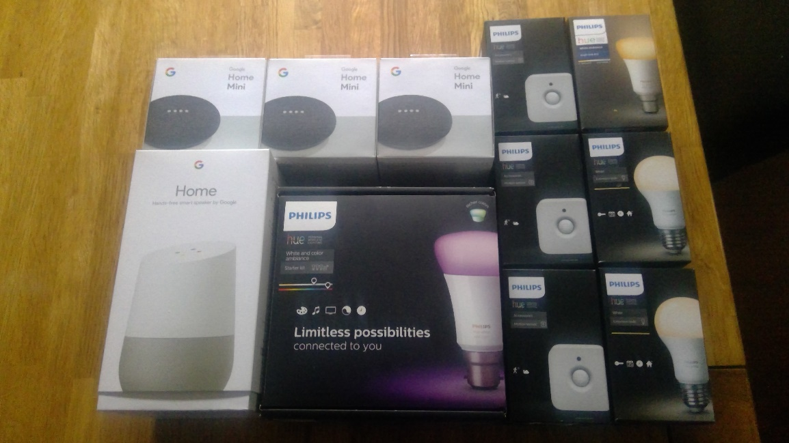
Image 1 | First Order of IoT Products
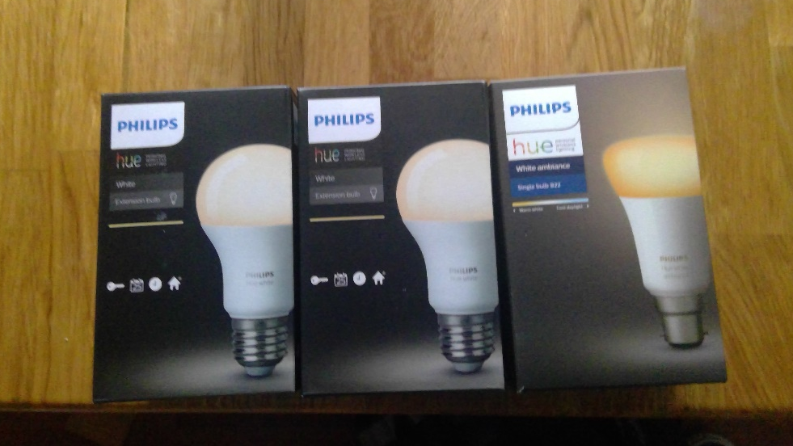
Image 2 | Order of Additional Smart Bulbs
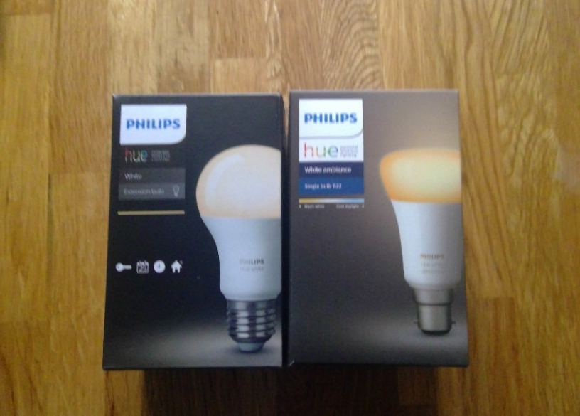
Image 3 | Last Order of Smart Bulbs.
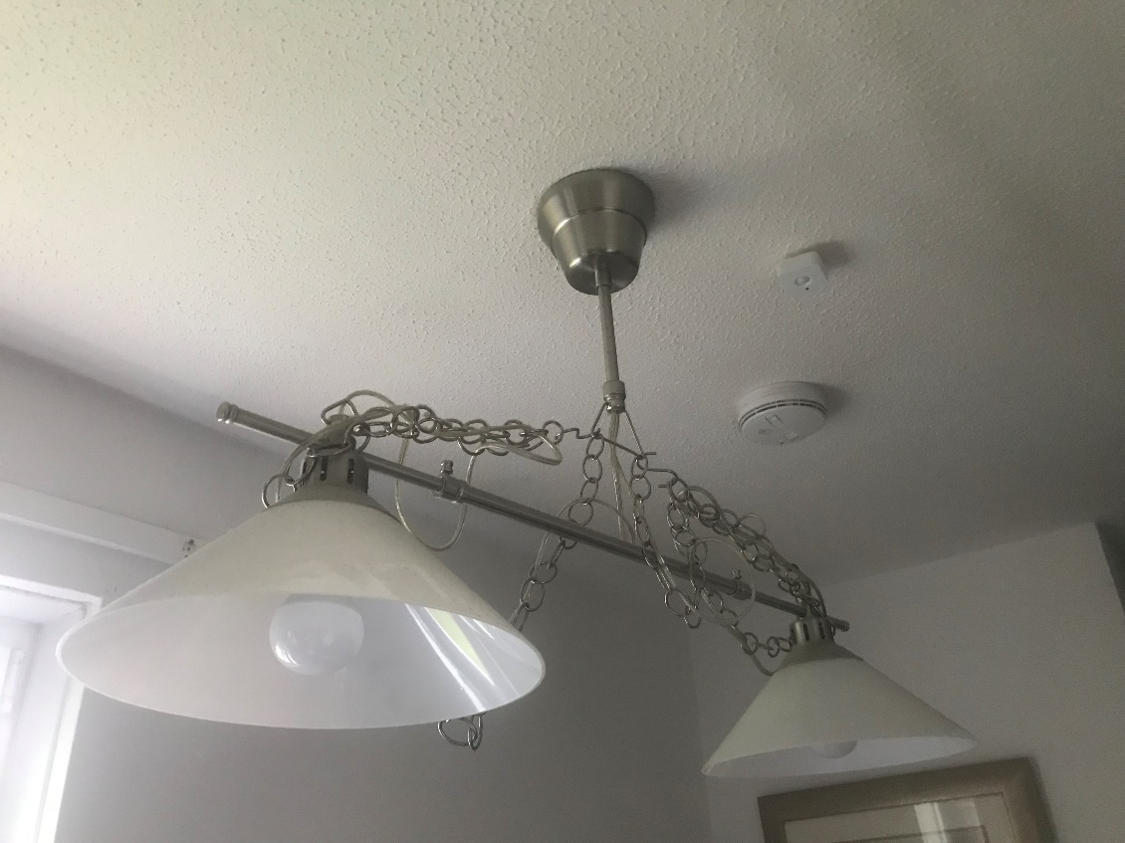
Image 4 | Installation of Smart Bulbs (Landing).
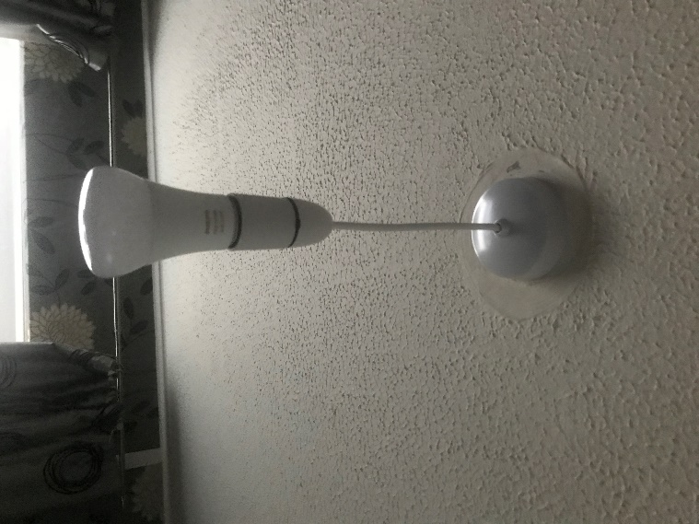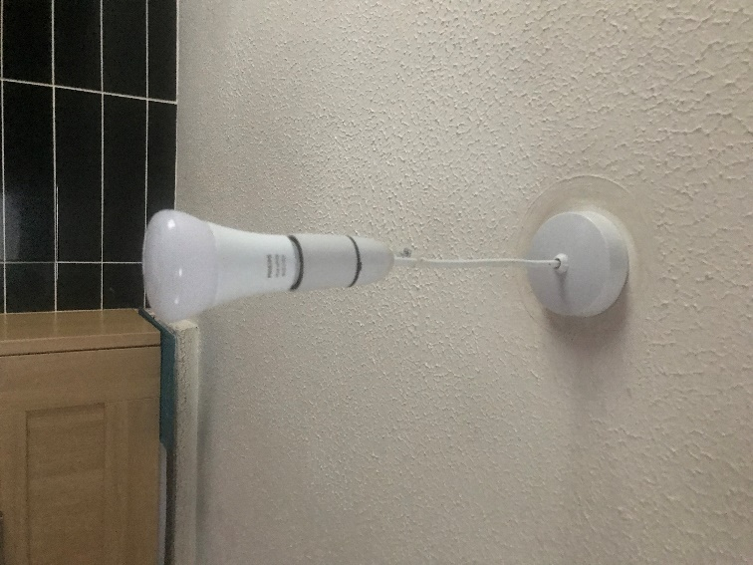
Image 5 | Installation of Smart Bulbs (Kitchen)
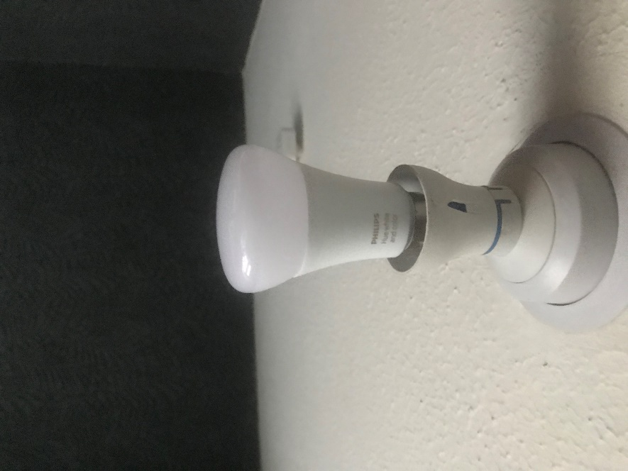
Image 6 | Installation of Smart Bulb (Toilet)
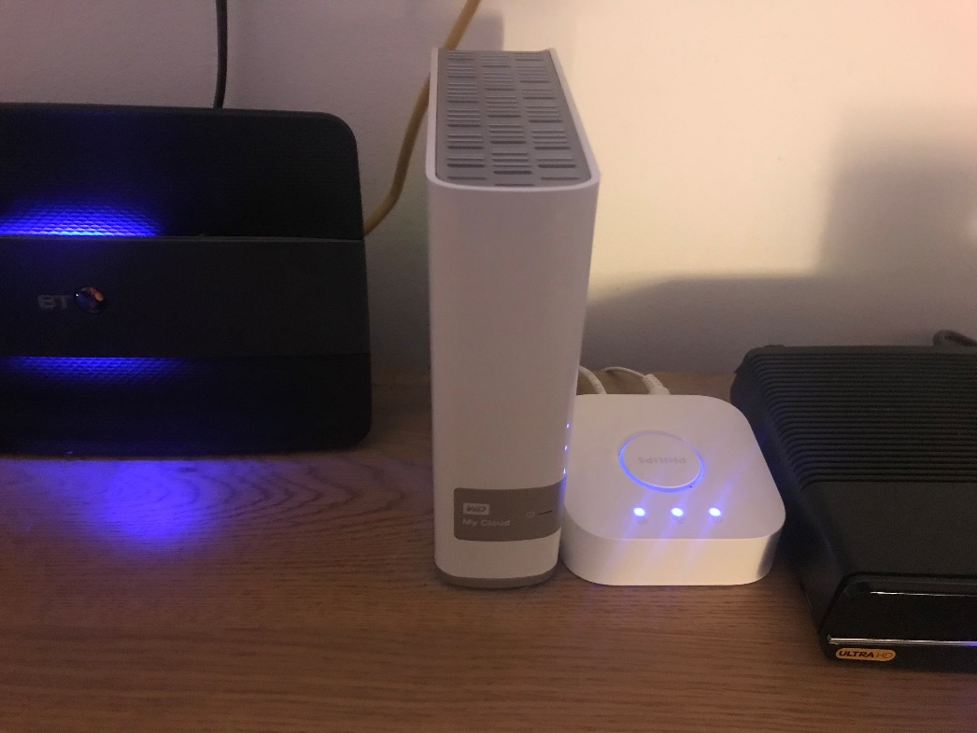
Image 7 | Installation of Hue Bridge
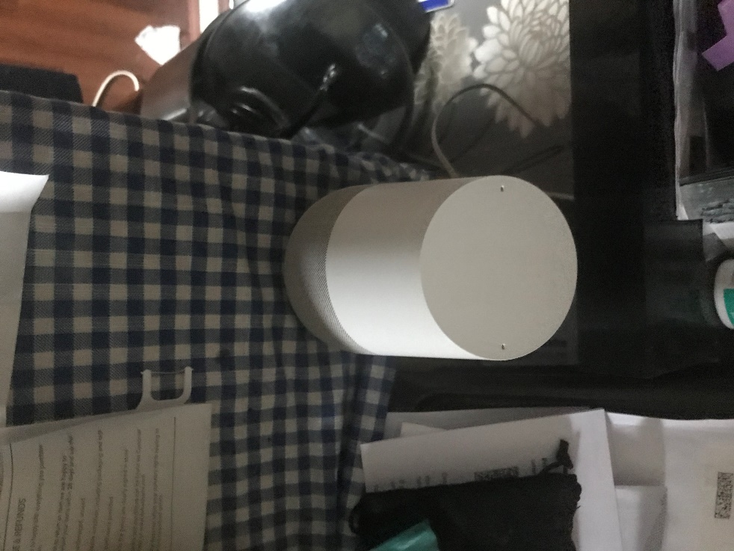
Image 8 | Installation of Google Home (Kitchen)
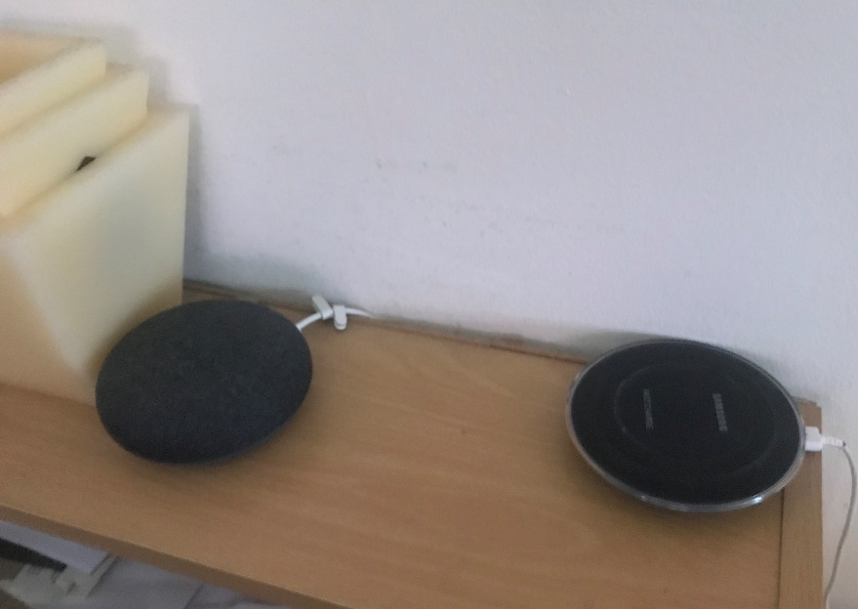
Image 9 | Installation of Google Home (Lounge)
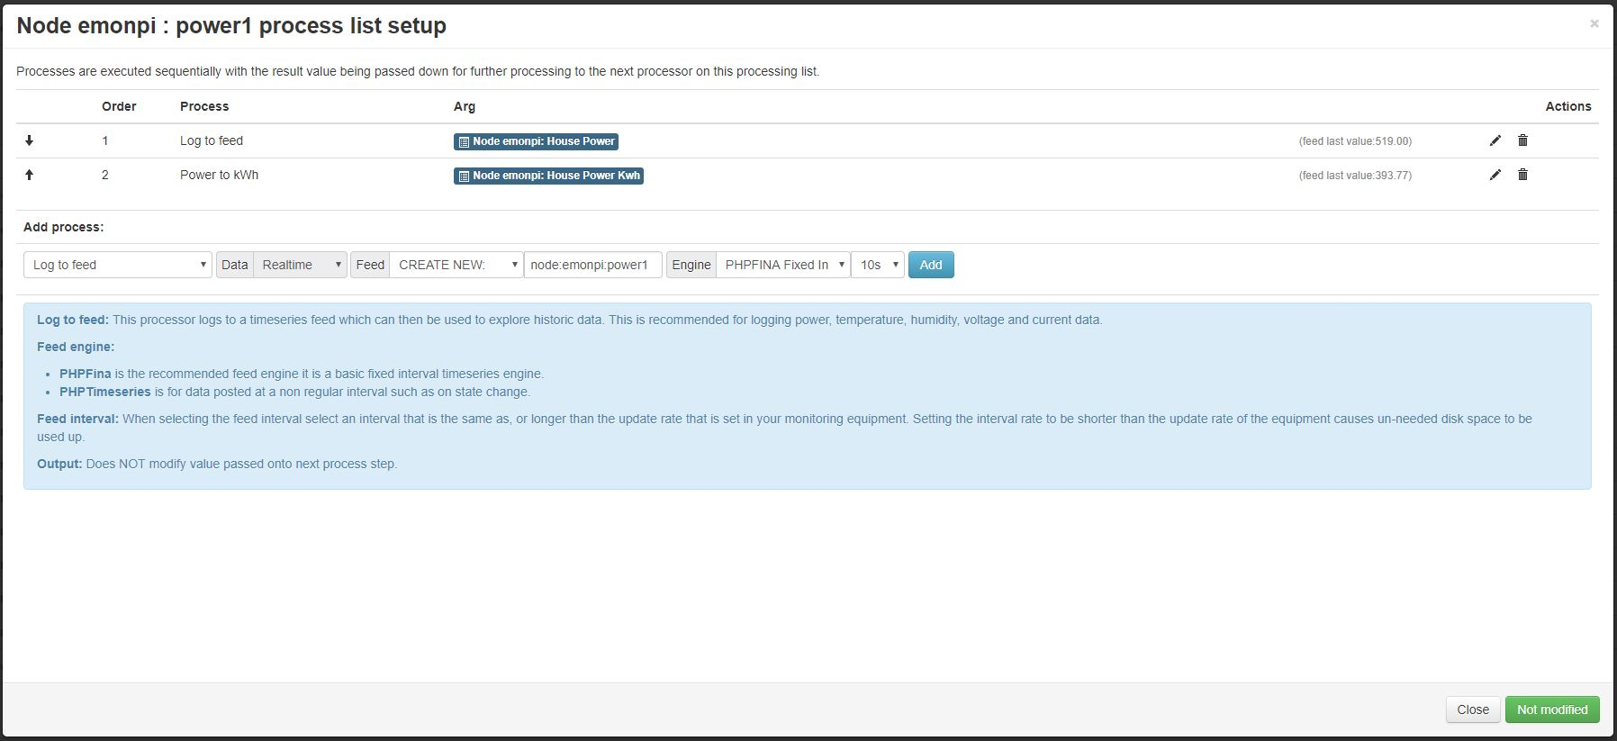
Image 10 | EmonPi Sensor Input Setup for Data Collection.
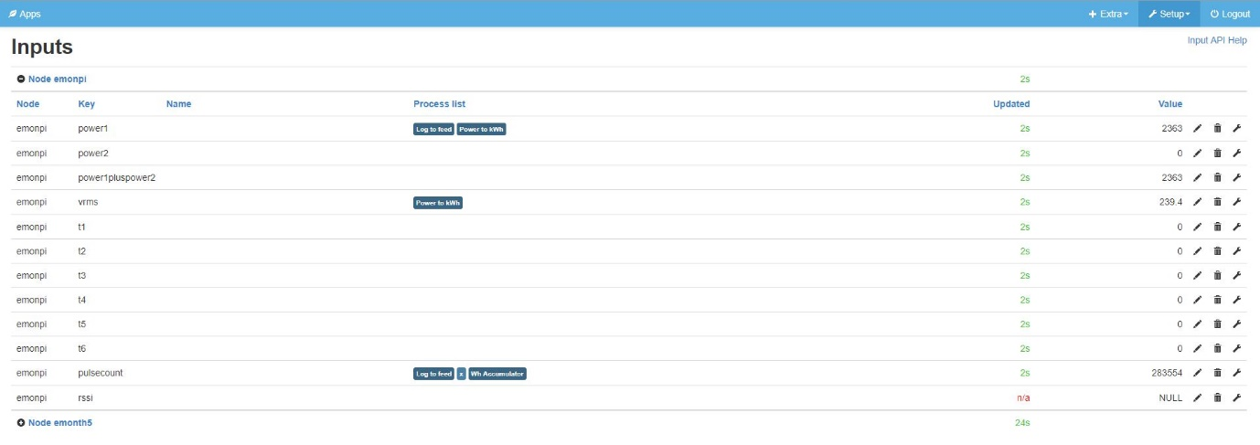
Image 11 | EmonPi Sensor Input List.
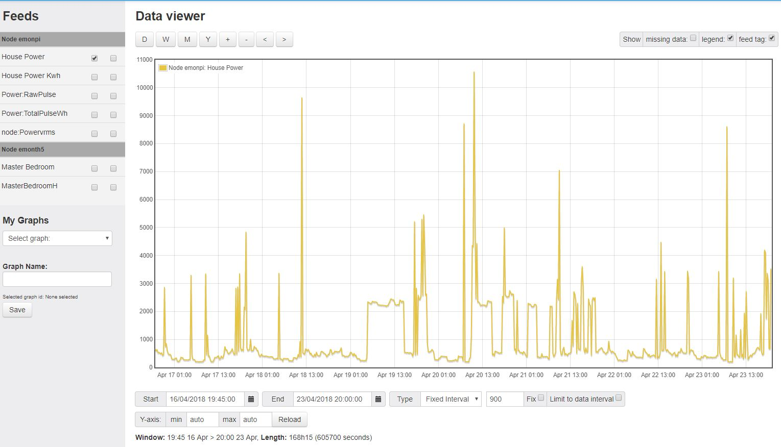
Image 12 | EmonPi Sensor Feeds Setup for Data Visulisation.
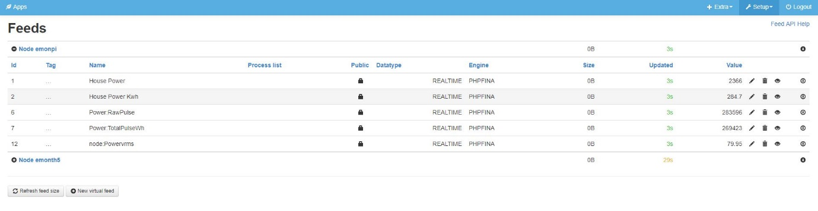
Image 12 | EmonPi Sensor Feeds List.
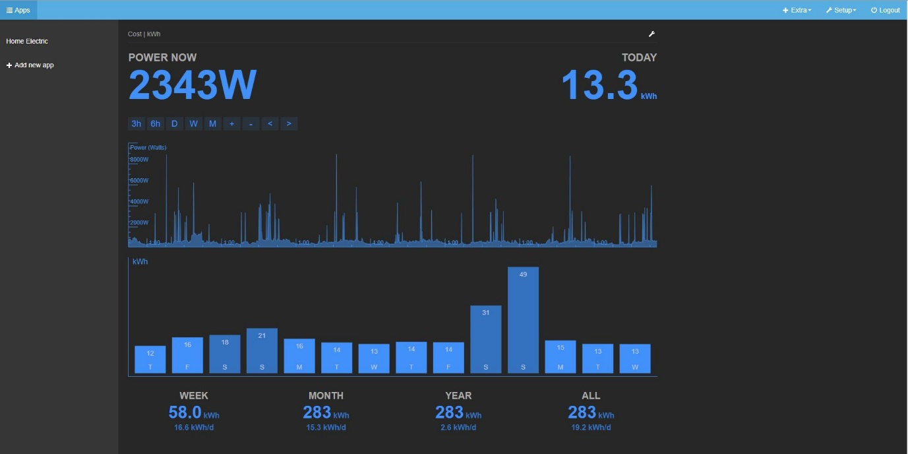
Image 13 | Emoncms Software App for kWh Display on Local and Remote Network.
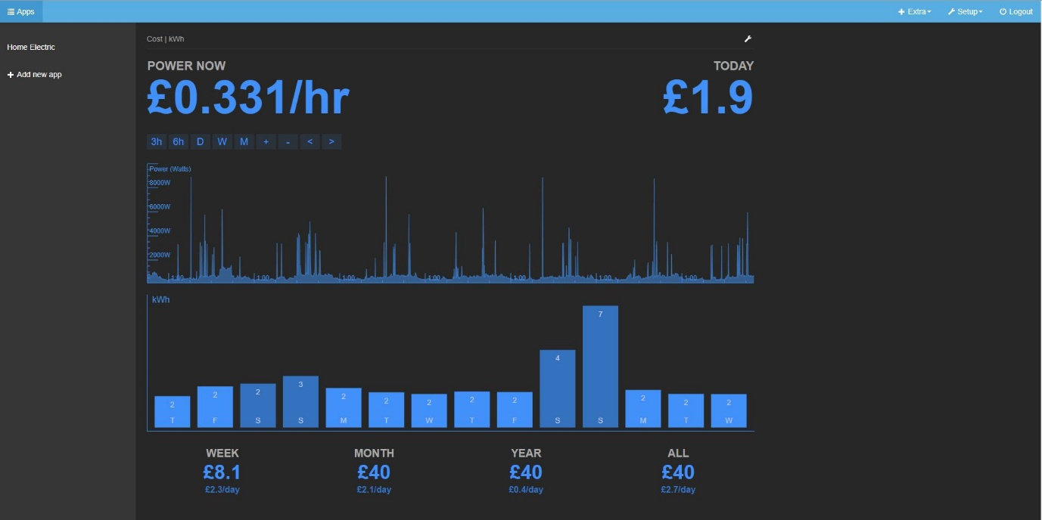
Image 13 | Emoncms Software App for Cost Display on Local and Remote Network.

LOGBOOK
Date | Report
23rd October 2017 | Report started with introduction, research in to Internet of Things begun.
30th October 2017 | First meeting with Supervisor, feedback was to change/ complete Chapter 1.
6th November 2017 | After second meeting changes are still needed for chapter 1 ready to start literature review Chapter 2.
13th November 2017 | Meeting occurred with supervisor Final changes needed to sign off Chapter 1 research in to Wireless Sensor Networks begun. Looking in to Open Source Hardware
20th November 2017 | Research is starting to take form, additional research needed on WSN and Smart Homes.
27th November 2017 | Chapter 1 is complete, Chapter 2 is progressing slower now. Difficulty in finding how to layout report.
4th December 2017 | Meeting with supervisor, lit review progressing to next research point, Revision starting to take priority.
11th December 2017 | Minor progress made to report revision for exam taking priority.
18th December 2017 | Designs for experiment started, taking a break from the Lit review section at this time. Changed to home environment.
8th January 2018 | Experiment implementation took place over Christmas, all IoT devices installed and working.
15th January 2018 | Lit review progressing has slowed, Cisco Live trip in a few weeks hoping for inspiration.
22nd January 2018 | Revision for exams have taken more time that thought due to the short time period between them. Happy with progress in project.
29th January 2018 | Looking forward to starting new modules especially Cybersecurity, hoping for it to assist with theoretic security part of project.
5th February 2018 | Returned from Cisco Live was a great experience, with the information from the event research has begun again.
12th February 2018 | Research in to monitoring the network begun, currently looking into open source using Raspberry Pi.
19th February 2018 | Research in to topic design, idea for demo needs to be discussed.
26th February 2018 | Waiting for meeting tomorrow to discuss lit review, chapter 4 progress needed.
5th March 2018 | Lit Review finished, starting research methodology, looking at project proposal for how to go about it
12th March 2018 | Progress is slow waiting for next meeting to discuss ideas on how to proceed.
19th March 2018 | Meeting with supervisor, finalisation of Chapters 3 and 4
26th March 2018 | Design and implementation Chapter finalising with testing to begin soon.
2nd April 2018 | Issues discovered with monitoring system, lack of checking
9th April 2018 | Testing of the experiment in progress waiting for data collection
16th April 2018 | Last 2 Chapters completed, ready for checking before printing.








EMONPI CODE
#######################################################################
####################### emonhub.conf #########################
#######################################################################
### emonHub configuration file, for info see documentation:
### http://github.com/openenergymonitor/emonhub/blob/emon-pi/configuration.md
#######################################################################
####################### emonHub settings #######################
#######################################################################

[hub]
### loglevel must be one of DEBUG, INFO, WARNING, ERROR, and CRITICAL
loglevel = DEBUG
### Uncomment this to also send to syslog
# use_syslog = yes
#######################################################################
####################### Interfacers #######################
#######################################################################

[interfacers]
### This interfacer manages the RFM12Pi/RFM69Pi/emonPi module
[[RFM2Pi]]
Type = EmonHubJeeInterfacer
[[[init_settings]]]
com_port = /dev/ttyAMA0
com_baud = 38400 # 9600 for old RFM12Pi
[[[runtimesettings]]]
pubchannels = ToEmonCMS,
subchannels = ToRFM12,

group = 210
frequency = 433
baseid = 5 # emonPi / emonBase nodeID
calibration = 230V # (UK/EU: 230V, US: 110V)
quiet = true # Disable quite mode (default enabled) to enable RF packet debugging, show packets which fail crc
# interval = 0 # Interval to transmit time to emonGLCD (seconds)

[[MQTT]]

Type = EmonHubMqttInterfacer
[[[init_settings]]]
mqtt_host = 127.0.0.1
mqtt_port = 1883
mqtt_user = emonpi
mqtt_passwd = emonpimqtt2016

[[[runtimesettings]]]
pubchannels = ToRFM12,
subchannels = ToEmonCMS,

# emonhub/rx/10/values format
# Use with emoncms Nodes module
node_format_enable = 1
node_format_basetopic = emonhub/

# emon/emontx/power1 format - use with Emoncms MQTT input
# http://github.com/emoncms/emoncms/blob/master/docs/RaspberryPi/MQTT.md
nodevar_format_enable = 1
nodevar_format_basetopic = emon/

[[emoncmsorg]]
Type = EmonHubEmoncmsHTTPInterfacer
[[[init_settings]]]
[[[runtimesettings]]]
pubchannels = ToRFM12,
subchannels = ToEmonCMS,
url = https://emoncms.org
apikey = ab4b26bd691a53ace59a0838ff5abb93
senddata = 1 # Enable sending data to Emoncms.org
sendstatus = 1 # Enable sending WAN IP to Emoncms.org MyIP > https://emoncms.org/myip/list
sendinterval= 30 # Bulk send interval to Emoncms.org in seconds

#######################################################################
####################### Nodes #######################
#######################################################################

[nodes]

## See config user guide: http://github.com/openenergymonitor/emonhub/blob/master/configuration.md

[[5]]
nodename = emonpi
[[[rx]]]
names = power1,power2,power1pluspower2,vrms,t1,t2,t3,t4,t5,t6,pulsecount
datacodes = h, h, h, h, h, h, h, h, h, h, L
scales = 1,1,1,0.01,0.1,0.1,0.1,0.1,0.1,0.1,1
units = W,W,W,V,C,C,C,C,C,C,p

[[6]]
nodename = emontxshield
[[[rx]]]
names = power1, power2, power3, power4, vrms
datacode = h
scales = 1,1,1,1,0.01
units =W,W,W,W,V

[[7]]
nodename = emontx4
[[[rx]]]
names = power1, power2, power3, power4, vrms, temp1, temp2, temp3, temp4, temp5, temp6, pulse
datacodes = h,h,h,h,h,h,h,h,h,h,h,L
scales = 1,1,1,1,0.01,0.1,0.1, 0.1,0.1,0.1,0.1,1
units =W,W,W,W,V,C,C,C,C,C,C,p

[[8]]
nodename = emontx3
[[[rx]]]
names = power1, power2, power3, power4, vrms, temp1, temp2, temp3, temp4, temp5, temp6, pulse
datacodes = h,h,h,h,h,h,h,h,h,h,h,L
scales = 1,1,1,1,0.01,0.1,0.1, 0.1,0.1,0.1,0.1,1
units =W,W,W,W,V,C,C,C,C,C,C,p

[[9]]
nodename = emontx2
[[[rx]]]
names = power1, power2, power3, power4, vrms, temp1, temp2, temp3, temp4, temp5, temp6, pulse
datacode = h
scales = 1,1,1,1,0.01,0.1,0.1, 0.1,0.1,0.1,0.1,1
units =W,W,W,W,V,C,C,C,C,C,C,p

[[10]]
nodename = emontx1
[[[rx]]]
names = power1, power2, power3, power4, vrms, temp1, temp2, temp3, temp4, temp5, temp6, pulse
datacode = h
scales = 1,1,1,1,0.01,0.1,0.1, 0.1,0.1,0.1,0.1,1
units =W,W,W,W,V,C,C,C,C,C,C,p

[[11]]
nodename = 3phase
[[[rx]]]
names = powerL1, powerL2, powerL3, power4, Vrms, temp1, temp2, temp3, temp4, temp5, temp6, pulse
datacodes = h,h,h,h,h,h,h,h,h,h,h,L
scales = 1,1,1,1,0.01,0.1,0.1,0.1,0.1,0.1,0.1,1
units =W,W,W,W,V,C,C,C,C,C,C,p

[[12]]
nodename = 3phase2
[[[rx]]]
names = powerL1, powerL2, powerL3, power4, Vrms, temp1, temp2, temp3, temp4, temp5, temp6, pulse
datacodes = h,h,h,h,h,h,h,h,h,h,h,L
scales = 1,1,1,1,0.01,0.1,0.1,0.1,0.1,0.1,0.1,1
units =W,W,W,W,V,C,C,C,C,C,C,p

[[13]]
nodename = 3phase3
[[[rx]]]
names = powerL1, powerL2, powerL3, power4, Vrms, temp1, temp2, temp3, temp4, temp5, temp6, pulse
datacodes = h,h,h,h,h,h,h,h,h,h,h,L
scales = 1,1,1,1,0.01,0.1,0.1,0.1,0.1,0.1,0.1,1
units =W,W,W,W,V,C,C,C,C,C,C,p

[[14]]
nodename = 3phase4
[[[rx]]]
names = powerL1, powerL2, powerL3, power4, Vrms, temp1, temp2, temp3, temp4, temp5, temp6, pulse
datacodes = h,h,h,h,h,h,h,h,h,h,h,L
scales = 1,1,1,1,0.01,0.1,0.1,0.1,0.1,0.1,0.1,1
units =W,W,W,W,V,C,C,C,C,C,C,p

[[19]]
nodename = emonth1
[[[rx]]]
names = temperature, external temperature, humidity, battery
datacode = h
scales = 0.1,0.1,0.1,0.1
units = C,C,%,V

[[20]]
nodename = emonth2
[[[rx]]]
names = temperature, external temperature, humidity, battery
datacode = h
scales = 0.1,0.1,0.1,0.1
units = C,C,%,V

[[21]]
nodename = emonth3
[[[rx]]]
names = temperature, external temperature, humidity, battery
datacode = h
scales = 0.1,0.1,0.1,0.1
units = C,C,%,V

[[22]]
nodename = emonth4
[[[rx]]]
names = temperature, external temperature, humidity, battery
datacode = h
scales = 0.1,0.1,0.1,0.1
units = C,C,%,V

[[23]]
nodename = emonth5
[[[rx]]]
names = temperature, external temperature, humidity, battery, pulsecount
datacodes = h,h,h,h,L
scales = 0.1,0.1,0.1,0.1,1
units = C,C,%,V,p

[[24]]
nodename = emonth6
[[[rx]]]
names = temperature, external temperature, humidity, battery, pulsecount
datacodes = h,h,h,h,L
scales = 0.1,0.1,0.1,0.1,1
units = C,C,%,V,p

[[25]]
nodename = emonth7
[[[rx]]]
names = temperature, external temperature, humidity, battery, pulsecount
datacodes = h,h,h,h,L
scales = 0.1,0.1,0.1,0.1,1
units = C,C,%,V,p

[[26]]
nodename = emonth8
[[[rx]]]
names = temperature, external temperature, humidity, battery, pulsecount
datacodes = h,h,h,h,L
scales = 0.1,0.1,0.1,0.1,1
units = C,C,%,V,p

