

An Investigation into the Psychological Effects of Trauma Exposure on Police Officers

Name: Sophie Jenkins
Student number: 2134318
Degree: Professional Policing Practice

Acknowledgements

I would like to thank my partner Jessica for her continued love, support and understanding. Without this, completing this project would have been extremely difficult.

I would also like to thank my mother Lisa, stepfather Scott and father Neil for their love and support throughout, their unwavering encouragement is so appreciated.

Declaration

- Declaration - This work has not previously been accepted in substance for any degree and is not being concurrently submitted in candidature for any degree. Signed: SM Jenkins
Date: 06/04/25

- Statement 1 - This dissertation is being submitted in partial fulfilment of the requirements for the degree of BSc.
Signed: SM Jenkins
Date: 06/04/25

- Statement 2 - This dissertation is the result of my own independent work/investigation, except where otherwise stated. Other sources are acknowledged by footnotes giving explicit references. A bibliography is appended.
Signed: SM Jenkins
Date: 06/04/25

- Statement 3 - I hereby give consent for my dissertation, if accepted, to be available for photocopying and for interlibrary loan, and for the title and summary to be made available to outside organisations.
Signed: SM Jenkins
Date: 06/04/25

- Statement 4 - I hereby give consent for my dissertation, if accepted, to be available on the university’s IT system to those who have consent to use the system.
Signed: SM Jenkins
Date: 06/04/25

Abstract

This paper examines the effect of traumatic experiences on police officers. This study explores the impact of trauma and how contemporary police constables experience trauma and the problems that arise consequently.
Police officers encounter traumatic experiences more often than the average person. It is estimated that most persons will experience between three or four traumatic events in their lifetime, whereas police officers are likely to experience upwards of 400 to 600 in their careers (Avon and Somerset Police Federation, 2021). These concerning statistics show that exposure to trauma in policing is inevitable, but treatments and education surrounding this topic is limited in modern literature. This is corroborated by Demou et al (2020) when they highlighted during their study into trauma in policing and trauma treatments that further research into effective interventions for mental health issues are needed – especially those that prevent and promote mental wellbeing for officers.
This study aims to fill the gap of modern literature and shed light on the topic. This study is integral as it highlights the need for further intervention and support for officers who work continuously to protect the community and support others; that support and protection needs to be reciprocated.

Table of Contents

Acknowledgements 2
Declaration 3
Abstract 4
Table of Contents 5
Introduction 6
Background 6
Research Proposal 8
Aims and Objectives 9
Research Methods 9
Purpose of Research 10
Timescales 11
Ethical Considerations 11
Structure 12
Conclusion 13
Literature Review 13
Treatments for trauma 22
Research Strategy 27
Sampling Strategy 28
Data Collection/Analysis 29
Limitations/Problems 29
Conclusion 30
Analysis of results 31
Data Preparation 31
Data Analysis 32
Results 33
Discussion of findings 40
Findings and Conclusions 43
Bibliography 45

Introduction

The purpose of this dissertation is to investigate the psychological effects of trauma exposure on police officers. This chapter of the dissertation will explore background and context for this study, and it will explain why this research is important. By understanding the psychological effects of trauma exposure, we can provide more support to police officers who face trauma daily.

Background

Trauma is defined as “severe and lasting emotional shock and pain caused by an extremely upsetting experience, or a case of such shock happening…” (Cambridge Dictionary, 2024). Many individuals experience trauma throughout their lifetimes and these experiences can originate from childhood trauma, occupational trauma, medical, domestic violence, and traumatic grief (The National Child Traumatic Stress Network, 2018). The impact of these experiences can depend on the individual and they can affect behaviours, reactions, mental health, and personal relationships. The Centre for Substance Abuse Treatments (2014) explains that the impacts of trauma can be subtle, insidious or ‘outright destructive’ and this all depends on a few factors including the person, the type of trauma, developmental processes, and any sociocultural factors.
Police officers encounter traumatic experiences more often than the average person. It is estimated that most persons will experience between three or four traumatic events in their lifetime, whereas police officers are likely to experience upwards of 400 to 600 in their careers (Avon and Somerset Police Federation, 2021). Exposure to these varying degrees of traumatic experiences can result in post-traumatic stress disorder (PTSD) and depressive disorder or anxiety disorders (Regehr et al., 2019). Concerningly, being exposed to large amounts personal risk, and threatening stimuli can result in stress vulnerability. These vulnerabilities affect the amygdala and hippocampus within the brain due to being unable to come down from a heightened state of alertness after responding to consecutive traumatic calls (Kwiatkowski et al., 2020).
Lewsey (2022) stated in his article that 90% of police officers had experienced trauma, according to ‘The Job, The Life’ survey (2018). Moreover, police officers may have different coping strategies to deal with these traumatic events. These coping strategies can be both positive and negative. Officers do rely on substances to relieve stress or burnout and there is a direct correlation between alcoholism and policing. A survey found that 33% of police officers met the criteria for hazardous alcohol use (14-35/50 units for women/men). Concerningly, officers with depression, anxiety or PTSD were twice as likely to drink harmfully (Stamper, 2021).
There are often stigmas attached to reaching out for mental health support and this is especially true in policing. Porter and Lee (2023) state that many factors stop officers from seeking mental health support such as: ‘macho culture’, exposure to trauma and an unacceptance of weaknesses. ‘Macho culture’ is the toxic masculinity mindset that prevents male police officers from seeking support as this can be regarded as emasculating. Secondly, officers believe that experiencing trauma is part of their job so feel as though they cannot ask for help. This ties in with policing culture and unacceptance of weakness. This culture often encourages officers to suppress their feelings out of fear they will be seen as incompetent in their role.
Rogers (2023) also highlights the limitations of current trauma therapy for police officers. The main barrier to seeking any support for mental vulnerabilities is reticence and unwillingness to accept help (Bell & Eski, 2016). There is a lack of diversity within therapy treatments in police forces stating that there is only a basic treatment or employee assist programmes, but these can have limited access, limited therapists and long-waiting lists, therefore increasing the likelihood of sickness, mental health issues and a lower quality of life (Rogers, 2023).

Research Proposal

The motivation for studying this important topic is the influx of mental health issues in police officers, the impact of trauma exposure, the subsequent mental vulnerabilities which has led to low morale and sickness/absence from work. The Oscar Kilo (2023) National Police Wellbeing Survey corroborates this by stating there had been a decline in emotional energy from officers who participated, which could lead to burnout symptoms. The survey also highlighted high levels of fatigue and an increase in intentions to quit the profession. Importantly, there was an increase in operational stressors and a decline in confidence for organisational support and wellbeing; highlighting the importance to examine these effects further and analyse potential solutions for poor mental health.

Aims and Objectives

Current literature suggests there is an abundance of research into the effects of trauma exposure on police officers which will be critically analysed. Conversely, there is a limited amount of research into alternative trauma therapy and the effectiveness of these techniques to aid officers who have developed mental health issues due to trauma. The aim of this study is to identify how many police officers experience mental vulnerabilities due to trauma exposure and how effective alternative therapies can be to improve mental wellbeing. This study will explore the impact of trauma on police officers and the impact of introducing trauma-focussed therapy across policing organisations.
These aims will be achieved by completing the following objectives:
- To critically research and analyse current literature surrounding trauma exposure and the effects on police officers.
- To understand alternative trauma therapies and research techniques that are most effective in reducing trauma responses.
- To provide recommendations to policing organisations of different types of trauma therapy for police officers.

Research Methods

I will be compiling a survey to self-administer to the focal group of police officers via a computerised survey. This means I will be creating multiple choice questions that are both qualitative and quantitative. The questions will be delivered in the same way and will be identical for every person answering the questionnaire. My questions will be both closed and open-ended questions to allow primary collection of both quantitative and qualitative data. I also feel this method will work most effectively to achieve the overall aim of the study. It is important to remember the importance of being clear and unambiguous when compiling the questions to use in the survey. Similarly, it’s also important not to include any leading questions. Within my questionnaire I will also be using a logical flow which means starting the survey with more simple questions and getting increasingly more complex.

Purpose of Research

The purpose of this mixed-method research proposal is to analyse and examine the effects of trauma on police officers. The aim is to gain a better understanding of the impact of past and present trauma on officers, their jobs and personal life. There is ample evidence of the disastrous impact of trauma from early-childhood and traumatic events experienced within policing. Despite this, there is limited research of more effective traumatic therapies and treatments that could aid officers in their work. This study will be focused on police officers and will be shared amongst officers via my work email address. Officers would be asked to voluntarily participate in the research questionnaire, and I will aim for 100 officers to complete the questionnaire via online means.

Timescales

This project will be completed in sections. The research proposal and ethics form are due on 26th August 2024, feedback is released on 16th September. The literature review is due on 4th November, feedback is released on 18th November. The research methodology and planning are due on 16th December, feedback is released on 30th December. During this time, the questionnaire will be compiled and sent out to serving police officers for their participation. Additionally, analysis of results is due on 3rd February 2025, feedback is released on 17th February. Findings and conclusions are due on 10th March, feedback is released on 24th March. The final project is due on 7th April and feedback is released on 21st April.

Ethical Considerations

When planning this research proposal, it is important to consider any ethical concerns. There is a risk of trauma exposure when asking sensitive questions on the questionnaire. To mitigate this risk there will be a ‘trigger warning’ at the start of the questionnaire and informed consent will be utilised to explain the aims and objectives of the study. A de-brief section will also be included at the conclusion of the questionnaire, and this will include helplines for advice if individuals require further support prior to any trauma exposure. Moreover, anonymity is integral during the survey to ensure that no personal information is divulged or obtained. This will be completed by not using parameters to obtain names, personal email addresses or phone numbers. I will also be aware of all questions asked and use more closed questions to ensure that the open-ended answers cannot be traced to any individual.

Structure

To meet the objectives for the research, the dissertation will be separated into five chapters:
Chapter one has explained background information surrounding trauma and the impact of traumatic experiences on police officers. This information outlines the reasoning for studying this topic. The research will consist of primary data in the form of a questionnaire and a literature review.
Chapter two will consist of the literature review which will analyse previous and current academia surrounding trauma, trauma responses, focusing on the impact on police officers and policing. Moreover, there will be analysis and evaluation of different trauma treatments and therapy. The main aim of the study will be to highlight the impact of trauma on police officers and suggest more effective treatments for trauma exposure.
Chapter three will identify the most appropriate research technique and methodology for the intended research and dissertation topic. Chapter four will then analyse the collected data from the proposed method identified in chapter three and it will seek to highlight any themes, patterns or understanding evident in the presented data.
Lastly, chapter five will be the concluding chapter of the dissertation, and it will address the impact and implications of trauma exposure on police officers. It will also recommend alternative trauma therapies collected from researching academia surrounding the topics of the dissertation.

Conclusion

The first chapter has successfully outlined the background of trauma exposure and policing along with identifying poor coping methods. The reasons and importance of studying trauma exposure and the impact both individually and collectively. Simultaneously, this chapter includes the aims and objectives of the study as well as outlining the intended structure. As previously established, the following chapter will critically analyse academic literature surrounding the identified topics.

Literature Review

This section of the study reviews the existing literature surrounding trauma, the effects of trauma and trauma-informed policing. The purpose of this chapter is to provide a critical analysis and comprehensive review of existing literature surrounding the topic of the study. This chapter will address the objectives outlined in the research proposal, it will analyse current research surrounding trauma exposure and the effects on police officers, it will provide an understanding about alternative trauma therapies and research techniques that are most effective in reducing trauma responses and provide recommendations to policing organisations of different types of trauma therapy for police officers.
‘Trauma’ is defined as “an emotional response to a terrible event like an accident, crime, natural disaster, physical or emotional abuse, neglect, experiencing or witnessing violence, death of a loved one, war, and more” (American Psychological Association, 2024). Concerningly, 90% of serving officers have reported exposure to traumatic events and one in five police officers have either PTSD or complex PTSD (Police Care UK, 2018).
Scholarly articles explore key themes related to trauma, its impact and focus on policing and these have been identified as: a trauma-informed approach with a focus on the impact of adverse childhood experiences; the effects of trauma on police officers and treatments for exposure to traumatic experiences.

Adverse Childhood Experiences

Adverse childhood experiences (ACE’s) are defined as “…childhood events, varying in severity and often chronic, occurring in a child’s family or social environment that cause harm or distress, thereby disrupting the child’s physical or psychological health and development” (Kalmakis and Chandler, 2013). Trauma-informed policing is a modern-day practice which aims to educate police officers about the impact of ACE’s and how they can influence deviance and criminality. This knowledge and further understanding can allow officers to recognise signs and symptoms of trauma, both in perpetrator and more interestingly, police officers – allowing those to become more self-aware (The Association of Directors of Public Health and The Wave Trust, 2021).
Bateson (2019) studied the use and misuse of adverse childhood experiences in trauma-informed policing within her research. This research explores how trauma impacts children and adults and the development and implementation of the trauma-informed approach in policing. Lastly, the research explores how understanding ACE’s can prevent criminal behaviour. However, the article also outlines how ACE’s can be misused in policing and the overall strengths and weaknesses of using ACE’s within the policing world.
The article concludes that there is a clear link between adverse childhood experiences and later poor life outcomes. The ACE’s system is effective for measuring childhood trauma and identifying vulnerable adults or children. By using the ACE system, we can better develop the trauma-informed approach within policing practices and responses (Piotrowski, 2020). Conversely, the article highlights the limitations of using the ACE’s system. The article raises the issue of validity within ACE questionnaires and the potential ethical harm on participants. Ethical harm may come from the re-experiencing the traumatic experience by asking the participants to explain and analyse their exposure to trauma. The questionnaire may require persons to be honest and answer sensitive questions, this should be mitigated by a trigger warning and de-brief at the conclusion of the study.
This literature review will examine and analyse the sources used whilst outlining any issues or gaps within the research. The strength of this article is it does explore the strengths and weaknesses of the ACE system, providing a more balanced approach. However, the article does fail to offer any alternatives to the ACE’s framework to measure childhood trauma. There are clear limitations to the study, the source was published in 2019 which is outdated by five years, so this is not reflective of recent research. Moreover, the study does not consider any alternatives to the ACE’s framework.
Comparatively, Gillespie-Smith (2020) published a study exploring police officer’s attitudes and perceptions towards ACE’s. Similarly to Bateson (2019) they state that “the higher the number of ACEs experienced has been associated with a higher chance of being involved with the criminal justice system, either as a victim or perpetrator of crime.” This is corroborated by statistics from Welsh Government (2021) which states that persons with four or more ACE’s were fifteen times more likely to commit violence against another person. Moreover, those with four or more ACE’s are also twenty times more likely to have been incarcerated. This study examines police officer’s attitudes to trauma-informed policing and ACE’s via a structured questionnaire. The same questionnaire is administered after providing a training session, these results were then compared to evaluate if attitudes changed due to more awareness.
The results found that the training session did not have any discernible impact on short-term attitudes of officers who attended. However, they did outline that further research would be needed to examine the effectiveness of the training session and how it altered perceptions. Lastly, officers raised concerns about how trauma-informed policing would be transferred from practice to reality (Gillespie-Smith, 2020).
One flaw of this research study is the small experiment group of only 29 police officers. A bigger sample group could improve validity and reliability of this research. This study could also be regarded as outdated; it is four years old. Another downfall of this study is that the training awareness session was not delivered to higher ranking officers and therefore, the real impact across all ranks cannot be measured. Also, the geographical location, the study was conducted in Scotland so results may vary due to many other contributing factors. This relates to the main objectives of this study which is to explore and analyse all literature relating to trauma in policing.
However, this study does address attitudes and perceptions of serving police officers which lacks in Bateson (2019) study. This is imperative because the overall study topic focuses on trauma and its impact on serving police officers.
Similarly, Basto-Pereira et al., (2022) corroborates the relationship between physical and sexual abuse and physical neglect with criminal behaviour. It was concluded that these ACE’s can undermine a child’s ability to model their behaviours and actions around cultural norms or expectations. Thus, increasing the risk of criminality and anti-social behaviour. Importantly, Gilgoff et al., (2020) also found that increased exposure to ACE’s could cause health problems in adulthood.
Zettler (2020) published an article examining the effects of trauma on youths and trauma treatments to aid crime prevention. Similarly to Bateson (2019) and Gillespie-Smith (2020), this study highlights the relationship between childhood trauma, violence and crime. They evaluate the trauma-informed approach for young people and how effective trauma treatments can be for reducing the effects of trauma.
This study explores how trauma treatments can be effective in reducing trauma symptoms. The study also shows a direct link between ACE’s and the likelihood of offending or having behavioural/mental health issues.
One advantage of this study is that it evaluates trauma treatments and their effectiveness of preventing crime and criminal behaviours. Importantly, the study allows further understanding of how traumatic experiences in youth can contribute to crime and criminality, rather than just focusing on the world of policing. Interestingly, this could explain how crime and deviance in youth may lead to criminality in adulthood; therefore, putting strain on police forces, officer’s workload and subsequently causing officer’s to feel stressed and burnout. This could add to poor mental health, meaning officer’s are more vulnerable to the effects of trauma.
Despite these positives, this study fails to examine the other perspective that adverse childhood experiences can increase resilience amongst youths; it is important to recognise that not all persons that experience ACE’s become criminals or engage in criminality. The study does explain that a trauma-informed approach can reduce trauma symptoms and behavioural problems however, it does not show effectiveness in reducing youth violence.
There does needs to be a longer-term study to evaluate specific treatments and how effective they can be at reducing youth or adult violence after years of treatment exposure. This study will investigate if persons feel as though ACE’s have contributed to poor mental health or further issues processing future trauma, especially within policing.
Lastly, Ashton (2016) explores adverse childhood experiences and their association with health-harming behaviours and mental wellbeing in the Welsh adult population. Importantly, this article highlights the detrimental effects that ACE’s have on health and wellbeing. The study examines and measures the prevalence of ACE’s, its impact and how early intervention and prevention could be utilised.
Results from this study stated that there was a clear relationship between ACE scores and health harming behaviours within adults in Wales. The study also explores how ACE’s contribute to issues with alcoholism, domestic violence relationships, crime victimisation and mental health issues. The study provides analysis of how health harming behaviours within adults in Wales also contributes to low mental wellbeing and poor life choices which could repeat the same generational behaviour patterns.
One negative of Ashton (2016) study is that it focuses on the impact of ACE’s and trauma-informed practices within the healthcare sector whereas, this study focuses on policing. Similarly to other sources, this study was conducted in 2016, which makes it the oldest source and could be outdated.
Ashton (2016) uses self-reporting to collect the data which relies on individuals telling the truth and not exaggerating about certain elements. It opens the results of the study up to criticism and poor validity and reliability. Furthermore, the article also fails to recognise the lack of ethical concerns surrounding the use of the questionnaire and personal interviews and asking about ACE’s.
One gap in this research is that Ashton (2016) only focuses on associations rather than causations of poor mental wellbeing in relation to traumatic experiences in childhood. Further studies need to be completed to analyse causes. This study will investigate the impact of trauma on officers and the impact of these experiences on mental health or unhealthy habits.
Merrick et al., (2020) also found a direct link between those who experienced ACE’s during their childhood and drug use. They focused on the likelihood of individuals becoming addicted to opioids and the increased risk of these addicts engaging in criminality to pay for their addiction. This is important because it could explain why persons engage in criminality and subsequently increase demand on police forces.

Trauma in Policing

Police officers attend a multitude of traumatic calls and experience extremely disturbing scenarios, a lot more than the average person. These calls can lead to acute, chronic stress and lasting trauma (Tehrani, 2011).
Jetelina (2020) explores in their study the prevalence of mental health issues among police officers. Their study was based on a sample of over 400 participants, and they did conclude that some officers were interested in seeking help. The participants were only selected from one force and therefore the external validity was limited. Perhaps future studies should aim to further understand the wider issues surrounding mental health issues and the impact of trauma on officers.
Another study conducted by Anders et al., (2022) was based on a large sample of police officers, they concluded that personality factors and coping mechanisms all contributed to the effects of traumatic experiences. They highlight the need to protect those in law enforcement which will increase mental resilience and provide a better service for communities.
Wills (2016) explored how chronic trauma effects personality traits in police officers. This study addresses the gap shown in Jetelina (2020) because they do not examine the effects of chronic trauma whereas, Wills (2016) found a high prevalence of officers struggling with complex trauma. Wills (2016) explores how trauma can affect personality rather than just focusing on the impact mentally. On the other hand, this study was conducted in America so findings and results may not be transferrable to other locations.
Wills (2016) concluded that most officers who engaged in the study recorded exposure to many traumatic events, with some experiencing post-traumatic stress disorder. There was a noticeable decline in the following traits: self-control, good impressions, well-being, independence and empathy. This decline could mean a decrease in public confidence and positive public engagement.
This study was completed by a singular police force which limits its demographic variability; the response was also quite poor with only 19% of officers engaging. Future studies should focus on larger sample sizes of participants to increase validity, reliability and repeatability.
A more effective study was produced by Foley (2020) who examined the ‘cost of caring’ by peer-reviewing other studies that explore burnout to PTSD in police officers in England and Wales. This study concluded that dealing with traumatised persons on a regular basis causes psychological harm for police officers. The studies that were peer-reviewed by Foley (2020) could be regarded as outdated and not reflective of modern policing – an issue found in previous studies. Foley (2020) highlights that further research is needed to explore the long-term effects of working with traumatised persons and the impact of this secondary trauma on individual constables.
Turgoose et al., (2022) does address this within their study by concluding that ‘burnout’ is prevalent in police officers. They add that chronic psychological stress occurs when several factors are interchangeable, namely: the stress of the role, organisational restrictions, conflict, and the emotional or cognitive processes of each officer.
Stevelink (2020) concluded that depression was the most frequently reported symptom of trauma (9.8%), followed by anxiety at 8.5% and PTSD at 3.9%. They also surmised that there was a direct relationship between these mental health conditions and heavy alcohol consumption. Additionally, employees who had been exposed to trauma within the last six months had a doubling in rates of anxiety or depression compared to those with no recent trauma exposure.
In addition to these findings, Garfin et al. (2018) stated in their conclusion that there is a direct link between trauma exposure and physical health. They found that increased exposure to trauma means subsequent sensitivity to chronic pain and disorders.
There were limitations in this study, the results were from estimating mental disorder prevalence from other studies instead of using population studies. When studies select people based on their occupation or there is a focus on adverse mental health outcomes; higher estimates are found because of contextual or response bias. There were over 40,000 respondents but their responses were spread over 10 years from 2004-2015 which would make the study significantly outdated. There needs to be further research in this area for modern day policing, this study will aim to address this gap and how trauma affects officers in 2024.

Treatments for trauma

Within the research questionnaire, I will also be evaluating current trauma treatments that are available to police officers and how effective they believe they are. Collazo (2020) conducted a study into how trauma-focused cognitive behavioural therapy can treat complex trauma in police officers. They found that mental health in policing is poor and can lead to unhealthy habits like excessive alcohol consumption. They also highlight the risk of not treating such mental health issues and the increase in suicidal ideation amongst officers.
Officers would greatly benefit from learning how to use skills from trauma-based cognitive behavioural therapy (CBT) intervention. Learning these skills can lead to overall better policing and more positive community interactions. Despite these positive findings, the research is limited, it does not evaluate the efficiency of using these treatments on law enforcement personnel. Individuals may question the usefulness of CBT especially if they are an avoidant personality. Future studies should explore the effectiveness of other trauma treatments compared to trauma-informed CBT.
Another piece of research from Biggs et al., (2021) explores trauma therapy for occupational trauma-related, post-traumatic stress disorder in UK police forces. The study highlights the risk of developing PTSD and the treatments that can be used. The research concludes that brief trauma therapy did reduce symptoms of PTSD, depression and anxiety. Those officers who had been exposed to primary and secondary trauma had poorer treatment outcomes than those who were exposed to singular occupational trauma.
The limitation of this research is the small sample, it cannot be representative of every police force in the UK as the occupation is subjective. It is possible that those officers with the most complex trauma symptoms were not included in this study due to the complexity. Another limitation is the therapists used to deliver the treatment are varied and there was a lack of consistency across all sample groups. There needs to be further research into assessing if complex PTSD symptoms can be reduced by trauma-informed CBT in the long-term.
Despite these positive results, these findings were based on a small number of studies, so they lack validity. There were also differences in results from developed versus developing countries, the sample sizes and the length of interventions. Many of the studies have short follow-up periods so you cannot draw firm conclusions about the longer-term effects of these trauma treatments.
Alshahrani (2022) evaluates the effectiveness of psychological interventions to reduce trauma in first responders. They conduct a meta-analysis and systematic review of other studies. This research found that psychological trauma interventions are effective in reducing mental distress, PTSD, depression and anxiety symptoms.
Similarly, Grupe et al., (2019) states in their study that mindfulness treatments are proven to reduce symptoms of PTSD within the police population. They collected promising feasibility, acceptability and adherence data. Moreover, positively they found there was improvements in work stressors, sleep quality and mental health outcomes. Despite these positive results, there were limitations to the study namely: the experimental design did not include a control group, and the respondents used self-report which is prone to responder bias.

Conclusion

The key findings from researching literature surrounding the topic of trauma is that police officers are prone to experiencing trauma and therefore mental health issues. There is minimal literature surrounding trauma treatments for police officers and the ones that are most effective. Noticeably, there is also minimal literature surrounding the effects of trauma on constables in 2024, in South Wales Police. Research into ACE’s has been insightful as it could explain the sociological reasons why a person may engage in criminality because of external and internal factors. This link may provide further insight into crime rates and increased demand on police services. Moreover, adding stress to officer’s due to workload demand, making them more vulnerable to the impact of trauma.
Whilst researching these key topics, it is evident that my original hypothesis is supported, officer’s are experiencing higher levels of trauma in work and are experiencing more mental health problems as a result. Concerningly, there are limited resources available to support officers who are struggling with the effects of trauma, and this is largely due to monetary issues and lack of knowledge or education surrounding the topics. This study aims to address that gap in knowledge and educate those surrounding the effects of trauma in policing.

Methodology

The purpose of this chapter is to outline the research methodology and explain why research into this topic is necessary. This chapter also allows the reader to evaluate the reliability and validity of any findings.
Police officers face much scrutiny, deal with extremely traumatic incidents and experience many different emotions throughout their tour of duty. The main aim of this study is to identify from the focus group the welfare concerns and impact of trauma on police constables; both personally and professionally. Another aim of the study is to identify and analyse the effectiveness of the current treatments and therapy utilised by police forces. This study will also examine other potential approaches to trauma that could further benefit officer welfare.
Current literature suggests there is an abundance of research into the effects of trauma exposure on police officers which will be critically analysed. Conversely, there is a limited amount of research into alternative trauma therapy and the effectiveness of these techniques to aid officers who have developed mental health issues due to trauma.
The aim of this study is to identify how many police officers experience mental vulnerabilities due to trauma exposure and how effective alternative therapies can be to improve mental wellbeing. This study will explore the impact of trauma on police officers and the impact of introducing trauma-focussed therapy across policing organisations.
These aims will be achieved by completing the following objectives:
To critically research and analyse current literature surrounding trauma exposure and the effects on police officers, to understand alternative trauma therapies and research techniques that are most effective in reducing trauma responses and to provide recommendations to policing organisations of different types of trauma therapy for police officers.
This research study will emphasise the impact of trauma on police officers and allow police forces to incorporate more effective treatments/therapies. Therefore, producing a more prosperous, resilient and potentially healthier workforce in policing and the country.

Research Strategy

This study will utilise a questionnaire to examine the psychological effects of trauma exposure on police constables. A survey will be compiled to self-administer to the focal group of police officers via a computerised survey. This means creating multiple choice questions that are both qualitative and quantitative. Qualitative data is defined as data which represents information rather than numerical. This can include interviews, diaries, notebooks admissions, photographs and observations (National Library of Medicine, 2022). Conversely, quantitative data is defined as data which represents numerical information, anything that can be measured or counted (National Library of Medicine, 2023). The questions will be delivered in the same format, via the electronic survey and will be identical for every person answering the questionnaire.
A questionnaire was chosen because they can be easily accessible and shared with many people, especially those created online and shared via email. Moreover, a questionnaire provides results quickly and it allows the researcher to compile questions with ease. Self-administered questionnaires are also cost-effective and allows anonymity for respondents.
Questions asked will be both closed and open-ended questions to allow primary collection of both quantitative and qualitative data, this will help achieve the overall aim of the study. It is important to remember the importance of being clear and unambiguous when compiling the questions to use in the survey. Similarly, it’s also important not to include any leading questions. Logical flow will be utilised within the questionnaire which means starting the survey with more simple questions and getting increasingly more complex (Cleave, 2021).

Sampling Strategy

The aim of the survey is to collate responses from 100 police officers who are currently serving constables in South Wales Police. The sampling group will be identified by sharing the questionnaire via South Wales Police email address. Anonymity must be integral during the survey to ensure that no personal information is divulged or obtained. This will be completed by not using parameters to obtain names, personal email addresses or phone numbers. I will also be aware of all questions asked and use more closed questions to ensure that the open-ended answers cannot be traced to any individual.
Feedback and a de-brief will be utilised for participants, this will be added at the end of the questionnaire to thank them for engaging with the study, it will explain briefly what was being studied and it will also include a contact for the researcher to allow participants to have a conversation about the research further if needed. Additionally, informed consent will also be included. This will be obtained by adding a sentence at the start of the questionnaire asking if the participant to confirm that they agree to complete the survey; this will be done by including yes/no tick boxes.

Data Collection/Analysis

Findings will be analysed from the questionnaire by populating bar and pie charts based on the quantitative question responses. By using graphs to show data collection, it allows the reader to identify results, themes, patterns or conclusions from the conducted research. They can also be user-friendly, easy to read and more engaging for those reading the study. Additionally, visual data reflection using graphs can simplify complex data and interestingly they can identify areas or limitations that need to be addressed. Moreover, content or thematic analysis of the qualitative question responses will be utilised, I could also use graphs to represent these common themes.

Limitations/Problems

One limitation could be the number of participant responses, the survey may not generate enough responses needed to conclude any viable findings on the subject. On the one hand, it may prove difficult to collect 100 responses from police constables or some might state that 100 responses do not adequately reflect the wider issues surrounding psychological effects of trauma on serving officers. The impact of not generating enough answers or respondents may be bias findings and inaccurate conclusions.
Another limitation or risk could be trauma exposure to respondents. Exposure to recollection or re-living traumatic experiences might cause distress and upset. To mitigate this risk, I would utilise a trigger warning at the start of the questionnaire, respondents will have informed consent and adequate understanding of aims and objectives prior to answering any questions. Moreover, there will be a de-brief section following their responses. I will add helplines for mental health support and advice focusing on trauma exposure for police officers.

Conclusion

To conclude, to best explore how trauma affects police constables, a questionnaire tool will be utilised. This will allow quick, efficient and cost-effective responses. Both qualitative and quantitative data will be collected to effectively gain insight into the effects of trauma in policing and how people feel about this issue. Moreover, anonymity and proper storage of data is integral for the validity of the research. The study aims to achieve 100 responses from serving police officers whilst ensuring feedback, trigger warnings and a de-brief at the end of the survey is used. To demonstrate any findings, a variety of graphs will be produced, this will allow the reader a visual aid when discussing results.

Analysis of results

This chapter will analyse data collected via the questionnaire which examined the effects of trauma exposure on police constables. This section will also include sub-sections explaining data preparation, data analysis techniques, results and discussion of findings. A questionnaire was utilised due to its ease and accessibility which allows it to be shared to many people. This method also allows the researcher to collect results promptly and its cost-effective. A questionnaire was produced and published via SmartSurvey (Smart survey, 2020) with the aim of collecting 100 responses. However, the questionnaire generated 66 responses conclusively, a potential discrepancy of the overall study.
The results and analysis of these findings will allow for conclusions to be drawn based on the initial aims and objectives. The aim of the study is to identify how many police officers experience mental vulnerabilities due to trauma exposure and how effective alternative therapies can be to improve mental wellbeing.

Data Preparation

To produce clean data, the raw data that is initially collected must be analysed using data preparation. This means the researcher must rectify any errors, refine the data used to ensure comprehensive results and therefore, accurate conclusions. The questionnaire utilised in this research collated some partial responses because of participants not completing the entirety of the survey. A total of 12 participants completed the questionnaire partially and to produce clean and comprehensive findings, these partial responses must be discounted. This will exclude any disparity and confusion about findings. The website used to collect the data also produces graphs to adequately display the data, allowing for the reader to easily understand the results of the study.

Data Analysis

This study consists of quantitative questions and to analyse this data the researcher has utilised both descriptive statistics. This means analysing the data by presenting it in a factual way, often using graphs or charts. This method allows conclusions to be drawn on known data whilst also providing visual aids to readers (Xu, 2021). This method was chosen due to its ability to present findings accurately and simply, using graphs and tables. It also allows the researcher to provide findings and reach conclusions based on the responses. The overall goal of the research is to identify the impact of trauma exposure on police officers and to establish the effectiveness of current trauma therapies. By using descriptive statistics, these aims, objectives and overall goal of the research can be achieved.

Results
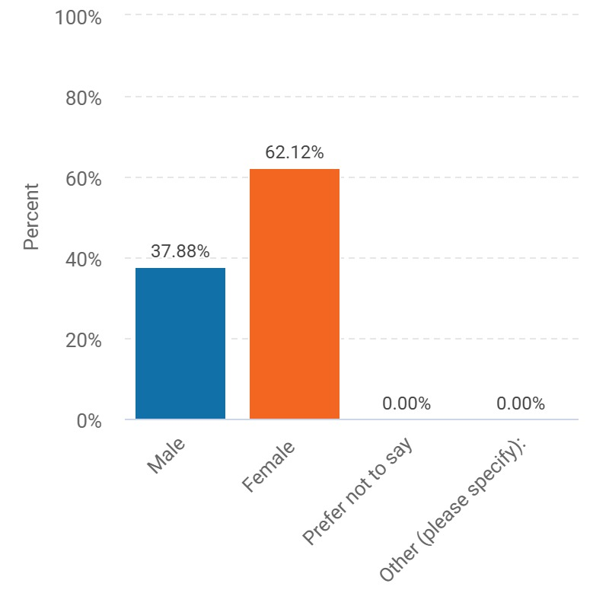

Figure 1. A graphical representation of the gender of police officers who responded to the questionnaire
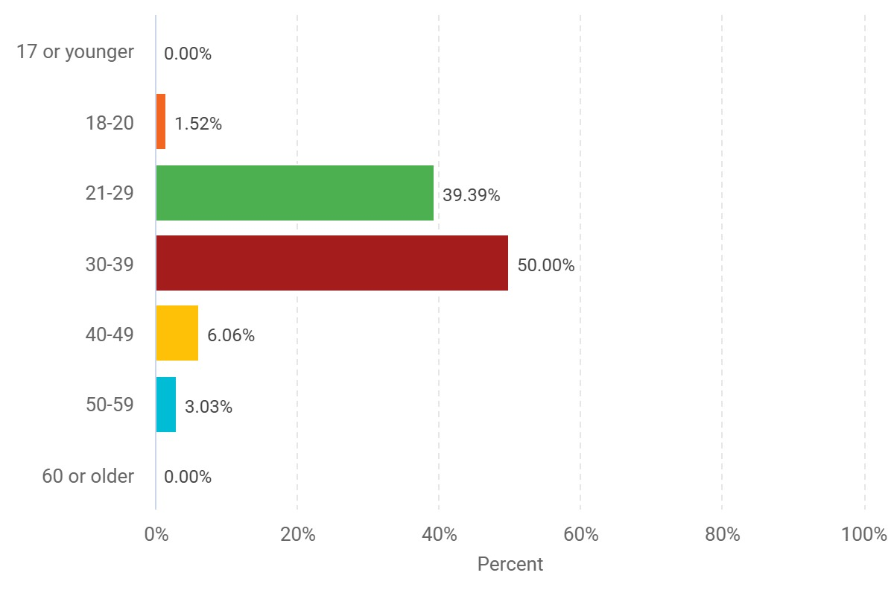

Figure 2. A graphical representation of the age groups of respondents.
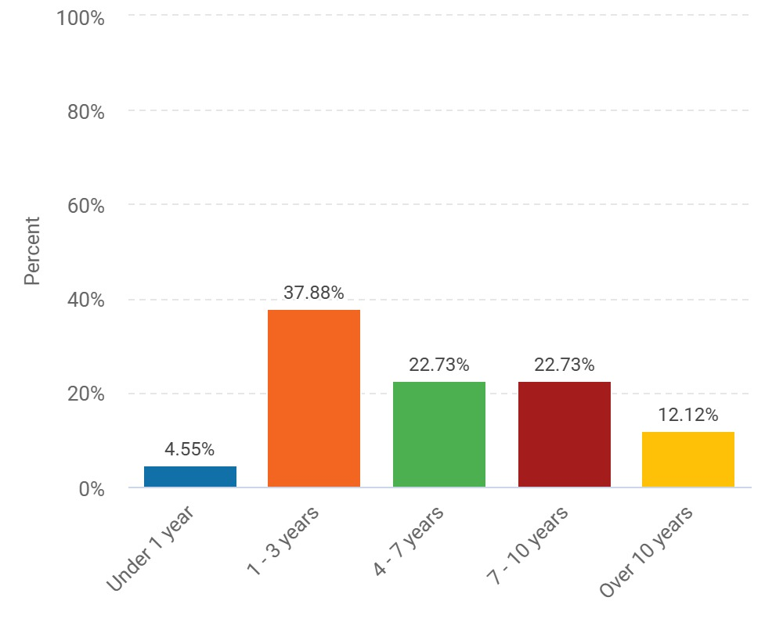

Figure 3. A graphical representation of years of service of respondents.

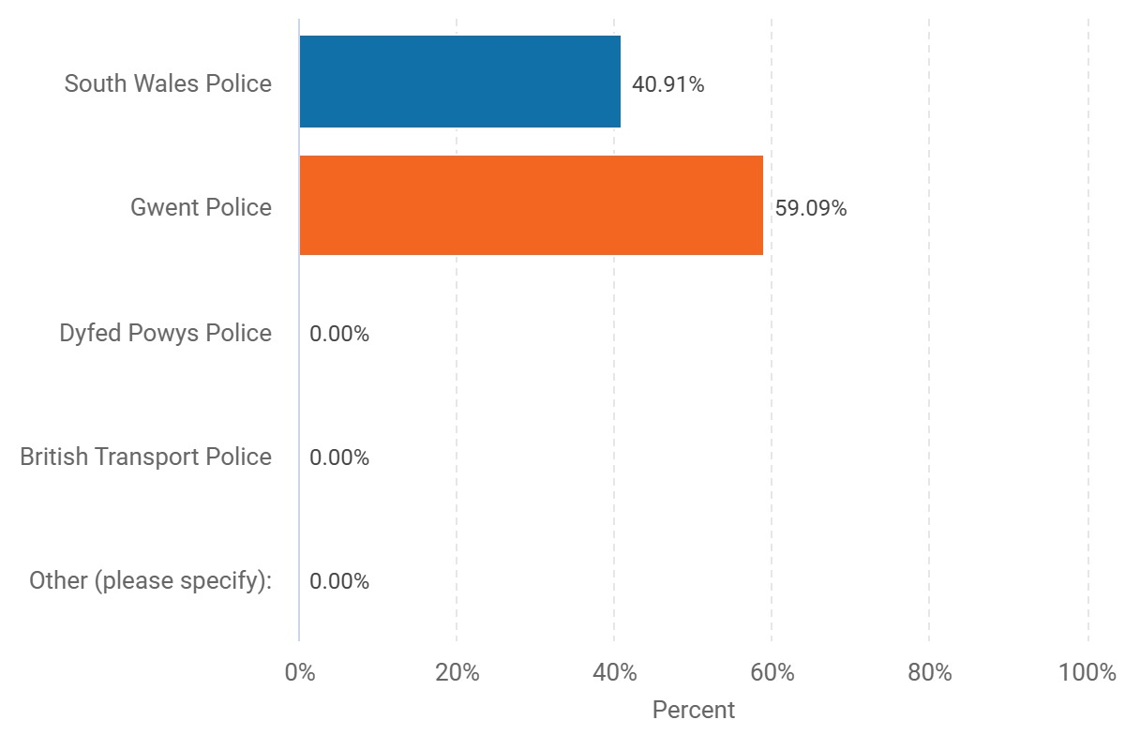

Figure 4. A graphical representation of the different police forces represented by respondents.

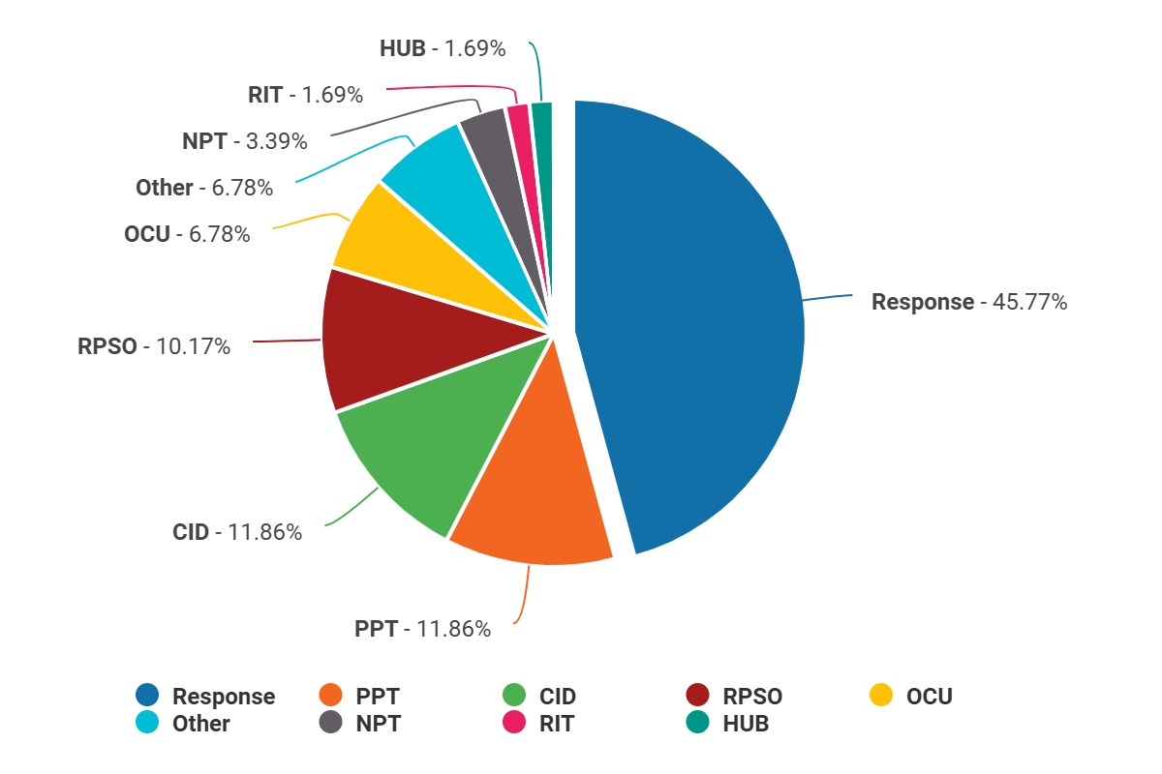

Figure 5. A graphical representation of the variety of departments represented by respondents.
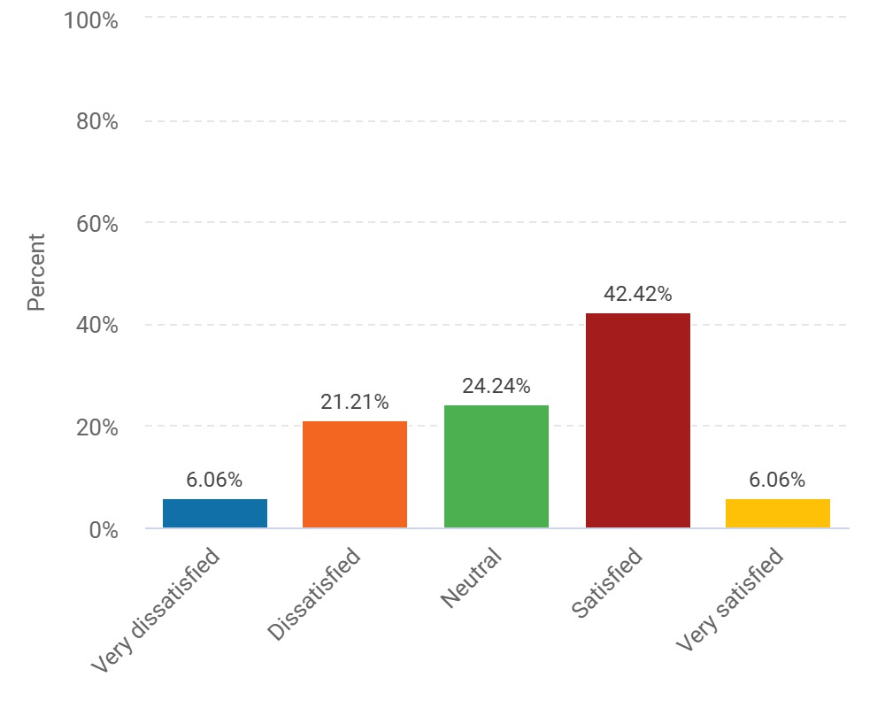

Figure 6. A graphical representation of the satisfaction levels felt by respondents at work.
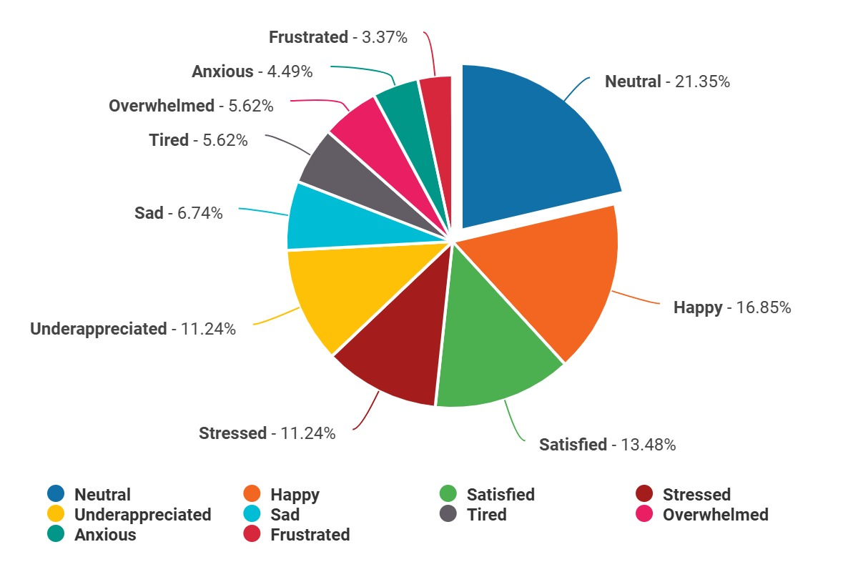

Figure 7. A graphical representation of the emotions felt by respondents at work.
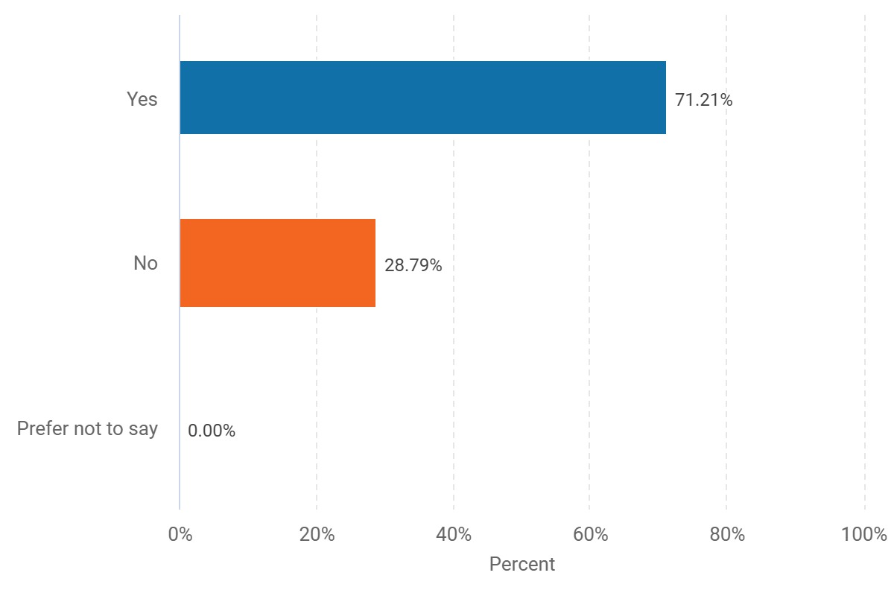

Figure 8. A graphical representation of whether respondents mental health has been affected since being a police officer.

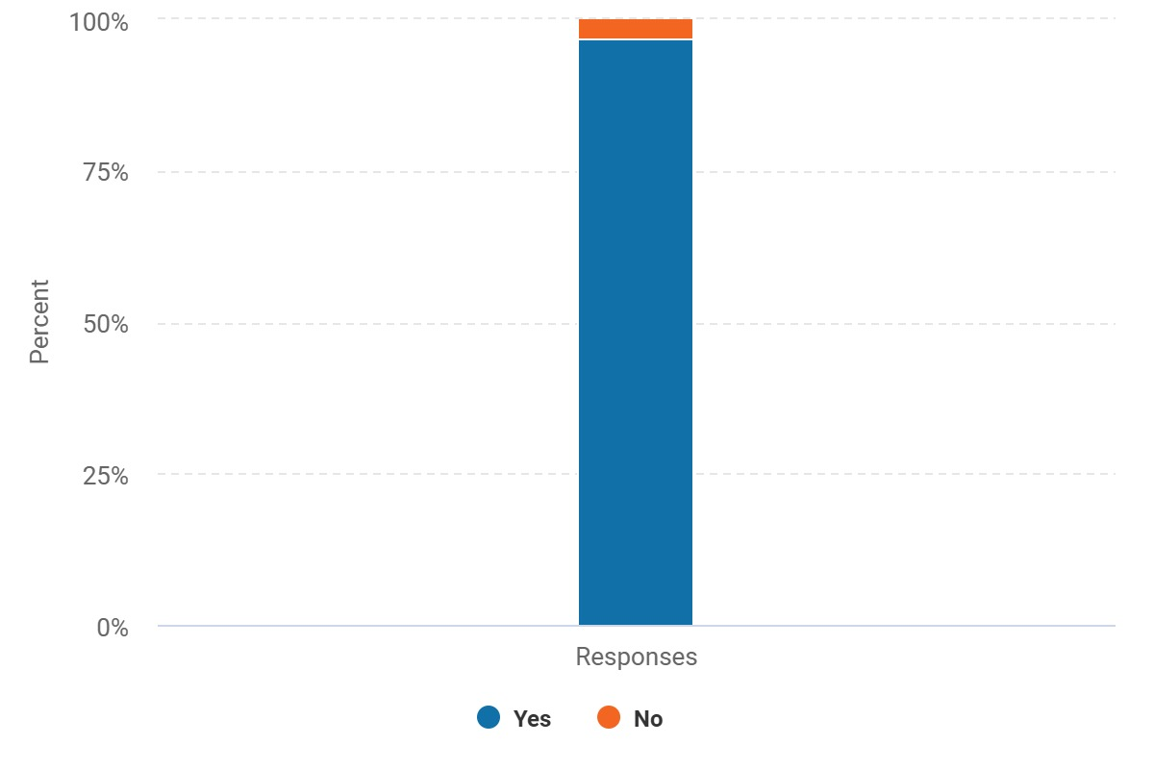

Figure 9. A graphical representation of whether respondents have experienced trauma at work.

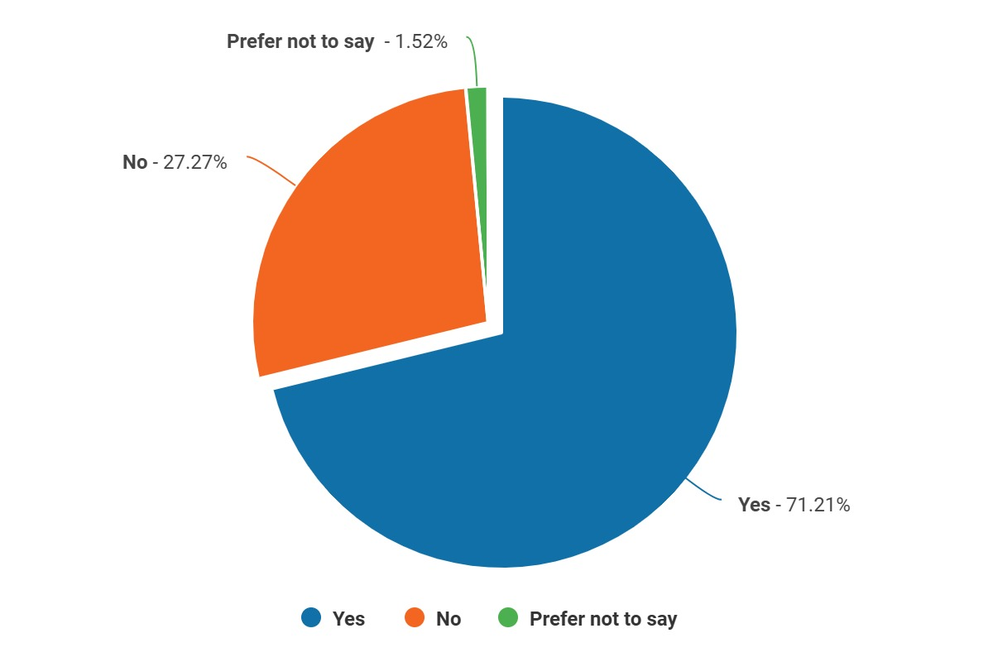

Figure 10. A graphical representation of whether these traumatic experiences have affected respondents.

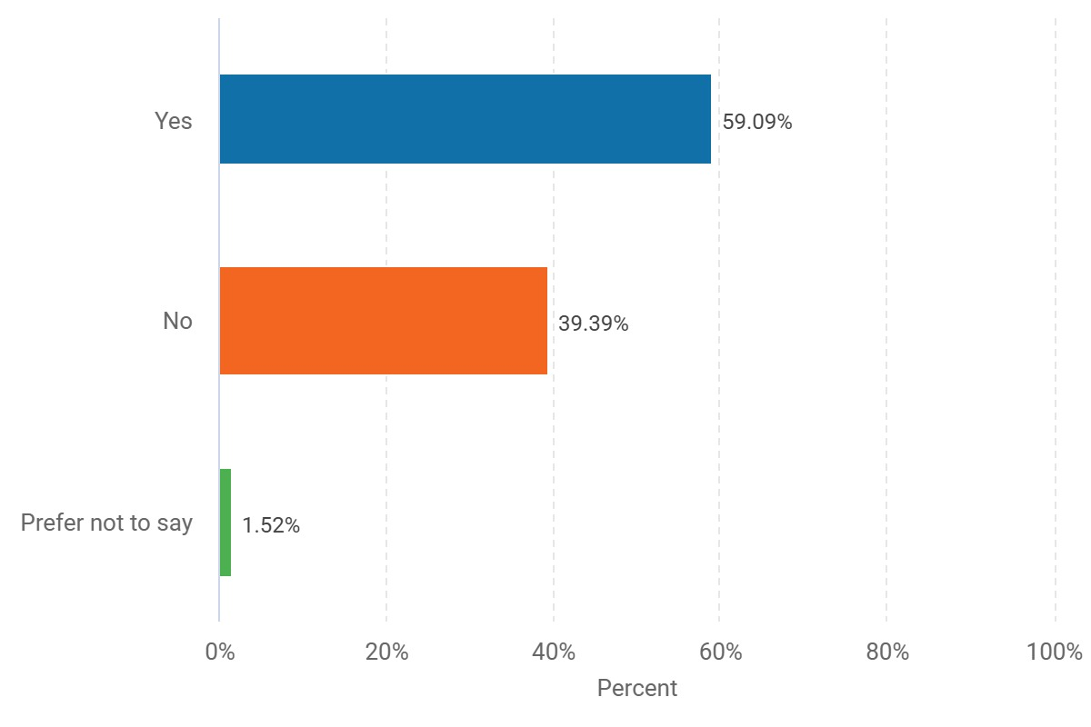

Figure 11. A graphical representation of whether these traumatic experiences have affected officers outside of work.
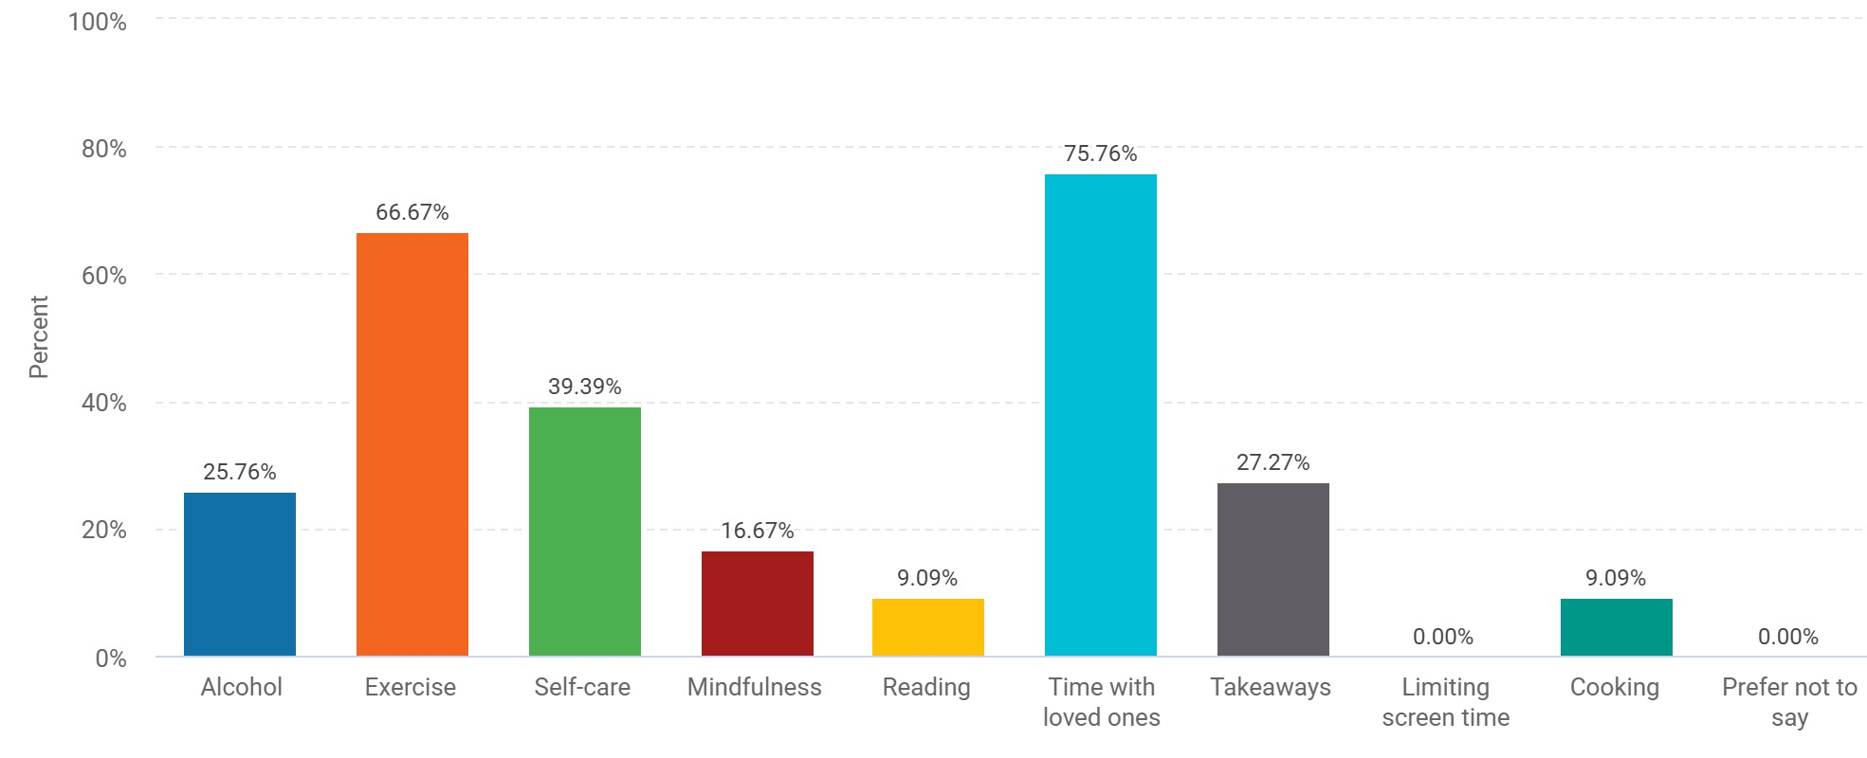

Figure 12. A graphical representation of the different types of coping mechanisms used by respondents.

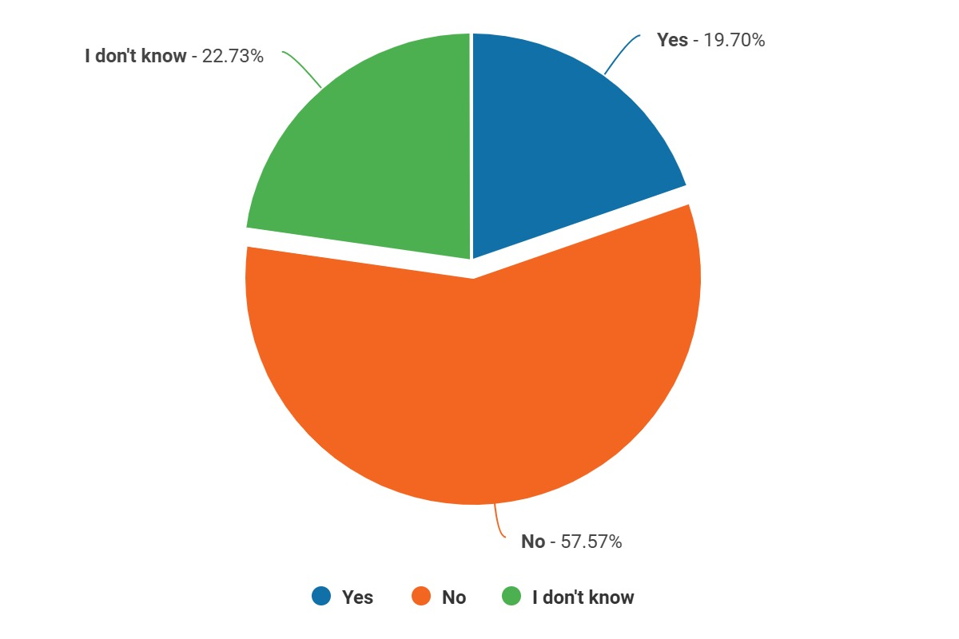

Figure 13. A graphical representation of whether there is adequate support for those suffering from trauma
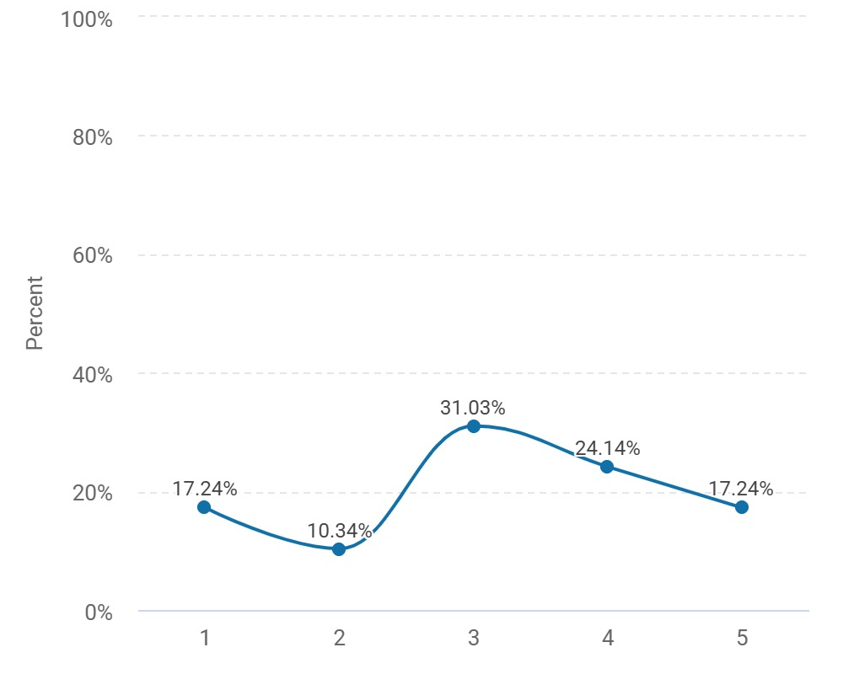

Figure 14. A graphical representation showing how beneficial respondents found the TRiM process (max.5 stars).
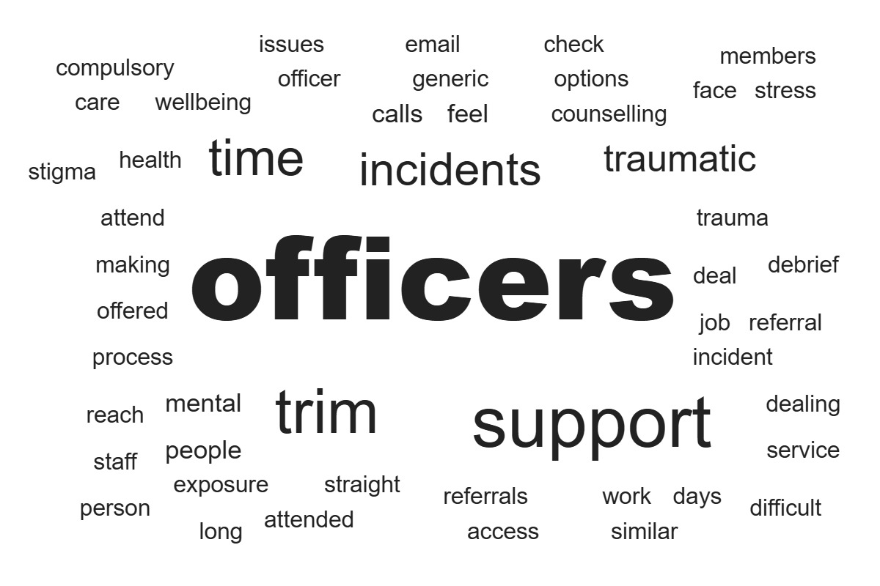

Figure 15. A graphical representation of how respondents believe organisations could better support officers suffering from trauma exposure.

Discussion of findings

This section of the chapter will be dedicated to discussing responses received back from the questionnaire. Of the 66 participants, more females (62.12%) answered the survey compared to males (37.88%). Most participants were also between the ages of 30-39 years old (50%) closely followed by 21-29 years old (39.39%). Similarly, most participants had 1 – 3 years’ service as a police officer (37.88%) with only 12.12% having over 10 years’ service. Interestingly, this corroborates the trend relating to a younger workforce within policing and the lack of more senior and experienced constables (Williams and Sondhi, 2022).
Perhaps a downfall in the questionnaire is the lack of responses from more than two police forces, most responses came from Gwent Police officers (59.09%) with South Wales Police officers (40.91%) following closely behind. There were no responses from the other two forces, Dyfed Powys Police or British Transport Police. The lack of variety could potentially hinder conclusions drawn based on this research. Most responses came from officers who are on response (45.76%) followed by officers on CID and PPT (11.86%). Positively, this questionnaire includes responses from officers from nine different departments. This allows a variety of perspectives to be included in the findings.
Participants were asked how satisfied they are in their current roles and interestingly 42.42% of respondents stated they were satisfied. However, this was followed by participants feeling neutral about their role (24.24%). Moreover, only 6.06% of respondents stated they were very satisfied, and the same percentile answered that they were very dissatisfied. According to other literature, this corroborates the trend that police officers often feel overwhelmed and overlooked whilst at work (Edwards and Kotera, 2020). Moreover, most respondents reported that they felt neutral feelings whilst at work (22.83%). Concerningly, 11.96% reported feeling stressed at work and 10.87% feel unappreciated. Sadness (6.52%), anxiety (4.35%) and tiredness (5.43%) were also reported however, these percentages were lower than initially expected. Interestingly, 16.30% reported feeling happy whilst at work.
Participants were asked if they feel their mental health has been affected since becoming a police officer and concerningly, 71.21% answered yes. These statistics are worrying and show a direct link between policing and the decline of mental wellbeing (Regehr et al., 2019). Additionally, participants were also asked if they had ever experienced traumatic experiences in work. An overwhelming statistic of 96.97% answered yes and 71.21% admitted that these traumatic experiences have affected them. This shows a clear correlation between traumatic experiences in policing and its detrimental effects on officers.
Positively, 66.67% of participants stated they use exercise and 39.39% use self-care to deal with trauma at work and time with loved ones was also popular with 75.76%. This emphasises positive coping mechanisms exhibited by many officers (Modula et al., 2024). Other unhealthy coping mechanisms were also selected with 27.27% admitting to eating takeaways and 25.76% using alcohol to cope. Demonstrating a range of coping strategies are used by officers. The unhealthy habits do corroborate previous research surrounding the correlation between stress in policing, unhealthy coping mechanisms and more physical/mental health (Galbraith et al., 2020).
Concerningly, 57.58% of respondents stated they do not feel there is adequate support for those struggling with trauma in work. This corroborates the hypothesis that there is not enough support for officers suffering from traumatic experiences and the psychological effects of trauma exposure on officers is monumental.
Participants were asked to rate the trauma risk management system utilised by police forces to help officers with the effects of trauma. Most respondents rated this system 3 out of 5 stars (31.03%). However, 17.24% persons rated TRiM referrals with 1 out of 5 stars but the same percentile rated the system 5 out of 5 stars. This shows mixed perspectives surrounding TRiM referrals and their effectiveness.
Lastly, respondents were asked how organisations could better support officers with trauma exposure. Most participants stated that de-briefs need to be a compulsory part of the aftermath of trauma exposure (Civilotti et al., 2021). Another common theme was further education and a better understanding from senior management about trauma, its effects and further support for officers (Collazo, 2020). Interestingly, officers also reported that TRiM referrals are not adequate and the ‘generic’ emails that are sent following these experiences are not adequate, and many officers do not feel individually supported (Phung et al., 2022). Moreover, low staffing levels also contributes to the lack of support and officers who are struggling often going over-looked (Cartwright and Roach, 2020). Overall, there was a clear theme to the answers in this question, there needs to be more variety and easier access to mental health services and trauma support.

Conclusions and Recommendations

This chapter will explore the conclusions of any findings outlined in this study. Traumatic experiences in policing are ever-increasing and consequently so are mental health issues among police officers. There is minimal research and surrounding literature on the effects, both long and short term of traumatic experiences on constables, in contemporary society. This study has attempted to bridge that gap in research by producing an electronic questionnaire for serving police officers to offer their opinions and provide insight into the systemic issue.
Moreover, the results have shown that there are serving police officers currently suffering with the effects of trauma, both outside and at work. Concerningly, an overwhelming 96.97% stated they had experienced trauma at work. Furthermore, 71.21% of officer’s stated that their mental health had declined since becoming a police officer. 57.58% stated that there was not enough support provided for those struggling and in addition to this, there were mixed opinions on the current support system (TRiM) and respondents were vocal about what other alternatives could be implemented.
Overall, the evidence from the survey clearly shows that most officers have experienced or do experience trauma whilst at work and it does affect them. The initial hypothesis wanted to explore the effects of trauma and how officers currently view the support available. This research paper has been successful in providing responses to these original statements whilst using external literature to corroborate these hypotheses.
The implications of this research study could be extremely positive and insightful for senior ranking officers and external bodies to read. It is transparent and honest in its approach; it offers a concerning conclusion that many police officers who responded have experienced trauma on the front line of policing and a vast majority have stated they’ve been affected by this. The study has included responses from a variety of persons, from a diverse group of departments and years of service – offering an insight into a bigger picture.
Interestingly, the study also calls for a further conversation surrounding trauma in policing, its effects and how we can better support those who support the public continually with integrity and professionalism. More effective support is needed for police officers, there is a requirement for a further and continuous discussion surrounding officer wellbeing and mental health issues. Without addressing these issues, there is a great risk of losing passionate individuals capable of making a difference in communities because of poor support and ever-increasing demand.

Bibliography

(2024) Trauma | English Meaning - Cambridge Dictionary. Available at: https://dictionary.cambridge.org/dictionary/english/trauma (Accessed: 15 July 2024).

8 key types of trauma therapy (2023). https://www.routledge.com/blog/article/8-key-types-of-trauma-therapy.

Ad de Jongh, Carlijn de Roos and Sharif El‐Leithy (2024). State of the science: Eye movement desensitization and reprocessing (EMDR) therapy. Journal of Traumatic Stress, 37(2). doi:https://doi.org/10.1002/jts.23012.

Alshahrani, K.M., Johnson, J., Prudenzi, A. and O’Connor, D.B. (2022). The effectiveness of psychological interventions for reducing PTSD and psychological distress in first responders: A systematic review and meta-analysis. PloS One, [online] 17(8), p.e0272732. doi:https://doi.org/10.1371/journal.pone.0272732.

American Psychological Association (2024). Trauma. American Psychological Association. [online] Available at: https://www.apa.org/topics/trauma.

Anders, R., Willemin-Petignat, L., Rolli Salathé, C., Samson, A.C. and Putois, B. (2022). Profiling Police Forces against Stress: Risk and Protective Factors for Post-Traumatic Stress Disorder and Burnout in Police Officers. International Journal of Environmental Research and Public Health, 19(15), p.9218. doi:https://doi.org/10.3390/ijerph19159218.

Ashton, K., Bellis, M. and Hughes, K. (2016). Adverse childhood experiences and their association with health-harming behaviours and mental wellbeing in the Welsh adult population: a national cross-sectional survey. The Lancet, 388, p.S21. doi:https://doi.org/10.1016/s0140-6736(16)32257-7.

Avon and Somerset Police Federation. (2021). Capture Data on Traumatic Incidents [internet]. [Accessed 7 July 2024]

Basto-Pereira, M., Gouveia-Pereira, M., Pereira, C.R., Barrett, E.L., Lawler, S., Newton, N., Stapinski, L., Prior, K., Costa, M.S.A., Ximenes, J.M., Rocha, A.S., Michel, G., Garcia, M., Rouchy, E., Al Shawi, A., Sarhan, Y., Fulano, C., Magaia, A.J., El-Astal, S. and Alattar, K. (2022). The global impact of adverse childhood experiences on criminal behavior: A cross-continental study. Child Abuse & Neglect, [online] 124(1), p.105459. doi:https://doi.org/10.1016/j.chiabu.2021.105459.

Bateson, K., McManus, M. and Johnson, G. (2019). Understanding the use, and misuse, of Adverse Childhood Experiences (ACEs) in trauma-informed Policing. The Police Journal: Theory, Practice and Principles, 93(2), pp.131–145. doi:https://doi.org/10.1177/0032258x19841409.

Biggs, C., Tehrani, N. and Billings, J. (2021). Brief trauma therapy for occupational trauma-related PTSD/CPTSD in UK police. Occupational Medicine, 71(4-5). doi:https://doi.org/10.1093/occmed/kqab075.

Center For Substance Abuse Treatment (2014). Trauma-informed care in behavioral health services. Rockville, Md: U.S. Department Of Health And Human Services, Substance Abuse And Mental Health Services Administration, Centre For Substance Abuse Treatment.

Civilotti, C., Di Fini, G. and Maran, D.A. (2021). Trauma and Coping Strategies in Police Officers: A Quantitative-Qualitative Pilot Study. International Journal of Environmental Research and Public Health, 18(3), p.982. doi:https://doi.org/10.3390/ijerph18030982.

Cleave, P. (2021). The Benefits of Anonymous Surveys. [online] SmartSurvey. Available at: https://www.smartsurvey.co.uk/blog/the-benefits-of-anonymous-surveys.

Collazo, J. (2020). Adapting Trauma-Focused Cognitive Behavioral Therapy to Treat Complex Trauma in Police Officers. Clinical Social Work Journal, 50(2). doi:https://doi.org/10.1007/s10615-020-00770-z.

Collazo, J. (2020). Adapting Trauma-Focused Cognitive Behavioral Therapy to Treat Complex Trauma in Police Officers. Clinical Social Work Journal, 50(2). doi:https://doi.org/10.1007/s10615-020-00770-z.

Edwards, A.-M. and Kotera, Y. (2020). Mental Health in the UK Police Force: a Qualitative Investigation into the Stigma with Mental Illness. International Journal of Mental Health and Addiction, [online] 19(4). Available at: https://link.springer.com/article/10.1007/s11469-019-00214-x.#

Foley, J. and Massey, K.L.D. (2020). The ‘cost’ of caring in policing: From burnout to PTSD in police officers in England and Wales. The Police Journal: Theory, Practice and Principles, [online] 94(3), p.0032258X2091744. doi:https://doi.org/10.1177/0032258x20917442.

Galbraith, N., Boyda, D., McFeeters, D. and Galbraith, V. (2020). Patterns of occupational stress in police contact and dispatch personnel: implications for physical and psychological health. International Archives of Occupational and Environmental Health, 94(2), pp.231–241. doi:https://doi.org/10.1007/s00420-020-01562-1.

Garfin, D.R., Thompson, R.R. and Holman, E.A. (2018). Acute stress and subsequent health outcomes: A systematic review. Journal of Psychosomatic Research, 112, pp.107–113. doi:https://doi.org/10.1016/j.jpsychores.2018.05.017.

Gilgoff, R., Singh, L., Koita, K., Gentile, B. and Marques, S.S. (2020). Adverse Childhood Experiences, Outcomes, and Interventions. Pediatric Clinics of North America, 67(2), pp.259–273. doi:https://doi.org/10.1016/j.pcl.2019.12.001.

Gillespie-Smith, K, Brodie, ZP, Collins, K, Deacon, K & Goodall, K 2020, Moving Towards Trauma-Informed Policing: An Exploration of Police Officer’s Attitudes and Perceptions Towards Adverse Childhood Experiences (ACEs)

Grupe, D.W., McGehee, C., Smith, C., Francis, A.D., Mumford, J.A. and Davidson, R.J. (2019). Mindfulness training reduces PTSD symptoms and improves stress-related health outcomes in police officers. Journal of Police and Criminal Psychology, 36. doi:https://doi.org/10.1007/s11896-019-09351-4.

Jetelina, K.K., Molsberry, R.J., Gonzalez, J.R., Beauchamp, A.M. and Hall, T. (2020). Prevalence of Mental Illness and Mental Health Care use among Police Officers. JAMA Network Open, [online] 3(10), p.e2019658. doi:https://doi.org/10.1001/jamanetworkopen.2020.19658.

Kalmakis, K.A. and Chandler, G.E. (2013). Adverse childhood experiences: towards a clear conceptual meaning. Journal of Advanced Nursing, [online] 70(7), pp.1489–1501. doi:https://doi.org/10.1111/jan.12329.

Kwiatkowski, C.C., Manning, C.E., Eagle, A.L. and Robison, A.J. (2020). The neurobiology of police health, resilience, and wellness. POWER, pp.77–96. doi:https://doi.org/10.1016/b978-0-12-817872-0.00006-9.

Leigh Wills, J. and Schuldberg, D. (2016). Chronic Trauma Effects on Personality Traits in Police Officers. Journal of Traumatic Stress, 29(2), pp.185–189. doi:https://doi.org/10.1002/jts.22089.

Lewsey, F. (2022). UK policing: psychological damage among officers heightened by bad working conditions. [online] University of Cambridge. Available at: https://www.cam.ac.uk/research/news/uk-policing-psychological-damage-among-officers-heightened-by-bad-working-conditions.

Merrick, M.T., Ford, D.C., Haegerich, T.M. and Simon, T. (2020). Adverse Childhood Experiences Increase Risk for Prescription Opioid Misuse. The Journal of Primary Prevention, 41(2), pp.139–152. doi:https://doi.org/10.1007/s10935-020-00578-0.

Modula, M.J., Mathapo-Thobakgale, E.M., Nyoni, C.N. and Jansen, R. (2024). Strategies for Coping with Occupational Trauma: A Scoping Review of the Police Officer Context. International Journal of Environmental Research and Public Health, [online] 21(7), p.921. doi:https://doi.org/10.3390/ijerph21070921.

National Library of Medicine (2022). Qualitative Data . [online] www.nnlm.gov. Available at: https://www.nnlm.gov/guides/data-glossary/qualitative-data.
National Library of Medicine (2023). Quantitative Data. [online] www.nnlm.gov. Available at: https://www.nnlm.gov/guides/data-glossary/quantitative-data.

Oscar Kilo (2023). National Police Wellbeing Survey 2023 results | Oscar Kilo. [online] www.oscarkilo.org.uk. Available at: https://www.oscarkilo.org.uk/news/national-police-wellbeing-survey-2023-results.

Papazoglou, K. and Tuttle, B.M. (2018). Fighting Police Trauma: Practical Approaches to Addressing Psychological Needs of Officers. SAGE Open, [online] 8(3). doi:https://doi.org/10.1177/2158244018794794.

Phung, V.-H., Sanderson, K., Pritchard, G., Bell, F., Hird, K., Wankhade, P., Asghar, Z. and Siriwardena, N. (2022). The experiences and perceptions of wellbeing provision among English ambulance services staff: a multi-method qualitative study. BMC Health Services Research, [online] 22(1). doi:https://doi.org/10.1186/s12913-022-08729-1.

Piotrowski, C. (2020). ACEs and trauma-informed care. Adverse Childhood Experiences, [online] pp.307–328. doi: https://doi.org/10.1016/B978-0-12-816065-7.00015-X.

Police Care UK. (2018). Police Traumatic Events Checklist. [online] Available at: https://www.policecare.org.uk/research/police-traumatic-events-checklist/.

Porter, C.N. and Lee, R. (2023). The policing culture: an exploration into the mental health of former British police officers. Current Psychology, [online] 43. doi:https://doi.org/10.1007/s12144-023-04365-y.
Psychologytoday (2022). Trauma-Focused Cognitive Behavior Therapy | Psychology Today United Kingdom. [online] www.psychologytoday.com. Available at: https://www.psychologytoday.com/gb/therapy-types/trauma-focused-cognitive-behavior-therapy.

Regehr, C., Carey, M.G., Wagner, S., Alden, L.E., Buys, N., Corneil, W., Fyfe, T., Matthews, L., Randall, C., White, M., Fraess-Phillips, A., Krutop, E., White, N. and Fleischmann, M. (2019). A systematic review of mental health symptoms in police officers following extreme traumatic exposures. Police Practice and Research, 22(1), pp.1–15. doi:https://doi.org/10.1080/15614263.2019.1689129.

Regehr, C., Carey, M.G., Wagner, S., Alden, L.E., Buys, N., Corneil, W., Fyfe, T., Matthews, L., Randall, C., White, M., Fraess-Phillips, A., Krutop, E., White, N. and Fleischmann, M. (2019). A systematic review of mental health symptoms in police officers following extreme traumatic exposures. Police Practice and Research, 22(1), pp.1–15. doi:https://doi.org/10.1080/15614263.2019.1689129.

Shapiro, F. (1989). Efficacy of the eye movement desensitization procedure in the treatment of traumatic memories. Journal of Traumatic Stress, 2(2), pp.199–223. doi:https://doi.org/10.1002/jts.2490020207.

Smart survey (2020). SmartSurvey. [online] Smartsurvey.co.uk. Available at: https://www.smartsurvey.co.uk/.

Stamper, S. (2021). Study finds link between heavy drinking and mental health problems in UK Police Service - University of Liverpool News. [online] News. Available at: https://news.liverpool.ac.uk/2021/06/23/study-finds-link-between-heavy-drinking-and-mental-health-problems-in-uk-police-service/#:~:text=Policing%20is%20a%20highly%20stressful [Accessed 19 Aug. 2024].

Stevelink, S.A.M., Opie, E., Pernet, D., Gao, H., Elliott, P., Wessely, S., Fear, N.T., Hotopf, M. and Greenberg, N. (2020). Probable PTSD, Depression and Anxiety in 40,299 UK Police Officers and staff: Prevalence, Risk Factors and Associations with Blood Pressure. PLOS ONE, [online] 15(11), p.e0240902. doi:https://doi.org/10.1371/journal.pone.0240902.
Tehrani, N. (2011). Managing trauma in the workplace: supporting workers and organizations. London: Routledge.

The Association of Directors of Public Health and The Wave Trust (2021). GUIDANCE FOR THE POLICING SECTOR. [online] Available at: https://www.adph.org.uk/wp-content/uploads/2021/12/ACES-Guidance-for-the-policing-Sector.pdf.

The National Child Traumatic Stress Network (2018). Trauma types. [online] The National Child Traumatic Stress Network. Available at: https://www.nctsn.org/what-is-child-trauma/trauma-types.

Turgoose, D., Glover, N. and Maddox, L. (2022). Burnout and the psychological impact of policing: trends and coping strategies. Elsevier eBooks, pp.63–86. doi:https://doi.org/10.1016/b978-0-12-816544-7.00004-8.

UK Statistics Authority. (2022). Ethical considerations associated with Qualitative Research methods. [online] Available at: https://uksa.statisticsauthority.gov.uk/publication/ethical-considerations-associated-with-qualitative-research-methods/pages/5/#:~:text=21%20October%202022-.

Welsh Government (2021). Review of Adverse Childhood Experiences (ACE) policy: report [HTML]. [online] GOV.WALES. Available at: https://www.gov.wales/review-adverse-childhood-experiences-ace-policy-report-html.

Williams, E. and Sondhi, A. (2022). A Narrative Review of the Literature on the Recruitment of Younger Police Officers in Age and in Service: What Are the Implications for the Police in England and Wales? Policing: A Journal Of Policy And Practice, 16(4). doi:https://doi.org/10.1093/police/paac001.

Xu, M. (2021). Understanding Graph Embedding Methods and Their Applications. SIAM Review, 63(4), pp.825–853. doi:https://doi.org/10.1137/20m1386062.

Zettler, H.R. (2020) ‘Much to Do About Trauma: A Systematic Review of Existing Trauma-Informed Treatments on Youth Violence and Recidivism’, Youth Violence and Juvenile Justice, 19(1), p. 154120402093964. Available at: https://doi.org/10.1177/1541204020939645.

