Name: Aimnumhenfo Iyoha
Student Number: 2329981
Module Code & Title: BMHP5014 Changemakers: Creativity and Value Creation
Assignment Title: Component 2: Written Assignment (Report)

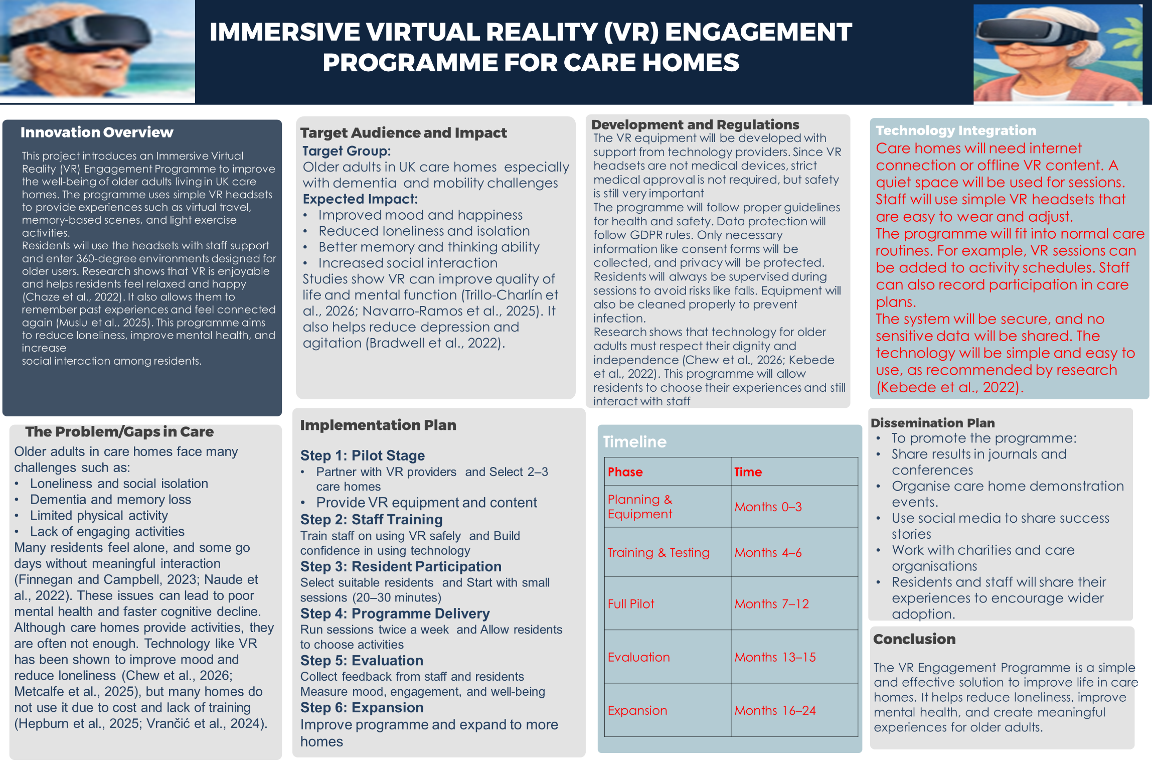
PITCH: BRINGING VR ENGAGEMENT TO CARE HOMES

Narrative of the Innovation
Imagine Mrs Patel, an 87-year-old widow living in a care home in Yorkshire. She has early dementia and most days she keeps to herself. She does not go out often and she hardly talks to people around her. One day, a nurse introduces her to a simple virtual reality headset. At first, she is unsure, but she agrees to try it. When she puts it on, something amazing happens. She suddenly finds herself on a quiet beach in India, close to where she grew up. She can see the waves, hear the water, and feel like she is really there. Tears come to her eyes as she remembers her childhood. She smiles and begins to talk. She points at things and tells stories from her past. She says she can see places she has not seen in many years. Later that day, she uses the headset again, but this time she is painting in a virtual art space. She enjoys it and feels happy. After the session, she talks more with other residents and even joins group activities. Staff notice that she is calmer and more involved than before.
This idea is not just imagination. Studies have shown that older people enjoy virtual reality and feel more connected when they use it. Researchers like Chaze et al. (2022) and Muslu et al. (2025) explain that many older adults feel happy and relaxed during VR sessions. Some even say it feels like going back in time. Another study by Saredakis et al. (2021) shows that older people often prefer VR to watching normal screens, and most of them do not have serious side effects. Over time, this kind of experience can help improve mood and slow down mental decline. For care homes, this means residents can have something new and meaningful that brings joy to their daily lives.

Legislation, Policy, and Professional Roles
This VR programme supports important health and social care policies in the UK. The Care Act (2014) focuses on improving the well-being of individuals. This programme supports that goal by helping older adults feel valued, respected, and included. It also allows them to make choices about what they want to experience, which supports their dignity. Moreover, guidelines from NICE (2018) encourage non-drug approaches for people with dementia. This VR programme fits well here because it provides emotional and mental support without medication. In addition, the NHS Long Term Plan supports the use of digital technology to improve care services (NHS, 2025). Data protection is very important in this programme. It will follow the UK GDPR and the Data Protection Act (2018). This means all personal information will be kept safe and secure. Any data collected will be protected, and residents’ privacy will be respected at all times.
Moreover, different professionals will be involved in making this programme work well. Care home managers will oversee the programme and ensure it fits into daily routines. Care workers and activity coordinators will help residents use the VR headsets and observe how they respond. Nurses and therapists can recommend residents who may benefit from the programme. IT staff will handle technical issues and maintain the equipment. Specialists like occupational therapists can also help design activities that support physical and mental health. Family members and volunteers can be involved by supporting residents during sessions or even sharing virtual experiences with them.
Also, because this is a new way of working, staff training is very important. The programme will provide training sessions to help staff understand how to use VR safely and effectively. Research shows that when staff feel confident, they are more likely to use new technology (Hepburn et al., 2025; Birati and Tzemag-Shahar, 2026). Clear rules, such as consent and scheduling, will also be put in place to guide the programme.

Public Engagement and Support Campaign
Public support will help this programme succeed. Local communities can take part through volunteering and awareness. Young people who understand technology can visit care homes and help residents use VR. This also creates a good connection between young and old people. Research shows that regular contact with younger people can reduce loneliness among care home residents (Phang et al., 2023). This programme can build on that by training volunteers to support VR sessions and help residents connect with family members. Charities can also support by donating equipment or providing funding. Organisations like Age UK and Alzheimer’s groups can help promote the programme and encourage more care homes to adopt it.
Furthermore, care homes can organise open days where people come and see how VR works. Visitors can try the technology and see the benefits for themselves. This can help change how people think about older adults and technology. Social media can also be used to share success stories. Short videos of residents enjoying VR can attract attention and support. Policymakers can be invited to see live demonstrations so they understand the value of the programme. In simple terms, everyone can help. People can volunteer, donate, or simply share information. Studies show that volunteer involvement improves mood and engagement among residents (Handley et al., 2022). Family involvement also makes the experience better. Schools and youth groups can even support care homes by sponsoring VR equipment.

Benefits to Older Adults in Care Homes
The VR program offers multi-faceted benefits to the target group:
- Improves mood and emotional well-being: Research shows that VR can make people feel happier and more relaxed (Eckert et al., 2025). Residents often feel excited and refreshed after sessions (Chaze et al., 2022; Muslu et al., 2025).
- Reduced Loneliness and Isolation: Many older adults feel isolated in care homes. VR can help them connect with others through shared experiences or virtual visits. Studies show that digital communication can reduce loneliness (Naudé et al., 2021). This is important because many residents feel alone (Finnegan and Campbell, 2023).
- Supports brain function: VR activities help improve memory and attention. Research shows that VR training can lead to improvements in thinking and problem-solving (Navarro-Ramos et al., 2025).
- Supports light physical activity: Some VR activities involve simple movements that can improve balance and strength. Studies show that this can help older adults feel more confident in movement (Metcalfe et al., 2025).
- Improves social interaction: Residents can talk about their experiences and share stories. This helps them build relationships and feel part of a community (Metcalfe et al., 2025; Fardeau et al., 2023; Yeo et al., 2023).
- Supports personalised care: Each resident can choose what they want to experience. This makes them feel important and respected. Research shows that personalised technology improves independence and identity (Metcalfe et al., 2025; Darley and Carroll, 2022).
- Reduce the need for medication: When residents feel calm and happy, there may be less need for drugs used to manage behaviour. Studies show that similar programmes can reduce agitation and improve overall well-being (Bradwell et al., 2022).

References
Birati, Y. and Tzemah-Shahar, R. (2026) Barriers to Digital Health Adoption in Older Adults: Scoping Review Informed by Innovation Resistance Theory. Journal of Medical Internet Research, 28, p.e75591.
Bradwell, H., Edwards, K.J., Winnington, R., Thill, S., Allgar, V. and Jones, R.B. (2022) Implementing affordable socially assistive pet robots in care homes before and during the COVID-19 pandemic: Stratified cluster randomized controlled trial and mixed methods study. JMIR aging, 5(3), p.e38864.
Chaze, F., Hayden, L., Azevedo, A., Kamath, A., Bucko, D., Kashlan, Y., Dube, M., De Paula, J., Jackson, A., Reyna, C. and Warren-Norton, K. (2022) Virtual reality and well-being in older adults: Results from a pilot implementation of virtual reality in long-term care. Journal of Rehabilitation and Assistive Technologies Engineering, 9, p.20556683211072384.
Chew, M., Pedell, S., Muñoz, D. and Basic, M. (2026) Technology Interventions and Well-Being Enhancement in Residential Aged Care: A Scoping Review. Technologies, 14(2), p.90.
Darley, A. and Carroll, Á. (2022) Conducting co-design with older people in a digital setting: methodological reflections and recommendations. International Journal of Integrated Care, 22(4), p.18.
Department of Health and Social Care (2025) Care Act 2014: supporting implementation. GOV.UK. Available at: https://www.gov.uk/government/publications/care-act-statutory-guidance[Accessed 31 March 2026].
Eckert, M., Radhakrishnan, V., Ostermann, T., Ehlers, J.P. and Hohenberg, G. (2025) August. Virtual and Augmented Reality Games in Dementia Care: Systematic and Bibliographic Review. In Healthcare (Vol. 13, No. 16, p. 2013). MDPI.
Fardeau, E., Senghor, A.S. and Racine, E. (2023) The impact of socially assistive robots on human flourishing in the context of dementia: a scoping review. International journal of social robotics, 15(6), pp.1025-1075.
Finnegan, D.J. and Campbell, S. (2023) Tackling loneliness and isolation in older adults with virtual reality: How do we move forward?. Gerontology and Geriatric Medicine, 9, p.23337214231186204.
Great Britain (2014) Care Act 2014. London: The Stationery Office.
Great Britain (2018) Data Protection Act 2018. London: The Stationery Office. Available at:https://www.legislation.gov.uk/ukpga/2018/12/notes/division/4/index.htm? [Accessed 31 March 2026].
Handley, M., Bunn, F., Dunn, V., Hill, C. and Goodman, C. (2022) Effectiveness and sustainability of volunteering with older people living in care homes: A mixed methods systematic review. Health & Social Care in the Community, 30(3), pp.836-855.
Hepburn, J., Williams, L. and McCann, L. (2025) Barriers to and facilitators of digital health technology adoption among older adults with chronic diseases: updated systematic review. JMIR aging, 8, p.e80000.
Kebede, A.S., Ozolins, L.L., Holst, H. and Galvin, K. (2022) Digital engagement of older adults: scoping review. Journal of Medical Internet Research, 24(12), p.e40192.
Lee, A., Lee, H. and Lee, S.H. (2025) Digital Healthcare Approaches for Fall Detection and Prediction in Older Adults: A Systematic Review of Evidence from Hospital and Long-Term Care Settings. Medicina, 61(11), p.1926.
Metcalfe, H., Robinson-Carter, E. and Joddrell, P. (2025) An Exploration of Exergaming for People Living with Dementia in Long-Term Care Settings: A Scoping Review. Home Health Care Management & Practice, p.10848223251359669.
Muslu, L., Karakuş, Z., Asï, E., Bayindir, R. and Özer, Z. (2025) Time travel of older people through virtual reality: a qualitative study. BMC geriatrics, 25(1), p.42.
Muslu, L., Karakuş, Z., Asï, E., Bayindir, R. and Özer, Z. (2025) Time travel of older people through virtual reality: a qualitative study. BMC geriatrics, 25(1), p.42.
Navarro-Ramos, C.D., Murataya-Gutiérrez, J., Acosta-Quiroz, C.O., García-Flores, R. and Echeverría-Castro, S.B. (2025) Effects of cognitive training with virtual reality in older adults: A systematic review. Brain Sciences, 15(9), p.910.
Navarro-Ramos, C.D., Murataya-Gutiérrez, J., Acosta-Quiroz, C.O., García-Flores, R. and Echeverría-Castro, S.B. (2025) Effects of cognitive training with virtual reality in older adults: A systematic review. Brain Sciences, 15(9), p.910.
NHS (2025) Fit for the Future: 10 Year Health Plan for England. UK Government. Availalbe at: https://webarchive.nationalarchives.gov.uk/ukgwa/20250707154011/https://www.gov.uk/government/publications/10-year-health-plan-for-england-fit-for-the-future [Accessed: 31 March 2026].
NICE (2018, June) Dementia: assessment, management and support for people living with dementia and their carers. NICE. Available at: https://www.nice.org.uk/guidance/ng97/chapter/recommendations [Accessed: 31 March 2026].
Phang, J.K., Kwan, Y.H., Yoon, S., Goh, H., Yee, W.Q., Tan, C.S. and Low, L.L. (2023) Digital intergenerational program to reduce loneliness and social isolation among older adults: realist review. JMIR aging, 6(1), p.e39848.
Saredakis, D., Keage, H.A., Corlis, M., Ghezzi, E.S., Loffler, H. and Loetscher, T. (2021) The effect of reminiscence therapy using virtual reality on apathy in residential aged care: multisite nonrandomized controlled trial. Journal of medical Internet research, 23(9), p.e29210.
Trillo-Charlín, I., Bravo-Aparicio, J., Avendaño-Coy, J. and Beltrán-Alacreu, H., 2026. Impact of 4 Weeks or More Immersive Virtual Reality on Quality of Life and Physical Activity in Older Adults: Systematic Review and Meta-Analysis. JMIR aging, 9, p.e80820.
UK General Data Protection Regulation (UK GDPR) (2021) Regulation (EU) 2016/679 as retained in UK law and amended by the Data Protection, Privacy and Electronic Communications (Amendments etc.) (EU Exit) Regulations 2019. Available at: UK GDPR legislation [Accessed 31 March 2026].
UK Government (2025) Data protection: The UK's data protection legislation. GOV.UK.
Vrančić, A., Zadravec, H. and Orehovački, T. (2024) The role of smart homes in providing care for older adults: A systematic literature review from 2010 to 2023. Smart Cities, 7(4), pp.1502-1550.
Yeo, Y., Lau, Y., Ang, W.W., Wong, Q.F., Tam, H.L., Loh, W.L., Wong, S.H. and Lau, S.T. (2023) Unpacking older adults’ experiences using mobile telepresence robots: A systematic mixed-studies review. Geriatric Nursing, 54, pp.280-301.

