Name: Morgan McGowan-Boswell
Student Number: 2203790
Module Number: ECSO4001
Title: The Marxist ideology and its impact on society

In this essay, the key features of the Marxist perspective and how it relates to contemporary society will be explored. Various sociological perspectives have shaped the structures of society, influencing change across many countries. Marxism being one of those influences is considered to be a movement built on the foundation of Marx’s ideologies rather than a theory created by Marx himself. Sayers (2021) defines Marxism as ‘the system of thought created by Marx which provides the main theoretical basis for modern socialism and communism’. Giddens (1973) acknowledges Marx & Weber as the founders of Marxism, detailing how Marx’s views were influenced by ‘the father of sociology’, ‘Saint-Simon’. In this assignment, the debates on the impact of capitalism and the predictions of a class war argued from the Marxist perspective will be explained as well as a variety of ideas brought forward through Marxism. Most sociological thinkers tend to be divided into two viewpoints (consensus & conflict). Marxism, as well as other sociological theories, stand on the foundation of conflict, some agreeing with Marx’s theory of a class war. The conflict side of sociology will argue that society is not perfectly structured. In places around the world where the structure is perceived to be a complete production of perfection, the inner workings of those same structures are argued to be influenced by bias and the rejection of equality across a variety of social structures.
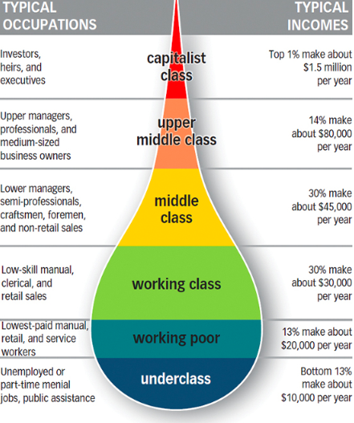
Capitalism is one of the most important concepts within sociology. The notion of capitalism was first designed and discussed by Marx. In modern-day society most individuals understand capitalism to be the exploitation of the working class which is correct. However, Giddens expands further into capitalism by referencing Marx’s views on capitalism, detailing how he saw that the bourgeoisie viewed labour. Giddens (1973, p. 34) ‘labour is treated on par with any other commodity’. To use the word commodity to describe the work or rather the understanding of a worker’s purpose suggests Marx believed workers were essentially products for economic production. This is shown further as Giddens references Marx’s ideas explaining how he thought that ‘what the worker sells, in fact, is his labour-power, an economic capacity, which can be quantified and assessed’ Giddens (1973, p. 34). It can be argued that this idea that one’s own labour is the same as items sold at a market is the same idea that pushed many sociologists to stand on side of conflict within the sociological debate. In today’s society capitalism is shown to not only be present within the economic and social structures of society but also considered to be one of the main factors on ideas brought forward by various sociological thinkers i.e. material deprivation, organised & unorganised crime, false consciousness, social stratification etc. The Gilbert & Kahl model perfectly depicts how class and capitalism intersect and where they are positioned in society’s structure. This model shows how one’s class status could impact where they are placed on the model as well, the career opportunities available for each group and the estimated income bracket. Wright (2012) argued that capitalism has continued to grow across the globe hardening its grip on various governments in various countries. ‘job insecurity in many economically developed countries have been deepening; capital has become increasingly footloose, moving across the globe and severely undermining the democratic capacity of states and communities; giant corporations dominate the media and cultural production’ Wright (2012). Taking into account the number of issues society is currently facing in many countries i.e. cost of living crisis in the Uk ‘Millions of households across the UK are struggling to make their incomes stretch to cover the rising cost of living’ HM Treasury (2022), homelessness rates in America ‘ New York, Hawaii, and California had the highest rates of homelessness relative to their population size. However, Washington, D.C., which has an estimated 90.4 homeless people per 10,000 inhabitants, was considerably higher than any of the 50 states’ Largest & Biggest (2022), exploitation of workers for big brands in China ‘Workers who make clothes sold on Shein get as little as 4 cents for each item they make, according to a new investigation’ Insider (2022), it can be fair to consider capitalism is a major enemy of progress in relation to the sustainability and survival of those at the bottom of the class ladder.
Image 1: Class Systems Of Stratification
(Course Hero Images, 2020)
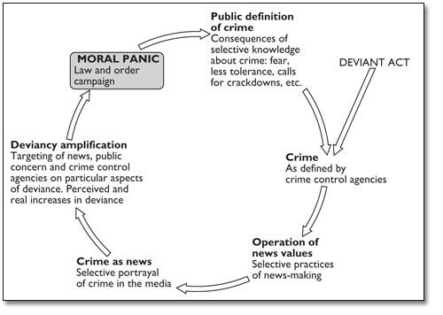
Understanding the structure of society is not a task that can be defined with one singular explanation. Religion & politics play a massive part in the structure of societies in various countries across the world. For instance, the United Arab Emirates is a country controlled and structured through religion just as much as the government. 76% of the population identifies as Muslim. With a religious percentage this high, it is arguable that gender norms and gender identity massively impact the socialisation of the citizens. Any form of sexuality outside of heterosexuality is not only illegal but seen as the greatest sin from a religious perspective, in some cases homosexuality is punishable by death. When this is compared to the UK the various divisions of religious belief openly demonstrate social inclusion can vary based on the relationship religion and the government share. Having the royal family follow an Anglicanism belief, 45% of Northern Ireland identified as Catholic, 72% of Wales identified as Christian, 46% of England identified as Christian and most recently the UK’s new prime minister identifying as Hindu it is arguable that these many religious divides make it difficult to have a simple system of control where the socialisation of the population is controlled. However, although the UK is religiously divided it has still been argued that there are many factors that affect how individuals & sub-cultures are labelled and how that affects society’s perception of others. Stanley Cohen coined the terms ‘folk devils’ & ‘moral panics’. He used these terms to explain the cycle of deviancy amplification. Cohen’s idea argued how much influence the media has on what society considers to be deviant. The morality of individuals and the wider society in most cases is governed by what people perceive to be right and wrong and it is the idea of right and wrong that any society across the globe is first built on. Cohen essentially argued that the media had the power to influence and amplify people’s views on particular actions, events and beliefs. Cottee (2002) ‘Most mundane crime, it was argued, was actually less politically or socially consequential than other social evils such as alienation, exploitation, or racism’, this directly links to Weber’s idea that capitalism does not just control the economic factors behind the structure of society but the social views are impacted just as much. Weber argued gender and religion amongst other factors heavily impacted the structures within society as well as capitalism. Cottee goes on to further support the debates of capitalism going on to say ‘ The institutional structure . . . is seen to be a seamless web of institutions which are unambiguously supportive of capitalism’, this claim could suggest that many of the structures societies around the world are built on are not maintained by our governments but rather major corporations.
Image 2: The Moral Panic Model
(Pinterest Images, 2015)
As Marxism contributes to debates through a macro perspective a lot of the studies and data collected have come in a quantitative form, qualitative data has been collected and demonstrated however it’s been argued that qualitative data is most effective and accurate when collected from smaller groups and done in covertly if possible. Giddens & Sutton (2017, p. 50) ‘quantitative methods try to measure social phenomena and will use mathematical models’, ‘qualitative methods attempt to gather detailed, rich data, allowing for an in-depth understanding’. Though the effectiveness of both quantitative and qualitative research has been argued both methods have proven to be extremely useful. As Marxism mainly focuses on class inequality, material deprivation, social stratification, capitalism & communism etc, it is understandable that quantitative methods would be useful as they provide a wider range of perspectives and gives researchers the ability to generalise their results. Marx travelled to many countries on various continents, and the research he did allowed him to make summarised judgments of the economic and social states of the cultures and sub-cultures within the places he visited, his macro perspective gave way to a lot of reform in today’s society in particular where the government is concerned. The influence of Marxism over the ages has caused massive change however smaller qualitative experiments and opinions have also previously stirred controversial debates. Jane Elliot (anti-racism activist & diversity educator) conducted an experiment known as ‘blue-eyed/brown-eyed’ she wanted her students to understand what racial discrimination feels like. She had divided her class by eye colour. In the beginning, the students with brown eyes were given superior treatment, became arrogant and unpleasant towards their peers. Elliot then reversed the experiment a few days later on the brown-eyed student, following this experiment Elliott recorded the student’s views on the experiment after supporting her claim that racism was a massive issue at the time as the majority of her students and parents of the students were displeased with the experiment. ‘An often-quoted letter stated’, "How dare you try this cruel experiment out on white children? Black children grow up accustomed to such behaviour, but white children, there's no way they could possibly understand it. It's cruel to white children and will cause them great psychological damage." Smithsonian Magazine (2005).
With the variety of changes brought forth by Marxism such as the birth of communism, the influence capitalism still has over society as well the various inequalities people are facing today it can be argued that Marxism is very much still an essential theory in an ongoing war for evenly distributed power between the bourgeoise and proletariat as well as those facing divides based on their own individual labels. It can also be argued with certain levels of deprivation certain countries are facing around the world in particular the cost of living crisis in the UK, that Marx’s idea of a class war/rebellion is highly possible.

Reference List:
Cottee, S. (2002) ‘Folk Devils and Moral Panics’, Left Idealism Reconsidered, 6(4), pp. 387-410.
Course Hero Images (2020) Class Systems of Stratification [Online]. Available at: https://www.coursehero.com/tutors-problems/Sociology/25002213-1-Class-systems-of-stratificationprovide-opportunity-for-open-mobilit/ (Accessed: 06 December 2022).
Gidden, A. & Sutton, P. W. (2017) Sociology 8th edn. Cambridge: Polity Press
Giddens, A. (1973) The Class Structure of The Advanced Societies
HM Treasury (2022) Policy Paper: Cost of Living Support Factsheet. Available at: Cost of living support factsheet: 26 May 2022 - GOV.UK (www.gov.uk) (Accessed: 07 December 2022).
Insider (2022) Shein Factory Employees are working 18-Hour Days For Pennies per garment and Washing Their Hair on Lunch Breaks Because They Have So Little Time off, New Report Finds. Available at: Shein Factory Employees Work 18-Hour Shifts, Make 4 Cents Per Garment: Report (businessinsider.com) (Accessed: 07 December 2022)
Largest & Biggest (2022) What Country Has The Largest Homeless Population? Available at: What Country Has the Largest Homeless Population? - LargestandBiggest.com (Accessed: 07 December 2022).
Pinterest Images (2015) The Moral Panic Model [Online]. Available at: https://www.pinterest.com/pin/487866572108335817/ (Accessed 10 December 2022).
Sayers, S. (2021) ‘International Critical Thought’, What is Marxism, 11(3), pp. 377-388.
Smithsonian Magazine (2005) Lesson of a Lifetime. Available at: Lesson of a Lifetime | Science| Smithsonian Magazine (Accessed 12 December 2022)

